create table movie(

-> id int auto_increment primary key,

-> name varchar(30),

-> year int,

-> director varchar(20),

-> grade int);

insert into movie(id,name,year,director,grade) values(1,"The Twilight Saga",2008,"Catherine",7);

insert into movie(name,year,director,grade)

values("feiwuhuanyouji",2009,"peter",9),("rangzidanfei",2012,"jiangwen",9),("chuanpuladadenvwang",2007,"david",8);

select * from movie;

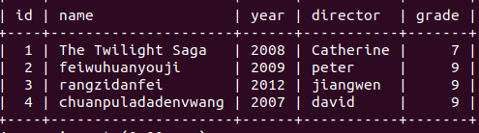

select * from movie where name like "%zidan%";

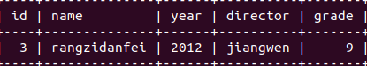

select * from movie where director like "jiang%";

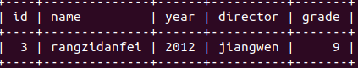

select * from movie where year=2008;

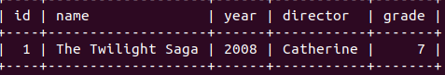

select * from movie where grade in(select max(grade) from movie);

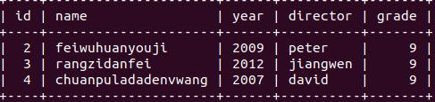

Exit;