sudo mysql -u root –p

show databases;

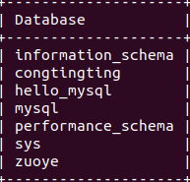

use zuoye;

creat table shoucang(

-> id int auto_increment primary key,

-> sc varchar(30));

desc shoucang;

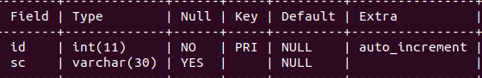

insert into shoucang(id,sc) values(1,"aa");

insert into shoucang(sc) values("bb"),("cc"),("dd"),("ee");

select * from shoucang;

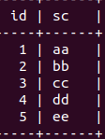

delete from shoucang where sc="bb";

select * from shoucang;

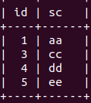

select * from shoucang where sc="aa";

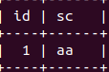

exit;