**The blockchain technical thinking accumulated by NULS community to carry business applications Module Chapter**

Business applications of blockchain are the hottest topics in blockchain discussion in 2018.In order to achieve this goal; people engaged in the blockchain have made different efforts in different aspects. The original intention of NULS is to enable the blockchain to carry different commercial applications. **In order to realize this vision, NULS takes the route to construct predictable technical demand, instead of guessing the possibility of business development in the future.** In the following article, the NULS Chinese community will demonstrate to us the technical thinking accumulated by NULS for corresponding application, from technical implementation of 5 aspects, such as modularization, multi-chain parallelism, cross-chain consensus, smart contract and consensus mechanism.

As is well-known to everyone, bitcoin is very sophisticated from the point of its logic and code. The reason why people criticize its expansive nature is that they have forgotten that its original design is just a point-to-point payment tool. **While during the initial period of the establishment of NULS, it took into account the rapid development of the business world and even its unpredictability. Therefore, NULS would rather build an infrastructure that can accompany the rapid development of the business world, than make any speculations about commercial development.** The obvious advantage of this infrastructure is sustainable upgrades. **The business world in the future is unpredictable, let alone the development of technology!**

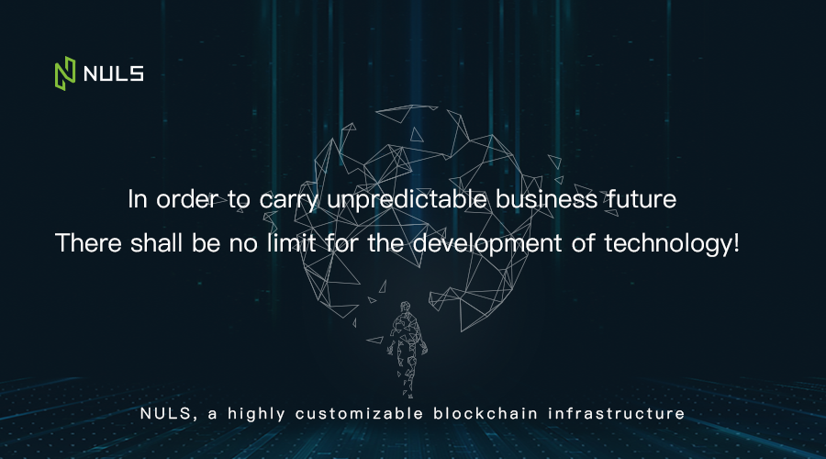

**Modular design at the current stage can enable the blockchain technology to upgrade continuously along with the change of the business world. The following picture shows the NNUS modular implementation path from the underlying architecture to the application layer.**

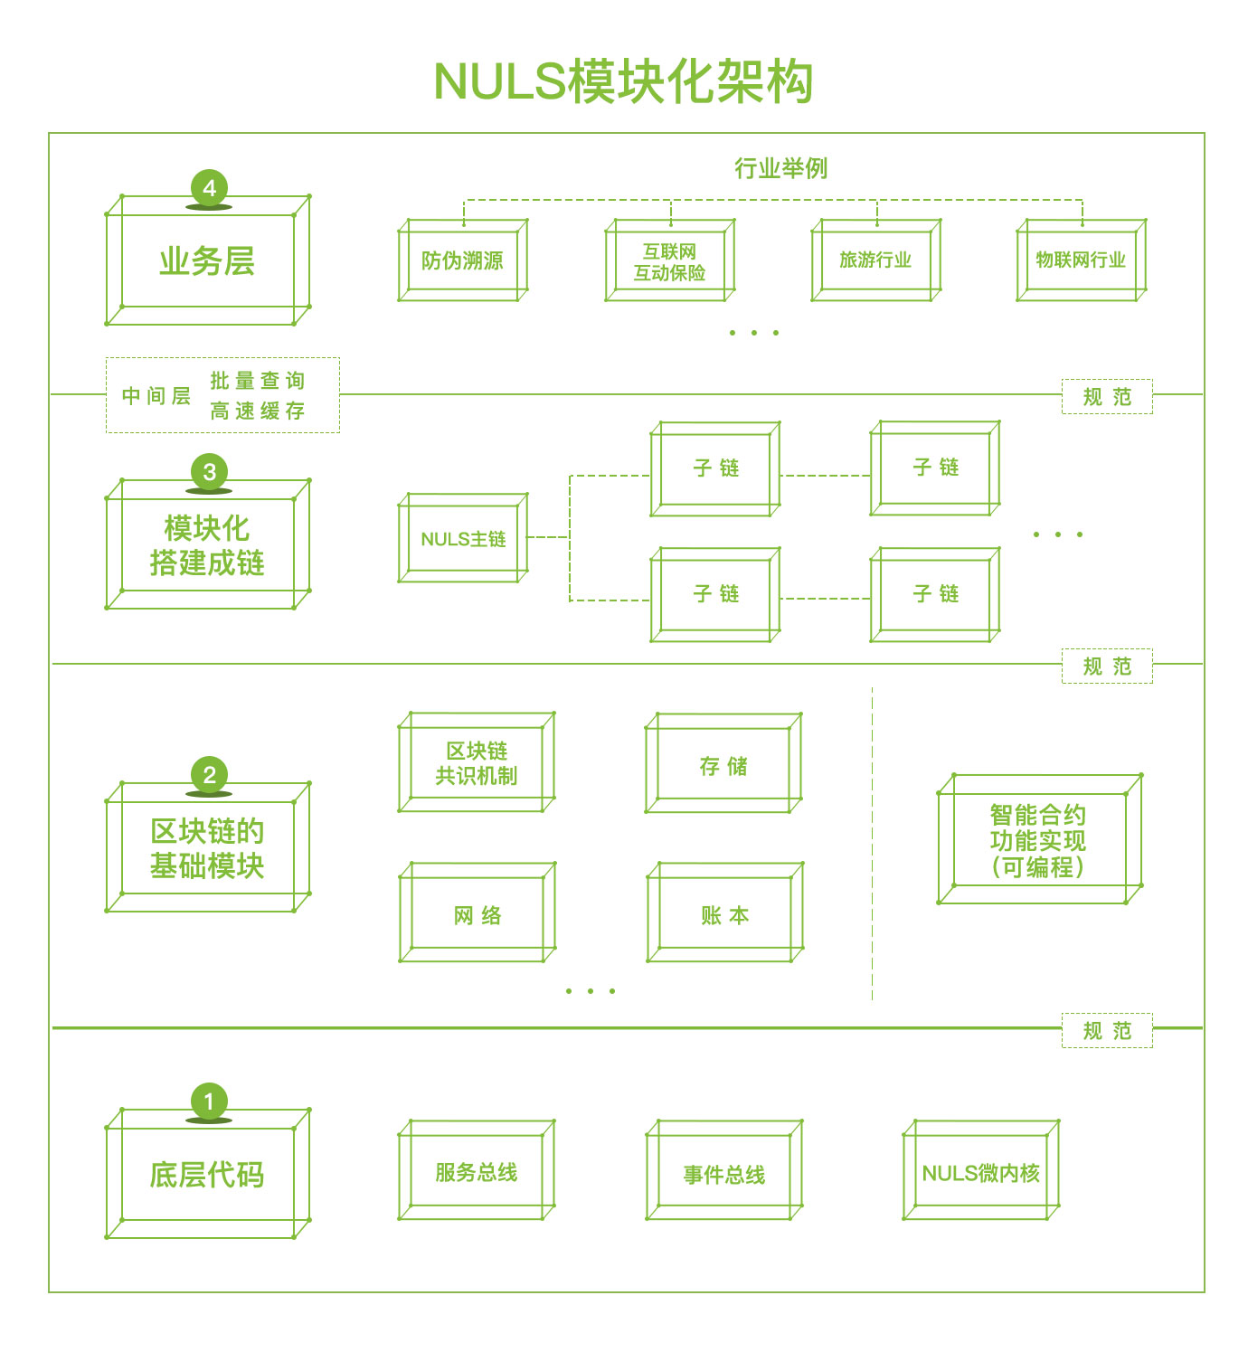

|  |  |
| --- | --- |
| **NULS模块架构** | **NULS module architecture** |
| **业务层** | **Business Layer** |
| **行业举例** | **Industry example** |
| **防伪溯源** | **Anti-counterfeiting traceability** |
| **互联网**  **互动保险** | **the Internet**  **Interactive insurance** |
| **旅游行业** | **Tourism industry** |
| **物联网行业** | **Internet of Things industry** |
| **中间层** | **Middle layer** |
| **批量查询**  **高速缓存** | **Batch query**  **Cache** |
| **模块化搭建成链** | **Modular chain building** |
| **NULS主链** | **NULS main chain** |
| **子链** | **Subchain** |
| **规范** | **Specifications** |
| **区块链的基础模块** | **Basic module of blockchain** |
| **区块链共识机制** | **Blockchain consensus mechanism** |
| **存储** | **Storage** |
| **网络** | **the Internet** |
| **账本** | **Ledger** |
| **智能合约功能实现（可编程）** | **Implementation of smart contract function (programmable)** |
| **底层代码** | **Underlying code** |
| **服务总线** | **Service bus** |
| **事件总线** | **Event Bus** |
| **NULS微内核** | **NULS microkernel** |

To achieve modular construction, the underlying code layer, which contains the basic logic of program execution, is needed first. Basic module layer of the blockchain is generated based on the code layer. There are five basic modules, including consensus mechanisms, storage, networks, ledgers and smart contract.

It is worth mentioning that, how to establish modular standards and unify all interface standards is a crucial step during the design of modules. Only after the standard is established can the module become a universal tool. Taking the consensus mechanism module as an example, POC and POW are two different consensus mechanisms. **The standard of the consensus mechanism module is to establish a common interface under different consensus mechanisms. With this interface (standard), the consensus mechanism can realize modular customized options, hot plugging and quick compatibility with other modules.** NULS provides a standard definition for a module. A complete module definition consists of four parts: basic information, module services, module events and module configuration. After the main network is released, NULS will provide detailed module specifications and plan to use Demo to demonstrate how to use modules to build applications.

**At the present stage, several major module standards (ledgers, consensus, storage, network and smart contracts) of NULS have been defined. And the NULS team will upgrade these standards according to the development of the industry while maintaining the contents of the modules.**

After the modularization standard is defined, the upper layer is the chain layer, which is selected and combined by different modules into the NULS main chain. The same principle can also be used to form other sub-chains. **The last layer is the business application layer. The ultimate goal for design of the first three layers is to support the business application layer.** In the figure above, there is an intermediate layer between the fourth layer and the third layer. The basis of this design is that there are some common requirements in the business application segmentation field. And these requirements can be abstracted and refined in terms of technology implementation, such as batch queries and high-speed storage in the anti-counterfeiting industry. NULS encapsulates these business functions (modularized output is available) and provide it directly to the application developer, for direct use when necessary. **NULS has achieved a combination of blockchain and different industries from the business level.**

In this four-tier structure, there is a specification (i.e., standard) for the link between each layer and the upper layer to ensure that the level of flow is executable and smooth, which is one of the difficulties in modular construction.

The above is the introduction of the modular implementation path of NULS, the advantages of NULS modular design will be summarized the next time:

1. **Convenient technology upgrades can be sustained and modules can be independently upgraded.**
2. **It is convenient for users to combine the contents under different modules to build and develop their own applications.**
3. **NULS is an open source ecosystem. In the modular mode, the late developers can easily join any module (part) of the bottom layer of NULS for development.**
4. **When the BUG is found, it is easier to locate the BUG and repair the BUG.**

NULS Chinese Community welcomes any question and suggestion. You can leave the message at the background through the WeChat public number "hinuls" of the NULS official community to us.