ITD110 – Assignment # 3A Web Design – Ankan Basu

1. URL of the website: <http://www.arm.gov>
2. Name of the website: ARM climate research facility
3. Target audience: Researchers and scientists most interested in climate research are the main target audience of the website as they provide free data in various format, including geospatial data.
4. Screenshot of homepage: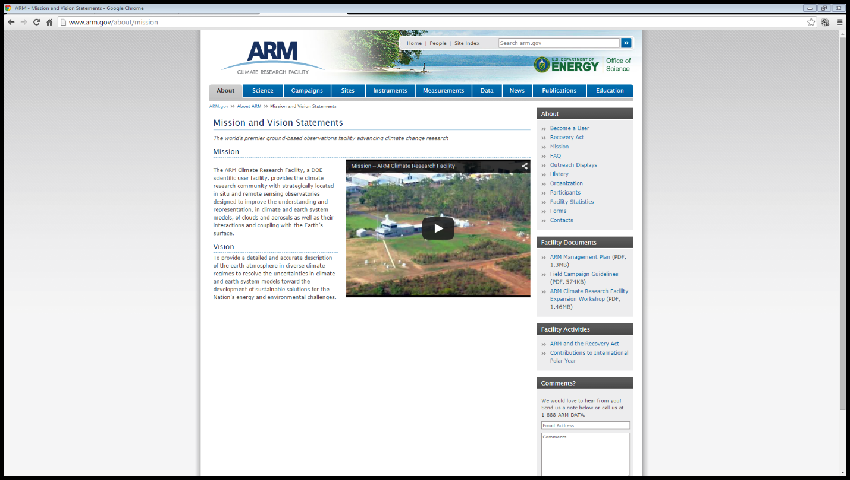
5. Indicate the type(s) of navigation evident: The website uses a horizontal navigation at the top and a vertical navigation to the right. However, the two navigation menus links to different resource pages of the site. The horizontal navigation menu also contains a more complex dynamic navigation menu that is only shown when a user hover over to a link in the horizontal navigation area.
6. Describe how the design principles of contrast, repetition, alignment, and proximity are applied. Be specific: As the website does not necessarily target a particular age group, it maximizes contrast by using a white background and dark gray text. The links in the horizontal navigation menu also have a nice contrast with a dark blue background and white text links. The same overall theme of the website is repeated in all pages across the website. Moreover, the featured images used in various articles are also chosen cleverly with an abundance of light blue color to flow seamlessly with the overall site design. The alignment of the website uses a three column design for the front page and two column design for the individual pages. Various similar information are grouped together to maintain a nice flow between contents. For example, featured datasets, user highlights are in the same group with upcoming meetings, such that users who are interested in climatic research can quickly learn about the latest meetings and proceedings related to climatic research.
7. Complete the Web Design Best Practices Checklist (see Table 3.1): Note, an updated version of the checklist was used from the author’s webpage at <http://terrymorris.net/bestpractices>

|  |  |
| --- | --- |
| **Page Layout** |  |
|  |  |
| ❏    Appealing to target audience | Yes |
| ❏    Consistent site header/logo | Yes |
| ❏    Consistent navigation area | Yes |
| ❏    Informative page title that includes the company/organization/site name | Yes |
| ❏    Page footer area includes copyright, last update, contact e-mail address | No |
| ❏    Good use of basic design principles: repetition, contrast, proximity, and alignment | Yes |
| ❏    Displays without horizontal scrolling at 1024×768 and higher resolutions | Yes |
| ❏    Balance of text/graphics/white space on page | Yes |
| ❏    Good contrast between text and background | Yes |
| ❏    Header and nav occupy less than ¼ to ⅓ of the browser at 1024×768 resolution | Yes |
| ❏    Home page has compelling, interesting information above the fold at 1024×768 | Yes |
| ❏    Home page downloads within ten seconds on dial-up connection | No |
| ❏    Viewport meta tag is used to enhance display on smartphones | No |
| ❏    Media queries configure responsive page layout for smartphone and tablet display | No |
|  |  |
| **Browser Compatibility** |  |
|  |  |
| ❏   Displays on popular/current versions of Internet Explorer | Yes |
| ❏   Displays on current versions of Firefox | Yes |
| ❏   Displays on current versions of Google Chrome | Yes |
| ❏   Displays on current versions of Opera | Yes |
| ❏   Displays on current versions of Safari (both Mac and Windows) | Yes |
| ❏   Displays on popular mobile devices (including tablets and smartphones) | Yes |
|  |  |
| **Navigation** |  |
|  |  |
| ❏   Main navigation links are clearly and consistently labeled | Yes |
| ❏   Navigation is easy to use for target audience | Yes |
| ❏   If main navigation uses images, clear text links are in the footer section of the page | N/A |
| ❏   If main navigation uses Flash, clear text links are in the footer section of the page | N/A |
| ❏   Navigation is structured in an unordered list | Yes |
| ❏   Navigation aids, such as site map, skip navigation link, or breadcrumbs are used | Yes |
| ❏   All navigation hyperlinks "work" — are not broken | Yes |
|  |  |
| **Color and Graphics** |  |
|  |  |
| ❏   Color scheme is limited to a maximum of three or four colors plus neutrals | Yes |
| ❏   Color is used consistently | Yes |
| ❏   Text color has sufficient contrast with background color | Yes |
| ❏   Color is not used alone to convey meaning | Yes |
| ❏   Use of color and graphics enhances rather than distracts from the site | Yes |
| ❏   Graphics are optimized and do not significantly slow download | Yes |
| ❏   Each graphic used serves a clear purpose | Yes |
| ❏   Image tags use the alt attribute to configure an alternate text description | Yes |
| ❏   Animated images do not distract from the site and do not endlessly repeat | N/A |
|  |  |
| **Multimedia** |  |
|  |  |
| ❏   Each audio/video/Flash file used serves a clear purpose | N/A |
| ❏   The audio/video/Flash files used enhance rather than distract from the site | N/A |
| ❏   Captions are provided for each audio or video file used | N/A |
| ❏   Download times for audio or video files are indicated | N/A |
| ❏   Links to downloads for media plug-ins are provided | N/A |
|  |  |
| **Content Presentation** |  |
|  |  |
| ❏   Common fonts such as Arial or Times New Roman are used | Yes |
| ❏   No more than one web font is used | Yes |
| ❏   Techniques of writing for the Web are used: headings, bullet points, brief paragraphs | Yes |
| ❏   Fonts, font sizes, and font colors are consistently used | Yes |
| ❏   Content provides meaningful, useful information | Yes |
| ❏   Content is organized in a consistent manner | Yes |
| ❏   Information is easy to find (minimal clicks) | Yes |
| ❏   Timeliness: The date of the last revision and/or copyright date is accurate | Yes |
| ❏   Content does not include outdated material | Yes |
| ❏   Content is free of typographical and grammatical errors | Yes |
| ❏   Content provides links to other useful sites | Yes |
| ❏   Avoids the use of "Click here" when writing text for hyperlinks | Yes |
| ❏   Hyperlinks use a consistent set of colors to indicate visited/nonvisited status | Yes |
| ❏   If graphics are used to convey meaning, the alternate text equivalent is provided | Yes |
| ❏   If media is used to convey meaning, the alternate text equivalent is provided | Yes |
|  |  |
| **Functionality** |  |
|  |  |
| ❏   All internal hyperlinks work | Yes |
| ❏   All external hyperlinks work | Yes |
| ❏   All forms function as expected | Yes |
| ❏   No JavaScript errors are generated | Yes |
|  |  |
| **Accessibility** |  |
|  |  |
| ❏   If main navigation uses images, text links are in the footer section of the page | N/A |
| ❏   If main navigation uses Flash, text links are in the footer section of the page | N/A |
| ❏   Navigation is structured in an unordered list | Yes |
| ❏   Navigation aids, such as site map, skip navigation link, or breadcrumbs are used | Yes |
| ❏   Color is not used alone to convey meaning |  |
| ❏   Text color has sufficient contrast with background color | Yes |
| ❏   Image elements use the alt attribute to configure an alternate text description | Yes |
| ❏   If graphics are used to convey meaning, the alternate text equivalent is provided | Yes |
| ❏   If media is used to convey meaning, the alternate text equivalent is provided | Yes |
| ❏   Captions are provided for each audio or video file used | Yes |
| ❏   Use attributes designed to improve accessibility such as title when appropriate | Yes |
| ❏   Use the id and headers attributes to improve the accessibility of table data | Yes |
| ❏   Configure frames with frame titles and place meaningful content in the noframes area | N/A |
| ❏   The html element's lang attribute indicates the spoken language of the page | Yes |
| ❏   The role attribute indicates ARIA landmark roles | Not used |

1. Recommend three improvements for the website: First of all, the font size could be made slightly larger, or option for viewing the page at different font size could be implemented. Secondly, the website does not have a mobile version. As the number of mobile user are growing rapidly, improvements should be made to accommodate site display in mobile browsers. Lastly, the total size of the homepage is 471.7 kB; there may be room to improve site performance by reducing the file size using various techniques such as image optimization.