ITD 110 – **Assignment #1A** Web Research – Ankan Basu

# #1 Web Research

1. How did the W3C get started? W3C was formed in 1994 to lead and promote the development of Web and to set protocols to enhance interoperability. It was founded by Tim Berners-Lee, the inventor of the Web. Prior to W3C, Tim Berners-Lee first initiated the World Wide Web (WWW) project at the European Organization for Nuclear Research (CERN). Presently, W3C enjoys a collaboration between the Massachusetts Institute of Technology (MIT) and the European Organization for Nuclear Research (CERN), with support from the U.S. Defense Advanced Research Project Agency (DARPA) and the European Commission
2. Who can join the W3C? What does it cost to join? According to the <http://w3.org>, membership is open to all types of organizations and individuals. The members may represent either not-for-profit or for-profit organizations. Most members are usually in the field of web development promoting web technologies. Membership fee varies between countries and also vary based on the size, type and revenue of a particular company. For example, while organizations with annual gross revenue more than a billion would pay $77,000 per year, enterprises and not-for-profit organizations with 10 or less employees would pay only $2,250 as annual fee.
3. The W3C home page lists a number of technologies. Choose one that interests you, click its link, and read several of the associated pages. List 3 facts or issues you discover. JavaScript is one of the technologies that is heavily used in webpages today. JavaScript is a scripting language that can be used with the structural language HTML and presentational language CSS to improve dynamic and visual nature of a website. A lot of server side scripting used to be done using PHP, is now replaced by client side applications built using JavaScript. JavaScript has an extensive library that web-developers can easily use to incorporate in any individual project.

# #2 Focus on Web Design

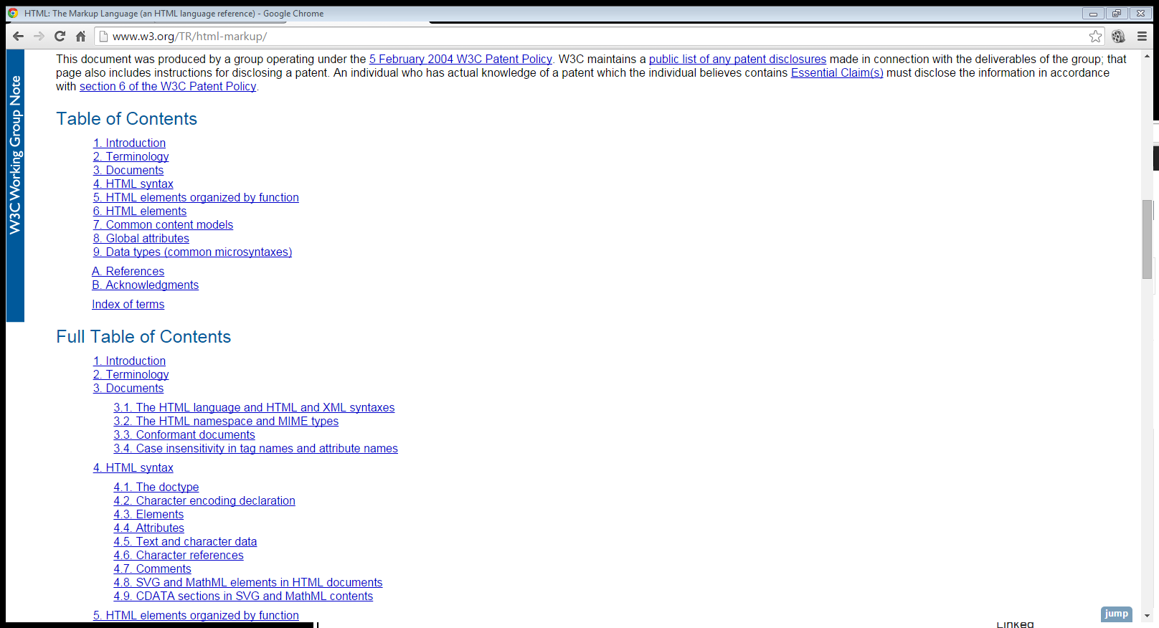

1. What is the purpose of the site? The purpose of this website is to create an online reference to the hypertext markup language (HTML).
2. Who is the intended audience? The main audience of the web page are web developers who are working with web technologies and can refer to the webpage for details of a particular syntax or to look up latest developments in the HTML architecture.
3. Do you think that the site reaches its intended audience? Why or why not? The site is extremely well known and definitely reaches its target audience.
4. Is the site useful to you? Why or why not? The site has been very useful to me as I can find references to various HTML syntax with some examples. It also provides guidelines for intended use and also has DOM reference for an element.
5. List one interesting fact or issue that this site addresses. Although the site is referenced in the textbook, the W3C developers decided not to update the site in late 2013. However, they kept all of the historical HTML documentations till 2013 which can be used to study the evolution of the web.
6. Would you encourage others to visit this site? Yes. Although, W3C do not update the webpage any longer, many of the HTML syntax is still the same and the examples presented in the webpage are very useful.
7. How could this site be improved? The webpage could use a fresher look. As a matter of the fact, <https://docs.webplatform.org/wiki/Main_Page> now maintains the most up to date HTML documentation, which has a very soothing appearance.