CCS3104 Project
The ‘project’ requirement for CCS3104 should be seen as a 3-fold opportunity:
- To practice your teamwork, leadership, and programming skills.
- To manage proper project to improve a business's efficiency, foster collaboration between teammates, boost a team's performance, and improve customer satisfaction.
- To improve your presentation and public-speaking skills.

What you need to do:
You need to create a new product or enhance an existing product that would be marketed through a well-known company. You are required to promote your product to potential customers.
For example: You might design a new type of shoe to be marketed through Nike company. This shoe automatically collects data on the running style of its wearer and suggests improvements though a GUI.

GENERAL TIPS
- When picking the topic:
  - Pick a service/product that you are: 1) passionate about, 2) comfortable to discuss, and 3) related to this course (CCS3104).
  - Consult four (4) types of new service/product
- New-to-the-company
- Improvement of an existing product
- Extension of product line
- New-to-the-market

- When delivering the presentation/slides:

Your presentation should address how to promote a new service or product to potential customers with excitement.

Your presentation should address the following key points pertaining to the selected service/product:

Project title

Company history

Company organization chart

Introduction to the new service/product

Targeted customers

Ways to promote your service/product

Impact of new service/product to the society, environment, and economy

Each group consists of 3/4 group members.
  - The presentation should be approx. 12/16 minutes long (4 minutes per presenter!).

When delivering the system:
  - The system must have at least GUI mock-ups.
  - Justify why the current solution is chosen and compare it with another solution.

TIMELINE

Week 7 | Teams of students formed.  Students are encouraged to form teams on their own.  A representative of each team must WhatsApp me the following information by end of Week 7:  - Names and matric numbers of all team members  - The potential topic
Week 13 | Submit presentation slides to PutraBlast before class. Do presentation in class.

1. Project Title
Project Title
IKEA AR Interior Design Assistant with Community-based Design Reuse
（可选副标题，用于 PPT 封面）
A Mobile Augmented Reality and AI-driven Interior Design Platform
说明（你不用写进 report）
- “AR + AI + Community” 三个关键词一次性点清楚
- 不夸张、不 marketing 化，很符合课程 project 的气质

2. Company History
2. Company History
IKEA is a multinational furniture and home furnishings company founded in 1943 by Ingvar Kamprad in Sweden. The name IKEA is an acronym derived from the founder’s initials (Ingvar Kamprad), the farm where he grew up (Elmtaryd), and his hometown (Agunnaryd).
Initially starting as a mail-order business selling everyday household items, IKEA gradually shifted its focus toward furniture. In the 1950s, the company introduced the concept of flat-pack furniture, which significantly reduced transportation costs and made furniture more affordable to a wider population. This innovation became one of IKEA’s core competitive advantages.
Over the decades, IKEA has expanded globally and now operates in more than 60 markets worldwide. The company is well known for its democratic design philosophy, which balances five key elements: form, function, quality, sustainability, and low price.
In recent years, IKEA has increasingly invested in digital transformation, including e-commerce platforms, mobile applications, and smart home solutions. These initiatives reflect IKEA’s strategic shift toward integrating technology with home living experiences, making it an ideal context for introducing an AR and AI-based interior design service.

3. Company Organization Chart
3. Company Organization Chart
IKEA operates under a complex but well-structured organizational model designed to support global scalability while maintaining local market adaptability.
At a high level, IKEA’s organizational structure can be described as follows:
- Inter IKEA Group
Responsible for brand ownership, product development, supply chain management, and overall concept direction.
- Ingka Group
Manages the majority of IKEA retail stores worldwide and focuses on customer experience, store operations, and digital services.
- Franchisees
Operate IKEA stores in specific regions under franchise agreements.
Within the context of this project, the proposed AR Interior Design Assistant would primarily involve collaboration between:
- Digital Innovation / IT Department
- Product Design and Development
- Marketing and Customer Experience
- Sustainability and Supply Chain Teams
Simplified Organization Chart (Conceptual)
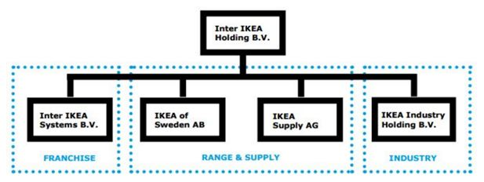
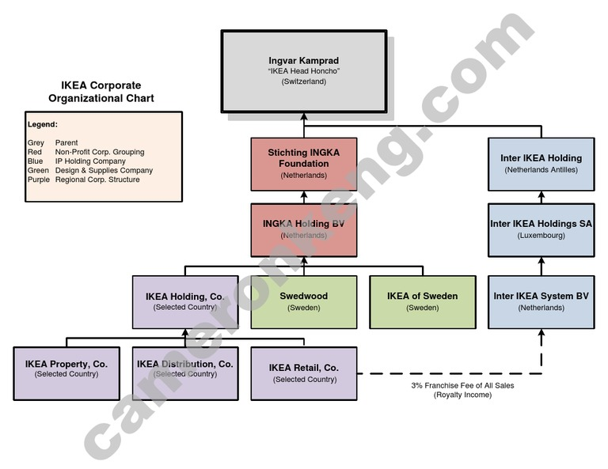
IKEA Group
│
├── Inter IKEA Group
│ ├── Product Design & Development
│ ├── Supply Chain & Sustainability
│ └── Brand & Concept Management
│
├── Ingka Group
│ ├── Retail Operations
│ ├── Digital Innovation & IT
│ ├── Marketing & Customer Experience
│ └── Data & Analytics
│
└── Franchise Partners
└── Regional Store Operations
The proposed service would be developed mainly under the Digital Innovation & IT division, with close integration with product data, sustainability metrics, and marketing strategies.

4. Introduction to the New Service / Product
4. Introduction to the New Service / Product
The proposed product, IKEA AR Interior Design Assistant, is a mobile-based intelligent interior design service that integrates Augmented Reality (AR), Computer Vision (CV), Generative AI, and a community-driven design platform.
The service enables users to scan their rooms using a smartphone camera to generate a real-time 3D spatial model. Based on this model, users can either:
- Generate furniture layout proposals using natural language inputs (e.g., preferred style and budget), or
- Manually select and place IKEA furniture items in an AR environment.
A key differentiating feature of the service is the community-based design reuse mechanism. Users can browse interior design solutions created by other users with similar room layouts and apply these designs to their own spaces with automatic adaptation.
Core Features
- Room scanning and 3D reconstruction
- AI-assisted furniture recommendation and layout generation
- Real-time AR visualization and interaction
- Community design browsing and reuse
- Automatic shopping list and budget estimation
- Sustainability-aware design evaluation
This service extends IKEA’s existing digital ecosystem by transforming furniture shopping from a static catalog-based experience into an interactive, intelligent, and socially supported design process.
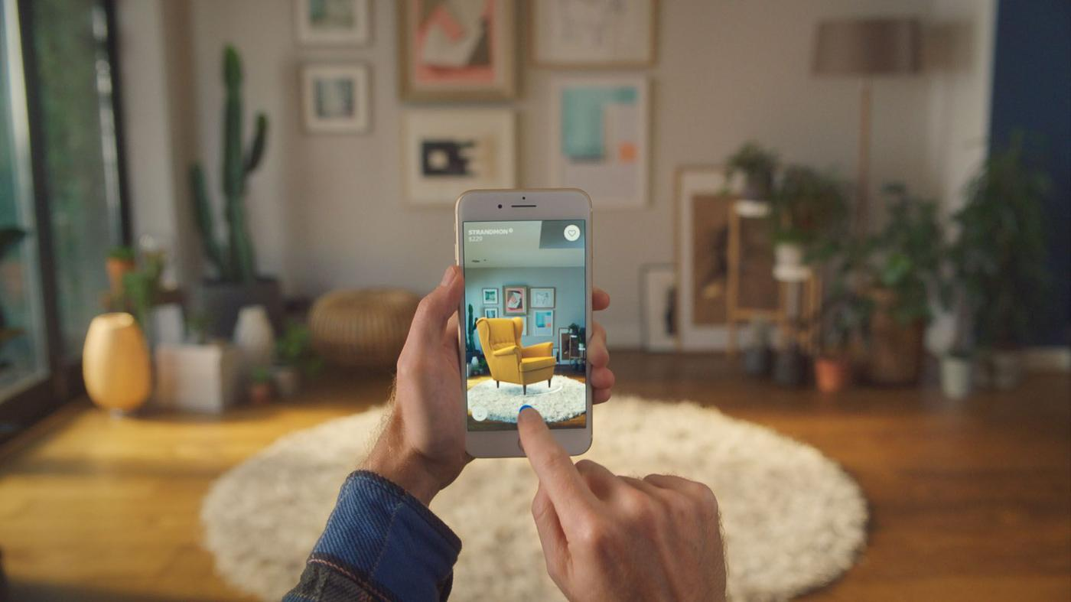
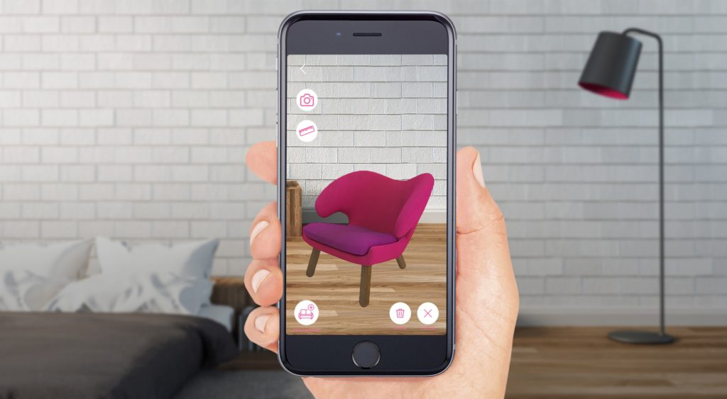
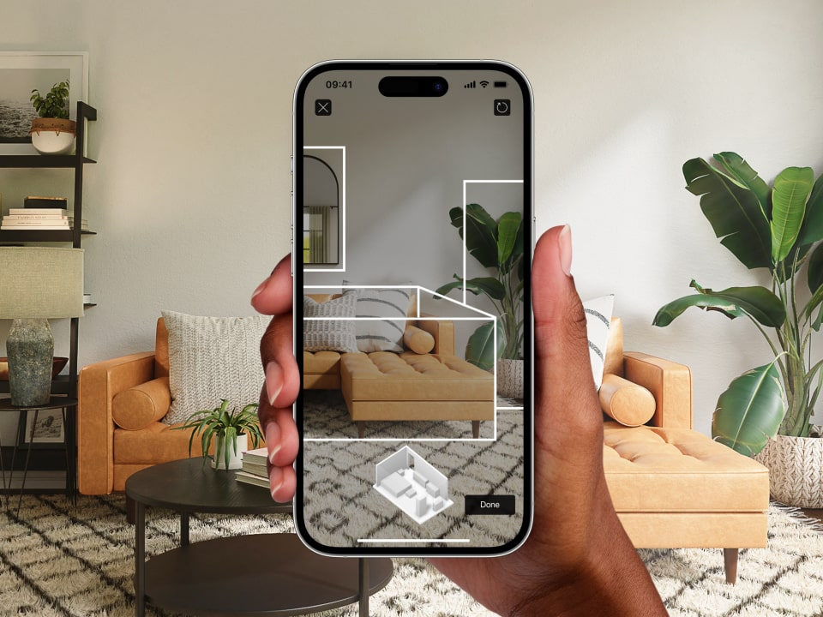

5. Targeted Customers
5. Targeted Customers
The proposed service targets a wide range of customers, with a primary focus on users who experience difficulties in visualizing and planning interior layouts.
5.1 Renters and Small-Apartment Residents
- Typically live in limited spaces
- Highly sensitive to furniture size compatibility and budget
- Prefer flexible and non-permanent solutions
The AR preview and community reuse features help this group avoid purchasing unsuitable furniture and reduce trial-and-error costs.

5.2 First-time Homeowners
- Often lack professional interior design knowledge
- Seek cohesive and aesthetically pleasing designs
- Willing to purchase complete furniture sets
AI-generated layout proposals and curated community designs provide reliable guidance and confidence before making purchasing decisions.

5.3 Busy Working Professionals
- Limited time for manual design exploration
- Prefer efficient and automated solutions
- Value explainability and convenience
For this group, the system’s “one-click design generation” and ready-to-purchase shopping list significantly reduce decision-making time.

6. Ways to Promote the Service / Product
6. Ways to Promote the Service / Product
To ensure successful adoption, the following promotion strategies are proposed:
6.1 Integration with Existing Digital Platforms
- Embed the AR assistant directly into the existing IKEA mobile application
- Cross-promote the service through IKEA’s website and online store
This reduces the learning curve and leverages IKEA’s existing user base.

6.2 In-store Experience and Demonstrations
- AR demo zones inside IKEA stores
- QR codes allowing customers to try the service instantly
- Staff-guided demonstrations for first-time users
This bridges online and offline customer experiences.

6.3 Community-driven Promotion
- Highlight popular and highly reused community designs
- Encourage users to share their designs on social media
- Introduce badges or recognition for top contributors
This strategy increases engagement and organic promotion.

6.4 Sustainability-focused Marketing
- Promote eco-friendly design options and sustainability scores
- Align the service with IKEA’s environmental commitments
- Appeal to environmentally conscious consumers

7. Impact of the New Service / Product
7. Impact on Society
The service lowers the barrier to interior design by enabling non-expert users to create functional and visually appealing living spaces. By combining AI assistance with community knowledge sharing, users gain confidence in their design decisions and experience reduced stress during the furniture selection process.
Additionally, the community platform encourages collaboration and creativity, fostering a sense of shared learning and social interaction.

7. Impact on the Environment
The AR preview and accurate room measurement features reduce the likelihood of purchasing incompatible furniture, which directly contributes to:
- Fewer product returns
- Lower transportation-related carbon emissions
- Reduced material waste
The inclusion of sustainability scores further guides users toward environmentally responsible purchasing decisions.

7. Impact on the Economy
From a business perspective, the service enhances customer engagement and increases conversion rates by enabling users to visualize products before purchase. Improved decision accuracy reduces after-sales costs related to returns and customer support.
At a broader level, the community-driven model generates valuable data on customer preferences and space usage patterns, supporting data-driven product development and supply chain optimization.

Project Report
IKEA AR Interior Design Assistant with Community-based Design Reuse

1. Introduction
Interior design is often a complex and time-consuming process, especially for users with limited design experience. Common challenges include inaccurate spatial understanding, uncertainty about furniture size compatibility, budget overruns, and difficulty visualizing final outcomes before purchase. These problems are particularly evident for renters, small-apartment residents, and first-time homeowners.
With the advancement of Augmented Reality (AR), Computer Vision (CV), and Generative AI, it is now possible to bridge the gap between imagination and physical space. IKEA, as a global home furnishing brand, has the opportunity to leverage these technologies to provide an intelligent, interactive, and scalable interior design solution.
This project proposes an IKEA AR Interior Design Assistant, a mobile application that enables users to:
- Scan and reconstruct their rooms into real-time 3D models,
- Generate furniture layout proposals based on natural language inputs such as style and budget,
- Preview and customize designs using AR,
- Access a community-driven design platform to reuse and adapt solutions from similar room layouts.
The system aims to reduce decision-making friction, minimize furniture mismatch, and promote sustainable and cost-effective interior design.

2. Project Objectives
The main objectives of this project are:
- To develop a conceptual system that reconstructs indoor spaces using mobile camera input and AR technology.
- To design an AI-assisted furniture recommendation and layout generation mechanism.
- To integrate a community platform that enables design sharing and reuse based on room similarity.
- To evaluate the social, economic, and environmental impact of the proposed solution.
- To justify the proposed system through comparison with alternative design approaches.

3. Target Users
The system is designed for the following user groups:
3.1 Renters and Small-Apartment Residents
- Limited space and strict budget constraints
- Need flexible and non-permanent furniture layouts
- High risk of purchasing incompatible furniture
3.2 First-time Homeowners
- Strong demand for cohesive design styles
- Willing to invest in complete furniture sets
- Require guidance and visualization before purchase
3.3 Busy Professionals
- Limited time for manual design
- Prefer automated and explainable recommendations
- Value convenience and one-click solutions

4. System Overview
The proposed system consists of six major functional modules:
- Room Capture Module
- Scene Understanding Module
- Design Generation Module
- AR Visualization Module
- Community Design Platform
- Shopping and Sustainability Module
These modules interact to form an end-to-end interior design workflow from room scanning to purchase decision.

5. Functional Design
5.1 Room Capture and Reconstruction
The Room Capture module uses a smartphone RGB camera (and optionally infrared or depth sensors) to scan the user's indoor environment. The system reconstructs a 3D representation of the room, including walls, floor, ceiling, doors, and windows.
Key features:
- Automatic room boundary detection
- Measurement of wall length, room area, and ceiling height
- Confidence indicators for estimated dimensions
- Manual calibration using known object sizes
This module ensures that generated furniture layouts are dimensionally feasible.

5.2 Scene Understanding and Semantic Analysis
Beyond geometric reconstruction, the system performs semantic scene understanding to identify:
- Existing furniture
- Fixed and movable objects
- Walkable and non-walkable areas
- Door swing and clearance zones
Semantic labeling allows the system to reason about spatial constraints, such as maintaining walkways or avoiding blocked doors.

5.3 AI-assisted Design Generation
Users can describe their preferences using natural language, for example:
“Scandinavian style, budget RM3000, suitable for rental.”
The Design Generation module processes these inputs and produces multiple design proposals:
- Budget-efficient version
- Balanced version
- Premium aesthetic version
Each proposal includes:
- Furniture layout
- Total estimated cost
- Style explanation
- Space utilization score
The system also detects conflicts such as insufficient clearance or incompatible furniture sizes and suggests alternatives.

5.4 AR Visualization and Interaction
The AR module overlays virtual furniture into the real environment in real time.
Supported interactions include:
- Drag, rotate, and scale furniture objects
- Automatic wall and floor snapping
- Occlusion handling for realistic placement
- Light estimation for visual consistency
Users can freely customize layouts while maintaining spatial correctness.

6. Community-based Design Platform
6.1 Motivation
Purely AI-generated designs may lack diversity and trust. The community platform introduces social validation and real-world design reuse.

6.2 Similar Room Matching
The system recommends community designs based on:
- Room size similarity
- Layout geometry
- Door and window placement
- Functional room type
This enables users to browse designs created by others with similar room conditions.

6.3 Design Content Structure
Each shared design includes:
- AR-compatible room layout
- IKEA product list and total price
- Style and usage tags
- Sustainability score
- User comments and reuse statistics

6.4 Design Adaptation
Users can apply community designs to their own rooms using an automatic adaptation process:
- Scale adjustment
- Conflict detection
- Furniture substitution suggestions
This significantly reduces design effort while preserving personalization.

7. Shopping and Sustainability Features
The system generates a complete shopping list with:
- IKEA product identifiers
- Quantity and color options
- Total price estimation
Additionally, a sustainability score is provided based on:
- Material durability
- Packaging volume
- Expected product lifespan
- Furniture reuse and replacement rate
This encourages environmentally responsible purchasing decisions.

8. System Comparison and Justification
8.1 Alternative Approach 1: Traditional Interior Design Apps
- Manual measurement
- Static images
- Limited customization
- High user effort
8.2 Alternative Approach 2: AI-only Design Systems
- Automated layouts
- Low user control
- Limited trust and explainability
8.3 Proposed Approach
- Combines AR realism, AI intelligence, and community knowledge
- Balances automation and user control
- Scalable and aligned with IKEA’s digital ecosystem
The proposed solution offers superior usability and engagement.

9. Impact Analysis
9.1 Social Impact
- Reduces design anxiety
- Lowers entry barriers for non-experts
- Encourages collaborative creativity
9.2 Environmental Impact
- Reduces furniture returns
- Promotes reuse of successful layouts
- Encourages sustainable product choices
9.3 Economic Impact
- Increases IKEA conversion rates
- Reduces customer support costs
- Creates a data-driven design ecosystem

10. Limitations and Future Work
Current limitations include:
- Accuracy constraints of mobile scanning
- Computational cost of real-time AR
- Community content moderation challenges
Future enhancements may include:
- LiDAR-supported scanning
- Personalized style learning
- Professional designer integration
- Multi-room and whole-house design

11. Conclusion
This project presents a comprehensive AR and AI-driven interior design assistant integrated with a community-based design platform. By combining spatial intelligence, generative design, and social knowledge sharing, the proposed system offers a scalable and user-centered solution for modern interior design challenges.

