UNIVERSITI PUTRA MALAYSIA

FAKULTI SAINS KOMPUTER DAN TEKNOLOGI MAKLUMAT

Name: YUE CHENGHAO Matric: 227154

The content shown in the screenshots may appear misaligned because my computer’s default language is Chinese. I wasn’t able to change CMD and Terminal to English in a short time. Therefore, after taking the screenshots, I used a translation tool to convert them into Chinese. I hope you can understand.

LAB 1 – Individual

OBJECTIVE:
The main objective of this lab is to introduce the students to the Windows operating system. Students will also be introduced to the Command Prompt.

DURATION:
1 week / 3 hours

DUE DATE OF SUBMISSION: WEEK 2
Submit your assignment to your demonstrator. Make sure you sign the submission form after submitting.

PROGRAMME OBJECTIVE (PO):
PO2: Use the available software package with appropriate computer components.

RUBRIC:

CRITERIA | LEVEL 1  Very Poor | LEVEL 2  Poor | LEVEL 3  Good | LEVEL 4  Very Good | LEVEL 5  Excellent
The ability to perform operating system (OS) tasks. | Unable to perform OS tasks or able to perform OS tasks with very limited success (< 40%). | Able to perform OS tasks with limited success (≥ 40%,< 60%). | Able to perform OS tasks with some success (≥ 60%, < 80%). | Able to perform OS tasks with considerable success (≥ 80%, < 100%). | Able to perform OS tasks with outstanding success (100%).

QUESTIONS:
Part A (Knowing about your computer)

- Answer the following questions about the computer that you are using in this lab.

- What is the version of the Windows OS in use?
Windows 10 Enterprise 10.0.19045 22H2

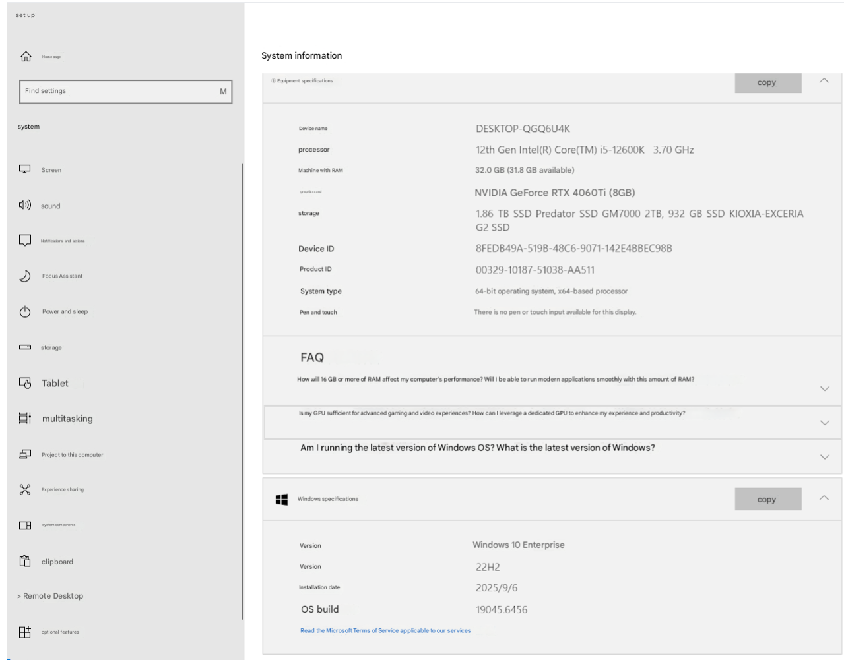

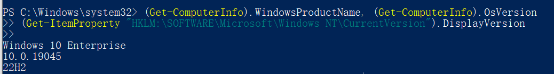
- What company manufactured the computer?
Colorful Technology And Development Co.,LTD
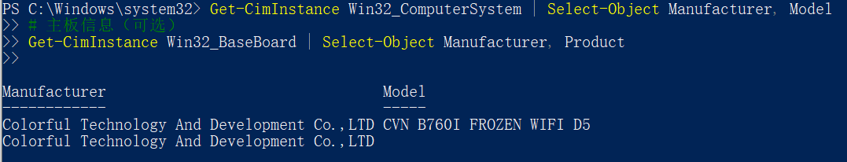
- What is the speed of the processor and how much RAM (physical memory) is in the computer?
12th Gen Intel(R) Core(TM) i5-12600K 3700Mhz
32G RAM 6400Mhz
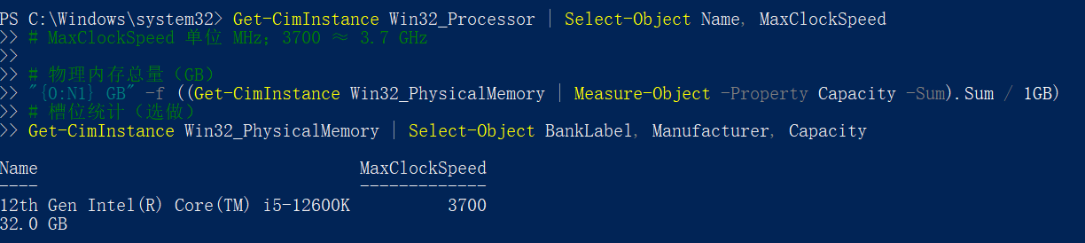
- How much data can you store on the C: drive and how much of the C: drive is in use? 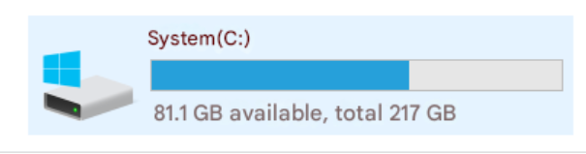
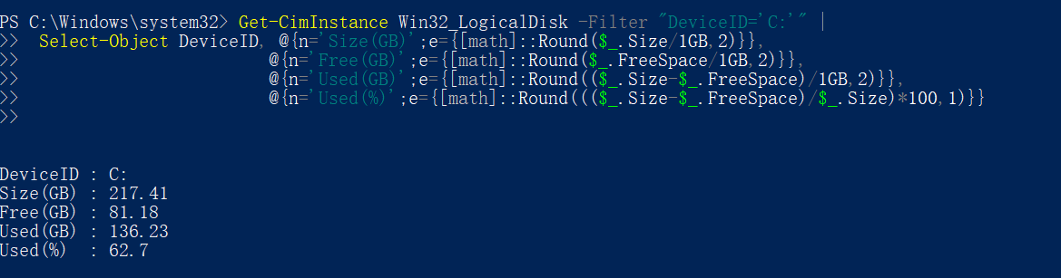

- What is the name of the antivirus program used in the computer (if any)?

Windows Defender
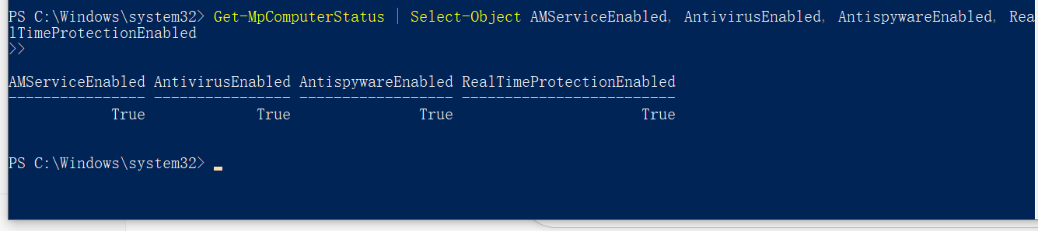
- On the computer which you are working, perform and list down a hardware and software inventory of at least three hardware devices and three application programs on the computer. List the vendor and product.

HARD DEVICES:
graphics card: NVIDIA Geforce RTX 4060ti
Solid-state drive: KIOXIA EXCERIA G2 SSD
Network Interface Card: INTEL AX211 WI-FI 6E
APPLICATION
GOOLE chrome web browser
MICROSOFT VS Code IDE, word
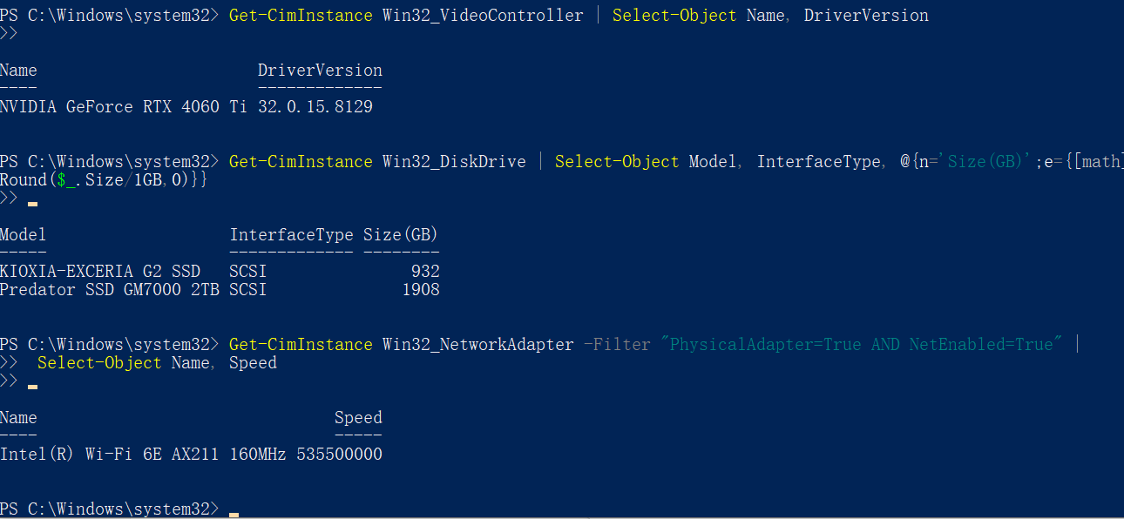
JETBRAINS InteliJ IDE
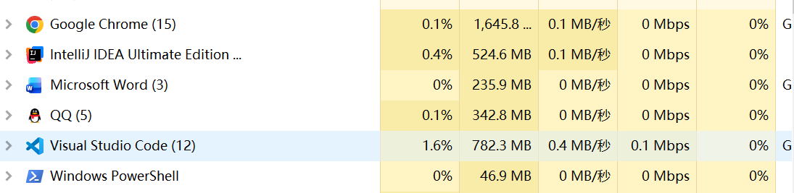’

Part B (The Command Prompt)

Objectives:
- use DOS commands to view, navigate, create and delete directories
- use DOS commands to copy, rename, and delete files

Microsoft’s Disk Operating System (DOS), also called MS-DOS, is a collection of programs and commands used to control the overall computer operations system. All modern Windows versions support DOS commands from the command line.

- Open a command line from Windows:
- Click the Start/Run button and type: cmd or command
1. What directory are you in? C:\Users\zxYch>
2. What does the prompt look like? C:\Users\zxYch>
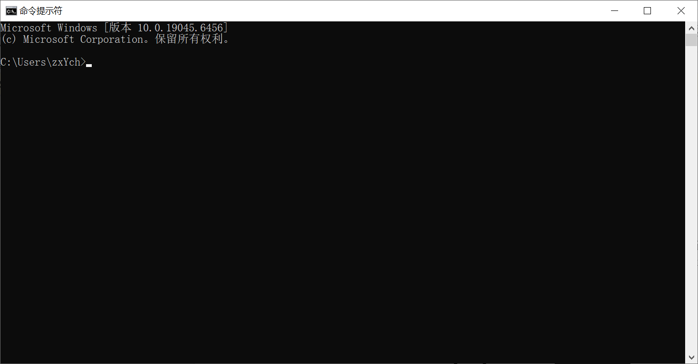
2. Displaying Directory Contents: Dir
DIR command will list directories and various files. Directories are specified with the<DIR> notation that precedes the file/directory. The DIR command also displays the volume name, free space, and total files and directories present.

Show a list of the directories located on this drive.
- type: cd\ change to the root directory
- type: cd windows change to the windows directory
- type dir
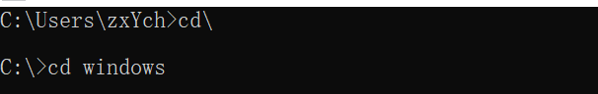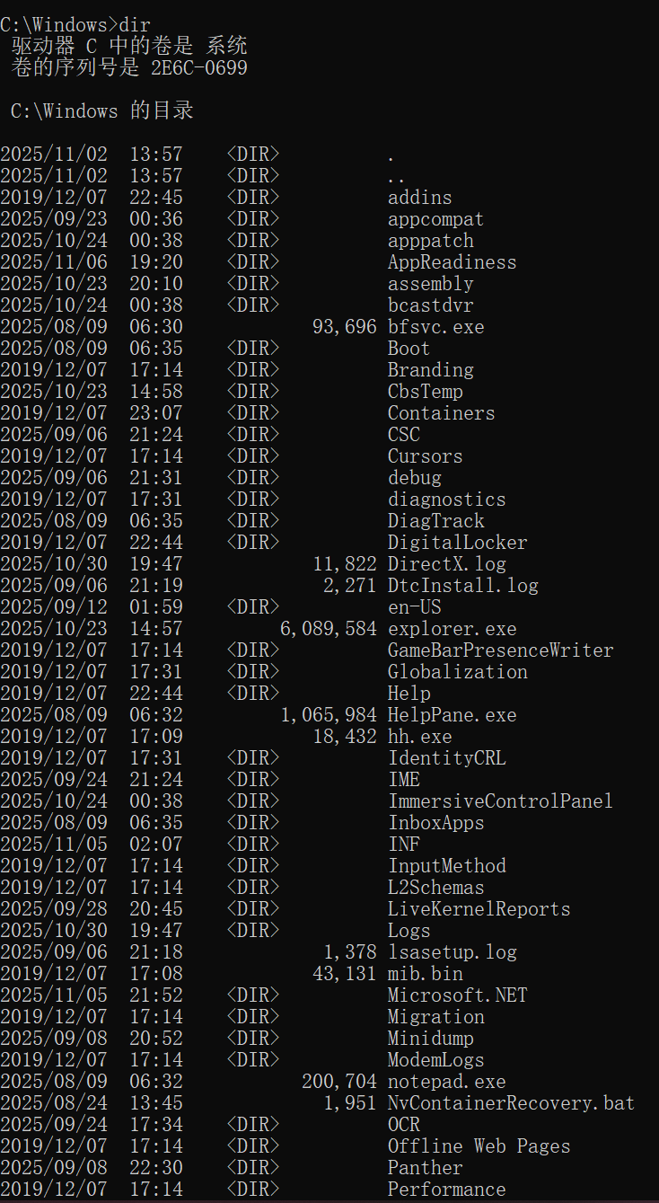
What happened? ______________________________________
The screen lists the contents of the C:\Windows directory: including several <DIR> (subdirectories) and files, and at the bottom it shows the number of files and directories, volume label, available space, etc.

- type: dir /p Press enter to continue the list 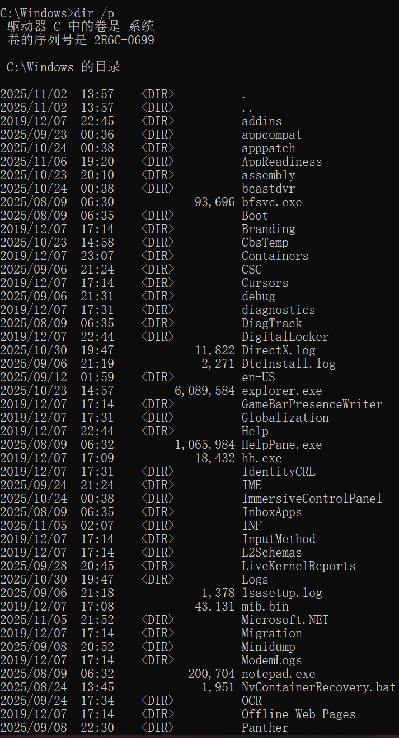

How many directories do you have in the windows folder?

77___________________________
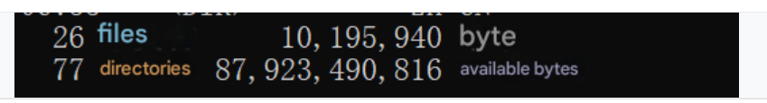
What does the /p switch do? _______________
The "/p" indicates pagination display (pausing at each screen, press any key to continue), to prevent long lists from flashing by in a flash.

3. The absolute path and relative path
The commands related with file and directory allows two ways in specifying location (for source or target), which are called the relative path and absolute path. A path is the direction from the current directory or other specific location to the intended file or directory (e.g. c:mydir\mysubdir\file.txt).

When you only specify a source or target without the parent directory name (e.g. file.txt), the command will search the source/target in current directory. This is known as relative path. But you may specify source/target located outside the current directory by providing the absolute path (e.g. c:mydir\mysubdir\file.txt).

Absolute path will allow you to specify to any source/target when you run a command from any location in the system/directory structure. There are also special sub directories named ‘.’ and ‘..’ provided in all directories.

- Find out the content of your current directory (use DIR command)
Find out the content of the root/base directory e.g. c:\ (use DIR command)
- Type the following command -> dir . don’t ignore the dot !
What is displayed on the screen? So what is the purpose of the dot (‘.’)?

What is displayed? : Same as dir (the current directory listing)
Purpose of ‘. ’ : Represents the current directory in a path.

- Type the following command -> dir .. don’t ignore the dots !
What is displayed on the screen? So what is the purpose of the dots (‘..’)?

What is displayed? : The contents of the parent (upper-level) directory.
Purpose of “.. ” : Refers to the parent directory (one level above the current).

- What is the command to determine the existence of a file named ‘file1.txt’ in the current directory?

if exist file1.txt (echo exists) else (echo does not exist) in CMD
- What is the command to determine the existence of a file named ‘file1.txt’ in a directory named ‘mydir’ in the upper level (1 level) above of the current directory?

if exist ..\mydir\file1.txt echo Found

4. Create and change a directory
To create directories in DOS, use the md directory_name or mkdir directory_name command.
To change directories use the cd directory_name command. To move up one level in the directory structure, use the command cd…

Create an IT directory in the C drive
- type: cd change to the root directory
- type: md IT

Verify the creation of the directory
- type: dir
Is the IT directory in the list? yeS
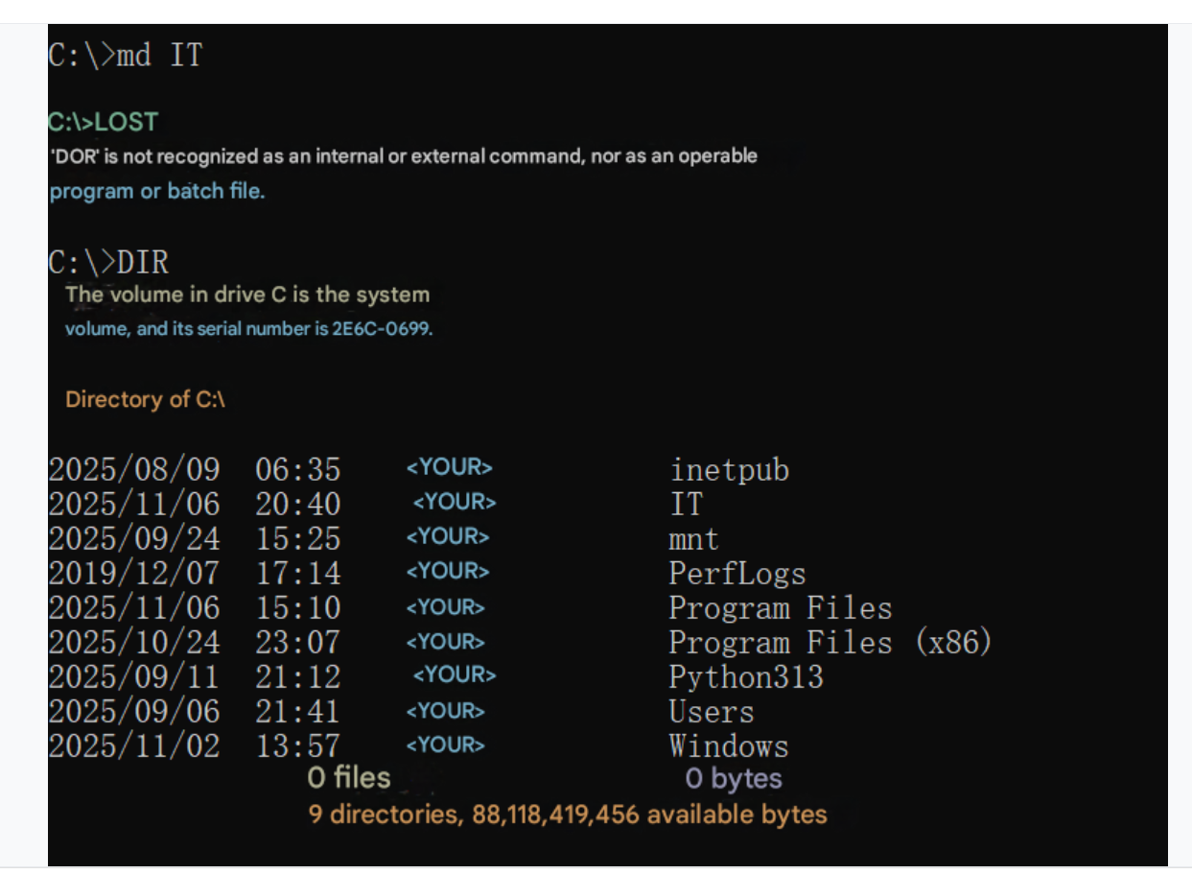

How to change to the IT directory?

CD IT
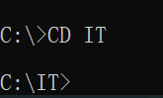

5. Managing Files: copy, ren, del
You can use the copy command to make a 2nd copy of a file, with a new name.
Save a file to IT directory (file name lab2.doc)
How to verify whether lab2.doc file is in the IT directory?

dir lab2.doc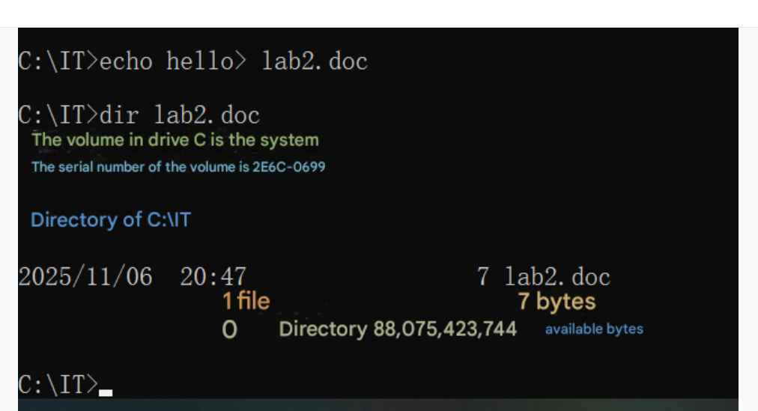
Make a backup of the lab2.doc file with other name labTWO.doc
- type: copy lab2.doc labTWO.doc
- type: dir
Are the new backup file and the original there? YES 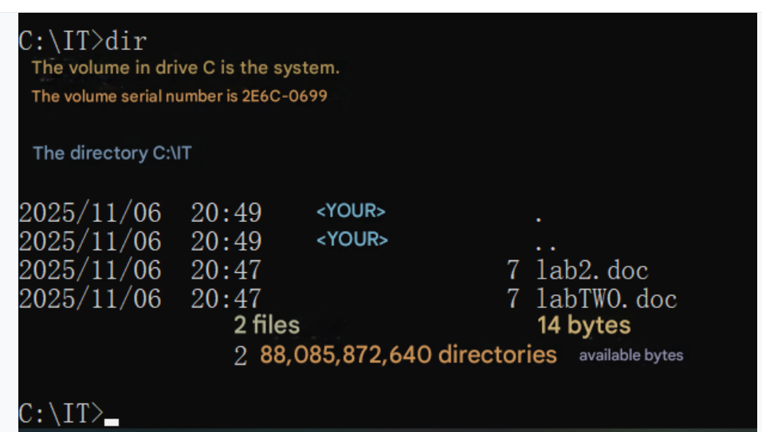

To rename a file, you can use the ren command.

Rename lab2.doc to lab.doc
- type: ren labTWO.doc lab.doc
- type: dir
Did the file renamed? yes
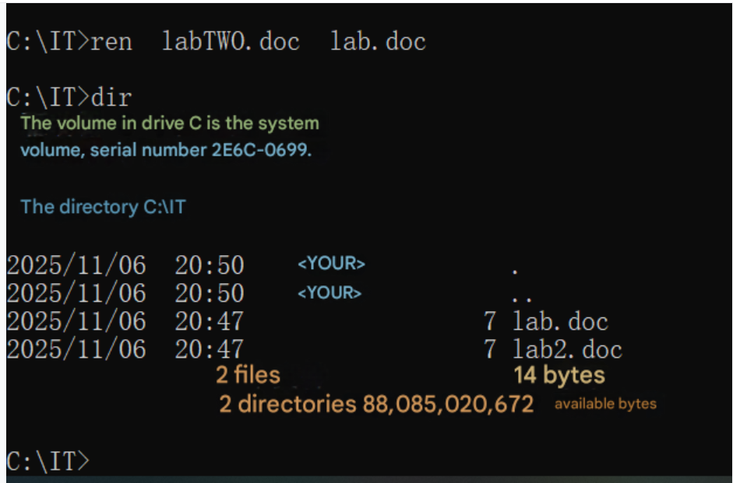
Delete files in DOS by using the del command.
Delete lab.doc file
- type: del labTWO.doc
Is the file has been deleted? NO
Why? There isn’t a file named labTWO, We have changed it into lab2

6. Delete a directory
To delete a directory in DOS, use the rd directory_name or rmdir directory_name command.

Delete the IT directory
- type: rd it
Is the folder deleted? NO
Why? The folder IT is not empty/ or we are now still in the path of IT
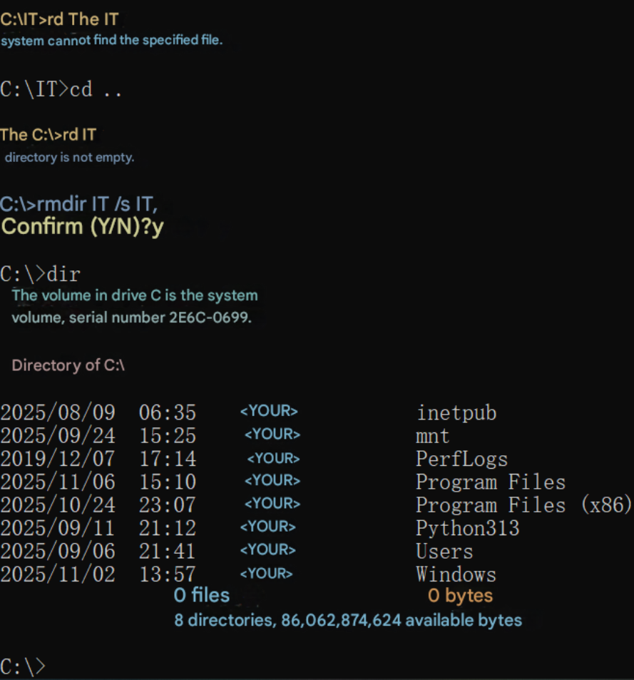
If your directories can’t be deleted, try this command:
- type cd\ to change to the c:\ drive
- type: rmdir IT /s
- type Y to confirm the removal of the it directory and all its subdirectories
Verify directory removal
- type: dir
Is the directory still exists? NO

Questions end. However students are encouraged to search and practice other commands that are provided by the command prompt shell to have more exposure to the shell.

