UNIVERSITI PUTRA MALAYSIA

FAKULTI SAINS KOMPUTER DAN TEKNOLOGI MAKLUMAT

Name: | YUE CHENGHAO | Matric: | 227154

The lab was conducted on Windows 10 using WSL2 (Ubuntu 22.04 LTS) as the Linux environment.
All commands were executed in the Bash shell, and outputs were captured from the Ubuntu terminal.

LAB 2 – Individual

OBJECTIVE:
The main objective of this lab is to introduce the students to the Linux/Unix operating system. Students will also be introduced to the Linux Command Line Shell (Bash@ Bourne Shell).

DURATION:
1 week / 3 hours

DUE DATE OF SUBMISSION: WEEK 3
Submit your assignment to your demonstrator. Make sure you sign the submission form after submitting.

PROGRAMME OBJECTIVE (PO):
PO2: Use the available software package with appropriate computer components.

RUBRIC:

CRITERIA | LEVEL 1  Very Poor | LEVEL 2  Poor | LEVEL 3  Good | LEVEL 4  Very Good | LEVEL 5  Excellent
The ability to perform operating system (OS) tasks. | Unable to perform OS tasks or able to perform OS tasks with very limited success (< 40%). | Able to perform OS tasks with limited success (≥ 40%,< 60%). | Able to perform OS tasks with some success (≥ 60%, < 80%). | Able to perform OS tasks with considerable success (≥ 80%, < 100%). | Able to perform OS tasks with outstanding success (100%).

QUESTIONS:

Objectives:
- use command line’s instructions
- to view, navigate, create and delete directories
- to copy, rename, and delete files
- to view information regarding process, switching processes

Bourne shell provides a collection of commands which can be used to control some of the important disk operations and operating system’s process management. All Unix and Linux versions support execution of the commands from the command line.

Instruction for the instructor

Explain about the following:
- Bourne Shell and the general purpose of the shell - purpose, example command, case-sensitive character restriction etc.
- the general structure of Unix/Linux file-system – file/directory, permission/access, important folders
- process management
This exercise requires Linux operating system. If you are not familiar with installing operating system, it is safer to install in the VMWare or VirtualBox (and don’t overwrite the existing OS in your computer). You can use Knoppix ‘Linux on CD-ROM’ distro which does not require installation. Download and use the bootable .iso file.

Lab Exercises

- Task: Open a command line shell’s window in Linux GUI (KDE) interface:

Find the ‘terminal emulator’ (computer monitor) icon and double-click. The terminal emulator (command prompt window) will appear. Type the command in the provided prompt (something like ~$).

Who are you in the system? Student(type whoami to identify)
What directory are you in? /home/student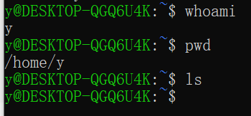
What does the prompt look like? student@ubuntu:~$

- Task : Working with files

touch command allows creating an empty file without editing.
Create two files named ‘a.txt’ and ‘b.txt’ in the current directory.
- type: touch a.txt
- type: touch b.txt

echo command is used to send (print) a text on the screen. Use echo “sometext”. Print out the text ‘this is a text’ to the computer screen.
- type: echo “this is a text”

echo command can be used to send (print) a text to file using redirection operator (>). Send the text ‘this is a text’ to the file a.txt
- type: echo “this is a text” > a.txt

You can add more content to the file using echo with redirection operator (>>)
- type: echo “adding more text” >> a.txt
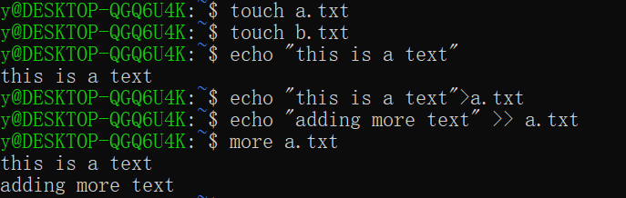
Why don’t we use ‘>’ to add content to the non-empty file? Try it and observe. What happened to the content of the file? _____________________________
Because doing it this way will overwrite the file; all existing content will be deleted.
To add new content, please use >>>.

more and less command can be used to view the content of a file. View the content of the file a.txt using more or less
- type: more a.txt
- type: less a.txt
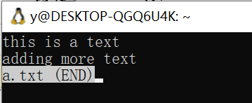
What is the difference between the two commands (more and less)?
More: One-way reading, can only turn pages downward.
Less: Can scroll up and down. Supports search, page turning, and exiting the keyboard (press 'q' to exit).
How to copy the content of a.txt into b.txt using more command?
cp a.txt b.txt
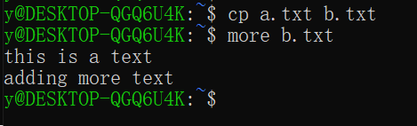

- Task : Displaying directory’s contents

ls command will list directories and files in a directory

(Tips: use ls –l to show attributes. Entries with directory types are specified with ‘d’ in the beginning of a line e.g. ‘drwxr-x--- …’. The command displays the related information for the files and directories, such as the permission, owner, timestamp of the file/directory created etc.)

Show a list of the directories located on a drive.

- type: cd $root change to the root directory
- type: ls
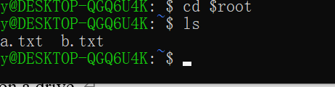
What happened? ______________________________________
It listed all the visible directories and files in the root (/) directory, such as bin, etc, home, usr, var, etc.
- type: ls -a
- type: ls -l
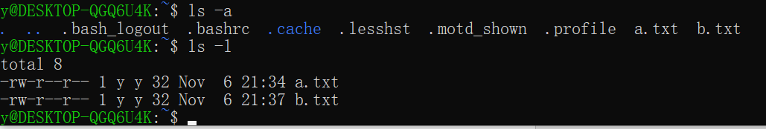
Based on your observation, describe the differences between –a and –l switches __________________________
-a shows all files including hidden ones (those starting with a dot), while -l shows detailed information such as file type, permissions, owner, group, size, and modification time.
What does the -l switch do? _______________
It lists files in long format, displaying attributes (permissions, owner, size, date).

- Task : Create and change a directory

To create directories, use the mkdir <directory_name> command. To change directories, use the cd <directory_name> command. To move up one level in the directory structure, use the command cd ..

Create an IT directory in the root directory
- type: cd (or cd $root) to change to the root directory
- type: mkdir IT

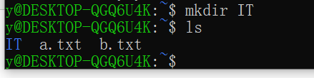
Verify the creation of the directory
- type: ls
Is the IT directory in the list? Yes
How to go into the IT directory? Cd IT

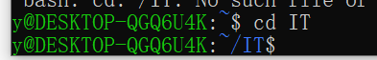
- Task : Managing Files using cp, mv, rm, rmdir

You can use the cp command to make a copy of a file, with a new name.

Create a dummy file to IT directory (touch lab.doc).
How to verify whether lab.doc file is in the IT directory?___
Ls lab.doc
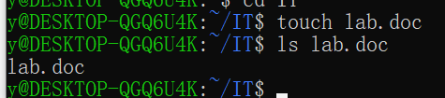
Make a backup of the lab.doc file with other name lab.bak
- type: cp lab.doc lab.bak

How to verify the new backup file and the original file are there?
Ls
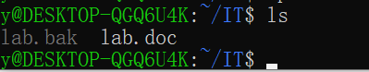
To rename a file, you can use the mv command. Rename lab.doc to labfile.doc
- type: mv lab.doc labfile.doc

Did the file renamed? How do you know? ___________
Yes, listed name changed in ls output.
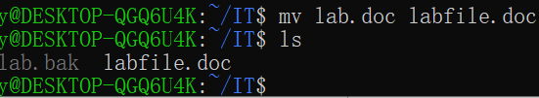
Delete files by using the rm command.
- type: rm labfile.doc

Is the file deleted? How do you know? _____________
Yes, listed name changed in ls output.
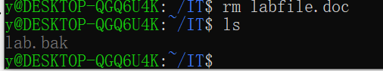
- Task : Delete a directory

To delete a directory in Linux, use the rmdir directory_name command.

Delete the IT directory
- type: rmdir it

Is the directory deleted? NO
Why? Because it is not empty

If your directories can’t be deleted, it might be because the directory is not empty. To remove non-empty directory (and also for empty directory), use rm -r
- type: rm IT -r
- type Y to confirm the removal of the it directory and all its subdirectories

(Tips: The deletion process will skip the question if using –f switch (force) e.g. rm IT -fr )
Verify directory removal. Is the directory still exists? How do you know?
NO , listed name changed in ls output.

- Task : View currently running process

To view currently running process(es) in user space, use the ps command.
- type: ps

How many process(es) is/are currently running?

2

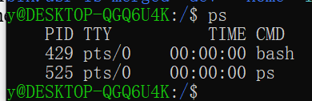

A current process can be suspended by pressing Ctrl+Z (e.g. open an application and then pressing Ctrl+Z will cause the application to stop and display the shell).
- type: vim

this will run the vim text editor. Press Ctrl+Z.

To view the stopped process,
- type: ps
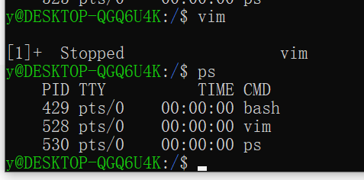
When user suspend a process, the process can be brought back by using the command fg. To bring back the Vim editor,
- type: fg

(to exit vim - press Esc, then type :q and press Enter)

- Task : Exploring other commands

Students are encouraged to search and practice other commands that are provided by the command prompt shell to have more exposure to the shell (search from the documentation, Internet, book etc), or study further the commands already learned. Use man <command> to get help about a specific command e.g. man ls or use --help switch e.g. ls –help , and answer the following question (answer either one):

Explain two new options/switches for any two commands that you have learned by showing examples how you used the commands with the switches.

Man ls” shows like this
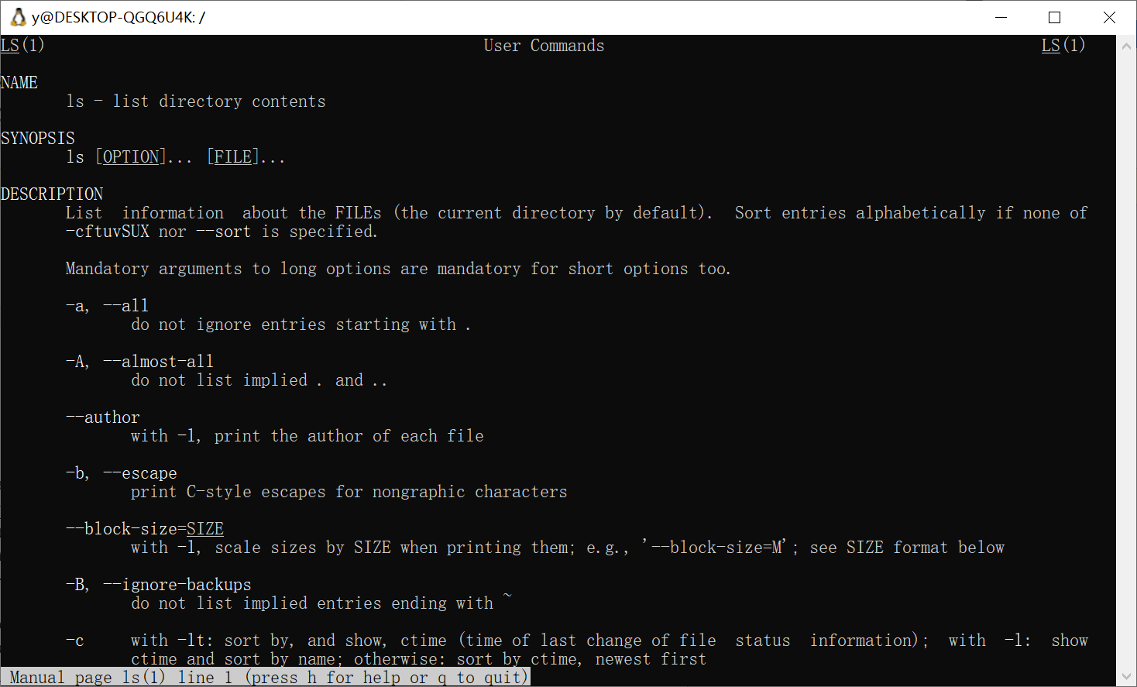
ls -lh
-l shows files in a detailed (long) list format.
-h means human-readable, so file sizes appear as KB/MB/GB instead of raw bytes
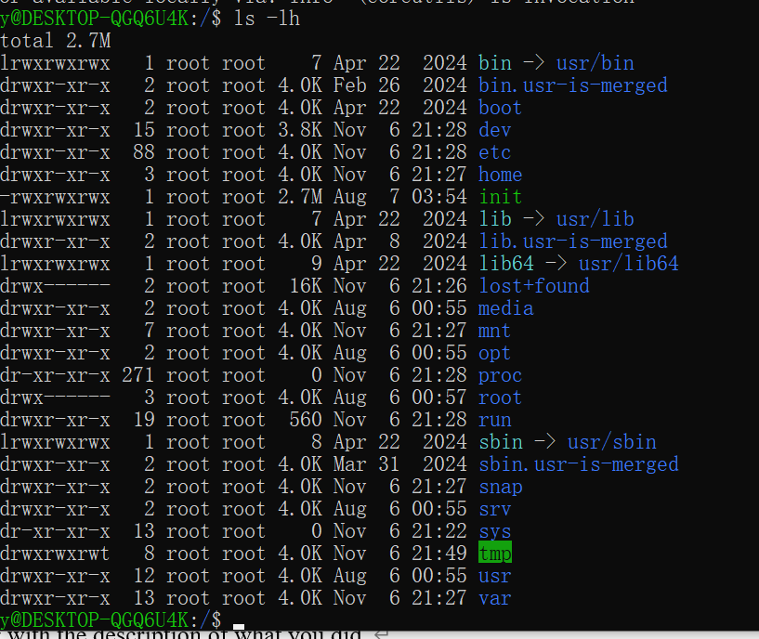
The -lh switch combination helps users view detailed file info with readable file sizes. This makes it easier to check which files occupy more space.
cp -i ask before overwriting files
mkdir -p create parent directories automatically
ps -u show processes for a specific user
grep -n show line numbers for matches

OR
Explain two new commands that you learned by showing the list of operations that you performed along with the description of what you did.
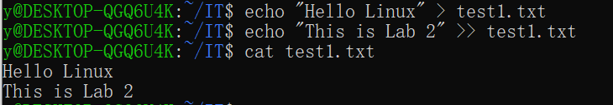 The cat command is used to display the contents of a file directly in the terminal, combine multiple files, or redirect output into a new file.
In this example:

echo created and added text into test1.txt.
cat test1.txt printed the file content line by line on the screen.

It is helpful to quickly check what’s inside a file without opening a text editor like Vim or Nano.
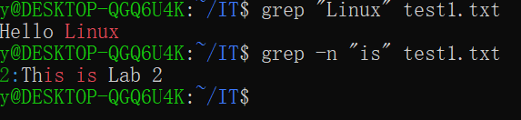
The grep command searches for specific words or text patterns inside a file.
The first command finds all lines containing the word “Linux.”
The second command (-n) also shows the line number where the word appears.
It’s useful when searching through configuration files or long text logs to find specific keywords quickly.
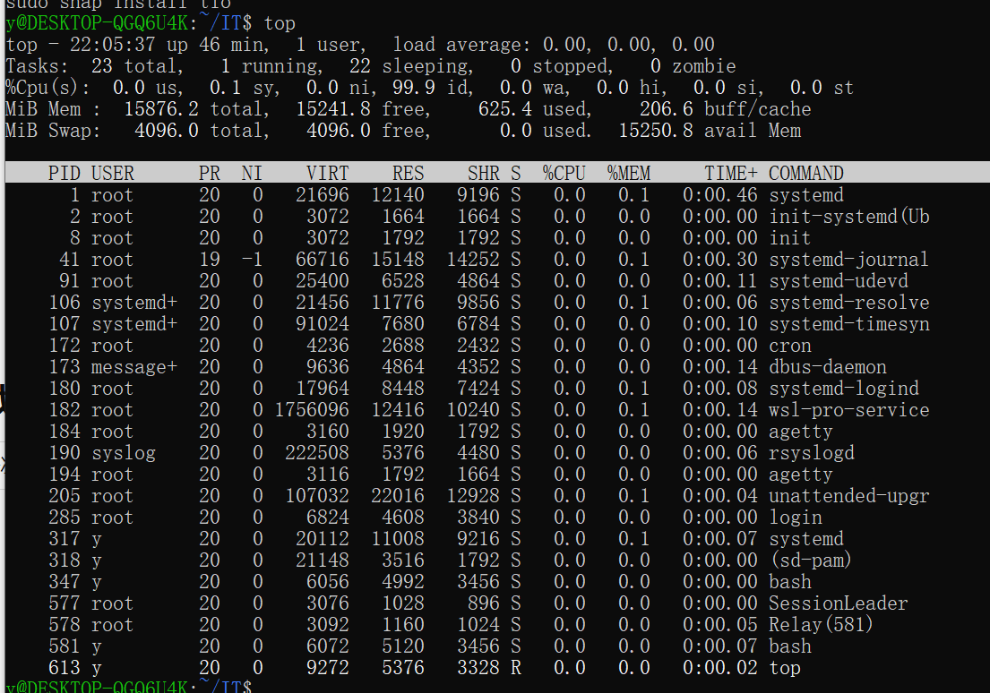 The top command shows a dynamic, real-time view of all running processes on the system.
It displays information such as:Process ID (PID) , CPU usage, Memory usage, User running the process, Command name

