

SamaRasa
AI-powered elderly companionship and health management system
Interface explanation with user manual
SSW3001 Software Engineering
First semester of the 2025/2026

Table of contents

interface explained 3
Interface for the elderly 3
Caregiver side interface 6
User manual 9
System Overview 9
Quick Start Guide 10
Function instructions 11
Frequently Asked Questions 14

UI explained
This section describes in detail the interface elements of the SamaRasa system and their functions. The system is mainly divided into two user terminals: the elderly side (tablet application) and the caregiver side (web dashboard).

For the elderly

Home screen
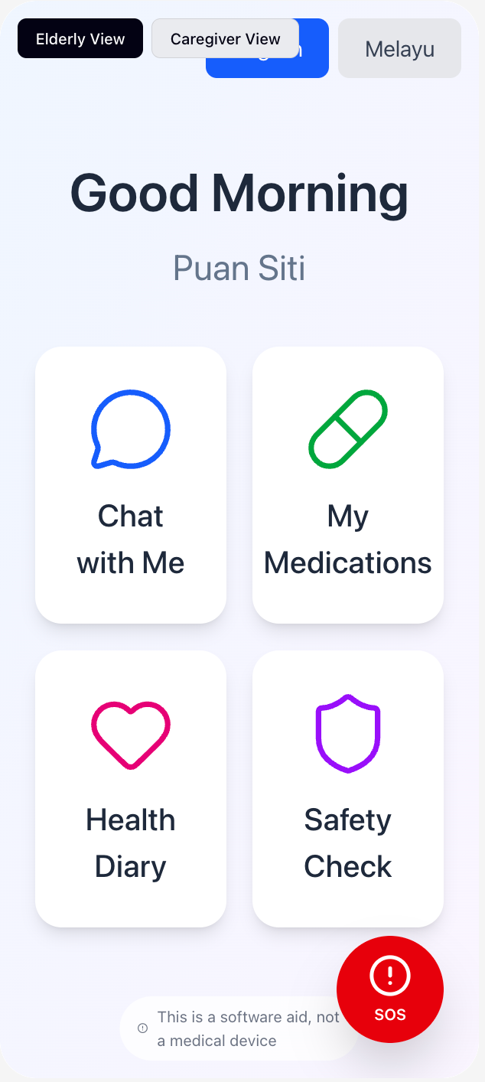
The home screen is the first interface for elderly users after opening the app, and the design principle is simple, intuitive and easy to operate.
Interface elements | Function description:
Greetings | Show time slot greetings like "Good Morning" or "Selamat Pagi" based on the current time
Username | Displays the name of the currently logged in user, such as Puan Siti
Function card area | 2×2 grid layout with four main function entrances
Chat with Me | Open the AI companion chat interface
My Medications | View medication plans and reminders
Health Diary | Record your daily mood and health
Safety Check | Perform a fall risk assessment questionnaire
SOS button | A red panic button fixed in the lower right corner of the screen
Language switching | The top button toggles English/Melayu
The main screen adopts high-contrast contrast (meets WCAG AAA standards), the font size is not less than 24px, and the touch target is not less than 48×48 pixels, ensuring that elderly users can easily identify and operate.

AI chat interface

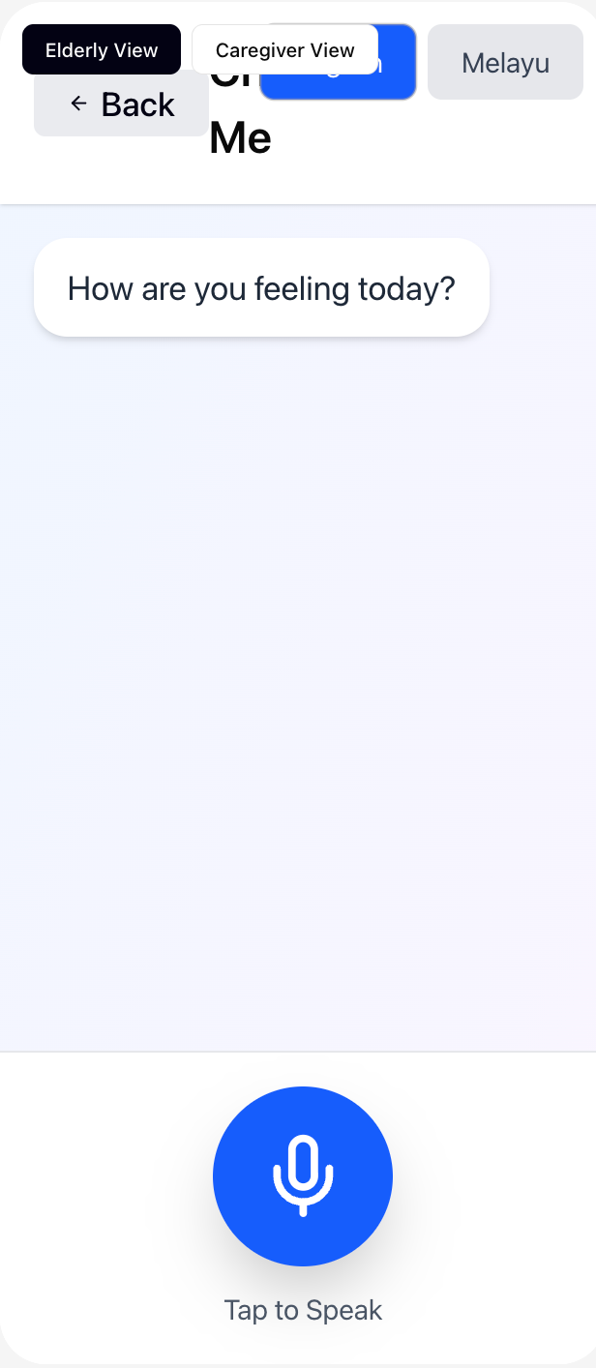
The AI chat interface offers voice interaction capabilities, allowing elderly users to engage in natural conversations with AI companions.
Interface elements | Function description:
Back button | The top left corner returns to the home screen
Title | "Chat with Me" identifies the current feature
AI message bubbles | Show the AI's greeting or response, such as "How are you feeling today?"
Voice typing button | Large blue circular button at the bottom with a microphone icon
Voice animation | Pulse waveform animation is displayed when recording
Status alert | Displays the status of "Listening", "Thinking...", etc

3. Medication management interface
The medication management interface displays all medication plans for older users, presented in the form of cards for easy viewing.
Interface elements | Function description:
Pill icon | Colored pill icon at the top of each medication card
Drug name | Such as Amlodipine, Metformin, etc
Dosage information | Shows the dosage of the drug, such as 5mg, 500mg
Medication time | Daily medication time is displayed, such as 08:00 and 20:00
Date of medication | Display of medication date in the form of a label (Mon, Tue, etc.)
Medication instructions | Display medication precautions, such as "Take with water after breakfast"

4. Medication reminder interface
Medication reminders are full-screen pop-up interfaces to ensure that elderly users do not miss medication time.
Interface elements | Function description:
Large tablet icon | A large pill icon appears in the center of the screen
Reminder title | "Medication Reminder" logo
Reminder subheading | "Time to take your medicine" prompt
Medication detail card | Display drug name, dosage, time, and instructions
Taken button | A large green button indicates that the medicine has been taken
Skip button | The gray button indicates that this medication is skipped
Countdown timer | Display reminder has been dured, such as "0m 50s"

5. Health diary interface
The health diary interface allows elderly users to record their daily mood and help track mood changes.
Interface elements | Function description:
Title | "Health Diary" logo
Mood record card | “Today's Mood - How are you feeling?” Tips
Mood options | 2× Emote options for 2+1 grid layouts
Happy😊 | Happy (green)
Okay😐 | It's okay (blue)
Sad😢 | Sad (yellow)
Anxious😰 | Anxiety (orange)
Lonely👤 | Loneliness (purple)

6. Emergency help interface
The SOS interface is triggered in an emergency to send a message for help to the caregiver.
Interface elements | Function description:
Check off the icon | A large green checkmark indicates that the alert has been sent
Success title | The red text reads "Emergency Alert Sent!"
Confirm the information | Inform users that emergency services and caregivers have been notified
Countdown timer | Displays alert activation time, such as "0:20"

Caregiver side interface

1. Login interface
Caregivers enter the system through the login interface and need to enter a valid email address and password.
Interface elements | Function description:
Logo | SamaRasa brand logo with a heart icon
Subtitle | The "Caregiver Dashboard" describes the current system
Email input box | Enter the caregiver's email address
Password input box | Enter your login password, which appears as a dot
Login button | The "Login" button submits the login information
Help text | Presentation use help text

2. Medication schedule interface
Medication schedules are the home page of caregiver dashboards to manage medication schedules for older adults.
Interface elements | Function description:
Top header | "SamaRasa Dashboard" brand identity
User information | Displays the current logged in caregiver email address
Exit button | Log out in the top right corner
Tab navigation | Medication schedules/health analysis/alerts and logs
Page title | "Medication Schedule" logo
page subtitle | Help page feature: "Manage daily medication reminders"
Add button | "+ Add Medication" adds a new medication
Medication cards | Displays details for each medication
Edit/delete button | Action button in the upper right corner of the card

3. Health analysis interface
The health analysis interface shows the trend of medication use and mood changes of the elderly through graphs.
Interface elements | Function description:
Medication tracking chart | The bar chart shows the daily medication usage
Legend | Missed (red) / Skipped (yellow) / Taken (green)
X-axis | Display date range (e.g. 12/20 - 1/16)
Mood trend chart | The line chart shows the mood changes over the past 14 days
Y-axis | Mood score range from 0-10
Chart title | "Daily tracking of medication intake" and "Mood Trend"

4. Alert and log interface
The alarm and log interface centralizes emergency alerts and medication records, making it easy for caregivers to quickly understand abnormal situations.
Interface elements | Function description:
SOS alert area | "SOS Alerts - Emergency notifications" heading
Active alert card | Displays the currently active SOS alert
Status labels | The "Active" red label indicates the alert status
Trigger time | Displays alert trigger times, such as Jan 16, 08:39 AM
GPS location | Display trigger location coordinates (3.1390, 101.6869)
Resolve button | The "Mark as Resolved" flag alert has been processed
Medication log area | “Medication Logs - Recent medication activity”
Log entries | Displays details for each medication record
Status labels | The green label "Taken" indicates that it has been taken

User manual

System Overview
SamaRasa is an AI-powered companionship and health management system designed specifically for seniors in Malaysia. The system supports bilingual interaction in English and Malay, and adopts a voice-based design concept, especially suitable for elderly users with limited digital literacy.
The main functions of the system include:
- AI Chat Companionship: Provides daily greetings and emotional support
- Intelligent medication reminder: Regular reminder and record medication status
- Health Diary: Record your daily mood and health status
- Emergency SOS Alert: One-click call for help
- Fall risk assessment: Regularly assess the risk of falls
- Caregiver Dashboard: Remote monitoring and management

Quick Start Guide

Older users get started quickly
1. After opening the app, wait for the AI's greeting voice to finish playing 2. Click the "Chat with Me" card to chat with the AI, press and hold the microphone button to speak 3. Click "My Medications" to view today's medication plan 4. When the medication time arrives, the system will automatically pop up a full-screen reminder 5. Click "Taken" to confirm that you have taken it, or click "Skip" to skip 6. In case of emergency, press and hold the SOS button in the lower right corner for 3 seconds or tap twice in a row

Caregiver Quick Start
1. Access the Caregiver Dashboard URL 2. Enter your email address and password to log in 3. Click "+ Add Medication" on the "Medication Schedule" page to add a new medication 4. Fill in the drug name, dosage, medication time, and instructions 5. Switch to "Health Analytics" to view medication status and mood trends 6. View emergency alerts and medication logs on the Alerts & Logs page

Function instructions

AI chat feature
The AI chat feature is based on voice interaction and supports natural conversations. The system will analyze the sentiment based on the content of the conversation and automatically record the user's mood state. If keywords such as "sad" and "dizzy" are identified, the AI will give care and suggestions.

Medication reminder function
Medication reminders are automatically triggered at a set time, and voice reminders are played and a full-screen interface is displayed. If there is no response within 15 minutes, the system automatically marks the status as "Missed" and sends a notification to the caregiver.

SOS Emergency Alert
The SOS button is designed with an anti-accidental touch mechanism: it takes a long press for 3 seconds or two consecutive taps to trigger. There will be a 5-second countdown after triggering, during which you can click Cancel. After the countdown ends, the system automatically sends an alert to the caregiver with the user ID, time and GPS location.

Frequently Asked Questions
Question | Answer
How do I switch languages? | Tap the [English] or [Melayu] button at the top of the main screen to switch
What should I do if the medication reminder is not responding? | Check if the device volume is turned on and confirm that the network connection is normal
How do I cancel by accidentally touching the SOS button? | Click the "Cancel" button during the 5-second countdown to cancel
How do I add a new medication? | Caregivers are added by clicking the "+ Add Medication" button on the dashboard
What should I do if my medication records are inaccurate? | Contact the caregiver to modify the record in the dashboard
What browsers are supported? | Supports modern browsers such as Chrome 90+ and Safari 14+
What equipment is needed? | It is recommended to use a tablet above 10 inches, making sure to have a microphone and speakers
If you encounter additional issues, please contact your system administrator or review the full Software Requirements Specification (SRS) and Software Design Document (SDD) for more technical information.



SamaRasa
AI-Powered Companion and Health Management System
SSW3001 Software Engineering · Universiti Putra Malaysia
© 2025/2026 version 1.0

