Table des matières

I. Installation 3

II. Generalities and project management 3

1. Language 3

2. Information panel 3

3. Create a new project 3

4. Open a project 3

5. Save a project 3

III. Gestion of videos 3

1. Add videos 3

2. Suppress video 4

3. Concatenate videos 4

IV. Main project table 4

1. Video identity 4

2. Frame rate 4

3. Cropping 5

4. Stabilization 6

5. Background 6

6. Definition of the arenas 7

7. Definition of the scale 8

V. Video reader 8

VI. Tracking preparation 9

Original video 10

Background 10

Threshold 10

Erosion/Dilation 10

Area selection 11

Distance threshold 12

Number of individuals per arena 13

VII. Tracking process 13

VIII. Visualization and correction of the trackings 13

1. Visualization 13

2. Corrections 13

Punctual error 14

Interpolation 14

Redo part of the tracking 14

Validate corrections 14

IX. Prepare analyses 15

1. Smoothing filter 15

2. Analyses of individual trajectories 15

3. Spatial repartition 16

Elements manipulation 16

Types of elements 16

Expend elements to other arenas 18

4. Interindividual distance 18

5. Exploration 18

Modern NEW NAME HERE 18

Meshes 18

X. Run analyses 19

Results per individual 19

Results of interindividual distances 19

Spatial 19

XI. Export a video 19

1. Installation

Bio-Track is a program developed in Python for usage under the Windows operating system. The Bio-Track installer can be downloaded from: <https://github.com/VioletteChiara/Bio-Track/releases>.

Download the file Bio-Track.installer.exe, launch it and follow the installer instruction.

1. Generalities and project management
2. Language

A drop menu is available on the top right corner of the Bio-Track window to change the displayed language. Note that changing the language will automatically close Bio-Track. Just reopen it to have the new set language.

1. Information panel

An information panel is always visible in the top right corner of the application. This panel aims to provide the user with information about the different components of the window simply by putting the mouse over them.

1. Create a new project

The notion of project is at the center of Bio-Track functioning. A project may be seen as a collection of videos, each associated with various information. By pressing the “New project” button, you will be able to choose a location on your computer where you want the files linked with your project to be located. Two things will be created in the indicated location: a *.btr* file which is your project’s file and a folder with the name of your project that will later contain all the outputs from Bio-Track.

1. Open a project

If you already have created a project before, you can reopen it using the “Open project button”. Then just select the *.btr* project file you want.

1. Save a project

An opened project can be saved using the “Save” Button. The last saved version of the project will be replaced by the current one.

1. Gestion of videos
2. Add videos

Use the “Add video(s)” button to add some videos to your project. The number of imported videos is not limited. Note that Bio-Track is not doing a copy of these videos, also once a video has been imported in the project, if you rename it or change its location you will not be to use it in Bio-Track anymore.

If one or more of the videos you want to import are not in *.avi* format, a window will appear proposing you to convert the videos. You can then choose which of these videos you want to convert. Only the converted videos will be added to the project. The converted videos may be found in the project folder, in the “converted_vids” subdirectory.

For each imported video, a line will appear in the table presents in the center of the main project (see section: **Main project table**). A video can be selected by clicking on its name, in this case, the rectangle at the left of the video name will appear in green to indicate which video is selected.

1. Suppress video

A selected video (see section: **Add videos**) can be suppressed using the “suppress the video” button. Note that this action will remove the video from the project without the possibility to cancel this action. All the data associated with this video will also be suppressed (deletion of the tracking parameters and coordinates resulting from tracking).

1. Concatenate videos

Often, video cameras recording for a long period of time will create several videos of short durations instead of one long video. To addition these short videos into one long, you must first import all the parts of the video in the project (see section: **Add videos**). Once the importation done, select the first of the video by clicking on its name, then press the “concatenate video” button, the button color will change to red. Finally, click on the second video’s name. The second video will be added after the first one and will disappear from the main project table. You can then repeat this operation as much as you need. If you pressed the “concatenate video” button by accident (button appears in red), you can cancel it by pressing it again or by selecting again the first video.

1. Main project table

In the main window of the project, each imported video is associated with one line of the table presents in the center of the window. A vertical scrollbar at the right of the table allow to scroll through the videos if they are too numerous to fit within the window. A horizontal scrollbar at the bottom of the table allows to scroll from left to right to see the whole table.

Each row of the table is separated in several sub-elements, described below from left to right. Changing these elements is not mandatory and the program will work even if no changes are done.

1. Video identity

The first section of each row contains three elements:

* A vertical rectangle whose color indicates whether the video is selected (green) or not (red). It is not possible to select more than one video at a time.
* The video name.
* The eye symbol. You can see the first frame of the video by putting your mouse over this symbol.

1. Frame rate

The fps (frame per second) or frame rate of a video corresponds to the number of images this video is displaying per second. Here reducing the fps means that you will only analyze part of the images of your video. For instance, dividing the fps by two mean that only one out of two images will be analyzed.

By reducing the frame rate, you can greatly improve the speed of the tracking and of the analyses. Decreasing too much the fps will decrease the precision of your measurements and the distances traveled by your subjects will be underestimated. In the opposite, a too high frame rate might result in a confusion between real displacements of the subjects and the noise related to the tracking imprecisions and induce an overestimation of the distances traveled. This last problem can be later corrected by applying a smoothing filter on the coordinates (see section: **Prepare analyses, Smoothing filter**).

*Figure 1: Illustration of the impact of the frame rate on the tracking results.*

If you are working with more than one video at a time, you can use the “Apply to other videos” button to use the same frame rate reduction to other videos. Note that the frame rate reduction consists in dividing the number of fps by a given number, also if your videos did not share the same frame rate before the transformation, they will also end up with different frame rates.

*If you don’t change this option:* the original video frame rate will be used.

1. Cropping

Many researchers use to record longer movies than needed when recording animal behavior, this method ensure that the whole test will be correctly recorded without missing the first or last seconds of the experiment. This second section allows to remove the useless part of the video *via* cropping.

When you press on the “Crop video” or “Modify cropping” buttons, the main project window will be replaced by a new one. In the center of this new window, you will see the video reader (see section:**video reader**) which displays your video.

Under the video reader, you have access to the information about your video cropping both in terms of seconds and frames. To indicate where you want your video to begin, you can either write it in the text field under the “start” label or go to the frame you want as the first frame using the video reader and then press the “Select video beginning” button. The time-bar will be immediately updated, and you will see a blue rectangle indicating where your video will begin (after the cropping). To indicate where you want you video to end you can either click on the time-bar and press the “Select video end” button or indicate the duration you want for your video by writing in the text fields below the “Duration” label.

Once you finished the cropping you can press the “validate” or “validate and go to next video” buttons. The first one will bring you back to the main project table, while the second will open the next video.

You can also move from one video to another using the drop menu in the top left corner of the window. Note that in this case, the changes you made regarding the cropping will not be saved.

*If you don’t change this option:* the whole video will be tracked.

1. Stabilization

This option allows to correct the video if the camera was not completely stable during the recording. Shortly, this option will look for points of interest in the first frame (after cropping) of the movie. Then, for each frame of the video these same points are identified, and a transformation is applied to ensure that the points of interest remain in the same place through the video. You can ensure that the result of the stabilization is satisfying by clicking the “Check stabilization” button. This option will open the video reader (see section: **video reader**) that will show which points of interest have been selected on the frame of reference (first frame). You will also see below the original video with the position of the pints of interest and the video after stabilization. If your background is highly homogenous, the program might have difficulties in finding good points of interest. Also, if you see that the stabilized video is not satisfactory, you can remove the problematic points by clicking on them in the reference frame from the video reader. A minimum of two points is mandatory. You can always press the “Add all points of interest” button to cancel the deletion of points.

Finally, the “Apply/remove stabilization to multiple videos” button in the main project window allows to generalize this option to several videos at the same time.

Note that the process of stabilization is time consuming, also we recommend to not apply a video stabilization on videos that are already stable.

For more technical information, see:

<https://docs.opencv.org/3.4/dc/d6b/group__video__track.html#ga473e4b886d0bcc6b65831eb88ed93323>

and

<https://learnopencv.com/video-stabilization-using-point-feature-matching-in-opencv/>

*If you don’t change this option:* the original cropped video will be used.

1. Background

To detect the moving targets in the video, Bio-Track uses a process of subtraction: it compares the frame with and without the targets to find the target’s position (see Figure 2).

*Figure 2: Illustration of the process of background subtraction.*

Also, prior to the tracking, it is important to have a background image (grayscale image without the targets). To automatically create this background image, you can press the “Create background button”. To create the background, Bio-Track will take a subsample of the images of the video and calculate the median color value of each pixel of the frame. This methodology will successfully remove all the targets from the image, except if these targets remain at the same place for more than half the duration of the video. In this case, the automatic background process will fail. To ensure that such problem did not arise, you can put your mouse over the eye symbol to see the background proposed by Bio-Track. If some targets are still present, even partially, you will need to correct this background. The correction can be simply done using the “Modify background” option.

This option will open a new window in which you will find the current background of the video, the objective is then to draw over the remaining targets to hide them and to recreate an image empty of targets. To do so, you can select a new color by right clicking in the image, the color under your cursor will be taken (the current color is displayed on the bottom right of the window, above the “validate” button. You can then paint over the targets using left click. The size of the painting area can be adjusted using the mouse wheel. If you are unsatisfied with the automatic background proposed by Bio-Track you can also directly use the first frame of the video by using the button in the bottom right corner.

|  |  |
| --- | --- |
| **Keys** | **Actions** |
| Right click | Change the current color |
| Left click | Paint |
| Ctrl + left click on the image | Zoom in |
| Ctrl + right click on the image | Zoom out |
| Mouse wheel | Change the size of the tool |
| Ctrl + Z | Cancel last painting operation |

Note that the “Do auto background for multiple videos” button will not reuse the same background for all videos but will recreate a new background of each of the videos.

*If you don’t change this option:* The method used to find the targets will be different and an adaptive thresholding will be used instead of a background subtraction. This second method can be better in case of videos with a lot of changes in luminosity or with important perturbations (see example videos: “Spiders” and “Fish”). With the adaptive threshold method, the program will look for black contrasts on each of the frame to localize the targets.

1. Definition of the arenas

This option allows to draw the delimitations or the arenas in which the targets may be found. Drawing the arenas ensures you that the targets will not be confused between arenas during the tracking: a target inside an arena cannot leave this arena or appear in another one. It also limits the risks that some elements outside the arena will be confused with the targets. Finally, the defined areas will be later used in the analyses to calculate for instance the proportion of the arena explored by the target, or the time spend close to the border of the arena.

Once you pressed the “Define arenas” button, a new window will appear. In this window you will see the image of your background (first image of the video if the background has not been defined) and you will be able to draw the different arenas. To draw an arena, simply click on the background where you want to place a corner of the first arena. At any moment, you can indicate the kind of shape your arena should be (Ellipse/Rectangle or Polygon). Once the corners are placed, you can move them by click and drag, or suppress them using the “suppr” key. Once your first arena is correctly defined, you can press the “return” key to validate it and begin the drawing of a new one. You can modify a precedent shape simply by clicking on one of its points. One area must be completely separated from the others, also if two shapes are overlapping, the combination of these two shapes will be considered as a unique area. You can use the “View” button to see the result. If the arenas have the same location in several videos, you can use the “Apply these arenas to other videos button”.

|  |  |
| --- | --- |
| **Keys** | **Actions** |
| Left click | Add/Move a corner |
| Suppr | Delete the selected corner |
| Enter | Validate a shape |
| Ctrl + left click on the image | Zoom in |
| Ctrl + right click on the image | Zoom out |

*If you don’t change this option:* The program will consider that there is only one arena occupying the whole image.

1. Definition of the scale

Defining the scale of your recording will first allow you to obtain data expressed in international units instead of pixels. Another advantage of defining the scale of your video is that it will allow to uniformize the tracking parameters between videos which are not recorded at the same scale (e.g. Figure 3).

After clicking the “Define scale” button, a new window will open in which you can see the first frame of the video. Click on the frame to place two points separated by a known distance. Then, indicate in the bottom right files the real distance between these two points and which unit you are using.

You can use the “Apply this scale to other video” if several videos have been recorded at the same scale (same distance between the camera and the arenas, same quality of recordings, same zoom).

*Figure 3: Illustration of the importance of the scaling: when the recording is not done from the same point of view, the values in pixels cannot be compared between videos but the distance in international units can be.*

*If you don’t change this option*: All the later measurements will be done in pixels.

1. Video reader

The video reader will be found in different situations using Bio-Track. It will show you the video you are working with (Fig 4, A). Under the video, you can see a time-bar (Fig4, B) that will show you the duration of the video and which indicate which frame of the video is visible on the screen (indicated by a black rectangle, Fig4 C). The red part of the time-bar is the part of the video you are working with (i.e. video after cropping, see section: **Main project table, Cropping****;** Fig 4, D), it is delimited by a blue and a red rectangles who indicate respectively the beginning and the end of the working part of the video. You can click directly on this time-bar to go to a particular moment of the video.

Four buttons are available under the time-bar:

Play/Stop buttons: play/stop the video

Go to begin/end buttons: Make you jump at the beginning/end of the video

A slider at the right of these buttons allows you to increase/decrease the speed at which the video is displayed while playing. A speed of 0 corresponds to the original video speed.

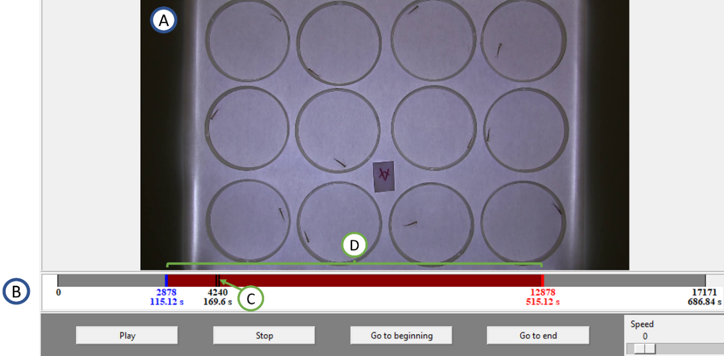

*Figure 4: Illustration of the video reader.*

Shortcuts:

|  |  |
| --- | --- |
| **Keys** | **Actions** |
| Ctrl + left click on the image | Zoom in |
| Ctrl + right click on the image | Zoom out |
| Spacebar | Play/Stop the video |
| Left arrow | Move backward of one frame |
| Right arrow | Move forward of one frame |

1. Tracking preparation

Once you finished with the preparation of the videos (see section **Main project table**), you will be able to define the parameters of the tracking. To that aim, select the video you are interested in and press the “Prepare tracking” button in the bottom left of the main project window. This will direct you toward a new window in which you will see the video reader (see section **video reader**) and several parameters in the right of the window. Each parameter corresponds to a transformation made to the video that will allow to detect the targets in the image. The transformations will be applied from top to bottom, also if you select the 4th checkbox (Erosion) it means that the image displayed in the video reader is the image that went through the 3 other transformations (Original video importation, Background subtraction and Thresholding).

From the main project window, you can see the tracking preparation’s parameters of a selected video in the bottom right of the window. You can also apply these parameters to other videos using the “Apply these parameters to other videos” button.

Original video

Show the video cropped and stabilized if this option was selected.

Background

If a background has been defined (see section **Main project table, Background**), this option shows the video after the background subtraction. Note that the process is not a simple background subtraction process but a combination of two subtractions (sub(background,frame) + sub(frame,background)) to detect both light and dark targets.

Threshold

If a background has been defined, this parameter transforms the image resulting from the background process to create a binary image (only composed of white and black pixels, no grey anymore). The threshold parameter determines the lightness above which a grey pixel will be converted to a white one and below which it will be converted to a black one (Figure 5). For a good quality tracking, the result (visible in the video reader) must be the closest possible of the targets in white and the rest of the image in black.

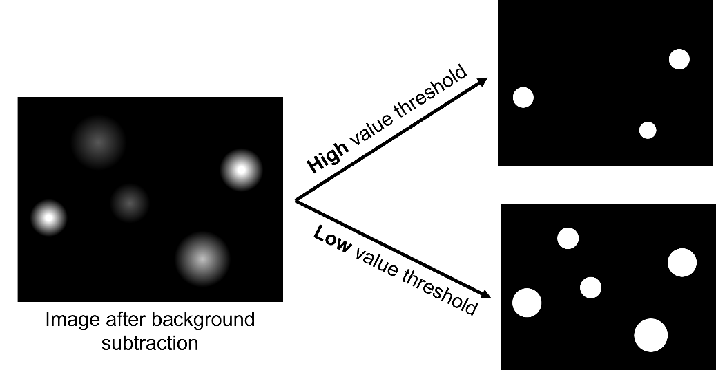

*Figure 5: Illustration of the process of thresholding.*

If there was no background defined for the selected video, this process will be replaced by an adaptive thresholding: the program will identify spots that are darker than their close environment. The parameter can be changed to change the range of considered environment (Figure 6).

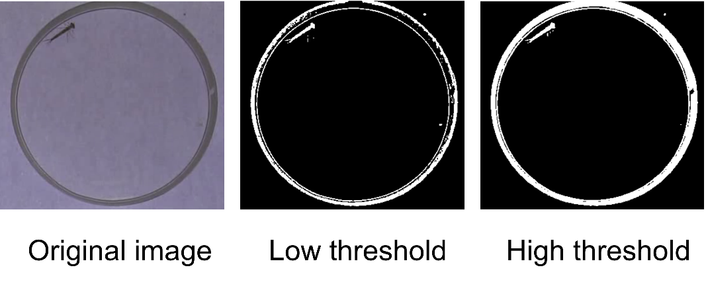

*Figure 6: Illustration of the process of adaptive thresholding.*

Erosion/Dilation

This allows to increase/decrease the size of the white areas resulting from the threshold process. While erode will remove white pixels from the borders of the white shapes, dilate will add some. These parameters allow to remove potential noise from the background and improve the visibility of the targets (see Figure 7).

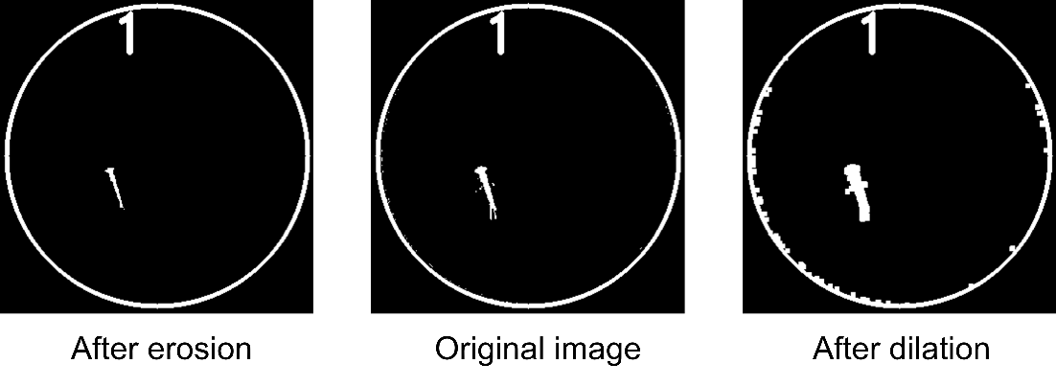

*Figure 7: Illustration of the processes of erosion and dilation.*

Area selection

This parameter allows to determine the minimum and maximum area of your targets. All white shapes that are smaller/bigger than the indicated value will be removed from the image (Figure 8). This way you will limit the risk that another element is considered as a target.

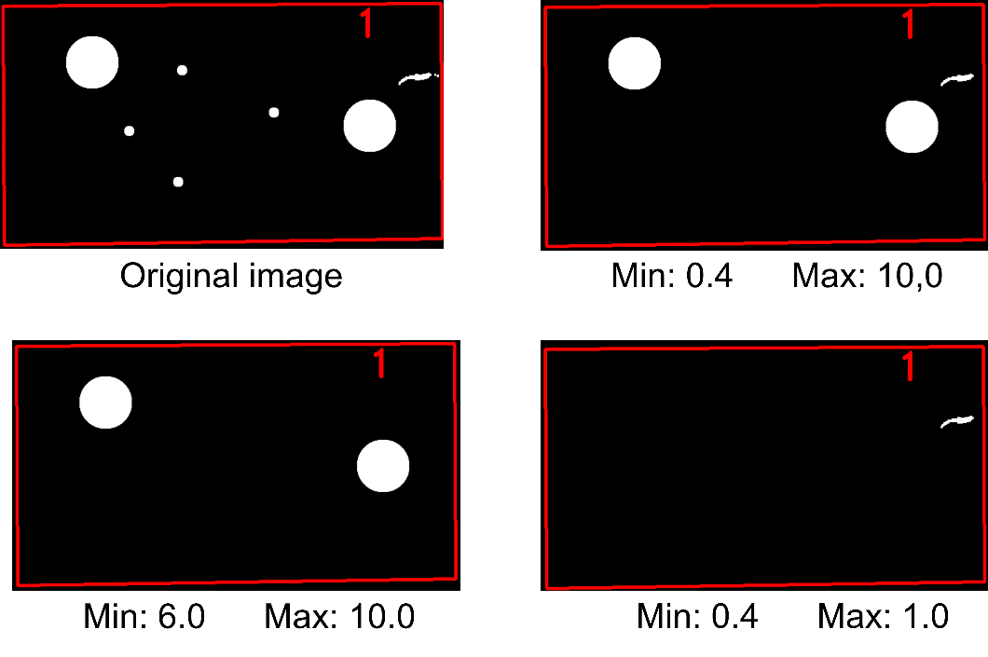

*Figure 8: Illustration of the process of area selection. Under each image is the value set for minimum and maximum areas.*

Distance threshold

This parameter may be used to indicate the maximum distance a target can move between two frames. During the tracking process, the distance between the target at a time *t* and the potentials targets at *t+1* is calculated, and all the potential targets whose distance from the target position at time *t* is higher than the threshold distance will be excluded. The best value for this parameter is not easy to find as it will depend on a lot of parameters like the maximum moving speed of the targets or the frame rate of the video.

To facilitate this process, after clicking the “Distance threshold” checkbox, you will see in the video reader light blue points: they indicate where the potential targets are located. You will also see dark blue disks whose center is the position of the potential targets at the previous image and whose radius is your distance threshold. Assuming that a target was correctly located at time *t-1*, when at *t* the target light point is inside the corresponding dark circle, it means that Bio-Track will consider this light point as a potential position of the target for time *t* (Figure 9). We advise to look for moments of the video where the targets are moving fast and to ensure the distance threshold is not too low. It will always be better to use a too high than a too low distance threshold.

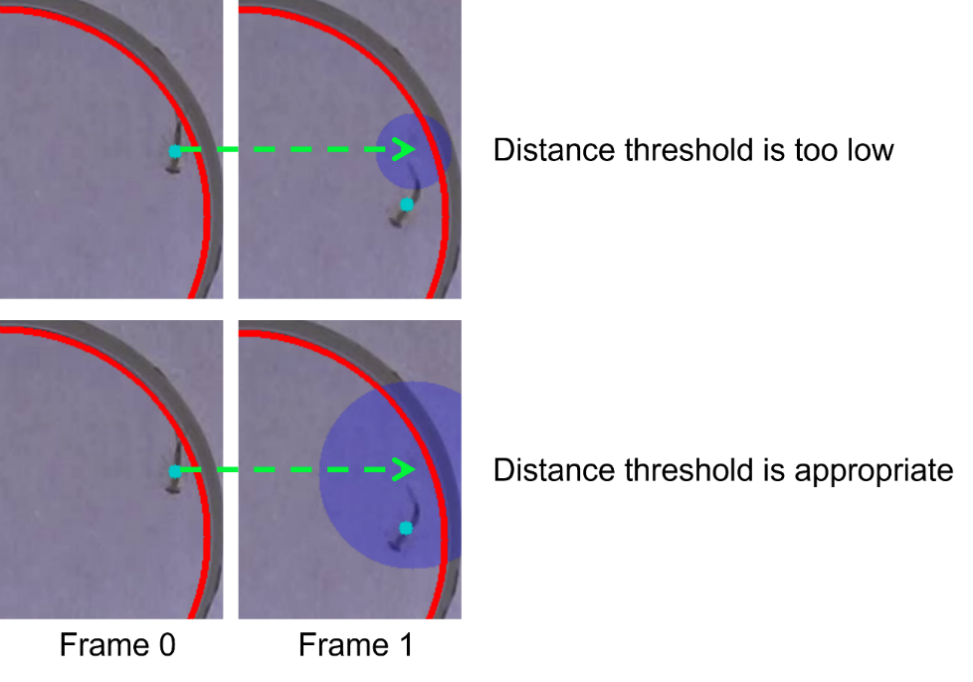

*Figure 9: Illustration of the distance threshold.*

Number of individuals per arena

According to your experimental design, you might have more than one target per arena, in that case you must indicate how much targets are to be found in each area. If this number is the same for all the arenas, you can just change the slider to adapt it to your needs. On the image, each arena is drawn in red, and the number of targets expected to be found appear as a red number close to the arena border.

If the number of targets per arena is variable, press the “P” button at the right of the “Number of individuals per arena” section to manually change the number of individuals for each arena.

Note that Bio-Track does not allow to track the identity of the different targets within a same area. For such kind of analyses, please see: <https://www.idtracker.es/> from Pérez-Escudero et al., 2014.

A. Pérez-Escudero, J. Vicente-Page, R.C. Hinz, S. Arganda, G.G. de Polavieja, Nature Methods 11(7):743-748 (2014)

1. Tracking process

Once that at least one of the videos is ready for the tracking, you will be able to click the “Begin tracking” button and to select the videos you want to track. According to the number of videos, their length and their quality, this process duration can be highly variable**.**

1. Visualization and correction of the trackings
2. Visualization

You can check the accuracy of the trackings using the “View and correct track” button in the bottom right part of the main window. A new window will then appear with the video reader on the left on which you can see the results of the tracking. The coordinates of the targets are marked by a colored point and the tails behind these points represents the previous positions of the targets. At the same time, you can see the coordinates in a table at the right of the window. The length of the tail may be increased using a slider which represent the tail length in seconds. You can also make appear all the trajectories recorded during the video by pressing the “see all trajectories” button. If the points/tail colors are determined randomly, you can change them with the “Change the point(s) colors” button.

In the table at the right of the window, you can see the coordinates corresponding to what is displayed in the video reader. The frame displayed is indicated by “>” preceding its number. Each column of the table corresponds to one target, each cell contains the X and Y coordinates of these targets. In addition to using the features of the video reader (see section **Video Reader**), you can set the video reader to a particular frame by clicking on a row from the table.

1. Corrections

There are three different ways of correcting tracking errors that must be used according to the duration of the according error.

Punctual error

To correct a punctual error which happened during only one frame, you can directly change the position of the points on the video reader by click and drag it, the table will be updated accordingly.

Interpolation

If the target has been lost during a short duration and that its trajectory during this period can be resumed by a straight line, you can interpolate the coordinates between two frames (see Figure 10). To do so, you must first select the concerned target. To do so, you can either click on it on the video reader or click on one corresponding cell of the table. The selected individual may be identified on the video as the point will be highlighted, on the table, the corresponding coordinates will appear between “ * ”. You must then select the frames on which you want to apply the interpolation. To that aim, you can either press <Shift> and click on another frame of the table or play the video maintaining the <Shift> key pressed. Once you made this selection, press the “Interpolate” button to apply the changes to the trajectories.

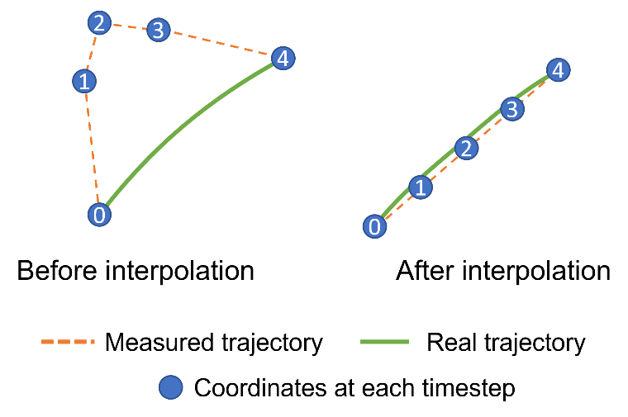

*Figure 10: Illustration of the process of interpolation. In this case, an interpolation is realized between frame 0 and 4.*

Redo part of the tracking

If you need to correct some bigger issues, you can simply redo a part of the tracking with different parameters. To do so, select the frames you want to change (see section *Interpolation*) and press the “Redo tracking button”. This will open a new window in which you will be able to choose the pre-tracking parameters for this portion of video (see sections **Main project table** and **Tracking preparations**). After changing the parameters, press the “Redo the track” button to see the result. Once you are satisfied with the result, press the “Validate these changes” button to apply them within the rest of the video.

Invert coordinates

If the identity of two targets has been inverted, you can swap it back by selecting one of the two targets and then click on the second one while holding the “Shift” key. The coordinates of these two targets will be inverted from the current frame until the end of the video.

Validate corrections

Once you pressed one of the two validate button, a new coordinates file will be created inside the project folder (see section **Generalities and project management**) under the “corrected coordinates" subdirectory. You can also remove all the corrections you did by pressing the “Remove all corrections” button.

1. Prepare analyses

From the main Project window, you can press the “Prepare analyses” button in the bottom right of the window after selecting a video.

1. Smoothing filter

You can smooth the trajectories of your targets by checking the “Smooth trajectories” checkbox. This parameter applies a Savitzky-Golay filter (function savgol_filter from the scipy python package) on the coordinates. The application of this filter allows to facilitate the identification of the movement phase and to correct the noises associated with the imprecision of the tracking (Figure 11, see also section **Main project table, Frame rate**). The parameters of the smoothing filter can be controlled by pressing the “P” button at the right of the checkbox. To compare the between video’s information, you might want to apply the same smoothing filter to all of them at the same time. To do so, you can use the “Apply smoothing to other video(s)” button to apply the smoothing parameters defined for this video to other ones. If no smoothing was applied at this moment, the smoothing filter will be removed in the other designated videos.

For more information, see:

<https://docs.scipy.org/doc/scipy/reference/generated/scipy.signal.savgol_filter.html>

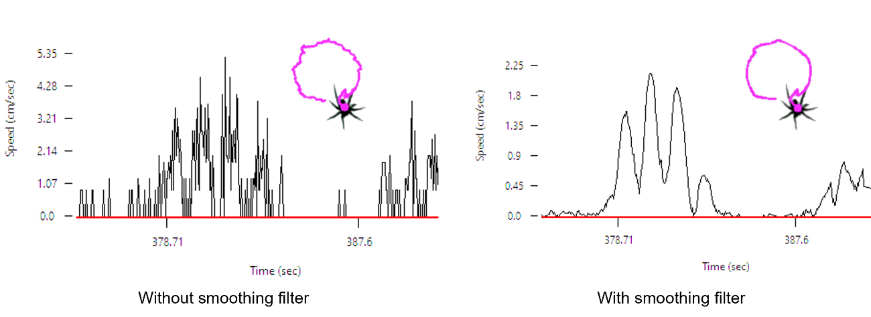

*Figure 11: Illustration of two trajectories before and after the application of the smoothing filter. The graphs show the measured speed of the individual as a function of time. We can see that the periods of movement are easier to identify after the application of the filter.*

1. Analyses of individual trajectories

If you click the corresponding checkbox, you will see on the video reader the movement speed of each target (except for the first frame). The speed value will appear in green/red if the target is considered as moving/stopped respectively. By default, a target will be considered as moving if the distance traveled between two frames is higher than 0. However, this method does not consider the tracking imprecisions which normally results in little trembling of the target.

To change the threshold of movement above which you want to consider that a target is moving, you can press the “P” button. This will open a new window in which you can see a graph of the speed of the selected target as a function of the time. You can press the drop menu on the top of the window to change the selected target, the selected target will also be highlighted on the video reader. A blue vertical line on the graph indicates the currently displayed frame in the video reader, you can move this line by simply clicking somewhere on the graph; the video reader will be immediately updated. A red horizontal line indicates the movement threshold: the speed above which an individual will be considered as moving. You can change this value by click and drag the red line.

Finally, in the bottom right corner of the window, you will have a summary of the measured data for the selected target:

* Proportion of time lost: Count the proportion of frames for which the target was not detected (appears as “NA NA” in the data tables).
* Average speed: The displacement speed between each frame will be calculated and averaged for the whole video.
* Average speed when moving: The displacement speed between each frame where the target is considered as moving (i.e. speed above the red movement threshold) will be calculated and averaged for the whole video.
* Proportion of time moving: Proportion of time the target is considered as moving.
* Total distance traveled: Sum the total distance traveled by the target.
* Total distance traveled when moving: Sum the total distance traveled by the target when we only consider the frame during which the target is considered as moving.

After validating, you can apply the same movement threshold to all videos using the “Apply the exploration parameters to other video(s)” button.

1. Spatial repartition

This section of Bio-Track allows to define some points or areas of interest. Click the corresponding checkbox to see the elements that are already defined (non by default). Click the “P” button to add some new elements. This will open a new window in which you can see the current frame of the video with the selected area highlighted. Use the drop menu in the top of the window to change the selected area. You can then press the “Add element” button (top left of the window) to add new elements.

Elements manipulation

The elements placed on the image can be easily moved by click and drag the associated points (except for borders, see below). When created, each element will appear in the right part of the window where you can see its name (by default the kind of element and an identity umber) and the measurements associated with this element. You can rename an element by simply writing in its name text filed. Note that you cannot have two elements with the same name. You can also suppress an element by pressing the “Suppr” button at the right of its name.

Types of elements

* Point

A point can be either freely placed (just click on the frame where you want to place it) or placed in the center of the area.

A point is associated with three different measurements: i) the average distance to this point, ii) the latency to approach at less than a given distance to this point (to be defined by the user by simply writing in the correspondent text field), iii) the proportion of time the target spent inside this at less than this distance from the point.

* Segment

A segment is defined by two points. These two points can be placed freely (click anywhere on the frame) or be associated with a border. If you choose the second option, you must click on the border/corner of the area where you want to place the first point of your segment. If you select a corner, the point will be immediately placed on the frame. If you choose a border, a small window will appear that will ask you what position you want this point to take on the border. Then repeat the same operation for the second point.

Three measurements are associated with a segment. i) The mean distance to the segment which is the average value measured for all frames as the shortest distance between the target and any point of the segment. ii) The number of times the target crossed the segment. iii) The latency before crossing the segment for the first time.

* Borders (All)

This will immediately select all the borders of the area (i.e. the whole contour of the area) and add it as a new element.

Two measurements are associated with this. i) The mean distance to the border is the averaged shortest distance between the target and the border. ii) The proportion of time the target spent at less than a given distance from the border (to be defined by the user by simply writing in the correspondent text field).

* Borders (selection)

You can also select specific borders. In this case, you must indicate on the frame which border(s) you want to consider. To do so, click on the border(s) you want to consider (their color will change from purple to red if they are selected). Once you selected all the borders you want, press the “Return” key to validate and the borders will appear in the list of elements.

Three measurements are associated with this. i) The mean distance to the border is the averaged shortest distance between the target and the selected border(s). ii) The proportion of time the target spent at less than a given distance from the border (to be defined by the user by simply writing in the correspondent text field). iii) The latency to approach the border(s) at less than the indicated distance.

* Area

To add an elliptical, circular or polygonal area, you must click on the frame where you want the corners of your area to be placed. Once all the corners are placed, press the “Return” key to validate the shape, which will appear in the list of elements.

Two measurements are associated with shapes: i) the proportion of time the target spent inside this area and ii) the latency to enter this area.

Expend elements to other arenas

Once you defined at least one element, you can duplicate this element and apply it in other arenas. To that aim, click the “Expend to other arena(s)” button. This will open a new window with two lists on it. The left list is the list of elements present in your arena; from this list you can select the elements you want to duplicate in other arenas. The second list is the list of arenas (all videos confounded). If you want to visualize an arena, just put your cursor over its name in the list, an image of the video with the arena drawn in blue will appear. Select in this list the arenas toward which you want to duplicate the elements. Simply click the “Validate” button to apply these duplications. It is important to note that except for the “All borders” elements the other elements will be duplicated only if the arena of origin and of reception are of the same shape (same number of corners, square/circle, …). If the shapes are too different or do not share the same number of corners, the duplication of elements will not be applied. Moreover, two elements in the same arena cannot have the same name. Also, of you try to add a new element in an arena which already possessed an element with the same name, the old element will be replaced by the new one.

1. Interindividual distance

The interindividual distance is simply measured as the sum of all distances between all the targets inside an arena. There is no option for this measure, by clicking this checkbox you will see on the video reader the calculated distances for the current frame.

1. Exploration

This option allows to calculate the proportion of the arena explored by each target. To change the parameters associated with the measurement of exploration, you can choose between them clicking the “P” button at the right of the checkbox. This will open a new window in which you can select a particular individual (you can change the current individual using the drop menu at the top of the window). Bio-Track proposes two different methods to measure the exploration. After defining the method of exploration, you can apply it to other videos using the “Apply the exploration parameters to other video(s)” button.

Modern NEW NAME HERE

This method allows a fine measurement of the explored area. With this method, we consider that a target explores a circular area around it at each frame. Each pixel that falls within this circular area at least once during the video is considered as visited while the others are considered as unvisited. The measure of exploration returned is simply the proportion of visited pixels within the arena. You can change the surface of the circular area around the target using the slider or by directly writing in the corresponding text field.

Meshes

This method is more traditional as it has been primarily invented to analyze videos by hand. It consists in drawing a mesh on the top of the arena and counting the number of visited cells of the mesh. We propose here two types of mesh: a rectangular or a circular one. In both cases, the surface of each cell of the mesh can be determined by the user. Regarding the circular mesh, a supplementary parameter can be defined (aspect parameter) which determine the shape of the mesh cells. To method used to draw the circular mesh are based on the work of Beckers and Beckers, 2012.

Beckers, B., & Beckers, P. (2012). A general rule for disk and hemisphere partition into equal-area cells. *Computational Geometry*, *45*(7), 275-283.

1. Run analyses

After you prepared the analyses, you can run them using the “Run analyses” button in the main project window. The results will be summarized as .csv files in the project folder, in the “Results” subfolder. In this subfolder, you will find two .csv files.

Results per individual

The file “Results_by_ind” is constituted of 16 columns and of one row per tracked target.

Video: the file name of the video.

Arena: The ID number of the arena in which the target was (the arenas are numerated from left to right and from top to bottom).

Individual: The ID number of the target from 0 to N, unique for each arena.

The other columns of this table are explained in the section **Prepare analyses**.

Results of interindividual distances

This file is a summary of the inter-individual distances, it contains one row par arena which contained more than one target. The data found here are the mean inter-individual distance (see section **Prepare analyses, interindividual distance**). It also computed the smallest interindividual distance measured and the biggest one. Note that Bio-Track does not allow to track the identity of the different targets within a same area and the targets are confused when they are touching each other’s (between target’s distance of 0).

Spatial

In the spatial folder, you will find one file per element of interest (see section**Prepare analyses, Spatial repartition**). The structure of these table is the same as the “Results per individual” ones, the measured variables are described in section **Prepare analyses, Spatial repartition**.

1. Export a video

As Bio-Track indirectly allows video-editing, you can export the videos you used during the program using the “Export the video” button in the main project table. This will open a new window in which you can select at which step of the process you want your video to be saved (after being cropped, cropped and stabilized, with the trajectories or with the smoothed trajectories). For the two last options you can choose the length of the tail to be displayed and the color of each target. To change a target’s color, select the target by clicking on it then click on the colored rectangle (under the tail length slider). A color palette will open in which you can click to choose a new color.