PRODUCT REQUIREMENTS DOCUMENT
CodeForge AI
AI-Powered Collaborative Coding Platform
Field | Value
Version | 1.0
Date | July 5, 2026
Owner | Vipasha Sharma
Repo | CodeForge-AI
Status | Active Development
Confidential — Internal Use Only

1. Product Overview
One-liner: CodeForge AI is a full-stack, AI-powered collaborative coding platform that enables developers, students, and interview candidates to write, share, and collaborate on code in real time from the browser — augmented by Google Gemini for intelligent coding assistance.
Field | Detail
Product Name | CodeForge AI
Repository | CodeForge-AI
Owner / Team | Vipasha Sharma
Date | July 5, 2026
Version | 1.0
Primary Language | JavaScript (React + Node.js)
License | Not specified
Description
CodeForge AI is a modern client-server web application designed for real-time code collaboration and AI-assisted programming. It combines a React + Vite frontend with a Node.js + Express backend, using Socket.io for live multi-user editing and Google's Gemini AI for in-editor coding assistance. Authentication is handled via bcrypt-hashed credentials and JWT sessions, while lightweight JSON-based storage (LowDB) keeps the system simple to deploy for educational, portfolio, and prototyping use cases.

2. Objectives and Goals
- Enable Real-Time Collaboration — Multiple users can edit the same code document simultaneously with negligible latency.
- Integrate AI Assistance — Provide inline Gemini-powered explanations, code generation, debugging, and optimization suggestions.
- Provide Secure Access — Ensure only authenticated users can create/join rooms via bcrypt-hashed credentials and JWT sessions.
- Simplify Collaborative Coding — Offer a low-friction, browser-based coding room model requiring no local setup for participants.
- Maintain a Single Source of Truth — The server holds canonical room state; all clients reconcile against it.
- Support Learning & Interviewing — Serve as a practical platform for pair programming, teaching, and interview practice.

3. Target Users
User Persona | Type | Description
Software Developer | Primary | Professionals collaborating on code or prototyping ideas with AI support
CS Student | Primary | Students learning to code and practicing collaboratively
Interview Candidate | Primary | Candidates practicing coding problems with AI hints and peer review
Programming Instructor | Secondary | Educators demonstrating concepts and reviewing student code live
Pair Programming Team | Primary | Small teams (2–4) iterating together on the same file
Open Source Contributor | Future | Contributors extending the platform with  new features

4. Actual Problem Statement
Core Problem: Existing collaborative coding tools are either too heavyweight (requiring installed IDEs and proprietary accounts) or too limited (share-only pastebins), and none combine real-time multi-user editing with integrated AI assistance in a single lightweight browser experience.
Specific pain points:
- Heavy IDE-based tools (VS Code Live Share, JetBrains Code With Me) require desktop installs and account setup.
- Snippet-sharing tools (Pastebin, JSFiddle) do not support true real-time multi-cursor editing.
- AI coding assistants (Copilot, ChatGPT) are single-user and disconnected from collaborative sessions.
- Existing collaboration tools lack integrated, context-aware AI help inside the shared editor.
- Interview and classroom scenarios need quick room-based sessions without heavy onboarding.

5. Proposed Solution
CodeForge AI addresses these gaps through a four-layer architecture:
- Layer 1 — Authentication: LowDB stores user credentials; passwords hashed with bcrypt; sessions managed via signed JWTs.
- Layer 2 — Collaboration Engine: Node.js + Express + Socket.io broadcast edits as events across all room participants in real time.
- Layer 3 — AI Assistance: A backend proxy securely calls Google's Gemini API for explanations, code generation, and debugging.
- Layer 4 — Rich Frontend: A React + Vite SPA delivers a responsive editor UI, room management, and an AI assistant panel.
Why this works:
- Browser-first — no installs required for collaborators
- AI is native to the editor, not a separate tab
- Modular architecture — LowDB today, easily swapped for MongoDB/PostgreSQL later
- Secure by default — hashed passwords, JWT-guarded routes and sockets

6. Features

6.1 F1 — Secure Authentication
- User registration and login with form validation
- Passwords hashed with bcrypt before storage
- JWT issued on login; used to authorize REST and Socket.io connections
- Credentials persisted in LowDB (JSON-based)

6.2 F2 — Collaborative Coding Rooms
- Users can create new coding rooms or join existing rooms via a room ID
- Each room maintains its own document state and participant list
- Room membership is authenticated via JWT

6.3 F3 — Real-Time Synchronized Editing
- Socket.io powers bidirectional communication between server and clients
- Edits are broadcast to all room participants and applied instantly
- Server maintains the canonical document state per room

6.4 F4 — AI-Powered Coding Assistance (Gemini)
- Ask coding questions and receive explanations without leaving the editor
- Generate code snippets from natural language prompts
- Debug errors and receive optimization suggestions
- All AI calls proxied through backend to protect the API key

6.5 F5 — Responsive, Developer-Friendly UI
- Clean, responsive layout that works on desktop and tablets
- Editor, participants list, and AI panel in one workspace
- Modern styling with a focus on readability

6.6 F6 — RESTful Backend APIs
- Well-defined REST endpoints for auth, rooms, and AI proxying
- Middleware for JWT verification, logging (Morgan), and security headers (Helmet)

7. Use Flow

7.1 Primary Flow — Collaborative Coding Session with AI
- User A registers/logs in and receives a JWT.
- User A creates a new coding room and shares the room ID with User B.
- User B logs in, joins the room using the shared room ID.
- Both users are connected via Socket.io; the room's current code is loaded in the editor.
- User A begins typing; changes are broadcast in real time to User B.
- User B highlights a code block and asks the AI assistant to explain it.
- The frontend calls the backend AI endpoint, which forwards the prompt to Gemini.
- The AI response is streamed back and displayed in the AI assistant panel.
- Users iterate on the code together, using AI suggestions as needed.
- Users log out; sessions are invalidated client-side.

7.2 Secondary Flow — Solo Practice with AI
- User registers and logs in.
- User creates a private room for solo practice.
- User writes code and uses the AI assistant for hints, debugging, and optimization.
- Session ends; user logs out.

8. Data Flow Diagram (DFD)
The Data Flow Diagrams below describe how data moves between users, the CodeForge AI system, and external services (Google Gemini API).

8.1 Level 0 — Context Diagram
The system is treated as a single process interacting with two external entities: the User and the Gemini AI Service.
+-----------+ credentials / code edits / prompts +------------------+ AI prompts +-------------+
| |--------------------------------------->| |---------------->| |
| User | | CodeForge AI | | Gemini AI |
| |<---------------------------------------| System |<----------------| Service |
+-----------+ auth tokens / synced code / AI reply +------------------+ AI responses +-------------+

8.2 Level 1 — Major Processes
Level 1 decomposes the system into its main processes and data stores.

+----------------------+
User ---creds---> | 1.0 Authentication |---writes/reads---> [D1: Users (LowDB)]
<--JWT------ | (bcrypt + JWT) |
+----------------------+
|
JWT v
+----------------------+
User ---join----> | 2.0 Room Management |---writes/reads---> [D2: Rooms (LowDB)]
<--room----- | |
+----------------------+
|
socket v
+----------------------+
User ---edits---> | 3.0 Realtime Sync |---updates--------> [D3: Room Doc State]
<--patches-- | (Socket.io) |
+----------------------+
|
prompt v
+----------------------+ API call +-------------+
User ---ask-----> | 4.0 AI Assistance |------------------>| Gemini API |
<--answer--- | (proxy) |<------------------| |
+----------------------+ AI reply +-------------+

8.3 Data Stores
ID | Data Store | Contents
D1 | Users (LowDB) | username, bcrypt password hash, user id, created_at
D2 | Rooms (LowDB) | room id, owner id, participants, created_at
D3 | Room Document State | in-memory current code buffer per active room

9. Functional Requirements
ID | Feature | Requirement | Priority
FR-01 | User Registration | System shall allow users to register with username and password | High
FR-02 | User Login | System shall validate credentials and issue a signed JWT | High
FR-03 | Password Security | All passwords shall be hashed with bcrypt before storage | High
FR-04 | Protected Routes | REST and Socket.io connections shall require a valid JWT | High
FR-05 | Create Room | Authenticated users shall create coding rooms and receive a room ID | High
FR-06 | Join Room | Authenticated users shall join existing rooms via room ID | High
FR-07 | Real-Time Sync | Code edits shall be broadcast to all room participants in real time | High
FR-08 | Canonical State | Server shall maintain the canonical document state per room | High
FR-09 | AI Assistance | Users shall query Gemini AI for explanations, generation, and debugging | High
FR-10 | AI Key Protection | Gemini API key shall never be exposed to the client | High
FR-11 | Session Persistence | JWT shall persist client-side and re-auth on refresh | Medium
FR-12 | Logout | Users shall be able to log out, invalidating their local session | Medium
FR-13 | Request Logging | All HTTP requests shall be logged via Morgan | Low
FR-14 | Security Headers | Helmet shall apply secure HTTP headers on all responses | Medium

10. Non-Functional Requirements

10.1 Performance
- Real-time edit broadcast latency under 200ms on a local network
- Frontend page load under 2 seconds on a modern browser
- Backend should handle at least 20 concurrent Socket.io connections
- AI responses returned to the client as soon as Gemini responds (streaming where possible)

10.2 Security
- Passwords stored as bcrypt hashes (cost factor >= 10)
- JWTs signed with a server-side secret and given an expiry
- Gemini API key stored server-side only, loaded from environment variables
- Helmet middleware applied for secure HTTP headers
- REST and Socket.io endpoints reject requests without a valid JWT

10.3 Reliability
- Server maintains a single authoritative copy of each room's state
- Reconnecting clients receive the current room document on rejoin
- Graceful handling of disconnects without crashing the server

10.4 Usability
- Setup requires no more than two commands (backend + frontend)
- UI is intuitive enough for a new user to join and start collaborating within a minute
- AI assistant produces readable, well-formatted responses

10.5 Maintainability
- Clear separation between /client and /server modules
- Modular route/controller structure in Express
- Data layer isolated to allow swapping LowDB for MongoDB/PostgreSQL later

10.6 Portability
- Runs on any OS with Node.js v18+
- No cloud services required for local development
- Compatible with Chrome, Firefox, and Edge (latest versions)

11. Tech Stack
Layer | Technology | Purpose
Frontend Framework | React + Vite | SPA with fast HMR development
Frontend Languages | HTML, CSS, JavaScript | Markup, styling, and interactivity
Backend Runtime | Node.js | JavaScript server runtime
Backend Framework | Express.js | HTTP routing and middleware
Real-Time Transport | Socket.io | Bidirectional real-time event broadcasting
Database | LowDB | Lightweight JSON-based storage for users and rooms
Auth — Hashing | bcrypt | Password hashing with salt rounds
Auth — Sessions | JWT | Stateless token-based authentication
AI Integration | Google Gemini API | AI coding assistance (Q&A, generation, debugging)
Security | Helmet | Secure HTTP headers
Logging | Morgan | HTTP request logging
Package Manager | npm | Dependency management (frontend and backend)
Version Control | Git / GitHub | Source control and collaboration

12. Risk Assessment
# | Risk | Likelihood | Impact | Severity | Mitigation
R1 | Concurrent edit conflicts — simultaneous edits may overwrite each other | Medium | High | High | Adopt Operational Transformation or CRDT (e.g., Yjs) for conflict-free merging
R2 | Gemini API key exposure via client bundle | Medium | High | High | Proxy all AI calls through backend; store key in environment variables
R3 | LowDB not suited for concurrent writes at scale | High | Medium | High | Acceptable at prototype scale; migrate to MongoDB/PostgreSQL for production
R4 | In-memory room state lost on server crash | High | Medium | High | Persist room state periodically; add crash recovery on startup
R5 | JWT secret leakage from repo | Medium | High | High | Use .env with dotenv; add to .gitignore; rotate on breach
R6 | No rate limiting — abusive users can flood sockets/AI calls | Medium | Medium | Medium | Add express-rate-limit and per-socket throttling; cap AI calls per user
R7 | Gemini API quota / cost overruns | Medium | Medium | Medium | Enforce per-user AI usage quotas; monitor spend
R8 | No HTTPS in default setup exposes JWTs on the network | Medium | High | High | Terminate TLS via reverse proxy (Nginx + Let's Encrypt) in production
R9 | Cross-room data leakage if room scoping is buggy | Low | High | Medium | Enforce room membership checks on every socket event and REST call
R10 | Browser incompatibility with older browsers | Low | Low | Low | Target latest Chrome/Firefox/Edge; document supported versions

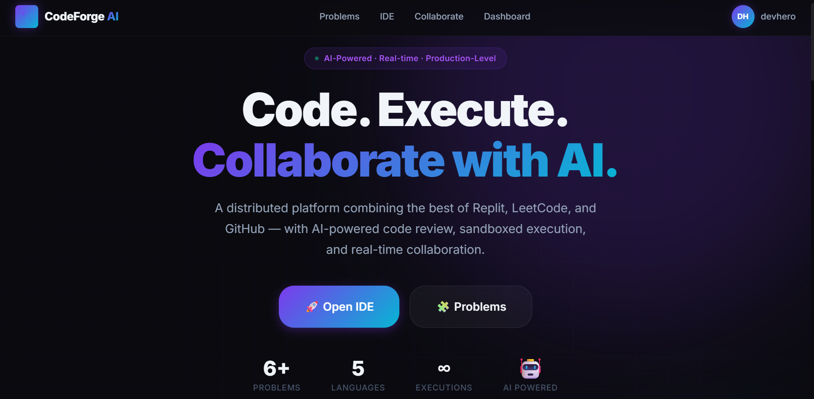

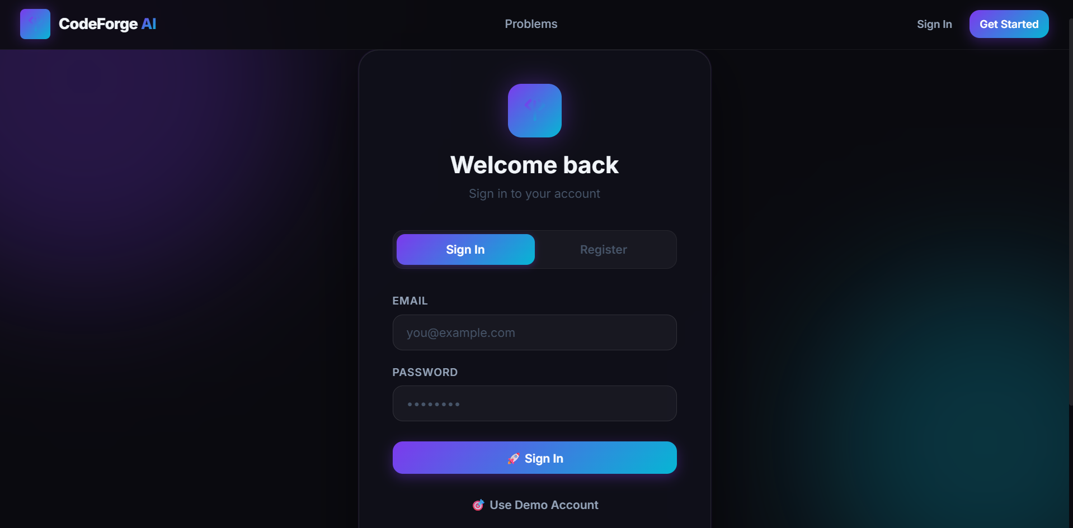

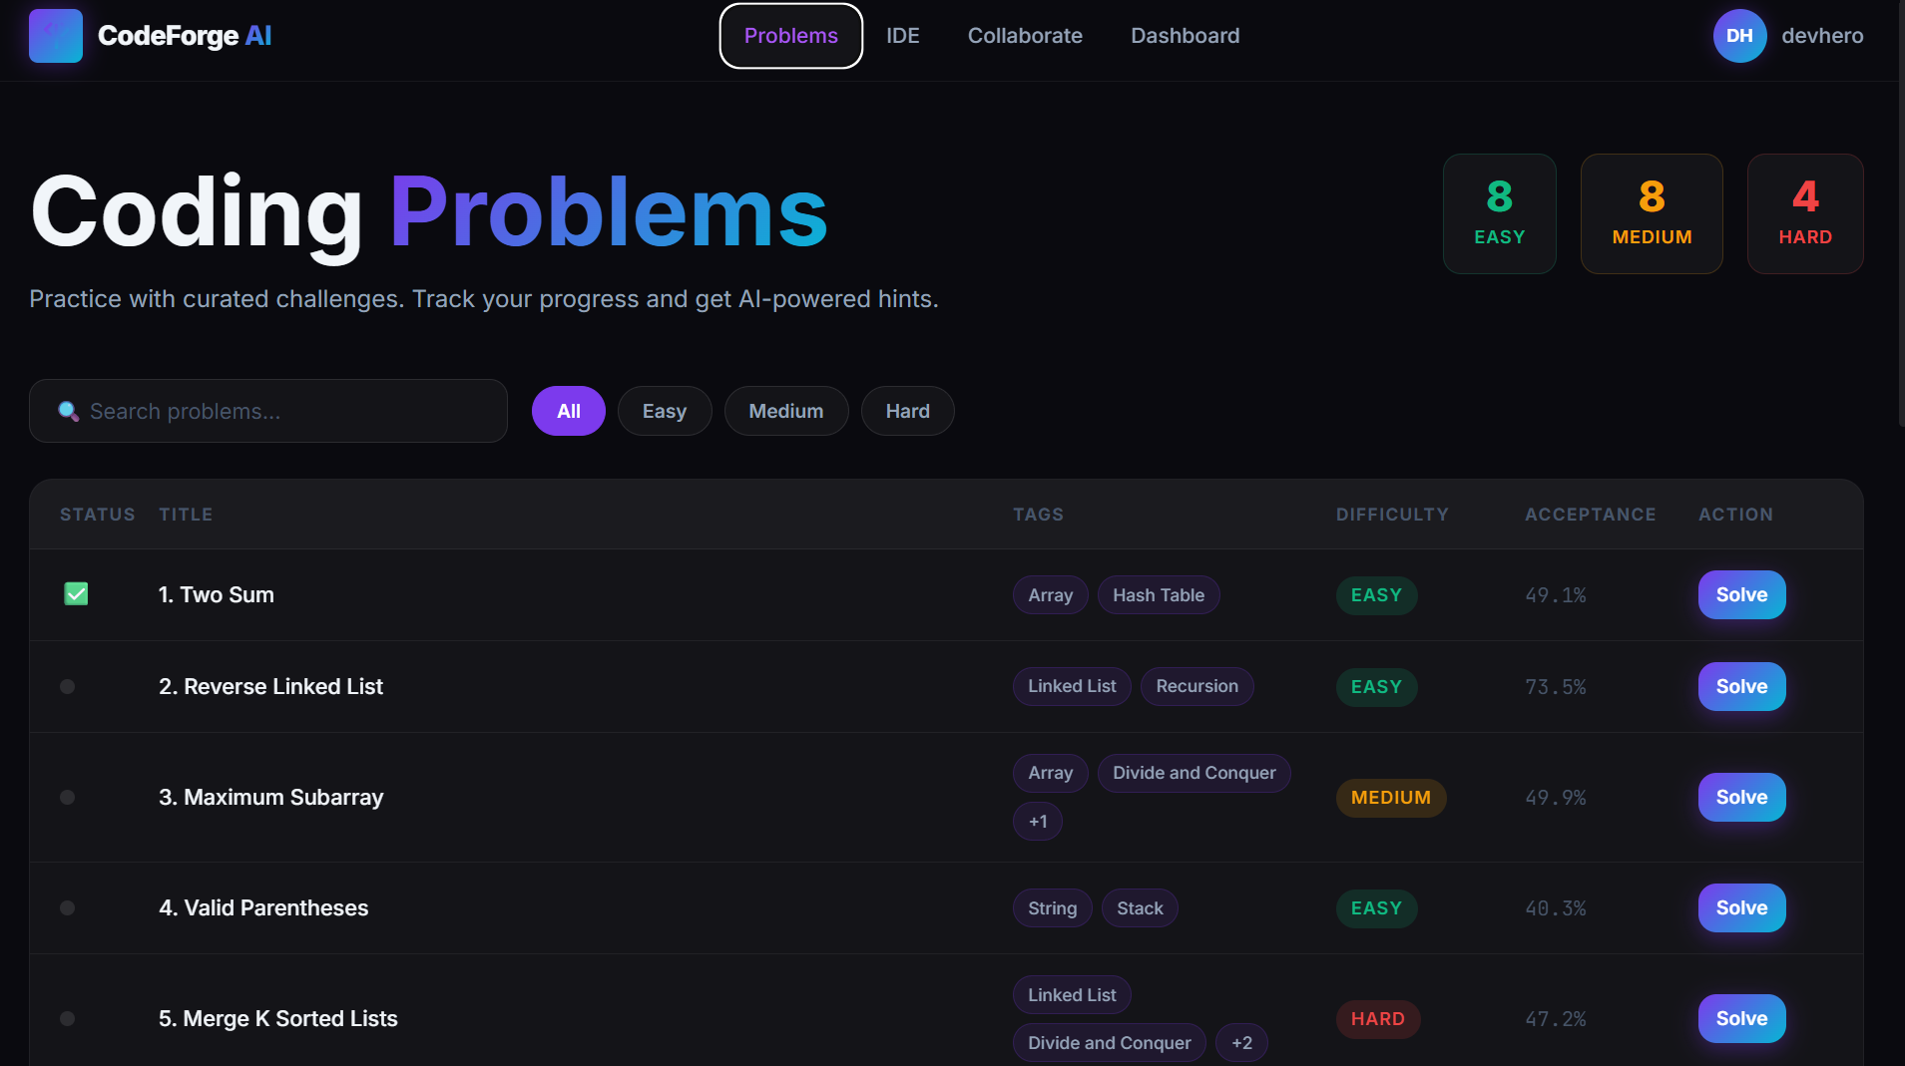

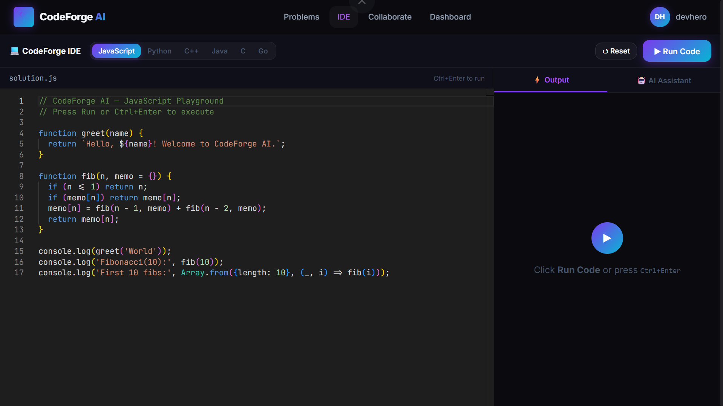

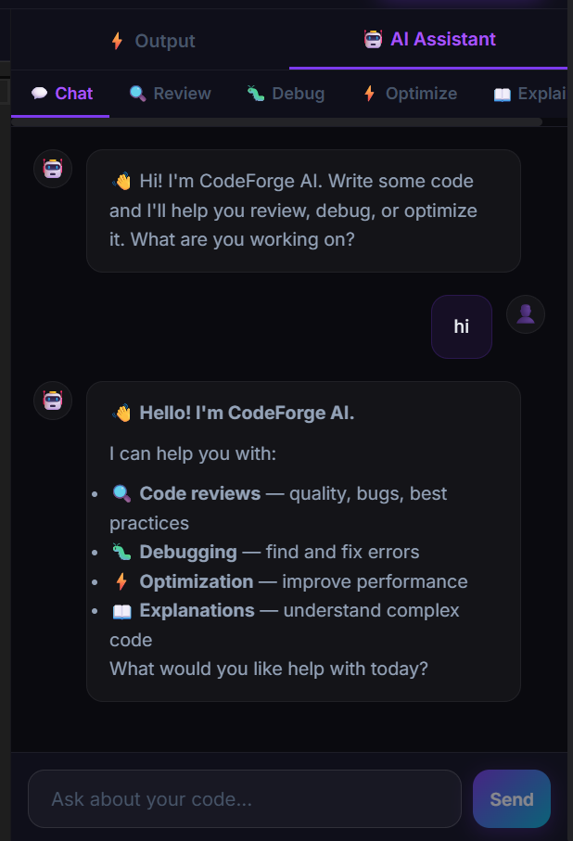

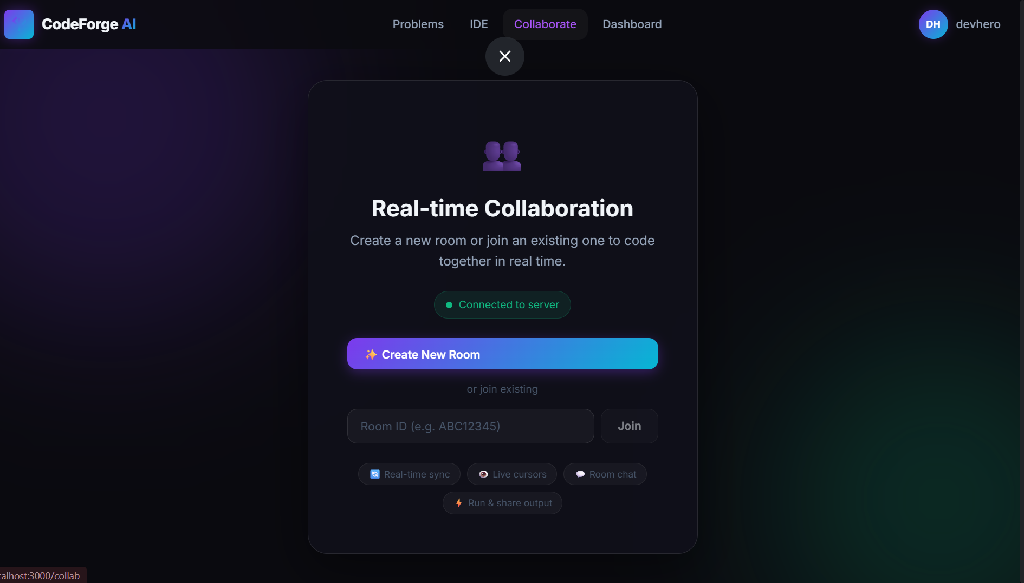

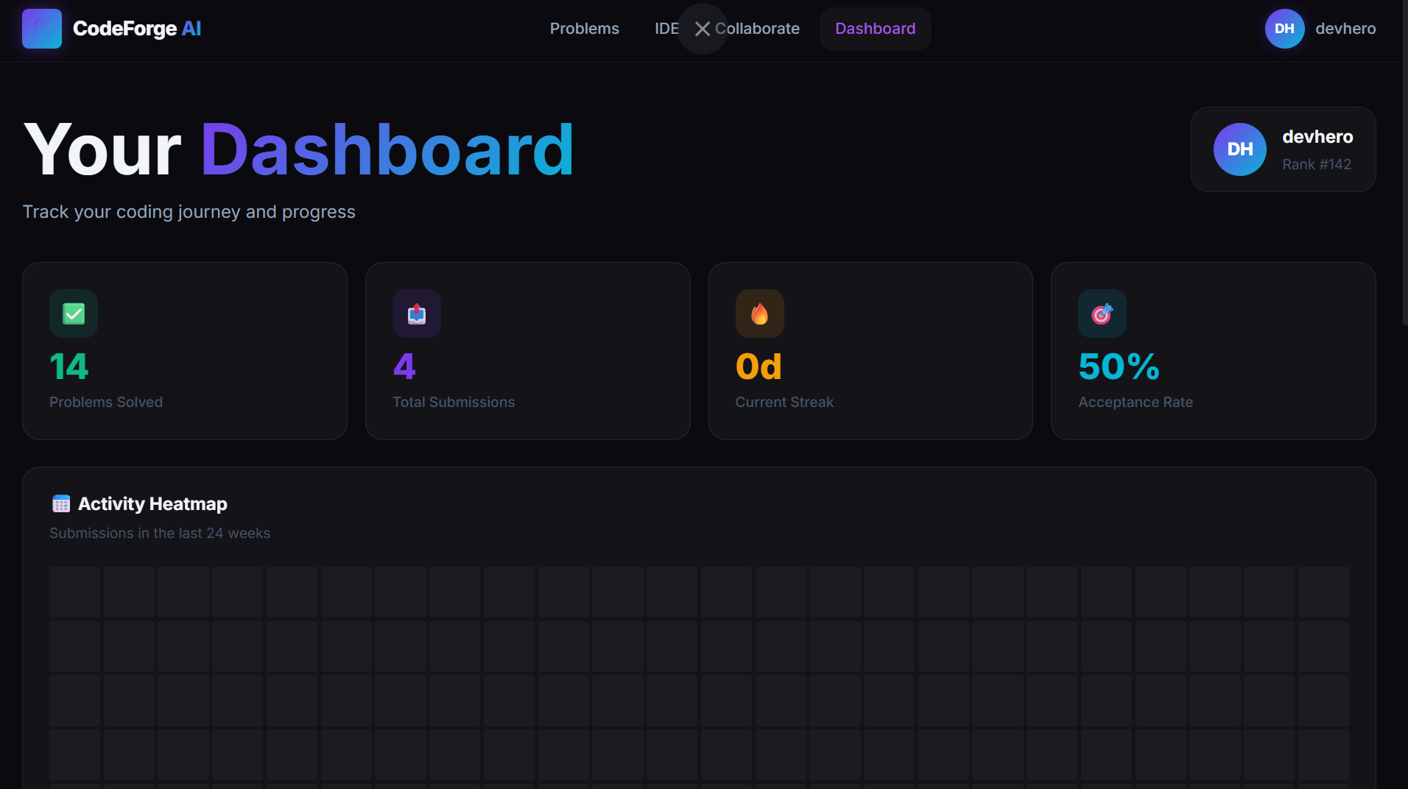

REFERENCES:
Product | Feature Inspiration
GitHub Codespaces | Cloud-based development environment
Visual Studio Code (VS Code) | Code editor UI, syntax highlighting, extensions
Replit | Browser-based coding and execution
LeetCode | Coding problems and submissions
GitHub Copilot | AI code suggestions and completions
Cursor AI | AI-assisted programming and code understanding
Google AI Studio (Gemini) | AI-powered code review and explanations
CodeSandbox | Instant project creation and collaboration
CodePen | Quick frontend code execution and sharing
Google Docs | Real-time collaborative editing model

Feature-to-Reference Mapping:

CodeForge Feature | CodeForge Feature
Code Editor | VS Code
AI Assistant | Cursor AI, GitHub Copilot
Code Review | Gemini
Real-time Collaboration | Google Docs
Online Code Execution | Replit
Coding Problems | LeetCode
User Authentication | GitHub
Dashboard & Analytics | LeetCode
Project Workspace | GitHub Codespaces

