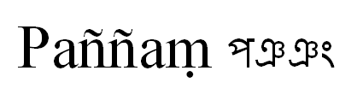
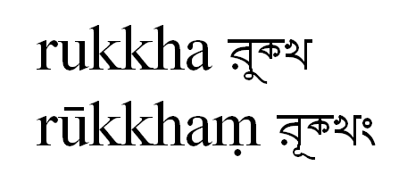
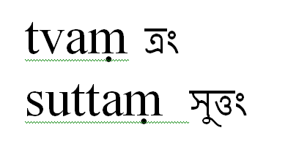
Known issues with Bengali font
- tta comes in place of tva.
----------------------------------------------------------------------------------------------------
- both ru and ruu - matra of short and long u comes next to 'r' as in Hindi.
----------------------------------------------------------------------------------------------------
- half nya is coming as full nya. अरञ्ञगतो comes as अरञञगतो
----------------------------------------------------------------------------------------------------
- that '0' of abbreviation, ie. सी॰ स्या॰ पी॰...पे॰... all o comes as blocks.




