Known issues with Tibetan font
1. The letters ca and ja are being displayed with a curve on the top called “rafar”. Some experts are of the view that this curve is not required. You are free to reach your own conclusion.
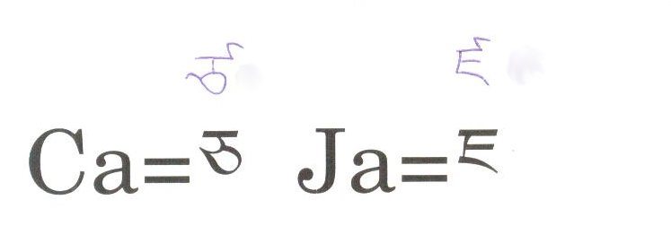
2. The traditional system of writing Pali in Tibetan required Dots in between letters as below – however the fonts are not able to do so.
