

Where2Go Website User Guide
A beginner-friendly walkthrough for customers, partners, and admins
Purpose
This document explains how to use Where2Go from the first visit through discovery, reservations, rewards, partner listing management, and admin approval.

Prepared for the Where2Go website - May 17, 2026

1. What Where2Go Is
Where2Go is a Cairo discovery website. It helps people find places to go, save places to their profile, make reservations at approved partner businesses, leave reviews, and use QR check-ins and rewards.
In one sentence
Where2Go helps users decide where to go, while giving partner businesses a place to publish approved listings, manage bookings, and participate in rewards.

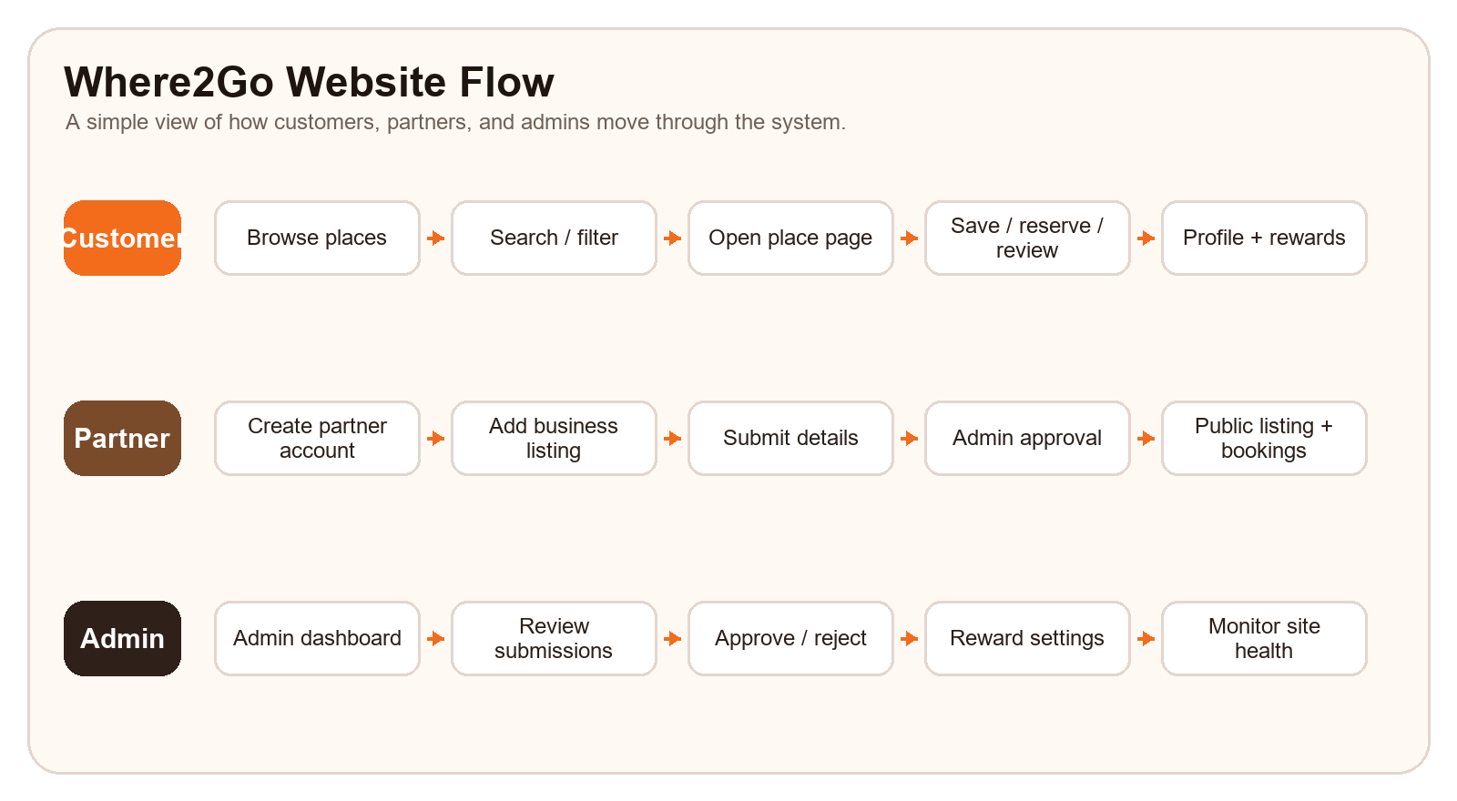
The three main sides of the website
Side | Who uses it | Main purpose
Customer / visitor | People looking for places around Cairo | Browse, search, save places, reserve, review, and claim rewards.
Partner | Business owners and managers | Create listings, add locations, manage offers, and handle reservations.
Admin | Approved internal users | Approve businesses, monitor activity, and configure reward rules.

Quick start for a new customer
- Open Home.php to start browsing the discovery homepage.
- Use category cards or the search page to narrow places by Restaurants, Cafes, Activities, Entertainment, Nightlife, or Heritage.
- Open a place page to view photos, details, reviews, menus, offers, locations, and reservation options.
- Create an account or log in if you want to save places, reserve, review, or collect rewards.
- Use the profile page to see saved places and reservations, then open suggestions for more ideas based on saved places.
- At partner locations, scan the QR code to claim points, level progress, mystery boxes, and vouchers.

2. Customer Side
The customer side is for discovering places and managing personal activity. Visitors can browse without logging in, but customer accounts unlock saving, reservations, reviews, and rewards.
Customer-facing pages
Page | What it is for | What users do there
Home.php | Main discovery homepage. | Browse original Where2Go picks, use category shortcuts, try the chooser, see saved count, and open place cards.
search.php | Search and catalog filtering. | Search by text, filter by catalog, and save matching results to the profile.
place.php | Detail page for one place. | View media, details, menus, offers, locations, reviews, reservations, and save controls.
register.php | Customer account creation. | Enter account details so the user can save, reserve, review, and earn rewards.
login.php | Customer sign-in. | Sign in with email and password, optionally returning to the page the user came from.
profile.php | Customer account dashboard. | Manage profile photo, saved places, reservations, and shortcuts to suggestions.
suggestions.php | Personal recommendations. | See new places based on the places already saved in the profile.
checkin.php | QR check-in and rewards. | Claim scan rewards, view points, levels, mystery boxes, and active vouchers.
about.php | Project information. | Read the mission, story, contact details, and the simple purpose of Where2Go.
index.php | Landing/showcase page. | See the branded public-facing Where2Go presentation and intro experience.

Catalog and category
Catalog is the broad section. Category is the more specific type inside that section. For example, catalog nightlife can contain categories such as Rooftop or Lounge.
Catalog options and example categories
Catalog | Label shown to users | Example category values
restaurant | Restaurants | Restaurant
cafe | Cafes | Cafe, Late-night Cafe, Relaxed Hangout
activity | Activities | Activity, Outdoor, Fun Spot
entertainment | Entertainment | Entertainment Hub, Mall
nightlife | Nightlife | Rooftop, Lounge
heritage | Heritage & Culture | Museum, Heritage Site, Market, Viewpoint
other | Other | Other

How search works
- Typing in the search bar looks for place names, categories, descriptions, and related search text.
- Choosing a catalog limits the results to places that belong to that broad catalog.
- The catalog filter is meant to prevent unrelated places from showing when a user selects a specific section.
- The quick pills on the search page link directly to filtered catalog results.

3. Place Pages, Reservations, and Reviews
The place detail page is where browsing becomes action. It works for both original Where2Go places and approved partner business listings.
What the place detail page contains
Area on place.php | What it shows | Important behavior
Hero section | Place name, short summary, save button, and website link when available. | Anonymous users are sent to login if they try to save.
Gallery | Main image or video plus thumbnails. | Multiple media items can rotate automatically and can be clicked manually.
What to expect | Description of the original place or partner business. | This is the main explanation of why the place is useful.
Details panel | Catalog/category, rating, address, phone, website, and listing status. | Partner listings show approved/pending/private preview state depending on access.
Reservation panel | Location, guest count, availability calendar, and time slots. | Only appears when the partner location allows reservations. Date changes refresh the panel without reloading the full page.
Reviews | Public customer reviews and review form. | Original places can be reviewed by logged-in users. Partner reviews unlock after a completed reservation time.
Offers and menus | Active offers and menu links from partner listings. | Partners control these from the business form.
Locations | All partner branches, hours, address, phone, and reservation status. | Each location can have different hours and reservation settings.

Reservation flow
- The customer opens an approved partner business.
- The customer chooses a reservable location.
- The customer sets the guest count.
- The customer chooses an available day from the calendar.
- The customer picks an available time slot.
- The reservation is submitted as pending.
- The partner approves, rejects, cancels, or completes the booking from the dashboard.
Important reservation note
A place can be visible on Where2Go but still be walk-in only. Reservations only appear when a partner enables reservations for that specific location.
“”””This is what we will be implementing in the future”””

4. Customer Profile, Suggestions, and Rewards

Profile
- Shows the customer profile photo and account activity.
- Lists saved places and upcoming or past reservations.
- Provides a shortcut to suggestions.
- Profile photos are stored in assets/images/uploads after upload; the folder is created automatically when needed.

Suggestions
- Uses saved places as the signal for recommending new ideas.
- Avoids recommending places already in the saved list.
- Gives users a quick path back into discovery when they are not sure what to search for.

Rewards and QR check-ins
- A customer visits a partner location.
- The customer scans the location QR code.
- The check-in page validates the token and customer login.
- The customer claims points for the scan.
- Points increase the customer level and streak progress.
- At configured level milestones, the customer unlocks a mystery reward box.
- A mystery box spins into a voucher such as a percentage discount.
Reward terms
Reward item | Meaning
Points | Earned from eligible QR scans and configured reward actions.
Level | Progress measure based on total points.
Streak | Tracks repeated customer reward activity over time.
Mystery box | Unlocked at configured level intervals and used to spin for a voucher.
Voucher | A reward code connected to a business/location with an expiry date.

5. Partner Side
Partners are business owners or managers. Partner accounts are separate from customer accounts and are used to create and manage business listings.
Partner portal pages
Partner page | What it is for | What the partner does there
partner-register.php | Create a partner account. | Enter owner details and create the login used for the partner portal.
partner-login.php | Partner sign-in. | Open the partner dashboard with business-owner credentials.
partner-dashboard.php | Partner control center. | See business metrics, listing statuses, views, reservations, offers, and upcoming bookings.
partner-business-form.php | Add or edit a business. | Manage identity, locations, reservation settings, hours, photos, menus, offers, and rules.
partner-logout.php | Partner sign-out. | End the partner session.

Partner listing lifecycle
- The business owner creates a partner account.
- The partner logs in and opens the dashboard.
- The partner adds a business listing with details customers need before visiting.
- The business is saved as pending approval.
- An admin reviews the listing.
- If approved, the listing becomes public in discovery/search.
- If rejected, the partner sees the admin note and can edit the listing.
- The partner continues managing offers, hours, locations, and reservations from the dashboard.
What partners can manage in the business form
Business form section | Fields or controls | Why it matters
Business identity | Name, website, logo URL, type, custom type, description, rules. | Creates the public identity and explains the business to customers.
Locations | Location name, address, phone, capacity, reservation toggle. | Supports one or more branches with different booking settings.
Working hours | Open/close time for each day, closed toggle, apply-to-all helper. | Controls availability display and reservation slot generation.
Photos | Up to 6 image URLs. | Builds the public gallery. The first image becomes the main photo.
Menus | Menu title and menu URL. | Gives customers direct access to food/service menus.
Offers | Title, description, discount, dates, active toggle. | Shows live promotions on the public business detail page.

Partner dashboard metrics and actions
- Businesses: number of listings connected to the partner account.
- Views: public detail-page visits on approved businesses.
- Reservations: total reservation requests across partner locations.
- Upcoming: pending or confirmed bookings from today forward.
- Live offers: currently active offers on approved businesses.
- Reservation actions: approve, reject, cancel, or complete bookings.
Partner approval rule
A partner can prepare and preview a listing, but it should not become public to customers until an admin approves it.

6. Admin Side
Admins are customer accounts whose emails are listed in the admin configuration. Admin access is used to review partner listings, monitor activity, and control rewards.
Admin pages
Admin page | What it is for | Main controls
admin/dashboard.php | Site-wide overview. | Tracks active views, customers, partners, businesses, reservations, reviews, pending approvals, and place performance.
admin/business-approvals.php | Business review workspace. | Approve valid listings, reject listings with notes, and inspect approved/rejected history.
admin/reward-config.php | Reward program settings. | Adjust scan points, cooldowns, daily limits, mystery box timing, voucher rules, and wheel probabilities.

Admin approval flow
- A partner submits a business listing.
- The listing appears as pending in admin/business-approvals.php.
- The admin opens the preview and checks the business details.
- The admin approves the listing if it is ready.
- The admin rejects the listing with a note if the partner needs to fix something.
- Approved and rejected businesses remain visible in review history for later inspection.

Reward configuration
- First scan points decide how much a customer earns the first time they scan a location.
- Repeat scan points and same-day repeat rules control repeat behavior.
- Daily limits and cooldowns reduce abuse.
- Mystery box timing controls how often reward boxes unlock.
- Wheel probabilities control the chance of each voucher value.
- Voucher expiry and safety rules protect the reward program from being too generous or indefinite.

7. Typical User Journeys
Common website journeys
Journey | Steps
Find a place quickly | Open Home.php -> choose a catalog card or search -> open a place -> save it or view details.
Make a reservation | Open an approved partner business -> choose location and guests -> pick available date -> pick time -> submit booking -> wait for partner approval.
Use suggestions | Log in -> save places -> open profile or suggestions -> choose a new recommendation.
Claim a reward | Visit partner location -> scan QR code -> log in if needed -> claim points -> spin a mystery box when unlocked.
Submit a partner listing | Partner registers -> logs in -> adds business details -> submits -> waits for admin review -> manages public listing after approval.
Approve a business | Admin logs in -> opens approvals -> reviews pending listing -> approves or rejects with a note.

8. Glossary
Key website terms
Term | Meaning
Catalog | Broad discovery section such as restaurant, cafe, activity, entertainment, nightlife, heritage, or other.
Category | More specific type inside a catalog, such as Rooftop, Museum, Late-night Cafe, or Mall.
Original pick | A built-in Where2Go place that exists before partner businesses are added.
Partner business | A business listing created by a partner account and reviewed by admin.
Location | A branch or address under a partner business. Each location has its own hours and reservation settings.
Reservation | A customer booking request for a location, date, time, and guest count.
QR check-in | A reward action that starts when a customer scans a location QR code.
Mystery box | A reward box unlocked through level progress and spun into a voucher.
Voucher | A reward code connected to a business/location with an expiry date.
Admin approval | The review step that decides whether a partner listing becomes public.

Final summary
Where2Go helps customers discover and save places, reserve approved partner locations, review experiences, and earn rewards. Partners manage their own listings and reservations through the partner portal. Admins protect quality by approving businesses and controlling reward rules.

