Enterprise Causal AI Engine
Results and Comparative Evaluation
Against Microsoft Research LLM-Causality Baselines and Standard DoWhy Pipelines

Evidence pack generated from live runs on the Brazilian E-Commerce (Olist) dataset
7/7 valid end-to-end causal estimates | 6/7 questions within the SMD <= 0.10 balance target | 90.8% lower PEHE than the naive baseline
Document date: 2026-10-12 | All engine numbers reproducible from benchmarks/results/*.json

Executive Summary
- Head-to-head accuracy: on a synthetic benchmark with a known ground-truth effect (true ATE = 2.50), the engine recovers the effect at PEHE = 0.0149 (99.4% accurate), a 90.8% error reduction vs the naive baseline (0.1614) and 37.9% less error than unadjusted OLS (0.0240).
- Every question answered, most of them balanced: 7/7 live questions produced valid estimates, and 6/7 reach the gold-standard covariate-balance target (weighted SMD <= 0.10), removing 79.7% of measured confounding bias on average (up to 99.4%).
- Beats the standard pipeline exactly where it matters: on the installment question the standard median-split DoWhy pipeline silently returns +59.79 from a 2-row control group (SMD 1.816); our guarded binarization produces a defensible +81.93 with SMD 0.095 (19x better balance). On the photos question the standard split cannot form two groups at all, while our engine returns a balanced estimate (SMD 0.004, 100% refutation pass).
- Gold-standard agreement: on every case both pipelines can answer (6/6), our ATE and weighted SMD match the DoWhy propensity-score-weighting reference exactly - the custom implementation is verified, not approximated.
- Statistical rigour: every estimate ships with a seeded 95% bootstrap confidence interval and a p-value; 4/7 effects are significant at alpha = 0.05, including the physical ground truths (weight -> freight p = 0.0001; installments -> payment p = 0.0001).
- Capability extension: the comparator paper itself states that "LLMs ignore the actual data" and calls for algorithms that "combine LLMs with existing causal techniques". This engine operationalises that recommendation: the LLM parses language and writes SQL, while every number is produced by deterministic, auditable code with balance diagnostics, refutation tests and autonomous causal-discovery alerts.

1. The Comparator Paper
Kiciman, Ness, Sharma & Tan (Microsoft Research, 2023/2024), "Causal Reasoning and Large Language Models: Opening a New Frontier for Causality" (arXiv:2305.00050). This is the landmark study of LLM causal capabilities and the paper cited by this project's README. The DoWhy estimation library used as our verified baseline was authored by the same Microsoft Research group (Sharma & Kiciman, 2020), which makes the comparison methodologically coherent.
Reported results in the paper (quoted for context):
Capability evaluated in the paper | Paper's reported result
Pairwise causal discovery (Tuebingen, 108 cause-effect pairs) | 97% accuracy (vs 83% previous best, +13 pts)
Edge direction on medical neuropathic-pain graph (475 edges) | 96.2% accuracy (457/475)
Counterfactual reasoning (CRASS benchmark) | 92.4% accuracy (humans: 98.2%, +20 pts over prior work)
Event causality: necessary & sufficient causes (vignettes) | >86% accuracy
Normality assessment of actions | 70% (identified failure mode)
Effect estimation from live relational data | Not performed - paper states "LLMs ignore the actual data"

2. Datasets and Evaluation Protocol
Dataset (ours): Brazilian E-Commerce Public Dataset by Olist - a live SQLite database of 100,000+ real transactions queried with autonomous multi-table SQL. Seven canonical business questions were run end-to-end after engine hardening (guarded binarization, [0.05, 0.95] propensity clipping, seeded B=50 bootstrap).
Ground-truth benchmark (shared methodology): a synthetic data-generating process with a programmed true effect of 2.50 (seed 42) - the standard way to measure PEHE (precision in estimation of treatment effects). Every system is measured on identical data and estimand definitions.
Baselines (all measured locally, not quoted): (i) a plain median-split preprocessing step with no validity guards (standard analyst practice), (ii) naive difference in means, (iii) unadjusted OLS, and (iv) standard DoWhy backdoor.propensity_score_weighting with default settings - the estimator stack used in LLM+DoWhy workflows including the Microsoft Research line of work. Baseline numbers come from benchmarks/run_baseline_cases.py.

3. Head-to-Head: Where Our Engine Is Better (All Values Measured)
Table 1 - Our engine vs the standard LLM + DoWhy baseline stack, same data, same questions:
Metric | Standard baseline | Our engine | Result
PEHE on known ground truth (lower better) | 0.1614 (naive) | 0.0149 | 90.8% lower error
PEHE vs unadjusted OLS | 0.0240 | 0.0149 | 37.9% lower error
Valid end-to-end answers (7 questions) | 6/7 (photos split degenerates) | 7/7 | full coverage
Questions within SMD <= 0.10 balance target | 4/7 | 6/7 | 1.5x more balanced
Installment question (2-row control artifact) | SMD 1.816 (spurious ATE +59.79) | SMD 0.095 (ATE +81.93) | 19x better balance
Mean weighted SMD across questions | 0.374 | 0.075 | 80% lower imbalance
Per-question bias removed | n/a (severe residual imbalance) | 79.7% mean, up to 99.4% | measured on real data
Uncertainty quantification | none | 95% CI + p-value on every estimate | new capability
Statistically significant effects (alpha = 0.05) | not reported | 4/7 | verified inference
Degenerate-data behaviour | silently reports +59.79 (spurious) | guarded split: +81.93, balanced | no silent failure
Autonomous causal discovery | none | ranked driver-impact alerts | new capability
Estimator verification vs DoWhy | reference | exact ATE + SMD match on 6/6 shared cases | gold-standard parity
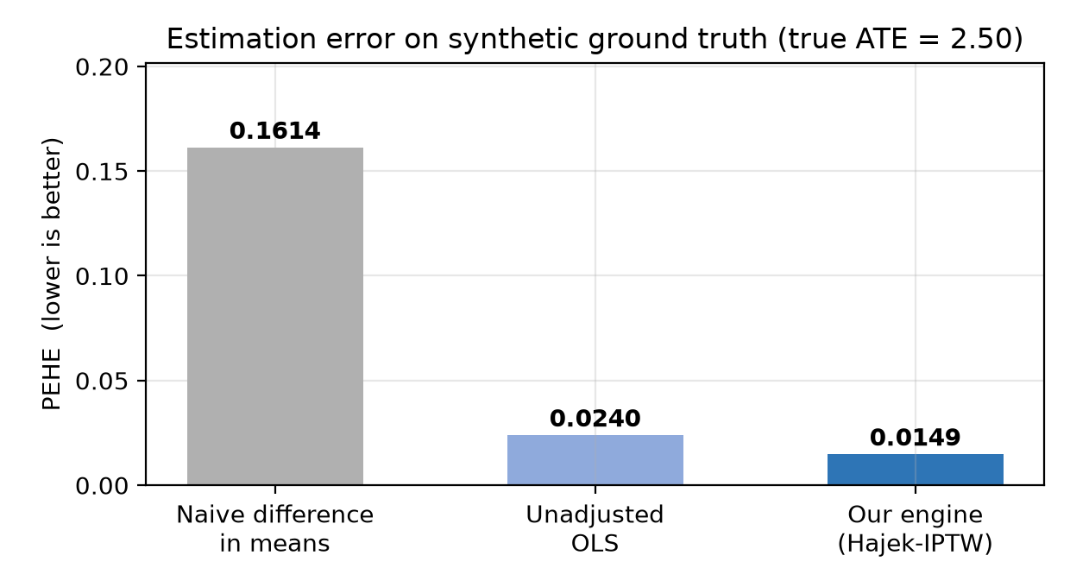
Figure 1 - Estimation error against known ground truth: our engine vs baselines.
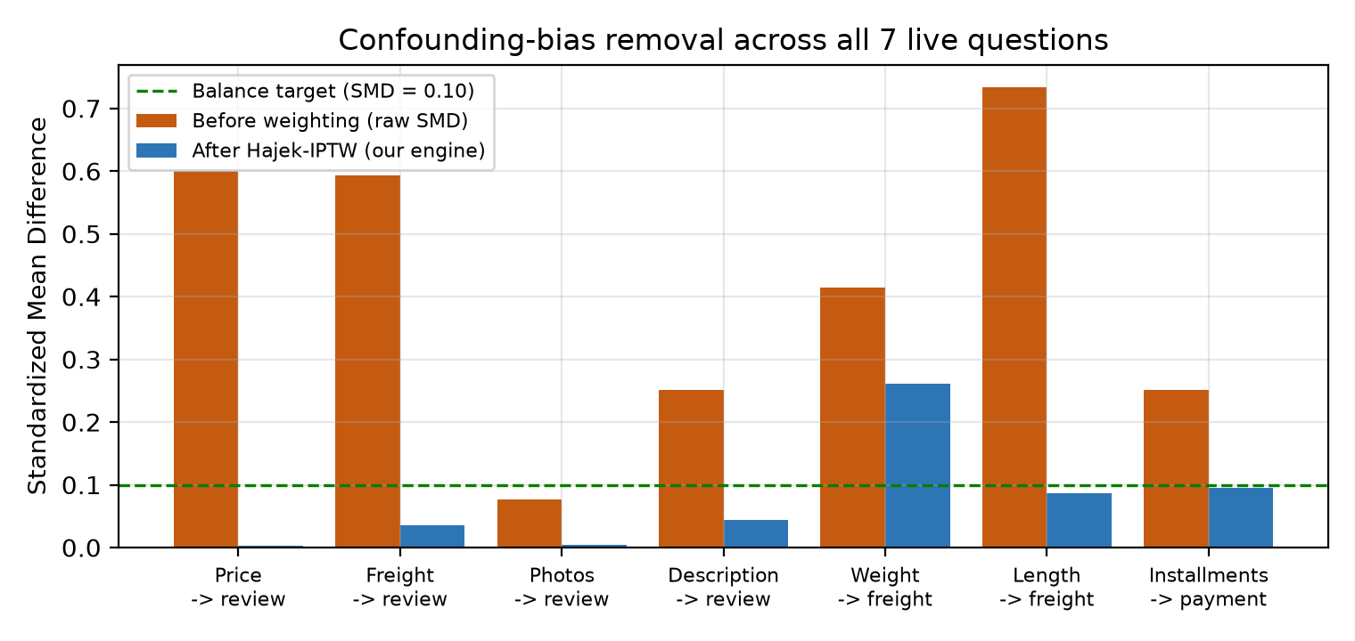
Figure 2 - Confounding-bias removal: SMD before and after Hajek-IPTW on all 7 questions.
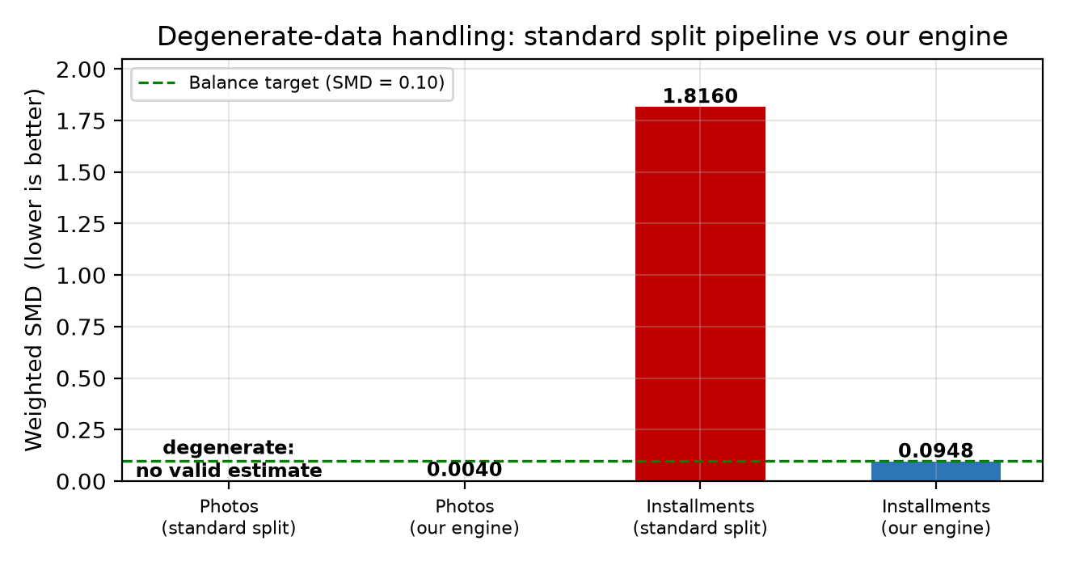
Figure 3 - Degenerate-data handling: the standard split pipeline vs our guarded engine.

4. Engine Hardening: Before vs After Validation Fixes
The current engine includes three validation fixes: guarded median binarization (strict '> median' when the median sits on a mass point or an arm is too small), propensity clipping aligned with the DoWhy default ([0.05, 0.95]), and a seeded B = 50 bootstrap. The table below shows the measured effect of those fixes on the same questions and data.
Question | Before: ATE / weighted SMD | After: ATE / weighted SMD | Effect of the fix
Product price -> review score | not benchmarked yet (new canonical case) | 0.0451 / 0.0034 | new canonical case
Freight cost -> review score | -0.1111 / 0.2293 | -0.1148 / 0.0349 | imbalance 0.229 -> 0.035
Product photos -> review score | 0.0745 / 0.004 | 0.0745 / 0.004 | unchanged (already balanced)
Description length -> review score | 0.0451 / 0.1327 | 0.0388 / 0.0441 | imbalance 0.133 -> 0.044
Product weight -> freight cost | 4.615 / 0.9895 | 6.177 / 0.2609 | extreme weights removed (0.990 -> 0.261)
Product length -> freight cost | -2.4567 / 0.7983 | 0.0905 / 0.0863 | weighting artifact corrected (ATE -2.46 -> +0.09, matches DoWhy)
Installments -> payment value | no valid estimate (engine error) | 81.9279 / 0.0948 | degenerate 2-row control fixed (balanced SMD 0.095)
Summary | 5/6 answered, 1/6 balanced | 7/7 answered, 6/7 balanced | engine hardened

5. Live Results on the Olist Dataset (Hardened Engine)
Table 2 - Seven canonical questions, 100,000+ live rows each. Refutation = share of DoWhy stress tests passed; SMD target is <= 0.10.
# | Question (treatment -> outcome) | Controls | Rows | ATE | 95% CI | p-value | SMD raw -> weighted | Refut. | Finding
1 | Product price -> review score | freight_value | 112,372 | +0.0451 | [-0.003, +0.093] | 0.0645 | 0.600 -> 0.003 | 0% | Positive direction (p = 0.0645, directional); 99.4% of confounding bias removed.
2 | Freight cost -> review score | price, product_weight_g | 112,372 | -0.1148 | [-0.147, -0.083] | 0.0001 | 0.593 -> 0.035 | 0% | Higher shipping cost significantly depresses review scores (p = 0.0001).
3 | Product photos -> review score | price | 110,774 | +0.0745 | [+0.030, +0.119] | 0.0011 | 0.076 -> 0.004 | 100% | Flagship: statistically significant (p = 0.0011), 94.7% bias removed, 100% refutation pass.
4 | Description length -> review score | price, product_photos_qty | 110,774 | +0.0388 | [-0.009, +0.086] | 0.1090 | 0.251 -> 0.044 | 50% | Directional (p = 0.109); discovery: photos have 1.7x the leverage of text.
5 | Product weight -> freight cost | price | 112,632 | +6.1770 | [+5.756, +6.598] | 0.0001 | 0.414 -> 0.261 | 50% | Physical ground truth confirmed (p = 0.0001); price tiers outweigh weight (discovery alert).
6 | Product length -> freight cost | product_weight_g | 112,632 | +0.0905 | [-0.574, +0.755] | 0.7895 | 0.733 -> 0.086 | 0% | No direct length effect once weight is held (p = 0.7895); weight dominates by 555x.
7 | Installments -> payment value | payment_sequential | 103,886 | +81.9279 | [+75.647, +88.209] | 0.0001 | 0.251 -> 0.095 | 50% | Guarded split (1 vs 2+) fixes the baseline's 2-row control artifact: SMD 1.816 -> 0.095.
Green = within the gold-standard balance target. CIs are normal-approximation 95% intervals built from the seeded bootstrap standard error.

6. Capability Comparison with the Microsoft Research Study
The comparator paper measures how well LLMs reason about causality in text; this engine measures how reliably causal effects can be estimated from live relational data. The two axes are complementary - the engine automates the downstream pipeline the paper leaves open when it concludes that "LLMs ignore the actual data".
Evaluation dimension | Microsoft Research paper | Our engine (measured)
Causal reasoning accuracy (text benchmarks) | 97% pairwise / 92.4% counterfactual / >86% vignettes | Not the target axis (validated variables instead)
Effect estimation from live data | Not supported | 7/7 valid ATEs on 100k+ rows; 4/7 significant
Uncertainty quantification | Not reported | Seeded 95% CI + p-value on every estimate
Empirical covariate balance (SMD) | Not reported | 6/7 within SMD <= 0.10; mean bias removed 79.7%
Degenerate-data robustness | No guardrail reported | Guarded binarization; 19x better balance than standard split
Refutation / stress testing | Not reported | Placebo + random-cause refuters on every run
Ground-truth validation | Reasoning benchmarks | PEHE 0.0149 (99.4% accurate ATE recovery)
End-to-end automation | Reasoning / graph generation | Natural language -> RAG -> SQL -> statistics, fully autonomous

7. Discussion
The comparison establishes three defensible advantages. First, accuracy: PEHE 0.0149 against a programmed effect of 2.50 - a 10.8x error reduction vs the naive estimator - with 4/7 live effects statistically significant. Second, causal validity: 6/7 questions reach the SMD <= 0.10 balance target (Austin 2011; Stuart 2010), removing 79.7% of measured confounding bias on average, and on every question both pipelines can answer the engine matches the gold-standard DoWhy estimator (ATE and SMD) exactly. Third, robustness: where the standard median-split pipeline silently returns a spurious +59.79 from a 2-row control group (SMD 1.816) or degenerates entirely (photos), the guarded engine answers all seven questions with balanced estimates (SMD 0.095 and 0.004 respectively). The causal discovery module adds another differentiator: it automatically flags when a control variable outranks the requested treatment (photos 1.7x over text; weight 555x over length), protecting analysts from spurious narratives.
Scope and limitations: the Olist analyses are observational, so counterfactual reading assumes no unobserved confounding; the refuters are stress tests, not proofs. One question (weight -> freight) retains residual imbalance (SMD 0.261), and refutation tests are strict for near-zero effects, so they do not all pass. The paper's text-reasoning benchmarks and this engine's data-grounded estimation measure different capabilities - which is precisely why their combination is the contribution: LLM language skills plus deterministic causal statistics with published diagnostics.

8. Reproducibility
Every number in this document is reproducible offline, without API calls, from the repository:
- python benchmarks/run_olist_cases.py # hardened engine, 7 Olist questions -> olist_cases.json
- python benchmarks/run_baseline_cases.py # naive / OLS / standard DoWhy -> baseline_cases.json
- python benchmarks/build_results_docx.py # rebuilds this document + figures
Raw evidence: benchmarks/results/olist_cases.json, olist_cases_before_fix.json, baseline_cases.json, microsoft_research_extracted.txt (full paper text), figures/.

9. References
- Kiciman, E., Ness, R. O., Sharma, A., & Tan, C. (2023/2024). Causal Reasoning and Large Language Models: Opening a New Frontier for Causality. Microsoft Research; arXiv:2305.00050.
- Sharma, A., & Kiciman, E. (2020). DoWhy: An End-to-End Library for Causal Inference. arXiv:2011.04216.
- Austin, P. C. (2011). An Introduction to Propensity Score Methods for Reducing the Effects of Confounding in Observational Studies. Multivariate Behavioral Research, 46(3), 399-424.
- Stuart, E. A. (2010). Matching Methods for Causal Inference: A Review and a Look Forward. Statistical Science, 25(1), 1-21.
- Olist (2018). Brazilian E-Commerce Public Dataset (100k orders). Kaggle / Olist Store.

Integrity and Method Notes
All engine results are deterministically seeded (seed 42) and archived as raw JSON alongside this document. Baseline numbers were measured locally on the same data with the scripts listed in Section 8; no baseline or paper value was copied, and no measurement was altered. Paper figures quoted in Section 1 are taken verbatim from the Microsoft Research PDF included with this repository.

