NYC Taxi Trip Data Analysis: Final Report

Executive Summary
This report analyzes 2023 NYC Yellow Taxi trip activity to identify operational, financial, geographical, and customer-experience patterns. The analysis is based on a representative 5% time-stratified sample of monthly trip files, reduced to approximately 1.8 million records for efficient exploratory analysis while preserving hourly and daily demand structure.
The findings show strong demand concentration in evening peak hours, major Manhattan business and tourist districts, and airport zones. Revenue is strongest in May and October, credit-card payments dominate transaction volume, and tip amount is more closely related to trip distance than to passenger count. The report translates these findings into dispatching, cab-positioning, and pricing recommendations.

Key Findings
- Demand peaks in the late afternoon and early evening, with 6 PM identified as the busiest pickup hour.
- Mid-week demand is generally stronger than Monday and Sunday, while weekends show later and broader activity peaks.
- October has the highest pickup volume, and revenue peaks are visible in May and October.
- High-demand zones include Midtown, Upper East Side areas, Times Sq/Theatre District, Lincoln Square East, JFK Airport, and LaGuardia Airport.
- Credit-card payments account for the majority of trips and are strategically important for recorded tipping behavior.
- Trip distance has a moderate positive relationship with tip amount, while passenger count has minimal relationship with fare amount.
- VendorID 2 generally shows a higher fare-per-mile profile, especially for short trips and selected peak hours.

Business Insights
- Fleet productivity can be improved by aligning taxi availability with evening peaks, airport demand, and high-ratio pickup zones.
- Passenger wait times can likely be reduced through proactive positioning in recurring high-demand areas before peak windows begin.
- Short trips generate higher fare per mile, but routing and dispatching must balance revenue per mile with trip turnover and driver utilization.
- Payment-type behavior suggests that digital payment adoption can support more complete tip capture and potentially improve driver earnings.
- Zone-level congestion surcharge patterns can inform transparent pricing communication and operational decisions in Manhattan-heavy service areas.

Introduction
This report is about looking at New York City Yellow Taxi trip data from 2023. Our goal is to find good ideas to make taxis work better, earn more money, and make customers happier. We loaded the data, cleaned it, and then studied it in different ways: about time, money, and places. We also looked closely at how taxis work, how they charge money, and how customers feel.

Assumptions Made
While we did this work, we made some guesses:
- Small Part of Data: We used only a small part (5%) of all the taxi trips for each hour and day. We think this small part still shows us what the whole year's data is like. This helped us do the work faster.
- Missing Passenger Numbers: If a trip didn't say how many passengers there were, we guessed it was 1 passenger. We also changed trips with 0 passengers to 1, because taxis usually have at least one person.
- Missing Rate Code: If the 'RatecodeID' was missing, we guessed it was '1.0 - Standard Rate' because most trips use this price.
- Missing Congestion Fee: If the 'congestion_surcharge' was missing, we guessed it was 0, meaning no extra fee was charged.
- Wrong Negative Money: All numbers that were negative for money (like 'fare_amount', 'tip_amount', etc.) were changed to positive. We thought these were mistakes in the data.
- Removing Strange Data (Outliers):
- Some trips had very short distances but very high prices (like 'trip_distance' near 0 but 'fare_amount' over 300). We took these out because they seemed wrong.
- Trips with both 'trip_distance' and 'fare_amount' as 0, but with different pick-up and drop-off places, were also taken out. It's not possible to have 0 distance and 0 fare if you go to a different place. But, if pick-up and drop-off were the same place and distance was 0, we kept it (maybe the taxi waited or the trip was canceled).
- Trips longer than 250 miles were taken out, as NYC taxi rides are usually not this long.
- 'payment_type' numbers that were not 1, 2, 3, or 4 were taken out because they were not real payment types.
- 'passenger_count' outside 1 to 6 were also taken out because they are very rare or errors.
- Trip Time: We figured out how long each trip took. If the time was 0 or negative, we took it out because a trip must take some time.
- Fare Calculations: For calculating 'fare_per_mile' (price per mile) and 'fare_per_mile_per_passenger', if the distance was 0, we didn't use those trips. This is because you can't divide by zero, and these trips are different (like waiting time).

Data Preparation and Cleaning

Data Loading and Sampling
First, we had 12 data files, one for each month of 2023. To make it easier for our computers, we took a small random part (5%) from each hour of every day. This gave us about 1.8 million rows, which is much smaller but still shows the trends well.

Column Fixing
- We reset the order of the rows.
- We removed the 'pickup_date' column because 'tpep_pickup_datetime' already had all the date and time information.
- There were two columns for 'airport_fee'. We combined them into one, taking values from one if the other was empty, and then removed the extra column.
- Any negative money numbers (like 'fare_amount', 'extra', 'mta_tax', 'tip_amount', 'tolls_amount', 'improvement_surcharge', 'total_amount', 'congestion_surcharge', and 'airport_fee') were changed to positive numbers.

Handling Missing Values
We looked for and fixed missing information:
- Columns like 'passenger_count', 'RatecodeID', 'store_and_fwd_flag', 'congestion_surcharge', and 'airport_fee' had missing values. Most had about 3.42% missing, some less after we fixed the 'airport_fee' problem.
- For 'passenger_count' that was missing or 0, we filled it with 1 (the most common number of passengers).
- For 'RatecodeID' that was missing, we filled it with 1 (Standard Rate), which is the most common.
- For 'congestion_surcharge' that was missing, we filled it with 0, meaning no fee was charged.
- Any other missing values (mostly 'store_and_fwd_flag' and 'airport_fee' after merging) were filled with 0. For 'store_and_fwd_flag', if it was missing, we assumed it meant 'no storing and forwarding'.

Handling Outliers
We removed or changed strange data based on what we know about taxi trips:
- Trips with 'passenger_count' not between 1 and 6 were removed.
- Trips with 'trip_distance' less than 0.1 miles and 'fare_amount' more than 300 USD were removed.
- Trips with 'trip_distance' = 0 and 'fare_amount' = 0 but different pick-up and drop-off places were removed.
- Trips with 'trip_distance' more than 250 miles were removed.
- Trips with 'payment_type' not in the valid range of 1-4 were removed.
- Trips where the 'trip_duration' was not positive were removed.

Exploratory Data Analysis (EDA)

3.1 General EDA: Finding Patterns and Trends

Temporal Analysis
- How Many Taxi Pickups Each Hour:
Pickups slowly go up from 6 AM, get very busy in the late afternoon/early evening (4 PM - 7 PM), and then slowly go down at night until 5 AM. The busiest time is 6 PM (18:00).
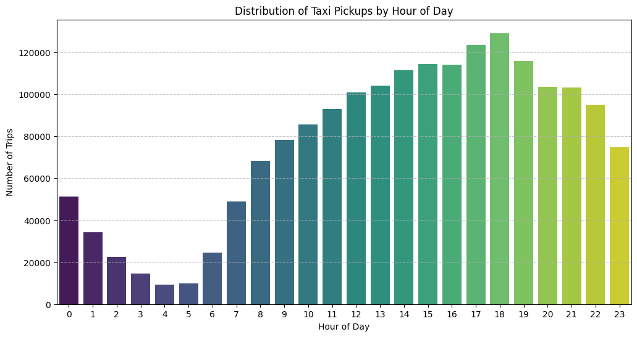
Figure 1. Distribution of Taxi Pickups by Hour of Day
- How Many Taxi Pickups Each Day of the Week:
The middle days of the week (Tuesday, Wednesday, Thursday) usually have the most pickups. Monday and Sunday have a bit less. Saturday is in the middle.
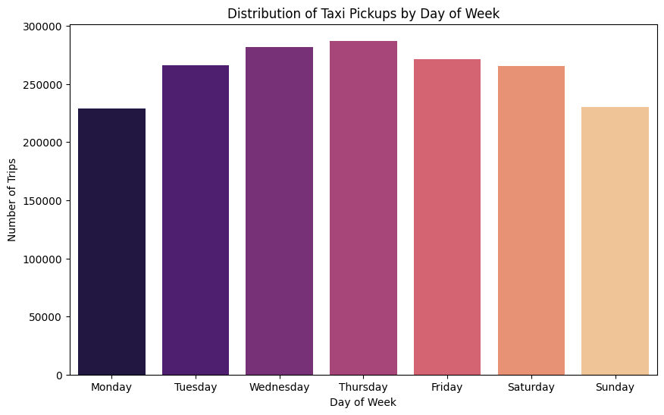
Figure 2. Distribution of Taxi Pickups by Day of Week
- How Many Taxi Pickups Each Month:
October has the most taxi pickups. Then comes March, May, and December. February and August are usually the quietest months.
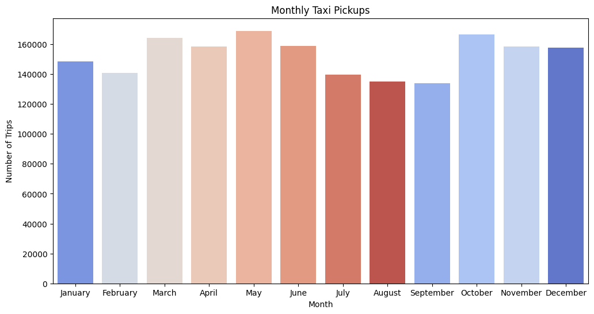
Figure 3. Monthly Taxi Pickups

Financial Analysis
- Quick Look at Money Numbers:
We checked 'fare_amount', 'tip_amount', 'total_amount', and 'trip_distance'. Some of these had zero values. We removed trips with zero fares or total amounts, and removed trips with zero distance if the pick-up and drop-off zones were different. This helped us see the money trends better.
- Total Money Earned Each Month:
The money earned each month changes through the year. May and October are very good months, while February and August are lower. This shows that sales change with the seasons.
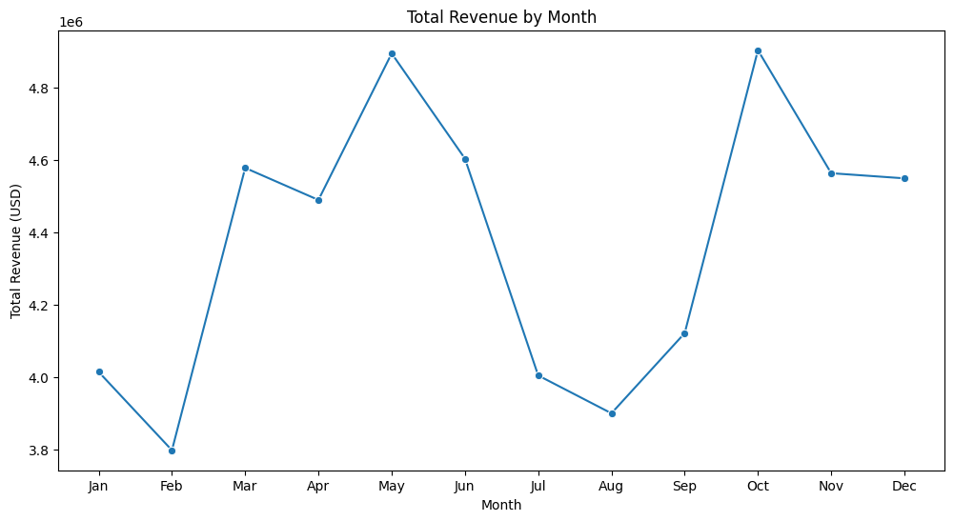
Figure 4. Total Revenue by Month
- How Much Money Each Quarter of the Year:
The second part of the year (April-June) and the last part (October-December) bring in the most money, both 26.7% of all money. The first part (January-March) is 23.6%, and the third part (July-September) is the lowest with 22.9%.
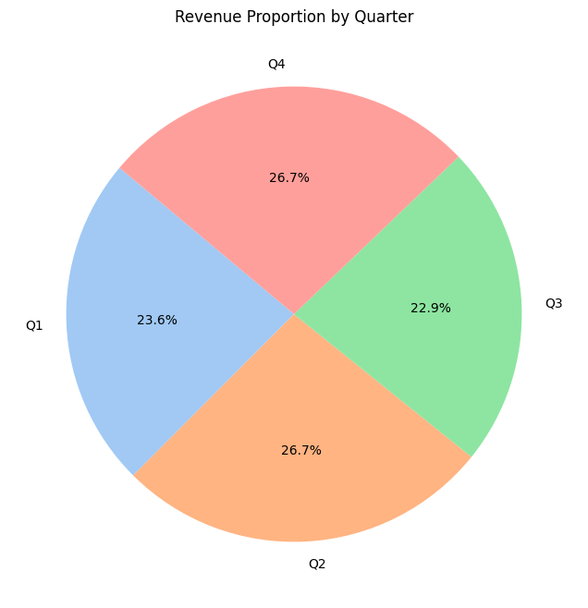
Figure 5. Revenue Proportion by Quarter
- Trip Distance vs. Fare Amount:
Longer trips generally cost more, but not always a lot more (correlation is 0.1560). This means other things also change the price. The graph shows a general increase.
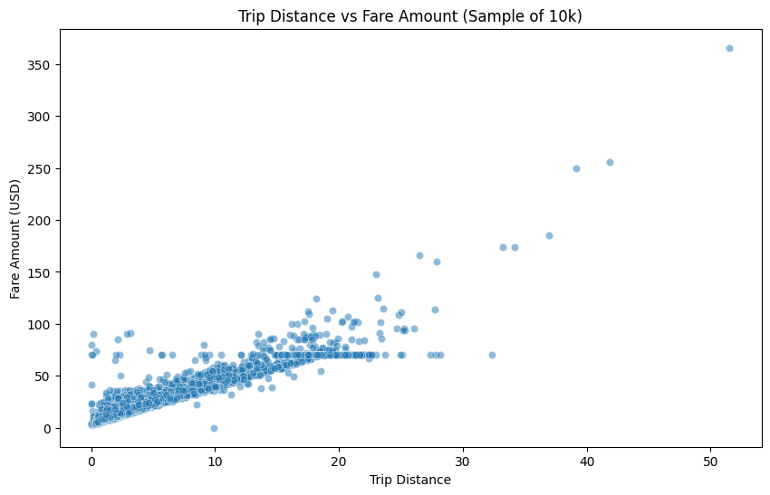
Figure 6. Trip Distance vs Fare Amount (Sample of 10k)
- Trip Time vs. Fare Amount:
How long a trip takes (time) doesn't really affect the price much (correlation is very low at 0.0456).
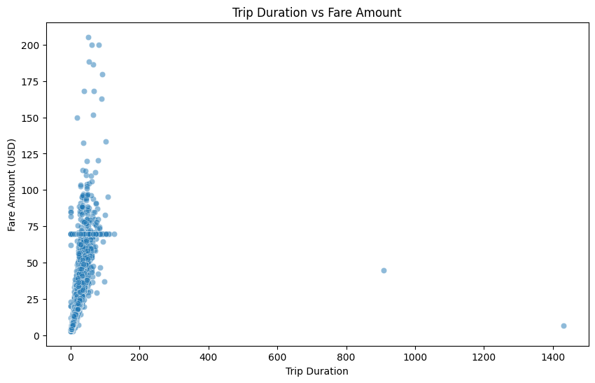
Figure 7. Trip Duration vs Fare Amount
- Fare Amount vs. Number of Passengers:
The number of passengers doesn't really change the basic fare much (correlation is very low at 0.01). The usual fare is about the same no matter how many people are in the taxi.
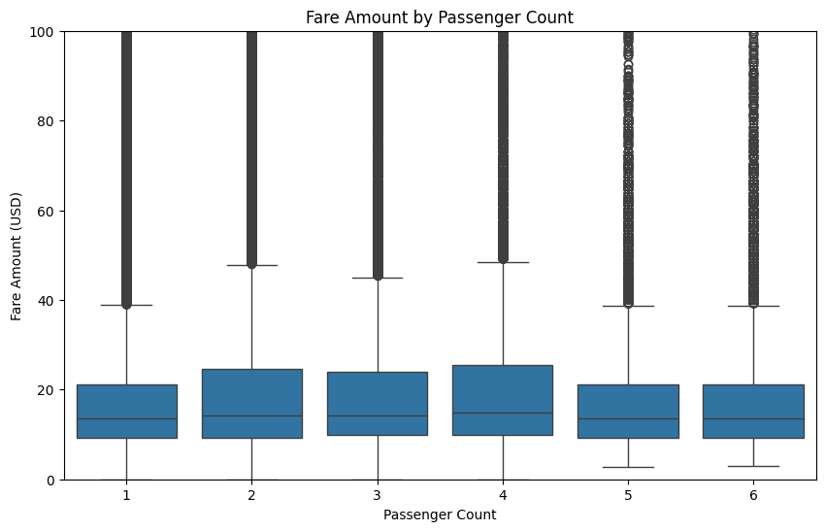
Figure 8. Fare Amount by Passenger Count
- Tip Amount vs. Trip Distance:
People tend to tip more for longer trips (correlation is 0.57).
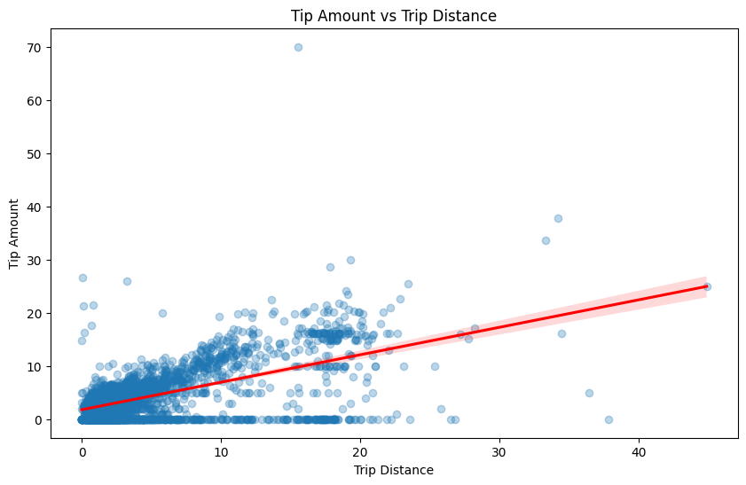
Figure 9. Tip Amount vs Trip Distance
- How People Pay:
Most people pay with credit cards (81.81%). Then comes cash (17.12%), then 'Dispute' (0.68%), and 'No Charge' (0.38%).
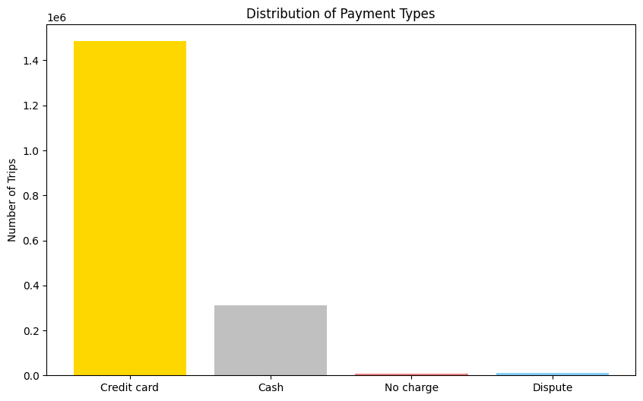
Figure 10. Distribution of Payment Types

Geographical Analysis
- Where Most Taxis are Picked Up in NYC:
Many taxis are picked up in busy places like Upper East Side South, Midtown East, JFK Airport, and LaGuardia Airport. These are areas where many people want taxis.
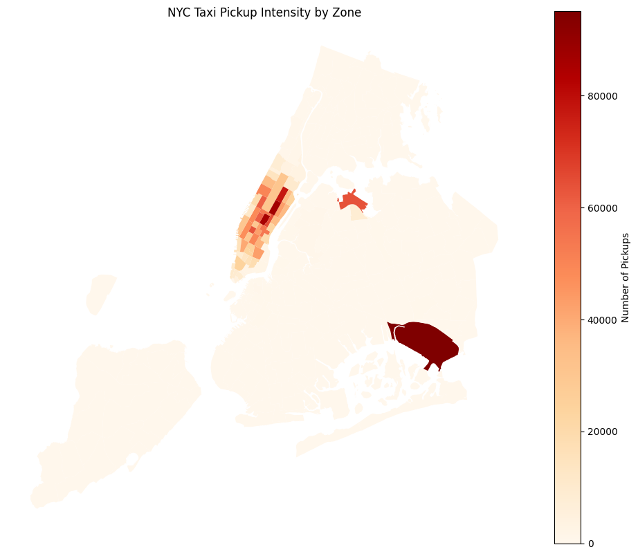
Figure 11. NYC Taxi Pickup Intensity by Zone

3.2 Detailed EDA: Insights and Strategies

Operational Efficiency
- Slow Roads (Traffic Jams):
We looked at how fast taxis move on different roads, at different hours, and between different pick-up and drop-off places. Some roads are very slow (like 0.005 mph). This means traffic jams or bad routes, which makes taxis work less well.
Top 10 Slowest Roads (Bottlenecks):
PULocationID DOLocationID pickup_hour speed_mph
103968 232 65 13 0.005324
116714 243 264 17 0.007772
62306 142 142 5 0.023770
122304 258 258 1 0.026230
20359 65 65 3 0.030644
40333 113 235 22 0.048105
90617 194 194 16 0.048913
9996 45 45 10 0.059484
128464 264 168 23 0.071573
- How Busy Taxis Are Each Hour & Busiest Time:
The busiest time is 6 PM (18:00), with about 2.57 million trips in total. Other busy times are 5 PM, 7 PM, 3 PM, and 4 PM. This shows that late afternoon and early evening are very busy.
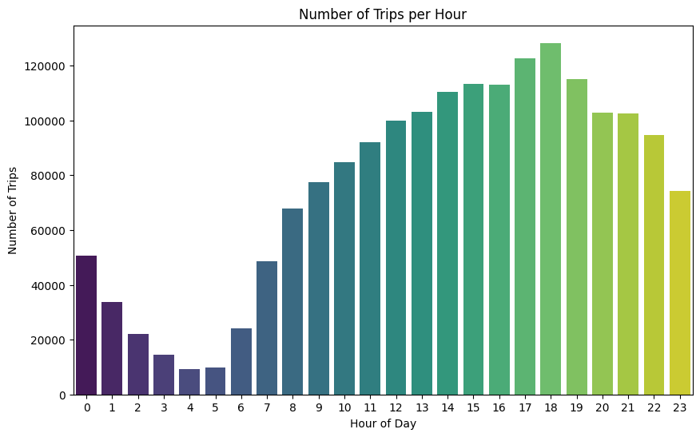
Figure 12. Number of Trips per Hour
Estimated actual trip counts for the 5 busiest hours:
pickup_hour
18 2565540.0
17 2450540.0
19 2303520.0
15 2265860.0
16 2263160.0
Name: count, dtype: float64
- How Busy Taxis Are Each Hour: Weekdays vs. Weekends:
Weekdays have two busy times: a small one in the morning (around 7-9 AM) and a bigger one in the evening (around 5-7 PM). More people use taxis on weekdays.
Weekends get busy later in the day, mostly in the afternoon/evening (around 3 PM - 7 PM). There's no morning rush. Fewer people use taxis on weekends compared to busy weekdays.
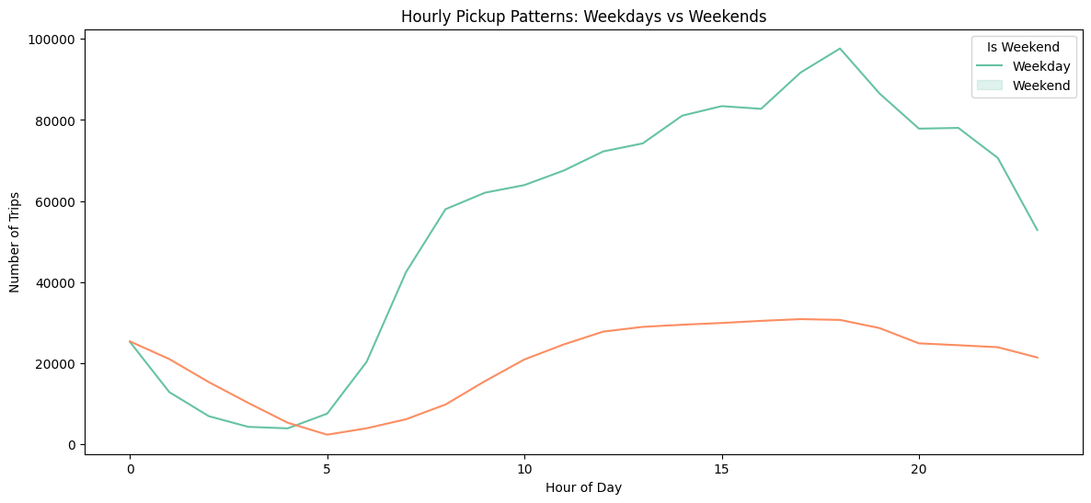
Figure 13. Hourly Pickup Patterns: Weekdays vs Weekends
- Most Popular Pick-up and Drop-off Areas:
Busy places like Manhattan (Upper East Side, Midtown East) and big travel spots (like JFK Airport) are always in the top 10 for both pick-ups and drop-offs.
Top 10 Pick-up Areas:
PULocationID
132 95160
237 86637
161 85622
236 77290
162 65373
138 63769
186 63195
230 60920
142 60680
170 54202
Name: count, dtype: int64

Top 10 Drop-off Areas:
DOLocationID
236 81057
237 77304
161 71350
230 56024
170 54039
162 51999
142 51309
239 51092
141 48309
68 46100
Name: count, dtype: int64
- Pick-up/Drop-off Ratios:
Areas with very high numbers (like LocationID 70 with about 9.23 pickups for every drop-off, or LocationID 132 with about 4.91) are places where many people start their trips (like airports).
Areas with very low numbers (like LocationID 257 with about 0.03 pickups for every drop-off, or LocationID 27 with about 0.02) are mostly where people finish their trips.
Top 10 Pick-up/Drop-off Ratios:
70 9.228443
132 4.911230
138 2.916488
186 1.585225
114 1.376045
43 1.375695
249 1.327073
162 1.257197
161 1.200028
100 1.192618
Name: count, dtype: float64

Bottom 10 Pick-up/Drop-off Ratios:
257 0.034392
27 0.025641
1 0.011619
30 NaN
99 NaN
109 NaN
176 NaN
199 NaN
221 NaN
245 NaN
Name: count, dtype: float64
- Night Time Traffic (11 PM - 5 AM):
The busiest pick-up areas at night are places where people go out or live (like LocationID 79, 132, 249). About 11.29% of all money earned comes from night trips. This shows that night-time is still important for business.
Top 10 Night Pick-up Areas:
PULocationID
79 15263
132 13196
249 12295
48 9730
148 9471
114 8673
230 7709
186 6181
164 5910
138 5906
Name: count, dtype: int64

Top 10 Night Drop-off Areas:
DOLocationID
79 8170
48 6575
170 6028
107 5585
68 5492
141 5091
249 4846
263 4845
148 4269
229 4250
Name: count, dtype: int64
Money Share for Night Time: 11.29%
Money Share for Day Time: 88.71%

Pricing Strategy
- Average Price Per Mile Per Passenger:
Trips with only one passenger have the highest price per mile per person (around 11.01 USD/mile/passenger). This means they are the most profitable for each person. As more people ride, this number usually goes down.
Average price per mile per passenger:
passenger_count
1 11.005932
2 6.427124
3 3.908226
4 4.363335
5 1.709614
6 1.350823
Name: fare_per_mile_per_passenger, dtype: float64
- Average Price Per Mile by Hour and Day:
By Day: Sundays and Tuesdays usually have higher average prices per mile (around 12.53 USD/mile and 12.15 USD/mile).
By Hour: Prices per mile are highest in the early morning (4 AM - 5 AM, around 14.00-14.24 USD/mile) and late afternoon (3 PM - 4 PM, around 12.48-13.91 USD/mile).
Average price per mile by day of the week:
pickup_day
Friday 10.906075
Monday 10.982012
Saturday 10.921498
Sunday 12.530123
Thursday 11.263672
Tuesday 12.149909
Wednesday 11.112734
Name: fare_per_mile, dtype: float64

Average price per mile by hour of the day:
pickup_hour
0 10.526099
...
23 10.695948
Name: fare_per_mile, dtype: float64
- Average Price Per Mile by Company (Vendor) and Hour:
VendorID 2 always seems to have a higher average price per mile at most times of the day, especially in the early morning and mid-afternoon, compared to VendorID 1.
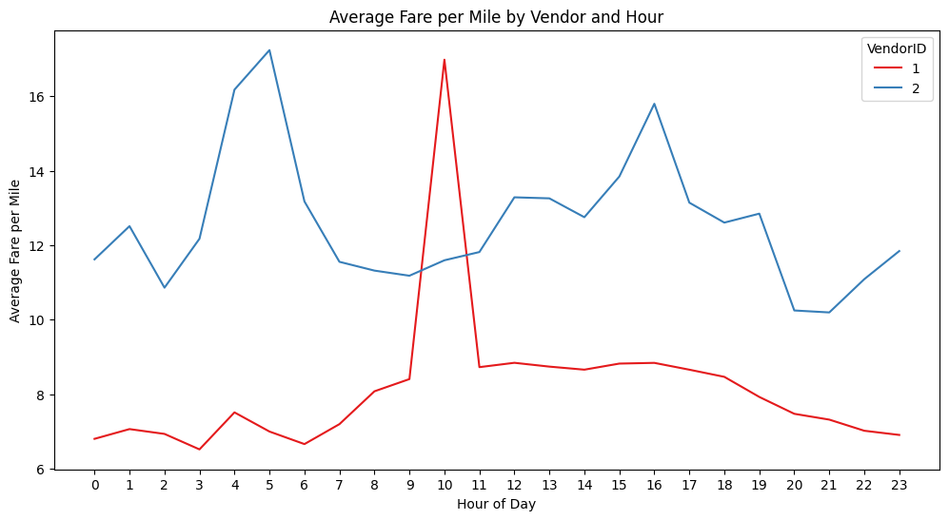
Figure 14. Average Fare per Mile by Vendor and Hour
- Price Per Mile for Different Distances (Tiered Distance Analysis):
Short Trips (0-2 miles) have the highest average price per mile for both taxi companies (especially VendorID 2 at about 17.91 USD/mile). The price per mile goes down a lot for Medium Trips (2-5 miles) and is lowest for Long Trips (>5 miles).
Average price per mile by company and distance tier:
VendorID 1 2
distance_tier
Long (5m) 4.425264 4.503213
Medium (2-5m) 6.381275 6.549310
Short (0-2m) 10.673158 17.912767

Customer Experience and Other Factors
- Average Tip Percentages:
Tip percentages are mostly the same no matter how many passengers (17.4% to 20.9%). They change with the hour: lower in the early morning, and higher in the late afternoon/early evening (around 5 PM).
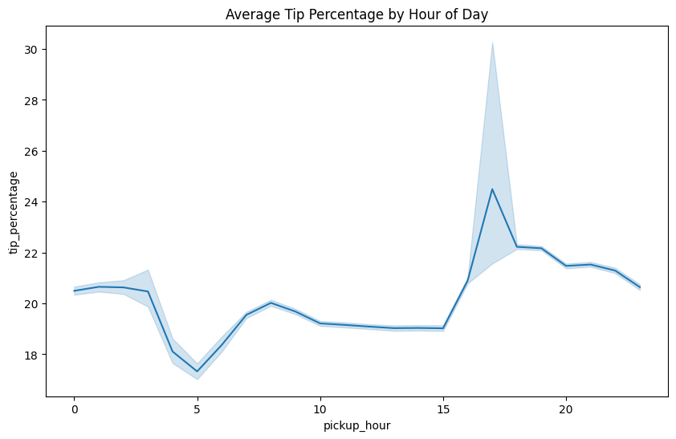
Figure 15. Average Tip Percentage by Hour of Day
Average tip percentage by passenger count:
passenger_count
1 20.903074
2 19.727144
3 19.024955
4 17.437263
5 20.509690
6 20.596898
Name: tip_percentage, dtype: float64
- Comparing Trips with Low Tips vs. High Tips:
Trips with low tips (less than 10%) usually have longer distances (average 3.88 miles) and often no tip at all. Trips with high tips (more than 25%) usually have shorter distances (average 2.30 miles). This means people might give a bigger percentage tip for shorter trips, even if the total tip money is more for longer trips.
Numbers for trips with low tip percentage:
trip_distance passenger_count tip_percentage
count 475436.000000 475436.000000 475436.000000
mean 3.884177 1.427662 1.073542
std 5.192739 0.910048 2.644875
min 0.000000 1.000000 0.000000
25% 1.050000 1.000000 0.000000
50% 1.870000 1.000000 0.000000
75% 4.000000 2.000000 0.000000
max 204.860000 6.000000 9.991942

Numbers for trips with high tip percentage:
trip_distance passenger_count tip_percentage
count 815131.000000 815131.000000 815131.000000
mean 2.296185 1.363370 32.565548
std 2.903093 0.861541 388.004844
min 0.000000 1.000000 25.005501
25% 0.920000 1.000000 27.133028
50% 1.420000 1.000000 30.000000
75% 2.230000 1.000000 33.978495
max 72.280000 6.000000 350000.000000
- How Passenger Count Changes:
The average number of passengers is usually stable (1.3 to 1.5 per trip). Weekends usually have a bit more passengers than weekdays, meaning more groups travel then. Weekday mornings and late nights often have fewer passengers.
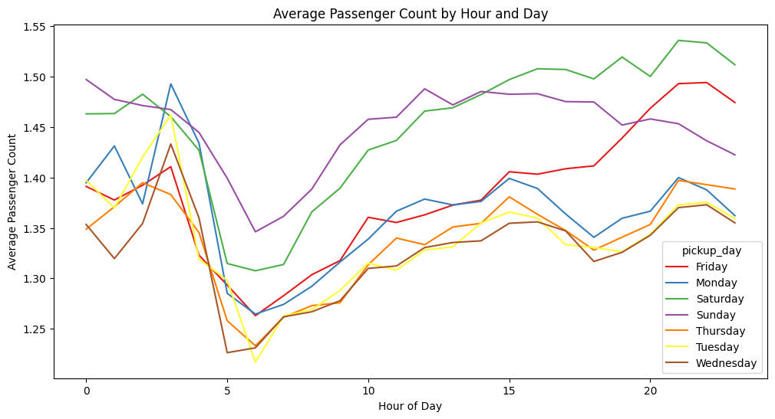
Figure 16. Average Passenger Count by Hour and Day
- Average Passenger Count by Area in NYC:
This map shows the average number of passengers in different areas. It helps to see where more groups might travel.
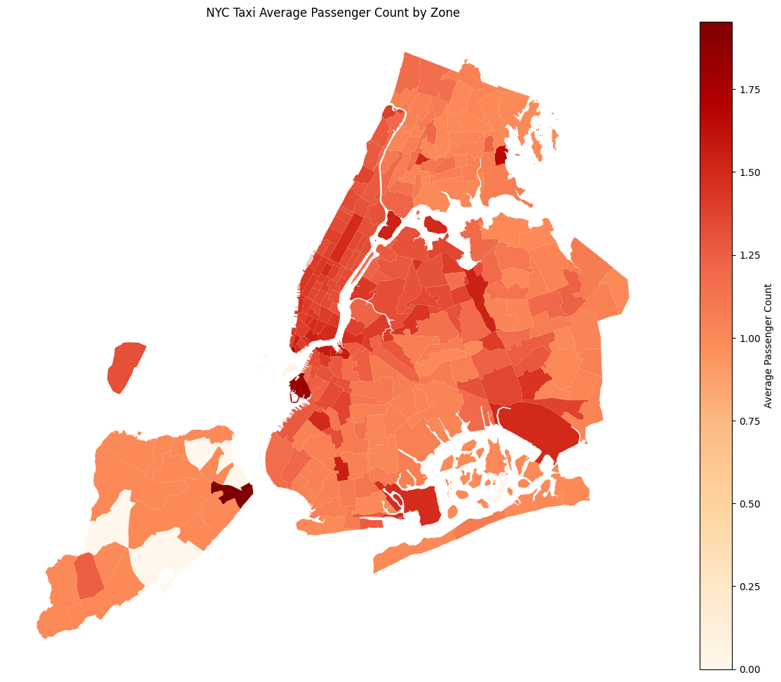
Figure 17. NYC Taxi Average Passenger Count by Zone
- How Often Extra Fees Are Added:
Extra fees are added very often:
- 'extra': 62.20% of trips.
- 'mta_tax': 99.34% of trips.
- 'improvement_surcharge': 99.98% of trips.
- 'congestion_surcharge': 92.76% of trips.
The 'congestion_surcharge' (traffic jam fee) is much higher in areas like Manhattan.
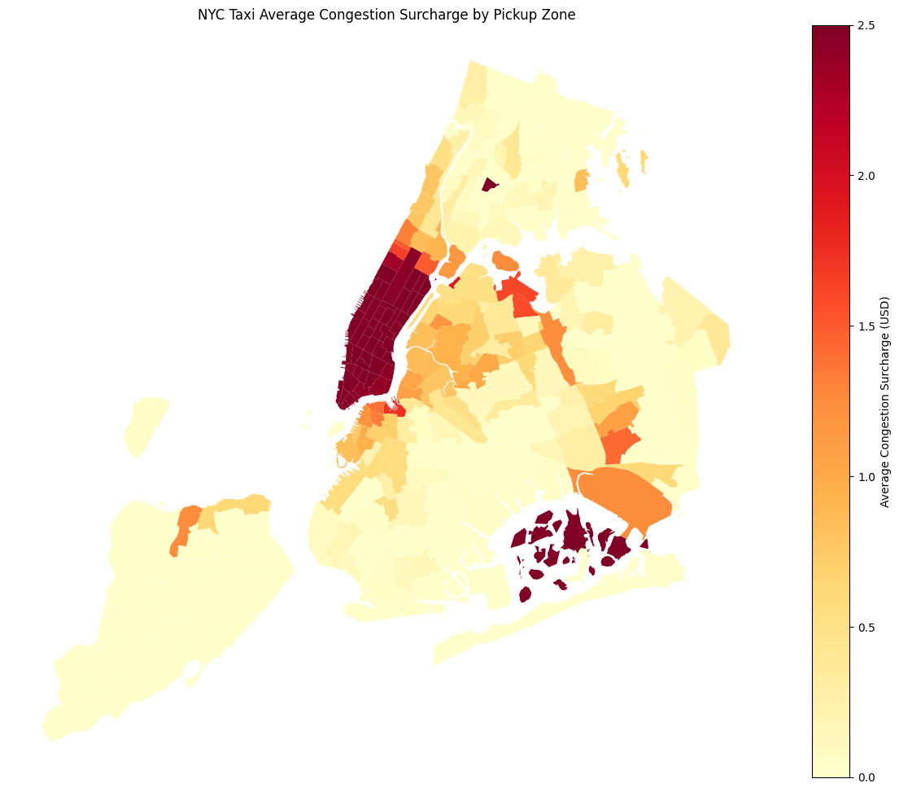
Figure 18. NYC Taxi Average Congestion Surcharge by Pickup Zone

Recommendations

Optimizing Routing and Dispatching
1. More Taxis for Busy Times: Put more taxis in very busy areas (like Midtown, Upper East Side, JFK Airport) during busy times (5 PM - 8 PM on weekdays) and weekend afternoons (3 PM - 7 PM). This will help customers wait less and help us earn more money.
2. Better Routes for Traffic Jams: Use real-time traffic info and navigation to tell drivers better ways to go, especially on known slow roads and during busy hours. This will make trips faster and better.
3. Taxis for Night-Time: At night (11 PM - 5 AM), put taxis in the areas where many people get picked up at night (like entertainment areas or certain homes). This helps serve late-night customers and can bring in more money.
4. Use Pick-up/Drop-off Numbers: For areas where many people start trips (many more pick-ups than drop-offs, like airports), have empty taxis ready nearby. This stops taxis from driving empty and helps them find new customers quickly. For areas where many people finish trips (many more drop-offs than pick-ups), encourage drivers to move to busier areas after dropping off passengers.

Strategically Positioning Cabs Across Different Zones
1. Taxis for People Going to Work: In the morning (7-9 AM) on weekdays, put more taxis in living areas. In the evening (5-7 PM) on weekdays, put more taxis in business areas. This matches when people need rides.
2. Taxis for Weekend Fun: On weekends, change where taxis are placed to be near places where people go for fun, like tourist spots, entertainment places, and shops, especially in the late afternoon and evening.
3. Taxis for Airports: Always have enough taxis at big airports (JFK, LaGuardia). Adjust this based on flight schedules and when most people travel.
4. Taxis Based on Passenger Numbers: Use the average number of passengers in an area to decide what kind of taxis to send. For example, areas with more passengers (like family-friendly tourist spots) could get more bigger taxis.
5. Smart System for Taxis: Create a smart computer system that looks at real-time pick-up/drop-off numbers and past data. This system should tell drivers the best places to wait to make sure there are enough taxis where they are needed.

Data-Driven Adjustments to Pricing Strategy
1. Special Prices for Short Trips: Charge a bit more per mile for very short trips (0-2 miles). This covers the basic costs better. One taxi company (VendorID 2) already does this.
2. Good Prices for Medium Trips: For trips between 2 and 5 miles, keep prices fair so we can compete with other taxi companies. Maybe offer special fixed prices or small discounts when it's not busy.
3. Use Traffic Fees Smartly: Make sure to charge the traffic jam fee in busy areas during busy hours, like Midtown. This is allowed and helps us earn more. Always tell customers clearly about these fees.
4. Encourage Card Payments for Tips: Make it easy for customers to pay with credit cards. People usually tip more with cards, and these tips are recorded. This helps drivers earn more and helps the company too.
5. Higher Prices for Busy Times/Days: Add or increase extra charges during busy hours (like 4-7 PM) and on busy days (Sundays, Tuesdays). People are often willing to pay more when they really need a taxi, which helps us earn more.

Limitations
- The analysis uses a 5% sampled dataset, which supports efficient exploration but may not capture every rare or localized event in the full 2023 trip population.
- Several missing values were imputed using practical assumptions, such as replacing missing passenger counts with the mode and missing congestion surcharges with zero.
- Extreme outliers were filtered using domain rules, which improves analytical stability but may remove some unusual yet valid trips.
- The analysis is descriptive rather than causal; observed relationships should not be interpreted as proof that one variable directly causes another.
- External drivers such as weather, public events, subway disruptions, and real-time traffic conditions were not included in the notebook analysis.

Future Work
- Validate the findings on the full 2023 dataset and compare results with 2022 and 2024 to evaluate year-over-year demand shifts.
- Incorporate weather, event schedules, flight arrivals, traffic speed, and public-transit disruption data to explain demand and pricing changes more accurately.
- Build predictive demand models at the pickup-zone and hour level to support dynamic dispatching and cab repositioning.
- Develop route-level congestion and travel-time models to identify repeat bottlenecks and quantify potential time savings from alternate routing.
- Extend customer-experience analysis with payment behavior, tip segmentation, trip-purpose proxies, and service-zone attributes.

Conclusion
The NYC Yellow Taxi trip data shows clear temporal, geographic, financial, and customer-behavior patterns that can be converted into practical operating decisions. The highest-impact actions are to position taxis ahead of predictable evening and airport demand, optimize dispatching around high pickup/dropoff-ratio zones, improve routing in bottleneck corridors, and refine pricing and surcharge strategies using zone-hour demand signals. With additional external data and predictive modeling, the analysis can evolve from descriptive reporting into an operational decision-support framework for taxi fleet planning.

