**VIPIN KUMAR VIMAL**

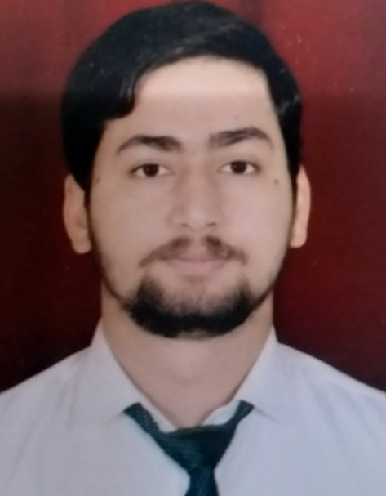

Trans Yamuna Colony, Rambagh ● Agra, 282006.

[● vipin.vimal_cs20@gla.ac.in](mailto:●%20vipin.vimal_cs20@gla.ac.in) ● +91 9119055076

# EDUCATION

**Bachelor of Technology CSE , *GLA University, Mathura*** May 2020-2024

**Intermediate, Delhi Public School, Agra** May 2018-2019

**High School, Delhi Public School, Agra** May 2016-2017

# INTERNSHIP EXPERIENCE_____________________________________________________________________________

# Certified in JOVAC (2 Months Experience) June 2022-July 2022

# Worked on Full Stack Web Development using various technologies

# PROJECTS

* Build a fully responsive **Food delivery website** June 2022-July 2022
* Build a fully responsive **Health & wellness (GYM Website)** Oct 2022-Nov 2022

Using HTML, CSS, JAVASCRIPT, Node.JS and MongoDB

# SKILLS

**Technical**

* HTML, CSS, JAVASCRIPT
* Data Structures and Algorithms
* JAVA, Python, C

**Professional**

* Effective Analytical Skills
* Ability to identify and solve problems
* Effective Communication Skills
* Leadership Quality

# EXTRA/CO-CURRICULAR ACTIVITIES

* Sports (Football. Cricket)
* Participated in Sports Fest GLA
* Attended seminar of Entreprenuership.
* Attended workshop of various Techfest

**ACHIEVEMENTS________________________________________________________________________________________**

* Certificate at **JOVAC**
* Solved 300+ problems on various coding platforms

**DECLARATION_____________________________________________________________________________________**

I hereby declare that all the above mentioned information is true and correct to the best of my knowledge.