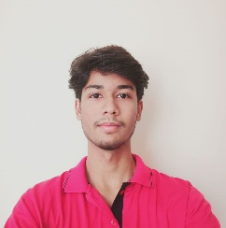**RESUME**

Vipin kumar

+91 99538 37158

Email id: [vipinkumar34515@gmail.com](mailto:vipinkumar34515@gmail.com)

**OBJECTIVE**

Computer Engineering student at DSEU seeking internship to apply skills in real-world projects and gain valuable industry experience.

**EDUCATION QUALIFICATION**

* Pursuing Diploma in Computer Engineering 2nd year from Delhi Skills & Entrepreneurship University at Dwarka­­ Sec-9.
* Passed out 10th from CBSE in 2021

Marks 76.4%

**TECHNICAL SKILL**

* HTML (Hypertext markup language).
* CSS (Cascading style sheets).
* JAVASCRIPT.

**STRENTH & HOBBIES**

* Good Communication skills.
* Watching Movie & listening Music.
* Playing Basketball & Cricket.

**WORK EXPERIENCE**

* FRESHER

**PERSONAL DETAILS**

* Father Name: Mr. Anil kumar
* Mother Name: Mrs. Reena Devi
* D.O.B: 04-JANUARY-2006
* Address: RZ-11/320, GALI NO-8, DEEP MODEL SCHOOL, GEETANJALI PARK WEST SAGARPUR .