Bug ID: BR-001
Title: UI | Login button not clickable on Chrome browser
Description:
When a user attempts to log in to the website using a valid username and password, the Login button is not clickable.
Application URL:
https://www.saucedemo.com/
Test Data:
- Username: standard_user
- Password: secret_sauce
Environment:
- Browser: Chrome 121
- OS: Windows 11
Precondition:
- The user is on the login page
Steps to Reproduce:
- Open the application URL (https://www.saucedemo.com/)
- Enter the username: standard_user
- Enter the password: secret_sauce
- Click on the Login button
Expected Result:
The user should be able to click the Login button and log in successfully.
Actual Result:
The Login button is not clickable.
Screenshot:
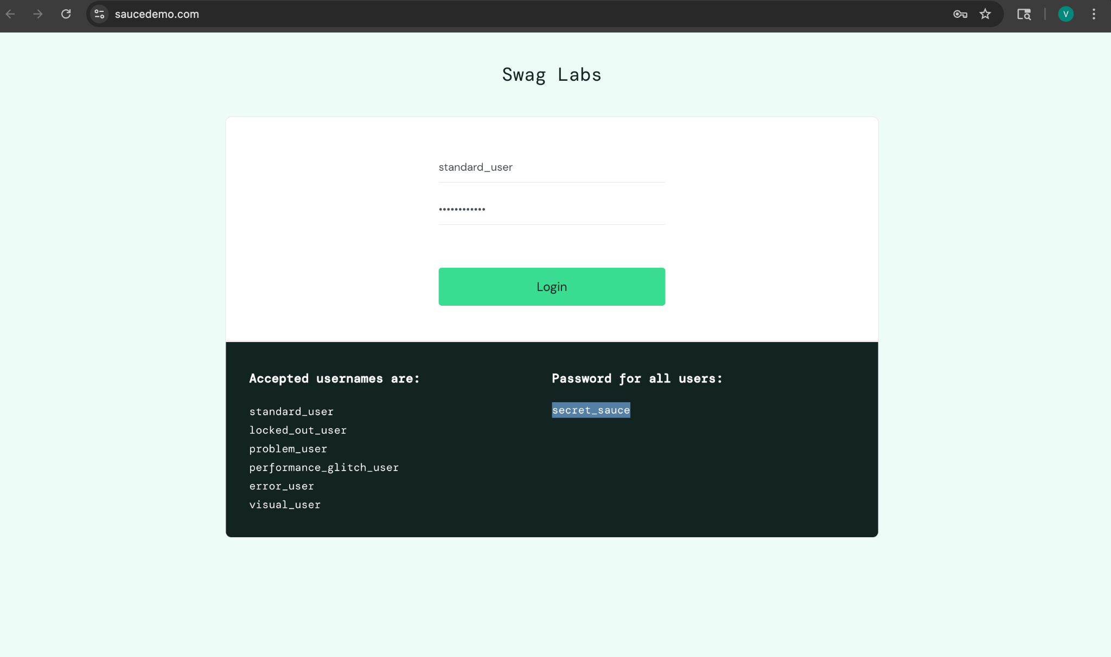
Severity: High
Priority: High
Status: Open

