Experiment 2

Create a HTML file to link different HTML pages which contain images which contains images, tables and also link within a page.

htmlpgm1.html

<html>
<head>
<title></title>
</head>
<body>
<h1>Major Ports in Idia</h1>
<i>Click on the map co-ordinate</i>
<br>
<img src="India.jpeg" usemap="#workmap">
<map name="workmap">
<area shape="rect" coords="34,44,55,55" href="htmpgm3.html">
</map>
<br>
To know about India <a href="htmlpgm2 .html">Click here</a>
</body>
</html>

OUT PUT

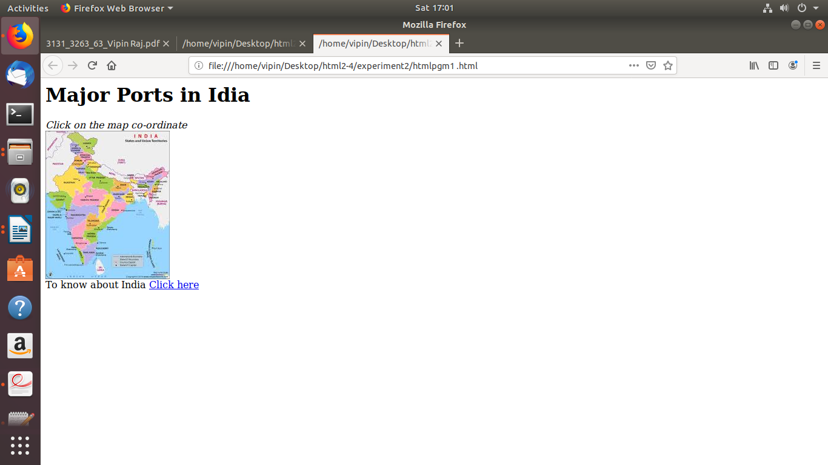
htmlpgm2.html

<html>
<head>
<title></title>
</head>
<body bgcolor="yellow">
<h1>INDIA</h1>
<p>India (Hindi: Bhārat), officially the Republic of India (Hindi: Bhārat Gaṇarājya),[23] is a country in South Asia. It is the second-most populous country, the seventh-largest country by land area, and the most populous democracy in the world.
<p>Bounded by the Indian Ocean on the south, the Arabian Sea on the southwest, and the Bay of Bengal on the southeast, it shares land borders with Pakistan to the west;[f] China, Nepal, and Bhutan to the north; and Bangladesh and Myanmar to the east. In the Indian Ocean, India is in the vicinity of Sri Lanka and the Maldives; its Andaman and Nicobar Islands share a maritime border with Thailand and Indonesia.
</body>
</html>

OUT PUT

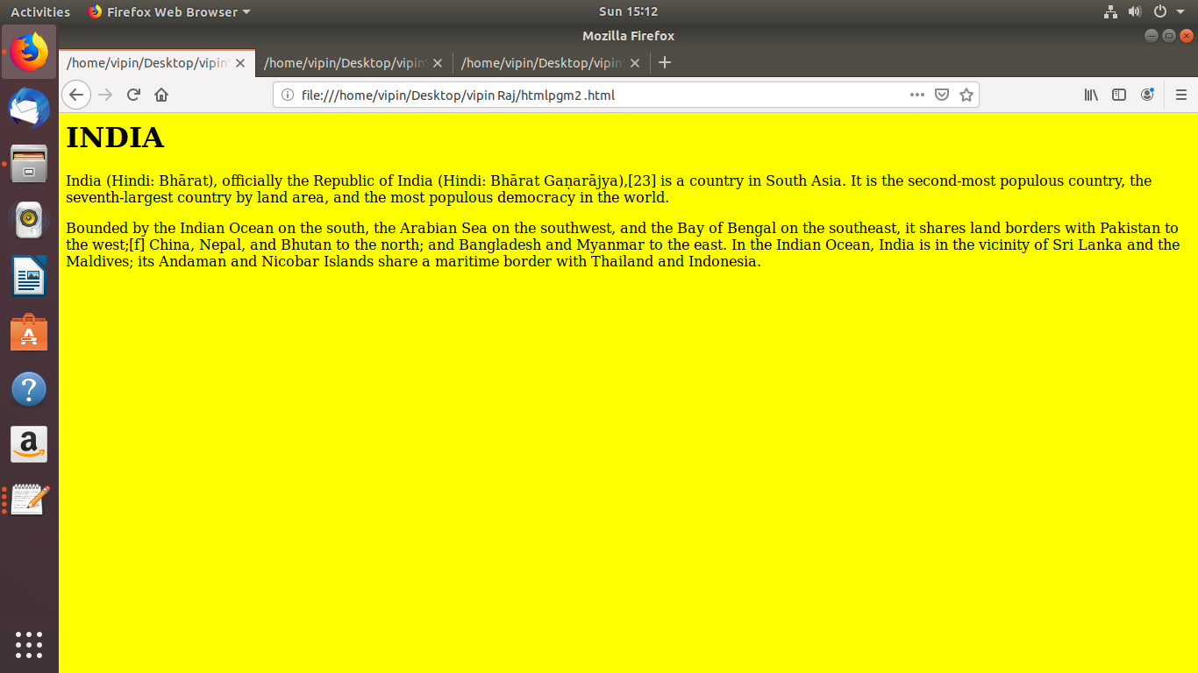

htmlpgm3.html

<html>
<head>
<title></title>
</head>
<body>
<h1>Major port in India</h1>
<table border="2">
<tr>
<th>State</th>
<th>Name</th>
</tr>
<tr><td>Tamil Nadu</td> <td>Chennai</td></tr>
<tr><td>Kerala</td> <td>Kochi</td></tr>
<tr><td>Tamil Nadu</td> <td>Ennore</td>
<tr><td>West Bengal</td><td>Kolkata</td></tr>
<tr><td>Gujarat</td> <td>Kandla</td></tr>
<tr><td>Karnataka</td> <td>Mangalore</td></tr>
<tr><td>Goa</td> <td>Mormugao</td></tr>
<tr><td>Maharashtra</td><td>Mumbai Port</td></tr>
</body>
</html>

OUT PUT

