WEB AND MOBILE PROGRAMMING

# ICP-10

Team Details :-

Team Number :-  11

Name :-  Mani Sai Gundumogula

Email:- [mgy3v@umsystem.edu](mailto:mgy3v@umsystem.edu)

GitHub:- https://github.com/ManiSaiGundumogula/WebICP10

Name :- Sai Saranya Vipparla

Email :- [svv7x@umsystem.edu](mailto:svv7x@umsystem.edu)

GitHub:- <https://github.com/VipparlaSaiSaranya/WebICP10>

“

This ICP is about a mobile programming on how to call and retrieve data from an API(GitHub) and display it to the users via screen.

So In order to interact with the API we used Retrofit. Because the HTTP request and response is automatically managed and also as it is one of the libraries in Android studio, it is easy to implement. As the class and interface is already in the GitHub repository, we need to pull it.

In main_activity, After the setContentView a textview is defined and interconnected using id and Retrofit is defined which extends baseUrl (“<https://api.github.com/>”) follow on addConverterFactory is used for serialization and deserialization of objects i.e; in this case we are converting the data in Gson and build is used to create the retrofit instance for conversion.

Once the request is sent, a method is defined that checks whether the response we received is successful or not. If the response is successful, the body of the response is placed in a list, which is iterated using a for loop. The date we received is appended to a string that is locally defined for each iteration, with each add containing a unique Id and username.

API Data:

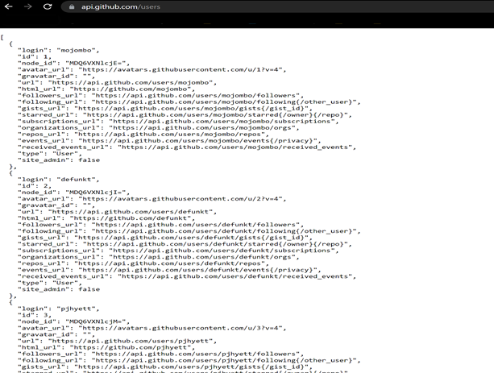

So, we created an empty project in Android studio with the name as ICP10 and added two dependencies which are retrofit2.9.0, converter-gson:2.9.0.In this project a new java class file is to be created in order to transfer the data through object using getters and setters method. In the onCreate function in the MainActivity.java, retrofit API is used consumed the GitHub rest API to fetch the users data. On Successful call of , response is collected in the onResponse method and casted to User class which is collected in the list. The collected list is then displayed in the text view which is present in the MainAcitivity.xml and displayed to the user.

So this is how we managed to create a mobile application and able to test and develop the application in android studio.

Code:

User class and the scroll functionality

On failure:

Output:

”