FUNDAMENTALS OF DATA SCIENCE
CASE STUDY 6
COMPARATIVE ANALYSIS OF CLASSIFICATION\nALGORITHMS FOR BANK MARKETING PREDICTION
Predicting term-deposit subscription using machine learning

Student Name | V. Sai Eshwar
Roll Number | 160124733205
Section | CSE-3
Year | Third Year
Subject | Fundamentals of Data Science
Faculty | Smt. S. Durga Devi
Assignment | FDS Assignment 1

1. Problem Statement
The objective is to develop and compare classification models that predict whether a customer subscribes to a bank term deposit following a telephone marketing campaign. The target variable is y, where “yes” indicates subscription and “no” indicates no subscription. Four algorithms are evaluated: Logistic Regression, Decision Tree, K-Nearest Neighbours (KNN), and Random Forest.

2. Dataset and Preprocessing
The supplied bank-full.csv dataset was read using a semicolon delimiter. It contains 45,211 rows and 17 columns, including the target. The target distribution is 39,922 “no” cases (88.30%) and 5,289 “yes” cases (11.70%), indicating class imbalance.
The analysis checks missing values and exact duplicate rows. Categorical “unknown” values are retained as explicit categories. The duration feature is excluded from all primary models because it is only known after the current call and would create an unrealistic pre-contact prediction. The remaining predictors are separated from the target. A stratified 80:20 train-test split with random_state=42 is used for all models.
Numerical features are median-imputed and standardized. Categorical features are imputed with their most frequent value and one-hot encoded. Preprocessing is fitted within each model pipeline to avoid learning preprocessing parameters from the test set.

3. Exploratory Data Analysis
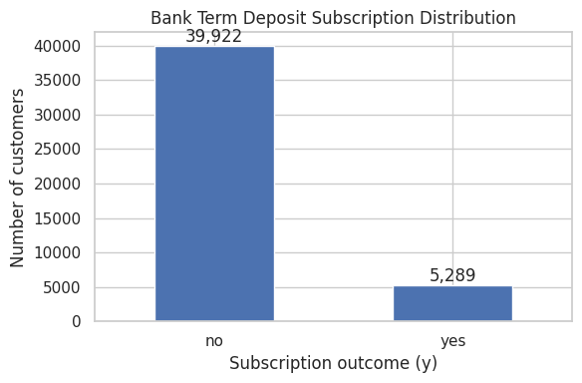
Figure 1. Distribution of target classes. Non-subscribers are substantially more common than subscribers.
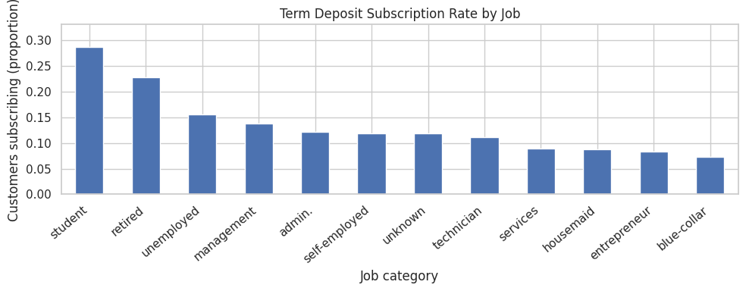
Figure 2. Observed subscription rate by job category.
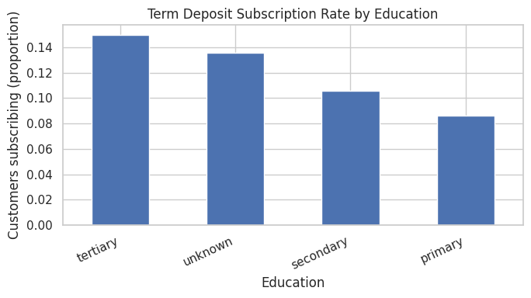
Figure 3. Observed subscription rate by education category.

Key observations
1. The target is imbalanced: only around 11.7% of records are subscribers. Accuracy alone can therefore be misleading.
2. Observed subscription rates vary across job and education groups, suggesting that customer characteristics may help prioritize outreach. These are associations and do not prove causation.
3. The age and balance distributions overlap between subscribers and non-subscribers. These numerical features alone are unlikely to separate the two outcomes reliably.
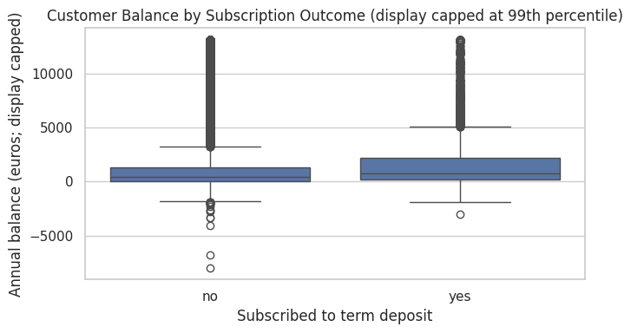
Figure 4. Customer balance by subscription outcome; the displayed upper range is capped at the 99th percentile.
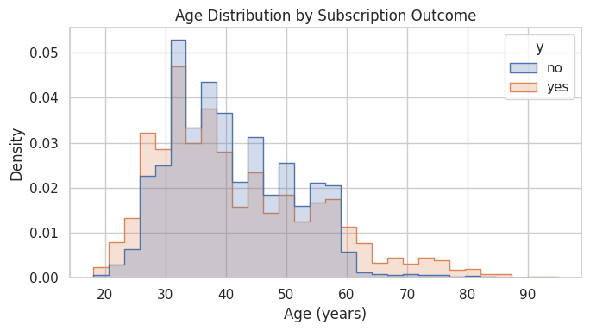
Figure 5. Age distribution by subscription outcome.

4. Model Development and Evaluation
The same train-test split and target definition were used for all models. The positive class is “yes”. Precision, recall and F1-score are calculated for this positive class. ROC-AUC is computed using predicted probabilities.
Model | Accuracy | Precision | Recall | F1-score | ROC-AUC
Logistic Regression | 0.8933 | 0.6632 | 0.1786 | 0.2815 | 0.7717
Decision Tree | 0.7485 | 0.2432 | 0.5444 | 0.3363 | 0.6812
KNN | 0.8891 | 0.5758 | 0.1975 | 0.2942 | 0.7138
Random Forest | 0.8851 | 0.5117 | 0.3922 | 0.4441 | 0.8002
Random Forest achieved the highest F1-score (0.4441) and ROC-AUC (0.8002) among these runs. Logistic Regression produced the highest accuracy (0.8933), but its recall was only 0.1786, meaning it identified a relatively small fraction of actual subscribers. Decision Tree had the highest recall (0.5444), but its precision and ROC-AUC were lower. These trade-offs show why model selection should not rely on accuracy alone.
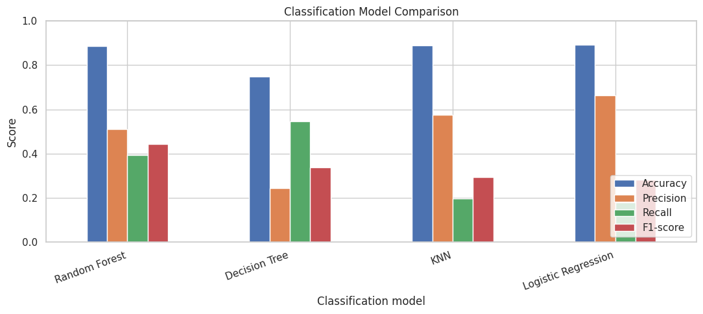
Figure 6. Comparison of accuracy, precision, recall and F1-score.
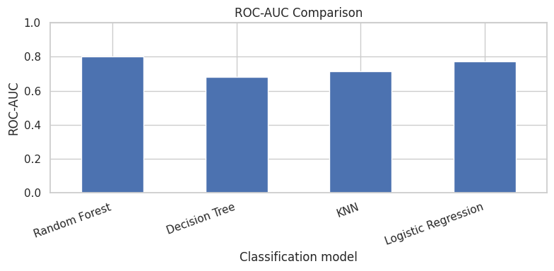
Figure 7. ROC-AUC scores by classifier.

5. Confusion Matrices and ROC Analysis
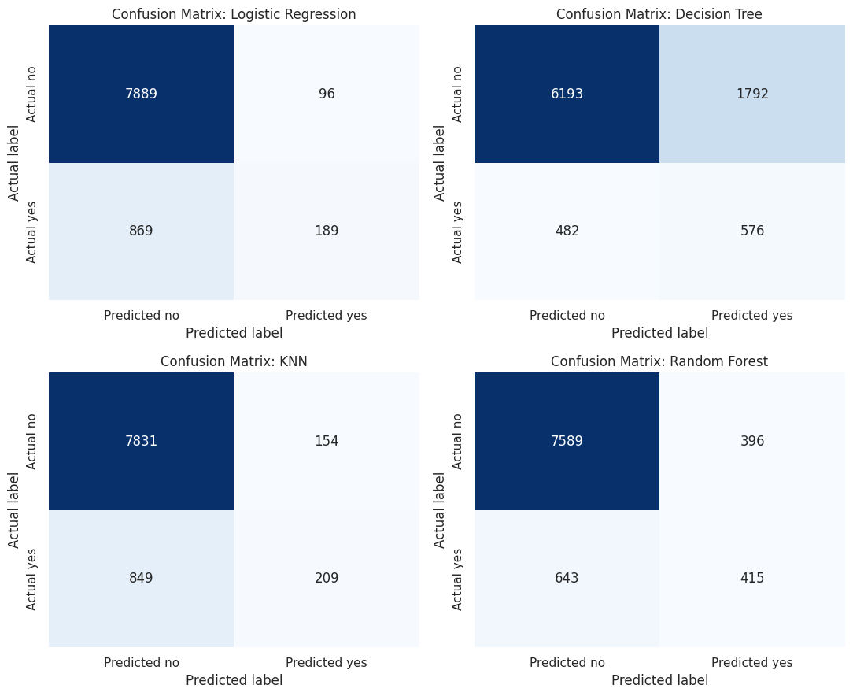
Figure 8. Confusion matrices for all four models. Rows represent actual classes and columns represent predicted classes.
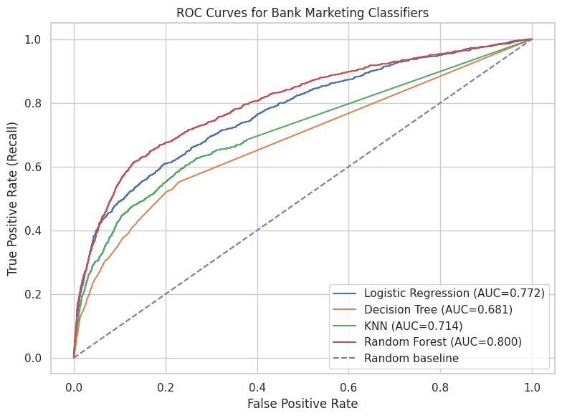
Figure 9. ROC curves comparing the four classifiers.
False negatives are actual subscribers predicted as non-subscribers and may represent missed campaign opportunities. False positives are customers predicted to subscribe who do not and may consume limited call resources. The best threshold depends on the bank’s campaign capacity and the relative cost of these errors.

6. Recommendation and Limitations
Based on F1-score with ROC-AUC as supporting evidence, Random Forest is the recommended model from this experiment. It offers the best balance of precision and recall among the four tested models and the strongest ROC-AUC. The Decision Tree identifies more actual subscribers at the default threshold, so it may be worth considering if maximizing recall is the primary goal and additional false positives are acceptable.
Business recommendations:
1. Use predicted subscription probabilities to rank eligible customers and prioritize outreach within the available campaign budget.
2. Select the classification threshold based on the costs of missed subscribers and unnecessary calls; validate the threshold on a later campaign before operational use.
Limitations:
1. Class imbalance makes positive-class recall difficult to optimize, and metrics can change substantially with the decision threshold.
2. The data is historical; customer preferences, campaign strategy and economic conditions may change, so performance may not generalize to future campaigns.
A further limitation is that excluding duration is intentional for realistic pre-contact prediction, but it may lower performance compared with a model using information only available after a call.

7. Conclusion
This case study compared Logistic Regression, Decision Tree, KNN and Random Forest for predicting bank term-deposit subscriptions. Random Forest was the strongest overall model by F1-score and ROC-AUC in the executed experiment, while the other classifiers showed different precision-recall trade-offs. The bank should use the model to prioritize, not automatically determine, campaign contacts and should monitor performance on new campaign data.

References
Moro, S., Laureano, R., & Cortez, P. (2011). Using Data Mining for Bank Direct Marketing: An Application of the CRISP-DM Methodology. Proceedings of the European Simulation and Modelling Conference, 117–121.
Dataset documentation: bank-names.txt supplied with the assignment dataset.

