**This is jasmine test**

Describe – to combine the tests (sut stands for system under test)

beforeEach – this is used to set variables declared to empty because we don’t want to pollute the future tests with results of previous tests

it – this where the test is written and it always have what the test is about or **‘should’**

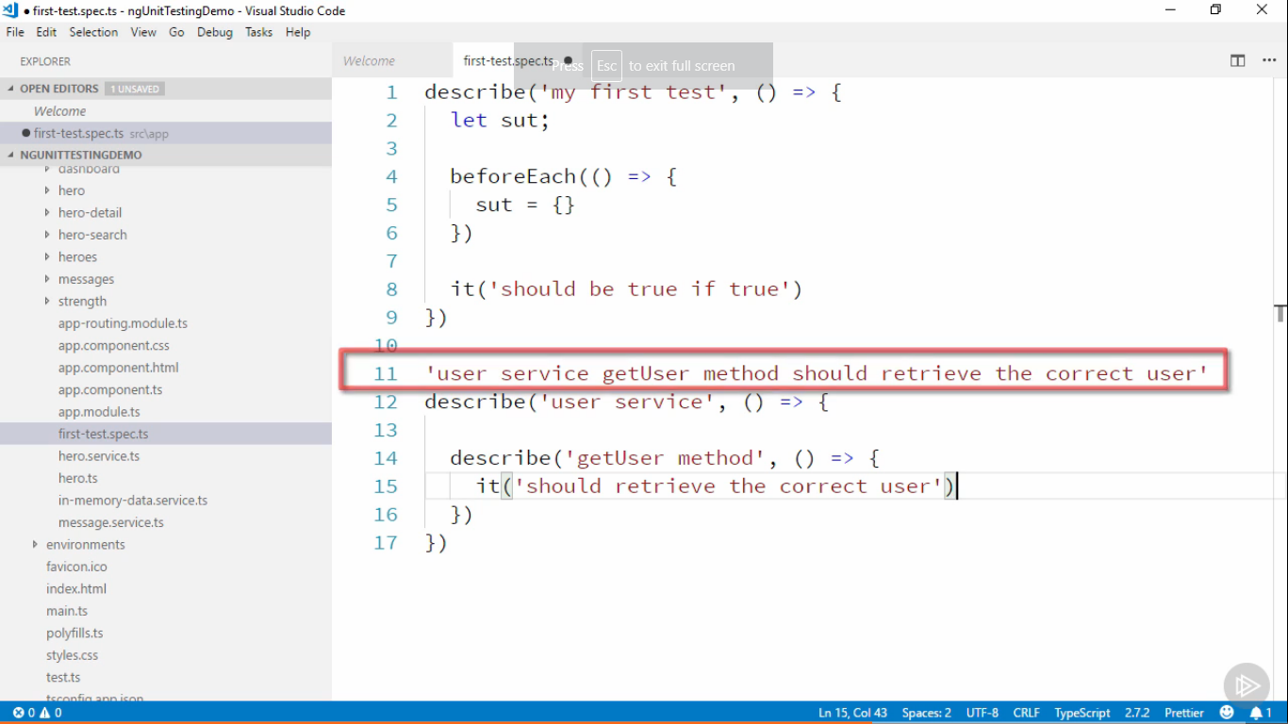

AAA test structure

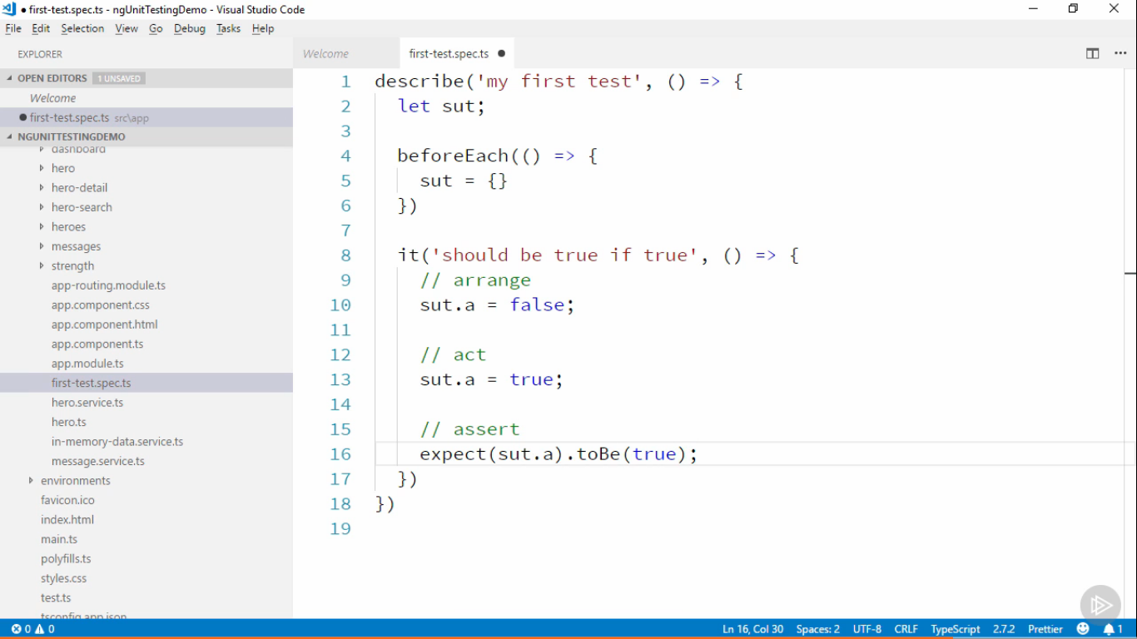

**Writing Good Unit Tests**

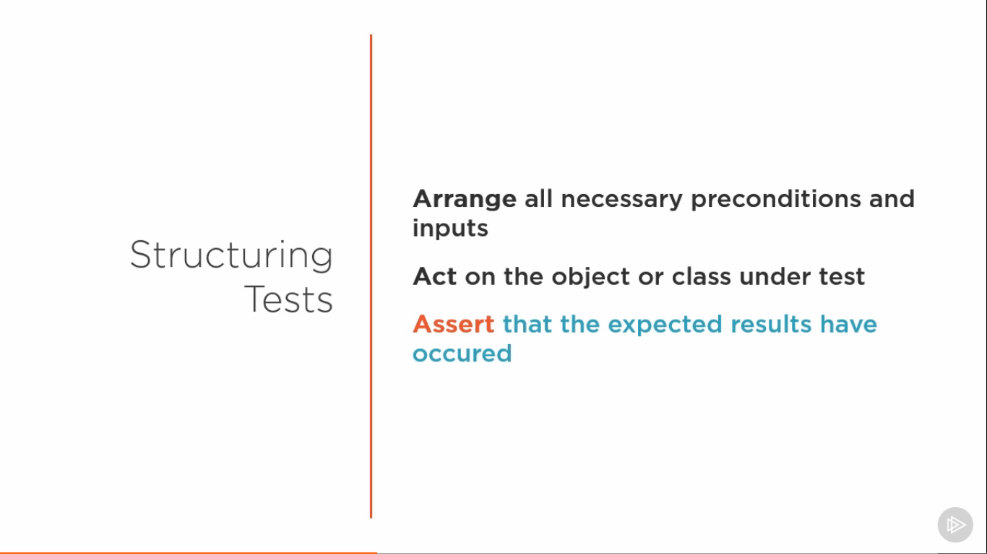

Concept in Programming

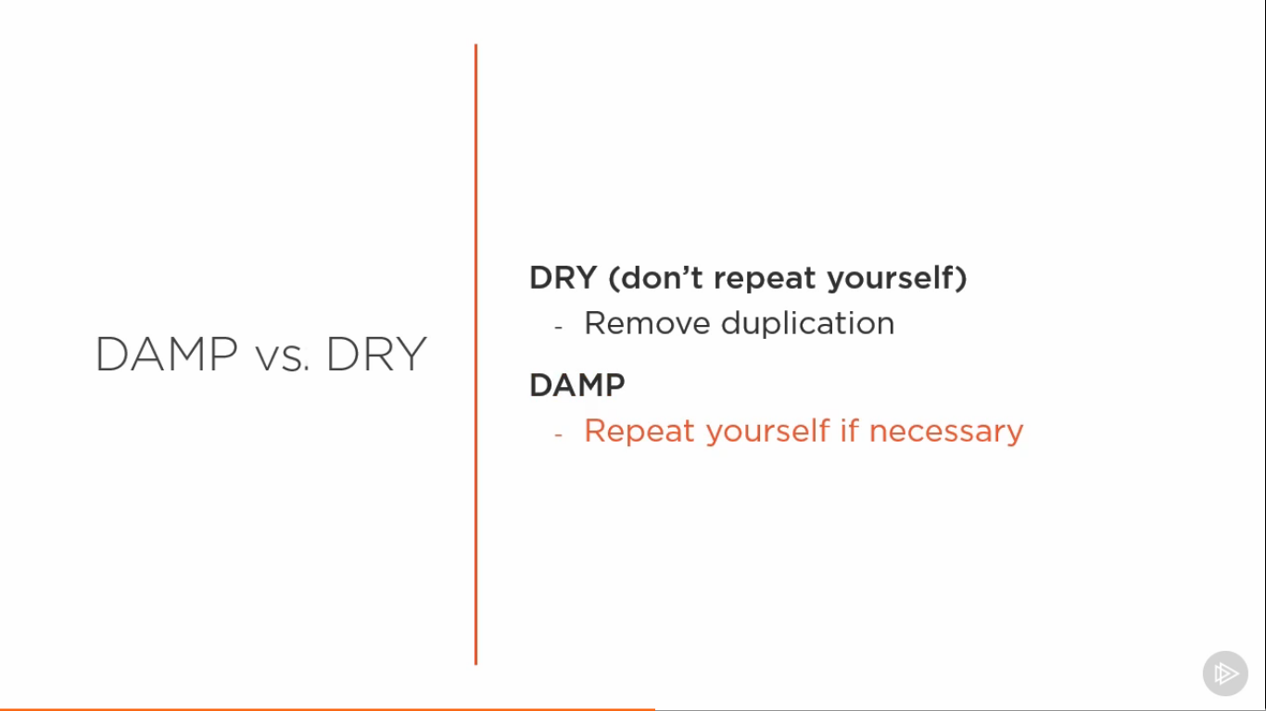

Good Practices

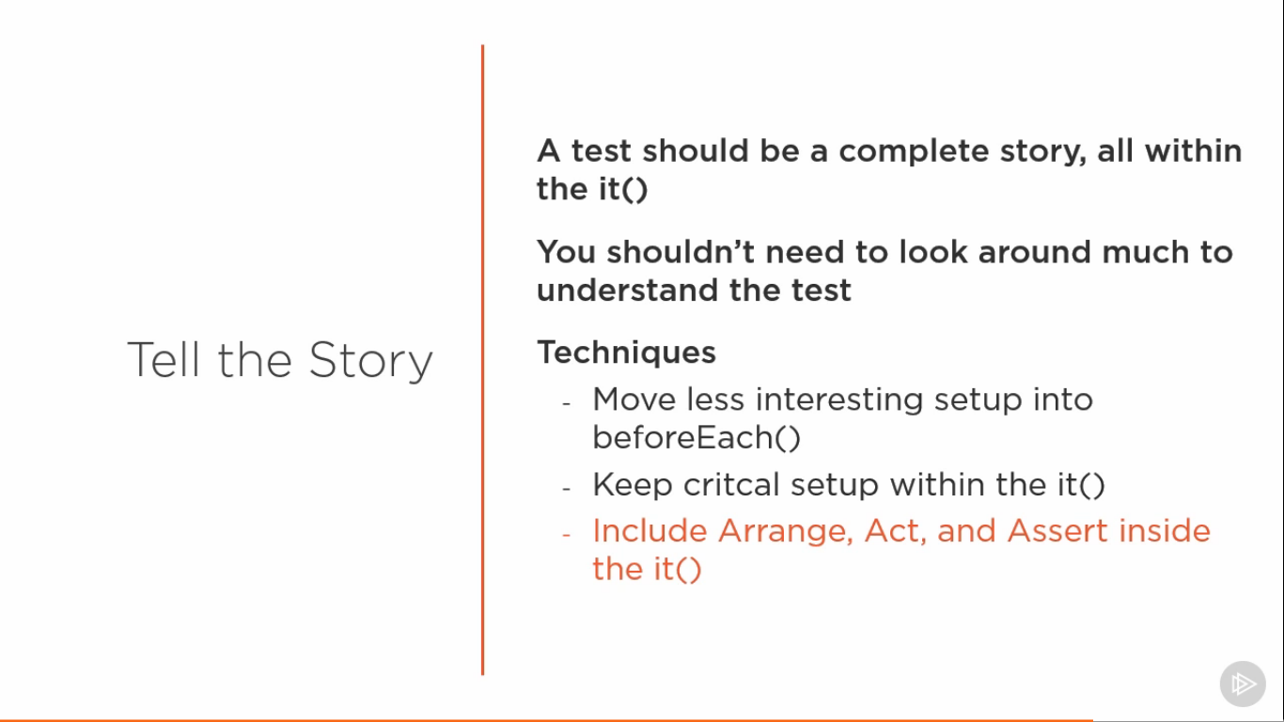

**Isolated Unit Tests**

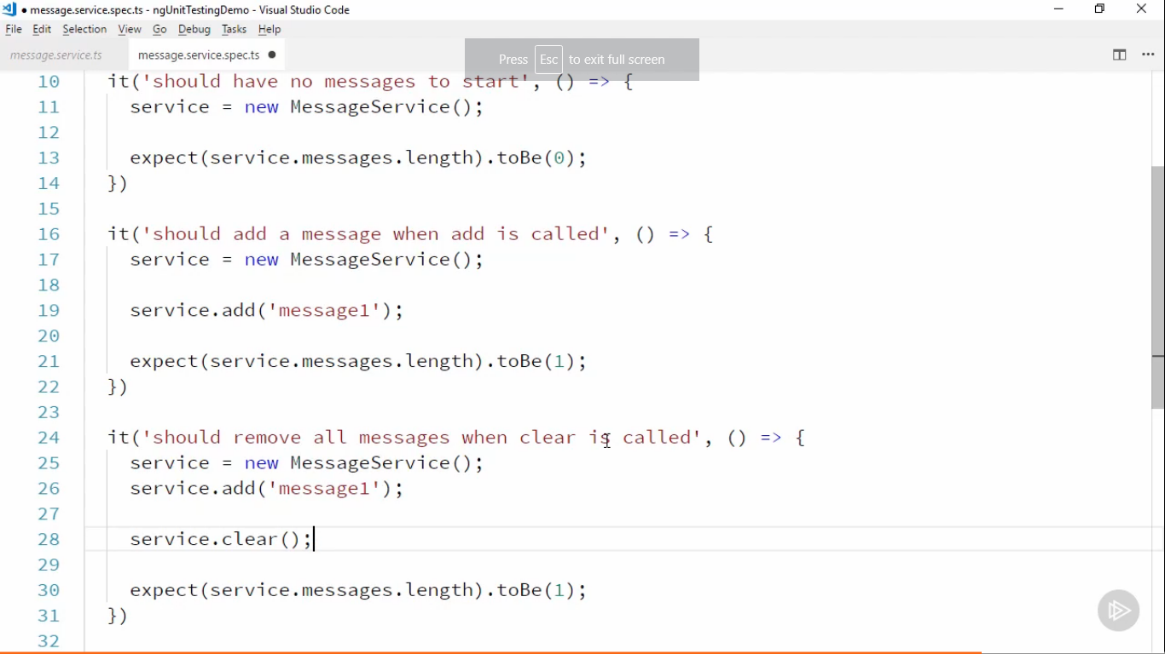

Interaction test component

import { HeroesComponent } from "./heroes.component"

import { of } from "rxjs";

describe('Heroscomponent',()=>

{

    let component : HeroesComponent;

    let HEROES;

    let mockHeroSer;

    beforeEach(()=>{

        HEROES =[

            {id:1,name:'yes',strength:8},

            {id:2,name:'true',strength:5},

            {id:3,name:'false',strength:11}

        ]

    mockHeroSer = jasmine.createSpyObj(['delete1Hero'])

    component = new HeroesComponent(mockHeroSer)

})

describe('delete',()=>

{

    it('should remove',()=>{

        mockHeroSer.delete1Hero.and.returnValue(of(true))

        component.heroes = HEROES

        component.delete(HEROES[2])

        expect(component.heroes.length).toBe(2)

    })

    it('should remove with parameter',()=>{

        mockHeroSer.delete1Hero.and.returnValue(of(true))

        component.heroes = HEROES

        component.delete(HEROES[2])

        expect(mockHeroSer.delete1Hero).toHaveBeenCalledWith(HEROES[2])

    })

})

})

For zone and karma conflict issue use

"test": "ng test --source-map=false",

**TestBed** allows us test both component and its template running together

Fixture allows us to take a component instance, it is like a wrapper around the component. It has more properties than the component itself

import { TestBed, ComponentFixture } from "@angular/core/testing";

import { HeroComponent } from "./hero.component";

describe('HeroComponent shallow',()=>

{

    let fixture:ComponentFixture<HeroComponent>;

    let del;

beforeEach(()=>{

   TestBed.configureTestingModule({

       declarations : [HeroComponent]

   });

   fixture = TestBed.createComponent(HeroComponent);

})

it('should have the correct hero',()=>{

    fixture.componentInstance.hero = {id:1,name:'hi',strength:8}

})

})