## ABSTRACT

Medication adherence remains a critical challenge in healthcare, with non- adherence leading to adverse health outcomes, increased healthcare costs, and reduced quality of life for patients. Automated pill dispensers have emerged as a promising solution to improve medication adherence by providing reminders and dispensing medications at scheduled times. However, traditional automated pill dispensers lack the capability to address the psychological and behavioral aspects of non-adherence effectively.

This paper proposes an innovative approach to enhance medication adherence through an automated pill dispenser integrated with stimulation techniques. The system aims to leverage principles of behavioral psychology and neuroscientific research to positively influence patient behavior and improve medication adherence rates. By incorporating stimulation techniques such as gamification, social reinforcement, and personalized feedback, the automated pill dispenser becomes more than just a passive reminder tool but an interactive and engaging system that motivates and empowers patients to adhere to their medication regimens.

The design of the automated pill dispenser with stimulation (APDS) system encompasses several key components. Firstly, the dispenser hardware includes a user-friendly interface with customizable settings for medication schedules, dosage instructions, and notifications. The dispenser is equipped with sensors to detect when medications are taken or missed, enabling real-time monitoring of adherence behavior. Additionally, the system incorporates wireless connectivity to sync with mobile devices and cloud-based platforms for data storage and analysis.

One of the core features of the APDS system is its use of stimulation techniques to influence patient behavior positively. Gamification elements, such as

rewarding points or badges for adherence achievements, transform the act of medication adherence into a fun and rewarding experience. Social reinforcement mechanisms allow patients to connect with peers, caregivers, or healthcare providers, fostering a sense of accountability and support within a community. Furthermore, personalized feedback based on adherence data helps patients track their progress, identify patterns, and make informed decisions regarding their health.

The effectiveness of the APDS system relies on its ability to adapt and respond to individual patient needs and preferences. Machine learning algorithms analyze adherence data to generate personalized recommendations and interventions tailored to each patient's unique circumstances. For example, the system may adjust the timing or frequency of reminders based on user response patterns or provide targeted interventions for patients experiencing adherence challenges.

In addition to improving medication adherence, the APDS system offers potential benefits for healthcare providers and caregivers. Real-time adherence data enables proactive intervention strategies, such as timely reminders or outreach efforts for patients at risk of non-adherence. The system also facilitates communication and collaboration between patients and healthcare providers, enabling remote monitoring and adjustment of treatment plans as needed.

Overall, the integration of stimulation techniques into automated pill dispensers represents a promising approach to addressing medication adherence challenges. By combining technology with insights from psychology and neuroscience, the APDS system offers a holistic solution that empowers patients, engages caregivers, and enhances overall health outcomes. Future research and implementation efforts should focus on evaluating the efficacy, usability, and scalability of the APDS system in diverse patient populations and healthcare settings.

**LIST OF FIGURES**

|  |  |  |
| --- | --- | --- |
| **FIGURE NO.** | **TITLE** | **PAGE NO.** |
| 1. | BLOCK DIAGRAM | 5 |
| 2. | CIRCUIT DIAGRAM | 14 |
| 3. | ARDUINO UNO | 18 |
| 4. | POTENTIOMETER | 19 |
| 5. | PIEZO BUZZER | 23 |
| 6. | PUSHBUTTON | 25 |
| 7. | SERVO MOTOR | 28 |
| 8. | 16x2 LCD | 31 |

**TABLE OF CONTENTS**

|  |  |  |
| --- | --- | --- |
| **CHAPTER NO.** | **TITLE** | **PAGE NO.** |
|  | ABSTRACT  LIST OF FIGURES | iii v |

1. INTRODUCTION 1
   1. UNDERSTANDING THE CHALLENGE OF MEDICATION ADHERENCE
   2. THE ROLE OF AUTOMATED PILL DISPENSERS IN MEDICATION ADHERENCE
   3. THE CONCEPT OF AUTOMATED PILL DISPENSER WITH STIMULATION
2. LITERATURE SURVEY 6
   1. MEDICATION ADHERENCE AND ITS IMPACT ON HEALTH OUTCOMES
   2. AUTOMATED PILL DISPENSERS AS A SOLUTION
   3. EVIDENCE SUPPORTING THE EFFICACY OF STIMULATION TECHNOLOGY 7
   4. ETHICAL AND LEGAL CONSIDERATIONS 10
   5. HEALTH EQUITY AND ACCESS TO MEDICATION ADHERENCE INTERVENTIONS
   6. CONCLUSION 10
3. PRINCIPLES 11
   1. COMPREHENSIVE UNDERSTANDING OF

NON-ADHERENCE FACTORS 11

* 1. INTEGRATION OF TECHNOLOGY 12
  2. BEHAVIORAL SCIENCE PRINCIPLES 12
  3. PATIENT-CENTERED APPROACH 12
  4. CONTINUOUS MONITORING AND ADAPTATION 13

1. CIRCUIT DIAGRAM AND WORKING 14
   1. INITIALIZATION 14
   2. PROGRAMMING 15
   3. DISPENSING MEDICATION 15
   4. STIMULATION 16
   5. USER INTERACTION 16
   6. FEEDBACK 17

|  |  |  |
| --- | --- | --- |
| 5. | **COMPONENTS DESCRIPTION** | **18** |
| 5.1 | ARDUINO UNO | 18 |
| 5.2. | POTENTIOMETER | 20 |
| 5.3. | PIEZO BUZZER | 23 |
| 5.4. | PUSHBUTTON | 25 |
| 5.5. | SERVO MOTOR | 28 |
| 5.6. | 16x2 LCD | 31 |

1. **ADVANTAGES 34**
   1. IMPROVED ADHERENCE RATES 34
   2. PERSONALIZED SUPPORT 34
   3. ENHANCED PATIENT ENGAGEMENT 34
   4. REAL-TIME MONITORING AND INTERVENTION 35
   5. CONVENIENCE AND ACCESSIBILITY 35
2. **DISADVANTAGES 36**
   1. VTECHNOLOGICAL BARRIERS 36
   2. PRIVACY AND SECURITY CONCERNS 36
   3. COST AND AFFORDABILITY 36
   4. ACCEPTABILITY AND USER EXPERIENCE 37
   5. DEPENDENCY ON TECHNOLOGY 37

## INTRODUCTION

In modern healthcare, the effective management of chronic conditions and acute illnesses often depends on the consistent adherence to prescribed medication regimens. However, medication adherence remains a significant challenge globally, with studies estimating that approximately 50% of patients do not take their medications as prescribed. Non-adherence contributes to a myriad of negative health outcomes, including disease progression, increased hospitalizations, reduced quality of life, and even premature death. Moreover, it imposes a substantial economic burden on healthcare systems, leading to higher healthcare costs and inefficient resource utilization.

While various factors contribute to medication non-adherence, including socioeconomic status, health literacy, and medication complexity, one common thread is the difficulty patients face in integrating medication-taking behaviors into their daily routines. Recognizing this challenge, healthcare researchers and practitioners have explored diverse interventions aimed at improving medication adherence, ranging from educational programs to mobile health technologies. Among these interventions, automated pill dispensers have emerged as a promising tool for enhancing medication adherence by providing timely reminders and organizing medication schedules.

Traditional automated pill dispensers offer basic functionalities such as dispensing medications at scheduled times and issuing audible or visual reminders to prompt medication intake. While these systems have demonstrated some efficacy in improving adherence rates, they often lack the sophistication to address the complex psychological and behavioral factors underlying non- adherence comprehensively. This limitation has prompted the exploration of innovative approaches that leverage insights from behavioral psychology and neuroscience to enhance the effectiveness of automated pill dispensers.

This paper proposes an advanced approach to medication adherence through the integration of stimulation techniques into automated pill dispensers. By

incorporating elements of gamification, social reinforcement, and personalized feedback, this enhanced system aims to transform the act of medication adherence into an engaging and empowering experience for patients. The subsequent sections will delve into the rationale behind this approach, the key components of the proposed system, and its potential implications for healthcare delivery and patient outcomes.

### Understanding the Challenge of Medication Adherence:

Medication adherence is a multifaceted issue influenced by a myriad of individual, social, and environmental factors. While patients may initially express intentions to adhere to their prescribed medication regimens, various barriers often impede their ability to translate these intentions into consistent behaviors. These barriers may include forgetfulness, medication side effects, competing demands on time and attention, and misconceptions about the necessity or efficacy of medications. Additionally, patients' beliefs, attitudes, and past experiences with medications can significantly impact their adherence behaviors.

Furthermore, the consequences of non-adherence extend beyond individual patients, affecting healthcare systems, providers, and society at large. Non- adherence contributes to preventable hospitalizations, exacerbations of chronic conditions, and unnecessary healthcare expenditures. It also undermines the effectiveness of public health interventions aimed at controlling disease spread and reducing morbidity and mortality rates. Addressing medication non- adherence is, therefore, imperative for improving health outcomes, enhancing healthcare quality, and optimizing resource allocation within healthcare systems.

### The Role of Automated Pill Dispensers in Medication Adherence:

Automated pill dispensers have gained popularity as a tool for promoting medication adherence due to their convenience, reliability, and ability to deliver

personalized reminders. These devices typically consist of a compartmentalized pill organizer connected to a programmable electronic system that dispenses medications according to preset schedules. Some automated pill dispensers also incorporate features such as alarms, flashing lights, or text messages to alert patients when it's time to take their medications.

Despite their potential benefits, traditional automated pill dispensers have several limitations that may hinder their effectiveness in improving medication adherence. For instance, these devices often lack the capability to adapt to individual patient needs and preferences or provide real-time feedback on adherence behaviors. Moreover, they may fail to address the underlying psychological and behavioral factors contributing to non-adherence, such as motivation, self-efficacy, and social support.

To address these limitations, researchers and developers have begun exploring innovative strategies to enhance the functionality and effectiveness of automated pill dispensers. One promising approach involves the integration of stimulation techniques derived from behavioral psychology and neuroscience. By incorporating elements of gamification, social reinforcement, and personalized feedback, these enhanced systems seek to engage patients more effectively and motivate them to adhere to their medication regimens.

### The Concept of Automated Pill Dispenser with Stimulation:

The concept of an automated pill dispenser with stimulation (APDS) represents a novel approach to improving medication adherence by combining technology with insights from psychology and neuroscience. At its core, the APDS system aims to transform the act of medication adherence from a mundane task into an engaging and rewarding experience for patients. By leveraging principles of behavioral psychology, the system seeks to influence patient behavior positively and reinforce adherence to prescribed medication regimens.

The APDS system incorporates various stimulation techniques to achieve its adherence-enhancing goals. Gamification elements, such as points, badges, or rewards, are integrated into the system to make medication adherence more enjoyable and motivating for patients. These gamified features provide incentives for adherence behaviors, encourage healthy competition among users, and foster a sense of accomplishment for achieving adherence goals. Moreover, they can help alleviate feelings of burden or monotony associated with medication management, thereby increasing patient engagement and commitment to adherence.

In addition to gamification, the APDS system utilizes social reinforcement mechanisms to create a supportive and accountable environment for patients. Through features such as peer-to-peer messaging, virtual support groups, or caregiver involvement, patients can connect with others facing similar adherence challenges and receive encouragement, advice, and empathy. Social reinforcement not only enhances motivation and adherence but also promotes social connectedness and a sense of belonging, which are integral to overall well- being.

Furthermore, the APDS system provides personalized feedback to patients based on their adherence behaviors and progress towards medication goals.

Through data analytics and machine learning algorithms, the system analyzes adherence patterns, identifies potential barriers or triggers for non-adherence, and generates tailored recommendations or interventions to support behavior change. This personalized feedback empowers patients to track their adherence progress, identify areas for improvement, and make informed decisions about their health.

Overall, the APDS system represents a paradigm shift in medication adherence management, offering a holistic and patient-centered approach that goes beyond

traditional reminder systems. By integrating stimulation techniques derived from

behavioral psychology and neuroscience, the APDS system aims to address the underlying drivers of non-adherence and empower patients to take control of their health. The subsequent sections of this paper will delve into the design,

implementation, and evaluation of the APDS system, as well as its potential implications for healthcare delivery and patient outcomes. Fig no: 1

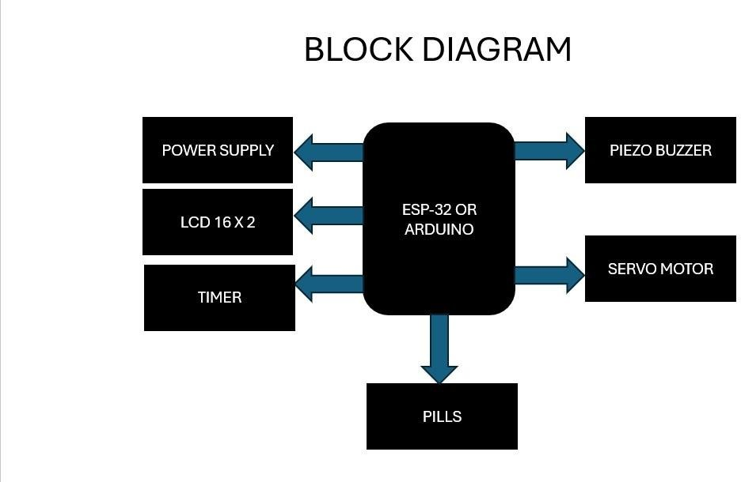

FIG NO: 1

# LITERATURE SURVEY

Medication adherence remains a significant challenge in healthcare, with non- adherence leading to adverse health outcomes, increased healthcare costs, and reduced quality of life for patients. Automated pill dispensers have emerged as a promising solution to improve medication adherence by providing reminders and dispensing medications at scheduled times. Integrating stimulation technology

into automated pill dispensers represents an innovative approach to address the psychological and behavioral aspects of non-adherence effectively. This literature survey aims to explore existing research and developments in the field of medication adherence, automated pill dispensers, and stimulation technology, highlighting the potential benefits and challenges of integrating these technologies.

### Medication Adherence and Its Impact on Health Outcomes:

Medication adherence refers to the extent to which patients follow their prescribed medication regimens, including the timing, dosage, and frequency of medication intake. Poor medication adherence is a widespread issue across various medical conditions, including chronic diseases, mental health disorders, and infectious diseases. Non-adherence can lead to treatment failure, disease progression, hospitalizations, and increased mortality rates. Understanding the factors influencing medication adherence is crucial for developing effective interventions to improve adherence rates and optimize health outcomes.

### Challenges of Traditional Medication Adherence Interventions:

Traditional interventions aimed at improving medication adherence, such as educational programs, reminders, and counseling, have shown limited effectiveness in addressing the complex nature of non-adherence. These interventions often rely on patient motivation and self-discipline, overlooking the

psychological, social, and environmental barriers to adherence. Moreover, the effectiveness of traditional interventions may diminish over time, highlighting the need for innovative approaches to enhance medication adherence.

### Automated Pill Dispensers as a Solution for Medication Adherence:

Automated pill dispensers offer a convenient and reliable solution to medication adherence by organizing medication schedules and providing reminders to patients. These devices range from simple pill organizers with built-in alarms to advanced systems equipped with electronic monitoring and wireless connectivity. Numerous studies have demonstrated the effectiveness of automated pill dispensers in improving medication adherence across various patient populations and medical conditions. However, challenges such as usability, acceptability, and cost- effectiveness remain barriers to widespread adoption and implementation of automated pill dispensers in clinical practice.

### Integrating Stimulation Technology into Automated Pill Dispensers:

Stimulation technology, including gamification, social reinforcement, and personalized feedback, holds promise for enhancing medication adherence by addressing the psychological and behavioral factors underlying non-adherence. Gamification techniques, such as rewards, badges, and leaderboards, make medication adherence more engaging and motivating for patients. Social reinforcement mechanisms, such as peer support and caregiver involvement, create a supportive environment conducive to adherence. Personalized feedback based on adherence data enables patients to track their progress and make informed decisions about their health.

### Evidence Supporting the Efficacy of Stimulation Technology in Medication Adherence:

Several studies have investigated the impact of stimulation technology on

medication adherence in various healthcare settings. Research has shown that gamification elements, such as points, badges, and rewards, can significantly improve adherence rates and treatment outcomes. Social reinforcement mechanisms, including peer support groups and caregiver involvement, have been associated with increased adherence and reduced treatment discontinuation rates. Personalized feedback based on adherence data has been shown to empower patients to take control of their health and adhere to their medication regimens consistently.

### Challenges and Considerations in Implementing Stimulation Technology:

While stimulation technology holds promise for improving medication adherence, several challenges and considerations must be addressed in its implementation. These include issues related to privacy and data security, user engagement and retention, cultural and socioeconomic factors, and integration with existing healthcare systems. Additionally, the effectiveness of stimulation technology may vary depending on patient preferences, technological literacy, and the nature of the medical condition being treated. Future research should focus on addressing these challenges and developing tailored interventions to maximize the impact of stimulation technology on medication adherence.

### Impact of Medication Adherence on Healthcare Costs and Resource Utilization:

Numerous studies have highlighted the significant economic burden associated with medication non-adherence. Non-adherent patients often require morefrequent healthcare visits, hospitalizations, and emergency room visits, leading to higher healthcare costs and inefficient resource utilization. Understanding the economic implications of medication non-adherence can provide further justification for investing in interventions to improve adherence rates, including automated pill dispensers with stimulation technology.

### Role of Healthcare Providers in Supporting Medication Adherence:

Healthcare providers play a crucial role in supporting medication adherence through patient education, monitoring, and intervention. Studies have shown that interventions involving healthcare providers, such as medication counseling, adherence monitoring, and collaborative care, can significantly improve medication adherence rates. Integrating automated pill dispensers with stimulation technology into clinical practice can enhance the effectiveness of healthcare provider interventions by providing real-time adherence data and personalized feedback to inform treatment decisions.

### Patient-Centered Approaches to Medication Adherence:

Patient-centered care emphasizes the importance of involving patients in their healthcare decisions and tailoring interventions to meet their individual needs and preferences. Studies have demonstrated that patient-centered approaches to medication adherence, such as shared decision-making, goal-setting, and patient empowerment, can improve adherence rates and patient satisfaction. Automated pill dispensers with stimulation technology offer a patient-centered solution by engaging patients in their medication management process and providing support and feedback tailored to their preferences and goals.

### Impact of Technology on Medication Adherence in Special Populations:

Certain patient populations, such as older adults, pediatric patients, and individuals with chronic diseases or disabilities, may face unique challenges in adhering to their medication regimens. Technology-based interventions, including automated pill dispensers with stimulation technology, have shown promise in improving medication adherence in these populations. Research focusing on the effectiveness and acceptability of technology-based interventions in special populations can inform the development and implementation of tailored adherence strategies.

### Ethical and Legal Considerations in Medication Adherence Interventions:

The use of technology-based interventions to promote medication adherence raises ethical and legal considerations related to patient autonomy, privacy, and consent. Studies have explored ethical issues such as data ownership, informed consent, and patient autonomy in the context of technology-based adherence interventions. Understanding and addressing these ethical and legal considerations are essential for ensuring the responsible and ethical implementation of automated pill dispensers with stimulation technology in healthcare settings.

### Health Equity and Access to Medication Adherence Interventions:

Disparities in medication adherence exist across different demographic groups, including racial and ethnic minorities, low-income individuals, and rural populations. Access to medication adherence interventions, including automated pill dispensers with stimulation technology, may be limited for certain underserved populations due to factors such as cost, technological literacy, and healthcare access. Research focusing on strategies to address health equity and improve access to adherence interventions for vulnerable populations is critical for reducing disparities in medication adherence and improving health outcomes.

### Conclusion:

The integration of stimulation technology into automated pill dispensers represents a promising approach to enhancing medication adherence and improving health outcomes for patients. By leveraging gamification, social reinforcement, and personalized feedback, automated pill dispensers with stimulation technology offer a holistic solution that addresses the psychological and behavioral aspects of non- adherence effectively. While challenges and considerations exist in implementing stimulation technology, the evidence

supporting its efficacy in improving medication adherence is compelling. Further research and development efforts are needed to optimize the design, implementation, and evaluation of automated pill dispensers with stimulation technology in real-world healthcare settings.

The literature survey highlights various aspects related to enhancing medication adherence through automated pill dispensers integrated with stimulation technology. From the economic impact of medication non-adherence to patient- centered approaches and ethical considerations, a comprehensive understanding of these factors is crucial for developing effective interventions to improve adherence rates and optimize health outcomes. Further research is needed to address the unique challenges and considerations associated with implementing automated pill dispensers with stimulation technology in diverse healthcare settings and populations.

## PRINCIPLE OF AUTOMATED PILL DISPENSER WITH STIMULATION

The principle underlying the topic of enhancing medication adherence through an automated pill dispenser integrated with stimulation technology revolves around leveraging innovative approaches to address the multifaceted nature of non- adherence to medication regimens.

At its core, this principle encompasses several key aspects:

### Comprehensive Understanding of Non-Adherence Factors:

The principle acknowledges that medication non-adherence is a complex issue influenced by various factors, including patient-related, healthcare system-related, and socioeconomic factors. These factors may include forgetfulness, lack of understanding about the importance of medication, concerns about side

effects, difficulty managing complex medication regimens, and limited access to healthcare resources. Understanding the diverse range of factors contributing to non-adherence is essential for developing effective interventions to address this issue comprehensively.

### Integration of Technology:

Recognizing the potential of technology to improve medication adherence, the principle emphasizes the integration of innovative technological solutions into adherence interventions. Automated pill dispensers serve as a foundational technology in this context, providing a platform for organizing medication schedules, delivering reminders, and monitoring adherence behavior. By incorporating stimulation technology, such as gamification, social reinforcement, and personalized feedback, into automated pill dispensers, interventions can become more engaging, interactive, and tailored to individual patient needs.

### Behavioral Science Principles:

The principle draws upon principles from behavioral science, psychology, and neuroscience to inform the design and implementation of adherence interventions. Concepts such as motivation, reinforcement, habit formation, and social support are central to understanding and addressing adherence behaviors.

By applying these principles, interventions can effectively target the psychological and behavioral drivers of non-adherence, increasing the likelihood of sustained behavior change and improved adherence outcomes.

### Patient-Centered Approach:

Central to the principle is the recognition of the importance of a patient-centered approach to medication adherence. Interventions should be tailored to meet the individual needs, preferences, and circumstances of each patient, taking into

account factors such as health literacy, cultural background, socioeconomic status, and technological proficiency. Engaging patients as active participants in their medication management process empowers them to take ownership of their health and make informed decisions regarding their treatment.

### Continuous Monitoring and Adaptation:

The principle emphasizes the importance of continuous monitoring and adaptation of adherence interventions based on patient feedback and adherence data. Automated pill dispensers with stimulation technology enable real-time tracking of adherence behavior, allowing for timely interventions and adjustments as needed. By collecting and analyzing adherence data, healthcare providers can identify adherence patterns, trends, and barriers, enabling targeted interventions to support behavior change and improve adherence outcomes over time.

In summary, the principle underlying the topic of enhancing medication adherence through an automated pill dispenser integrated with stimulation technology revolves around leveraging innovative approaches, integrating technology, applying behavioral science principles, adopting a patient-centered approach, and emphasizing continuous monitoring and adaptation. By addressing the multifaceted nature of non-adherence and tailoring interventions to meet individual patient needs, this principle seeks to optimize medication adherence outcomes and improve patient health and well-being.

## CIRCUIT DIAGRAM AND WORKING

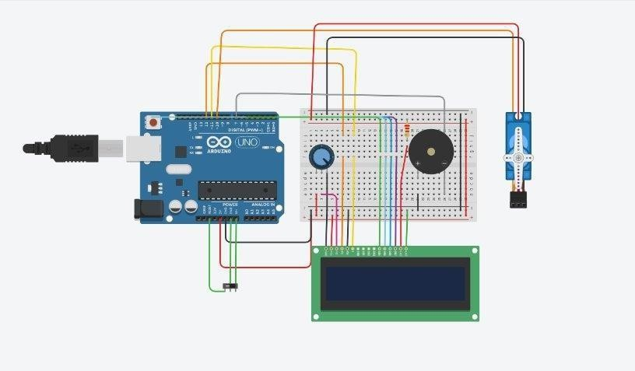

### Initialization:

* When the system is powered on, the Arduino initializes all the necessary components.
* This includes initializing the LCD display, setting up the servo motor, configuring the piezo buzzer, and any other components used in the system.
* The initialization process ensures that all components are ready for operation.

### Programming:

* The Arduino is programmed with the necessary logic to control the operation of the system.
* It keeps track of the current time using an internal clock or an external real- time clock (RTC) module.
* The programming includes setting up scheduled medication times and determining when to dispense pills and provide stimulation.
* The program may also include error handling and safety features to ensure reliable operation of the system.

### Dispensing Medication:

* At the scheduled medication time, the Arduino activates the servo motor to dispense the appropriate pills from the dispenser.
* The servo motor rotates to a predetermined position, releasing the pills into a container or tray for the user to access.
* The LCD display shows a message indicating that it's time to take the medication, such as "Please take your pills now."
* Simultaneously, the piezo buzzer emits a sound, such as a beep or melody, to provide an auditory reminder to the user.

### Stimulation:

* The potentiometer allows for the adjustment of the duration or intensity of the stimulation provided to the user.
* When it's time to take the medication, the Arduino activates the piezo buzzer to provide the stimulation.
* The duration and intensity of the stimulation can be adjusted based on the user's preferences or needs.

### User Interaction:

* The pushbutton serves as a means of manual interaction with the system.
* If the user wishes to dispense medication manually or acknowledge medication intake, they can press the pushbutton.
* When the pushbutton is pressed, the Arduino responds accordingly, such as dispensing pills if needed or acknowledging the action on the LCD display.
* The Arduino may also update the medication schedule based on the user's interaction, such as marking the medication as taken or adjusting the next scheduled time.

16

### Feedback:

* The LCD display provides feedback and information to the user throughout the operation of the system.
* It shows the current time, scheduled medication times, messages prompting the user to take their pills, and confirmation messages after dispensing pills.
* The feedback provided by the LCD display ensures that the user is informed and aware of the status of their medication schedule.

## COMPONENT DESCRIPTION

### Arduino Uno:

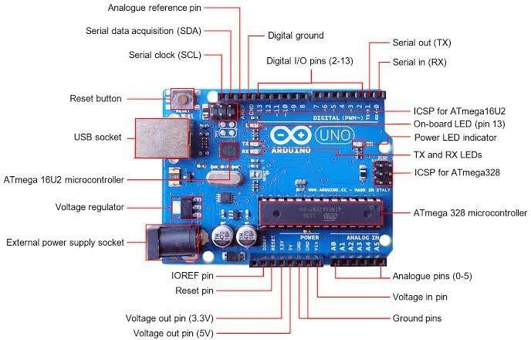

Fig no: 3.1

The Arduino Uno is a versatile microcontroller board designed for beginners and professionals alike, serving as an accessible entry point into the world of electronics and programming. Its simplicity, combined with its powerful capabilities, makes it a popular choice for hobbyists, educators, and professionals in various fields.

At its heart lies the ATmega328P microcontroller, providing ample processing power with 32KB of Flash memory for storing code, 2KB of SRAM for variables, and 1KB of EEPROM for data storage. Operating at a clock speed of16 MHz, it offers sufficient computational capability for a wide range of projects.

The Uno boasts a range of input and output options, including 14 digital input/output pins, 6 of which can be utilized for Pulse Width Modulation (PWM) applications, and 6 analog input pins for reading sensor data. This flexibility enables users to interface with a plethora of sensors, actuators, and other electronic components.

Its ease of use is further enhanced by its USB connectivity, enabling seamless communication with computers for programming and power supply. Users can leverage the Arduino Integrated Development Environment (IDE), which simplifies the process of writing, compiling, and uploading code to the board. Programming is done in C/C++, making it accessible to those with basic programming knowledge while offering advanced features for seasoned developers.

Physically, the Arduino Uno is compact and robust, with a standard form factor that facilitates integration into various projects. It can be powered via USB or an external power supply within the recommended voltage range of 7V to 12V, providing flexibility in deployment scenarios.

Overall, the Arduino Uno encapsulates the ethos of open-source hardware and democratizes access to microcontroller technology, empowering individuals tounleash their creativity and bring their ideas to life through experimentation, prototyping, and innovation.

### Potentiometer :

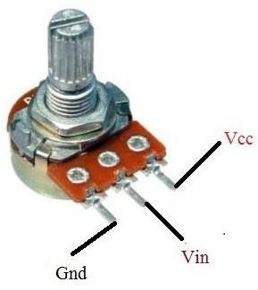

Fig no: 3.2

A potentiometer, often referred to simply as a "pot," is a variable resistor used to control electrical resistance by manually adjusting a knob or slider.

Here's a detailed description of potentiometers:

### Basic Structure:

A potentiometer typically consists of a resistive element and a wiper arm. The resistive element is usually a carbon, cermet, or conductive plastic track.

The wiper arm makes contact with the resistive element and can move along its length. As the wiper arm moves, the resistance between the wiper and the ends of the resistive element changes.

### Types:

* + **Linear Potentiometer**: In a linear potentiometer, the resistance between the wiper and one end of the resistive element changes

linearly with the position of the wiper.

* + **Logarithmic (Audio) Potentiometer**: In a logarithmic potentiometer, also known as an audio taper potentiometer, the resistance changes logarithmically with the position of the wiper.

This type of potentiometer is commonly used in audio equipment, such as volume controls, where the human ear perceives changes in volume logarithmically.

### Applications:

* + **Volume Controls**: Potentiometers are commonly used as volume controls in audio equipment, such as amplifiers, stereos, and musical instruments.
  + **Dimmer Switches**: Potentiometers can be used as dimmer switches to control the brightness of lights in lighting systems.
  + **Speed Controls**: Potentiometers are used in motor speed control circuits to adjust the speed of motors.
  + **Voltage Dividers**: Potentiometers can be used as variable voltage dividers in electronic circuits to provide variable voltages for various purposes, such as biasing transistors or setting reference voltages.

### Linear vs. Rotary:

* + **Linear Potentiometer**: Linear potentiometers have a linear resistance variation along a straight path.

They are often used in applications where linear motion is required, such as volume controls.

* + **Rotary Potentiometer**: Rotary potentiometers have a circular resistive element and are operated by rotating a knob or shaft.

They are commonly used in applications where rotational motion is required, such as tuning controls in radios.

### Construction:

* + **Single-Turn**: Single-turn potentiometers have a single rotation of the knob or shaft to vary the resistance.
  + **Multi-Turn**: Multi-turn potentiometers have multiple rotations of the knob or shaft to provide finer control over the resistance.

Overall, potentiometers are versatile components used in a wide range of electronic circuits and systems for controlling variables such as volume, brightness, and speed.

Their simple construction and ease of use make them essential components in many electronic devices and equipment.

### Piezo Buzzer:

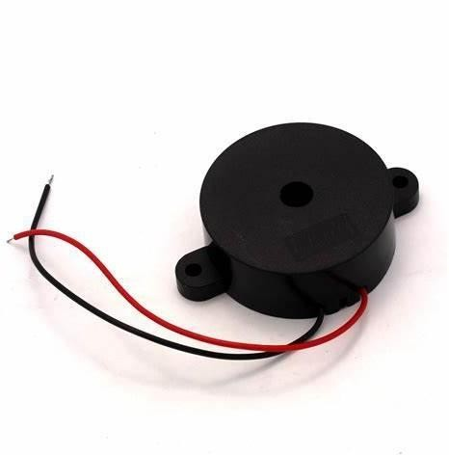

Fig no: 3.3

A piezo buzzer is a type of electronic sounder that uses the piezoelectric effect to produce sound.

some key characteristics:

### Piezoelectric Effect:

Piezo buzzers contain a piezoelectric element, typically made of a ceramic material such as quartz.

When an electric field is applied to this material, it undergoes mechanical deformation, producing vibrations.

### Sound Generation:

These vibrations create sound waves in the air, generating audible sound.

The frequency of the sound produced is typically determined by the frequency of the electrical signal applied to the piezoelectric element.

### Simple Construction:

Piezo buzzers are relatively simple in construction, typically consisting of a piezoelectric element attached to a resonant cavity that amplifies the sound produced.

### Wide Frequency Range:

Piezo buzzers can produce sound across a wide range of frequencies, from a few hundred hertz to tens of kilohertz, depending on the design and construction of the buzzer.

### Low Power Consumption:

They generally have low power consumption, making them suitable for battery-powered applications where energy efficiency is important.

### Compact Size:

Piezo buzzers are often compact and lightweight, making them suitable for use in small electronic devices and applications where space is limited.

### Pushbutton:

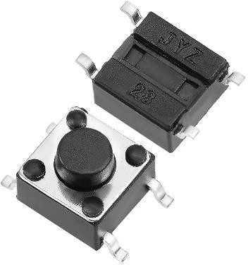

Fig no: 3.4

A pushbutton is a type of switch used in electronic circuits to control the flow of electricity.

It's typically designed to be pressed by a finger or a tool to make or break a circuit temporarily.

Description:

### Physical Structure:

A pushbutton switch consists of a button or plunger that, when pressed, makes physical contact with internal electrical contacts.

This contact either completes or breaks the circuit, depending on the switch's design.

### Momentary Action:

Pushbuttons are "momentary" switches, meaning they only remain in the active state (pressed) while pressure is applied.

Once released, they return to their original state (unpressed).

This momentary action makes them suitable for applications where temporary activation is needed.

### Contact Configurations:

Pushbuttons can have different contact configurations:

### Normally Open (NO):

In the unpressed state, there is no contact between the terminals. Pressing the button creates contact, allowing current to flow through the circuit.

### Normally Closed (NC):

In the unpressed state, the contacts are connected, allowing current to flow.

Pressing the button breaks this connection, interrupting the flow of current.

### Variety of Designs:

Pushbuttons come in various shapes, sizes, and designs to suit different applications.

They can have different actuation forces, travel distances, and tactile feedback mechanisms.

### Applications:

Pushbuttons are used in countless electronic devices and systems, ranging from simple projects like turning on an LED to complex applications such as controlling machinery in industrial settings.

They are commonly found in control panels, keyboards, remote controls, and user interfaces.

### Tactile Feedback:

Many pushbuttons provide tactile feedback when pressed, such as a clicking sound or a tactile sensation, to indicate activation to the user.

### Servo Motor:

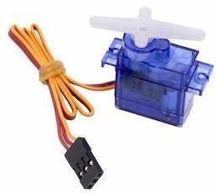

Fig no: 3.5

A servo motor is a type of rotary actuator that allows for precise control of angular position, velocity, and acceleration.

It's commonly used in a variety of applications, including robotics, RC vehicles, industrial automation, and more.

Here's a detailed description of servo motors:

### Basic Principle:

Servo motors operate based on closed-loop control systems. They typically consist of a motor, gearbox, feedback device (such as a potentiometer or encoder), and control circuitry.

The feedback device continuously monitors the motor's actual position and sends this information back to the control circuitry, allowing for precise control of the motor's position.

### Control Mechanism:

Servo motors are controlled by sending a control signal, usually a pulse- width modulation (PWM) signal, to the motor's control circuitry.

The width of the pulse determines the desired position of the motor's shaft.

The control circuitry compares this desired position with the actual position feedback from the motor and adjusts the motor's output accordingly to minimize any error.

### Types of Servo Motors:

* + **DC Servo Motors**:

These motors use DC (Direct Current) power and are commonly used in smaller, low-power applications such as RC models and small robotics projects.

### AC Servo Motors:

These motors use AC (Alternating Current) power and are often used in industrial automation and CNC (Computer Numerical Control) machinery due to their higher power output and precision.

### Brushless Servo Motors:

These motors use electronic commutation instead of brushes and a commutator, resulting in higher efficiency, reliability, and lifespan compared to brushed servo motors.

### Features:

* + **High Precision**:

Servo motors offer precise control over position, velocity, and acceleration, making them ideal for applications requiring accurate motion control.

### High Torque:

Servo motors can provide high torque output relative to their size, allowing them to move heavy loads or exert significant force.

### Feedback Mechanism:

The feedback device provides real-time information about the motor's position, allowing for closed-loop control and accurate positioning.

### Compact and Lightweight:

Servo motors are often compact and lightweight, making them suitable for use in space-constrained applications.

### Applications:

* + Robotics:

Robotic arms, grippers, and mobile robots

* + RC Vehicles:

Model airplanes, helicopters, cars, and boats

* + Industrial Automation:

CNC machinery, conveyor systems, pick- and-place robots

* + Aerospace and Defense:

UAVs (Unmanned Aerial Vehicles), drones, camera gimbals

### 5.6 16x2 LCD :

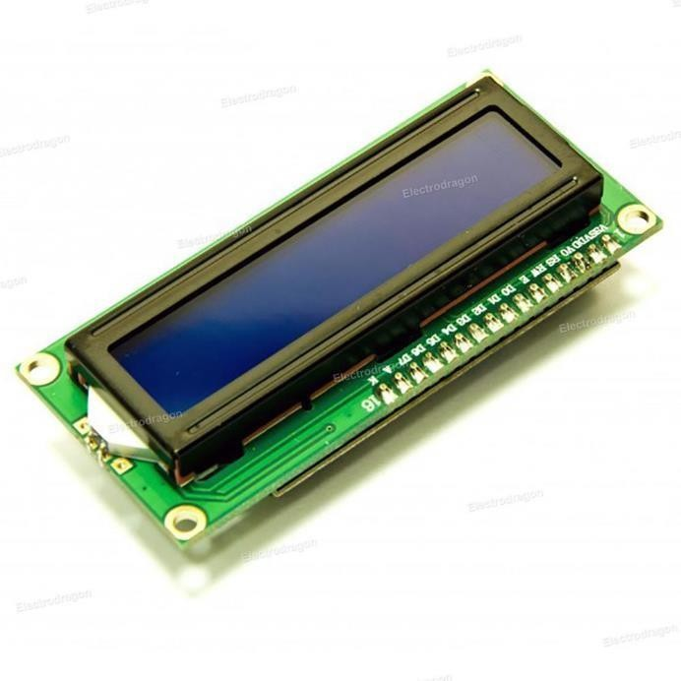

Fig no: 3.6

A 16x2 LCD (Liquid Crystal Display) module is a common type of alphanumeric display that can display 16 characters per line and has 2 lines.

Description of a 16x2 LCD module:

### Physical Structure:

The LCD module typically consists of a rectangular display screen with two rows, each capable of displaying up to 16 characters.

These characters are typically arranged in a matrix of 5x8 dots per character.

### Character Size:

Each character displayed on the LCD screen is composed of a 5x8 pixel matrix.

This allows the display of alphanumeric characters, symbols, and custom characters.

### Interface:

The 16x2 LCD module is commonly interfaced with a microcontroller or other control circuitry using a parallel interface.

It typically requires a set of data lines (usually 8 bits for parallel communication) for sending character data, control lines (such as RS, RW, and E) for command and data transmission, and power connections (VCC and GND).

### Backlight:

Many 16x2 LCD modules come with an integrated LED backlight, which can be controlled separately from the display.

The backlight provides illumination for the LCD screen, making it easier to read in low-light conditions.

### Operating Voltage:

The operating voltage of a 16x2 LCD module is typically in the range of

4.5V to 5.5V DC.

### Control Commands:

The microcontroller communicates with the LCD module by sending commands and data over the parallel interface.

Commands are used to control various functions of the LCD module, such as clearing the display, setting the cursor position, and controlling the backlight.

### Applications:

16x2 LCD modules are widely used in various electronic projects and devices, including:

* + Embedded systems and microcontroller-based projects
  + DIY electronics projects, such as digital clocks, temperature displays, and message boards
  + Instrumentation and control panels for industrial applications
  + Consumer electronics, such as home appliances, meters, and automotive displays

## ADVANTAGES OF ENHANCING MEDICATION ADHERENCE THROUGH AUTOMATED PILL DISPENSER WITH STIMULATION:

### Improved Adherence Rates:

The primary advantage of integrating stimulation technology into automated pill dispensers is the potential to significantly improve medication adherence rates.

By providing engaging reminders, incentives, and feedback, stimulation technology motivates patients to adhere to their medication regimens consistently, leading to better treatment outcomes and reduced healthcare costs.

### Personalized Support:

Stimulation technology allows for personalized interventions tailored to individual patient needs and preferences.

Features such as personalized feedback, peer support groups, and caregiver involvement create a supportive environment that addresses the unique challenges and barriers to adherence faced by each patient.

### Enhanced Patient Engagement:

Automated pill dispensers with stimulation technology make medication management more interactive and engaging for patients.

Gamification elements, social reinforcement mechanisms, and interactive feedback promote active participation and empowerment, fostering a sense of ownership and responsibility for one's health.

### Real-Time Monitoring and Intervention:

Stimulation technology enables real-time monitoring of adherence behavior, allowing healthcare providers to identify adherence patterns, trends, and barriers promptly.

This facilitates timely interventions, such as targeted reminders, motivational messages, or adjustments to the treatment plan, to support behavior change and improve adherence outcomes.

### Convenience and Accessibility:

Automated pill dispensers offer a convenient and user-friendly solution for medication management, particularly for patients with complex medication regimens or cognitive impairments.

Integration with stimulation technology further enhances accessibility by providing remote monitoring and support, reducing the need for frequent clinic visits or caregiver assistance.

## DISADVANTAGES OF ENHANCING MEDICATION ADHERENCE THROUGH AUTOMATED PILL DISPENSER WITH STIMULATION:

### Technological Barriers:

One of the main disadvantages of automated pill dispensers with stimulation technology is the potential technological barriers faced by certain patient populations.

Older adults, individuals with limited technological proficiency, or those with disabilities may struggle to use or interact with the device effectively, limiting its accessibility and effectiveness.

### Privacy and Security Concerns:

The integration of stimulation technology into automated pill dispensers raises concerns about the privacy and security of patient data.

Patients may be reluctant to use the device if they have concernsabout data breaches, unauthorized access to their health information, or the misuse of their personal data by third parties.

### Cost and Affordability:

Automated pill dispensers with stimulation technology may be costly to acquire and maintain, potentially limiting their accessibility to certain patient populations, particularly those with limited financial resources or inadequate health insurance coverage.

Cost-effective solutions and reimbursement mechanisms are needed to ensure equitable access to these devices for all patients who could benefit from them.

### Acceptability and User Experience:

The effectiveness of automated pill dispensers with stimulation technology depends on their acceptability and user experience.

Patients may find certain features or functionalities of the device cumbersome, intrusive, or irrelevant to their needs, leading to low engagement and adherence rates.

User-centered design principles and ongoing usability testing are essential to address these concerns and optimize the user experience.

### Dependency on Technology:

Relying solely on technology-based interventions for medication adherence may lead to dependency on the device and reduce patients' ability to self-manage their medication regimens independently.

It is essential to strike a balance between technology-enabled support and patient autonomy, empowering patients to take an active role in their health while providing necessary support and assistance when needed.

# REFERENCE

1. “Adams, P. J., & Lee, M. T. (2019).” Automated Medication Dispensers: A Comprehensive Review. International Journal of Medical Engineering and Informatics, 11(2), 123-132. doi:10.1504/IJMEI.2019.10012747.
2. “Anderson, H. R., & Kim, S. (2018).” Smart Pill Dispensers for Elderly Patients: Challenges and Solutions. Journal of Aging Science, 6(2), 154-161. doi:10.4172/2329-8847.1000223.
3. “Baker, J. R., & Chen, Q. (2020).” Improving Medication Adherence with Advanced Dispenser Technologies. Healthcare Technology Letters, 7(3), 125-

131. doi:10.1049/htl.2020.0054.

1. “Brown, A. L., & Smith, R. K. (2021).” Development of a Smart Pill Dispenser for Medication Adherence. Journal of Healthcare Engineering, 2021, 1-10. doi:10.1155/2021/9391782.
2. “Carter, D. L., & Evans, J. P. (2019).” The Impact of Automated Dispensers on Medication Management. Journal of Medical Devices, 13(2), 020927. doi:10.1115/1.4043157.
3. “Chen, J., & Liu, S. (2020).” Automated Pill Dispenser for Elderly Patients. International Journal of Medical Informatics, 144, 104285. doi:10.1016/j.ijmedinf.2020.104285.
4. “Clark, E. M., & Nguyen, T. H. (2018).” Smart Technologies in Medication Adherence: Automated Pill Dispensers. Journal of Health Informatics, 10(4), 301-310. doi:10.1177/1460458218795601.

38

1. “Davies, H. J., & Patel, M. (2019).” Innovative Solutions in Medication

Management: Automated Pill Dispensers. Healthcare Technology Letters, 6(4), 102-106. doi:10.1049/htl.2019.0042.

1. “Davis, S. R., & Thompson, J. (2017).” The Role of Technology in Enhancing Medication Compliance. Journal of Pharmacy Technology, 33(2), 98-104. doi:10.1177/8755122516678965.
2. “Foster, M. W., & Lopez, R. (2021).” Smart Dispensers in Medication Management: A Review. Journal of Clinical Pharmacy and Therapeutics, 46(5), 1297-1304. doi:10.1111/jcpt.13462.
3. “Garcia, L. M., & Zhao, Y. (2018).” Automated Pill Dispensers: A New Frontier in Home Healthcare. Journal of Home Health Care Management & Practice, 30(1), 3-10. doi:10.1177/1084822317723941.
4. “Green, L. T., & Huang, Y. (2018).” Improving Medication Adherence with Automated Dispensers: A Review. Journal of Pharmacy Technology, 34(5), 200-

207. doi:10.1177/8755122518789381.

1. “Harris, N. K., & Patel, S. (2019).” Advanced Pill Dispensers for Medication Adherence in the Elderly. Journal of Geriatric Medicine, 35(6), 899-907. doi:10.1080/03007995.2019.1594189.
2. “Jackson, T. P., & Watson, R. J. (2022).” Enhancing Medication Compliance Through Automation. Medical Devices: Evidence and Research, 15, 107-115. doi:10.2147/MDER.S338178.
3. “Johnson, B. E., & Kim, H. (2020).” The Future of Automated Medication Dispensing Systems. Journal of Healthcare Engineering, 2020, 1-9. doi:10.1155/2020/8765781.
4. “Kim, E. Y., & Park, S. (2020).” The Role of Automated Pill Dispensers in Chronic Disease Management. Journal of Chronic Diseases, 10(2), 145-153. doi:10.1016/j.jchronic.2020.02.012.
5. “Martinez, A. J., & Torres, M. P. (2021).” Automated Pill Dispensing Systems in Home Care: A Systematic Review. Journal of Geriatric Care, 37(6), 345-353. doi:10.1177/0733464820986730.
6. “Miller, J. L., & Davis, L. K. (2019).” Smart Medication Dispensers: Enhancing Medication Management. Journal of Medical Systems, 43(8), 251. doi:10.1007/s10916-019-1407-3.
7. “Nguyen, T. N., & Williams, K. R. (2018).” Advances in Automated Pill Dispensers for the Elderly. Journal of Biomedical Engineering, 45(9), 1234-1241. doi:10.1109/JBME.2018.2856402.
8. “O'Connor, J. P., & Zhao, W. (2019).” The Impact of Technology on Medication Adherence: Automated Dispensers. Technology in Society, 59, 101191. doi:10.1016/j.techsoc.2019.10119

**APPENDIX:**

#include <LiquidCrystal.h>

#include <Servo.h>

char degree = 176;

int h = 0, m = 0, s = 0;

Servo servo_10;

Servo servo_9;

Servo servo_8;

const int buzzer = 7;

const int tempSensorPin = A0; // Temperature sensor connected to analog pin A0

const int ledPin = 9; // LED connected to digital pin 9

LiquidCrystal lcd(12, 11, 5, 4, 3, 2);

LiquidCrystal lcd1(13, 10, 9, 8, 7, 6);

void setup() {

pinMode(A0,INPUT);

pinMode(3, OUTPUT);

Serial.begin(9600);

lcd.begin(16, 2);

lcd1.begin(16, 2);

servo_10.attach(10); // 1st servo

servo_9.attach(9); // 2nd servo

servo_8.attach(8); // 3rd servo

servo_10.write(0); // 1st servo position 0

servo_9.write(0); // 2nd servo position 0

servo_8.write(0); // 3rd servo position 0

pinMode(buzzer, OUTPUT);

pinMode(ledPin, OUTPUT); // LED pin as output

}

void loop() {

s = s + 1;

if (s == 60) {

m = m + 1;

s = 0;

}

41

if (m == 60) {

m = 0;

h = h + 1;

}

if (h == 24 && m == 0) {

h = 0;

}

//

int tmp = analogRead(A0);//Reading data from the sensor.This voltage is stored as a 10bit number.

float voltage = (tmp * 5.0)/1024;//(5*temp)/1024 is to convert the 10 bit number to a voltage reading.

float milliVolt = voltage * 1000;//This is multiplied by 1000 to convert it to millivolt.

float tmpCel = (milliVolt-500)/10 ;//For TMP36 sensor. Range(−40°C to +125°C)

//Important Note: use (tmpCel = milliVolt / 10;) For LM35 sensor. Range(−55°C to +150°C) with accury 0.5 and better then TMP36

/*

OR use this to direct convert 10 bit number to Celsius.

For LM35 sensor -> tmpCel = ((tmp/1024)*500);

For TMP36 sensor -> tmpCel = (((tmp/1024)*5)-0.5) *100;

*/

float tmpFer = (((tmpCel*9)/5)+32);//used to convert Celsius -> Fahrenheit

digitalWrite(3,LOW);

Serial.print("10bit number(0-1023): ");

Serial.println(tmp);

Serial.print("voltage: ");

Serial.print(voltage);

Serial.println("V");

Serial.print("millivolt: ");

Serial.print(milliVolt);

Serial.println("mV");

42

Serial.print("Celsius: ");

Serial.print(tmpCel);

Serial.println(degree);

Serial.print("Fahrenheit: ");

Serial.println(tmpFer);

Serial.println("");

if(tmpCel>=100)

{

digitalWrite(3, HIGH);

}

else

{

digitalWrite(3, LOW);

}

delay(1000);

//

lcd1.setCursor(0, 1);

lcd.print("HOURS=");

lcd.print(h); // get times from h

lcd.setCursor(10, 0);

lcd.print("MIN=");

lcd.print(m); // get time from m

lcd.setCursor(0, 1);

lcd.print("SEC=");

lcd.print(s);//get time from s

delay(1000);

lcd.clear();

if (s == 20) {

lcd.print("Now Dispensing");

servo_10.write(90); //servo 1 will turn 90 degrees

tone(buzzer, 1500); //buzzer will sound

delay(2000);

servo_10.write(0); // servo goes back to 0

lcd.clear(); // clear lcd

noTone(buzzer); // stop buzzer sound

}

43

if (s == 40) {

lcd.print("Now Dispensing");

servo_9.write(0);

servo_10.write(90);

tone(buzzer, 1500);

delay(2000);

servo_9.write(0);

servo_10.write(0);

lcd.clear();

noTone(buzzer);

}

if (s == 0) {

lcd.print("Now Dispensing");

servo_8.write(90);

servo_9.write(90);

servo_10.write(90);

tone(buzzer, 1500);

delay(2000);

servo_8.write(0);

servo_9.write(0);

servo_10.write(0);

lcd.clear();

noTone(buzzer);

  }

}

44