PROGRAM 5

OBJECTIVE: Write a script to implement circle generation algorithm with the following method : cartesian co-ordinate representation,polar co-ordinate representation,Bresenham,midpoint, in above all methods .demonstrate with the following cases

function circle clc;
clear; close all;

disp('--- CARTESIAN CIRCLE GENERATION ---')
xc = input('Enter center X: '); yc = input('Enter center Y: '); r = input('Enter radius: ');
sym = input('Symmetry (1=8way, 2=4way, 3=no symmetry): '); figure;
subplot(2,2,1) cartesian_circle(xc,yc,r,sym) title('Cartesian Method')

disp('--- POLAR CIRCLE GENERATION ---')
xc = input('Enter center X: '); yc = input('Enter center Y: '); r = input('Enter radius: ');
sym = input('Symmetry (1=8way, 2=4way, 3=no symmetry): '); subplot(2,2,2)
polar_circle(xc,yc,r,sym) title('Polar Method')

disp('--- BRESENHAM CIRCLE GENERATION ---')
xc = input('Enter center X: '); yc = input('Enter center Y: '); r = input('Enter radius: ');
sym = input('Symmetry (1=8way, 2=4way, 3=no symmetry): '); subplot(2,2,3)
bresenham_circle(xc,yc,r,sym) title('Bresenham Method')

disp('--- MIDPOINT CIRCLE GENERATION ---')
xc = input('Enter center X: '); yc = input('Enter center Y: '); r = input('Enter radius: ');
sym = input('Symmetry (1=8way, 2=4way, 3=no symmetry): '); subplot(2,2,4)
midpoint_circle(xc,yc,r,sym) title('Midpoint Method') end

function cartesian_circle(xc,yc,r,sym) hold on
axis equal for x=-r:r
y = sqrt(r^2 - x^2); plot_sym(xc,yc,round(x),round(y),sym)
end end

function polar_circle(xc,yc,r,sym) hold on
axis equal
theta = 0:0.01:pi/2; for t = theta
x = r*cos(t); y = r*sin(t);
plot_sym(xc,yc,round(x),round(y),sym) end
end

function bresenham_circle(xc,yc,r,sym) hold on
axis equal x=0;
y=r; d=3-2*r;
while x<=y plot_sym(xc,yc,x,y,sym) if d<0
d = d + 4*x + 6;

else
d = d + 4*(x-y) + 10; y = y-1;
end
x = x+1; end

enD

function midpoint_circle(xc,yc,r,sym) hold on
axis equal x=0;
y=r;
p = 1-r; while x<=y
plot_sym(xc,yc,x,y,sym) x = x+1;
if p<0
p = p + 2*x + 1; else
y = y-1;
p = p + 2*(x-y) + 1; end
end end

function plot_sym(xc,yc,x,y,sym) if sym==1 % 8-way symmetry
pts=[ x y;
y x;
-x y;
-y x;
-x -y;
-y -x;
x -y; y -x];
elseif sym==2 % 4-way symmetry pts=[ x y;
-x y;

-x -y;
x -y];
else % no symmetry pts=[x y];
end
plot(xc+pts(:,1), yc+pts(:,2),'r.') End

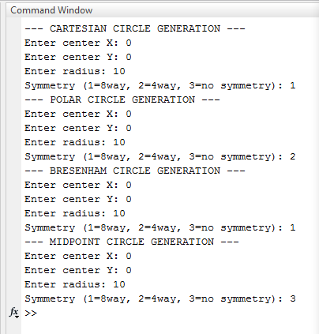
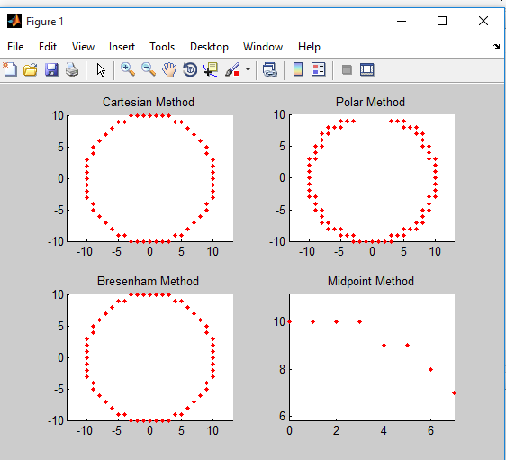
OUTPUT:

PROGRAM 6

OBJECTIVE: Write a script to demonstrate 2-D transformation as per the following manner
- Transition
- Rotation about origin and arbitrary point 3)Scaling
- Shearing
- Mirror Reflection about coordinate axis and arbitrary line
In all cases use triangle as an object and ask the user to enter the parameters for each of the case

function transform2D_triangle clc;
clear; close all;
disp('Enter coordinates of Triangle') for i = 1:3
x(i) = input(['Enter x',num2str(i),': ']);
y(i) = input(['Enter y',num2str(i),': ']); end
x(4) = x(1);
y(4) = y(1);
figure subplot(3,3,1) plot(x,y,'b-o')
title('Original Triangle') axis equal
grid on
tx = input('Enter translation in X direction: '); ty = input('Enter translation in Y direction: '); xt = x + tx;
yt = y + ty; subplot(3,3,2) plot(xt,yt,'r-o') title('Translation') axis equal
grid on
theta = input('Enter rotation angle (degrees) about origin: '); theta = theta*pi/180;

xr = x*cos(theta) - y*sin(theta); yr = x*sin(theta) + y*cos(theta); subplot(3,3,3)
plot(xr,yr,'g-o') title('Rotation about Origin') axis equal
grid on
xp = input('Enter arbitrary point X: '); yp = input('Enter arbitrary point Y: ');
theta = input('Enter rotation angle (degrees): '); theta = theta*pi/180;
for i=1:4
xr2(i) = xp + (x(i)-xp)*cos(theta) - (y(i)-yp)*sin(theta);
yr2(i) = yp + (x(i)-xp)*sin(theta) + (y(i)-yp)*cos(theta); end
subplot(3,3,4) plot(xr2,yr2,'m-o')
title('Rotation about Arbitrary Point') axis equal
grid on
sx = input('Enter scaling factor in X: '); sy = input('Enter scaling factor in Y: '); xs = x * sx;
ys = y * sy; subplot(3,3,5) plot(xs,ys,'c-o') title('Scaling') axis equal grid on
shx = input('Enter shearing factor in X: '); shy = input('Enter shearing factor in Y: '); xsh = x + shx*y;
ysh = y + shy*x; subplot(3,3,6) plot(xsh,ysh,'k-o') title('Shearing') axis equal
grid on
disp('Reflection Options')

disp('1. About X-axis') disp('2. About Y-axis') disp('3. About Origin')
choice = input('Enter your choice: '); switch choice
case 1
xr = x; yr = -y;
case 2
xr = -x; yr = y;
case 3
xr = -x;
yr = -y;
end subplot(3,3,7) plot(xr,yr,'r-o')
title('Mirror Reflection') axis equal
grid on end

OUTPUT:
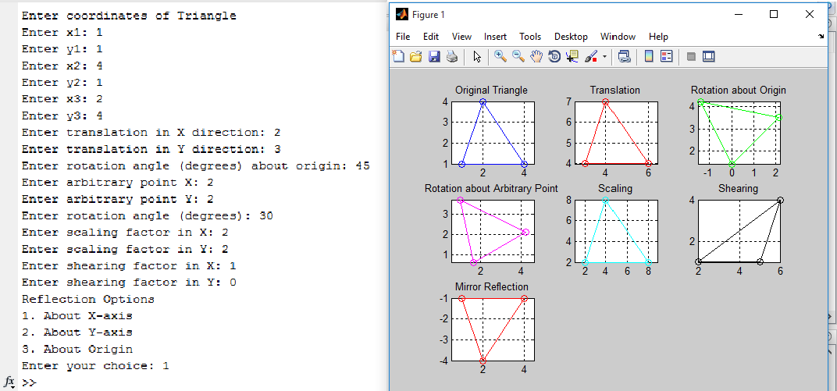

PROGRAM 7

OBJECTIVE:Write a script to calculate the following distance for the following two points 1) Euclidean distance 2. city block 3. chessboard distance

% Take input from user
p1 = input('Enter first point as [x1 y1]: ');
p2 = input('Enter second point as [x2 y2]: ');

% Extract coordinates x1 = p1(1); y1 = p1(2);
x2 = p2(1); y2 = p2(2);

% 1) Euclidean Distance
euclidean = sqrt((x2 - x1)^2 + (y2 - y1)^2);

% 2) City Block (Manhattan) Distance city_block = abs(x2 - x1) + abs(y2 - y1);

% 3) Chessboard (Chebyshev) Distance chessboard = max(abs(x2 - x1), abs(y2 - y1));

% Display results fprintf('\nResults:\n');
fprintf('Euclidean Distance: %.2f\n', euclidean); fprintf('City Block Distance: %.2f\n', city_block); fprintf('Chessboard Distance: %.2f\n', chessboard);

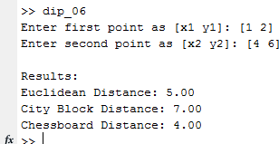
OUTPUT:

PROGRAM 8

OBJECTIVE:Write a script to compute the following adjacent points of the given points
- four connecting
- eight connecting
- diagonal connecting also mention the error

clc; clear;

% Input from user
p = input('Enter the point as [x y]: ');

% Error handling
if ~isnumeric(p) || numel(p) ~= 2
error('Invalid input! Please enter a numeric vector like [x y].'); end

x = p(1);
y = p(2);

% 1) Four-connected neighbors (up, down, left, right) four_connected = [
x-1, y; x+1, y; x, y-1; x, y+1
];

% 2) Eight-connected neighbors (includes diagonals) eight_connected = [
x-1, y; % left x+1, y; % right x, y-1; % down x, y+1; % up
x-1, y-1; % bottom-left x-1, y+1; % top-left x+1, y-1; % bottom-right x+1, y+1 % top-right

];

% 3) Diagonal-connected neighbors only diagonal_connected = [
x-1, y-1;
x-1, y+1;
x+1, y-1; x+1, y+1
];

% Display results
fprintf('\nFour-connected neighbors:\n'); disp(four_connected);

fprintf('Eight-connected neighbors:\n'); disp(eight_connected);

fprintf('Diagonal-connected neighbors:\n'); disp(diagonal_connected);

OUTPUT:
