# Report

ON

### SUMMER TRAINING AT

Reliance Patalganga

By

### Vipul Shrikant Patil

**Pillai HOC college of Engineering and Technology, Rasayani**

Guided By

**Mr. Kantimahanti Sivananda Kumar**

# CERTIFICATE

This is to certify that Mr. Vipul Shrikant Patil, has successfully completed his summer training

At Reliance Patalganga in the partial fulfilment of the Under Graduate Degree course in Computer Engineering, is a bonafied record of project work carried out by him under my supervision.

Mr. K S Kumar Mr. Sanjay B Shukla

Mentor HOD - IT

Datacentre Operations

# ACKNOWLEDGEMENT

I take immense pleasure in thanking **Mr. Prashant B Gaikwad**, HR Learning Dept. for giving me an opportunity to pursue an internship at Reliance Patalganga.

I express my deep gratitude to **Mr. K S Kumar**, Manager IT Operation who has without any hesitation permitted us to undertake the Work Report in Overview of IT System Overview His dedication and keen interest above all his overwhelming attitude to help his student had been solely and mainly responsible for completing my work.

I also thank to **Mr. Sanjay B Shukla**, HOD-IT Dept. for extending his immense support and attention throughout my internship training.

I would also like to extend my thanks to **Mr. Hitendra Mehta, Mr. Narvirsinh Raj of Network & Mr. Santosh Vinekar of Polyester Automation team** for their valuable guidance and supervision.

I would also like to extend my thanks to **Mr. Adapa Kaliprasad** for the support and guidance to give us a project on database linking to a webpage using PHP.

My special thanks to **Mrs. Rohini Bhosale,** Head of Department, Computer Engineering for her kind help and cooperation throughout the project.

Last but not the least, I express my profound gratitude to those who helped me directly or indirectly in my endeavour and infused their help for success of this summer training.

**Gaurav Thakur**

|  |  |  |
| --- | --- | --- |
|  | **INDEX** |  |
| **Serial No** | **Title** | **Page No** |
| **1** | **Safety Training** | **5** |
| 1.1 | Introduction | 5 |
| 1.2 | Safety Equipment | 5 |
| 1.3 | Zero Tolerance | 7 |
| **2** | **Database management system** | **8** |
| 2.1 | Introduction | 8 |
| 2.2 | Types of SQL statements | 10 |
| 2.3 | Normalization IN DBMS | 12 |
| **3** | **Server Backup** | **14** |
| 3.1 | Types of backups | 15 |
| **4** | **Automated Product Handling System** | **16** |
| **5** | **Project** | **21** |
| **6** | **Windows Installation** | **28** |

# SAFETY TRAINING

## 1.1 Introduction

A Safety Management System (SMS) is a systematic approach to managing safety, including the necessary organizational structures, accountabilities, policies and procedures. As per ICAO requirements, service providers are responsible for establishing an SMS, which is accepted and overseen by their State.

## Safety Equipment:

* + - Safety shoes :

A steel-toe boot (also known as a safety boot, steel-capped boot or safety shoe) is a durable boot or shoe that has a protective reinforcement in the toe which protects the foot from falling objects or compression, usually combined with a mid- sole plate to protect against punctures from below.

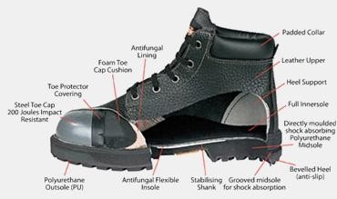

* + - Safety Helmets:

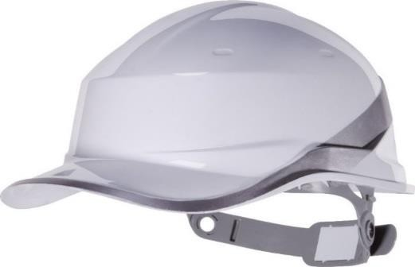A hard hat is a type of helmet predominantly used in workplace environments such as industrial or construction sites to protect the head from injury due to falling objects, impact with other objects, debris, rain, and electric shock. Suspension bands inside the helmet spreads the helmet's weight

and the force of any impact over the top of the head.

* + - Safety gloves:

Safety gloves are hand garments meant for the protection of the wrist, hand, fingers, and thumbs from adverse processes or conditions. These items are virtually limitless in application and find employment in both industrial and commercial marketplaces. Their functionality is determined by the material and design of the glove.



* + - Safety Googles:

Goggles or safety glasses are forms of [protective eyewear](https://en.wikipedia.org/wiki/Eye_protection) that usually enclose or protect the area surrounding the eye in order to prevent particulates, water or [chemicals](https://en.wikipedia.org/wiki/Chemical) from striking the [eyes.](https://en.wikipedia.org/wiki/Human_eye) They are used in [chemistry](https://en.wikipedia.org/wiki/Chemistry) laboratories and in [woodworking](https://en.wikipedia.org/wiki/Woodworking). They are often used in snow sports as well, and in [swimming](https://en.wikipedia.org/wiki/Swimming_(sport)). Goggles are often worn when using [power tools](https://en.wikipedia.org/wiki/Power_tool) such as [drills](https://en.wikipedia.org/wiki/Drill) or [chainsaws](https://en.wikipedia.org/wiki/Chainsaw) to prevent flying particles from damaging the eyes.

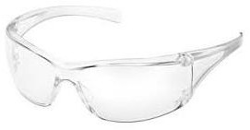

## Zero Tolerance:

A zero**-tolerance** policy is one which imposes strict punishment for infractions of a stated rule, with the intention of eliminating undesirable conduct.

Zero-tolerance policies have been adopted in all around RIL Industries. These policies are usually promoted as preventing smoking, drinking and prohibiting mobile phones. Staff members, workers and other visitors, who possess a banned item or perform any prohibited action for any reason are automatically punished.

Zero Tolerance Rules:

1.) No Smoking, No Drugs, No Alcohol, No Ignition sources. 2.) No Violation of Work Permit Conditions.

3.) No Line Break Without Authorization.

4.) No Entering Confines Space Without Authorization.

# DATABASE MANAGEMENT SYSTEM

## Introduction

Database is an organized collection of data. It is the collection of schema, tables, queries, reports, views and other objects. The data are typically organized to model aspects of reality in a way that supports process requiring information, such as modelling the availability of rooms in hotels in a way that supports finding a hotel with vacancies.

A Database Management System is a computer application that interacts with the user, other application and the database itself to capture and analyse data. Well known DBMS include MySQL, Microsoft SQL Server, oracle, Sybase, IBM DB2, Postgre SQL and SAP HANA.

DATA

Data is distinct pieces of information, usually formatted in a special way. All software is divided into two general categories: data and programs. Data can exist in a variety of forms as numbers or text on pieces of paper, as bits and bytes stored in electronic memory, or as facts stored in a person's mind.

DATABASE

A database is an organized collection of data. It is the collection of schemas, tables, queries, reports, views and other objects.

DBMS

A database management system (DBMS) is system software for creating and managing databases. The DBMS provides users and programmers with a systematic way to create, retrieve, update and manage data.

RDBMS

A relational database management system (RDBMS) is a program that lets you create, update, and administer a relational database.

SQL

SQL stands for Structured Query Language. SQL is used to communicate with a database. According to ANSI (American National Standards Institute), it is the standard language for relational database management systems.

SQL SERVER

SQL Server is a Microsoft product used to manage and store information. Technically, SQL Server is a “relational database management system” (RDMS). Broken apart, this term means two things. First, that data stored inside SQL Server will be housed in a “relational database”, and second, that SQL Server is an entire “management system”, not just a database.

## Types of SQL Statements

* + 1. **Data Definition Language (DDL) Statements:**

The CREATE, ALTER, and DROP commands require exclusive access to the specified object. For example, an ALTER TABLE statement fails if another user has an open transaction on the specified table.

## Data Manipulation Language (DML) Statements:

The SELECT statement is a limited form of DML statement in that it can only access data in the database. It cannot manipulate data in the database, although it can operate on the accessed data before returning the results of the query.

## Data Control Language (DCL) Statements:

Data Control Language (DCL) is used to control privilege in Database. To perform any operation in the database, such as for creating tables, sequences or views we need privileges.

## Data Definition Language (DDL) Statements:

CREATE - to create objects in the database. ALTER - alters the structure of the database. DROP - delete objects from the database.

TRUNCATE - remove all records from a table, including all spaces allocated for the records are removed.

RENAME - rename an object.

## Syntax:

### Create Table Statement :

CREATE TABLE "table_name"

("column 1" "data type for column 1" [column 1 constraint(s)], "Column 2" "data type for column 2" [column 2 constraint(s)],

[Table constraint(s)]);

### Example:

CREATE TABLE product(pr_id numeric(5) primary key not null,pr_name varchar(25) not null,price varchar(5) null,productdesc varchar(100) null)

### Drop Table Statement :

DROP TABLE "table_name";

### Example:

DROP TABLE product

### Truncate Table Statement

TRUNCATE TABLE "table_name";

### Example:

TRUNCATE TABLE product

# Normalization IN DBMS

Normalization is the process of minimizing redundancy from a relation or set of relations. Redundancy in relation may cause insertion, deletion, and update anomalies. So, it helps to minimize the redundancy in relations. Normal forms are used to eliminate or reduce redundancy in database tables.

**Types of Normalization:**

1. 1NF (First Normal Form)
2. 2NF (Second Normal Form)
3. 3NF (Third Normal Form)
4. BCNF (Boyce-Codd Normal Form)
5. 4NF (Fourth Normal Form)
6. 5NF (Fifth Normal Form)
7. 6NF (Sixth Normal Form)

Detailing about the most common types i.e., the first 4:

**First Normal Form:** If a relation contains composite or multi-valued attribute, it violates first normal form or a relation is in first normal form if it does not contain any composite or multi- valued attribute. A relation is in first normal form if every attribute in that relation is singled valued attribute.

**Second Normal Form:** To be in second normal form, a relation must be in first normal form and relation must not contain any partial dependency. A relation is in 2NF if it has No Partial Dependency, i.e., no non-prime attribute (attributes which are not part of any candidate key) is dependent on any proper subset of any candidate key of the table.

**Third Normal Form:** A relation is in third normal form, if there is no transitive dependency for non-prime attributes as well as it is in second normal form.

A relation is in 3NF if at least one of the following condition holds in every non-trivial function dependency X -> Y

1. X is a Super Key
2. Y is a prime attribute (each element of Y is part of some Candidate key).

**Boyce-Codd Normal Form:** A relation R is in BCNF if R is in Third Normal Form and for every FD, LHS is super key. A relation is in BCNF if in every non-trivial functional dependency X –> Y, X is a super key.

**SERVER BACKUP**

Server backup is the process of creating and storing a copy of your server's data on a separate device or location. The data backed up can include critical system files, applications, databases, and user data. The backup can be scheduled to run automatically or initiated manually.

There are several reasons why you might need to perform server backups. Here are some common scenarios:

**Disaster Recovery**: In case of a disaster, such as a fire, flood, or cyberattack, server backup ensures that your data is safe and accessible. With a backup in place, you can restore your servers and get your business up and running quickly

**Human Error**: Accidents happen, and sometimes data can be deleted or overwritten by mistake. Server backup provides a safety net, allowing you to recover data quickly and avoid data loss.

**Hardware Failure**: Servers, like any other hardware, can fail. In case of a hardware failure, a server backup ensures that you can restore your data to a new device without losing anything critical.

Backups can be divided into three categories: full, differential, and incremental.

Let's learn more about the various backup options, how they differ, and which one would work best for your company.

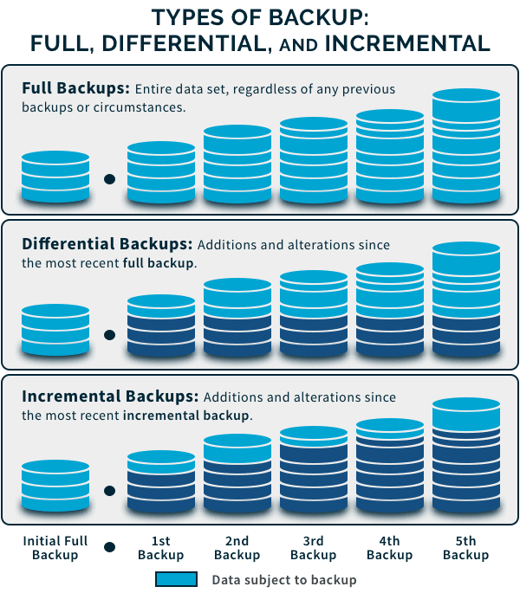

### ****Full Backup****

### The most comprehensive backup is a full backup, which copies all the chosen data. This include documents, directories, SaaS programs, hard disks, and more. A complete backup's best feature is how quickly data can be restored. However, compared to other forms of backup, it takes longer to backup because everything is done at once.

### Running complete backups frequently also overuses the available storage. Due of this, the majority of businesses frequently perform a full backup followed by a differential or incremental backup. This speeds up backups by lessening the demand on the storage space.

### ****Differential Backup****

Between a full and an incremental backup, a differential backup sits. Data that has been added to or modified since the last complete backup is backed up with this sort of backup. Simply said, after doing a full backup, additional backups are executed to include all changes made to the files and directories.

Since it only needs two backup components—the first full backup and the most recent differential backup—you can restore data more quickly than with a full backup.

Let’s see how a differential backup works:

**Day 1** – Schedule a full backup

**Day 2** – Schedule a differential backup. It will cover all the changes that took place between Day 1 and Day 2

**Day 3** – Schedule a differential backup. It will make a copy of all the data that has changed from Day 2 (this includes the full backup on Day 1 + differential backup) and Day 3.

### ****Incremental Backup****

A complete backup is the initial backup in an incremental backup. Only modifications made since the last backup will be retained in subsequent backups. Businesses have more freedom to rotate these backups as frequently as they like, storing only the most recent changes.

Since just the changes (increments) need to be stored, incremental backups can be completed very quickly.

# Automated Product Handling System

## Introduction to APHS:

More than 120 automation systems installed worldwide, Salmoiraghi may certainly be considered as the absolute market leader.

Our Automated Handling System featuring high efficiency and excellent cost performance ratio incorporate highly innovative solutions developed along the years (many of which are protected by international patents).

We offer a wide range of field-proven solutions for handling and computerized tracking of yarn bobbins all the way from the winding machines to packings.

## Overview of APHS :

The end product POY (Partially Oriented Yarn) from the manufacturing division is winded on a single unit called as a Bobbin, at the rate of 3000 frequency. On each Doff (bobbins carrying unit) eight bobbins are assembled using automated shuttle. The shuttle has a scanning machine that scan the barcode of each Doff and assembles accordingly.

For Example

Barcode 0 4 3 0 6 5 2 3 8 1

Machine No Bobbin No. Checksum

Position No. Doff No.

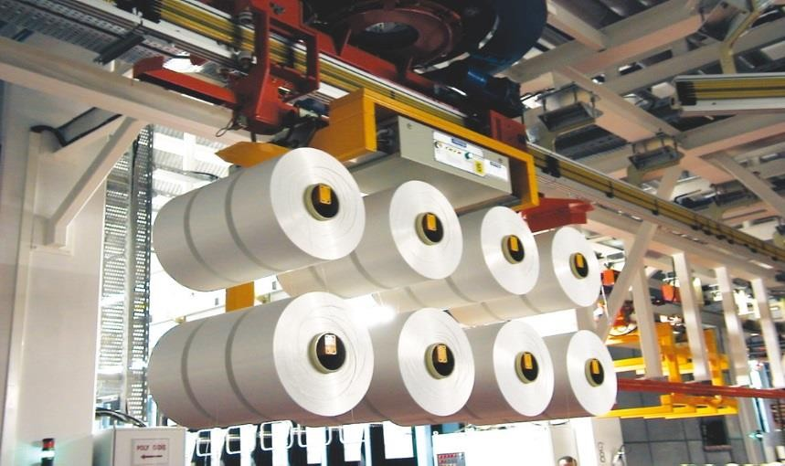

This Doff travels through three major station :

1. Physical Testing Station :

Test performed are as follows :

* + Cross Section
  + Denier
  + Draw Tension
  + Tenacity Elongation
  + Entanglement

1. Pre-visual Inspection Station :

Mirrors are installed on the both ends of doff through which all sides of bobbins are examined by the examiner and faults are identified.

1. Visual Inspection Stations :

Final weight and grade of the bobbins are determined and accordingly bobbins are accepted or rejected.

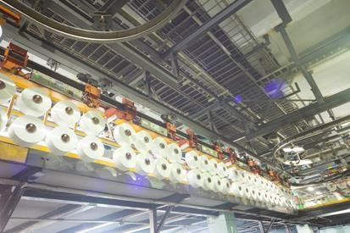

The storage area of bobbins is called as CAROUSELS. It has 9 Bobbin Storage Towers with the capacity of 27000 bobbins. Each tower has 3 layers- UPPER, MIDDLE, LOWER.

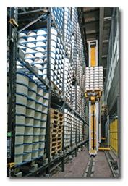

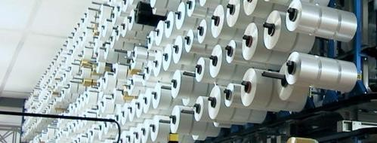

SALMOIRAGHI LOADER loads bobbins from the Doff to the assigned towers.



As per the order by the particular agency, the bobbins are unloaded by the Salmoiraghi Unloader.

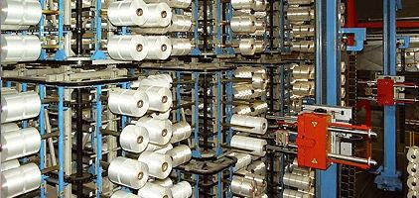

As per the company’s requirements, Salmoiraghi system is programmed to pack the bobbins in the order of 3*3 or 4*4 manner.

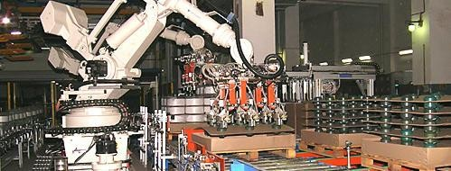

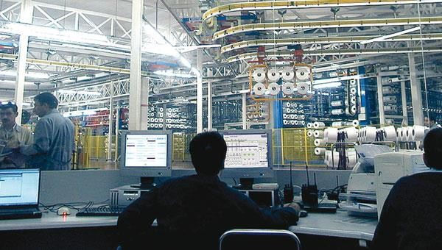

These Packed bobbins are then transported to the Dispatch Department.

1. **Project**

## Sign In page:

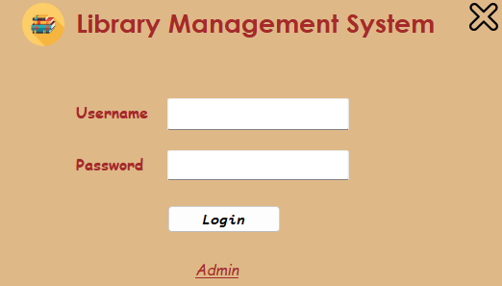

**Admin login page:**

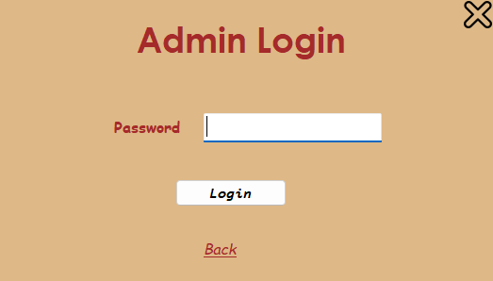

## New librarians Registration:

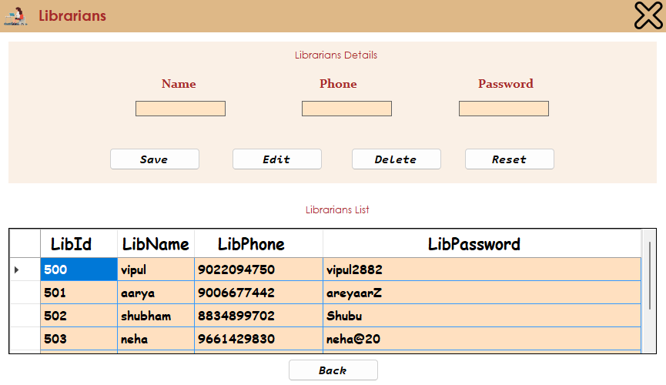

**Librarians database :**

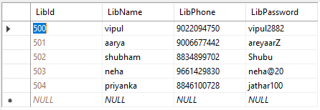

## Home page:

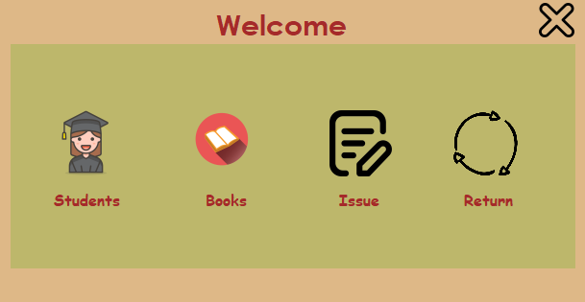

**Students registration page:**

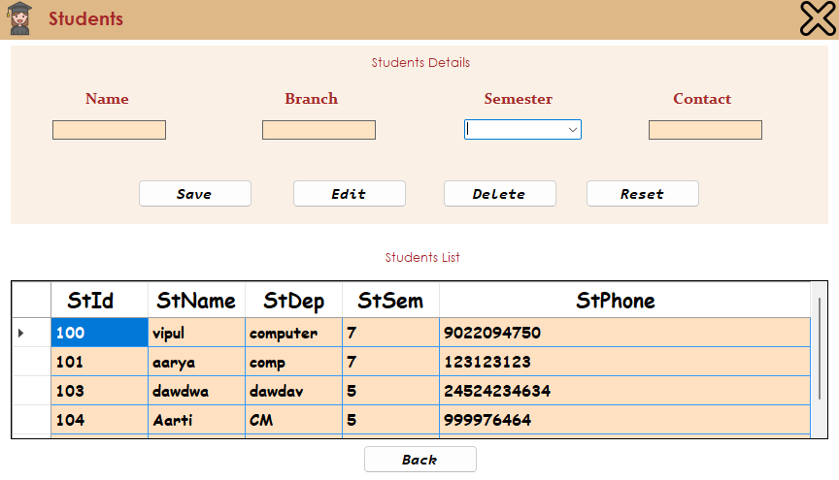

## Books page:

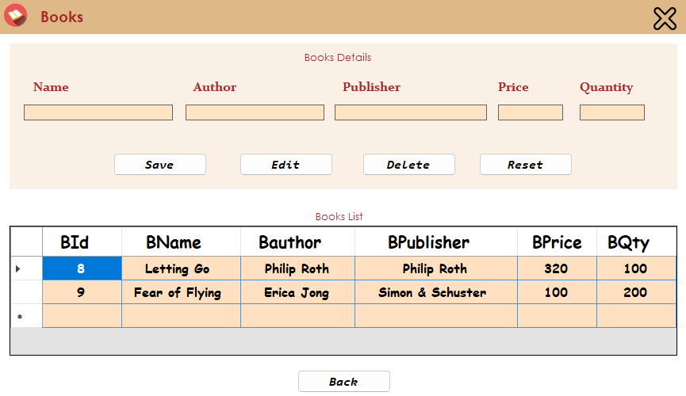

## Issuing book page:

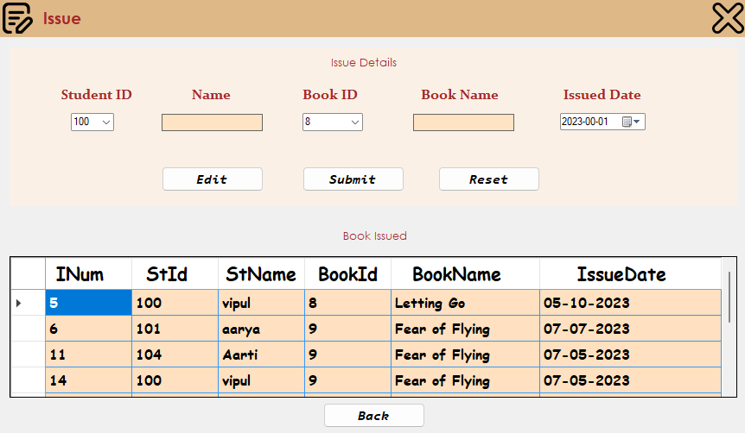

## Database:

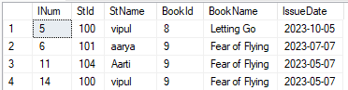

**Issuing book page:**

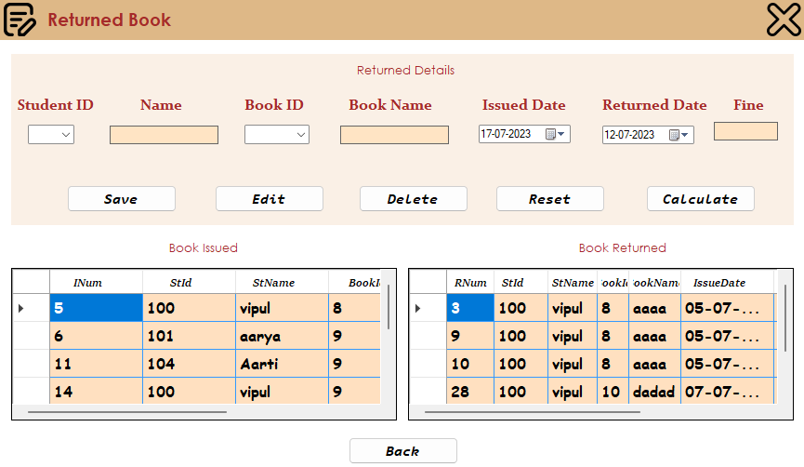

## Database:

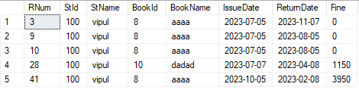

**Windows OS Installation and Dual Boot:**

## Steps:

1. If the PC being used has important files, create a backup to recover data in case of any data loss.
2. Creation of an image backup
3. Shrink the existing Windows 10 partition to create space for windows 7.
4. Acquire ISO File of the required Windows 7 and store it in an external medium like an USB Drive or CD Drive.
5. Restart the PC and the Windows 7 installer prompt should pop up otherwise select the appropriate function key to install from the external drive.
6. Now the Windows 7 Installation will start.
7. By this way, two OS i.e. Windows 10 and Windows 7 are installed on the same PC.
8. Now every time the PC boots up, the BIOS screen prompts to ask which OS to boot into.
9. This Dual Boot is Successful.

