FINAL DATA ANALYTICS PROJECT | TASK 4
SWYNEX
E-commerce Sales Analytics
From messy orders data to a Power BI dashboard
and business recommendations
Vipul Dubey
Data Analytics Internship, Swynex
Aptech Data Analyst: SQL, Excel, Power BI, Python
Gurugram, India | October 2026
github.com/VipulAnalyst/Ecommerce-Dashboard
CONTENTS

Table of Contents

1. Introduction and Problem Statement 3
2. Dataset Information 4
3. Data Cleaning Process 6
4. Exploratory Data Analysis 7
5. Power BI Dashboard 8
6. Key Business Insights and Recommendations 9
7. Conclusion 10
8. Repository Structure and Links 11

All figures are in Indian rupees (Rs.) and were calculated from the project data.
CHAPTER 1

Introduction and Problem Statement

Why this project exists and what it sets out to answer.

1.1 Background
Swynex is an e-commerce company that records every customer order in a single orders table. Before this data can guide decisions, it has to be checked for quality problems, explored for patterns, and presented in a form the business can use.

1.2 Problem Statement
Swynex needs a clear view of how its online store is performing and how far its order data can be trusted. This project answers four business questions:
- How much revenue is the business generating, and how does it trend over time?
- Which products, categories and regions perform best?
- How do discounts and order status affect sales?
- What data-quality problems exist, and how can they be prevented?

1.3 Approach and Tools
The work moved through four stages, each delivered as an internship task: data cleaning in Python (pandas), exploratory analysis in a Jupyter notebook, an interactive Power BI dashboard, and finally this report with insights and recommendations. Tools used: Python, VS Code, Power BI, Excel, Git and GitHub.
Stage | Task | Tool | Output
Clean | Task 1 | pandas, VS Code | cleaned_data.csv
Explore | Task 2 | pandas, matplotlib, seaborn | EDA_data.ipynb
Visualise | Task 3 | Power BI | E_Commerce_Dashboard.pbix
Report | Task 4 | GitHub, LinkedIn | This report
CHAPTER 2

Dataset Information

What the data contains and how the files relate.

2.1 Overview
Item | Detail
Source | Swynex e-commerce orders export (internship assignment)
Granularity | One row per order
Raw size | 118 rows, 116 retained after cleaning
Cleaned size | 116 rows x 14 columns
Time span | 1 January 2026 to 25 September 2026
Scope | 12 customers, 9 cities, 10 products in 5 categories, 4 payment methods,  3 order statuses

2.2 Files Used
File | Purpose
raw_messy_data.csv | Original data with quality problems
cleaned_data.csv | Output of Task 1; used for the EDA in Task 2
dashboard_data.csv | Cleaned data with three anomalies repaired; used in Power BI in Task 3

2.3 Data Dictionary
Column | Description | Type
Order_ID | Unique order identifier, e.g. ORD0052 | Integer
Customer_ID | Customer identifier, e.g. C007 | Integer
Customer_Name | Name of the customer | Text
City | City the order was placed from | Text
Order_Date | Date the order was placed | Date
Product_ID | Product identifier, e.g. P104 | Integer
Product_Name | Name of the product, e.g. Power Bank | Text

Column | Description | Type
Category | Product category (Electronics, Bags, Home & Kitchen,  Accessories, Stationery) | Text
Quantity | Units ordered | Integer
Unit_Price | Price of one unit in Rs. | Number
Discount | Discount applied, in percent | Integer
Payment_Method | Cash On Delivery, Credit Card, Debit Card or UPI | Text
Order_Status | Delivered, Cancelled or Pending | Text
Total_Amount | Order value in Rs. = Unit_Price x Quantity x (1 -  Discount/100) | Number

CHAPTER 3

Data Cleaning Process

Notebook: notebooks/data_cleaning.ipynb

3.1 Issues Found and Actions Taken
Issue | Action | Reason
2 rows with unparseable  Order_Date (missing values) | Dropped | A valid date is needed for trend analysis and could not be recovered reliably
3 rows where Total_Amount does not match Unit_Price x Quantity x (1 - Discount/100) | Left unchanged in the cleaned  file | These are exactly the three anomaly rows below. Their inputs (quantity, discount, total) are themselves invalid, so no total could be trusted until the inputs were corrected; the repair was done for the dashboard in Task 3

3.2 The Three Anomaly Rows
Three rows hold values that are impossible in a real order. They were deliberately left untouched in the EDA, so the problem stayed visible, and repaired in dashboard_data.csv so they would not distort the dashboard.
Order | Problem in cleaned_data.csv | Recalculated total would be | Repair in dashboard_data.csv
ORD0052 | Quantity = -2 (Total_Amount  1,396) | Negative (-698) | Total replaced with the calculated value
ORD0071 | Discount = 110  (Total_Amount 2,547.45) | Negative (-299.70) | Total replaced with the calculated value  Total replaced with the calculated value
ORD0091 | Total_Amount = 99,999, status  Pending | 1,017.45 | Total replaced with the calculated value

3.3 Result
The cleaned file has 116 orders and 14 columns and is saved as cleaned_data.csv. The repaired version for the dashboard is dashboard_data.csv. Both are in the data folder of the repository.
CHAPTER 4

Exploratory Data Analysis

Notebook: notebooks/EDA_data.ipynb. Covers summary statistics, the monthly trend, category, city and payment breakdowns, order status and anomaly checks; revenue figures exclude ORD0091's placeholder total, as in the notebook.

4.1 Key Figures
Metric | Value
Total orders | 116
Total revenue | Rs. 247,436 (115 orders, excluding the ORD0091 placeholder)
Average order value | Rs. 2,152 (median order Rs. 1,703)
Delivered revenue | Rs. 127,421 from 63 delivered orders (51.5% of revenue)
Top category by revenue | Electronics: Rs. 114,710, 46.4% of revenue
Busiest month | August: 25 orders, Rs. 59,517 (24% of revenue)

4.2 Main Findings
- Electronics leads. Electronics earns Rs. 114,710 (46.4%), followed by Bags at Rs. 62,433 (25.2%). Bags orders are the largest, averaging Rs. 3,902 against Rs. 2,549 for Electronics.
- Delhi NCR dominates. Delhi, Gurugram and Noida together bring in about 50% of revenue (Delhi Rs. 45,096; Gurugram Rs. 41,644; Noida Rs. 36,134). Bengaluru is lowest at Rs. 7,359.
- August is the peak. August revenue of Rs. 59,517 is nearly double the next best month (May, Rs. 33,992). March is the low at Rs. 11,887.
- Discounts show no clear lift. Among 114 valid orders, average order value is Rs. 2,240 with no discount and Rs. 2,063 at 11-15%, so deeper discounts did not raise order value.
- Fulfilment is weak. Only 54.3% of orders were delivered; 24.1% were cancelled and 21.6% are pending. Credit Card orders cancel most often (35.5%), UPI least (12.0%).

4.3 A Note on the Anomalies
The EDA ran on data that still contained the three anomaly rows. Had ORD0091's 99,999 been counted, revenue would read Rs. 347,435 and average order value Rs. 2,995, about 40% too high. The dashboard uses repaired data, so its totals (Rs. 248K revenue) differ slightly from the EDA (Rs. 247K).
CHAPTER 5

Power BI Dashboard

File: dashboard/E_Commerce_Dashboard.pbix | Preview: dashboard/dashboard.png

5.1 Dashboard Screenshot
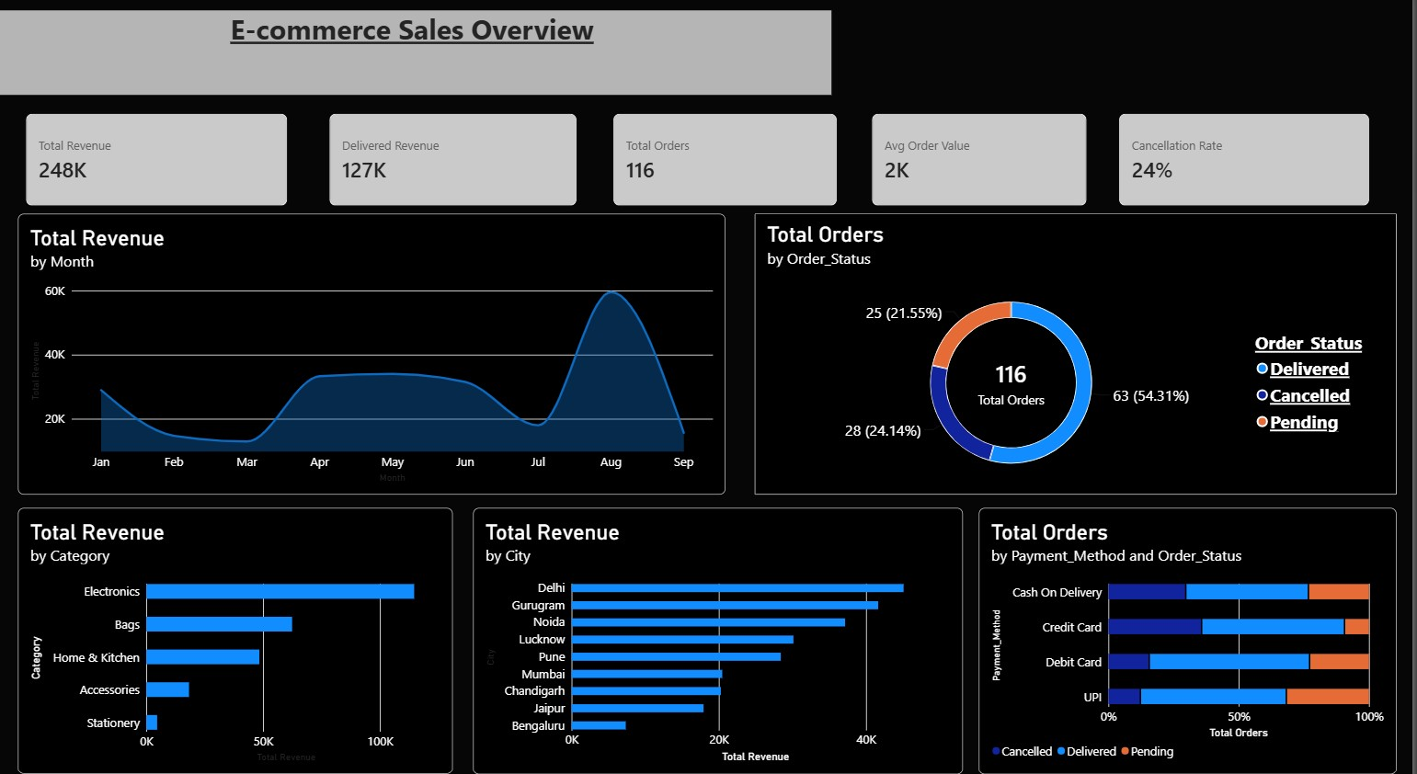

5.2 KPIs
KPI | Value | Meaning
Total Revenue | 248K | Sum of all order values
Delivered Revenue | 127K | Revenue from delivered orders only
Total Orders | 116 | Number of orders
Avg Order Value | 2K | Revenue divided by orders (about Rs. 2,100)
Cancellation Rate | 24% | Share of orders cancelled

5.3 Charts
- Revenue by Month (area): trend from January to September, with the August peak.
- Orders by Order_Status (donut): 63 delivered, 28 cancelled, 25 pending.
- Revenue by Category (bar): Electronics leads, then Bags and Home & Kitchen.
- Revenue by City (bar): Delhi, Gurugram and Noida lead.
- Orders by Payment_Method and Order_Status (100% stacked bar): outcome mix per payment method.
Selecting a status, category, city or payment method in one chart updates every KPI and chart.
The dashboard uses dashboard_data.csv, so the anomaly rows distort no figure.
CHAPTER 6

Key Business Insights and Recommendations

What the numbers mean and what Swynex should do about them.
# | Insight | Recommendation
1 | Electronics brings 46% of revenue (Rs.  114,710) and Bags the highest order value (Rs. 3,902 average); Stationery adds under 2%. | Keep Electronics well stocked and promoted. Push Bags (Backpack alone is Rs. 62,433) with bundles and cross-sell cheap Accessories to raise order value.
2 | Only 54% of orders are delivered. Cancelled and pending orders hold about Rs. 120,000, nearly half of order value. | Chase pending orders with reminders and set a time limit for them. Record cancellation reasons to find the cause.
3 | Credit Card orders cancel 35.5% of the time and Cash On Delivery 29.4%, against 12.0% for UPI. UPI has the most pending orders (32%). | Investigate Credit Card payment failures and COD refusals. Promote UPI and Debit Card at checkout, and add a payment-confirmation step for UPI.
4 | August brought Rs. 59,517 (24% of revenue), almost double any other month; Feb-Mar and July are weak. Delhi NCR gives about 50% of revenue. | Plan stock and campaigns ahead of August and find what drove it. Run offers in the weak months, and test marketing in under-served cities such as Bengaluru.
5 | The order data accepted a negative quantity (-2), a discount above 100 (110) and a placeholder total of 99,999. | Add input validation at order entry:  quantity above zero, discount between 0 and 100, and a total calculated automatically from price, quantity and discount.
Insight 5 comes from the cleaning stage and does not depend on the dashboard figures: it is the cheapest fix in this report and prevents every anomaly row described in Chapter 3 from recurring.
CHAPTER 7

Conclusion

What the project achieved, where it falls short, and what comes next.
Across 116 orders from January to September 2026, Swynex earned about Rs. 247,000, led by Electronics and Delhi NCR and peaking in August. The main weakness is fulfilment: nearly half of order value sits in cancelled or pending orders, and cancellations are heaviest on Credit Card and Cash On Delivery. The data itself needs protection, since three impossible values entered the system unchecked.

7.1 Limitations
- The dataset is small (116 orders from 12 customers) and September is incomplete, ending on 25 September, so patterns may not hold at larger scale.
- The three Total_Amount mismatches were left unresolved in the cleaned file.
- The repairs to the three anomaly rows in the dashboard data are assumptions and should be confirmed against the source system.

7.2 Next Steps
- Validate the repairs against the source system.
- Add more months of data and build a sales forecast.
- Analyse the reasons behind cancellations and pending orders.
- Automate the cleaning steps as a repeatable pipeline.
CHAPTER 8

Repository Structure and Links

Everything in this report is reproducible from the repository.

8.1 Folder Structure
Ecommerce-Dashboard/ README.md data/
raw_messy_data.csv cleaned_data.csv dashboard_data.csv notebooks/
data_cleaning.ipynb EDA_data.ipynb dashboard/ E_Commerce_Dashboard.pbix dashboard.png

8.2 Links
Item | Link
Final project repository (Task 4) | github.com/VipulAnalyst/Ecommerce-Dashboard
Task 1: Data cleaning | github.com/VipulAnalyst/ecommerce-data-cleaning
Task 2: EDA | github.com/VipulAnalyst/Ecommerce_eda
LinkedIn video | https://lnkd.in/p/gz_vMdu9

