Insurance Smart Contract
This project develops a decentralized, transparent, automated insurance system using Ethereum blockchain technology.
Aim: building an Insurance System on Ethereum using a Smart Contract.
- No paper work
- No manual approvals (mostly)
- Everything recorded permanently on blockchain
- Rules are written in code (Solidity)

Who are the actors?
- Insurer → issues policies, approves claims
- Policyholder → pays premium, submits claims
- Smart Contract → enforces rules automatically
In Remix VM (Prague):
Account 0 → INSURER (contract deployer)
0:
address: 0x5B38Da6a701c568545dCfcB03FcB875f56beddC4
Account 1 → POLICY HOLDER
0xAb8483F64d9C6d1EcF9b849Ae677dD3315835cb2
policy issued policyId: 0

1. Issue Insurance Policy
Function: issuePolicy
Insurer creates a policy with:
- Policyholder address
- Premium amount
- Coverage amount
- Policy duration
✔ Only authorized insurer can do this
✔ Policy is stored on blockchain
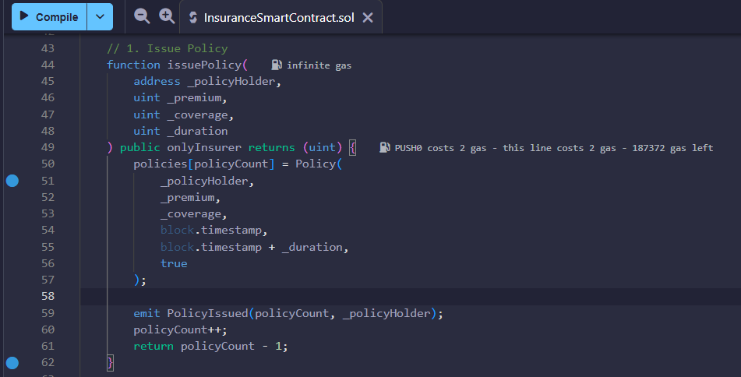
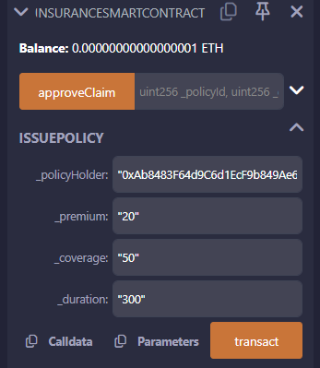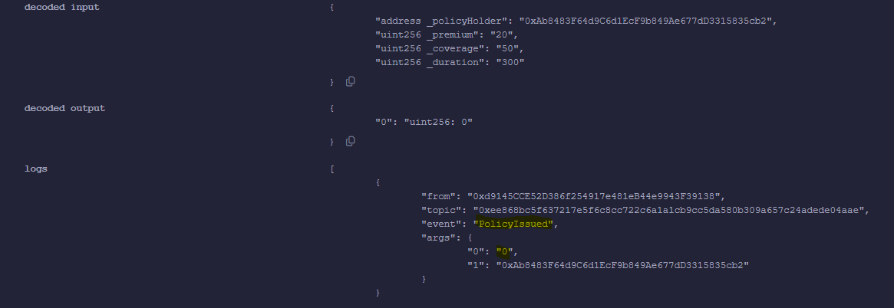

2. Pay Premium
Function: payPremium
Policyholder:
- Sends exact premium amount
- Only if policy is active
- Payment is sent to smart contract
✔ Update policy status
✔ Emit event PremiumPaid
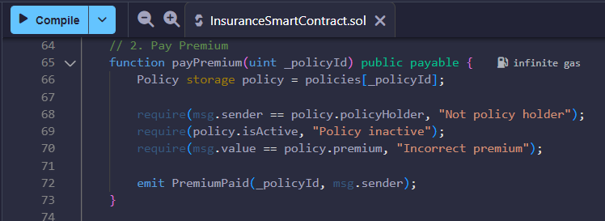
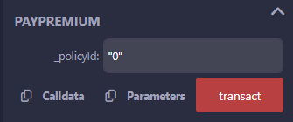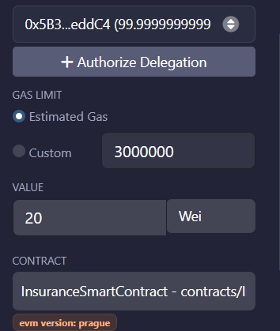
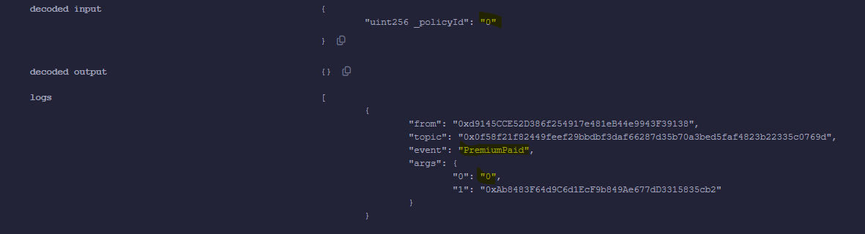

3. Submit Claim
Function: submitClaim
Policyholder:
- Submits claim amount
- Gives reason (string)
✔ Policy must be active
✔ Claim stored on blockchain
✔ Emit event ClaimSubmitted
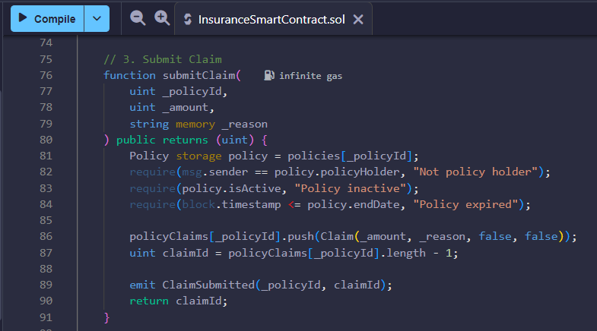
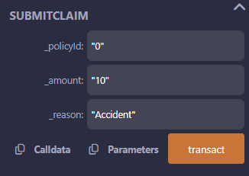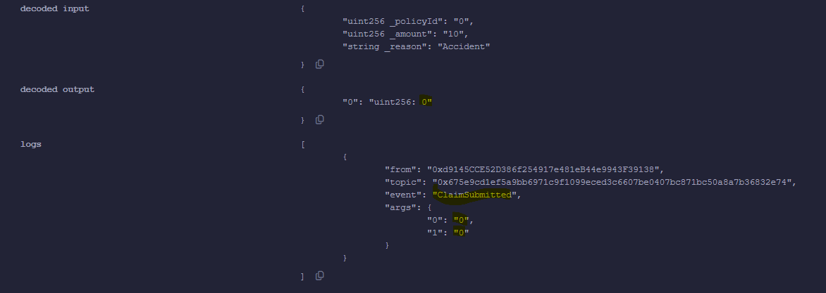

4. Approve & Pay Claim
Functions:
- approveClaim
- payClaim
Insurer:
- Approves claim (once)
- Pays claim amount to policyholder
✔ Cannot approve twice
✔ Cannot pay twice
✔ Emit ClaimApproved and ClaimPaid
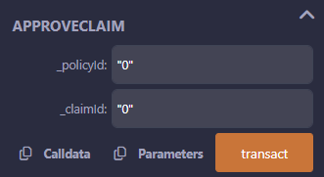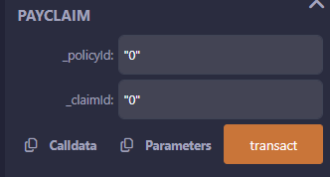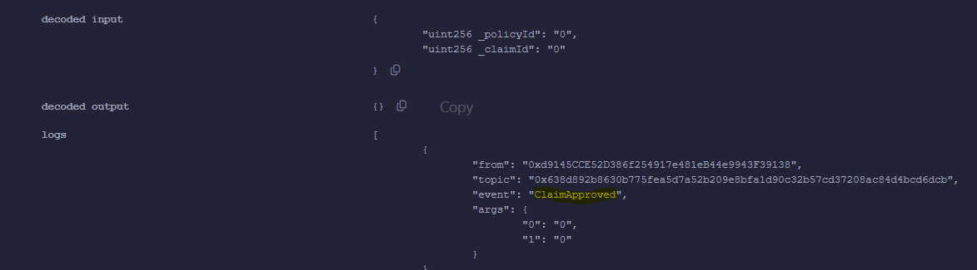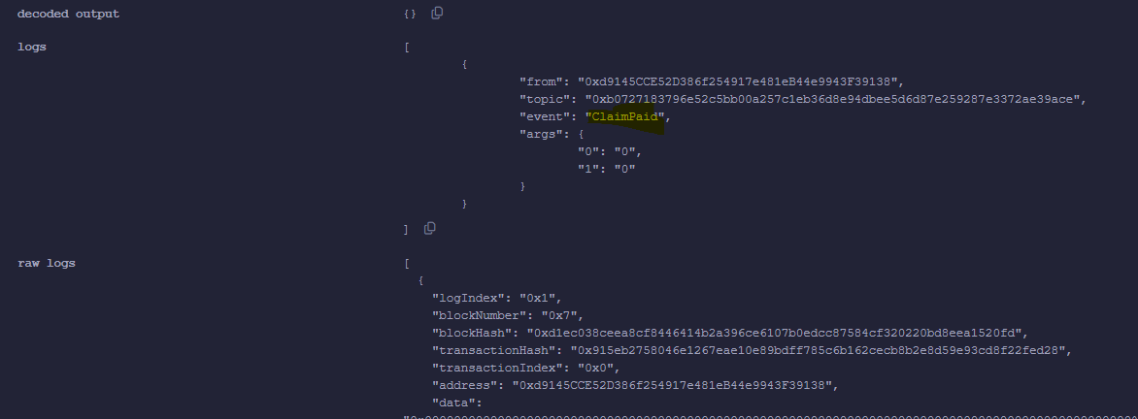

5. Transparency & Security
This comes automatically from blockchain:
- Immutable data
- Public transactions
- Events for auditing
Whole Output:
