A-1]C CODE

int Z;

void main()
{
int a, b, c;
int p = 6;
int q;
// double r;

a = 10;
b = 20;

c = a * b + 25;

p = 6;
q = Z;
/* r = 34.5;
Z = r;
Z = Z + 1;
*/

}

A-1] .i CODE

# 1 "A-1.c"
# 1 "<built-in>"
# 1 "<command-line>"
# 31 "<command-line>"
# 1 "/usr/include/stdc-predef.h" 1 3 4
# 32 "<command-line>" 2
# 1 "A-1.c"
int Z;

void main()
{
int a, b, c;
int p = 6;
int q;

a = 10;
b = 20;

c = a * b + 25;

p = 6;
q = Z;

}
A-1] .s CODE

.file "A-1.c"
.text
.comm Z,4,4
.globl main
.type main, @function
main:
.LFB0:
.cfi_startproc
pushq %rbp
.cfi_def_cfa_offset 16
.cfi_offset 6, -16
movq %rsp, %rbp
.cfi_def_cfa_register 6
movl $6, -20(%rbp)
movl $10, -16(%rbp)
movl $20, -12(%rbp)
movl -16(%rbp), %eax
imull -12(%rbp), %eax
addl $25, %eax
movl %eax, -8(%rbp)
movl $6, -20(%rbp)
movl Z(%rip), %eax
movl %eax, -4(%rbp)
nop
popq %rbp
.cfi_def_cfa 7, 8
ret
.cfi_endproc
.LFE0:
.size main, .-main
.ident "GCC: (Ubuntu 7.5.0-3ubuntu1~18.04) 7.5.0"
.section .note.GNU-stack,"",@progbits

A-1]SCREENSHOTS

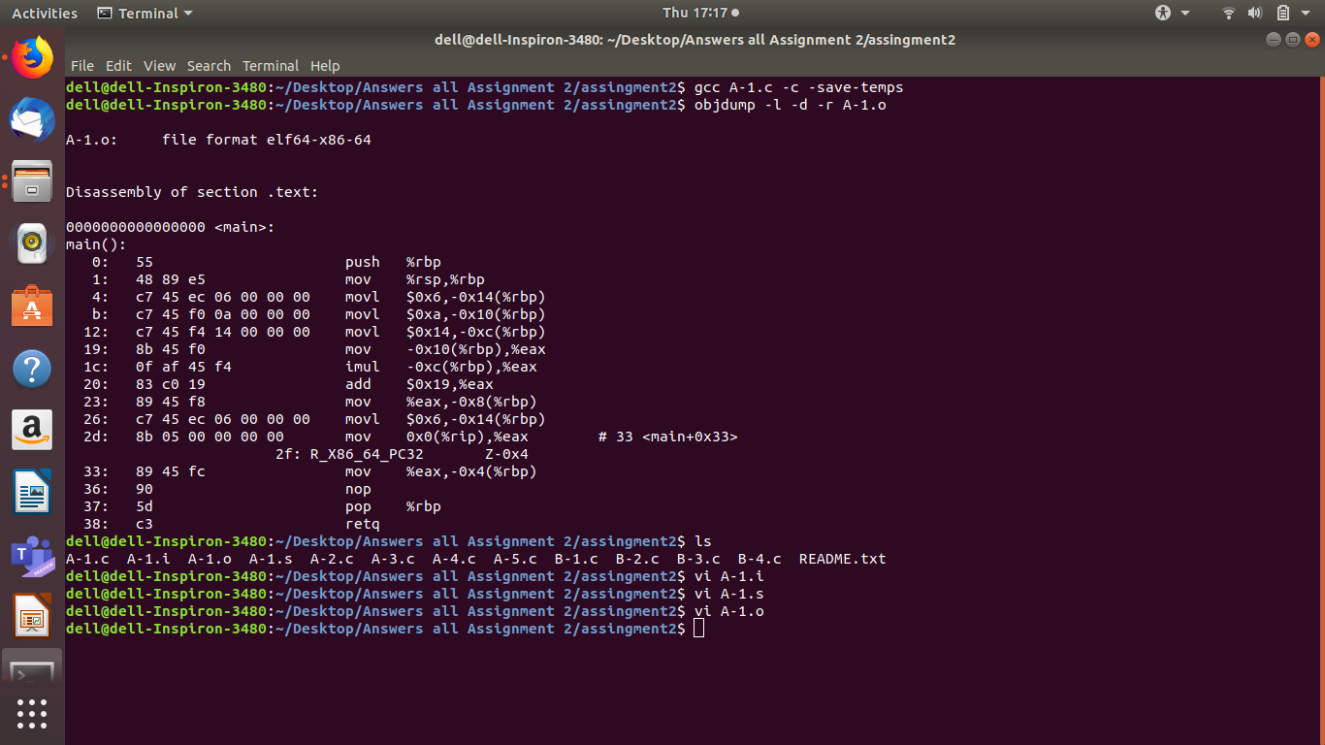
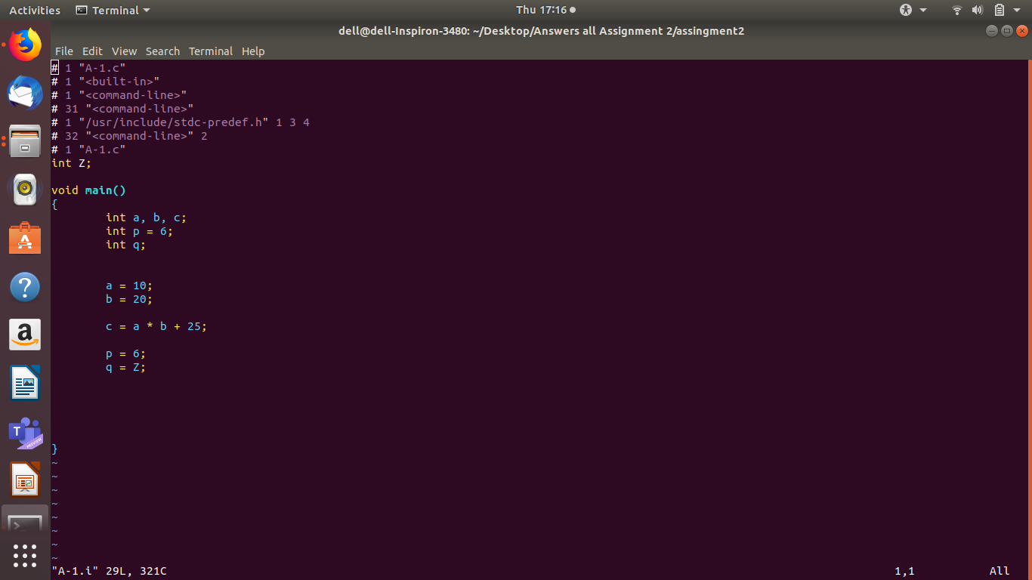
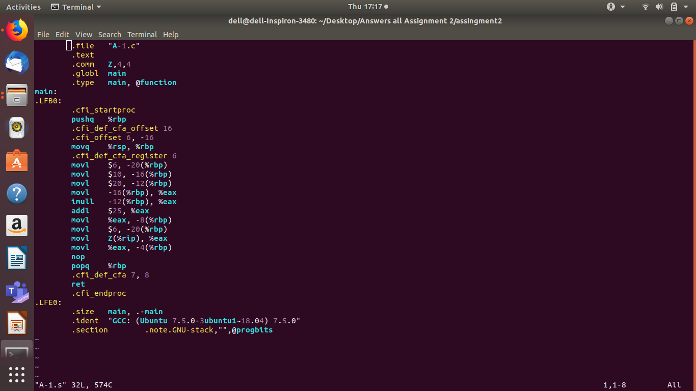

A-2]C CODE

int Z;

void f()
{
int a, b, c;
a = Z;
if (a < 10) {
b = 5;
c = 17;
} else {
b = 6;
c = 20;
if (a == 0) {
c = 0;
}
}
Z = b * 10 + c;
}

A-2] .i CODE

# 1 "A-2.c"
# 1 "<built-in>"
# 1 "<command-line>"
# 31 "<command-line>"
# 1 "/usr/include/stdc-predef.h" 1 3 4
# 32 "<command-line>" 2
# 1 "A-2.c"
int Z;

void f()
{
int a, b, c;
a = Z;
if (a < 10) {
b = 5;
c = 17;
} else {
b = 6;
c = 20;
if (a == 0) {
c = 0;
}
}
Z = b * 10 + c;
}

A-2] .s CODE

.file "A-2.c"
.text
.comm Z,4,4
.globl f
.type f, @function
f:
.LFB0:
.cfi_startproc
pushq %rbp
.cfi_def_cfa_offset 16
.cfi_offset 6, -16
movq %rsp, %rbp
.cfi_def_cfa_register 6
movl Z(%rip), %eax
movl %eax, -4(%rbp)
cmpl $9, -4(%rbp)
jg .L2
movl $5, -12(%rbp)
movl $17, -8(%rbp)
jmp .L3
.L2:
movl $6, -12(%rbp)
movl $20, -8(%rbp)
cmpl $0, -4(%rbp)
jne .L3
movl $0, -8(%rbp)
.L3:
movl -12(%rbp), %edx
movl %edx, %eax
sall $2, %eax
addl %edx, %eax
addl %eax, %eax
movl %eax, %edx
movl -8(%rbp), %eax
addl %edx, %eax
movl %eax, Z(%rip)
nop
popq %rbp
.cfi_def_cfa 7, 8
ret
.cfi_endproc
.LFE0:
.size f, .-f
.ident "GCC: (Ubuntu 7.5.0-3ubuntu1~18.04) 7.5.0"
.section .note.GNU-stack,"",@progbits

A-2]SCREENSHOTS

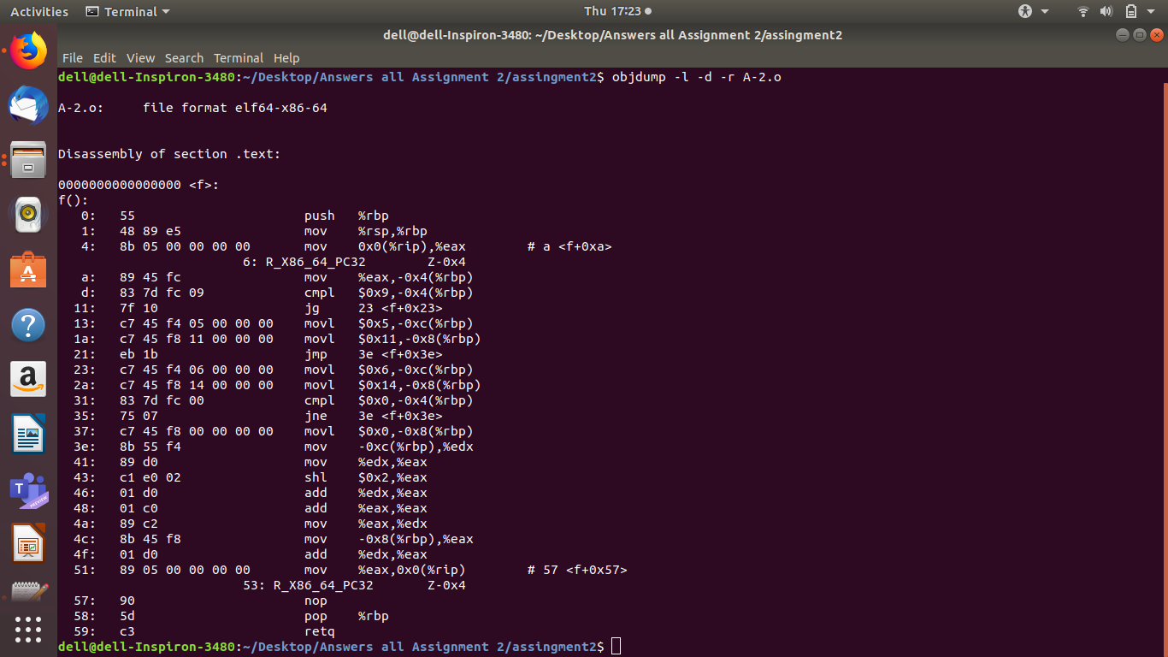

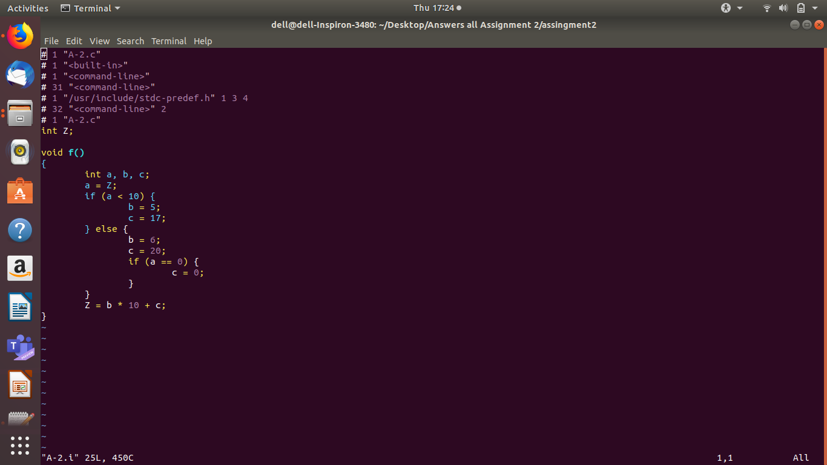
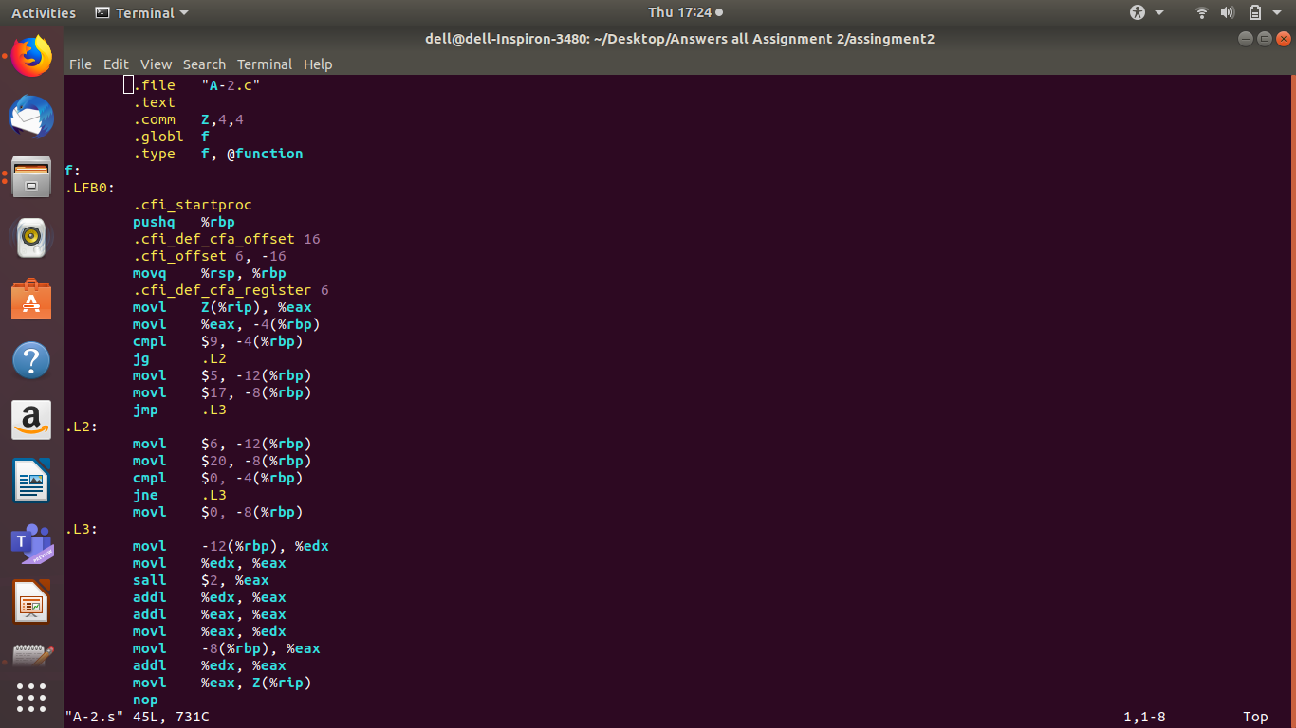

A-3] C CODE

int main()
{
int sum = 0;
int i, j;

while(sum < 100) {
sum = sum * 2;
}

for(i=0; i<25; i++) {
for(j=0; j<50; j++) {
sum = sum + i*j;
}
}
}

A-3] .i CODE

# 1 "A-3.c"
# 1 "<built-in>"
# 1 "<command-line>"
# 31 "<command-line>"
# 1 "/usr/include/stdc-predef.h" 1 3 4
# 32 "<command-line>" 2
# 1 "A-3.c"
int main()
{
int sum = 0;
int i, j;

while(sum < 100) {
sum = sum * 2;
}

for(i=0; i<25; i++) {
for(j=0; j<50; j++) {
sum = sum + i*j;
}
}
}

A-3] .s CODE

.file "A-3.c"
.text
.globl main
.type main, @function
main:
.LFB0:
.cfi_startproc
pushq %rbp
.cfi_def_cfa_offset 16
.cfi_offset 6, -16
movq %rsp, %rbp
.cfi_def_cfa_register 6
movl $0, -12(%rbp)
jmp .L2
.L3:
sall -12(%rbp)
.L2:
cmpl $99, -12(%rbp)
jle .L3
movl $0, -8(%rbp)
jmp .L4
.L7:
movl $0, -4(%rbp)
jmp .L5
.L6:
movl -8(%rbp), %eax
imull -4(%rbp), %eax
addl %eax, -12(%rbp)
addl $1, -4(%rbp)
.L5:
cmpl $49, -4(%rbp)
jle .L6
addl $1, -8(%rbp)
.L4:
cmpl $24, -8(%rbp)
jle .L7
movl $0, %eax
popq %rbp
.cfi_def_cfa 7, 8
ret
.cfi_endproc
.LFE0:
.size main, .-main
.ident "GCC: (Ubuntu 7.5.0-3ubuntu1~18.04) 7.5.0"
.section .note.GNU-stack,"",@progbits

A-3] SCREENSHOTS

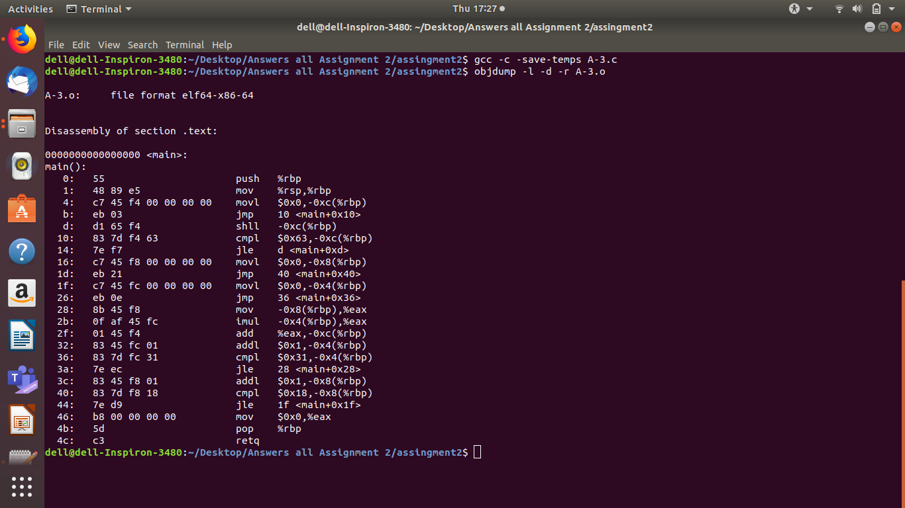
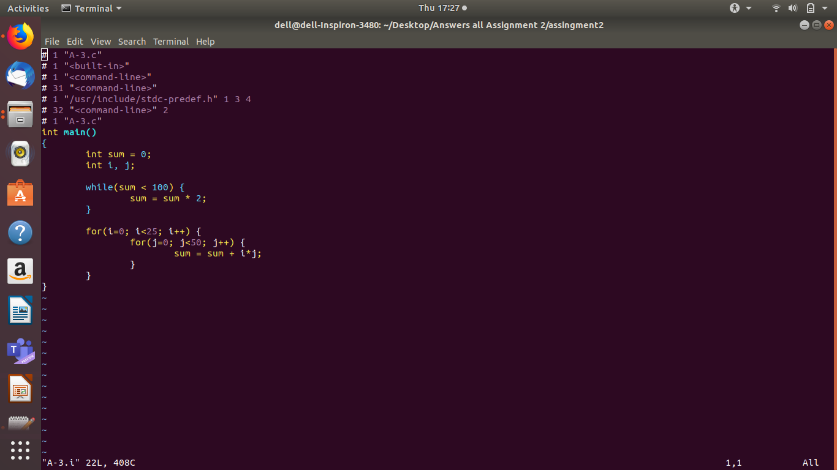
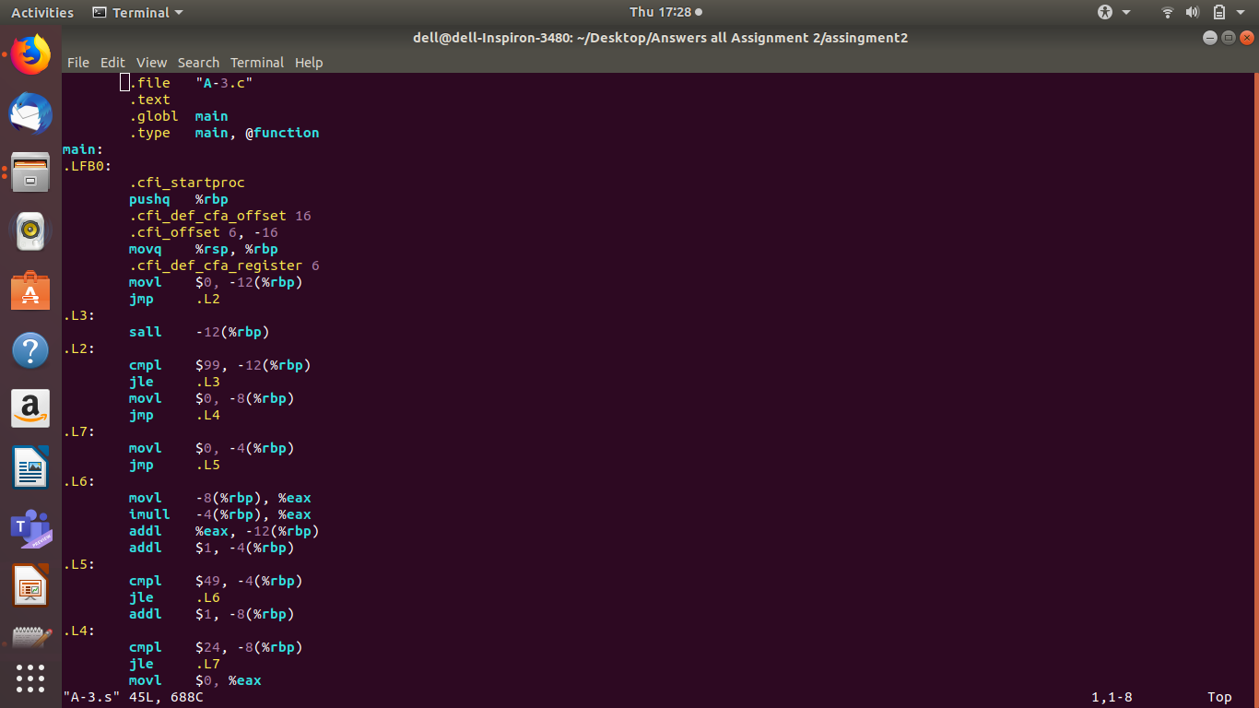

A-4] C CODE

int main()
{
int a[3];
int b[] = {1, 2, 3};
int i, *p;
for (i=0; i<3; i++) {
a[i] = b[i];
}
p = a;
*(p + 2) = 5;
}

A-4] .i CODE

# 1 "A-4.c"
# 1 "<built-in>"
# 1 "<command-line>"
# 31 "<command-line>"
# 1 "/usr/include/stdc-predef.h" 1 3 4
# 32 "<command-line>" 2
# 1 "A-4.c"
int main()
{
int a[3];
int b[] = {1, 2, 3};
int i, *p;
for (i=0; i<3; i++) {
a[i] = b[i];
}
p = a;
*(p + 2) = 5;
}

A-4] .s CODE

.file "A-4.c"
.text
.globl main
.type main, @function
main:
.LFB0:
.cfi_startproc
pushq %rbp
.cfi_def_cfa_offset 16
.cfi_offset 6, -16
movq %rsp, %rbp
.cfi_def_cfa_register 6
subq $48, %rsp
movq %fs:40, %rax
movq %rax, -8(%rbp)
xorl %eax, %eax
movl $1, -20(%rbp)
movl $2, -16(%rbp)
movl $3, -12(%rbp)
movl $0, -44(%rbp)
jmp .L2
.L3:
movl -44(%rbp), %eax
cltq
movl -20(%rbp,%rax,4), %edx
movl -44(%rbp), %eax
cltq
movl %edx, -32(%rbp,%rax,4)
addl $1, -44(%rbp)
.L2:
cmpl $2, -44(%rbp)
jle .L3
leaq -32(%rbp), %rax
movq %rax, -40(%rbp)
movq -40(%rbp), %rax
addq $8, %rax
movl $5, (%rax)
movl $0, %eax
movq -8(%rbp), %rcx
xorq %fs:40, %rcx
je .L5
call __stack_chk_fail@PLT
.L5:
leave
.cfi_def_cfa 7, 8
ret
.cfi_endproc
.LFE0:
.size main, .-main
.ident "GCC: (Ubuntu 7.5.0-3ubuntu1~18.04) 7.5.0"
.section .note.GNU-stack,"",@progbits

A-4]SCREENSHOTS

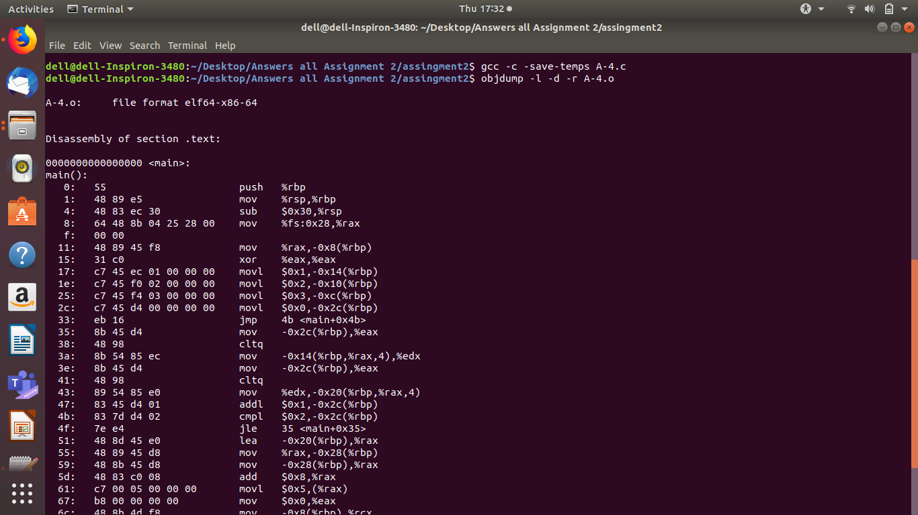
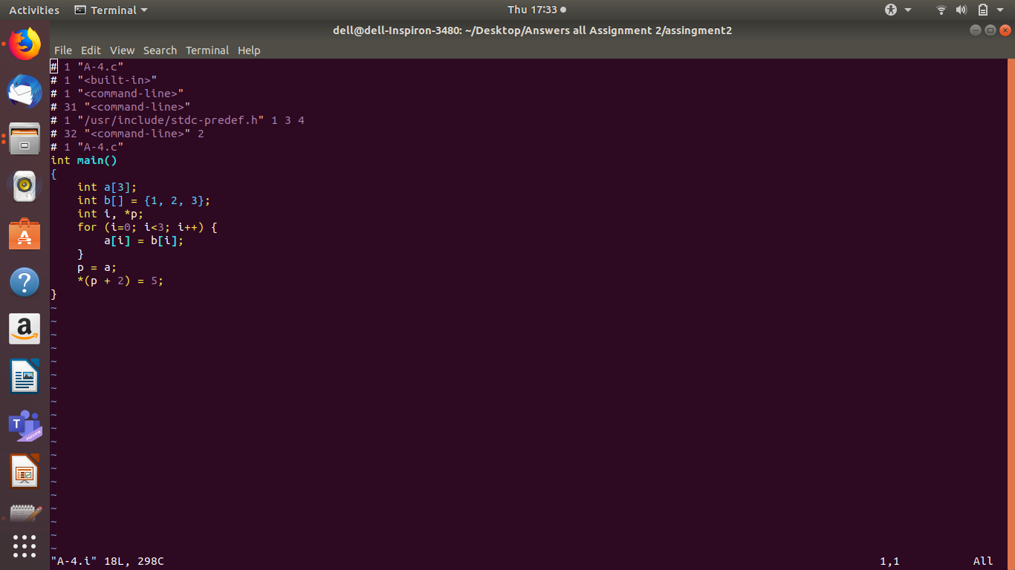
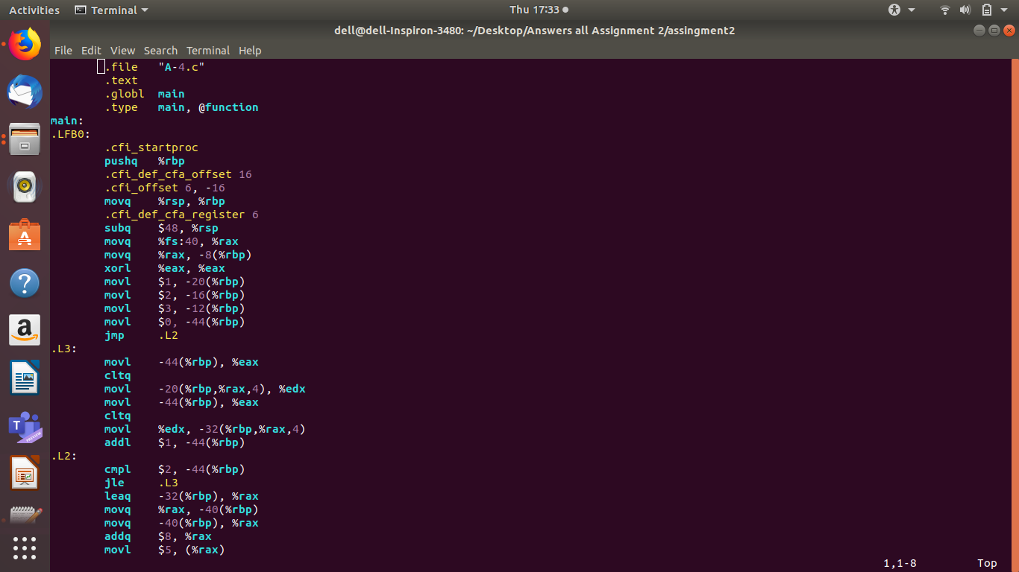
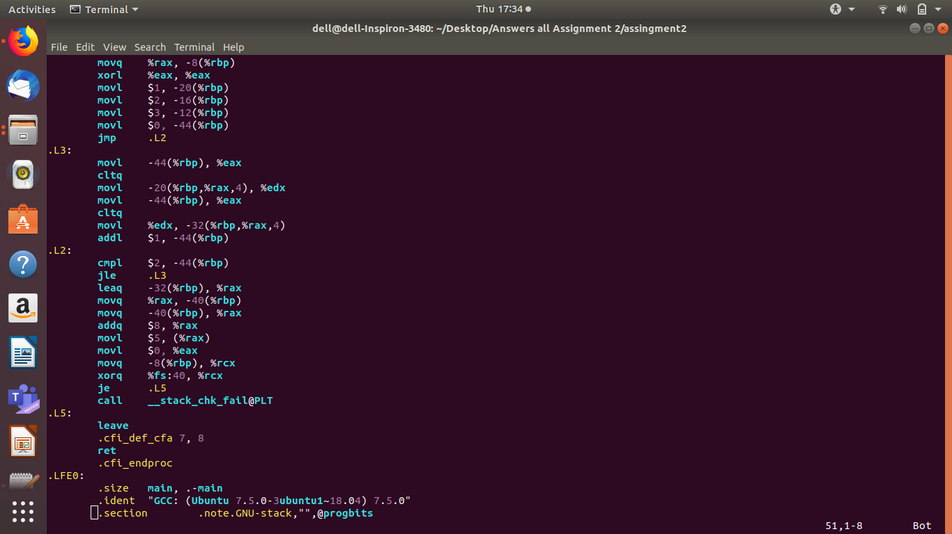

A-5] C CODE

int main()
{
int a, b, c, d;

d = 10;
if (c > d) {
a = 3;
b = 2;
} else {
a = 2;
b = 3;
}

c = a + b;
}

A-5] .i CODE

# 1 "A-5.c"
# 1 "<built-in>"
# 1 "<command-line>"
# 31 "<command-line>"
# 1 "/usr/include/stdc-predef.h" 1 3 4
# 32 "<command-line>" 2
# 1 "A-5.c"
int main()
{
int a, b, c, d;

d = 10;
if (c > d) {
a = 3;
b = 2;
} else {
a = 2;
b = 3;
}

c = a + b;
}

A-5] .s CODE

.file "A-5.c"
.text
.globl main
.type main, @function
main:
.LFB0:
.cfi_startproc
pushq %rbp
.cfi_def_cfa_offset 16
.cfi_offset 6, -16
movq %rsp, %rbp
.cfi_def_cfa_register 6
movl $10, -8(%rbp)
movl -4(%rbp), %eax
cmpl -8(%rbp), %eax
jle .L2
movl $3, -16(%rbp)
movl $2, -12(%rbp)
jmp .L3
.L2:
movl $2, -16(%rbp)
movl $3, -12(%rbp)
.L3:
movl -16(%rbp), %edx
movl -12(%rbp), %eax
addl %edx, %eax
movl %eax, -4(%rbp)
movl $0, %eax
popq %rbp
.cfi_def_cfa 7, 8
ret
.cfi_endproc
.LFE0:
.size main, .-main
.ident "GCC: (Ubuntu 7.5.0-3ubuntu1~18.04) 7.5.0"
.section .note.GNU-stack,"",@progbits

A-5]SCREENSHOTS
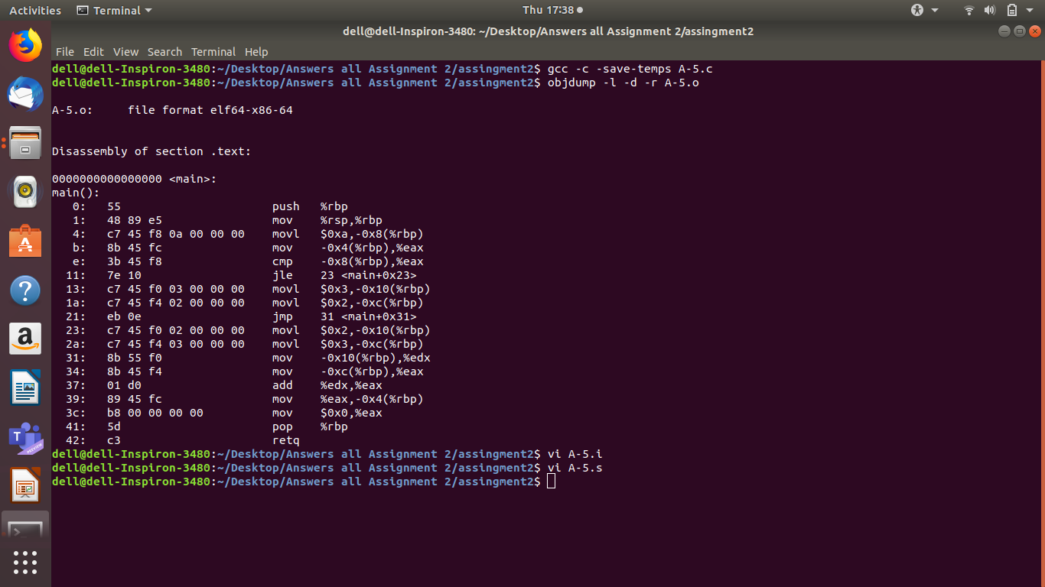
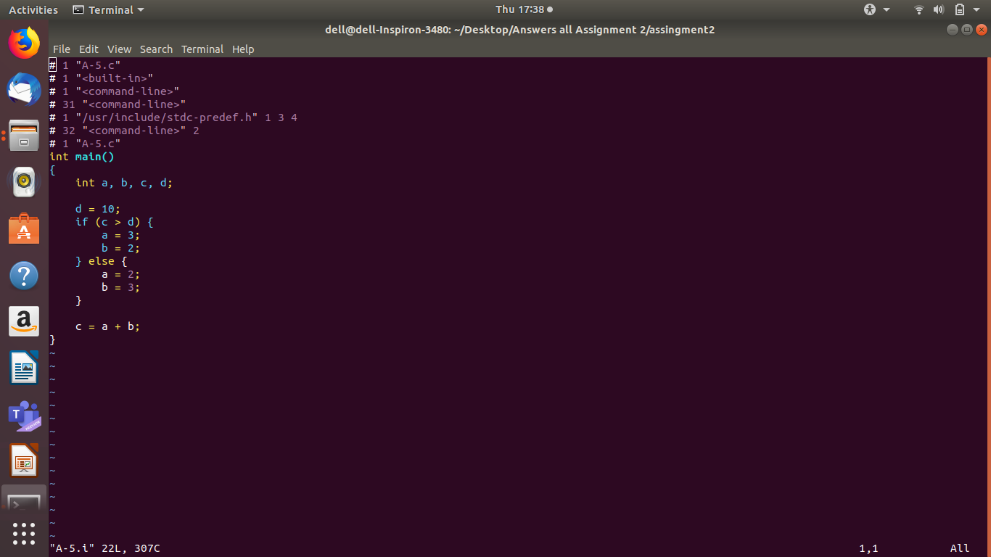
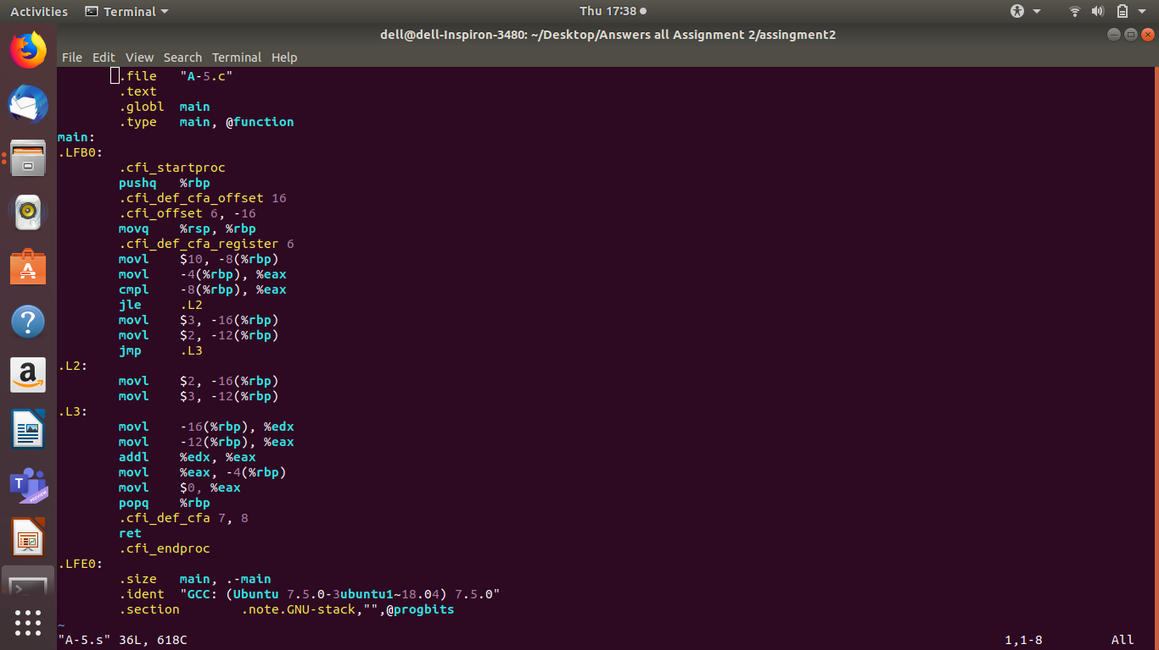

B-1] C CODE

int AddTwo(int a)
{
a = a + 2;
return a;
}

int main()
{
int x = 3;
x = AddTwo(x);
return x;
}

B-1] .i CODE

# 1 "B-1.c"
# 1 "<built-in>"
# 1 "<command-line>"
# 31 "<command-line>"
# 1 "/usr/include/stdc-predef.h" 1 3 4
# 32 "<command-line>" 2
# 1 "B-1.c"
int AddTwo(int a)
{
a = a + 2;
return a;
}

int main()
{
int x = 3;
x = AddTwo(x);
return x;
}

B-1] .s CODE

.file "B-1.c"
.text
.globl AddTwo
.type AddTwo, @function
AddTwo:
.LFB0:
.cfi_startproc
pushq %rbp
.cfi_def_cfa_offset 16
.cfi_offset 6, -16
movq %rsp, %rbp
.cfi_def_cfa_register 6
movl %edi, -4(%rbp)
addl $2, -4(%rbp)
movl -4(%rbp), %eax
popq %rbp
.cfi_def_cfa 7, 8
ret
.cfi_endproc
.LFE0:
.size AddTwo, .-AddTwo
.globl main
.type main, @function
main:
.LFB1:
.cfi_startproc
pushq %rbp
.cfi_def_cfa_offset 16
.cfi_offset 6, -16
movq %rsp, %rbp
.cfi_def_cfa_register 6
subq $16, %rsp
movl $3, -4(%rbp)
movl -4(%rbp), %eax
movl %eax, %edi
call AddTwo
movl %eax, -4(%rbp)
movl -4(%rbp), %eax
leave
.cfi_def_cfa 7, 8
ret
.cfi_endproc
.LFE1:
.size main, .-main
.ident "GCC: (Ubuntu 7.5.0-3ubuntu1~18.04) 7.5.0"
.section .note.GNU-stack,"",@progbits

B-1]SCREENSHOTS

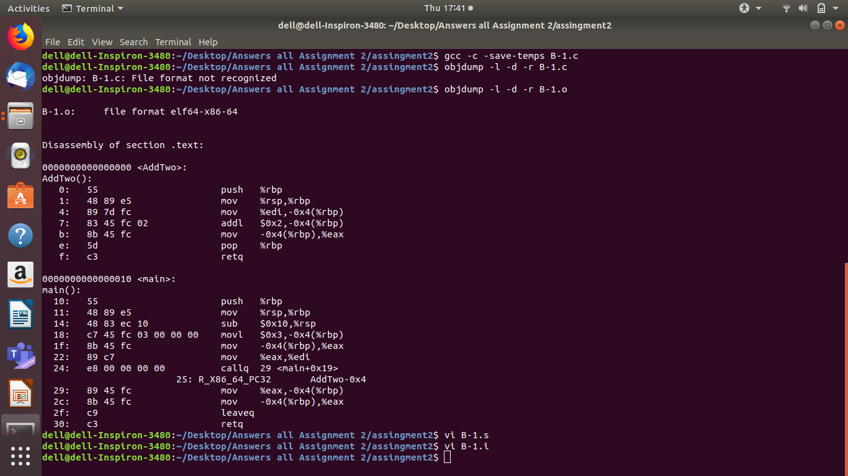
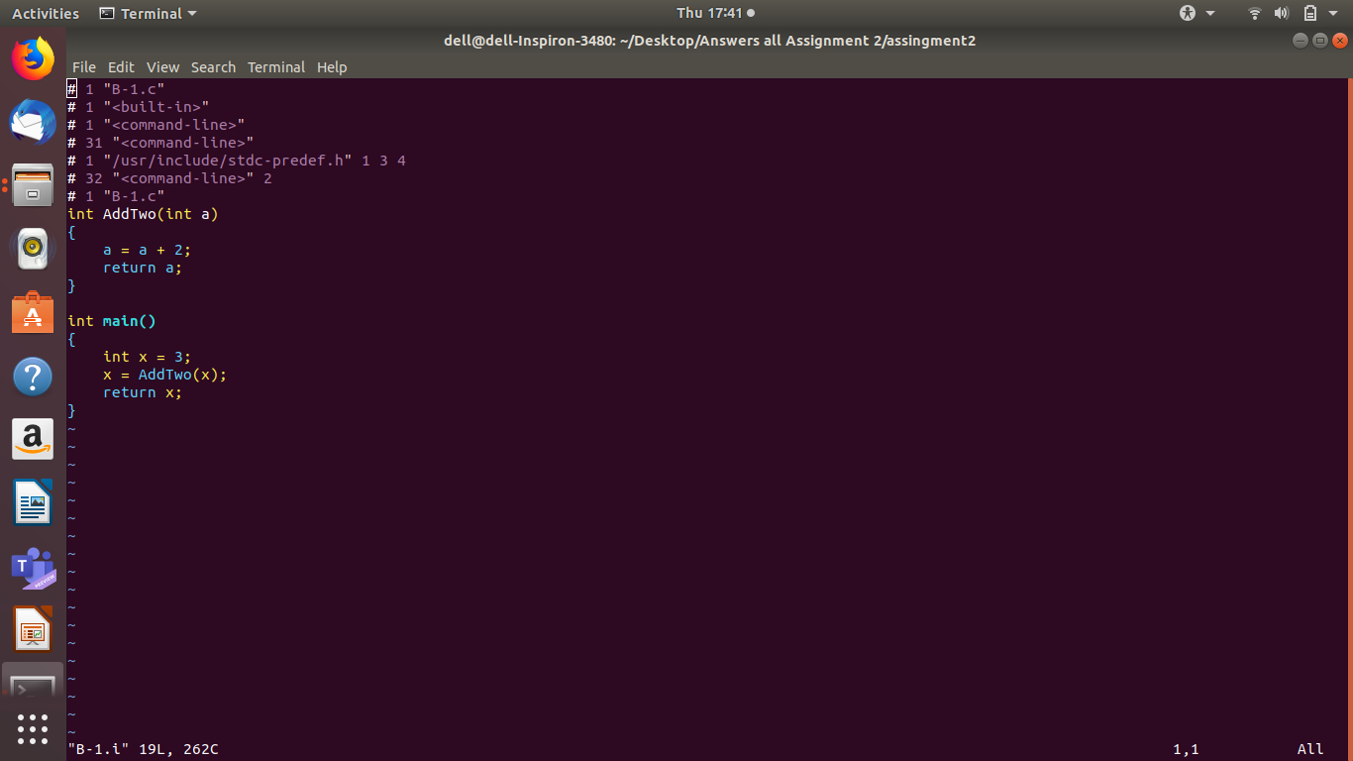
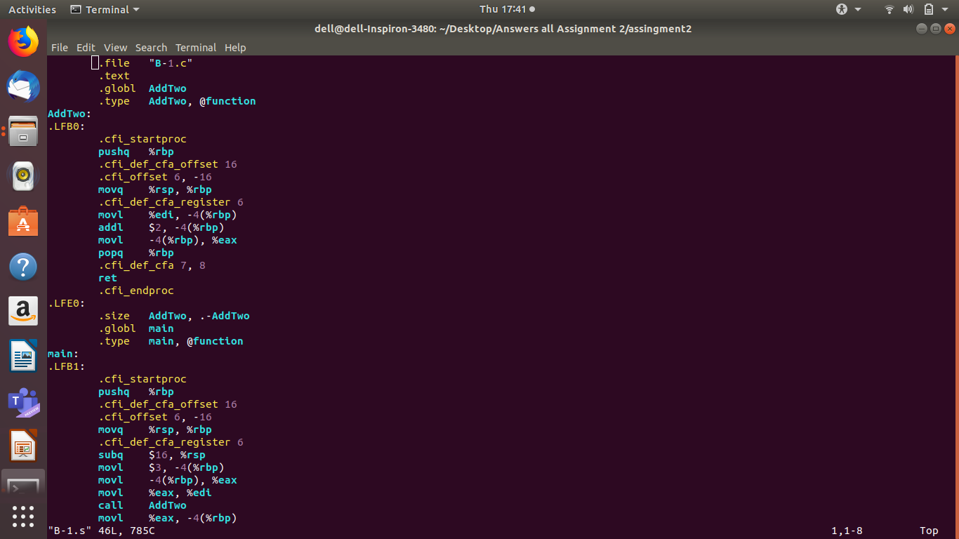
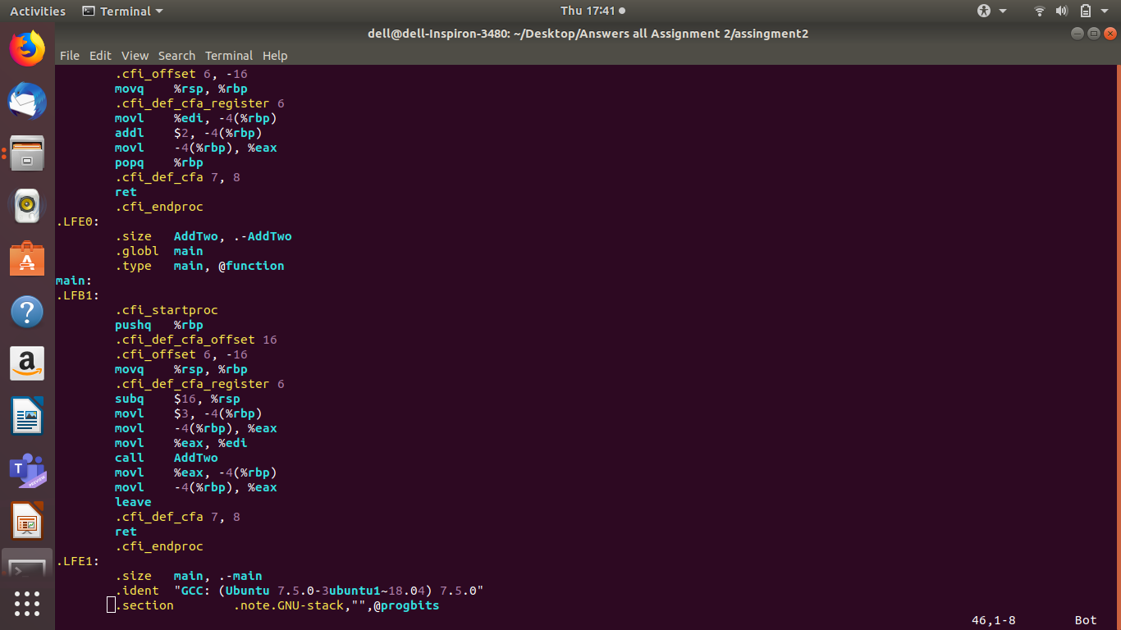

B-2] C CODE

int N;

int main()
{
int i, a = 10;
for(i= 0; i < 4; i++)
{
a = a + N;
};
return a;
}

B-2] .i CODE

# 1 "B-2.c"
# 1 "<built-in>"
# 1 "<command-line>"
# 31 "<command-line>"
# 1 "/usr/include/stdc-predef.h" 1 3 4
# 32 "<command-line>" 2
# 1 "B-2.c"
int N;

int main()
{
int i, a = 10;
for(i= 0; i < 4; i++)
{
a = a + N;
};
return a;
}

B-2] .s CODE

.file "B-2.c"
.text
.comm N,4,4
.globl main
.type main, @function
main:
.LFB0:
.cfi_startproc
pushq %rbp
.cfi_def_cfa_offset 16
.cfi_offset 6, -16
movq %rsp, %rbp
.cfi_def_cfa_register 6
movl $10, -4(%rbp)
movl $0, -8(%rbp)
jmp .L2
.L3:
movl N(%rip), %eax
addl %eax, -4(%rbp)
addl $1, -8(%rbp)
.L2:
cmpl $3, -8(%rbp)
jle .L3
movl -4(%rbp), %eax
popq %rbp
.cfi_def_cfa 7, 8
ret
.cfi_endproc
.LFE0:
.size main, .-main
.ident "GCC: (Ubuntu 7.5.0-3ubuntu1~18.04) 7.5.0"
.section .note.GNU-stack,"",@progbits

B-2]SCREENSHOTS

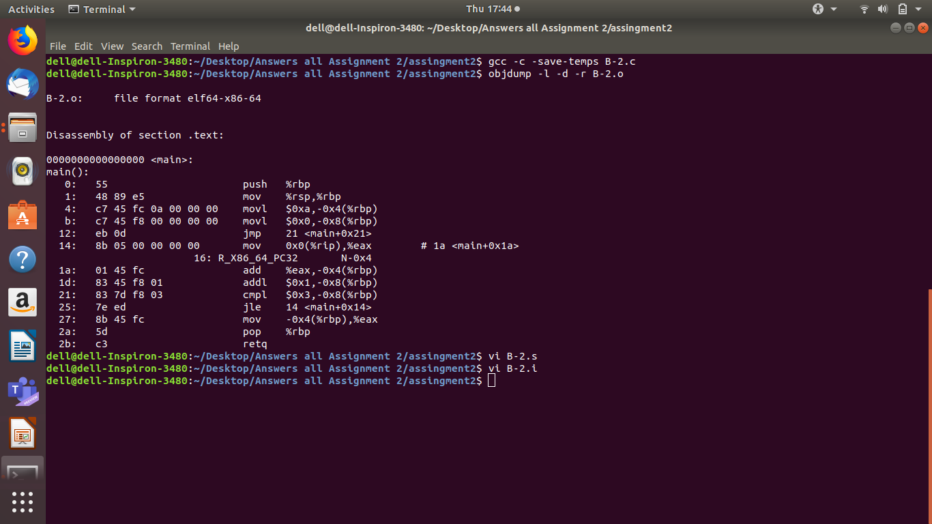
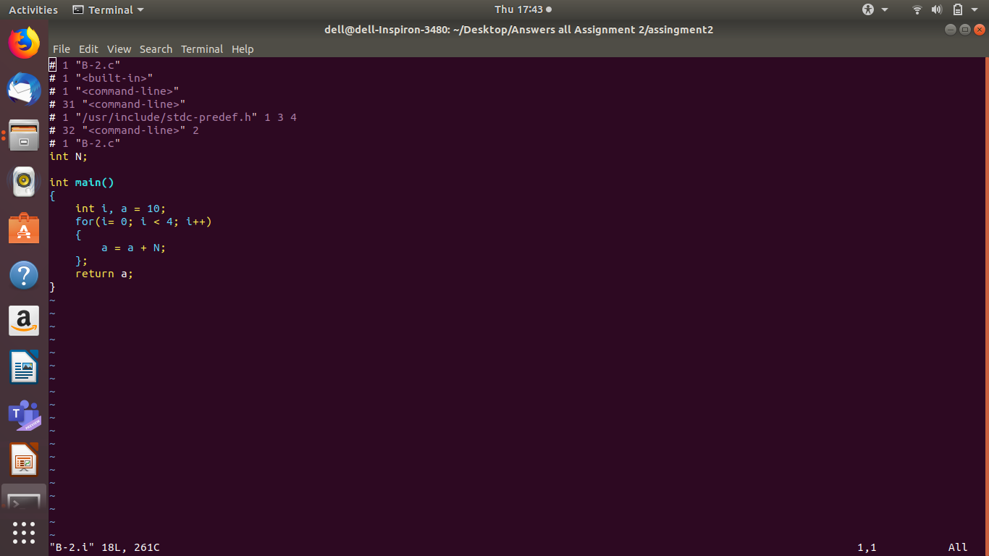
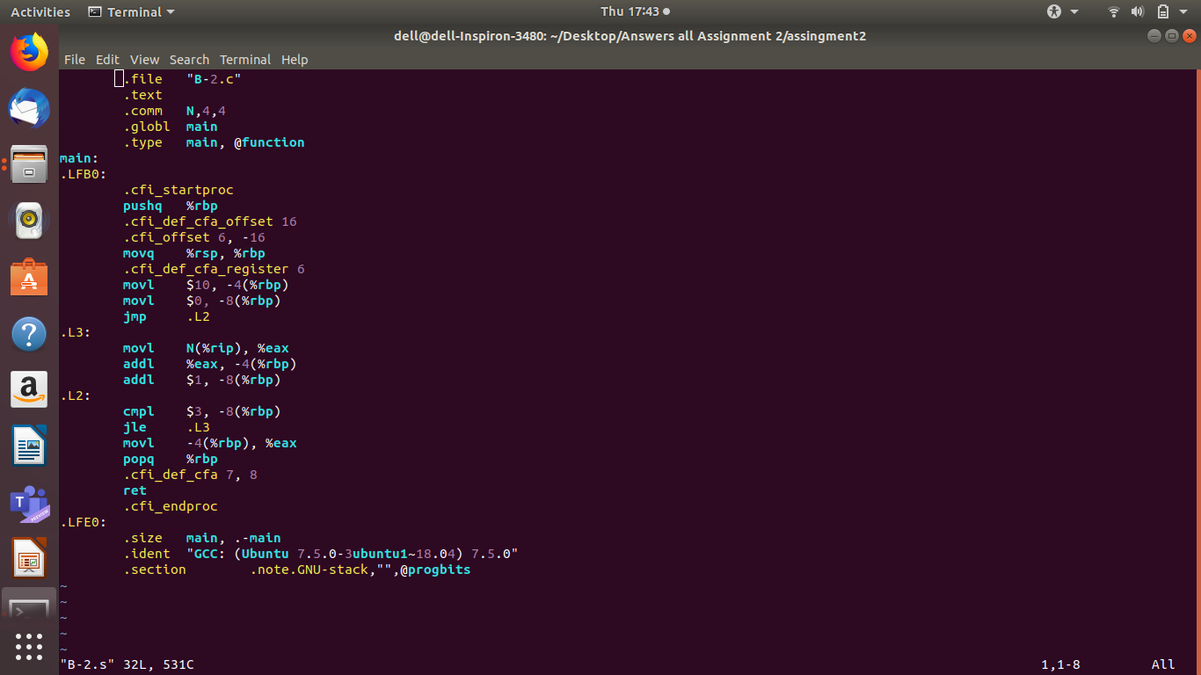
B-3] C CODE

#include <stdio.h>
int main ()
{
int a, b;
for (a=4 ; a<100; a++) {
if (a < 4)
b = b + 2;
else
b = b * 2;
}
printf ("%d%d", a, b);
}

B-3] .i CODE

# 1 "B-3.c"
# 1 "<built-in>"
# 1 "<command-line>"
# 31 "<command-line>"
# 1 "/usr/include/stdc-predef.h" 1 3 4
# 32 "<command-line>" 2
# 1 "B-3.c"
# 1 "/usr/include/stdio.h" 1 3 4
# 27 "/usr/include/stdio.h" 3 4
# 1 "/usr/include/x86_64-linux-gnu/bits/libc-header-start.h" 1 3 4
# 33 "/usr/include/x86_64-linux-gnu/bits/libc-header-start.h" 3 4
# 1 "/usr/include/features.h" 1 3 4
# 424 "/usr/include/features.h" 3 4
# 1 "/usr/include/x86_64-linux-gnu/sys/cdefs.h" 1 3 4
# 427 "/usr/include/x86_64-linux-gnu/sys/cdefs.h" 3 4
# 1 "/usr/include/x86_64-linux-gnu/bits/wordsize.h" 1 3 4
# 428 "/usr/include/x86_64-linux-gnu/sys/cdefs.h" 2 3 4
# 1 "/usr/include/x86_64-linux-gnu/bits/long-double.h" 1 3 4
# 429 "/usr/include/x86_64-linux-gnu/sys/cdefs.h" 2 3 4
# 425 "/usr/include/features.h" 2 3 4
# 448 "/usr/include/features.h" 3 4
# 1 "/usr/include/x86_64-linux-gnu/gnu/stubs.h" 1 3 4
# 10 "/usr/include/x86_64-linux-gnu/gnu/stubs.h" 3 4
# 1 "/usr/include/x86_64-linux-gnu/gnu/stubs-64.h" 1 3 4
# 11 "/usr/include/x86_64-linux-gnu/gnu/stubs.h" 2 3 4
# 449 "/usr/include/features.h" 2 3 4
# 34 "/usr/include/x86_64-linux-gnu/bits/libc-header-start.h" 2 3 4
# 28 "/usr/include/stdio.h" 2 3 4

# 1 "/usr/lib/gcc/x86_64-linux-gnu/7/include/stddef.h" 1 3 4
# 216 "/usr/lib/gcc/x86_64-linux-gnu/7/include/stddef.h" 3 4

# 216 "/usr/lib/gcc/x86_64-linux-gnu/7/include/stddef.h" 3 4
typedef long unsigned int size_t;
# 34 "/usr/include/stdio.h" 2 3 4

# 1 "/usr/include/x86_64-linux-gnu/bits/types.h" 1 3 4
# 27 "/usr/include/x86_64-linux-gnu/bits/types.h" 3 4
# 1 "/usr/include/x86_64-linux-gnu/bits/wordsize.h" 1 3 4
# 28 "/usr/include/x86_64-linux-gnu/bits/types.h" 2 3 4

typedef unsigned char __u_char;
typedef unsigned short int __u_short;
typedef unsigned int __u_int;
typedef unsigned long int __u_long;

typedef signed char __int8_t;
typedef unsigned char __uint8_t;
typedef signed short int __int16_t;
typedef unsigned short int __uint16_t;
typedef signed int __int32_t;
typedef unsigned int __uint32_t;

typedef signed long int __int64_t;
typedef unsigned long int __uint64_t;

typedef long int __quad_t;
typedef unsigned long int __u_quad_t;

typedef long int __intmax_t;
typedef unsigned long int __uintmax_t;
# 130 "/usr/include/x86_64-linux-gnu/bits/types.h" 3 4
# 1 "/usr/include/x86_64-linux-gnu/bits/typesizes.h" 1 3 4
# 131 "/usr/include/x86_64-linux-gnu/bits/types.h" 2 3 4

typedef unsigned long int __dev_t;
typedef unsigned int __uid_t;
typedef unsigned int __gid_t;
typedef unsigned long int __ino_t;
typedef unsigned long int __ino64_t;
typedef unsigned int __mode_t;
typedef unsigned long int __nlink_t;
typedef long int __off_t;
typedef long int __off64_t;
typedef int __pid_t;
typedef struct { int __val[2]; } __fsid_t;
typedef long int __clock_t;
typedef unsigned long int __rlim_t;
typedef unsigned long int __rlim64_t;
typedef unsigned int __id_t;
typedef long int __time_t;
typedef unsigned int __useconds_t;
typedef long int __suseconds_t;

typedef int __daddr_t;
typedef int __key_t;

typedef int __clockid_t;

typedef void * __timer_t;

typedef long int __blksize_t;

typedef long int __blkcnt_t;
typedef long int __blkcnt64_t;

typedef unsigned long int __fsblkcnt_t;
typedef unsigned long int __fsblkcnt64_t;

typedef unsigned long int __fsfilcnt_t;
typedef unsigned long int __fsfilcnt64_t;

typedef long int __fsword_t;

typedef long int __ssize_t;

typedef long int __syscall_slong_t;

typedef unsigned long int __syscall_ulong_t;

typedef __off64_t __loff_t;
typedef char *__caddr_t;

typedef long int __intptr_t;

typedef unsigned int __socklen_t;

typedef int __sig_atomic_t;
# 36 "/usr/include/stdio.h" 2 3 4
# 1 "/usr/include/x86_64-linux-gnu/bits/types/__FILE.h" 1 3 4

struct _IO_FILE;
typedef struct _IO_FILE __FILE;
# 37 "/usr/include/stdio.h" 2 3 4
# 1 "/usr/include/x86_64-linux-gnu/bits/types/FILE.h" 1 3 4

struct _IO_FILE;

typedef struct _IO_FILE FILE;
# 38 "/usr/include/stdio.h" 2 3 4

# 1 "/usr/include/x86_64-linux-gnu/bits/libio.h" 1 3 4
# 35 "/usr/include/x86_64-linux-gnu/bits/libio.h" 3 4
# 1 "/usr/include/x86_64-linux-gnu/bits/_G_config.h" 1 3 4
# 19 "/usr/include/x86_64-linux-gnu/bits/_G_config.h" 3 4
# 1 "/usr/lib/gcc/x86_64-linux-gnu/7/include/stddef.h" 1 3 4
# 20 "/usr/include/x86_64-linux-gnu/bits/_G_config.h" 2 3 4

# 1 "/usr/include/x86_64-linux-gnu/bits/types/__mbstate_t.h" 1 3 4
# 13 "/usr/include/x86_64-linux-gnu/bits/types/__mbstate_t.h" 3 4
typedef struct
{
int __count;
union
{
unsigned int __wch;
char __wchb[4];
} __value;
} __mbstate_t;
# 22 "/usr/include/x86_64-linux-gnu/bits/_G_config.h" 2 3 4

typedef struct
{
__off_t __pos;
__mbstate_t __state;
} _G_fpos_t;
typedef struct
{
__off64_t __pos;
__mbstate_t __state;
} _G_fpos64_t;
# 36 "/usr/include/x86_64-linux-gnu/bits/libio.h" 2 3 4
# 53 "/usr/include/x86_64-linux-gnu/bits/libio.h" 3 4
# 1 "/usr/lib/gcc/x86_64-linux-gnu/7/include/stdarg.h" 1 3 4
# 40 "/usr/lib/gcc/x86_64-linux-gnu/7/include/stdarg.h" 3 4
typedef __builtin_va_list __gnuc_va_list;
# 54 "/usr/include/x86_64-linux-gnu/bits/libio.h" 2 3 4
# 149 "/usr/include/x86_64-linux-gnu/bits/libio.h" 3 4
struct _IO_jump_t; struct _IO_FILE;

typedef void _IO_lock_t;

struct _IO_marker {
struct _IO_marker *_next;
struct _IO_FILE *_sbuf;

int _pos;
# 177 "/usr/include/x86_64-linux-gnu/bits/libio.h" 3 4
};

enum __codecvt_result
{
__codecvt_ok,
__codecvt_partial,
__codecvt_error,
__codecvt_noconv
};
# 245 "/usr/include/x86_64-linux-gnu/bits/libio.h" 3 4
struct _IO_FILE {
int _flags;

char* _IO_read_ptr;
char* _IO_read_end;
char* _IO_read_base;
char* _IO_write_base;
char* _IO_write_ptr;
char* _IO_write_end;
char* _IO_buf_base;
char* _IO_buf_end;

char *_IO_save_base;
char *_IO_backup_base;
char *_IO_save_end;

struct _IO_marker *_markers;

struct _IO_FILE *_chain;

int _fileno;

int _flags2;

__off_t _old_offset;

unsigned short _cur_column;
signed char _vtable_offset;
char _shortbuf[1];

_IO_lock_t *_lock;
# 293 "/usr/include/x86_64-linux-gnu/bits/libio.h" 3 4
__off64_t _offset;

void *__pad1;
void *__pad2;
void *__pad3;
void *__pad4;

size_t __pad5;
int _mode;

char _unused2[15 * sizeof (int) - 4 * sizeof (void *) - sizeof (size_t)];

};

typedef struct _IO_FILE _IO_FILE;

struct _IO_FILE_plus;

extern struct _IO_FILE_plus _IO_2_1_stdin_;
extern struct _IO_FILE_plus _IO_2_1_stdout_;
extern struct _IO_FILE_plus _IO_2_1_stderr_;
# 337 "/usr/include/x86_64-linux-gnu/bits/libio.h" 3 4
typedef __ssize_t __io_read_fn (void *__cookie, char *__buf, size_t __nbytes);

typedef __ssize_t __io_write_fn (void *__cookie, const char *__buf,
size_t __n);

typedef int __io_seek_fn (void *__cookie, __off64_t *__pos, int __w);

typedef int __io_close_fn (void *__cookie);
# 389 "/usr/include/x86_64-linux-gnu/bits/libio.h" 3 4
extern int __underflow (_IO_FILE *);
extern int __uflow (_IO_FILE *);
extern int __overflow (_IO_FILE *, int);
# 433 "/usr/include/x86_64-linux-gnu/bits/libio.h" 3 4
extern int _IO_getc (_IO_FILE *__fp);
extern int _IO_putc (int __c, _IO_FILE *__fp);
extern int _IO_feof (_IO_FILE *__fp) __attribute__ ((__nothrow__ , __leaf__));
extern int _IO_ferror (_IO_FILE *__fp) __attribute__ ((__nothrow__ , __leaf__));

extern int _IO_peekc_locked (_IO_FILE *__fp);

extern void _IO_flockfile (_IO_FILE *) __attribute__ ((__nothrow__ , __leaf__));
extern void _IO_funlockfile (_IO_FILE *) __attribute__ ((__nothrow__ , __leaf__));
extern int _IO_ftrylockfile (_IO_FILE *) __attribute__ ((__nothrow__ , __leaf__));
# 462 "/usr/include/x86_64-linux-gnu/bits/libio.h" 3 4
extern int _IO_vfscanf (_IO_FILE * __restrict, const char * __restrict,
__gnuc_va_list, int *__restrict);
extern int _IO_vfprintf (_IO_FILE *__restrict, const char *__restrict,
__gnuc_va_list);
extern __ssize_t _IO_padn (_IO_FILE *, int, __ssize_t);
extern size_t _IO_sgetn (_IO_FILE *, void *, size_t);

extern __off64_t _IO_seekoff (_IO_FILE *, __off64_t, int, int);
extern __off64_t _IO_seekpos (_IO_FILE *, __off64_t, int);

extern void _IO_free_backup_area (_IO_FILE *) __attribute__ ((__nothrow__ , __leaf__));
# 42 "/usr/include/stdio.h" 2 3 4

typedef __gnuc_va_list va_list;
# 57 "/usr/include/stdio.h" 3 4
typedef __off_t off_t;
# 71 "/usr/include/stdio.h" 3 4
typedef __ssize_t ssize_t;

typedef _G_fpos_t fpos_t;
# 131 "/usr/include/stdio.h" 3 4
# 1 "/usr/include/x86_64-linux-gnu/bits/stdio_lim.h" 1 3 4
# 132 "/usr/include/stdio.h" 2 3 4

extern struct _IO_FILE *stdin;
extern struct _IO_FILE *stdout;
extern struct _IO_FILE *stderr;

extern int remove (const char *__filename) __attribute__ ((__nothrow__ , __leaf__));

extern int rename (const char *__old, const char *__new) __attribute__ ((__nothrow__ , __leaf__));

extern int renameat (int __oldfd, const char *__old, int __newfd,
const char *__new) __attribute__ ((__nothrow__ , __leaf__));

extern FILE *tmpfile (void) ;
# 173 "/usr/include/stdio.h" 3 4
extern char *tmpnam (char *__s) __attribute__ ((__nothrow__ , __leaf__)) ;

extern char *tmpnam_r (char *__s) __attribute__ ((__nothrow__ , __leaf__)) ;
# 190 "/usr/include/stdio.h" 3 4
extern char *tempnam (const char *__dir, const char *__pfx)
__attribute__ ((__nothrow__ , __leaf__)) __attribute__ ((__malloc__)) ;

extern int fclose (FILE *__stream);

extern int fflush (FILE *__stream);
# 213 "/usr/include/stdio.h" 3 4
extern int fflush_unlocked (FILE *__stream);
# 232 "/usr/include/stdio.h" 3 4
extern FILE *fopen (const char *__restrict __filename,
const char *__restrict __modes) ;

extern FILE *freopen (const char *__restrict __filename,
const char *__restrict __modes,
FILE *__restrict __stream) ;
# 265 "/usr/include/stdio.h" 3 4
extern FILE *fdopen (int __fd, const char *__modes) __attribute__ ((__nothrow__ , __leaf__)) ;
# 278 "/usr/include/stdio.h" 3 4
extern FILE *fmemopen (void *__s, size_t __len, const char *__modes)
__attribute__ ((__nothrow__ , __leaf__)) ;

extern FILE *open_memstream (char **__bufloc, size_t *__sizeloc) __attribute__ ((__nothrow__ , __leaf__)) ;

extern void setbuf (FILE *__restrict __stream, char *__restrict __buf) __attribute__ ((__nothrow__ , __leaf__));

extern int setvbuf (FILE *__restrict __stream, char *__restrict __buf,
int __modes, size_t __n) __attribute__ ((__nothrow__ , __leaf__));

extern void setbuffer (FILE *__restrict __stream, char *__restrict __buf,
size_t __size) __attribute__ ((__nothrow__ , __leaf__));

extern void setlinebuf (FILE *__stream) __attribute__ ((__nothrow__ , __leaf__));

extern int fprintf (FILE *__restrict __stream,
const char *__restrict __format, ...);

extern int printf (const char *__restrict __format, ...);

extern int sprintf (char *__restrict __s,
const char *__restrict __format, ...) __attribute__ ((__nothrow__));

extern int vfprintf (FILE *__restrict __s, const char *__restrict __format,
__gnuc_va_list __arg);

extern int vprintf (const char *__restrict __format, __gnuc_va_list __arg);

extern int vsprintf (char *__restrict __s, const char *__restrict __format,
__gnuc_va_list __arg) __attribute__ ((__nothrow__));

extern int snprintf (char *__restrict __s, size_t __maxlen,
const char *__restrict __format, ...)
__attribute__ ((__nothrow__)) __attribute__ ((__format__ (__printf__, 3, 4)));

extern int vsnprintf (char *__restrict __s, size_t __maxlen,
const char *__restrict __format, __gnuc_va_list __arg)
__attribute__ ((__nothrow__)) __attribute__ ((__format__ (__printf__, 3, 0)));
# 365 "/usr/include/stdio.h" 3 4
extern int vdprintf (int __fd, const char *__restrict __fmt,
__gnuc_va_list __arg)
__attribute__ ((__format__ (__printf__, 2, 0)));
extern int dprintf (int __fd, const char *__restrict __fmt, ...)
__attribute__ ((__format__ (__printf__, 2, 3)));

extern int fscanf (FILE *__restrict __stream,
const char *__restrict __format, ...) ;

extern int scanf (const char *__restrict __format, ...) ;

extern int sscanf (const char *__restrict __s,
const char *__restrict __format, ...) __attribute__ ((__nothrow__ , __leaf__));
# 395 "/usr/include/stdio.h" 3 4
extern int fscanf (FILE *__restrict __stream, const char *__restrict __format, ...) __asm__ ("" "__isoc99_fscanf")

;
extern int scanf (const char *__restrict __format, ...) __asm__ ("" "__isoc99_scanf")
;
extern int sscanf (const char *__restrict __s, const char *__restrict __format, ...) __asm__ ("" "__isoc99_sscanf") __attribute__ ((__nothrow__ , __leaf__))

;
# 420 "/usr/include/stdio.h" 3 4
extern int vfscanf (FILE *__restrict __s, const char *__restrict __format,
__gnuc_va_list __arg)
__attribute__ ((__format__ (__scanf__, 2, 0))) ;

extern int vscanf (const char *__restrict __format, __gnuc_va_list __arg)
__attribute__ ((__format__ (__scanf__, 1, 0))) ;

extern int vsscanf (const char *__restrict __s,
const char *__restrict __format, __gnuc_va_list __arg)
__attribute__ ((__nothrow__ , __leaf__)) __attribute__ ((__format__ (__scanf__, 2, 0)));
# 443 "/usr/include/stdio.h" 3 4
extern int vfscanf (FILE *__restrict __s, const char *__restrict __format, __gnuc_va_list __arg) __asm__ ("" "__isoc99_vfscanf")

__attribute__ ((__format__ (__scanf__, 2, 0))) ;
extern int vscanf (const char *__restrict __format, __gnuc_va_list __arg) __asm__ ("" "__isoc99_vscanf")

__attribute__ ((__format__ (__scanf__, 1, 0))) ;
extern int vsscanf (const char *__restrict __s, const char *__restrict __format, __gnuc_va_list __arg) __asm__ ("" "__isoc99_vsscanf") __attribute__ ((__nothrow__ , __leaf__))

__attribute__ ((__format__ (__scanf__, 2, 0)));
# 477 "/usr/include/stdio.h" 3 4
extern int fgetc (FILE *__stream);
extern int getc (FILE *__stream);

extern int getchar (void);
# 495 "/usr/include/stdio.h" 3 4
extern int getc_unlocked (FILE *__stream);
extern int getchar_unlocked (void);
# 506 "/usr/include/stdio.h" 3 4
extern int fgetc_unlocked (FILE *__stream);
# 517 "/usr/include/stdio.h" 3 4
extern int fputc (int __c, FILE *__stream);
extern int putc (int __c, FILE *__stream);

extern int putchar (int __c);
# 537 "/usr/include/stdio.h" 3 4
extern int fputc_unlocked (int __c, FILE *__stream);

extern int putc_unlocked (int __c, FILE *__stream);
extern int putchar_unlocked (int __c);

extern int getw (FILE *__stream);

extern int putw (int __w, FILE *__stream);

extern char *fgets (char *__restrict __s, int __n, FILE *__restrict __stream)
;
# 603 "/usr/include/stdio.h" 3 4
extern __ssize_t __getdelim (char **__restrict __lineptr,
size_t *__restrict __n, int __delimiter,
FILE *__restrict __stream) ;
extern __ssize_t getdelim (char **__restrict __lineptr,
size_t *__restrict __n, int __delimiter,
FILE *__restrict __stream) ;

extern __ssize_t getline (char **__restrict __lineptr,
size_t *__restrict __n,
FILE *__restrict __stream) ;

extern int fputs (const char *__restrict __s, FILE *__restrict __stream);

extern int puts (const char *__s);

extern int ungetc (int __c, FILE *__stream);

extern size_t fread (void *__restrict __ptr, size_t __size,
size_t __n, FILE *__restrict __stream) ;

extern size_t fwrite (const void *__restrict __ptr, size_t __size,
size_t __n, FILE *__restrict __s);
# 673 "/usr/include/stdio.h" 3 4
extern size_t fread_unlocked (void *__restrict __ptr, size_t __size,
size_t __n, FILE *__restrict __stream) ;
extern size_t fwrite_unlocked (const void *__restrict __ptr, size_t __size,
size_t __n, FILE *__restrict __stream);

extern int fseek (FILE *__stream, long int __off, int __whence);

extern long int ftell (FILE *__stream) ;

extern void rewind (FILE *__stream);
# 707 "/usr/include/stdio.h" 3 4
extern int fseeko (FILE *__stream, __off_t __off, int __whence);

extern __off_t ftello (FILE *__stream) ;
# 731 "/usr/include/stdio.h" 3 4
extern int fgetpos (FILE *__restrict __stream, fpos_t *__restrict __pos);

extern int fsetpos (FILE *__stream, const fpos_t *__pos);
# 757 "/usr/include/stdio.h" 3 4
extern void clearerr (FILE *__stream) __attribute__ ((__nothrow__ , __leaf__));

extern int feof (FILE *__stream) __attribute__ ((__nothrow__ , __leaf__)) ;

extern int ferror (FILE *__stream) __attribute__ ((__nothrow__ , __leaf__)) ;

extern void clearerr_unlocked (FILE *__stream) __attribute__ ((__nothrow__ , __leaf__));
extern int feof_unlocked (FILE *__stream) __attribute__ ((__nothrow__ , __leaf__)) ;
extern int ferror_unlocked (FILE *__stream) __attribute__ ((__nothrow__ , __leaf__)) ;

extern void perror (const char *__s);

# 1 "/usr/include/x86_64-linux-gnu/bits/sys_errlist.h" 1 3 4
# 26 "/usr/include/x86_64-linux-gnu/bits/sys_errlist.h" 3 4
extern int sys_nerr;
extern const char *const sys_errlist[];
# 782 "/usr/include/stdio.h" 2 3 4

extern int fileno (FILE *__stream) __attribute__ ((__nothrow__ , __leaf__)) ;

extern int fileno_unlocked (FILE *__stream) __attribute__ ((__nothrow__ , __leaf__)) ;
# 800 "/usr/include/stdio.h" 3 4
extern FILE *popen (const char *__command, const char *__modes) ;

extern int pclose (FILE *__stream);

extern char *ctermid (char *__s) __attribute__ ((__nothrow__ , __leaf__));
# 840 "/usr/include/stdio.h" 3 4
extern void flockfile (FILE *__stream) __attribute__ ((__nothrow__ , __leaf__));

extern int ftrylockfile (FILE *__stream) __attribute__ ((__nothrow__ , __leaf__)) ;

extern void funlockfile (FILE *__stream) __attribute__ ((__nothrow__ , __leaf__));
# 868 "/usr/include/stdio.h" 3 4

# 2 "B-3.c" 2

# 2 "B-3.c"
int main ()
{
int a, b;
for (a=4 ; a<100; a++) {
if (a < 4)
b = b + 2;
else
b = b * 2;
}
printf ("%d%d", a, b);
}

B-3] .s CODE

.file "B-3.c"
.text
.section .rodata
.LC0:
.string "%d%d"
.text
.globl main
.type main, @function
main:
.LFB0:
.cfi_startproc
pushq %rbp
.cfi_def_cfa_offset 16
.cfi_offset 6, -16
movq %rsp, %rbp
.cfi_def_cfa_register 6
subq $16, %rsp
movl $4, -8(%rbp)
jmp .L2
.L5:
cmpl $3, -8(%rbp)
jg .L3
addl $2, -4(%rbp)
jmp .L4
.L3:
sall -4(%rbp)
.L4:
addl $1, -8(%rbp)
.L2:
cmpl $99, -8(%rbp)
jle .L5
movl -4(%rbp), %edx
movl -8(%rbp), %eax
movl %eax, %esi
leaq .LC0(%rip), %rdi
movl $0, %eax
call printf@PLT
movl $0, %eax
leave
.cfi_def_cfa 7, 8
ret
.cfi_endproc
.LFE0:
.size main, .-main
.ident "GCC: (Ubuntu 7.5.0-3ubuntu1~18.04) 7.5.0"
.section .note.GNU-stack,"",@progbits

B-3] SCREENSHOTS

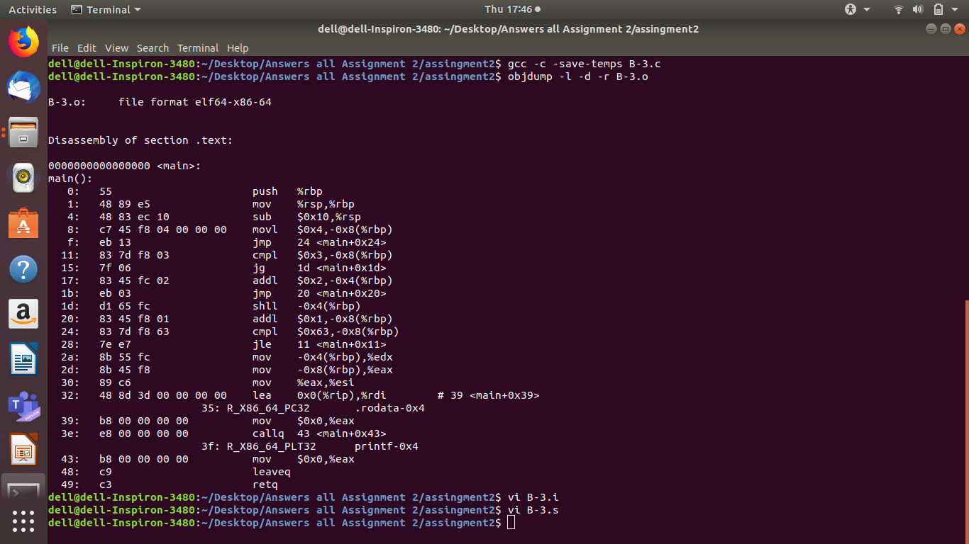
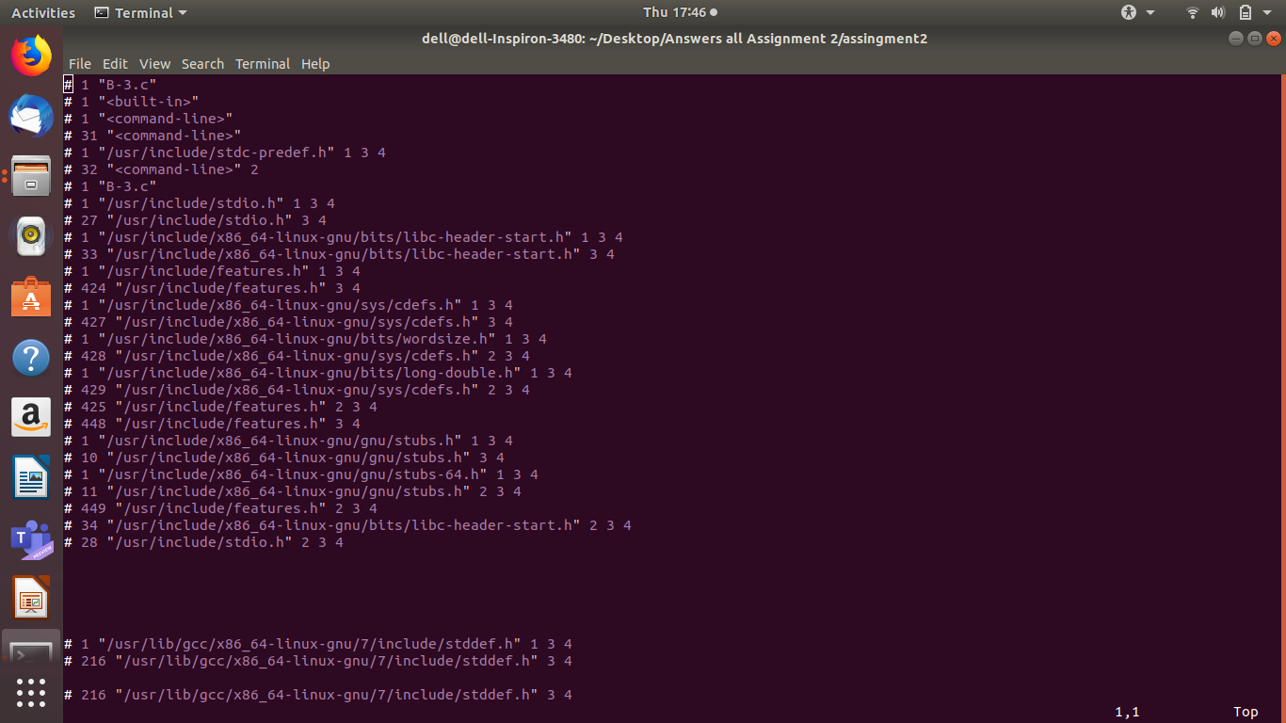
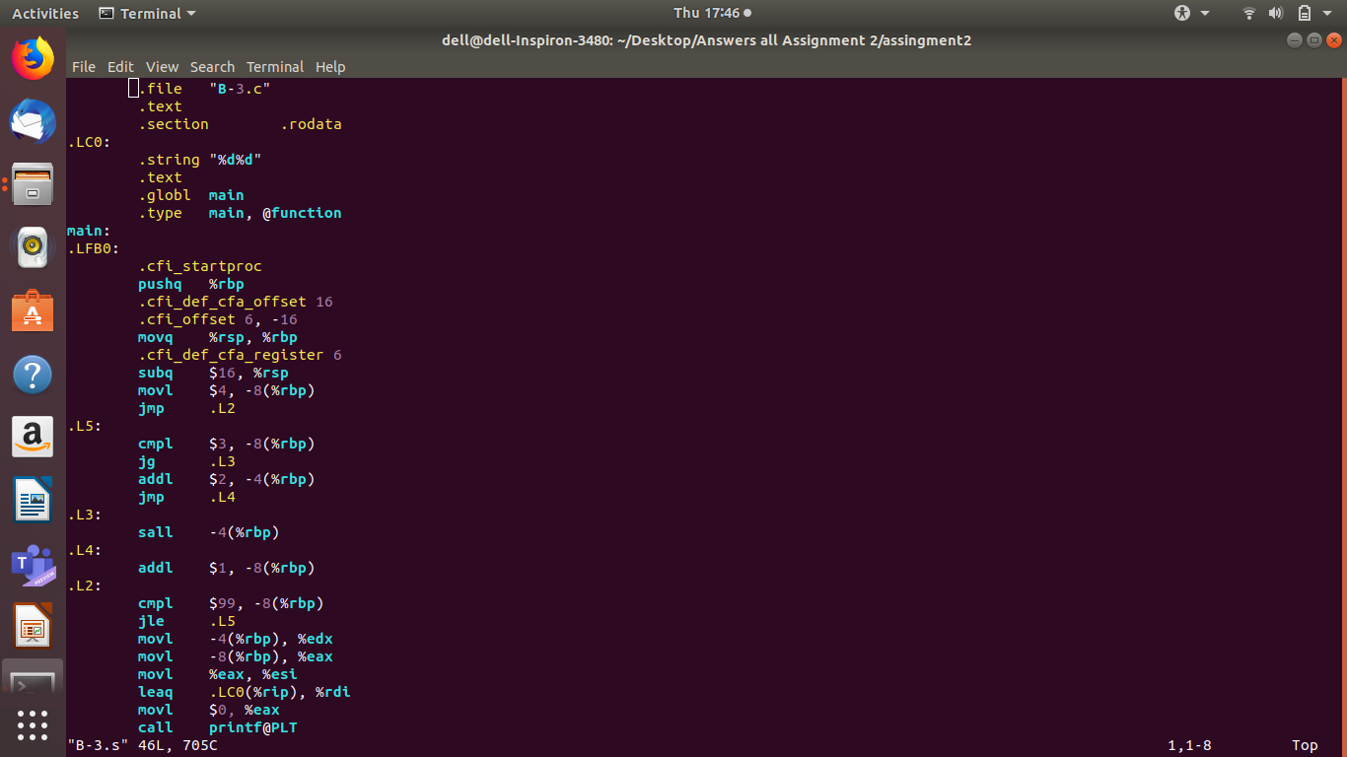

B-4] C CODE

int main()
{
int a, b, c;
b = (a + c + b) * (c + a);
return b;
}

B-4] .i CODE
# 1 "B-4.c"
# 1 "<built-in>"
# 1 "<command-line>"
# 31 "<command-line>"
# 1 "/usr/include/stdc-predef.h" 1 3 4
# 32 "<command-line>" 2
# 1 "B-4.c"
int main()
{
int a, b, c;
b = (a + c + b) * (c + a);
return b;
}

B-4] .s CODE

.file "B-4.c"
.text
.globl main
.type main, @function
main:
.LFB0:
.cfi_startproc
pushq %rbp
.cfi_def_cfa_offset 16
.cfi_offset 6, -16
movq %rsp, %rbp
.cfi_def_cfa_register 6
movl -12(%rbp), %edx
movl -8(%rbp), %eax
addl %eax, %edx
movl -4(%rbp), %eax
leal (%rdx,%rax), %ecx
movl -8(%rbp), %edx
movl -12(%rbp), %eax
addl %edx, %eax
imull %ecx, %eax
movl %eax, -4(%rbp)
movl -4(%rbp), %eax
popq %rbp
.cfi_def_cfa 7, 8
ret
.cfi_endproc
.LFE0:
.size main, .-main
.ident "GCC: (Ubuntu 7.5.0-3ubuntu1~18.04) 7.5.0"
.section .note.GNU-stack,"",@progbits

B-4]SCREENSHOTS

