A-1] CODE

int Z;

void main()
{
int a, b, c;
int p = 6;
int q;
double r;

a = 10;
b = 20;
c = a * b + 25;
p = 6;
q = Z;
r = 34.5;
Z = r;
Z = Z + 1;
}

A-1]GIMPLE

main ()
{
int a;
int b;
int c;
int p;
int q;
double r;

p = 6;
a = 10;
b = 20;
_1 = a * b;
c = _1 + 25;
p = 6;
q = Z;
r = 3.45e+1;
_2 = (int) r;
Z = _2;
Z.0_3 = Z;
_4 = Z.0_3 + 1;
Z = _4;
}

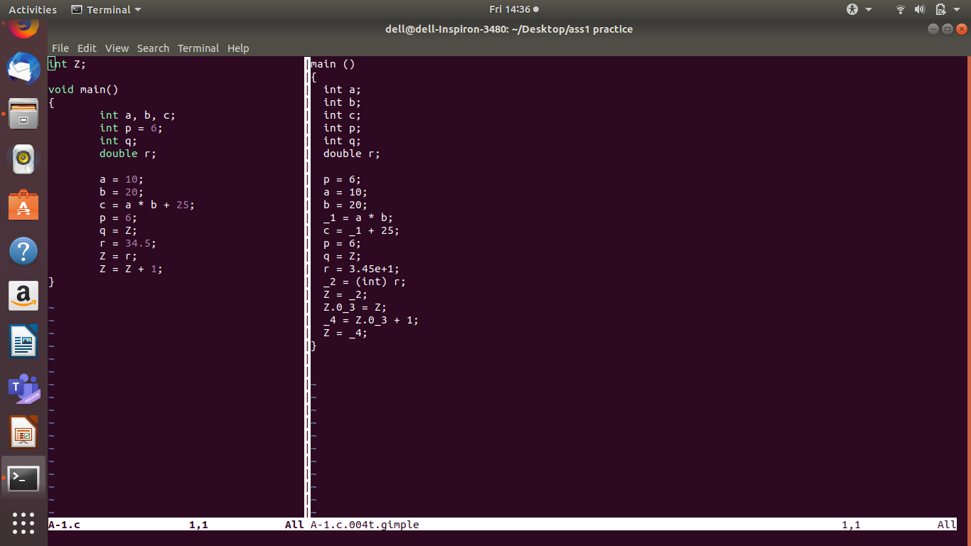
A-1]SCREENSHOT

A-1]QUESTION AND ANSWERS
1 How do the declarations look in the GIMPLE? Specifically, what happens to multiple variables declared and initialized on the same line? What happens to global declaration [int Z]?
tro
Solution: In the GIMPLE the the variables which are decalred they dont come in a single line. The variables are declared as a separate local variables.
The multiple variables come in different lines and not in a single line. The variables which are initialized the value is not assigned to the variable immediately in GIMPLE it is assigned later.
There is no declaration for the global variable in GIMPLE, they are used directly.

2 How are complex expressions such as [c = a * b + 25] broken down? Can you determine a rule as to when temporary variables will be introduced?

Solution: The complex expression [c = a * b + 25] is broken down and instead of directly solving it the GIMPLE solves the expression by the introduction of the temporary variables. The temporary variables are introduced when there is more than one operation to be performed i.e, a * b + 25 in this case it will be broken down because it contains more than one expressioni.e, * and +.

3 How are floats/doubles represented in GIMPLE? What happens when a float/double is assigned to an integer in [Z = r]?

Solution:The float and doubles is represented in the scientfic form i.e, in the exponential form. The float/double is converted into int form when we are assigning its value to the int type variable.

4 How are reads/writes to the global variable Z performed? Why is there a temporary introduced for the statement [Z = Z + 1] but not for the statements [q = Z] or [Z = p]?

Solution:The global is variable is converted into local variable and this is how the read/write is performed in the global variable. The temporary is introduced for the Z because it is a global variable and we first have to convert it into local variable and it is there not for 'q' because it is a already a local variable.

A-2]CODE

int Z;

void f()
{
int a, b, c;
a = Z;
if (a < 10) {
b = 5;
c = 17;
} else {
b = 6;
c = 20;
if (a == 0) {
c = 0;
}
}
Z = b * 10 + c;
}

A-2]GIMPLE
f ()
{
int a;
int b;
int c;

a = Z;
if (a <= 9) goto <D.1799>; else goto <D.1800>;
<D.1799>:
b = 5;
c = 17;
goto <D.1801>;
<D.1800>:
b = 6;
c = 20;
if (a == 0) goto <D.1802>; else goto <D.1803>;
<D.1802>:
c = 0;
<D.1803>:
<D.1801>:
_1 = b * 10;
_2 = c + _1;
Z = _2;
}

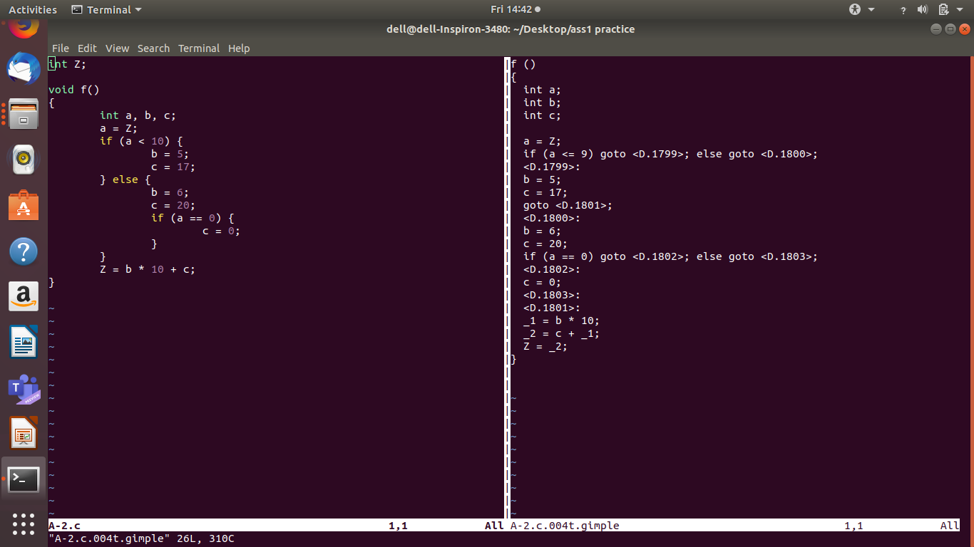
A-2]SCREENSHOT

A-2]QUESTION AND ANSWERS

1 How have if-blocks been translated into GIMPLE statements? Can you differentiate between conditional and unconditional gotos?

Solutions:The if-else block is converted into a single line statement with the introduction of the goto statements. And later the goto statement values like <D.1799> is used to go specifically in the if statement declarations and there is another goto value for the else statement. And also the if statements condition is changed to less than or equal to. In the conditional goto the conditions are displayed immediately after the <D> statement. But in the unconditional statement it is not displayed the <D> block remains empty.

2 Repeat the above compilation, but now asking for another dump that of the pass "cfg". View this pass and say whether this representation makes it easier to read and understand GIMPLEs. Draw the control-flow graph of the program A-2.c on a piece of paper by looking at the CFG dump.

Solutions:This representation definitely make it easier to read and understand GIMPLEs because when you compile the code by this method the if and else blocks remain in their positions and only the goto is introduced in the if statements conditions.

A-3]CODE

int main()
{
int sum = 0;
int i, j;

while(sum < 100) {
sum = sum * 2;
}

for(i=0; i<25; i++) {
for(j=0; j<50; j++) {
sum = sum + i*j;
}
}
}

A-3]CGF

;; Function main (main, funcdef_no=0, decl_uid=1792, cgraph_uid=0, symbol_order=0)

;; 4 loops found
;;
;; Loop 0
;; header 0, latch 1
;; depth 0, outer -1
;; nodes: 0 1 2 3 4 5 6 7 8 9 10 11 12
;;
;; Loop 2
;; header 10, latch 9
;; depth 1, outer 0
;; nodes: 10 9 8 6 7
;;
;; Loop 3
;; header 8, latch 7
;; depth 2, outer 2
;; nodes: 8 7
;;
;; Loop 1
;; header 4, latch 3
;; depth 1, outer 0
;; nodes: 4 3
;; 2 succs { 4 }
;; 3 succs { 4 }
;; 4 succs { 3 5 }
;; 5 succs { 10 }
;; 6 succs { 8 }
;; 7 succs { 8 }
;; 8 succs { 7 9 }
;; 9 succs { 10 }
;; 10 succs { 6 11 }
;; 11 succs { 12 }
;; 12 succs { 1 }
main ()
{
int j;
int i;
int sum;
int D.1807;

<bb 2> [0.00%]:
sum = 0;
goto <bb 4>; [0.00%]

<bb 3> [0.00%]:
sum = sum * 2;

<bb 4> [0.00%]:
if (sum <= 99)
goto <bb 3>; [0.00%]
else
goto <bb 5>; [0.00%]

<bb 5> [0.00%]:
i = 0;
goto <bb 10>; [0.00%]

<bb 6> [0.00%]:
j = 0;
goto <bb 8>; [0.00%]

<bb 7> [0.00%]:
_1 = i * j;
sum = sum + _1;
j = j + 1;

<bb 8> [0.00%]:
if (j <= 49)
goto <bb 7>; [0.00%]
else
goto <bb 9>; [0.00%]

<bb 9> [0.00%]:
i = i + 1;

<bb 10> [0.00%]:
if (i <= 24)
goto <bb 6>; [0.00%]
else
goto <bb 11>; [0.00%]

<bb 11> [0.00%]:
D.1807 = 0;

<L9> [0.00%]:
return D.1807;

}
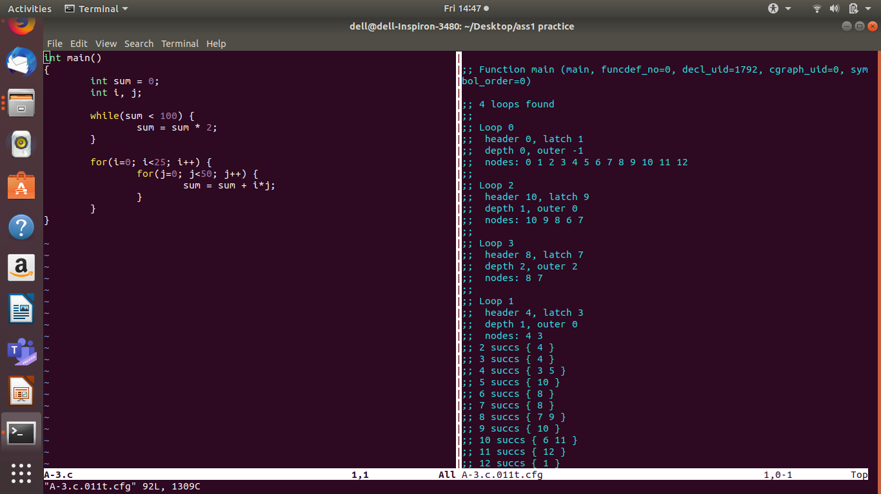
A-3]SCREENSHOT

A-3]QUESTION AND ANSWERS

1 Identify the basic blocks that correspond to the while loop. How is the GIMPLE for a while loop different from simple if-else jumps?

Solution:Basic block number 2, 3, 4 belog to the while loop. .The <D> factor is not introduced in the while loop exection and the conditions appear here without the introduction of the <D> factor. And also the while loop is not implemented directly the conditions for the while loop are executed with the introduction of the if-else statements.

2 Identify the basic blocks for the nested for-loop. You should be able to identify intializers, conditions and increments for each
loop as well as the shared inner body. Is there really anything special about a for-loop as compared to a while-loop?

Solution: The basic blocks for the nested for loop are block number 6, 7, 8.

A-4]CODE

int main()
{
int a[3];
int b[] = {1, 2, 3};
int i, *p;
for (i=0; i<3; i++) {
a[i] = b[i];
}
p = a;
*(p + 2) = 5;
}

A-4]CGF

;; Function main (main, funcdef_no=0, decl_uid=1792, cgraph_uid=0, symbol_order=0)

;; 2 loops found
;;
;; Loop 0
;; header 0, latch 1
;; depth 0, outer -1
;; nodes: 0 1 2 3 4 5 6
;;
;; Loop 1
;; header 4, latch 3
;; depth 1, outer 0
;; nodes: 4 3
;; 2 succs { 4 }
;; 3 succs { 4 }
;; 4 succs { 3 5 }
;; 5 succs { 6 }
;; 6 succs { 1 }
main ()
{
int * p;
int i;
int b[3];
int a[3];
int D.1802;

<bb 2> [0.00%]:
b[0] = 1;
b[1] = 2;
b[2] = 3;
i = 0;
goto <bb 4>; [0.00%]

<bb 3> [0.00%]:
_1 = b[i];
a[i] = _1;
i = i + 1;

<bb 4> [0.00%]:
if (i <= 2)
goto <bb 3>; [0.00%]
else
goto <bb 5>; [0.00%]

<bb 5> [0.00%]:
p = &a;
_2 = p + 8;
*_2 = 5;
a = {CLOBBER};
b = {CLOBBER};
D.1802 = 0;

<L3> [0.00%]:
return D.1802;

}

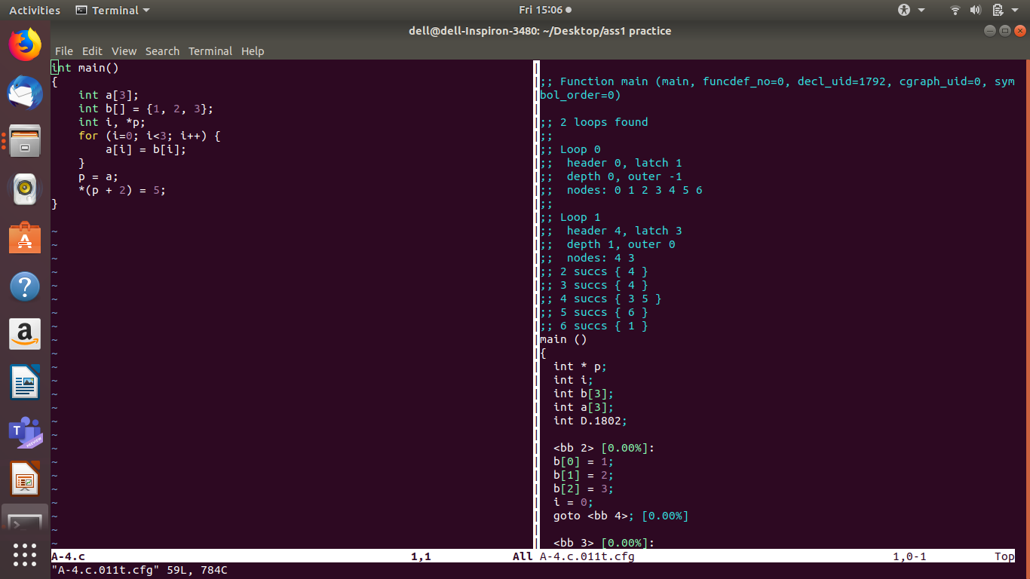
A-4]SCREENSHOT

A-4]QUESTION AND ANSWERS

1 How is array declaration and initialization handled?

Solution:The cfg program automatically detects the number of elements present in the array if is not given as happened in the case of array 'b'. And also the elements of the array are declared on the separate lines with their index values.

2 Why does the statement a[i] = b[i] get broken down to two steps with an intermediate temporary?

Solution:As we know that the cfg file like the GIMPLE file can perform only one operation at a time. So according to these rule the a[i]=b[i] gets broken down with the introduction of the temporary variable because here they are performing two operations of reading and writing.

3 Why are there CLOBBER statements at the end?

Solution:CLOBBER statements are used for address-escaped variables. It is an annotation to signify that the scope of this address-escaped variable has ended.

A-5]CODE

int main()
{
int a, b, c, d;

d = 10;
if (c > d) {
a = 3;
b = 2;
} else {
a = 2;
b = 3;
}

c = a + b;
}

A-5]SSA

;; Function main (main, funcdef_no=0, decl_uid=1792, cgraph_uid=0, symbol_order=0)

main ()
{
int d;
int c;
int b;
int a;
int D.1802;
int _10;

<bb 2> [0.00%]:
d_3 = 10;
if (c_4(D) > d_3)
goto <bb 3>; [0.00%]
else
goto <bb 4>; [0.00%]

<bb 3> [0.00%]:
a_7 = 3;
b_8 = 2;
goto <bb 5>; [0.00%]

<bb 4> [0.00%]:
a_5 = 2;
b_6 = 3;

<bb 5> [0.00%]:
# a_1 = PHI <a_7(3), a_5(4)>
# b_2 = PHI <b_8(3), b_6(4)>
c_9 = a_1 + b_2;
_10 = 0;

<L3> [0.00%]:
return _10;

}

A-5]SCREENSHOT

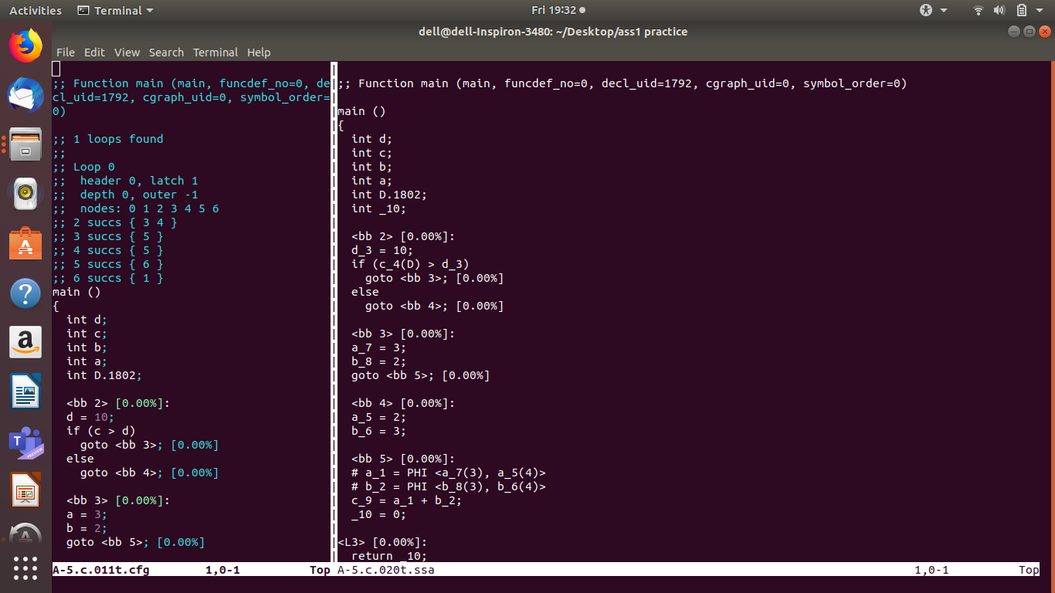
A-5]QUESTION AND ANSWERS

1 Do you notice that each usage of local variable as an operand uses a suffix that can be tracked to it's assignment? Why do some variables
have a suffix `(D)'?

Solution: Yes the local variable are suffixed with a unique number which helps us to understand to track to its assignment. Some variables here 'c' have been suffixed with (D), it happens in case of variables which are used directly before there assignment in the program.

2 Find the point in the CFG in which the paths of the two assignments to variable `a' and `b' merge. You will notice that PHI statements
have been introduced. Can you guess the syntax of the PHI statements?

Solution: The variables 'a' and 'b' will are merging with each other in block number 5. Yes the PHI statements are introduced in the block 5 in ssa. The syntax for the PHI statements is that first a local variable is introduced in which the value of 'a' and 'b' is stored and later the value to the variable 'a' and 'b' are assigned accordingly which block is correct. And the block number is checked while assigning the value to the variable 'a' and 'b'.

3 Can you think of an example in which a PHI node merges more than two versions of a variable?

Solution:The PHI node merges with more than two versions of variables in the case when we use the if-else statement with the help of the use of else-if blocks. And also we can use the switch case to merge more than two versions of a variable.

A-6]CFG DUMP

main ()
{
int j;
int i;
int D.2168;

<bb 2>:
i = 2;
goto <bb 11>;

<bb 3>:
j = 2;
goto <bb 7>;

<bb 4>:
D.2168 = i % j;
if (D.2168 == 0)
goto <bb 5>;
else
goto <bb 6>;

<bb 5>:
goto <bb 8>;

<bb 6>:
j = j + 1;

<bb 7>:
if (j < i)
goto <bb 4>;
else
goto <bb 8>;

<bb 8>:
if (i == j)
goto <bb 9>;
else
goto <bb 10>;

<bb 9>:
printf ("%d \n", i);

<bb 10>:
i = i + 1;

<bb 11>:
if (i <= 100)
goto <bb 3>;
else
goto <bb 12>;

<bb 12>:
return;

}

A-6]ANSWER

The C program for the given CFG dump is

#include<stdio.h>

void main()
{
int i,j;
for(i=2;i<101;i++){
for(j=2;j<i;j++){
if(I%j==0)
break;
}
if(i==j){
printf ("%d \n", i);
}

}

}

B-1]CODE

int AddTwo(int a)
{
a = a + 2;
return a;
}

int main()
{
int x = 3;
x = AddTwo(x);
return x;
}

B-1]SCREENSHOT

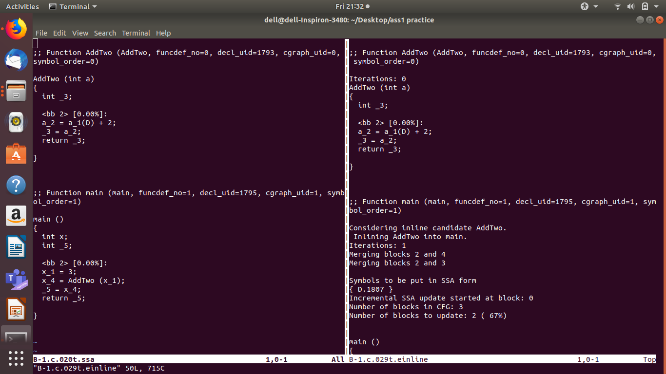

B-1]QUESTION AND ANSWERS

1 The body of AddTwo(x) seems to be inlined into the call of main rendering the function useless (nobody else is calling it). Then why
is the definition of AddTwo(x) still there all the way till the last pass (B-1.c.*.optimized)?

Solution:Maybe the body of the function exist because it may be called from another file. The compiler cannot know before the link time.

2 Is there any way to get rid of it?

Solution:If the function was declared with 'static' keyword (which , in C is something like "Private to these file only.") then the function body will disappear if there is no caller within the file.

B-2]CODE

int N;

int main()
{
int i, a = 10;
for(i= 0; i < 4; i++)
{
a = a + N;
};
return a;
}

B-2]SCREENSHOT

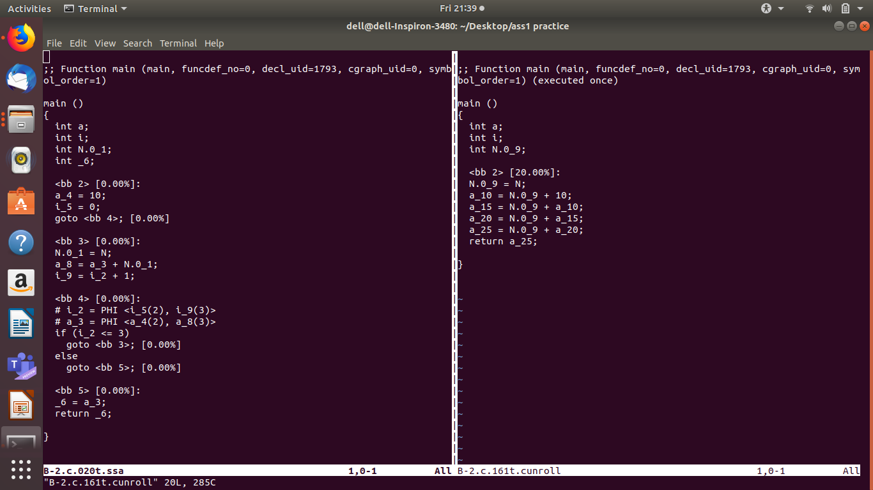

B-2]QUESTION AND ANSWER

1 What will happen if "a = a + N" is replaced by "a = a + 1"?

Solution:The loop will be unrolled and constant of propagation will allow GCC to compute the final value of 'a'. Hence the loop will be removed entirely.

B-3]CODE

#include <stdio.h>
int main ()
{
int a, b;
for (a=4 ; a<100; a++) {
if (a < 4)
b = b + 2;
else
b = b * 2;
}
printf ("%d%d", a, b);
}

B-3]SCREENSHOT

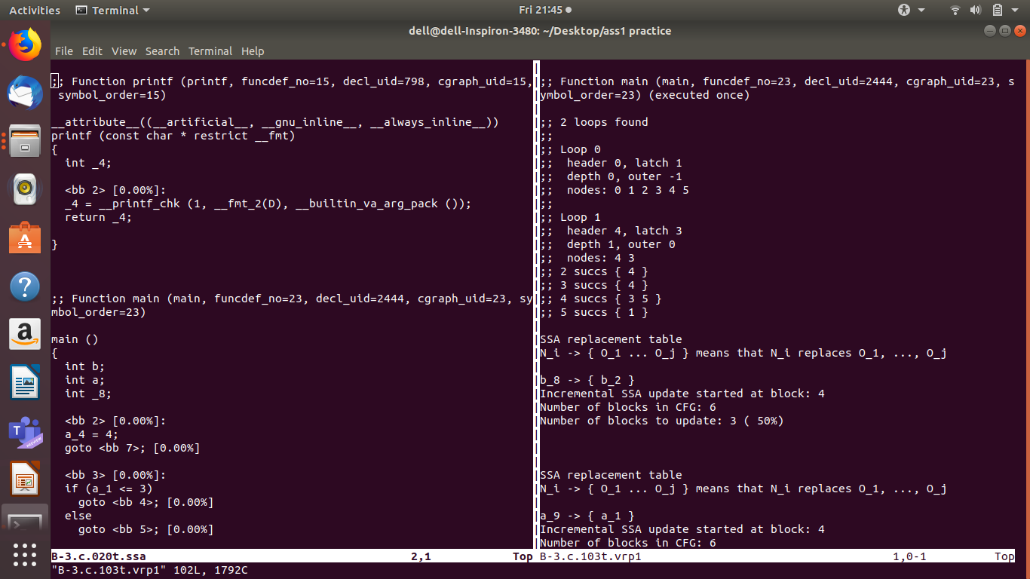

B-3]QUESTION AND ANSWER

1 In the file B-3.c, what values can variable `a' take? Will the `if' condition [a < 4] ever be true? Inspect the file B-3.c.*.vrp1 to
analyze the dump.

Solution:In the file B-3.c 'a' can take the values from 4 to 99. The 'if' condition will never be true. Therefore the statement b=b+2 will never be executed and so the code will eliminate it.

B-4]CODE

int main()
{
int a, b, c;
b = (a + c + b) * (c + a);
return b;
}

B-4]SCREENSHOT

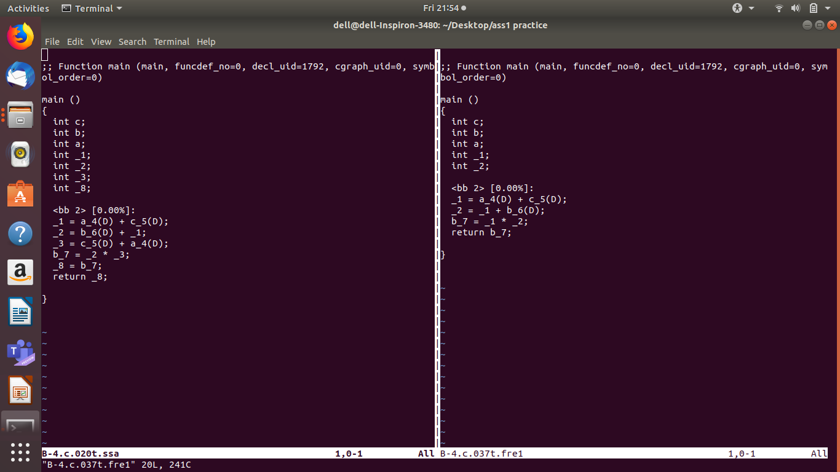

B-4]QUESTION AND ANSWERS

1 How many times is the expression (a + c) computed in the original code (as seen in the SSA pass)? What about after the FRE pass?

Solution:The expression (a+c) is computed 2 times in the original code (i.e, in ssa). When we apply the FRE pass the expression (a+c) is only calculated once.

2 Have there been any more optimizations after FRE? How will you check?

Solution:There are no many more optimizations of the FRE. We can check it by compiling and running the program of the file B-4.c.*.optimized

3 Why did we have to put a "return b" in this assignment? What if "return b" is changed to "return 0"? Will it make any difference?

Solution:return "b" was required to make the computation of the variable 'b' meaningful. If function 'main' is going to return 0 and there is no other output ,GCC will realise that the enitre computation of variable 'b' was dead code and will eliminate its dependencies one by one until the resluting program reduces to:
int main()
{
return 0;
}

