INDEX
Sr.no | Title | Page.no
Part-I Introduction
1.1 | Introduction to Project | 3
1.2 | Project Profile | 6
Part-II System Analysis and Design
2 | Project Planning | 8
2.1 | Scope of the Project | 8
2.2 | Software Process Model | 10
2.3 | Project Team | 13
3 | System Design | 14
3.1 | Data Flow Diagrams | 14
3.2 | ER Diagram | 16
3.3 | Database Design | 17
Part-III Implementation Details
4 | Screen Layouts | 23
Part-IV Tools and Technologies
5 | About MongoDB | 44
6 | About Express.js | 45
7 | About React.js | 46
8 | About Node.js | 47
9 | Bibliography | 48

PART-I
Introduction

  - Introduction to project

Project Title: CAMPUS BALLOT
Project Profile
- CAMPUS BALLOT is a web-based E-Voting and Polling System designed for college elections and campus opinion polls. It enables election officers to create ballots, while allowing students to register, vote once per poll, and view live results.
- The platform solves the problem of scattered, paper-based, or unofficial voting by combining registration, ballot casting, and result display into a single system. Students no longer need separate processes for enrolment, voting, and checking outcomes, resulting in a more efficient and transparent campus election experience.
- CAMPUS BALLOT includes one-vote-per-student enforcement and a live tally of candidates or poll options. These features allow students to cast a fair vote, prevent duplicate voting, and understand results clearly after they submit a ballot.
- The system enhances interaction between election officers and students through open and closed ballots, candidate lists, and result bars. Officers can publish elections, close voting, and remove polls, which supports a controlled and accountable election process.
- Additionally, CAMPUS BALLOT aims to deliver a simple, interactive, and beginner-friendly environment for both student voters and election officers.

Project Users and Functionalities
Student (Voter)
• Register and login using the authentication system
• Browse open elections and campus opinion polls
• View poll details and the candidate or option list before voting
• Cast exactly one vote in each poll
• Access the ballot dashboard after login
• See live result bars after a vote is submitted
• Track which polls have already been voted on
• View total vote counts for each poll
• Receive a confirmation message after a successful vote
• Enroll using college email and a unique student ID
• Open a selected poll from the ballot list
• View candidate names and party or option labels
• Cannot submit a second vote in the same poll
• View results of closed polls
• Log out securely from the current session
• Access only voter features and not the officer desk
• Can vote only before ending deadline.

Election Officer
• Login using the officer authentication system
• Open the officer desk to manage campus ballots
• Create and publish new elections or opinion polls
• Add poll details including title, description, and category
• Add at least two candidates or poll options
• View and manage existing polls
• Monitor the total number of votes on each poll
• Close or reopen voting for a poll
• Delete a poll along with its recorded votes
• View results without being allowed to vote
• Election officer can set voting deadline with date and time.

Guest User
• View the Campus Ballot home page
• Read how student voting and officer tools work
• Open the login and student registration pages
• Cannot cast a vote without creating an account

  - Project Profile

Project Title | Campus Ballot (E-Voting and Polling System)
Project Type | Web Application
Front End Technologies | React
Back End Technologies | Node, MongoDB
Internal Guide | Mayuri Patel
Submitted By | 39 - Vipul Maurya, 75 - Adarsh Singh

PART-II
SYSTEM ANALYSIS
AND DESIGN

- Project Planning

  - Scope of System:
The scope of CAMPUS BALLOT is to provide a web-based platform for college e-voting that enables election officers to create and manage ballots while allowing students to register, vote once, and view results. The system integrates authentication, ballot delivery, vote recording, and result display into a single platform.
The platform focuses on reducing unofficial or paper-based voting by combining enrolment, one-time voting, and result viewing. It includes features such as JWT login, unique student ID registration, candidate lists, live tallies, and poll open or close controls to create a complete campus voting environment.
The system is developed using a monolithic architecture with a modular structure, where different functionalities such as user management, poll management, and vote recording are organized into separate modules within a single application. This approach ensures maintainability, scalability, and efficient development.
The system supports three types of users: Election Officer, Student (Voter), and Guest User.
Election Officer:
When an Election Officer is logged in, they can create, publish, close, reopen, and delete polls. Officers can add candidates or options and watch vote totals from the officer desk.
They can also view results without voting, which keeps the election process supervised and prevents officer ballots from mixing with student votes.
Student:
When a Student is logged in, they can manage their account details, browse open ballots, and cast one vote per poll.
Students can open a poll, select a candidate or option, submit the vote, and then see result bars. A second vote in the same poll is blocked by the system.

Guest User:
Guest users can view the home page and read about the system, then open login or registration. They cannot vote until they create a student account.

System Benefits
The system provides a unified voting platform that enhances accessibility and fairness for users. Students benefit from a simple ballot and instant results, while officers gain tools for creating elections and controlling when voting is open.

  - Software Process Model
Iterative Model
The Iterative Model is a software development process in which the system is developed and improved through repeated cycles. Instead of defining all requirements at the beginning, the system evolves over time as new features and improvements are added in multiple iterations.

In this model, development starts with a basic implementation, and additional functionalities are incorporated gradually. Each iteration includes planning, design, implementation, and testing, allowing continuous refinement and enhancement of the system.

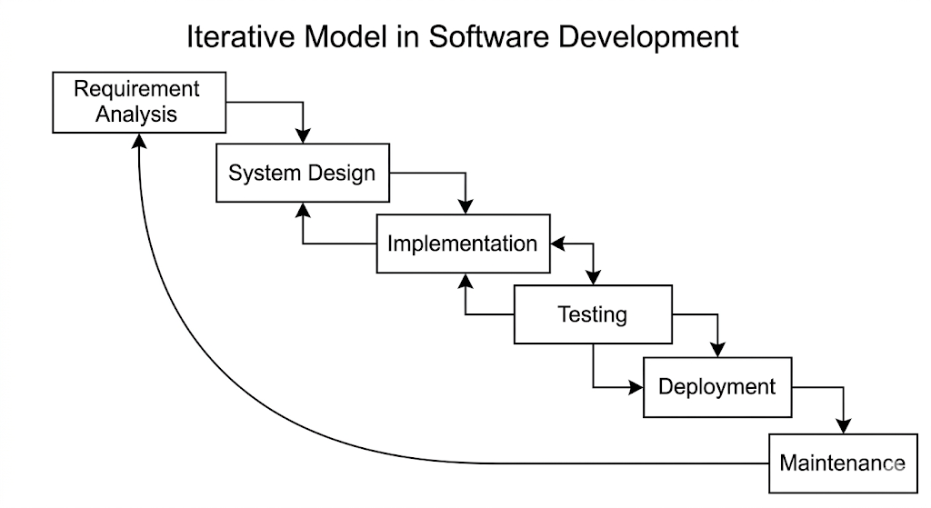

Requirement gathering and analysis
In this phase, initial requirements are identified to build a basic version of the system. Unlike traditional models, requirements are not fixed and may evolve during development.
For CAMPUS BALLOT, core features such as student registration, login, poll listing, and basic voting were identified initially, while additional features were introduced in later stages.
System Design
In this phase, the system design is prepared based on the current set of requirements. The design is flexible and can be modified in subsequent iterations as new features are added.
For CAMPUS BALLOT, the system was designed using a modular monolithic architecture, allowing different functionalities to be developed and updated independently.
Implementation
In this phase, the system is developed incrementally. A basic version is created first, and new features are added in subsequent iterations.
For CAMPUS BALLOT, initial development began with core functionalities, followed by the addition of advanced features such as live result bars, poll close or reopen controls, unique vote indexing, and the officer desk.
Testing
Testing is performed in every iteration to ensure that newly added features work correctly and do not affect existing functionalities.
For CAMPUS BALLOT, continuous testing was carried out after each feature addition to maintain system stability and performance.

Deployment of System
After multiple iterations and successful testing, the system is deployed for user access.
CAMPUS BALLOT was deployed as a web-based application, allowing students and officers to access voting features and interact with the platform online.
Maintenance
After deployment, the system continues to evolve with further improvements, bug fixes, and feature enhancements based on user needs.
For CAMPUS BALLOT, maintenance includes refining existing features and adding new functionalities to improve the overall voting experience.

  - Project Team
Personal-Profile
Name | Vipul Maurya
Address | Silvassa, D.N.H
Contact No. | 8128922158
E-Mail Address | maurya.vipul2006@gmail.com
Exam No | 1349

Partner-Profile
Name | Adarsh Singh
Address | Masat, D.N.H
Contact No. | 91574653386
E-Mail Address
Exam No

- SYSTEM DESIGN :
  - Data Flow Diagram
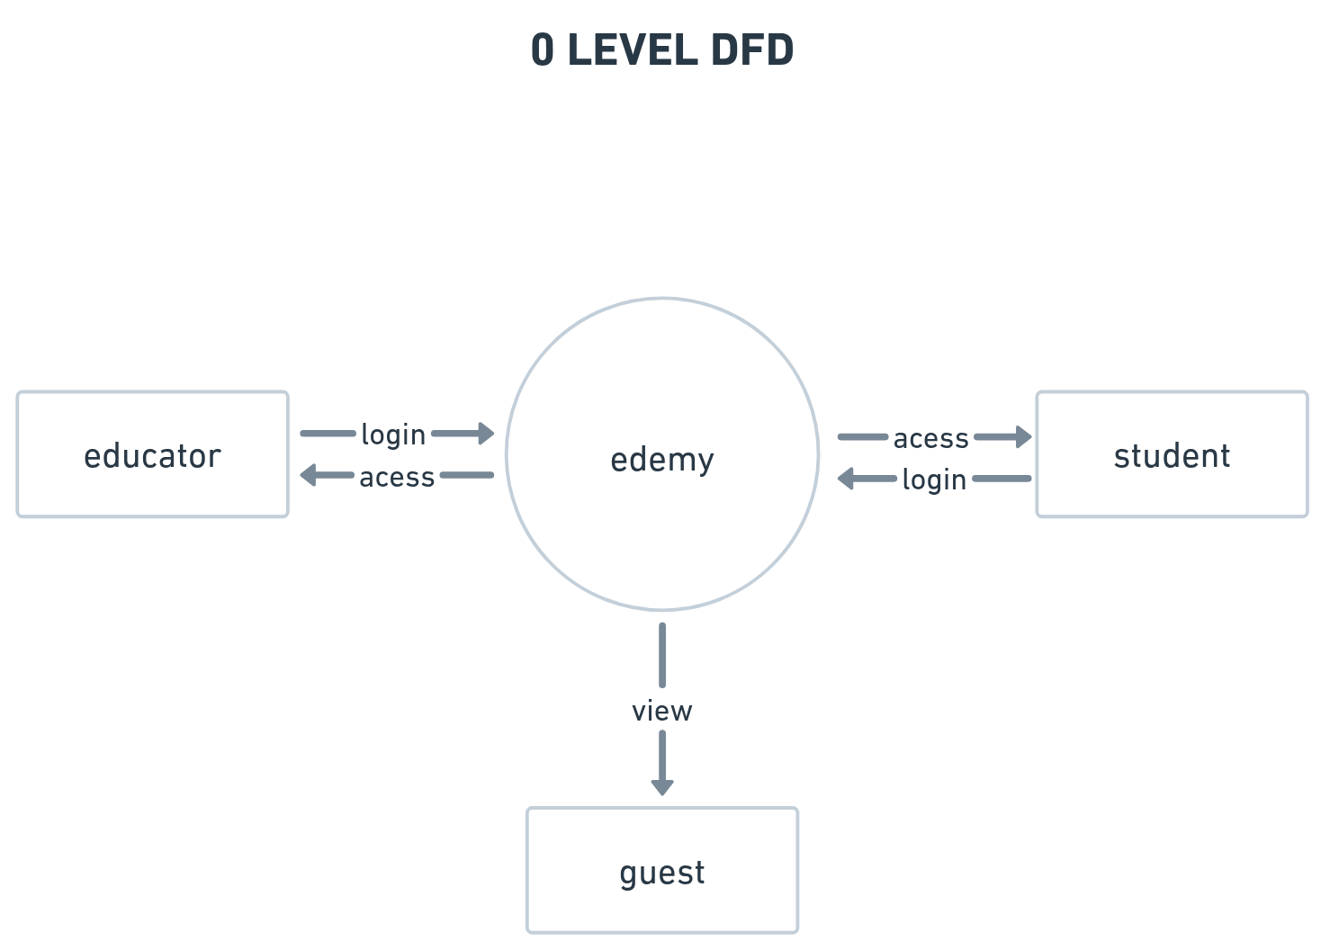
Student
Admin
Campus Ballot

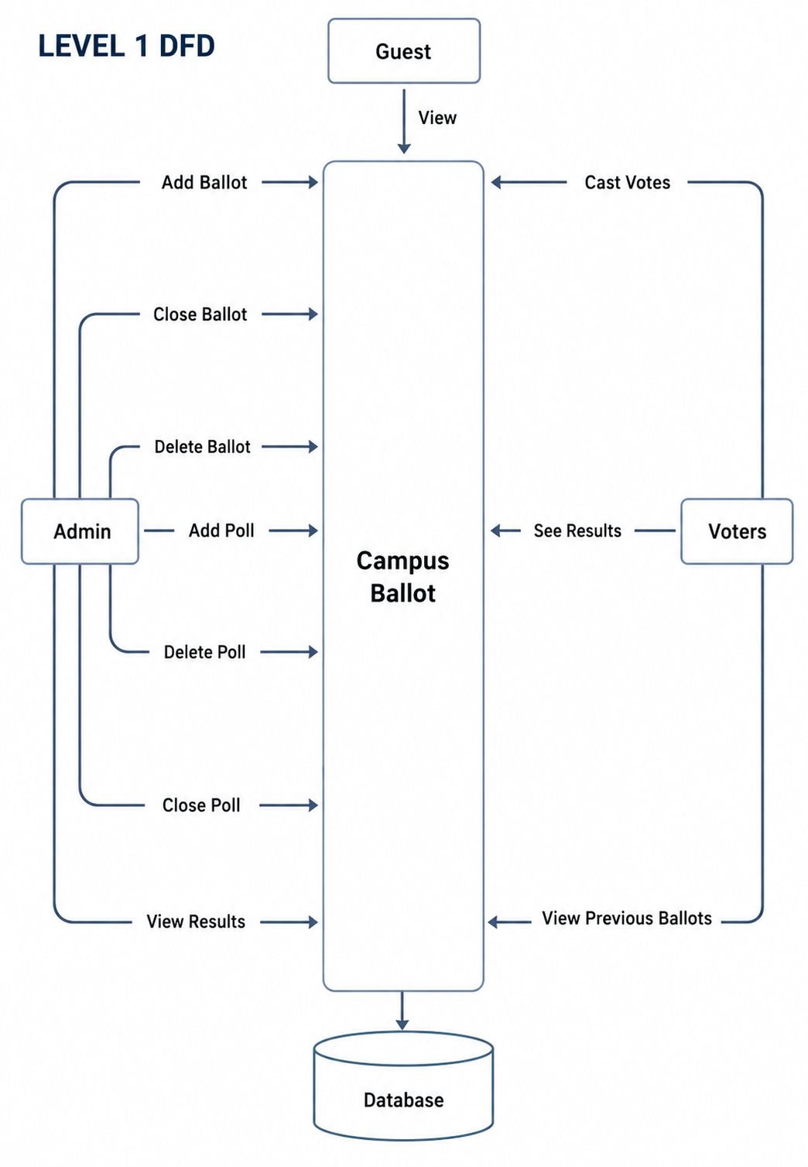
  - ER DIAGRAM

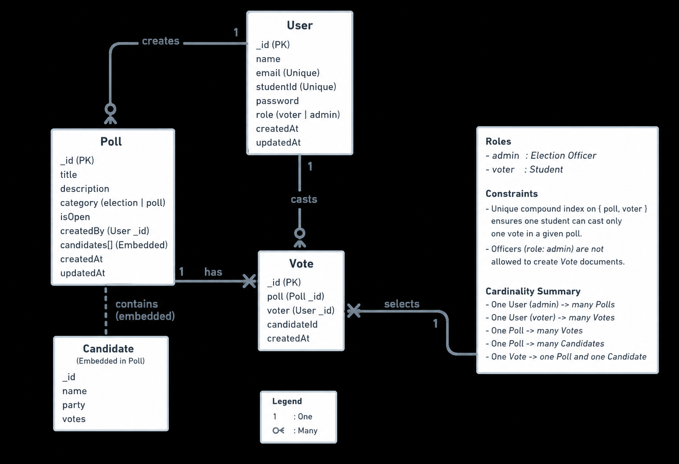
The ER diagram of CAMPUS BALLOT shows three main collections used by the system: User, Poll, and Vote. Candidate details are stored as embedded documents inside each Poll.
User entity: _id, name, email, studentId, password, role (voter or admin), createdAt, updatedAt. Email and studentId are unique. A user with role admin is an Election Officer. A user with role voter is a Student.
Poll entity: _id, title, description, category (election or poll), isOpen, createdBy (User _id), candidates[], createdAt, updatedAt. Each poll is created by one officer.
Candidate (embedded in Poll): _id, name, party, votes. A poll must contain at least two candidates or options. The votes field stores the running tally for that option.
Vote entity: _id, poll (Poll _id), voter (User _id), candidateId, createdAt. Each vote links one student to one poll and one candidate.
Relationships: User (officer) CREATES Poll (1 to many). User (student) CASTS Vote (1 to many). Poll HAS Vote (1 to many). Poll CONTAINS Candidate (1 to many, embedded). Vote SELECTS Candidate (many to 1).
Constraint: a unique compound index on { poll, voter } ensures that one student can cast only one vote in a given poll. Officers are not allowed to create Vote documents.
Cardinality summary: One User -> many Polls (if admin). One User -> many Votes (if voter). One Poll -> many Votes. One Poll -> many Candidates. One Vote -> one Poll and one Candidate.

  - DATABASE DESIGN
Users
Column Name | Type
_id | objectId
__v | Int
createdAt | Date
email | String
name | String
password | String
role | String
studentId | String
updatedAt | date

votes
column name | type
_id | objectid
__v | int
candidateid | objectid
createdAt | date
poll | objectid
updatedat | date
voter | objectid

polls
column name |  | type
_id |  | objectid
__v |  | int
candidates |  | []
 | _id |  | objectid
 | name |  | string
 | party |  | string
 | votes |  | int
category |  | string
createdAt |  | date
createdBy |  | objectid
description |  | string
isopen |  | bool
title |  | string
updatedat |  | date

MongoDB database: college_evoting. Collections: users, polls, votes.
users: db.users.insertOne({ name: "Aisha Khan", email: "aisha@college.edu", studentId: "STU-1001", password: "<bcrypt hash>", role: "voter" })
polls: db.polls.insertOne({ title: "Student Council President 2026", description: "Choose the next president.", category: "election", isOpen: true, createdBy: ObjectId("..."), candidates: [{ name: "Priya Sharma", party: "Campus Unity", votes: 0 }, { name: "Arjun Patel", party: "Forward Students", votes: 0 }] })
votes: db.votes.insertOne({ poll: ObjectId("..."), voter: ObjectId("..."), candidateId: ObjectId("...") })
Prevent double voting: db.votes.createIndex({ poll: 1, voter: 1 }, { unique: true })
Useful queries: db.polls.find({ isOpen: true }); db.votes.find({ poll: ObjectId("..."), voter: ObjectId("...") }); db.polls.updateOne({ _id: ObjectId("..."), "candidates._id": ObjectId("...") }, { $inc: { "candidates.$.votes": 1 } }); db.users.findOne({ email: "admin@college.edu" })

PART-III
Implementation
Details

- Screen Layout
Guest User :
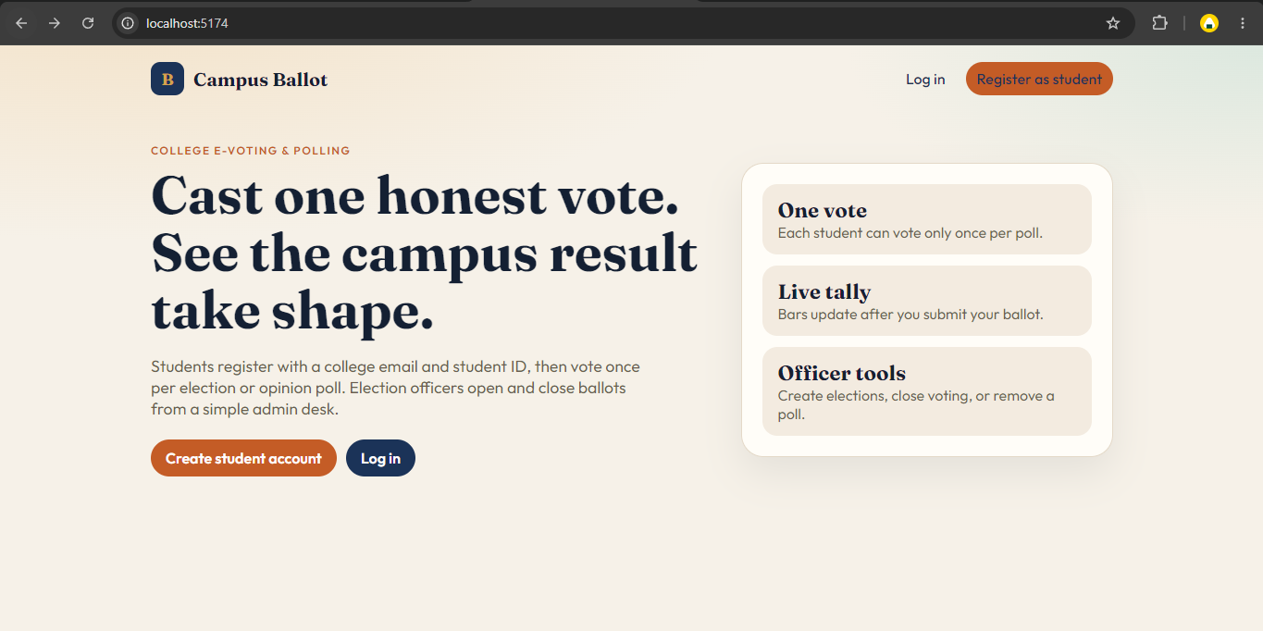
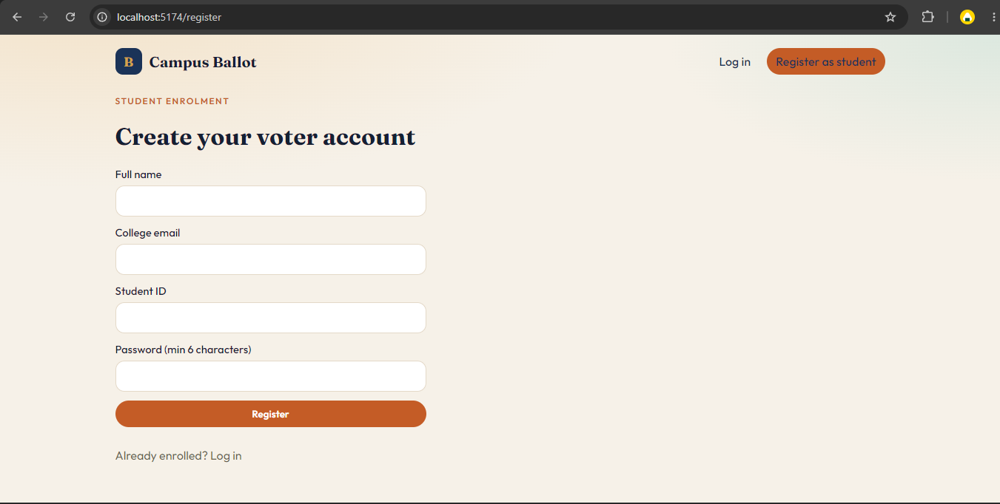
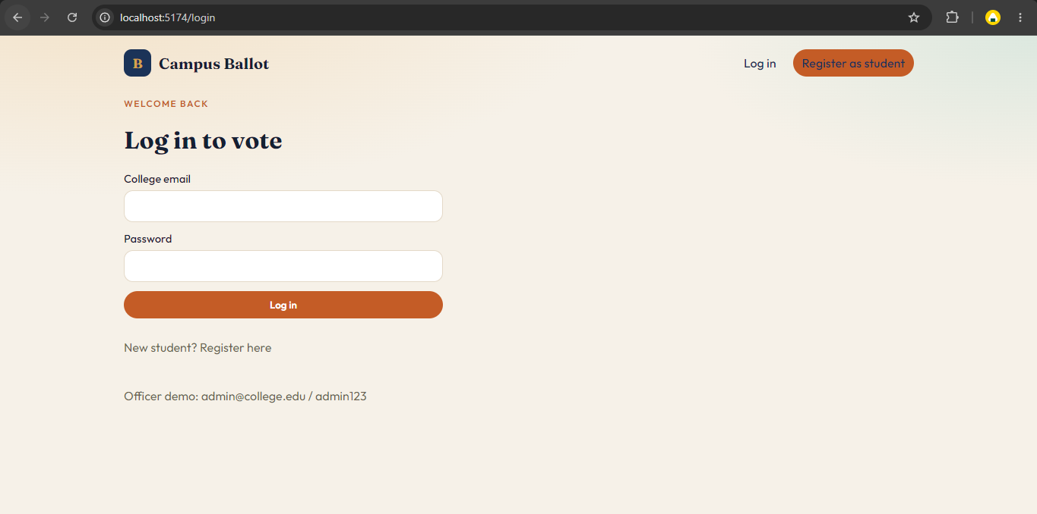
Student User:
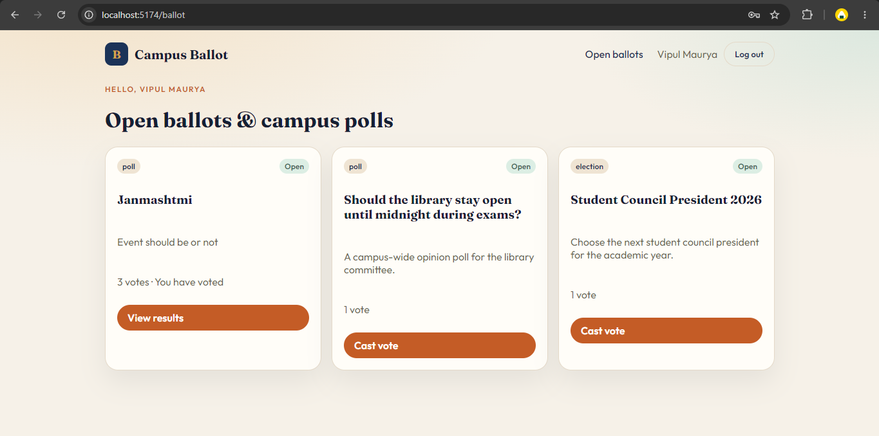
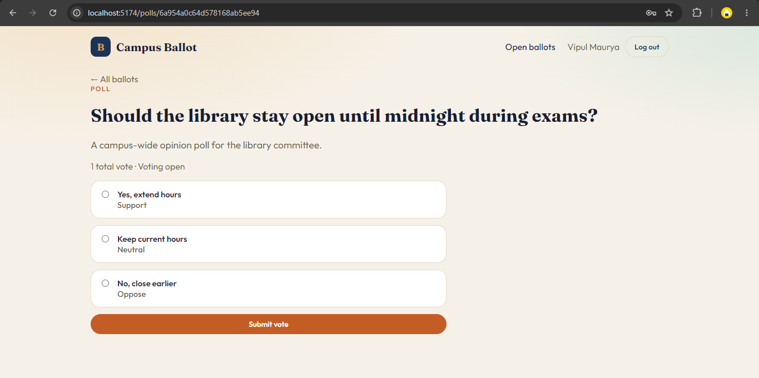
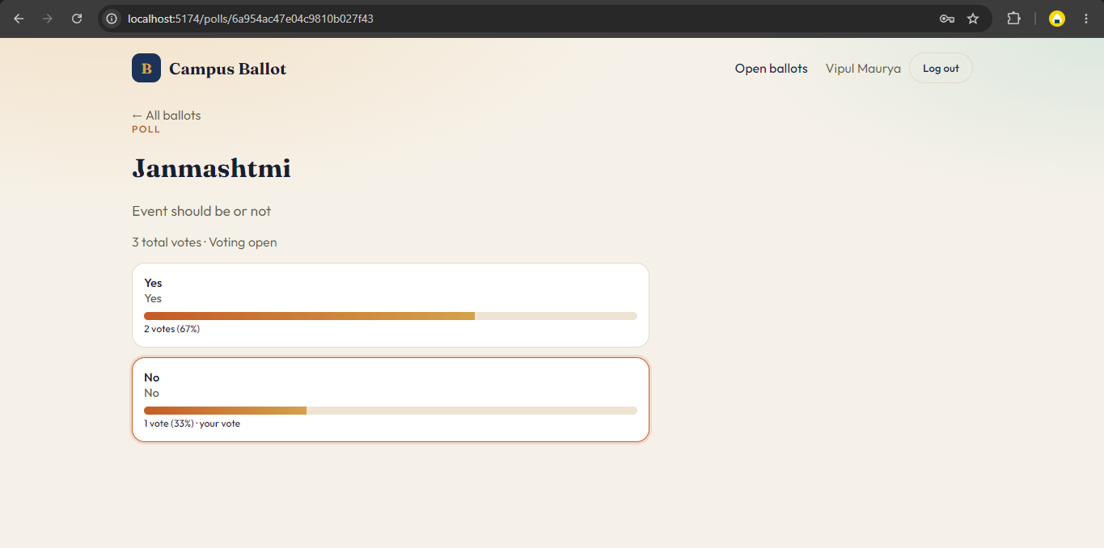

Admin User:
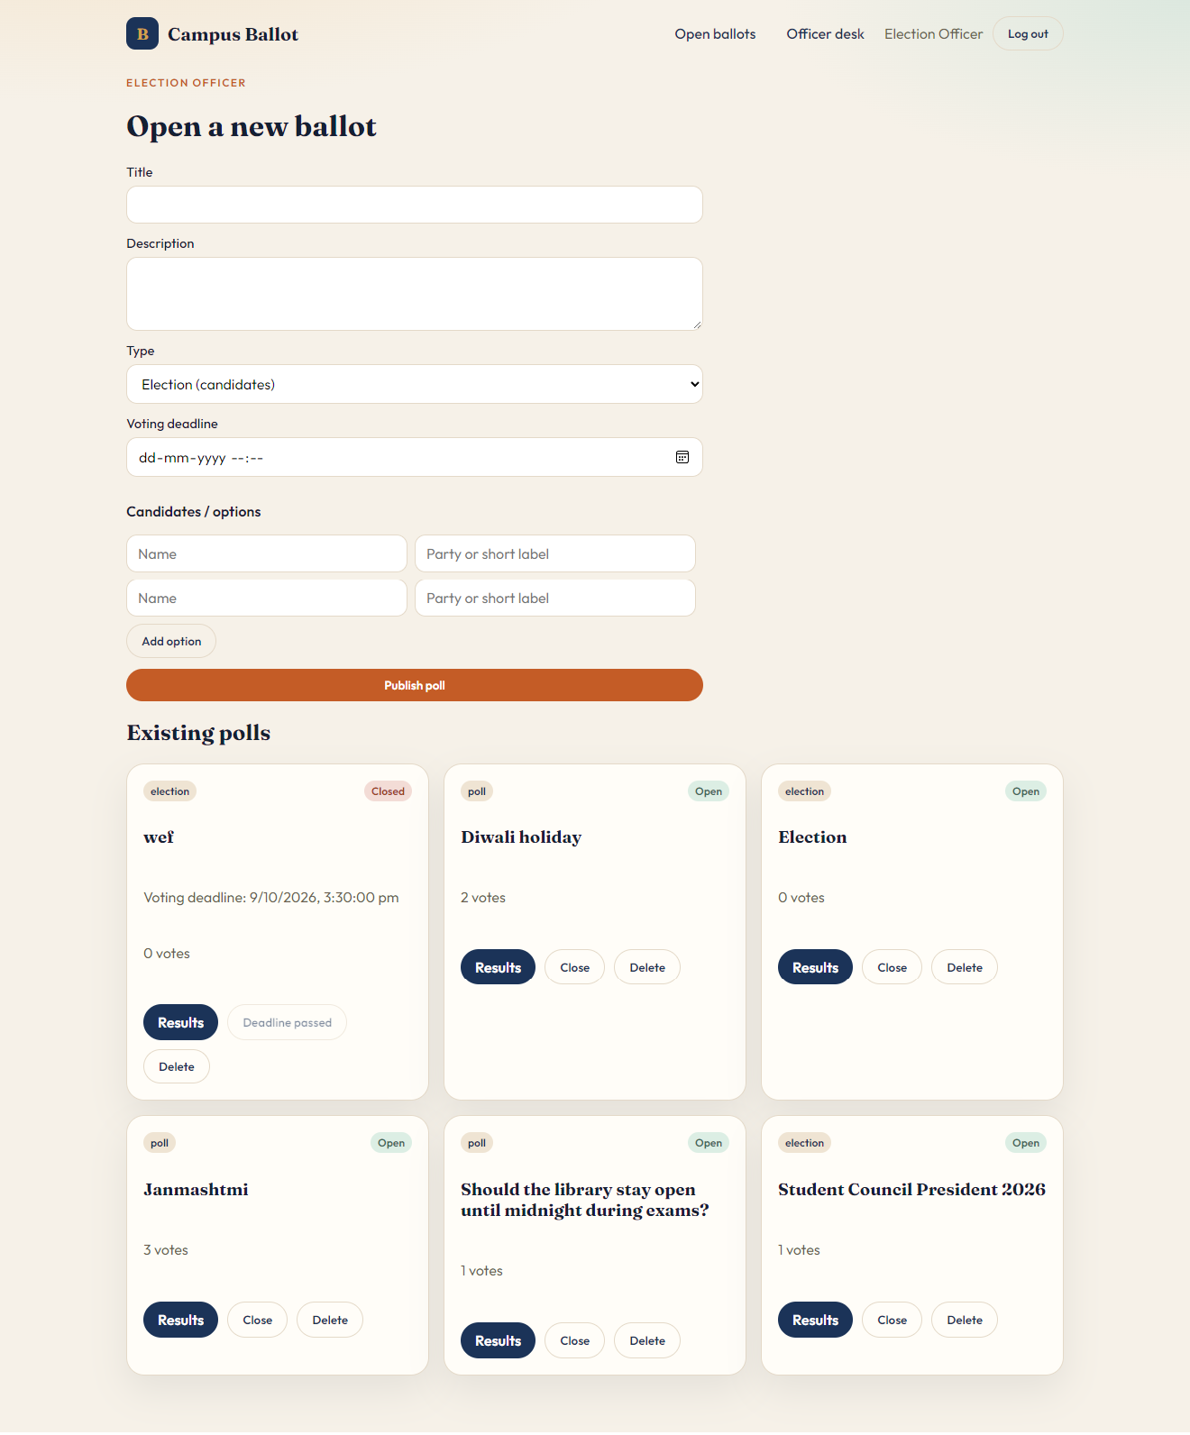
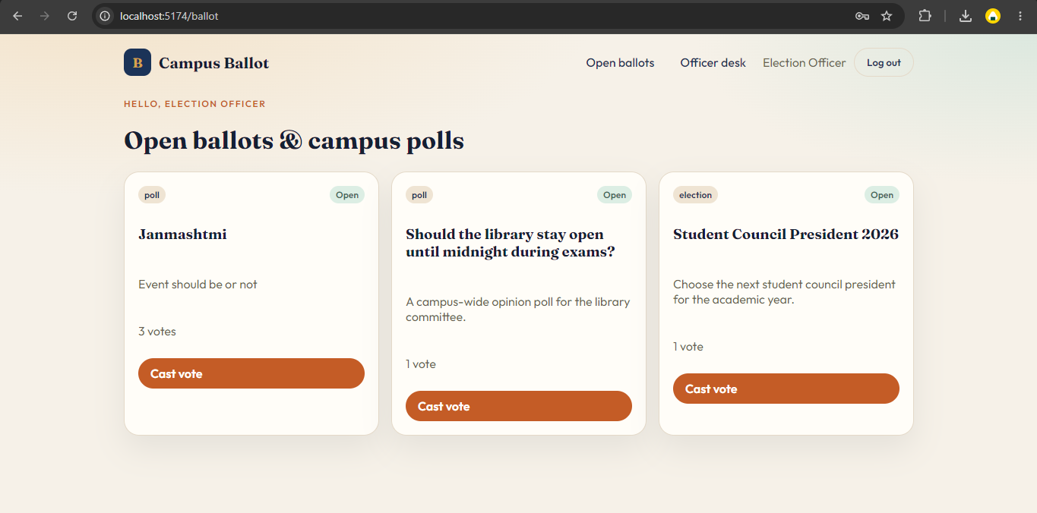

PART-IV
Tools &
Technology

5. About MongoDB

Introduction to MongoDB
MongoDB is a popular open-source NoSQL database that stores data in a flexible, document-oriented format using JSON-like structures.
Unlike traditional relational databases, MongoDB does not use tables and rows but instead uses collections and documents, making it highly scalable and adaptable.
MongoDB is designed to handle large volumes of data and is widely used in modern web applications due to its high performance, flexibility, and ease of integration with JavaScript-based technologies.
In this project, MongoDB is used as the primary database to store user accounts, poll and candidate information, recorded votes, and other system-related data.

Key Features of MongoDB
Document-Oriented Storage – Data is stored in JSON-like documents, allowing flexible and dynamic schema design.
Schema Flexibility – MongoDB does not require a fixed schema, making it easy to modify data structures as the application evolves.
High Scalability – MongoDB supports horizontal scaling using sharding, making it suitable for large-scale applications.
High Performance – Efficient indexing and data retrieval mechanisms ensure fast read and write operations.
Aggregation Framework – MongoDB provides powerful data aggregation features for processing and analyzing data.

Applications of MongoDB
MongoDB is widely used for:
- Web Applications
- Learning Management Systems
- E-Voting and Polling Systems
- Real-Time Analytics Applications
- Big Data Applications

6. About Express.js

Introduction to Express.js
Express.js is a fast, minimal, and flexible web application framework for Node.js used to build backend applications and APIs.
It simplifies server-side development by providing a robust set of features for handling HTTP requests, routing, middleware, and server configuration.
Express.js is widely used for building RESTful APIs and web applications due to its simplicity and performance.
It allows developers to structure backend logic efficiently and integrate easily with databases and frontend technologies. In this project, Express.js is used to handle server-side logic, API creation, and communication between the React client and MongoDB.

Key Features of Express.js
Minimal and Flexible Framework – Express provides a lightweight structure that allows developers to build applications as per their requirements.
Routing System – It offers a powerful routing mechanism to handle different HTTP requests efficiently.
Middleware Support – Express uses middleware functions to process requests and responses, improving modularity and control.
Fast Performance – Being built on Node.js, Express ensures high-speed execution and efficient handling of multiple requests.
Easy Integration – Express can be easily integrated with databases and frontend frameworks for full-stack development.

Applications of Express.js
Express.js is widely used for:
• Building RESTful APIs
• Web Application Development
• Backend Services
• Single Page Applications
• Real-Time Applications
7. About React.js

Introduction to React.js
React.js is a popular open-source JavaScript library used for building user interfaces, especially for single-page applications.
It allows developers to create fast and interactive web applications by breaking the UI into reusable components. React uses a virtual DOM to efficiently update and render only the necessary parts of the user interface, improving performance.
In this project, React.js is used to build the frontend interface where students interact with ballots, results, and the officer desk.

Key Features of React.js
Component-Based Architecture – React applications are built using reusable components, making the code more organized and maintainable.
Virtual DOM – React uses a virtual DOM to update only the changed parts of the UI, resulting in better performance.
JSX Syntax – React uses JSX, which allows writing HTML-like code inside JavaScript for better readability.
Unidirectional Data Flow – Data flows in a single direction, making debugging and state management easier.
Strong Community Support – React has a large community and ecosystem, providing extensive resources and libraries.

Applications of React.js
React.js is widely used in:
• Single Page Applications
• User Interface Development
• Dashboard Applications
E-Voting and Dashboard Applications
• Real-Time Web Applications
8. About Node.js

Introduction to Node.js
Node.js is an open-source, cross-platform runtime environment that allows developers to execute JavaScript code on the server side.
It is built on Chrome’s V8 JavaScript engine and is designed for building fast and scalable network applications. Node.js uses an event-driven, non-blocking I/O model, which makes it efficient and suitable for handling multiple requests simultaneously.
In this project, Node.js is used to build the backend server, handle business logic, and manage communication between the frontend and the database.

Key Features of Node.js
Asynchronous and Non-Blocking – Node.js uses a non-blocking architecture, allowing multiple operations to run concurrently without delays.
Event-Driven Architecture – It follows an event-driven model, making it efficient for real-time applications.
High Performance – Built on the V8 engine, Node.js executes code quickly and efficiently.
Scalability – Node.js is highly scalable and suitable for building large-scale applications.
JavaScript Everywhere – It allows using JavaScript on both frontend and backend, improving development consistency.

Applications of Node.js
Node.js is widely used in:
• Backend Development
• RESTful APIs
• Real-Time Applications
• Streaming Applications

• Scalable Network Applications

9. Bibliography
Search Engine: Google
Online Resources:
- www.mongodb.com
- www.nodejs.org
- www.expressjs.com
- www.react.dev

