INDEX
Sr.no | Title | Page.no
Part-I Introduction
1.1 | Introduction to Project | 3
1.2 | Project Profile | 6
Part-II System Analysis and Design
2 | Project Planning | 8
2.1 | Scope of the Project | 8
2.2 | Software Process Model | 10
2.3 | Project Team | 13
3 | System Design | 14
3.1 | Data Flow Diagrams | 14
3.2 | ER Diagram | 16
3.3 | Database Design | 17
Part-III Implementation Details
4 | Screen Layouts | 23
Part-IV Tools and Technologies
5 | About MongoDB | 44
6 | About Express.js | 45
7 | About React.js | 46
8 | About Node.js | 47
9 | Bibliography | 48

PART-I
Introduction

  - Introduction to project

Project Title: EDEMY
Project Profile
- EDEMY is a web-based Learning Management System designed to provide an integrated platform for online education. It enables educators to create and sell courses, while allowing students to explore, purchase, and learn through structured digital content.
- The platform solves the problem of fragmented learning by combining multiple functionalities into a single system. Students no longer need separate platforms for learning, doubt solving, and interaction, resulting in a more efficient and seamless educational experience.
- EDEMY includes an AI-powered chat feature and a community-based question and answer system. These features allow students to clarify doubts, engage in discussions, and gain knowledge collaboratively, improving understanding beyond traditional course-based learning.
- The system enhances interaction between educators and students through announcements, assignment sharing, and resource distribution such as files and links. This ensures continuous engagement and supports a more dynamic and interactive teaching-learning process.
- Additionally, the platform supports secure payment integrations for course purchases and modern authentication methods for user access. Overall, EDEMY aims to deliver a comprehensive, interactive, and user-friendly environment for both learners and educators.

Project Users and Functionalities
Educator
• Register and login using authentication system
• Manage personal profile details
• Browse and search courses by keywords
• View detailed course information before purchase
• Purchase courses through payment integration
• Access and view enrolled courses
• Watch course lectures using video player
• Track course progress
• View and download certificates after completion
• Add or remove courses from wishlist
• Interact with AI-based chat system for assistance
• Ask questions in the Q&A section
• View, edit, and delete their own questions
• Post answers to questions and manage their answers
• View announcements shared by educators
• Access additional course resources such as files and links
• Provide ratings and reviews for courses
Student
• Register and login using authentication system
• Manage personal profile details
• Create and publish new courses
• Add course details including content, pricing, and thumbnails
• Upload lectures and structure course content
• View and manage their own courses
• Monitor students enrolled in their courses
• Share announcements related to courses
• Assign tasks or updates to students
• Upload and manage additional resources such as files and links

Guest User
• Browse available courses
• Search courses by keywords
• View course details including description and content
• View course ratings and reviews

  - Project Profile

Project Title | Edemy
Project Type | Web Application
Font End Technologies | React
Back End Technologies | Node
Internal Guide | Pritesh Patel
Submitted By | Shubham Mohapatra

PART-II
SYSTEM ANALYSIS
AND DESIGN

- Project Planning

  - Scope of System:
The scope of EDEMY is to provide a web-based platform for online learning that enables educators to create and sell courses while allowing students to explore, purchase, and learn through structured digital content. The system integrates course delivery, interaction, and support features into a single platform.
The platform focuses on reducing fragmented learning by combining course access, doubt-solving mechanisms, and interactive communication tools. It includes features such as AI-based assistance, question and answer discussions, course resources, announcements, and certification to create a complete learning environment.
The system is developed using a monolithic architecture with a modular structure, where different functionalities such as user management, course management, communication, and payments are organized into separate modules within a single application. This approach ensures maintainability, scalability, and efficient development.
The system supports three types of users: Educator, Student, and Guest User.
Educator:
When an Educator is logged in, they can manage their profile and create, publish, and manage courses. Educators can upload course content, structure lectures, and define pricing details.
They can also share announcements, assign updates, and provide additional resources such as files and links to support student learning and engagement.
Student:
When a Student is logged in, they can manage their profile, browse and search courses, and purchase courses through integrated payment functionality.
Students can access enrolled courses, watch lectures, track progress, and receive certificates upon completion. They can also interact through the Q&A system and use the AI-based chat feature for assistance.
Guest User:
Guest users can browse available courses, search based on keywords, and view course details including descriptions, content, and ratings without logging into the system.

System Benefits
The system provides a unified learning platform that enhances accessibility and interaction for users. Students benefit from an integrated environment for learning and doubt resolution, while educators gain tools for effective content delivery and communication.

  - Software Process Model
Iterative Model
The Iterative Model is a software development process in which the system is developed and improved through repeated cycles. Instead of defining all requirements at the beginning, the system evolves over time as new features and improvements are added in multiple iterations.

In this model, development starts with a basic implementation, and additional functionalities are incorporated gradually. Each iteration includes planning, design, implementation, and testing, allowing continuous refinement and enhancement of the system.

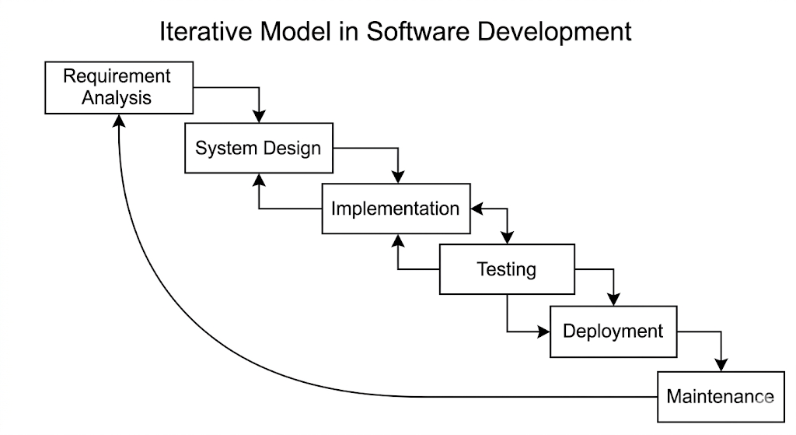

Requirement gathering and analysis
In this phase, initial requirements are identified to build a basic version of the system. Unlike traditional models, requirements are not fixed and may evolve during development.
For EDEMY, core features such as course browsing, user management, and basic course functionality were identified initially, while additional features were introduced in later stages.
System Design
In this phase, the system design is prepared based on the current set of requirements. The design is flexible and can be modified in subsequent iterations as new features are added.
For EDEMY, the system was designed using a modular monolithic architecture, allowing different functionalities to be developed and updated independently.
Implementation
In this phase, the system is developed incrementally. A basic version is created first, and new features are added in subsequent iterations.
For EDEMY, initial development began with core functionalities, followed by the addition of advanced features such as AI chat, Q&A system, course resources, announcements, and certification.
Testing
Testing is performed in every iteration to ensure that newly added features work correctly and do not affect existing functionalities.
For EDEMY, continuous testing was carried out after each feature addition to maintain system stability and performance.

Deployment of System
After multiple iterations and successful testing, the system is deployed for user access.
EDEMY was deployed as a web-based application, allowing users to access learning features and interact with the platform online.
Maintenance
After deployment, the system continues to evolve with further improvements, bug fixes, and feature enhancements based on user needs.
For EDEMY, maintenance includes refining existing features and adding new functionalities to improve the overall learning experience.

  - Project Team
Personal-Profile
Name | Shubham Mohapatra
Address | Vapi, Gujarat
Contact No. | 9726197900
E-Mail Address | shubhammohapatra2005@gmail.com
Exam No | 1326

- SYSTEM DESIGN :
  - Data Flow Diagram
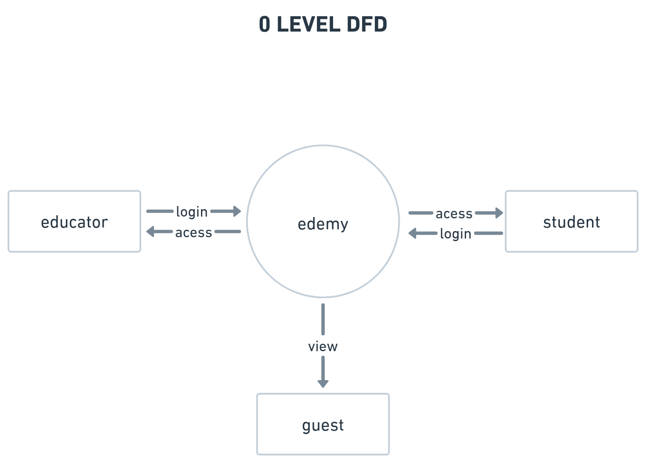

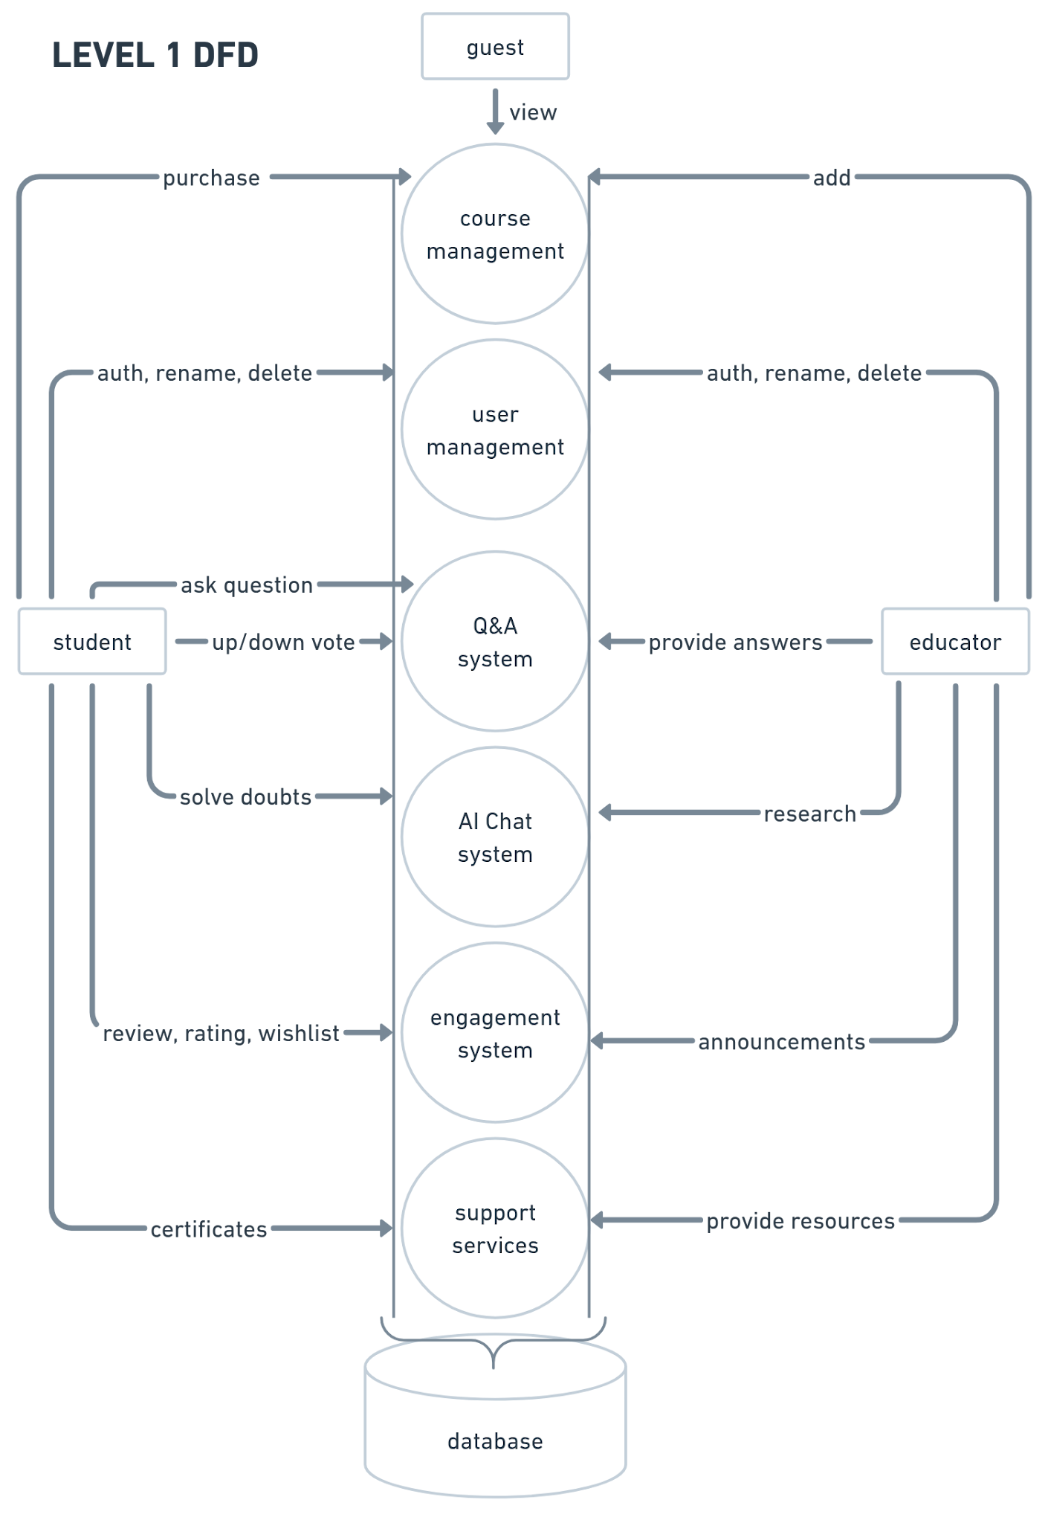
  - ER DIAGRAM

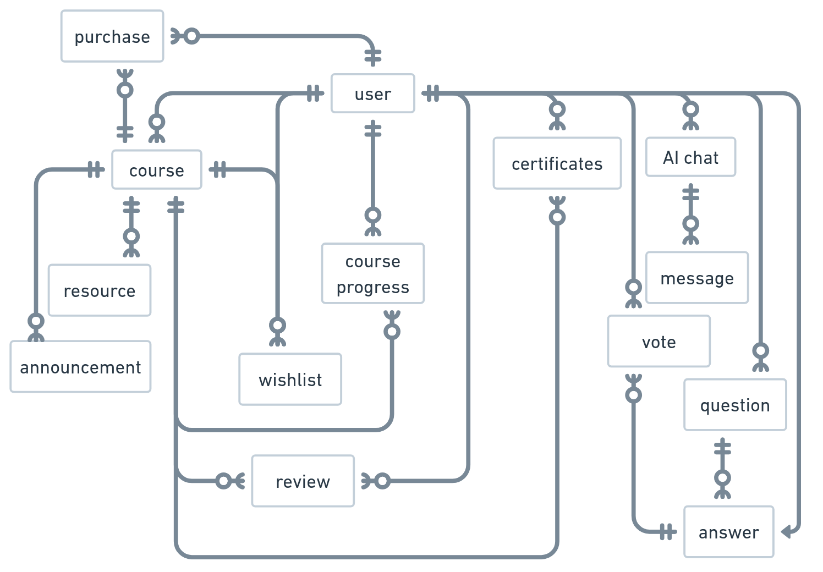

  - DATABASE DESIGN
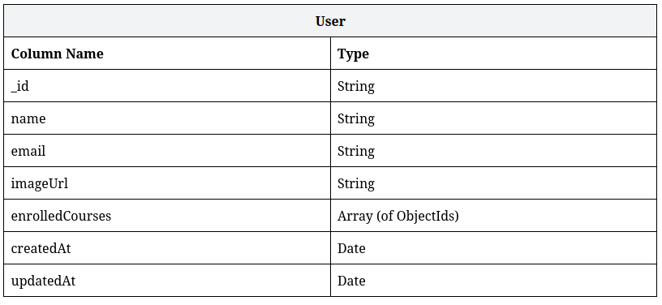
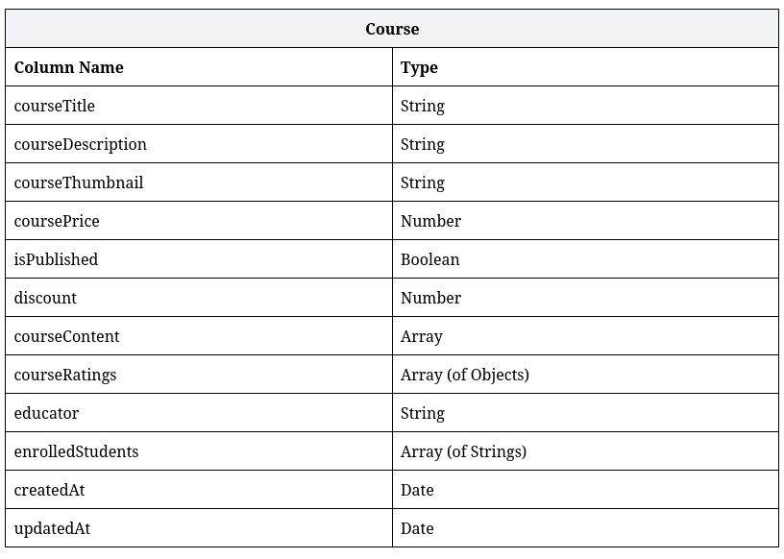
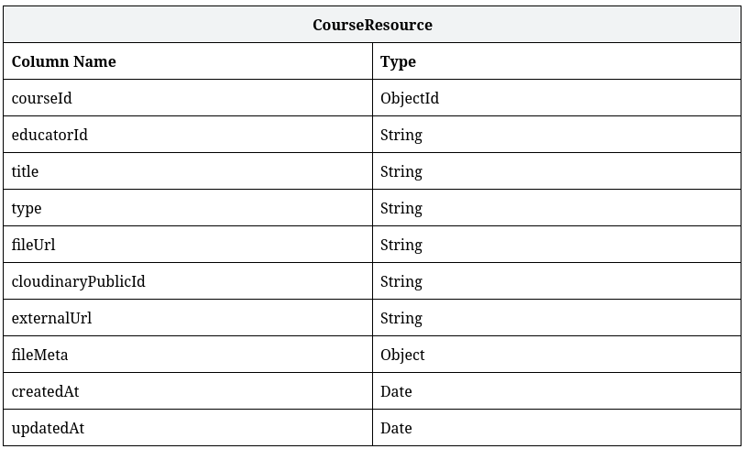
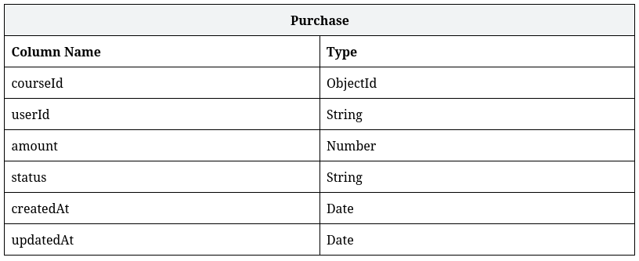
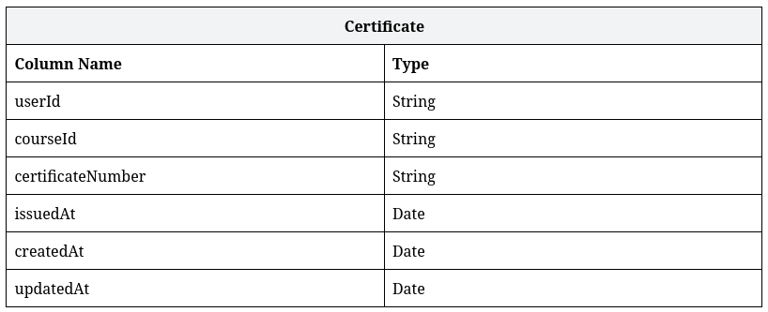
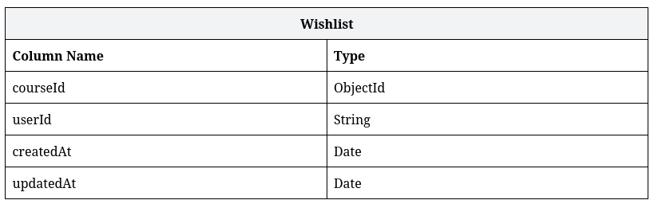
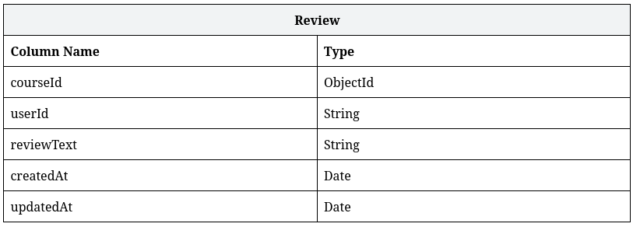
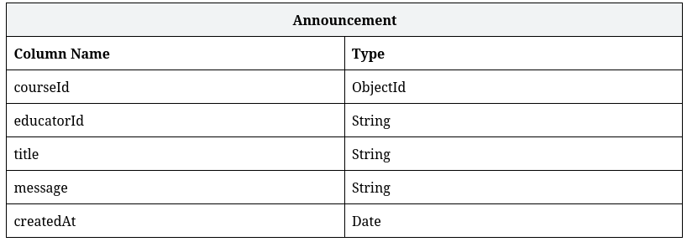
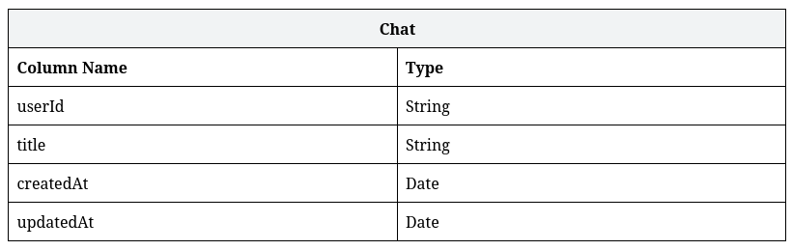
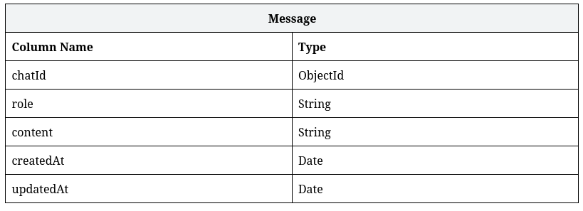
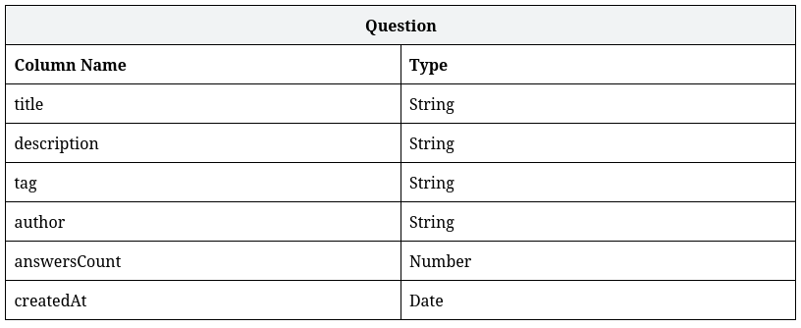
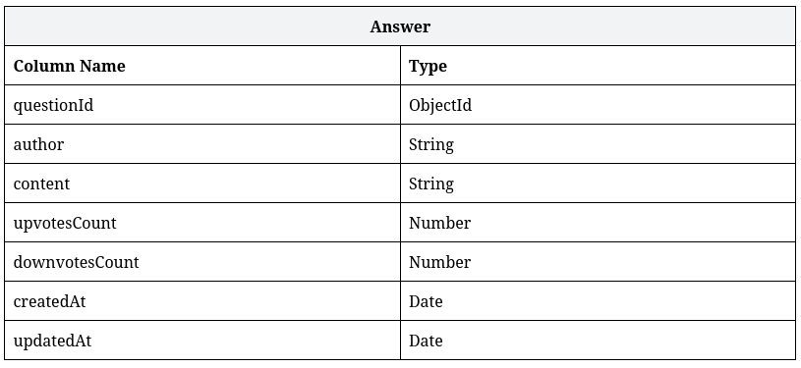
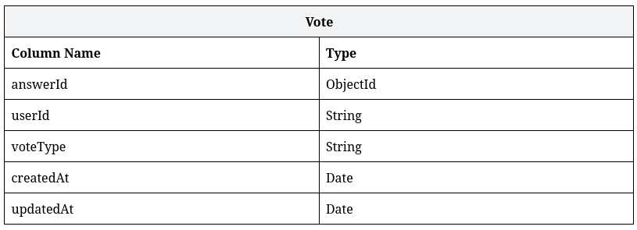

PART-III
Implementation
Details

- Screen Layout
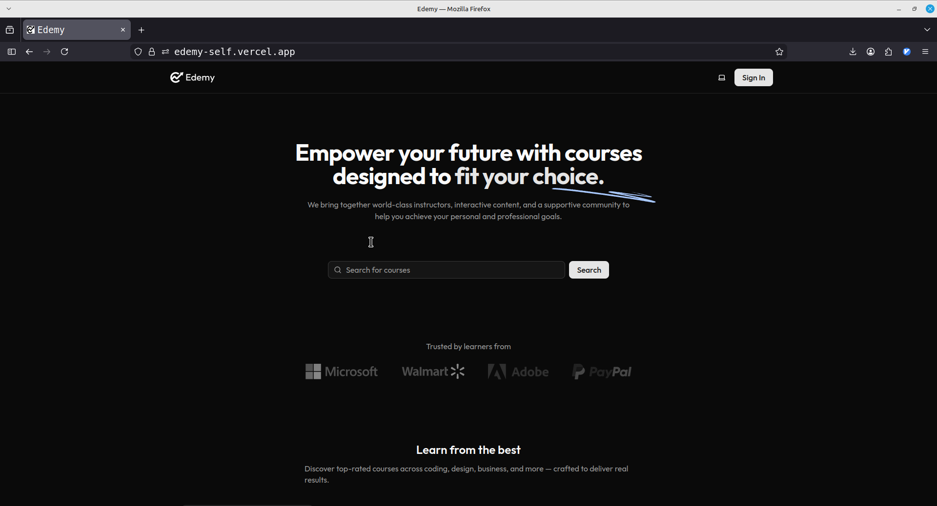
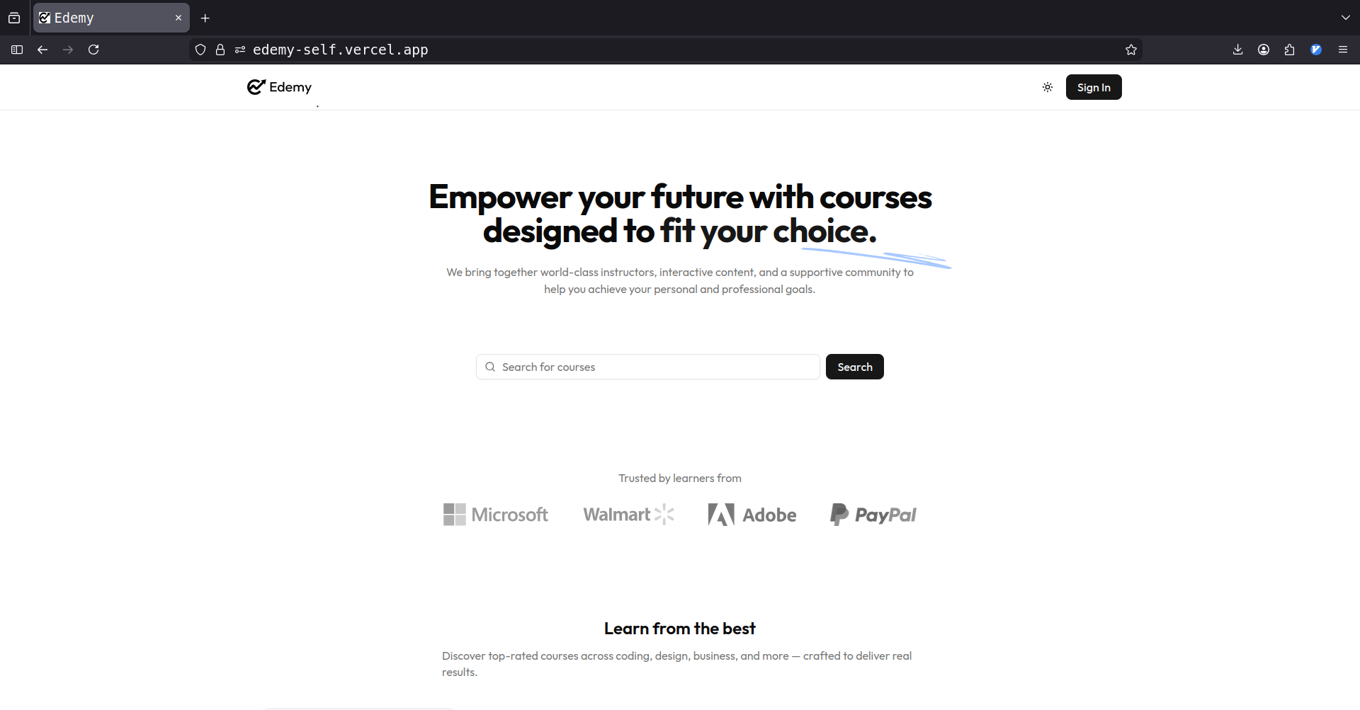

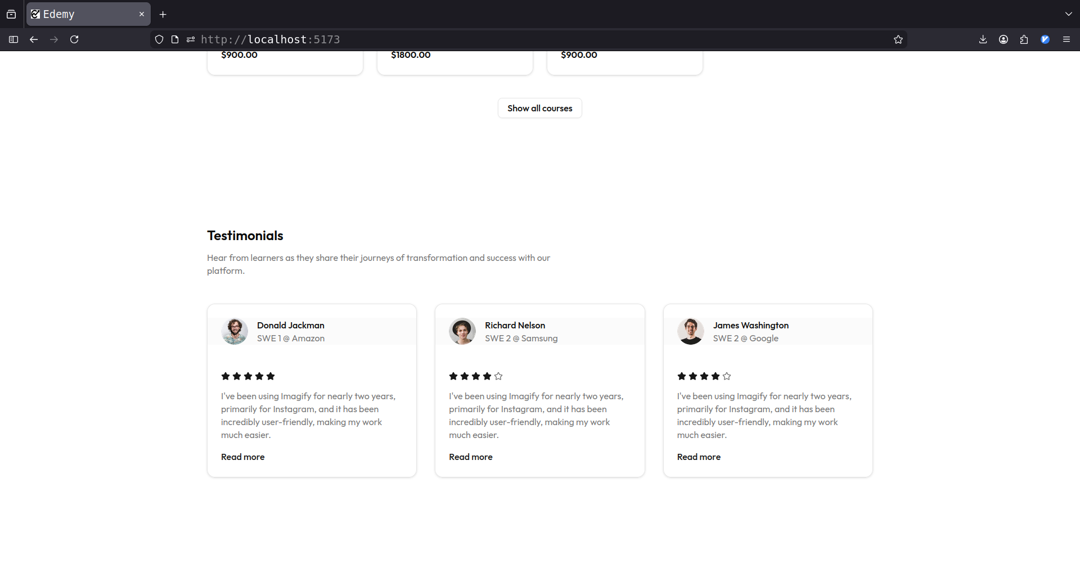

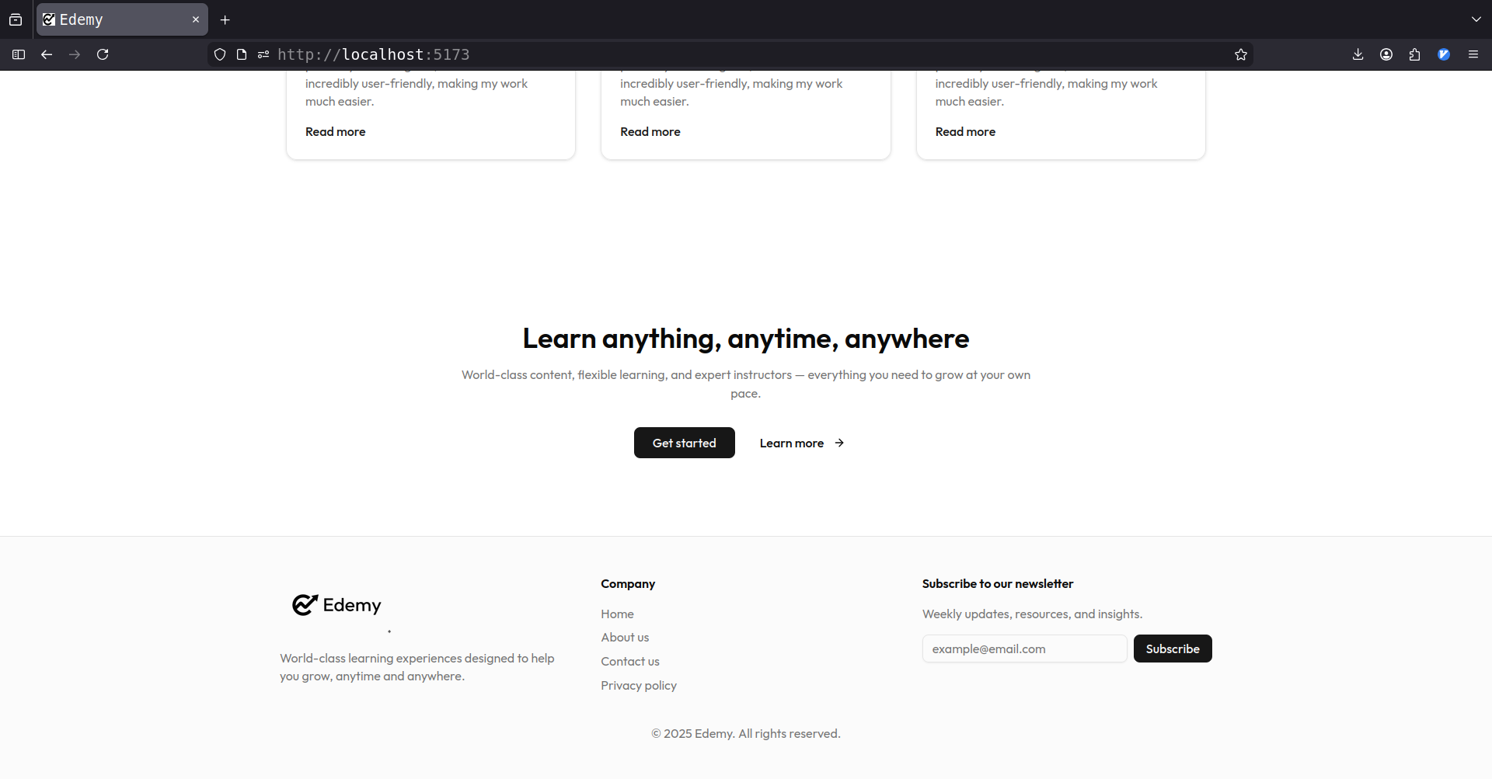

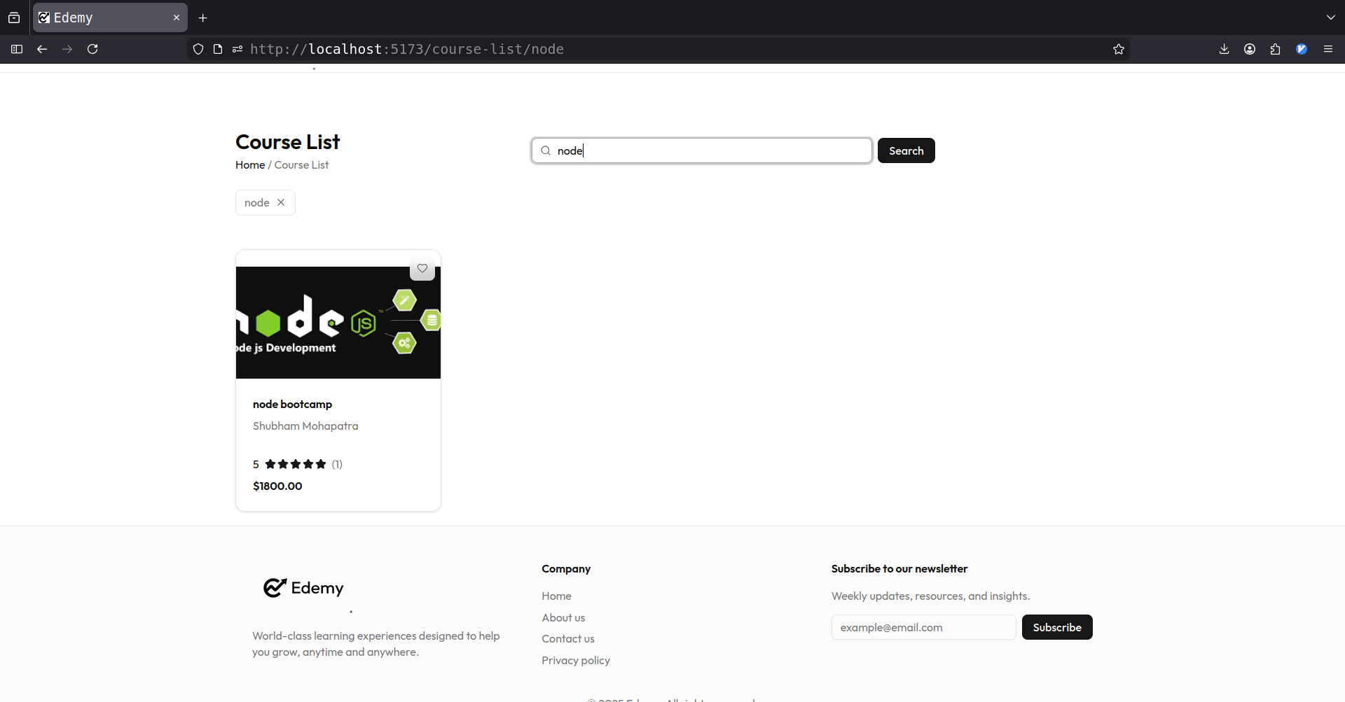

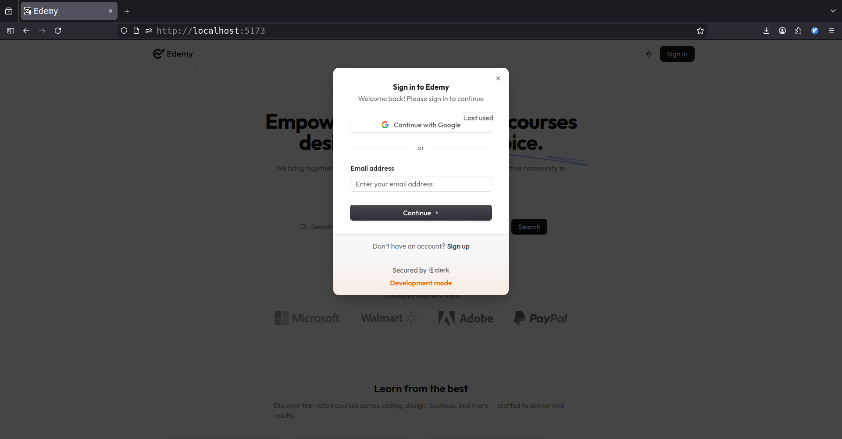

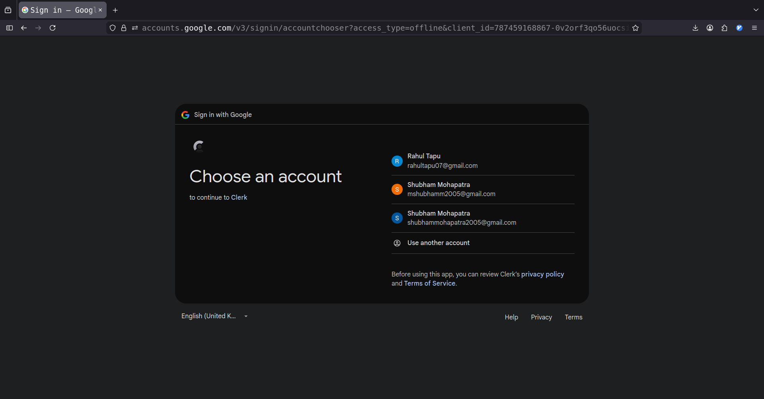

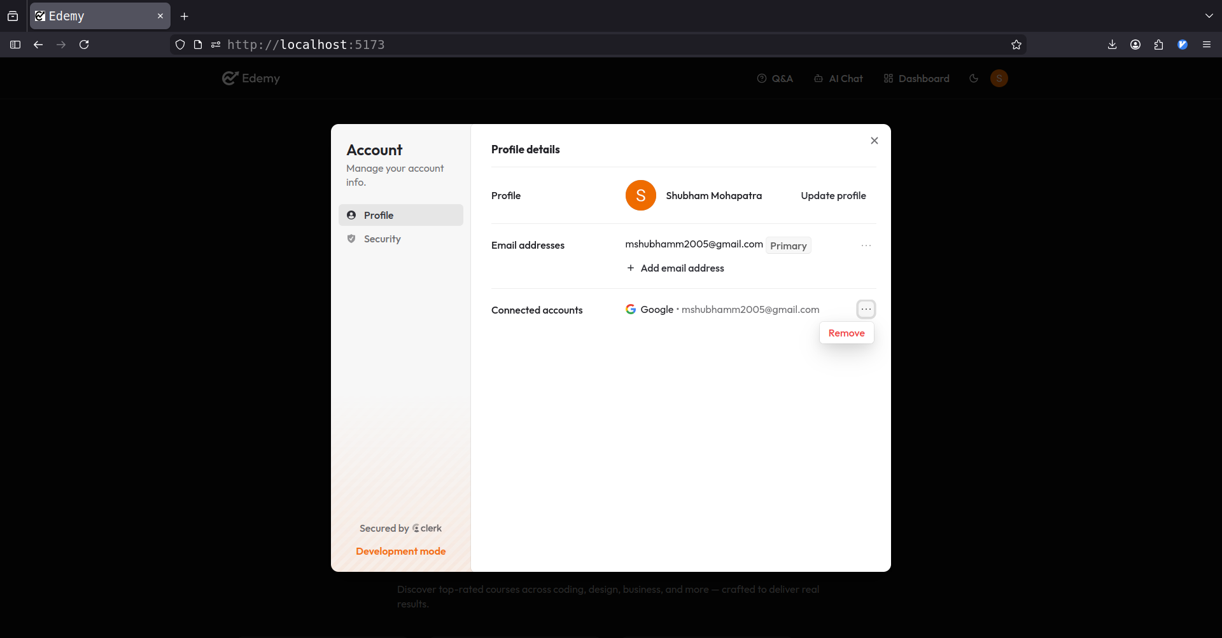

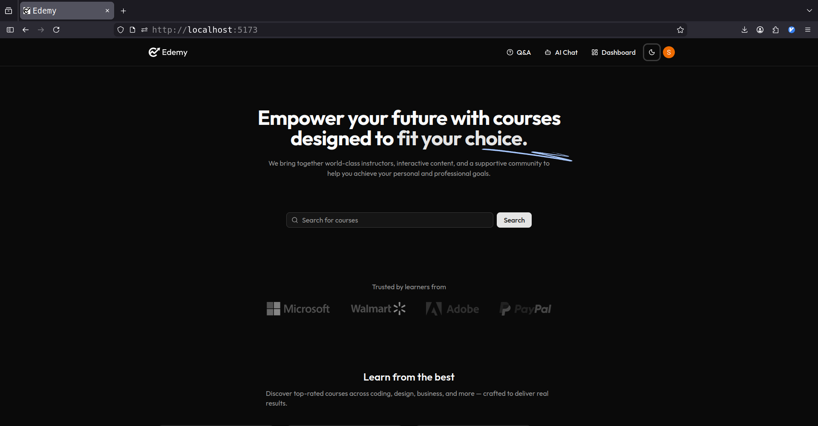

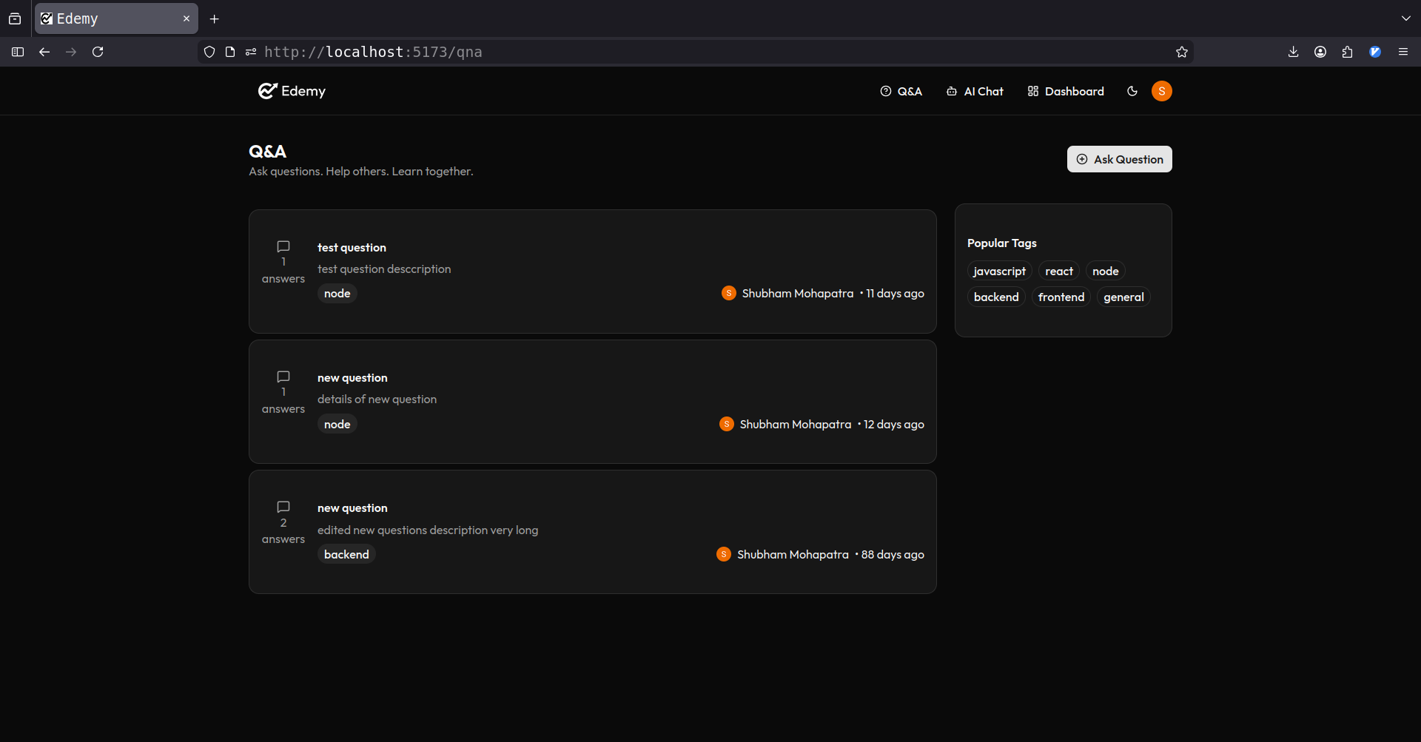

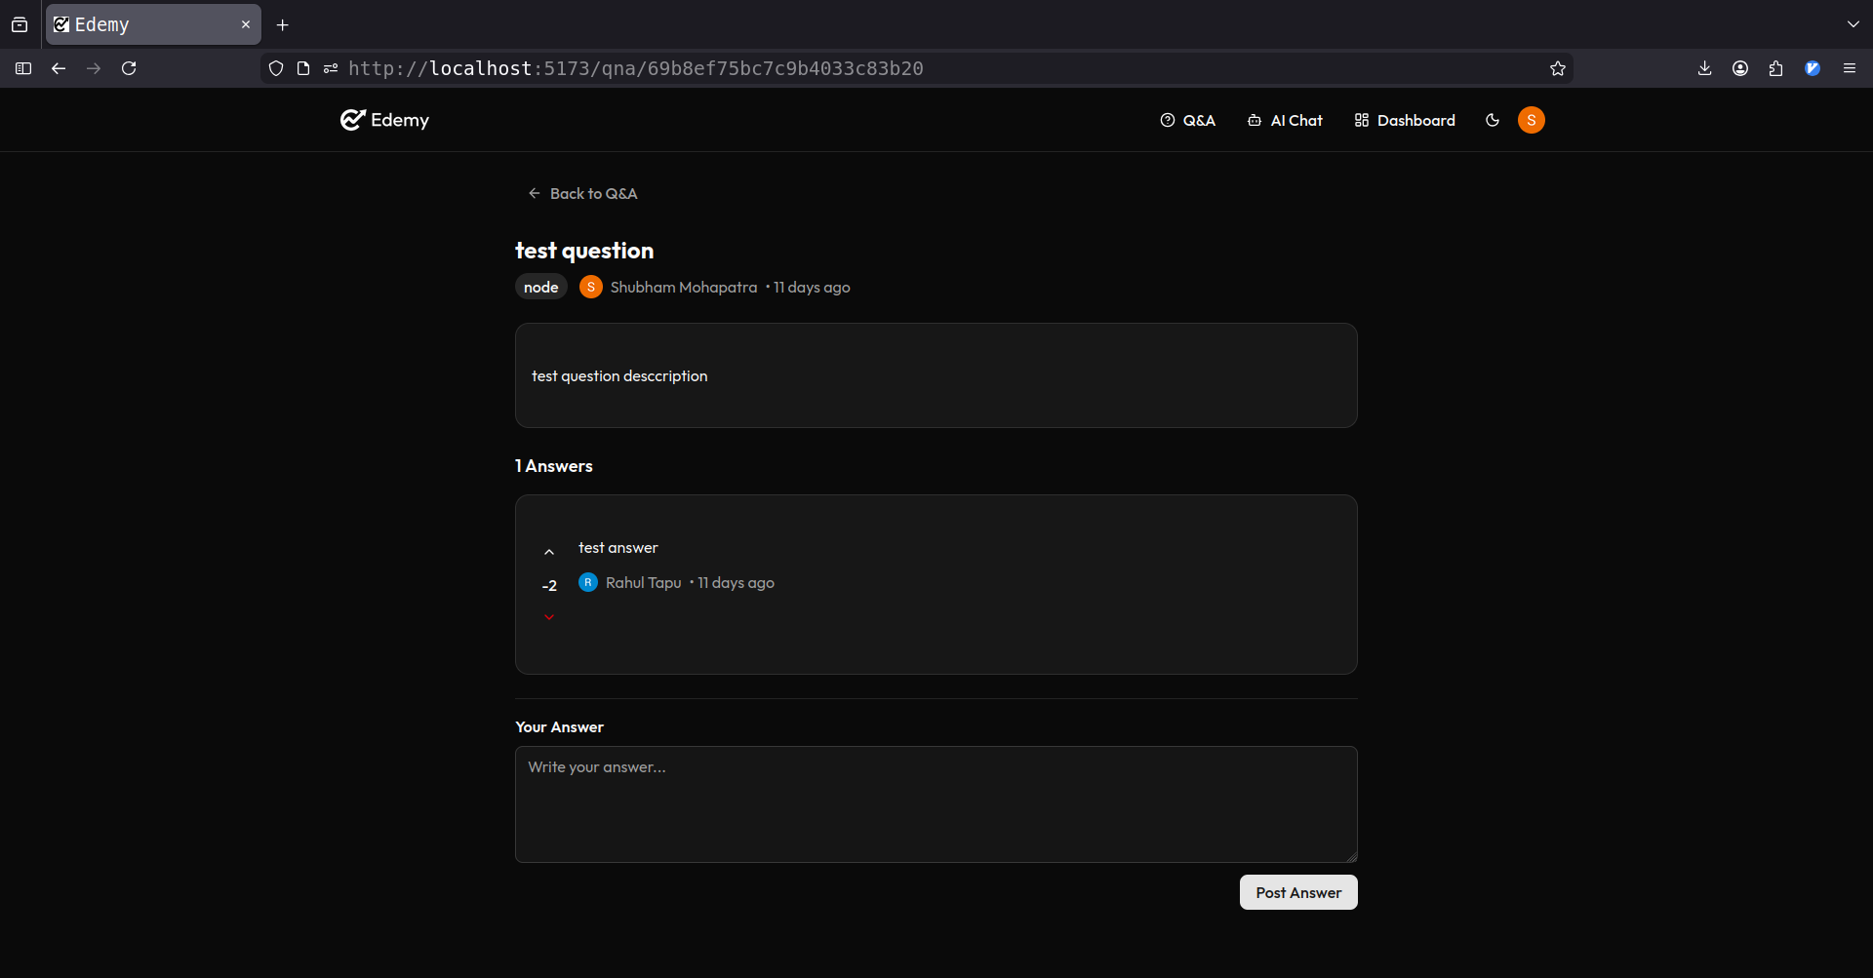

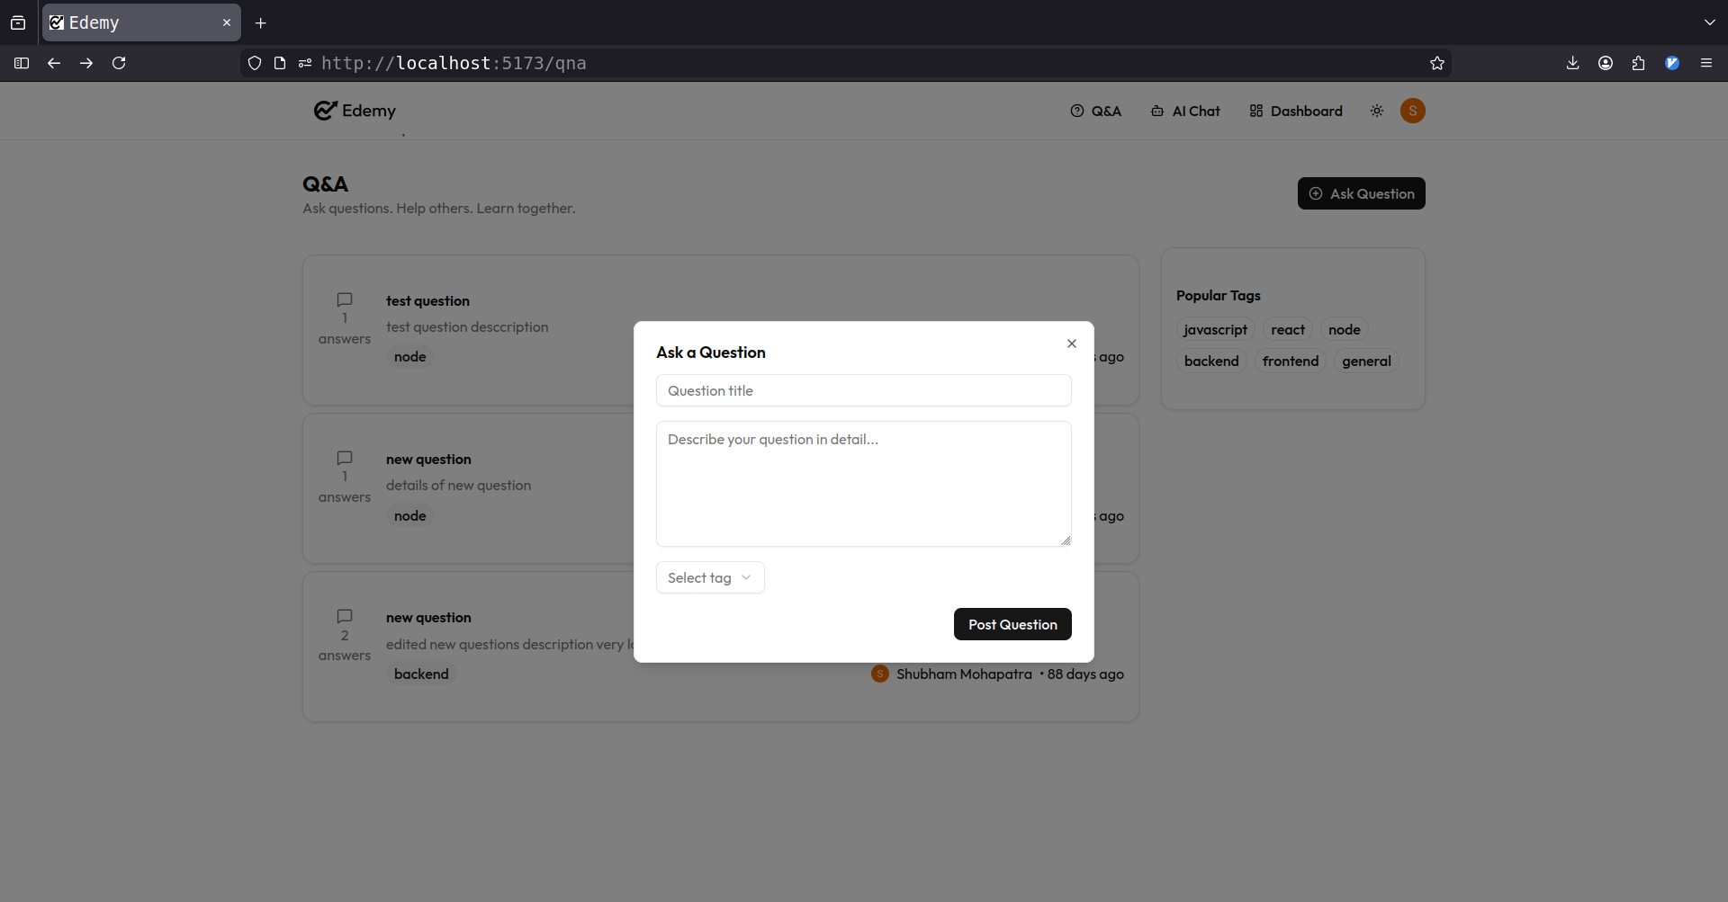

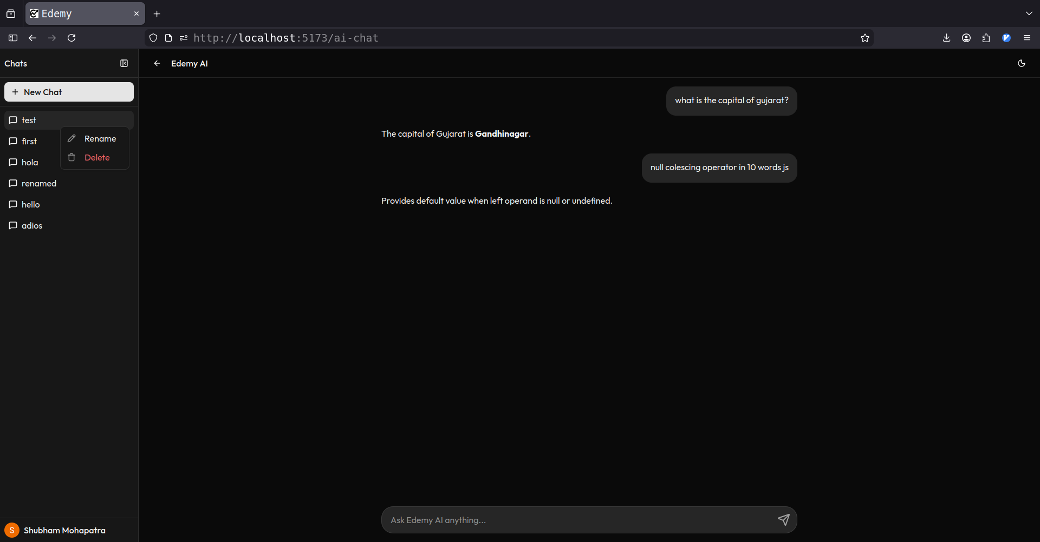

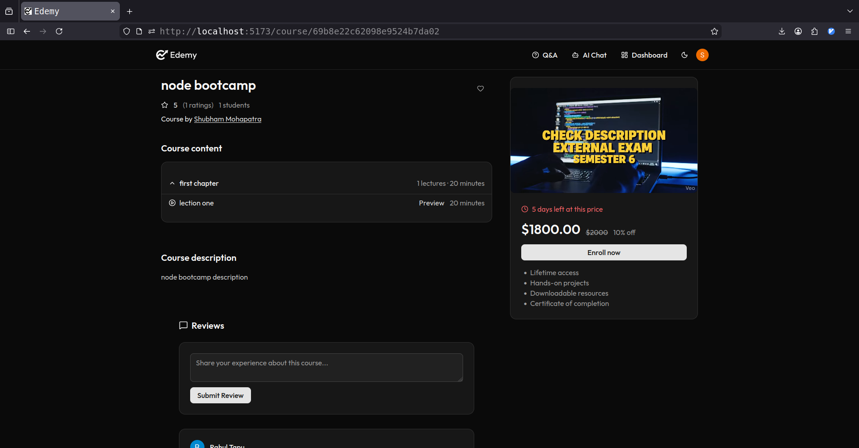

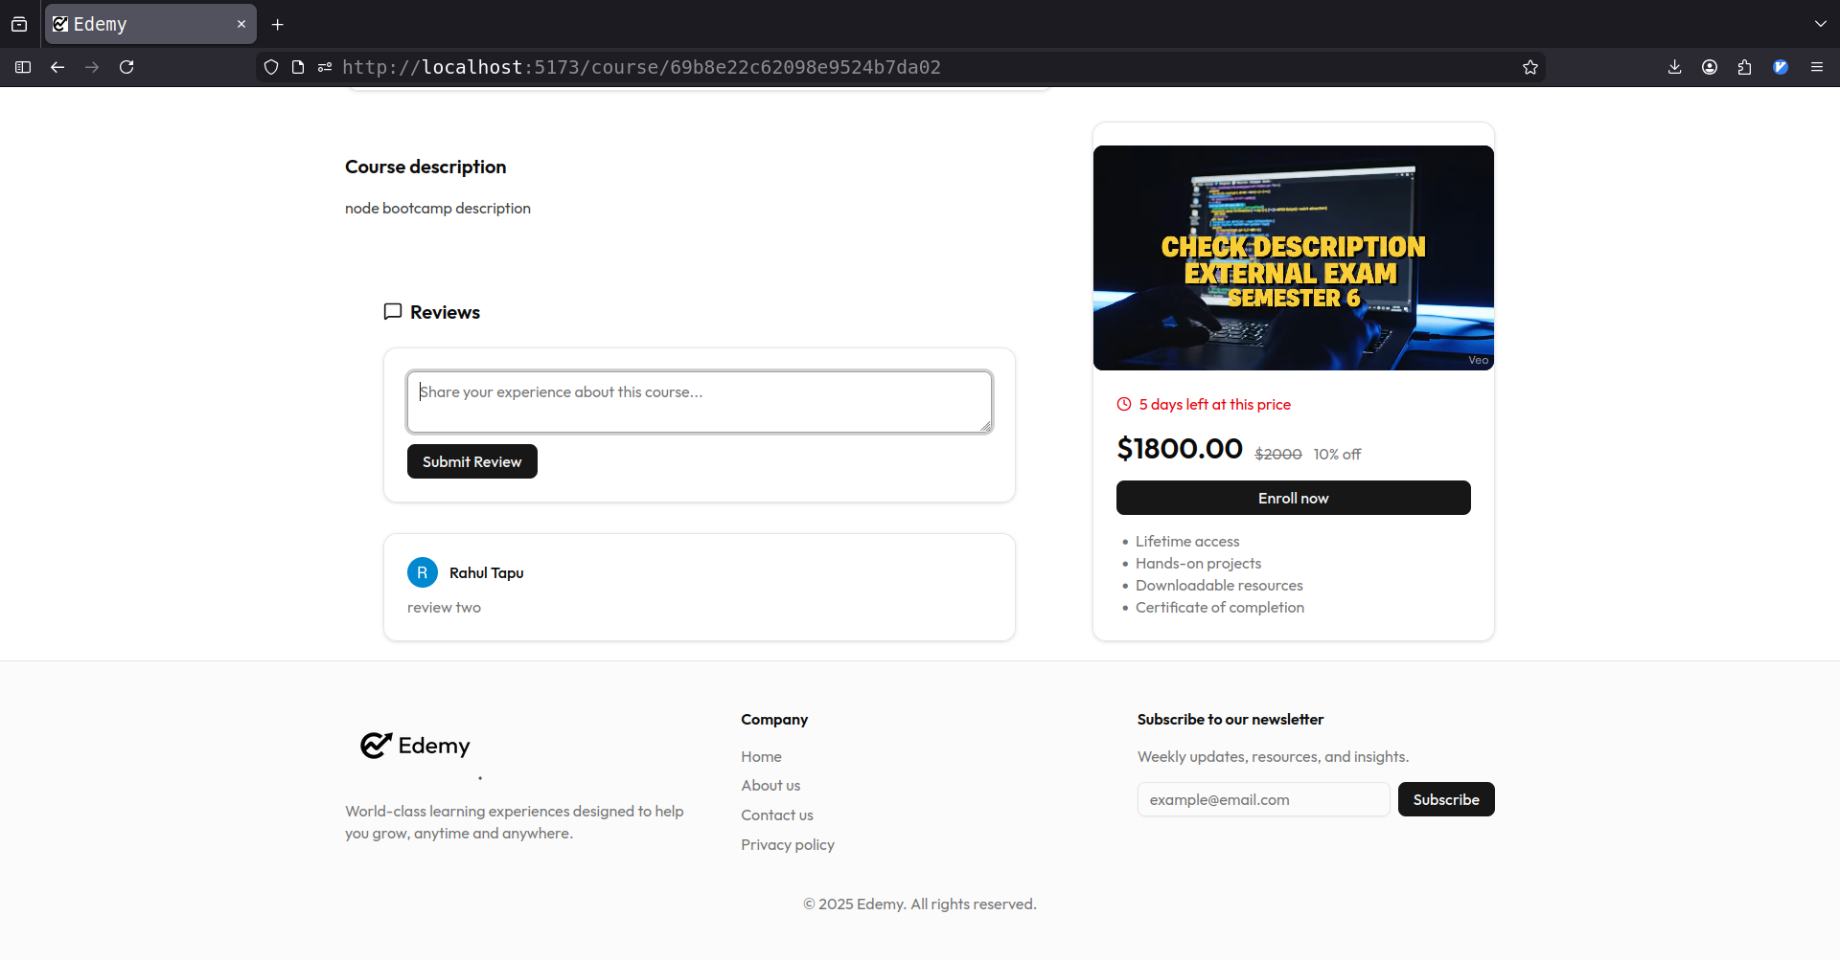

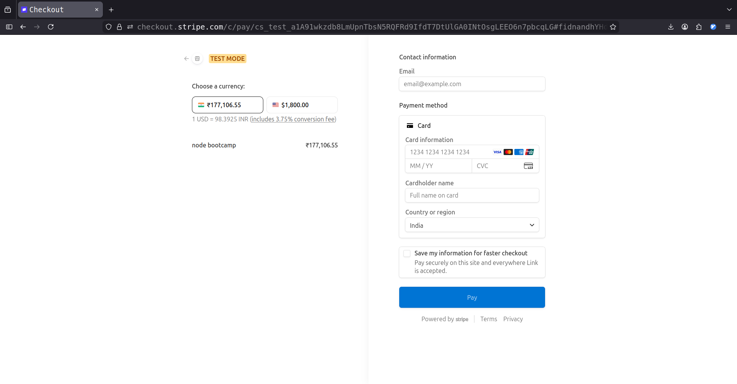

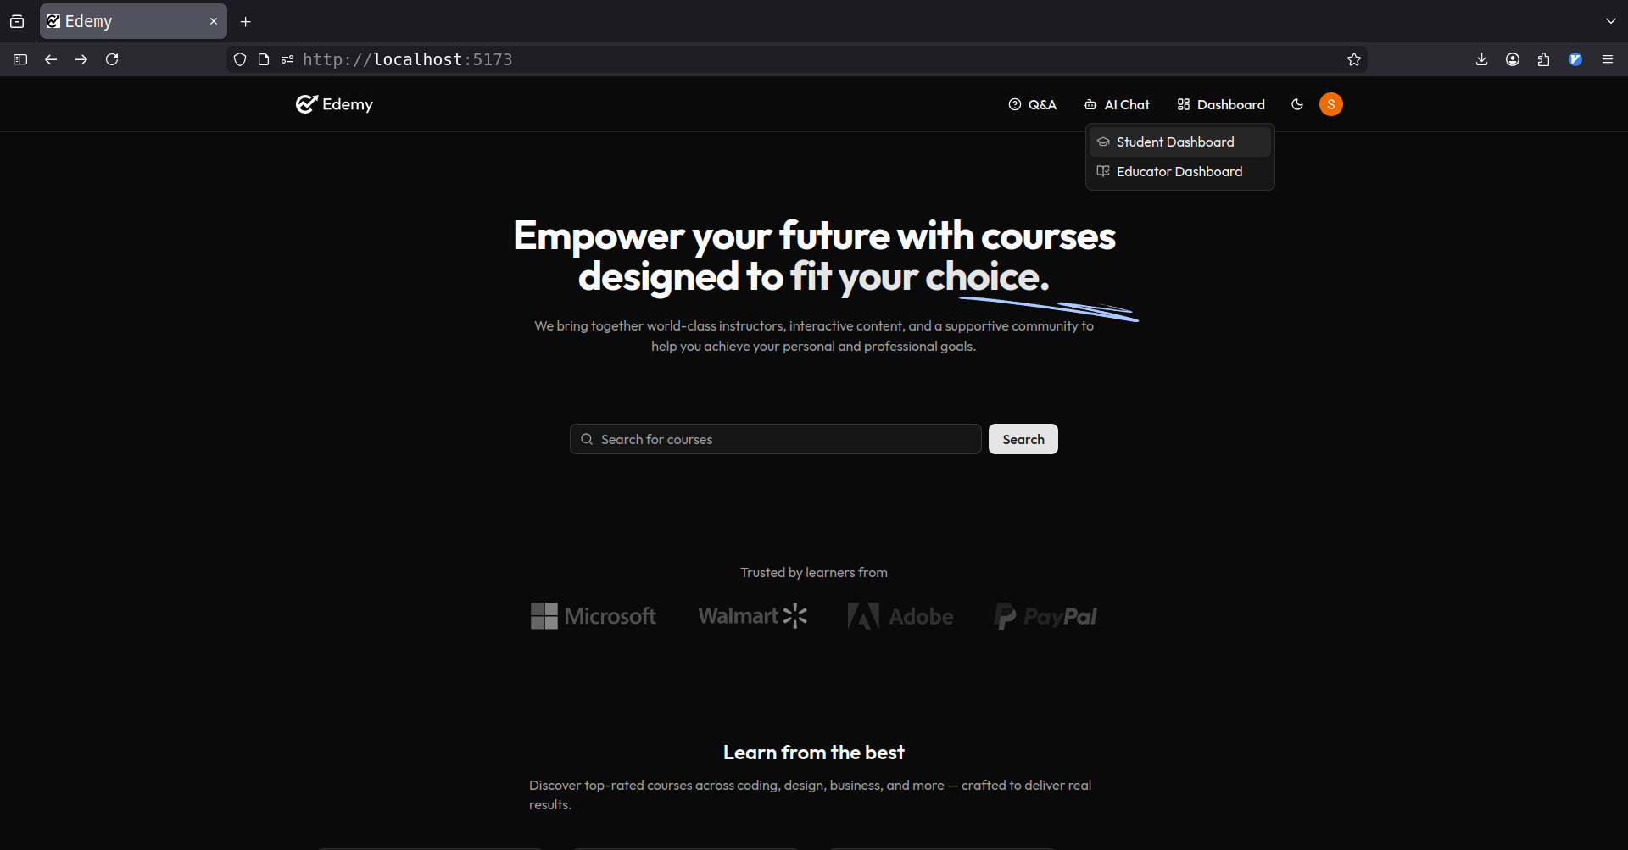

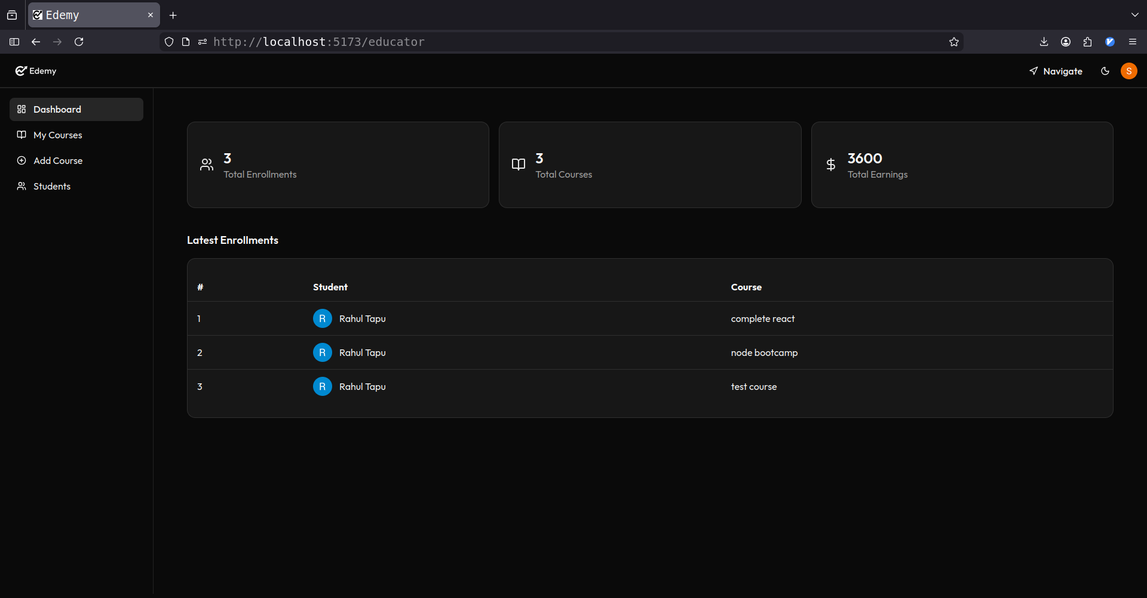

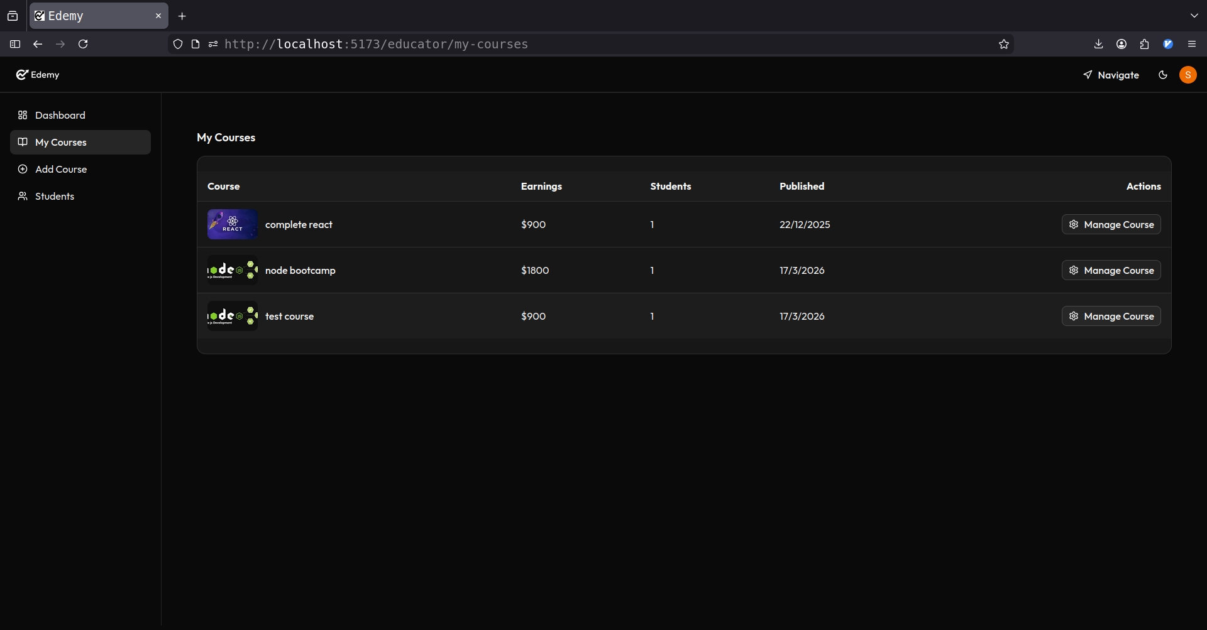

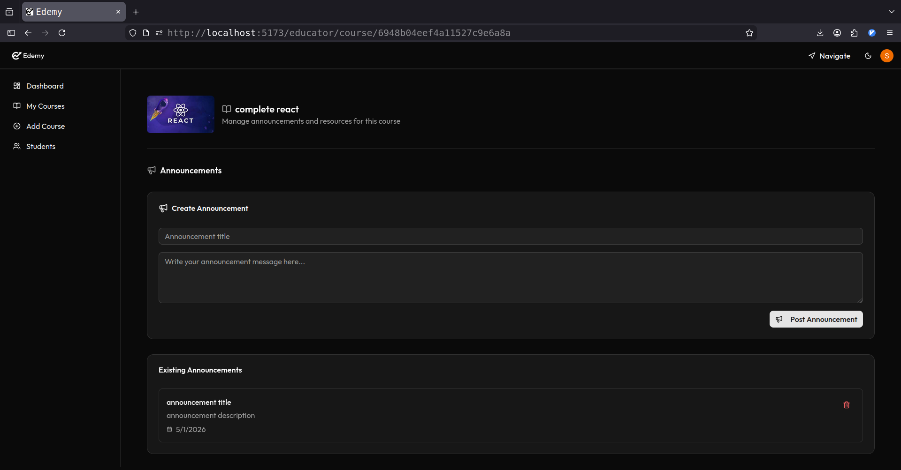

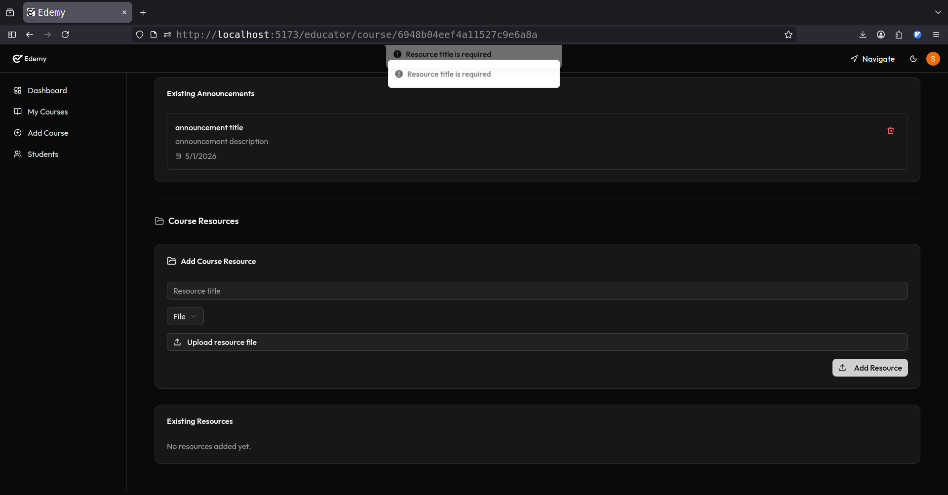

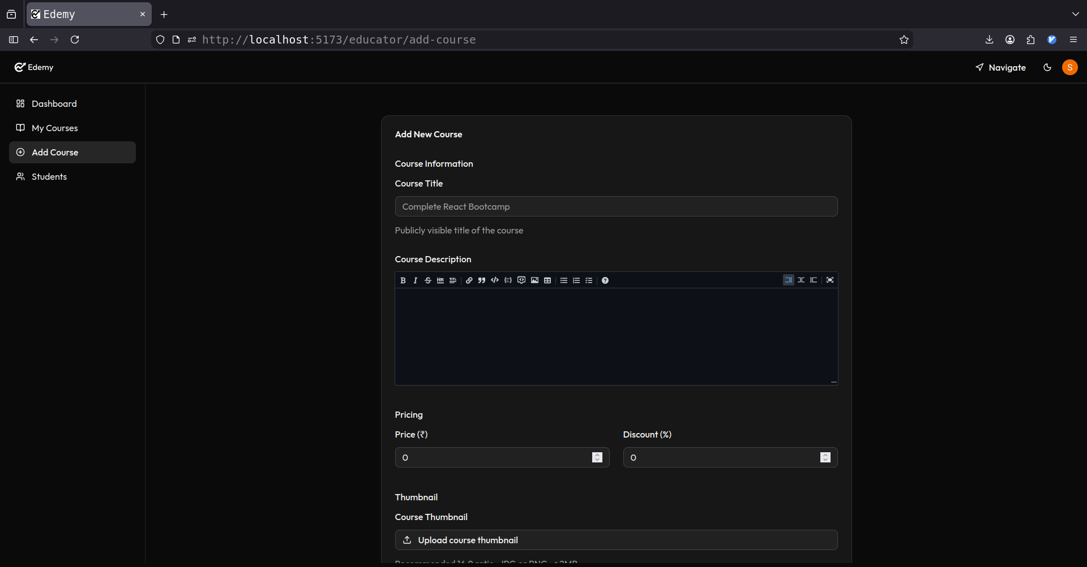

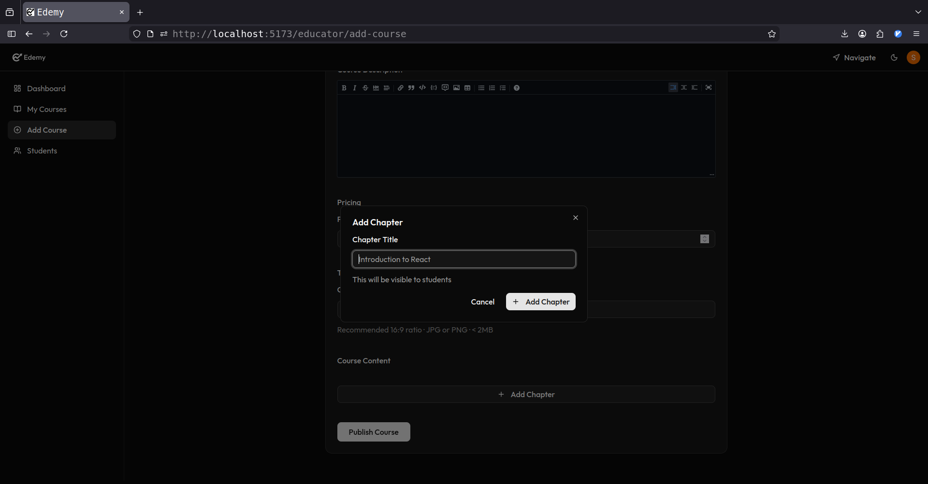

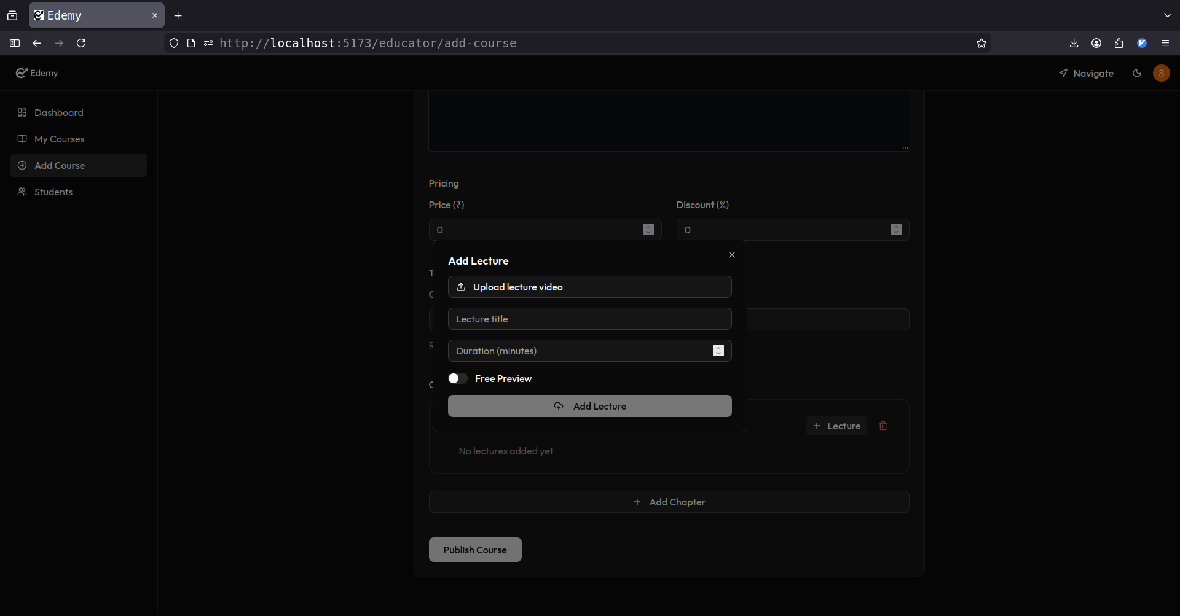

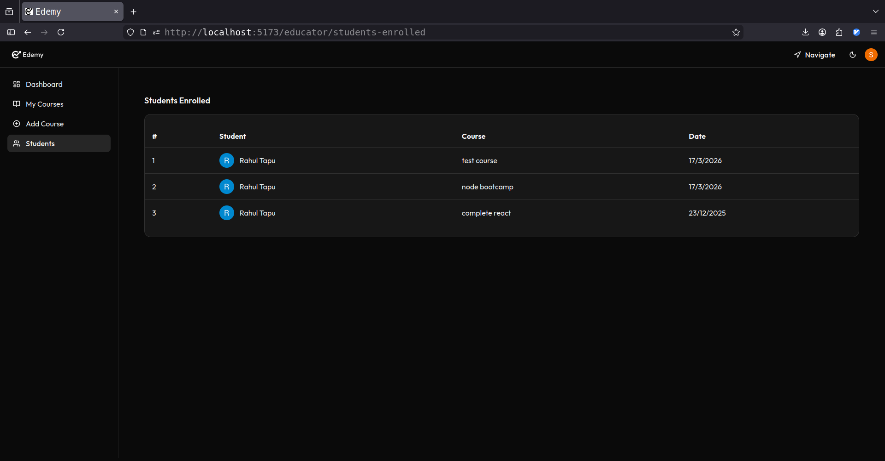

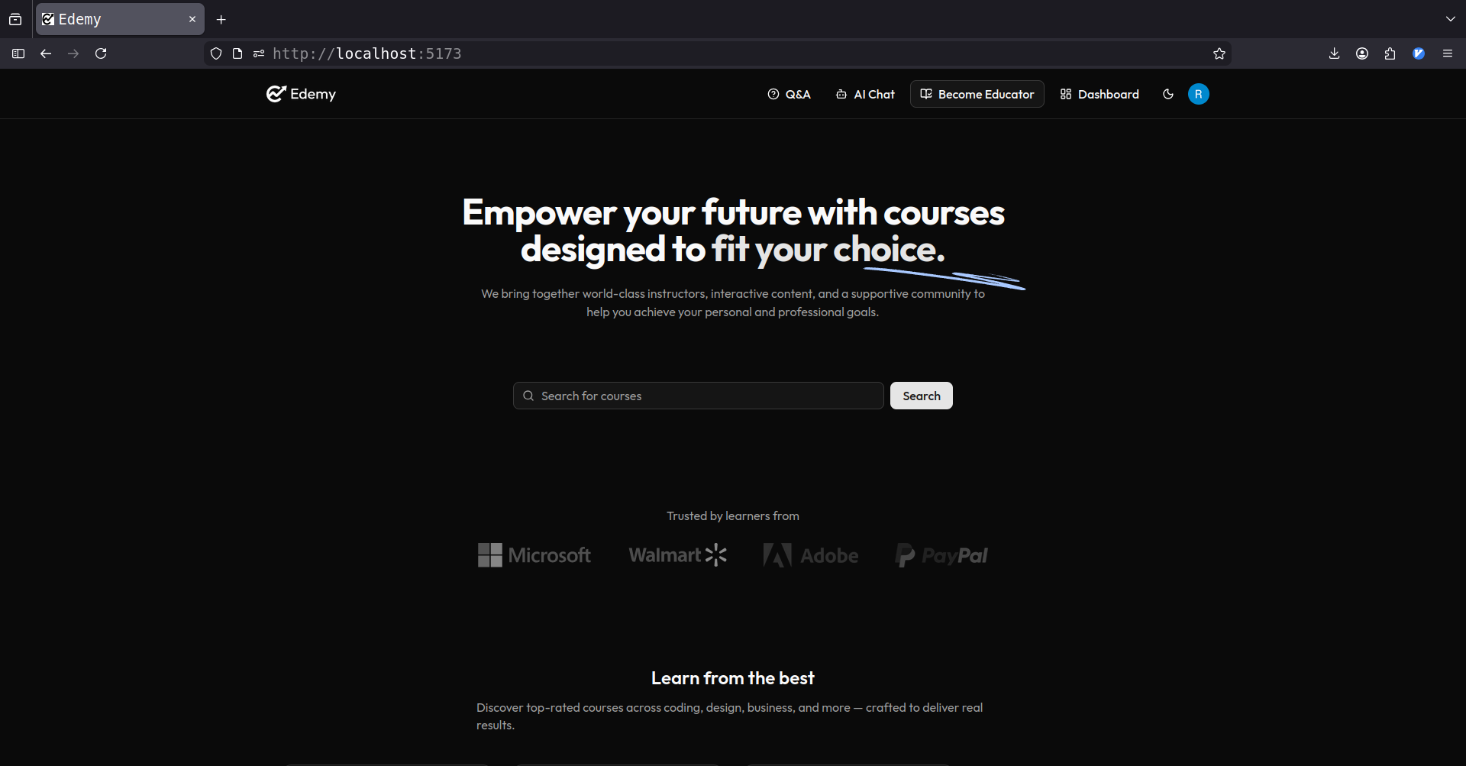

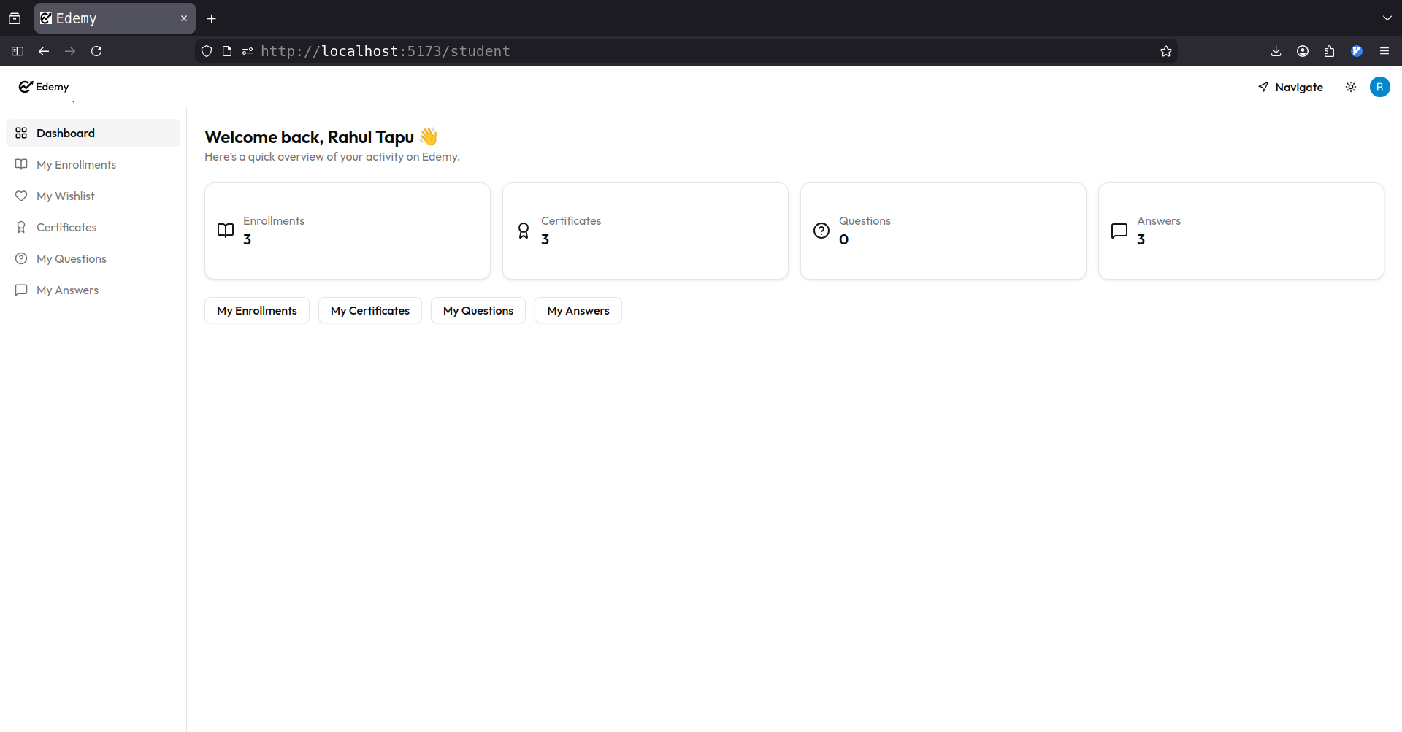
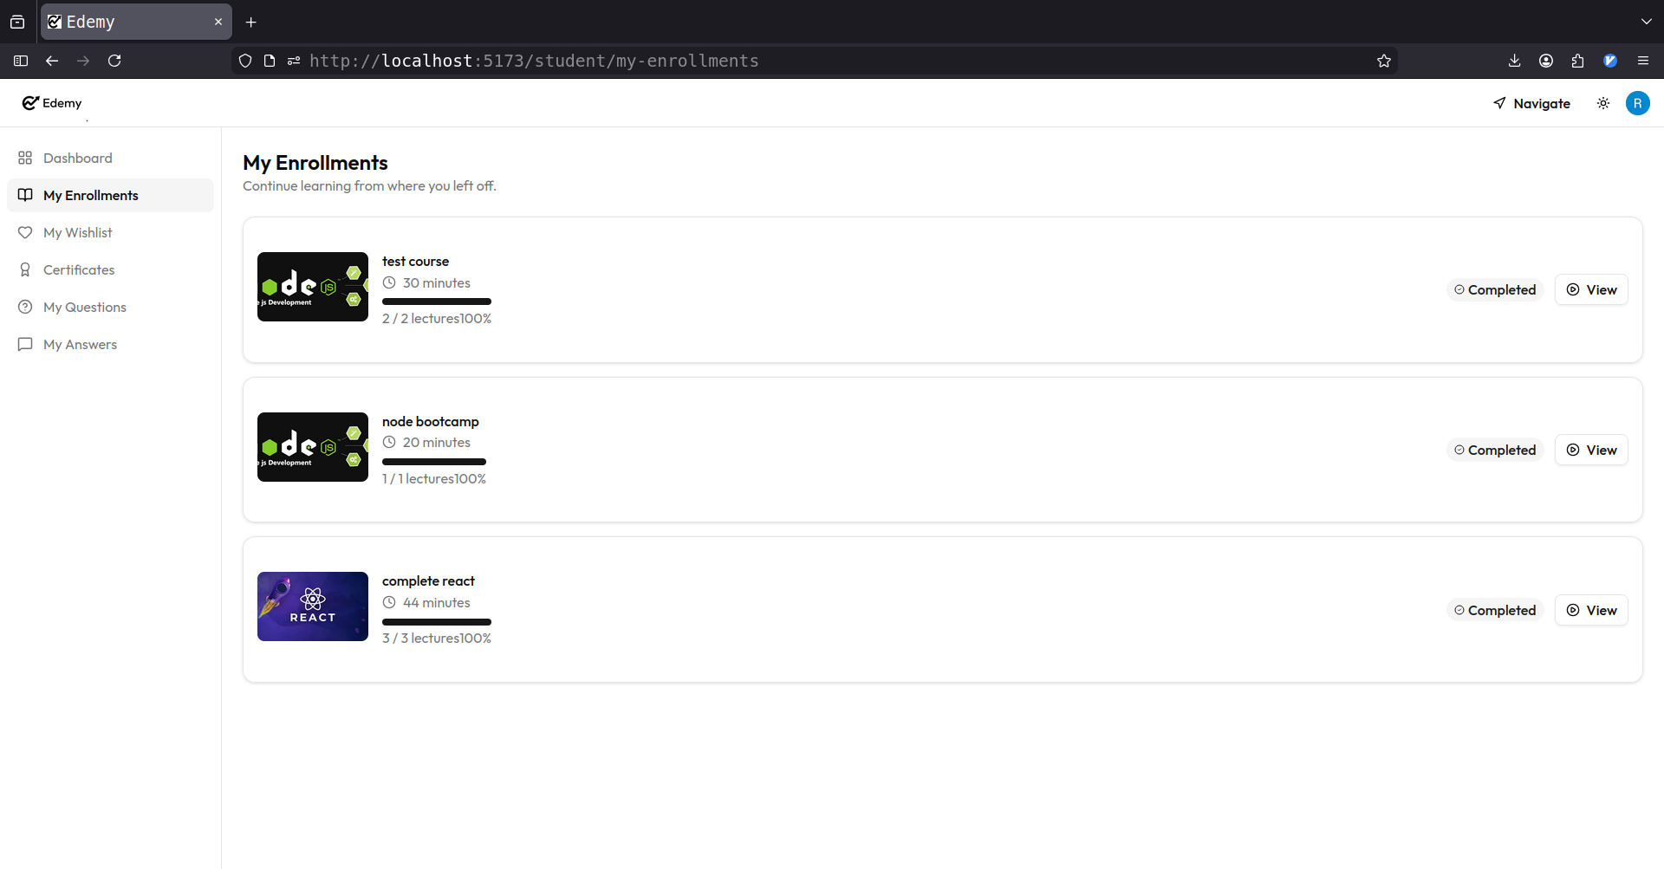

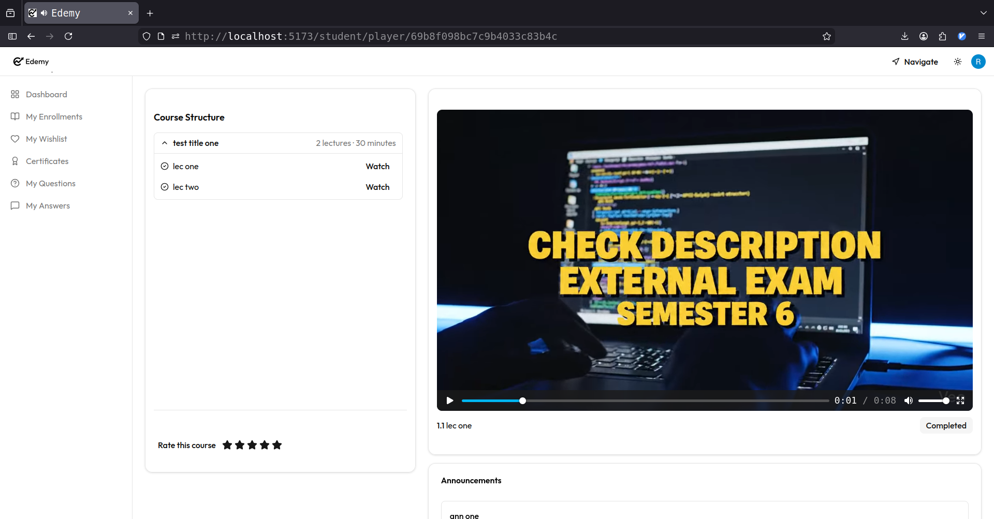

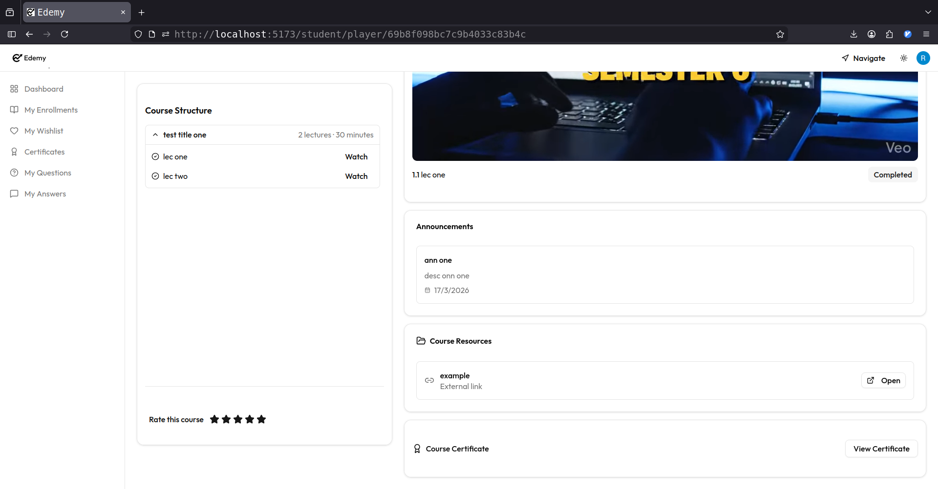

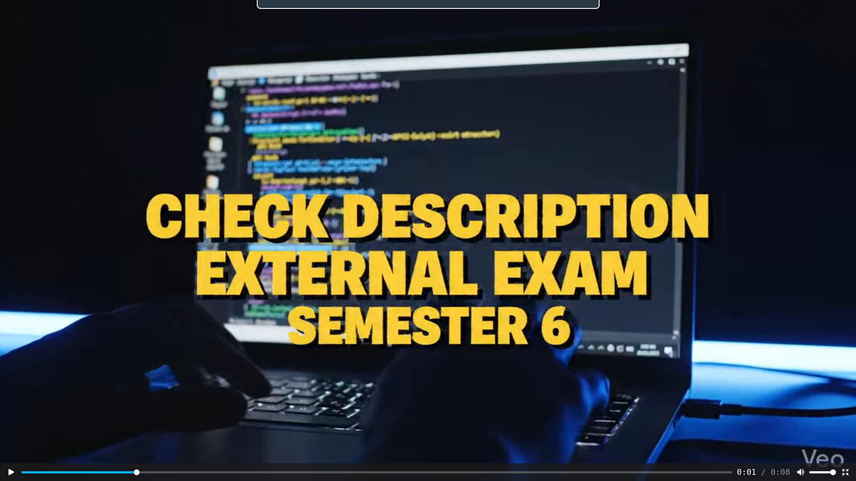

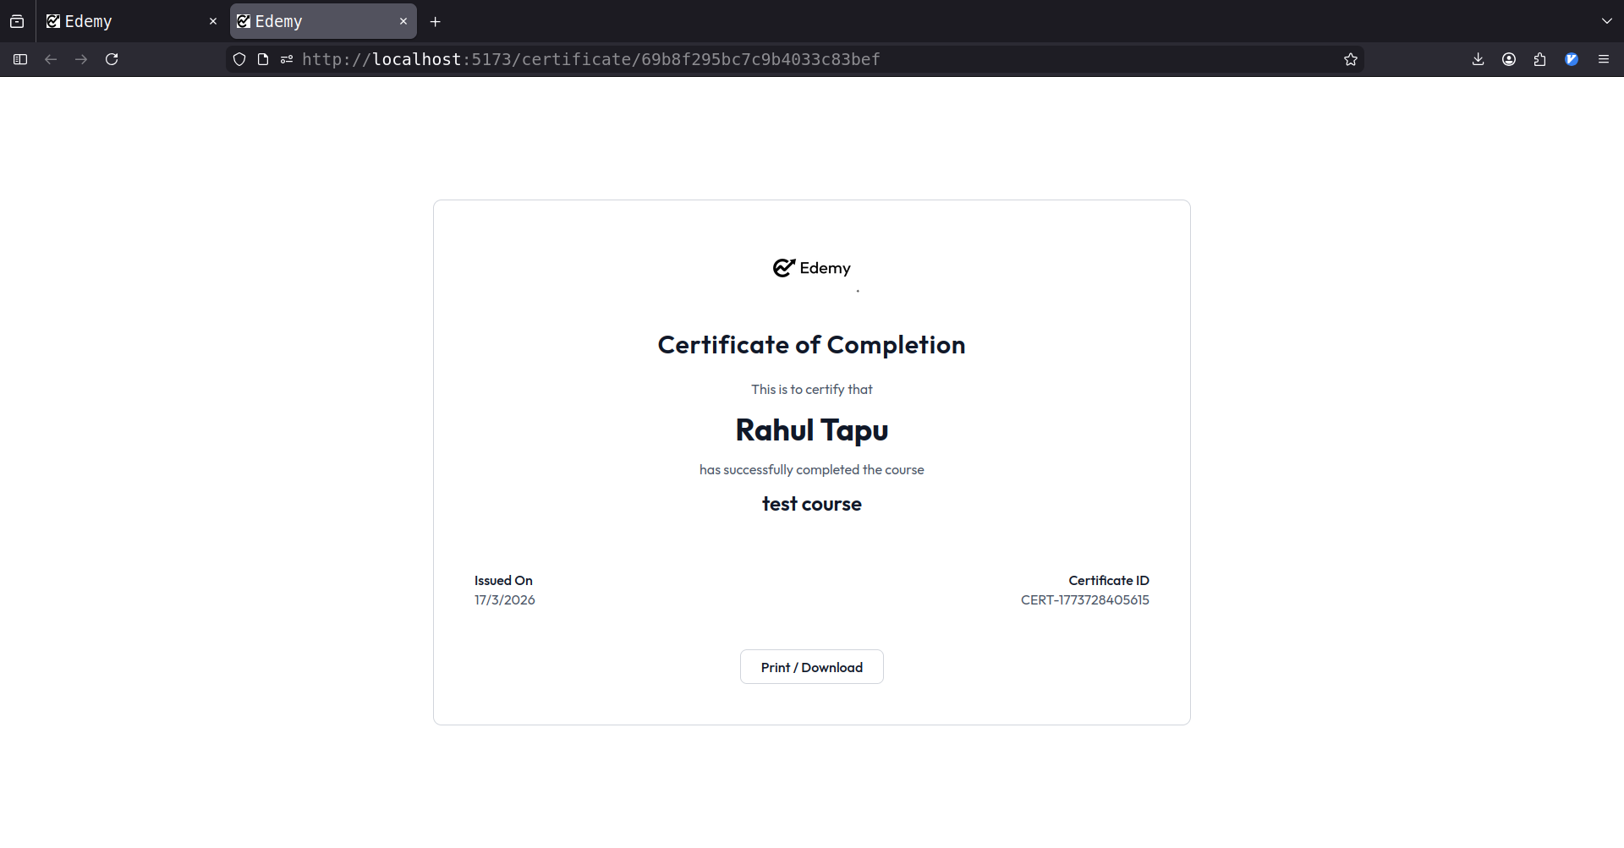

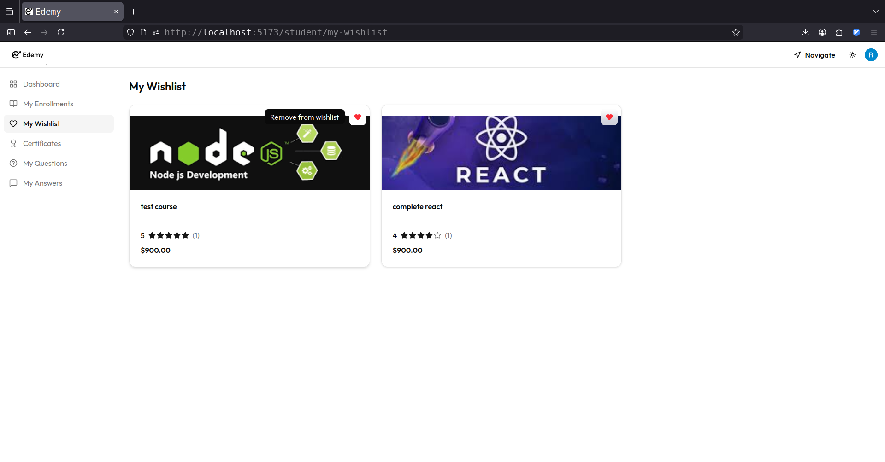
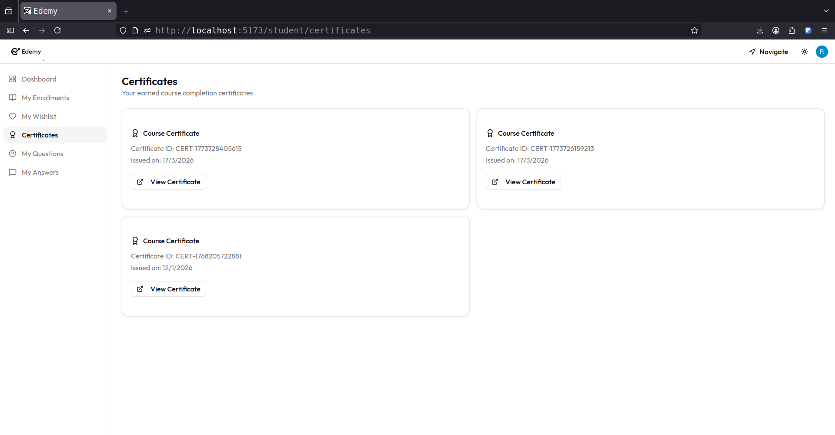

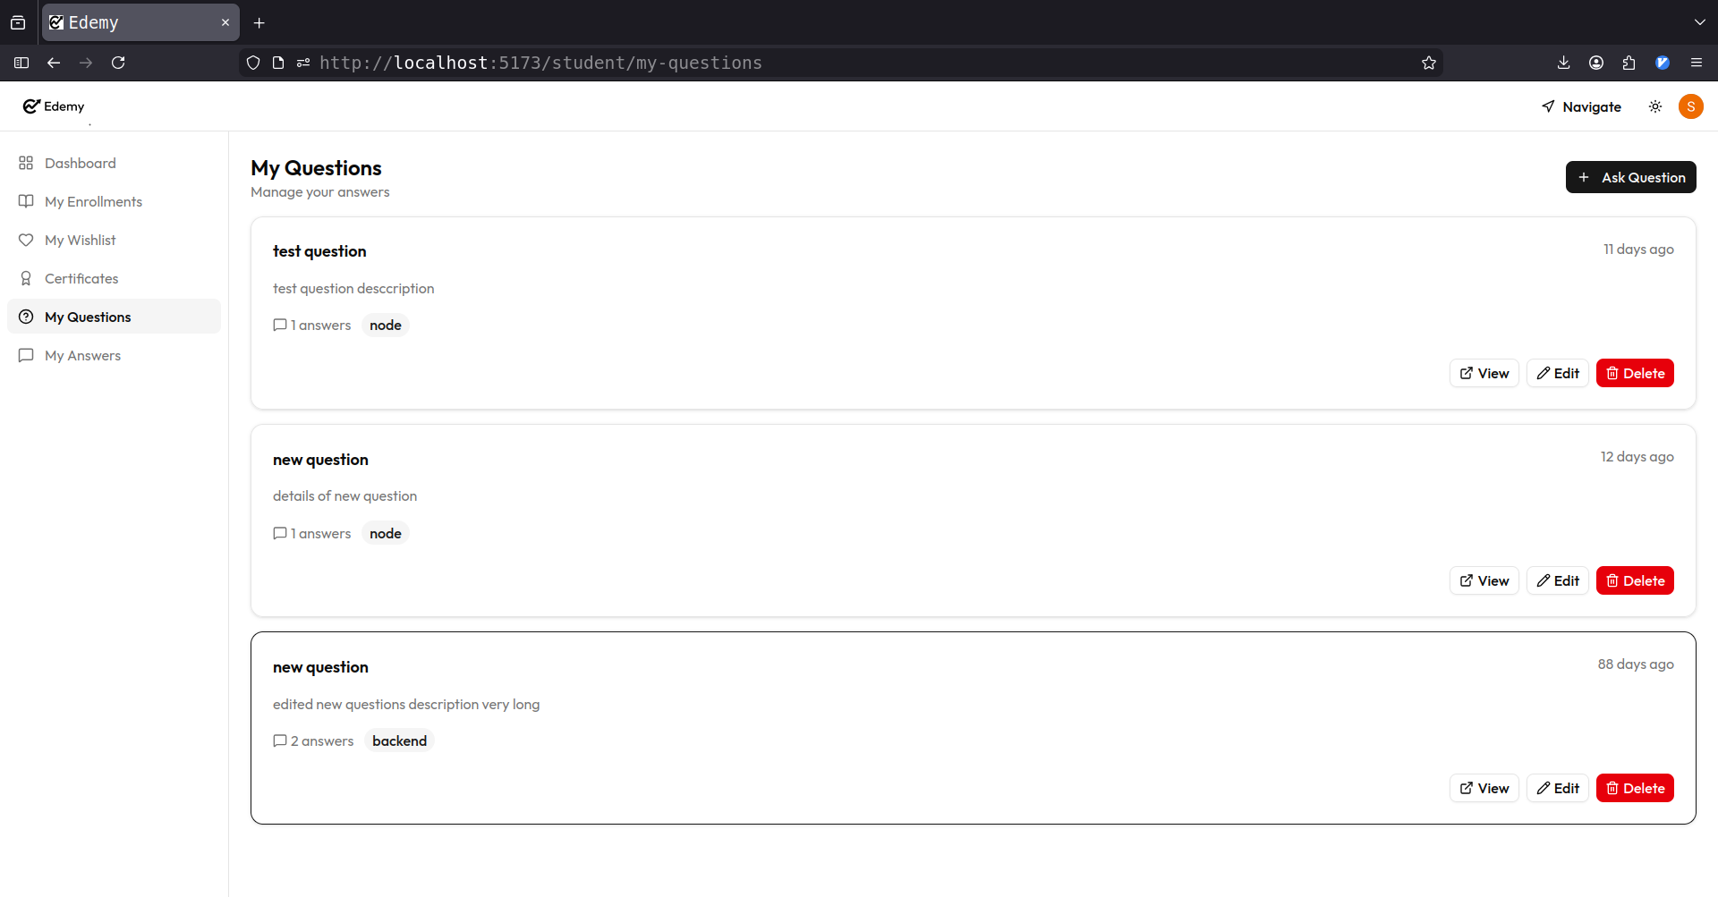

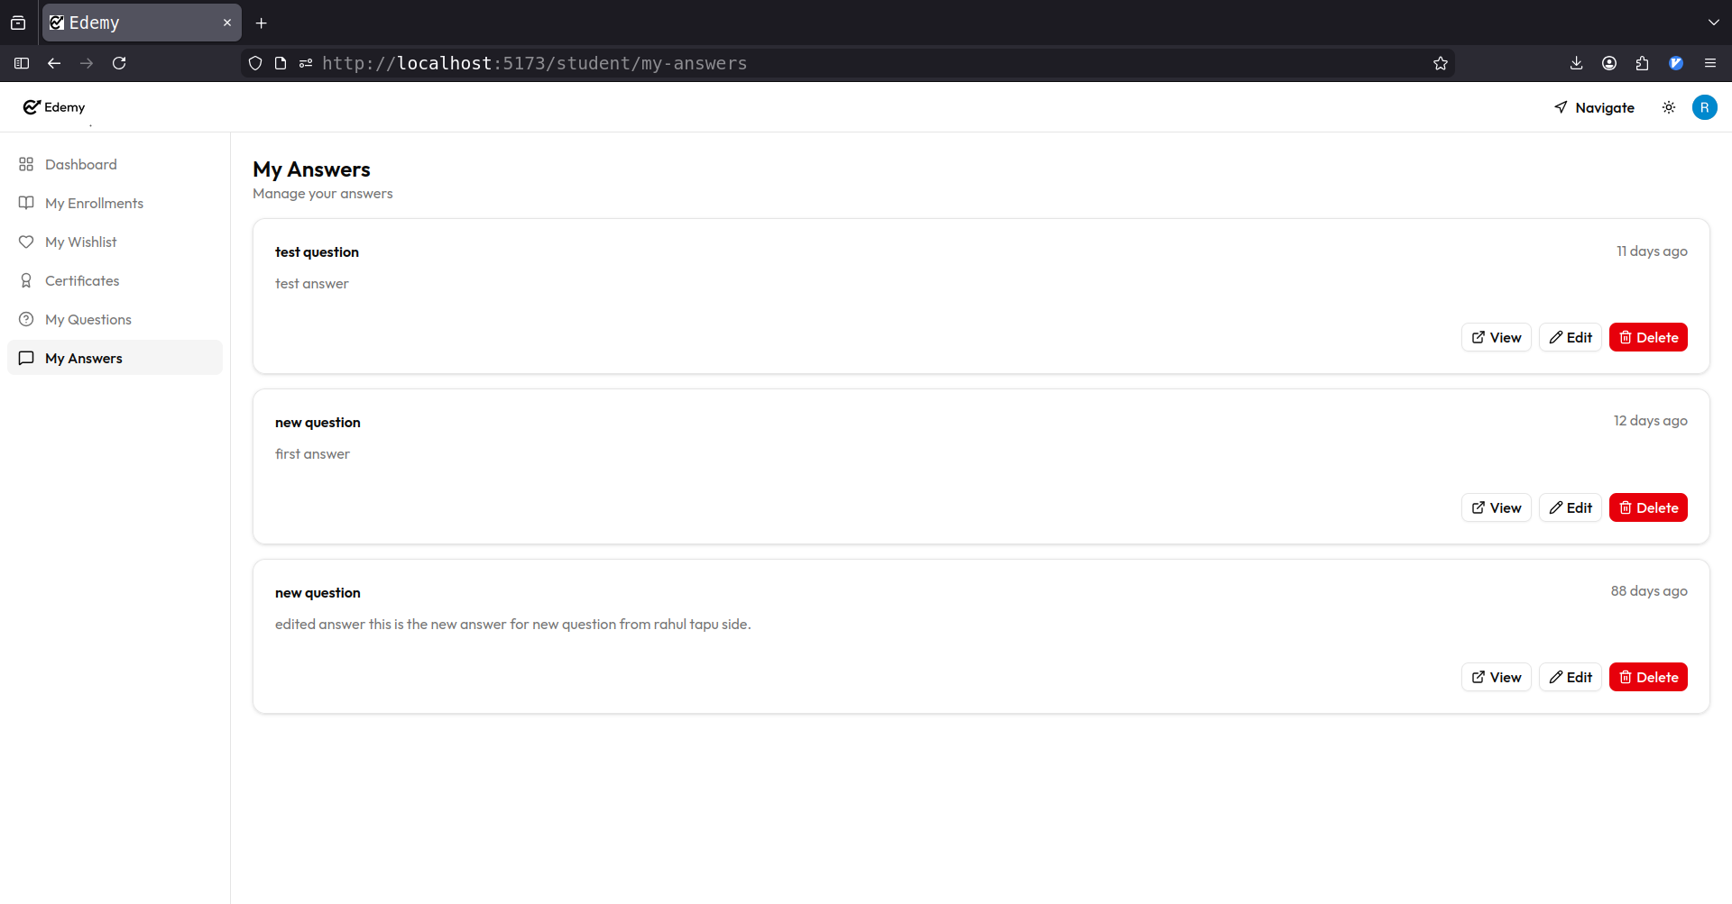

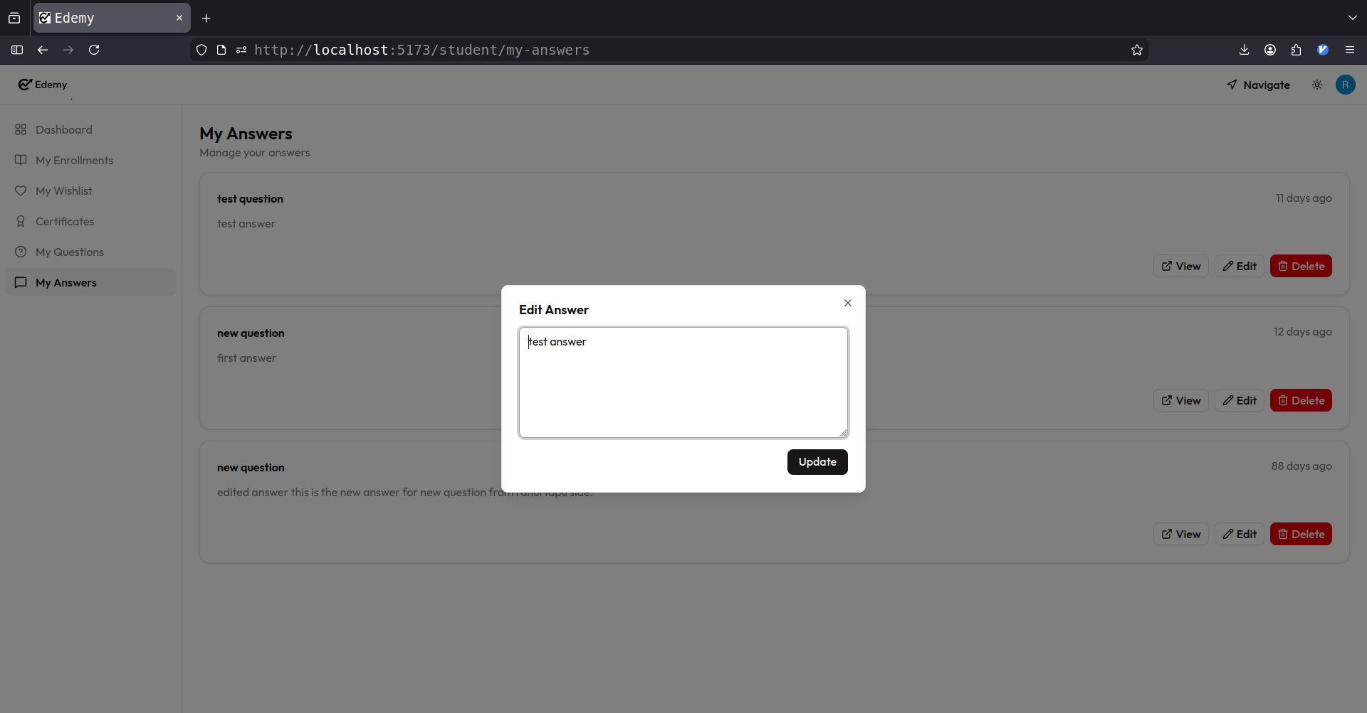
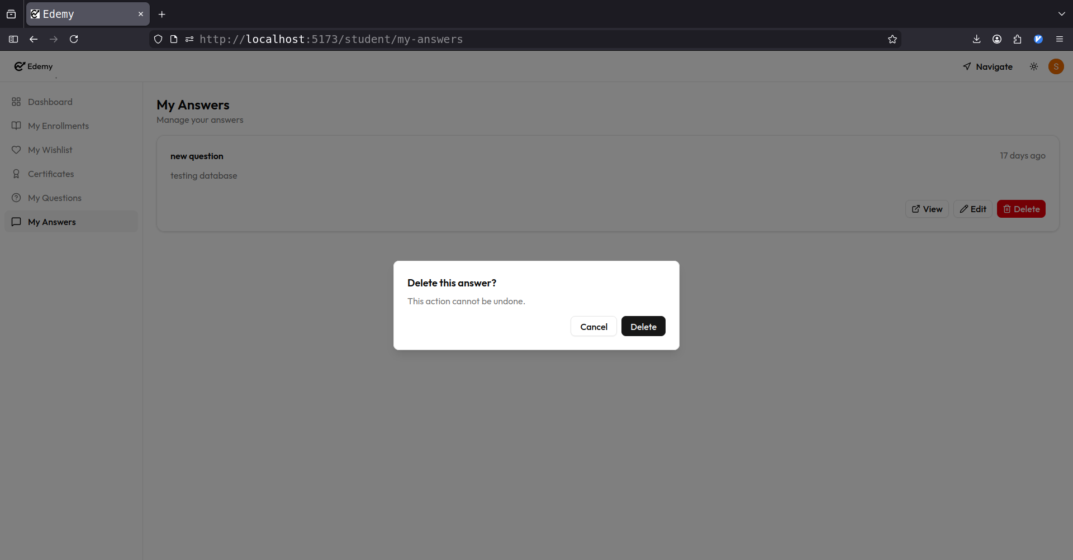

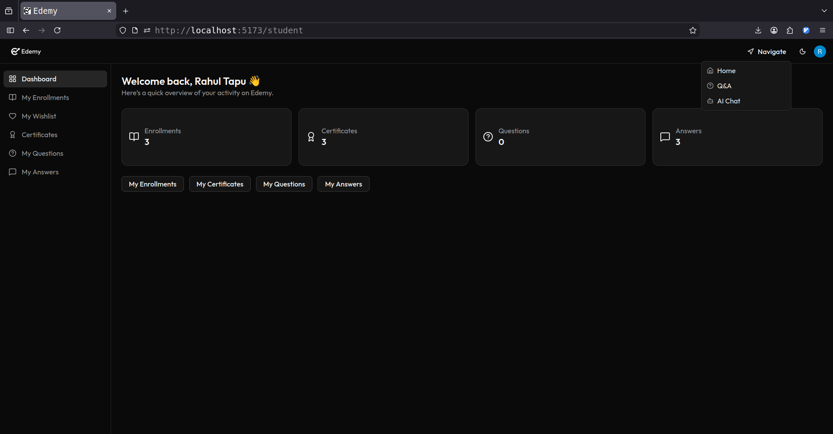

PART-IV
Tools &
Technology

5. About MongoDB

Introduction to MongoDB
MongoDB is a popular open-source NoSQL database that stores data in a flexible, document-oriented format using JSON-like structures.
Unlike traditional relational databases, MongoDB does not use tables and rows but instead uses collections and documents, making it highly scalable and adaptable.
MongoDB is designed to handle large volumes of data and is widely used in modern web applications due to its high performance, flexibility, and ease of integration with JavaScript-based technologies.
In this project, MongoDB is used as the primary database to store user data, course information, transactions, and other system-related data.

Key Features of MongoDB
Document-Oriented Storage – Data is stored in JSON-like documents, allowing flexible and dynamic schema design.
Schema Flexibility – MongoDB does not require a fixed schema, making it easy to modify data structures as the application evolves.
High Scalability – MongoDB supports horizontal scaling using sharding, making it suitable for large-scale applications.
High Performance – Efficient indexing and data retrieval mechanisms ensure fast read and write operations.
Aggregation Framework – MongoDB provides powerful data aggregation features for processing and analyzing data.

Applications of MongoDB
MongoDB is widely used for:
- Web Applications
- Content Management Systems
- E-commerce Platforms
- Real-Time Analytics Applications
- Big Data Applications

6. About Express.js

Introduction to Express.js
Express.js is a fast, minimal, and flexible web application framework for Node.js used to build backend applications and APIs.
It simplifies server-side development by providing a robust set of features for handling HTTP requests, routing, middleware, and server configuration.
Express.js is widely used for building RESTful APIs and web applications due to its simplicity and performance.
It allows developers to structure backend logic efficiently and integrate easily with databases and frontend technologies. In this project, Express.js is used to handle server-side logic, API creation, and communication between the client and database.

Key Features of Bootstrap
Minimal and Flexible Framework – Express provides a lightweight structure that allows developers to build applications as per their requirements.
Routing System – It offers a powerful routing mechanism to handle different HTTP requests efficiently.
Middleware Support – Express uses middleware functions to process requests and responses, improving modularity and control.
Fast Performance – Being built on Node.js, Express ensures high-speed execution and efficient handling of multiple requests.
Easy Integration – Express can be easily integrated with databases and frontend frameworks for full-stack development.

Applications of Express.js
Bootstrap is widely used for:
• Building RESTful APIs
• Web Application Development
• Backend Services
• Single Page Applications
• Real-Time Applications
7. About React.js

Introduction to React.js
React.js is a popular open-source JavaScript library used for building user interfaces, especially for single-page applications.
It allows developers to create fast and interactive web applications by breaking the UI into reusable components. React uses a virtual DOM to efficiently update and render only the necessary parts of the user interface, improving performance.
In this project, React.js is used to build the frontend interface where users interact with courses, dashboards, and other system features.

Key Features of MongoDB
Component-Based Architecture – React applications are built using reusable components, making the code more organized and maintainable.
Virtual DOM – React uses a virtual DOM to update only the changed parts of the UI, resulting in better performance.
JSX Syntax – React uses JSX, which allows writing HTML-like code inside JavaScript for better readability.
Unidirectional Data Flow – Data flows in a single direction, making debugging and state management easier.
Strong Community Support – React has a large community and ecosystem, providing extensive resources and libraries.

Applications of React.js
React.js is widely used in:
• Single Page Applications
• User Interface Development
• Dashboard Applications
• E-commerce Platforms
• Real-Time Web Applications
8. About Node.js

Introduction to Node.js
Node.js is an open-source, cross-platform runtime environment that allows developers to execute JavaScript code on the server side.
It is built on Chrome’s V8 JavaScript engine and is designed for building fast and scalable network applications. Node.js uses an event-driven, non-blocking I/O model, which makes it efficient and suitable for handling multiple requests simultaneously.
In this project, Node.js is used to build the backend server, handle business logic, and manage communication between the frontend and the database.

Key Features of Node.js
Asynchronous and Non-Blocking – Node.js uses a non-blocking architecture, allowing multiple operations to run concurrently without delays.
Event-Driven Architecture – It follows an event-driven model, making it efficient for real-time applications.
High Performance – Built on the V8 engine, Node.js executes code quickly and efficiently.
Scalability – Node.js is highly scalable and suitable for building large-scale applications.
JavaScript Everywhere – It allows using JavaScript on both frontend and backend, improving development consistency.

Applications of Node.js
Node.js is widely used in:
• Backend Development
• RESTful APIs
• Real-Time Applications
• Streaming Applications

• Scalable Network Applications

9. Bibliography
Search Engine: Google
Online Resources:
- www.mongodb.com
- www.nodejs.org
- www.expressjs.com
- www.react.dev

