**SCAMSNIFFER:**

**THE PHISHING DETECTION TOOL**

## *A PROJECT REPORT*

***Submitted by,***

**1. VIPUL JOSEPH PINTO 20201CSE0596**

**2. NIKHIL KUMAR 20201CSE0613**

**3. DISHA R 20201CSE0625**

**4. DHONE CHETANA REDDY 20201CSE0648**

**5. HEMANTH KUMAR SHETTY M 20201CSE0655**

### *Under the guidance of,*

**Dr. Mohamadi Begum Syed Riaz Ahamed**

***in partial fulfillment for the award of the degree***

***of***

**BACHELOR OF TECHNOLOGY**

**IN**

**COMPUTER SCIENCE AND ENGINEERING**

**At**

**PRESIDENCY UNIVERSITY**

**BENGALURU**

 **JANUARY 2024**

**PRESIDENCY UNIVERSITY**

**SCHOOL OF COMPUTER SCIENCE & ENGINEERING**

**CERTIFICATE**

This is to certify that the Project report **“SCAMSNIFFER – THE PHISHING TOOL”** being submitted **by** “VIPUL JOSEPH PINTO, NIKHIL KUMAR, DISHA R, DHONE CHETANA REDDY, HEMANTH KUMAR SHETTY M”bearing roll number(s**)** “20201CSE0596, 20201CSE0613, 20201CSE0625, 20201CSE0648 and 20201CSE0655” in partial fulfilment of requirements for the award of the degree of Bachelor of Technology in Computer Science and Engineering is a bonafide work carried out under my supervision.

|  |  |
| --- | --- |
| **Dr. Mohamadi Begum S**  Professor  School of CSE  Presidency University | **Dr. PALLAVI R**  Professor & HOD  School of CSE  Presidency University |

|  |  |  |
| --- | --- | --- |
| **Dr. C. KALAIARASAN**  Associate Dean  School of CSE&IS  Presidency University | **Dr. SHAKKEERA L**  Associate Dean  School of CSE&IS  Presidency University | **Dr. SAMEERUDDIN KHAN**  Dean  School of CSE&IS  Presidency University |

**PRESIDENCY UNIVERSITY**

**SCHOOL OF COMPUTER SCIENCE AND ENGINEERING**

**DECLARATION**

We hereby declare that the work, which is being presented in the project report entitled **“SCAMSNIFFER – THE PHISHING TOOL”** in partial fulfilment for the award of Degree of **Bachelor of Technology** in **Computer Science and Engineering**, is a record of our own investigations carried under the guidance of **Dr. Mohamadi Begum Syed Riaz Ahamed, Professor,** **School of Computer Science Engineering & Information Science, Presidency University, Bengaluru.**

We have not submitted the matter presented in this report anywhere for the 20902award of any other Degree.

|  |  |  |  |
| --- | --- | --- | --- |
| **Sl no.** | **Name** | **Roll no.** | **Signature** |
| 1. | Vipul Joseph Pinto | 20201CSE0596 |  |
| 2. | Nikhil Kumar | 20201CSE0613 |  |
| 3. | Disha R | 20201CSE0625 |  |
| 4. | Dhone Chetana Reddy | 20201CSE0648 |  |
| 5. | Hemanth Kumar Shetty M | 20201CSE0655 |  |

**ABSTRACT**

ScamSniffer is a user-focused phishing detection website equipped with essential sections - Home, Learn, About, Report Links, and Contact. Its Home section facilitates link scanning, guiding users safely based on link evaluations. The Learn page educates users on phishing signs and causes interactively. Trust is established in the About section, assuring reliability through a user-friendly UI. The Report Links feature aids in user feedback for potential model retraining. The Contact page innovatively offers diverse support options, including educational links and reporting mechanisms. ScamSniffer's design aims to empower users against phishing threats while fostering trust and engagement.

ScamSniffer is built to help users stay safe online. It brings together learning, easy-to-use features, and smart technology to fight against phishing. By teaching users about phishing tricks, involving them in the process, and adapting its technology to catch new threats, ScamSniffer aims to make the internet safer. It builds trust by being open about how it works and involving users in the fight against phishing scams effectively.

**ACKNOWLEDGEMENT**

First of all, we indebted to the **GOD ALMIGHTY** for giving me an opportunity to excel in our efforts to complete this project on time.

We express our sincere thanks to our respected dean **Dr. Md. Sameeruddin Khan**, Dean, School of Computer Science Engineering & Information Science, Presidency University for getting us permission to undergo the project.

We record our heartfelt gratitude to our beloved Associate Deans **Dr. C. Kalaiarasan and Dr. Shakkeera L,** School of Computer Science Engineering & Information Science, Presidency University and Dr. Pallavi R, Head of the Department, School of Computer Science Engineering, Presidency University for rendering timely help for the successful completion of this project.

We would like to convey our gratitude and heartfelt thanks to the University Project-II Coordinators **Dr. Sanjeev P Kaulgud, Dr. Mrutyunjaya MS** and also the department Project Coordinators, Mr. Zia Ur Rahman.

We are greatly indebted to our guide **Dr. Mohamadi Begum Syed Riaz Ahamed, Professor**, School of Computer Science Engineering, Presidency University for her inspirational guidance, valuable suggestions and providing us a chance to express our technical capabilities in every respect for the completion of the project work.

We thank our family and friends for the strong support and inspiration they have provided us in bringing out this project.

|  |  |
| --- | --- |
|  | VIPUL JOSEPH PINTO (20201CSE0596)  NIKHIL KUMAR (20201CSE0613)  DISHA R (20201CSE0625)    DHONE CHETANA REDDY (20201CSE0648)  HEMANTH KUMAR SHETTY M (20201CSE0655) |

**LIST OF TABLES**

|  |  |  |  |  |
| --- | --- | --- | --- | --- |
| **Sl. No.** | **Table Name** | | **Table Caption** | **Page No.** |
| 1 | Table 1.1 | Timeline for execution of project | | 39 |

**LIST OF FIGURES**

|  |  |  |  |
| --- | --- | --- | --- |
| **Sl. No.** | **Figure Name** | **Caption** | **Page No.** |
| 1. | Figure 1.1 | Flow Chart for link Scanning | 21 |
| 2. | Figure 1.2 | Flow Chart for reporting link | 24 |
| 3. | Figure 2.1 | High level design of Scamsnifffer | 33 |

**TABLE OF CONTENTS**

|  |  |  |
| --- | --- | --- |
| **CHAPTER NO.** | **TITLE** | **PAGE NO.** |
|  | ABSTRACT  ACKNOWLEDGEMENT  LIST OF TABLES  LIST OF FIGURES | **iv**  **v**  **vi**  **vii** |
| **1.** | **INTRODUCTION** | **1** |
|  | 1.1 EXECUTIVE SUMMARY  1.1.1 Overview of Cybersecurity Threats  1.1.2 Importance of Phishing Detection  1.1.3 ScamSniffer Tool |  |
|  | 1.2 KEY FEATURES |  |
|  | 1.2.1 Phishing Link Detection |  |
|  | 1.2.2 Real-time Threat Guidance |  |
|  | 1.2.3 Machine Learning Approach |  |
|  | 1.2.4 User-Friendly Interface |  |
|  | 1.2.5 Educational Resources Integration |  |
|  | 1.3 PROJECT SCOPE  1.3.1 Target Users and Audience  1.3.2 Supported Platforms and Environments |  |
| **2.** | **LITERATURE REVIEW** | **6** |
|  | 2.1 USER EDUCATION |  |
|  | 2.2 PHISHING E-MAIL |  |
| **3.**  **4.**  **5.**  **6.**  **7.**  **8.**  **9.**  **10.** | 2.3 FUTURE TRENDS  2.4 EMERGING THREATS  2.5 VISUAL SIMILAIRITY PHISHING DETECTION  2.6 MALWARE BASED PHISHING  **RESEARCH GAPS OF EXISTING METHODS**  3.1 EFFECTIVENESS OF ANTI-PHISHING  3.2 USER-BEHAVIOUR ANALYSIS  3.3 MACHINE LEARNING AND BEHAVIOURAL ANALYSIS  3.4 USER EDUCATION INTEGRATION  3.5 PHISHING ATTACKS IN CLOUD ENVIRONMENTS  **PROPOSED METHODOLOGY**  **OBJECTIVES**  **SYSTEM DESIGN AND IMPLEMENTATION**  **TIMELINE FOR EXECUTION OF PROJECT**  **OUTCOMES**  **RESULTS AND DISCUSSIONS**  **CONCLUSION**  REFERENCES  APPENDIX-A  APPENDIX-B | **12**  **19**  **30**  **32**  **39**  **40**  **43**  **46**  47  48  49 |

**CHAPTER-1**

**INTRODUCTION**

**1.1 Executive Summary**

**1.1.1 Overview of Cybersecurity Threats**

In the ever-evolving landscape of the digital era, where technological advancements pave the way for convenience and connectivity, the parallel rise of cyber threats poses a formidable challenge to the security and integrity of online ecosystems. The ubiquity of digital platforms and the seamless integration of technology into various facets of daily life have undeniably improved efficiency and accessibility. However, this interconnectedness has given rise to a pressing concern – the escalating threat of cyber-attacks. Among the myriad forms of cyber threats, phishing attacks have assumed a particularly insidious and pervasive nature, posing a significant menace to both unsuspecting users and organizations. Phishing attacks, as a prevalent tactic employed by malicious actors, exploit the trust and vulnerability of users through deceptive means. This technique involves the use of fraudulent communications, often disguised as legitimate entities, to manipulate individuals into divulging sensitive information.

**1.1.2 Importance of Phishing Detection**

The importance of phishing detection lies in its role as a fundamental pillar of cybersecurity. The financial stakes associated with phishing attacks underscore the urgency of addressing this pervasive menace. Cybersecurity experts and organizations are confronted with the challenge of developing sophisticated defense mechanisms capable of identifying and thwarting these deceptive tactics. The ever-evolving nature of phishing attacks necessitates adaptive and proactive cybersecurity measures to stay one step ahead of the adversaries. Beyond protecting sensitive information and financial assets, efficient

detection contributes to maintaining trust, safeguarding identities, promoting cybersecurity awareness, and ensuring compliance with regulatory frameworks. As the digital landscape continues to evolve, the significance of robust phishing detection mechanisms cannot be overstated in fostering a secure and resilient online environment. In response to this escalating threat, our team has embarked on a pioneering initiative with the development of the "ScamSniffer Tool".

**1.1.3 ScamSniffer Tool**

The ScamSniffer Tool stands as a sophisticated and meticulously designed software solution, emerging as a vigilant guardian within the complex realm of cybersecurity. Specifically tailored to combat the ever-present threat of phishing attacks, this innovative tool is engineered to provide robust defense against the perils of malicious online activities. Its design goes beyond conventional security measures, integrating cutting-edge technologies and intelligent algorithms to create a dynamic and adaptive defense system. ScamSniffer's primary function is the swift and accurate detection of phishing links, marking a crucial front line against cyber threats. Its advanced capabilities not only identify potential dangers but also empower users with real-time guidance, offering a proactive approach to navigating the digital landscape securely. This multifaceted tool not only enhances the security posture of individuals and organizations but also fosters a sense of confidence in users, assuring them of a resilient defense against the intricate tactics employed by cyber adversaries. In essence, ScamSniffer represents a paradigm shift in cybersecurity tools, transcending traditional boundaries to provide a comprehensive, intelligent, and user-focused solution in the ongoing battle against online threats.

**1.2 Key Features:**

**1.2.1 Phishing Link Detection:**

ScamSniffer employs sophisticated algorithms to scrutinize URLs, identifying the hallmark signs of phishing attempts. Through an exhaustive link analysis process, the tool swiftly recognizes malicious URLs, delivering prompt alerts to users. This capability acts as a robust defense, offering proactive protection against potential cyber threats. By leveraging advanced algorithms, ScamSniffer ensures a comprehensive and dynamic approach to phishing link detection, enhancing the overall security posture.

**1.2.2 Real-time Threat Guidance:**

Beyond the conventional role of detecting phishing links, ScamSniffer stands out by providing real-time guidance to users navigating potentially hazardous situations. The tool's user-friendly interface facilitates seamless interaction, offering educational insights and empowering individuals to take informed actions. This proactive approach to online security not only identifies threats but also equips users with the knowledge to navigate the digital landscape securely. Real-time threat guidance transforms ScamSniffer from a passive defender to an active educator, fostering a sense of user empowerment.

**1.2.3 Machine Learning Approach:**

ScamSniffer's efficacy is significantly elevated through the integration of machine learning capabilities. This empowers the tool to adapt and evolve continuously in response to emerging cyber threats. By leveraging historical data and recognizing evolving patterns, ScamSniffer remains at the forefront of cybersecurity. The machine learning approach ensures that the tool is not static but rather dynamic, staying ahead of the ever-changing tactics employed by malicious actors. This adaptive nature enhances the precision and efficiency of phishing link detection.

**1.2.4 User-Friendly Interface:**

Recognizing the importance of accessibility, ScamSniffer boasts an intuitive and user-friendly interface. Designed to cater to a diverse user base, including individuals, small businesses, and large enterprises, the tool ensures that cybersecurity is accessible to all. The interface facilitates ease of use, encouraging users to navigate and leverage the tool's features effortlessly. This commitment to user-friendliness enhances the tool's adoption rate and contributes to a positive cybersecurity experience for all users.

**1.2.5 Educational Resources Integration:**

One of ScamSniffer's distinctive features is its role as an educational catalyst. Beyond serving as a protective shield against phishing threats, the tool seamlessly integrates educational resources. In the event of a potential threat, users not only receive alerts but are also provided with real-time educational content. This dual functionality not only informs users about immediate dangers but also educates them on recognizing and avoiding similar threats in the future. The integration of educational resources transforms ScamSniffer into a holistic cybersecurity solution, nurturing a well-informed and cyber-resilient user base.

**1.3 Project Scope:**

**1.3.1 Target Users and Audience:**

The ScamSniffer Tool is meticulously designed to meet the diverse needs of individuals, businesses, and educational institutions. Particularly focused on the older generation, a demographic often targeted by phishing attacks, the tool tailors its features to create a versatile and inclusive solution. By catering to each group's unique requirements, ScamSniffer emerges as a comprehensive defense mechanism against phishing attacks across various sectors, ensuring a widespread impact on cybersecurity.

**1.3.2 Supported Platforms and Environments:**

ScamSniffer extends its protective capabilities across various platforms and environments. Compatible with major web browsers like Google Chrome, Mozilla Firefox, and Microsoft Edge, the tool seamlessly integrates into users' online experiences. Additionally, with dedicated applications for Windows, macOS, and Android/iOS mobile devices, ScamSniffer ensures a comprehensive cybersecurity solution. The tool's scalability is highlighted by its ability to accommodate a growing user base without compromising performance, making it an adaptable and effective defense mechanism in diverse technological landscapes.

**CHAPTER-2**

**LITERATURE SURVEY**

**1.User education:**

It plays a pivotal role in fortifying individuals against the ever-growing threat of phishing attacks. By imparting knowledge on the intricacies of these deceptive tactics, users become less susceptible to falling prey to malicious schemes. Various educational approaches can be employed to achieve this goal, ranging from online training modules to awareness campaigns and in-person workshops. However, despite the evident benefits, there are notable disadvantages associated with current methods aimed at mitigating phishing attacks.

**Advantages of User Education:**

Empowerment: Educating users about phishing attacks empowers them with the knowledge to identify and avoid deceptive tactics employed by cybercriminals.

Variety of Training Methods: User education can be delivered through diverse channels such as online modules, awareness campaigns, and workshops, catering to different learning preferences.

**2.The authentication server:**

It operates as a crucial component in the security infrastructure of the described system, orchestrating a meticulous process to safeguard user access to the bank's services. Commencing with the user's initiation by inputting both the Bank URL and mobile ID, the system channels this information through a secure conduit by redirecting to the authentication server over the robust SSL/TLS protocol. Subsequently, the authentication server fortifies the process by dispatching a Nonce (a cryptographic number used only once) or a One-Time Password (OTP) to the user's mobile device, introducing an additional layer of dynamic authentication. Notably, the user's role extends beyond mere data submission, as they employ artificial intelligence in crafting a signature message that encapsulates crucial authentication details.

Components used are:

* User Input
* Bank redirection
* Nonce/OTP Generation
* Signature Message Construction & Verification

**Countermeasures** -

It includes fraudulent emails, infectious software, DNS spoofing, harmful content insertion, and Man-in-the-Middle (MITM) approaches. The defense strategy is detailed and is applied at both the user and organizational levels. However, there are challenges in maintaining a balance between effectiveness and usability, and there is a need for addressing user education. The countermeasure employs a multi-layered approach that integrates various defense mechanisms. These mechanisms include email filtering, authentication protocols, webpage comparison, and Bayesian filters. While the comprehensive nature of this approach is commendable, there are certain disadvantages to consider. The complexity of implementing this multi-layered defense could pose challenges, requiring significant resources.

The effectiveness of the defense layers needs to be balanced with usability considerations and the ongoing need for user education. Continuous updates are crucial for the success of these countermeasures, along with maintaining user awareness and technical expertise for deployment and maintenance.

**3.Phishing e-mail:**

The most common threat derived by an attacker is deceiving people via email communications and this remains the most popular phishing type to date. A Phishing email or Spoofed email is a forged email sent from an untrusted source to thousands of victims randomly. These fake emails are claiming to be from a person or financial institution that the recipient trusts in order to convince recipients to take actions that lead them to disclose their sensitive information.

The basic scenario for this attack can be described in the following steps:

1. The phisher sets up a fraudulent email containing a link or an attachment (planning phase).

2. The phisher executes the attack by sending a phishing email to the potential victim using an appropriate medium (attack conducting phase).

3. The link (if clicked) directs the user to a fraudulent website, or to download malware in case of clicking the attachment (interaction phase).

4. The malicious website prompts users to provide confidential information or credentials, which are then collected by the attacker and used for fraudulent activities. (Valuables acquisition phase).

**4.Future Trends:**

**AI and Machine Learning in Phishing Attacks:**

Anticipate an increase in the sophistication of phishing attacks leveraging artificial intelligence and machine learning.AI can be used to create more convincing and personalized phishing messages, making detection more challenging.

**Deepfake Technology:**

Expect the use of deepfake technology to create convincing audio and video content for phishing.

Deepfakes may be used to impersonate executives or colleagues in voice and video communications.

**Cross-Channel Attacks:**

Anticipate an increase in cross-channel attacks, where attackers combine various methods such as email, social media, and messaging apps to create a more coordinated and effective phishing campaign.

**IoT Devices as Targets:**

With the proliferation of Internet of Things (IoT) devices, there may be an increase in phishing attacks targeting smart devices and connected systems.

**Evolution of Phishing Tactics:**

Expect continuous evolution in phishing tactics, with attackers adapting to security measures and finding new ways to exploit human vulnerabilities.

**5.Emerging Threats:**

**Voice Phishing (Vishing) Evolution:**

Vishing attacks may evolve to become more sophisticated, using AI-generated voices and social engineering techniques to deceive individuals over voice communications.

**5G Networks and Phishing:**

With the rollout of 5G networks, there may be new opportunities for phishing attacks, leveraging increased connectivity and faster data transfer speeds.

**Quantum Computing Threat:**

As quantum computing advances, there is a potential threat to traditional encryption methods, which could impact the security of sensitive information in phishing attacks.

**Blockchain Exploitation:**

Phishers may explore ways to exploit vulnerabilities in blockchain technology, particularly in the context of cryptocurrency-related phishing attacks.

**Augmented Reality (AR) and Phishing:**

As augmented reality becomes more prevalent, there may be attempts to use AR interfaces to deceive users in phishing scenarios.

**1.Visual-Similarity-Based Phishing Detection:**

It refers to a method of identifying phishing attacks by looking at visual similarities. In other words, it examines the appearance or visual aspects of websites or content to figure out if they look like known phishing sites. This approach is often used to catch fake websites that try to mimic the look of legitimate ones to trick people into sharing sensitive information.

Here's how it typically works:

**Image Analysis:** The method involves analysing images, logos, and visual elements on a webpage. Legitimate websites often have consistent branding and design elements.

**Template Matching:** Phishing websites may use templates that mimic the layout of legitimate sites. Visual-similarity-based detection compares the structure and design of web pages to known templates or patterns.

**Icon and Logo Verification:** Legitimate websites have specific icons and logos. Visual phishing detection checks if these elements match the expected visuals, helping to identify fake sites.

**Colour and Style Analysis:** Phishing websites may replicate the colour schemes and styles of legitimate ones. Visual analysis looks at colour patterns, fonts, and styles to identify anomalies.

**1.Malware-Based Phishing:**

It refers to a type of phishing attack where the attacker uses malicious software (malware) to carry out the phishing attempt. In this scenario, the phishing email or message typically contains an infected attachment or a link that, when clicked, installs malware on the victim's device. The malware is then used to steal sensitive information, such as login credentials, personal data, or financial information.

Here's how malware-based phishing generally works:

**Delivery of Malicious Content:** The phishing attack often starts with a deceptive email, message, or even a social media post that contains a malicious attachment or a link.

**Social Engineering Tactics:** The content of the email or message usually employs social engineering tactics to trick the recipient into taking action. This could involve creating a sense of urgency, pretending to be a trusted entity, or using other manipulative techniques.

**Malware Installation:**

If the recipient opens the attachment or clicks the link, it leads to the download and installation of malware on their device without their knowledge.

**CHAPTER-3**

**RESEARCH GAPS OF EXISTING METHODS**

**1.Effectiveness of Anti-Phishing Technologies:**

Evaluate the real-world effectiveness of current anti-phishing technologies, including email filters, web page analyzers, and browser extensions. Research could focus on the ability of these tools to adapt to evolving phishing techniques.

Here are key considerations in evaluating the effectiveness of anti-phishing technologies:

* **False Positive and False Negative Rates:**

Research should assess the rates of false positives (legitimate emails or websites incorrectly identified as phishing) and false negatives (phishing emails or websites not detected) by anti-phishing technologies. Striking the right balance between these rates is crucial for minimizing both missed threats and unnecessary alerts.

* **Adaptability to Evolving Techniques:**

Evaluate how well anti-phishing technologies adapt to evolving phishing techniques. Phishers constantly change tactics, and effective technologies should be capable of recognizing new patterns and behaviours associated with phishing attacks.

* **Real-time Detection and Response:**

Assess the real-time detection capabilities of anti-phishing solutions. Quick identification and response to phishing threats are essential to prevent users from falling victim to attacks.

* **Machine Learning and Behavioural Analysis:**

Research should explore the integration of machine learning and behavioural analysis in anti-phishing technologies. These approaches can enhance the ability to identify phishing patterns and anomalies in user behaviour.

**1.User Behaviour Analysis:**

Investigate in-depth the psychological and behavioural aspects of users falling victim to phishing attacks. Understand the factors that make certain demographics more susceptible and how user awareness programs can be tailored to address these factors.

Here are key aspects of user behaviour analysis:

* **Baseline Establishment:**

Create a baseline of normal user behaviour by analysing regular activities, access patterns, and typical interactions within a system or network. This baseline serves as a reference point for detecting deviations.

* **Anomaly Detection:**

Use advanced analytics and machine learning algorithms to identify anomalous behaviour. Anomalies may indicate potential security incidents, such as unauthorized access or compromised accounts.

* **User Authentication Patterns:**

Analyse the ways users typically authenticate themselves, considering factors like login times, locations, and device types. Unexpected changes in these patterns could signal account compromise.

* **Privilege Escalation Monitoring:**

Monitor changes in user privileges over time. Unexpected or unauthorized privilege escalations may indicate suspicious activity, especially if they deviate from typical user roles.

**2.Machine Learning and Behavioural Analysis:**

Research should explore the integration of machine learning and behavioural analysis in anti-phishing technologies. These approaches can enhance the ability to identify phishing patterns and anomalies in user behaviour.

Here's how machine learning and behavioural analysis work together in the context of cybersecurity:

**Baseline Establishment:**

* Behavioural Analysis: Establish a baseline of normal user and system behaviour by analysing patterns, access times, and interactions within the network.
* Machine Learning: Use machine learning algorithms to automatically learn and adapt to the established baseline over time.

**Anomaly Detection:**

* Behavioural Analysis: Identify anomalies or deviations from the established baseline, signalling potentially malicious activities or security threats.
* Machine Learning: Machine learning models can automatically detect anomalies by learning patterns and recognizing deviations that may indicate suspicious behaviour.

**Continuous Learning:**

* Behavioural Analysis: Continuously update the baseline as user and system behaviour evolves.
* Machine Learning: ML models can adapt and learn from new data, enabling them to improve over time and stay effective in the face of evolving threats.

**User Authentication Monitoring:**

* Behavioural Analysis: Monitor typical user authentication patterns, such as login times, locations, and devices used.
* Machine Learning: ML algorithms can recognize changes in authentication patterns, detecting anomalies that may suggest unauthorized access or compromised accounts.

**3.User Education Integration:**

Examine how well anti-phishing technologies integrate with user education efforts. Technologies that empower users by providing clear warnings and educational messages contribute to a more resilient defence.

Here's a closer look at how well these technologies can integrate with user education efforts to create a more resilient defence against phishing attacks:

**Clear Warning Messages:**

* Integration Aspect: Anti-phishing technologies should provide clear and comprehensible warning messages to users when a potential phishing threat is detected.
* Objective**:** The objective is to convey the risk to users in a straightforward manner, prompting them to exercise caution and take appropriate actions.

**Educational Pop-ups:**

* Integration Aspect: When a user encounters a phishing attempt, the anti-phishing solution can trigger educational pop-ups to provide information about common phishing tactics and how to identify them.
* Objective: The aim is to educate users in real-time, helping them recognize phishing red flags and avoid falling victim to similar attacks in the future.

**Phishing Simulation Exercises:**

* Integration Aspect: Anti-phishing technologies can be integrated with phishing simulation platforms to conduct periodic exercises.
* Objective: Simulations allow organizations to test the effectiveness of both the technology and user awareness. They create a learning environment where users can experience and learn from simulated phishing attacks.

**User-Friendly Interface:**

* Integration Aspect: The user interface of anti-phishing solutions should be designed with user-friendliness in mind.
* Objective: A user-friendly interface enhances the overall user experience and ensures that educational elements, such as warnings and tips, are easily accessible and understandable.

**4.Phishing attacks in cloud environments:**

It represents a growing concern as organizations increasingly rely on cloud services for storing, processing, and accessing their data.

Here are key considerations and challenges related to phishing in cloud environments:

**Cloud Service Credential Theft:**

* Concern: Phishers may attempt to trick users into revealing their cloud service credentials, such as usernames and passwords.
* Challenge: Credential theft can lead to unauthorized access to cloud accounts, potentially compromising sensitive data stored in the cloud.

**Targeting Cloud-Based Applications:**

Concern: Phishing attacks may focus on tricking users into interacting with cloud-based applications, leading to unauthorized data access or the installation of malicious software.

Challenge: Organizations need to secure not only traditional on-premises applications but also cloud-based services.

**Email-Based Cloud Phishing:**

* Concern: Phishers may use email-based tactics to trick users into clicking on malicious links that lead to fake cloud login pages.
* Challenge: Traditional email security measures may not be sufficient to detect and block all cloud phishing attempts.

**Cloud Storage and File Sharing Exploitation:**

* Concern: Phishers may exploit cloud storage and file-sharing services to distribute malicious files or links.
* Challenge: Organizations need to implement robust security controls to prevent the uploading and sharing of malicious content through cloud platforms.

**Disadvantages:**

**Limited Understanding of Emerging Threats:**

* Disadvantage: Research gaps may lead to a limited understanding of emerging phishing threats and tactics used by cybercriminals.
* Impact: This limitation can result in a lack of proactive measures to counter evolving phishing techniques, leaving organizations and users vulnerable to new and sophisticated attacks.

**Ineffective Countermeasures:**

* Disadvantage: Without comprehensive research, the development of countermeasures may lag behind the evolving strategies employed by phishing attackers.
* Impact: Organizations and security professionals may struggle to implement effective preventive measures, leading to increased susceptibility to phishing attacks.

**Underestimation of Human Factors:**

* Disadvantage: A lack of research on human factors in phishing attacks may result in an underestimation of the impact of psychological and sociological aspects on user vulnerability.
* Impact: Without a deep understanding of user behavior, organizations may struggle to design effective user education programs and awareness campaigns.

**Insufficient Legal and Regulatory Frameworks:**

* Disadvantage: Inadequate research on the legal and regulatory aspects of phishing attacks may hinder the development of effective frameworks for prosecuting cybercriminals.
* Impact: Legal and law enforcement efforts may face challenges in addressing the global nature of phishing attacks, resulting in limited deterrence.

**Reduced Preparedness for Industry-Specific Threats:**

* Disadvantage: Industry-specific research gaps may result in reduced preparedness for phishing threats that are unique to certain sectors.
* Impact: Organizations in specific industries may be less equipped to defend against targeted phishing attacks that exploit sector-specific vulnerabilities.

**Delayed Awareness and Education Initiatives:**

* Disadvantage: Limited research on the effectiveness of awareness and education programs may lead to delays in implementing impactful training initiatives.
* Impact: Users may remain unaware of evolving phishing tactics, making them more susceptible to falling victim to attacks.

**Ineffective Integration of Technologies:**

* Disadvantage: Research gaps in the integration of anti-phishing technologies with user education efforts may result in less effective security measures.
* Impact: The lack of seamless integration could lead to missed opportunities to empower users with real-time guidance and education during potential phishing incidents.

**Inadequate Protection for Emerging Technologies:**

* Disadvantage: Insufficient research on phishing threats targeting emerging technologies may result in inadequate protection measures for these platforms.
* Impact: As organizations adopt new technologies, they may be unaware of specific phishing risks associated with these innovations.

**Challenges in Global Collaboration:**

* Disadvantage: Limited research on international collaboration in combating phishing attacks may impede efforts to address the global nature of cybercrime.
* Impact: Coordinated international responses to phishing may be hindered, allowing attackers to operate with greater impunity.

**CHAPTER-4**

**PROPOSED METHODOLOGY**

**1.Website Overview:**

* **Header section:** The header features the logo of ScamSniffer on the right end, ensuring brand recognition.

The Navigation sections on the left end provide easy access to different parts of the website: Home, Learn, About, Report Links, and Contact.

* **Home page:** This serves as the entry point for users. The prominent feature is a link pasting box, enabling users to input suspicious URLs. Upon pasting a link, users can click the "Scan" button for analysis.

Based on the analysis:

* If the link is identified as safe, users are offered a "Proceed" button to visit the site.
* If the link is deemed unsafe, users are redirected to an "Unsafe" page to prevent access.
* **Learn page:** Aimed at educating users about phishing.

Content covers various aspects of phishing attacks, including signs, causes and motivations behind phishing attacks. To enhance user engagement, interactive elements such as quizzes are integrated.

* **About page:** Provides detailed information about ScamSniffer's mission and trustworthiness. Uses a light, engaging tone to explain ScamSniffer's role in aiding users against phishing attacks. Highlights the user-friendly UI and reliability in detecting potential threats.
* **Report link page:** Enables users to report links as safe or unsafe based on their perception.

*Handling user input:*

* If a link is reported unsafe and confirmed by the system's algorithm, it's stored in the database for analysis and future reference.
* In cases where a link is reported as unsafe but classified as safe by the algorithm, it triggers the retraining of the machine learning model to improve accuracy.
* If a link is reported unsafe and not present in the system database , it is scanned fresh for verification and stored in the database for analysis and future reference.
* **Contact page:** Offers multiple contact options for user support.

Features 4 flip cards:

* "General Queries" card provides contact information (e.g., Gmail ID, phone number) on the backside.
* "I don't understand" card directs users to the Learn page, encouraging them to explore more about phishing.
* "I'm phished" card offers a link to cybercrime.gov, facilitating users to report phishing incidents to the appropriate authorities.
* "Our Efficiency" card links to a dedicated page showcasing ScamSniffer’s efficiency and success stories.

**1.Phishing Detection Mechanism:**

* **Input Method:**

Link Pasting Box on Home Page:

Users input suspicious links by pasting them into a dedicated box on the home page. This straightforward and intuitive method allows users to quickly submit URLs they suspect might be phishing attempts.

* **Processing:**

Link Analysis Workflow:

* Once a user pastes a link and triggers the "Scan" button, the system begins processing the link for analysis.
* The system initiates a series of checks and analyses to determine the safety of the submitted link.
* This process involves examining various elements of the URL and its associated metadata to identify potential risks or patterns associated with phishing attempts.

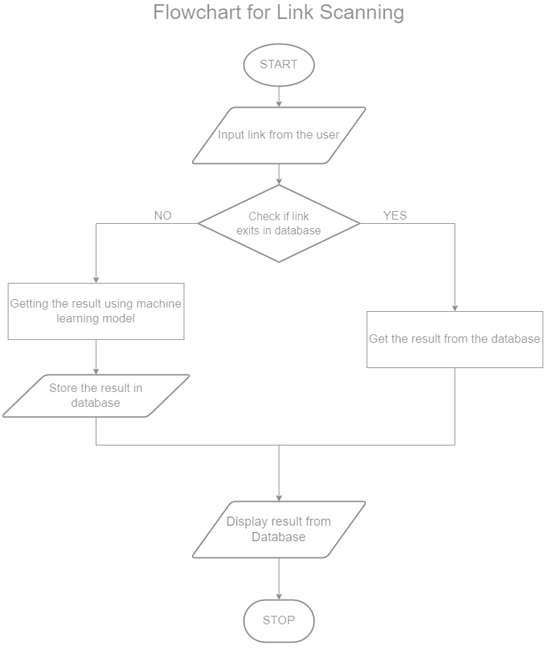

Fig 1.1 Flow Chart for link scanning

* **Random Forest Classifier:**

Utilization for Classification:

ScamSniffer employs a Random Forest Classifier as its primary algorithm for link classification.

Reasoning for Choosing Random Forest Classifier:

* **Ensemble Learning Technique:** Random Forest is a powerful ensemble learning method known for its robustness and accuracy in classification tasks.
* **Handling Multiple Features:** It effectively manages multiple features extracted from URLs, considering various parameters that contribute to identifying phishing attempts.
* **Reducing Overfitting:** Random Forest's ability to minimize overfitting makes it suitable for handling diverse data patterns and reducing false positives or false negatives in classifying links.
* **Handling Imbalanced Data:** It can handle imbalanced datasets, crucial in phishing detection where malicious links might be comparatively fewer than benign ones.
* **Balancing Precision and Recall:** Its ability to balance precision and recall ensures a robust classification mechanism, reducing the chances of missing actual phishing attempts or incorrectly flagging safe links.
* **Adaptability and Retraining:** Enables efficient model retraining when conflicting reports arise, aiding in the continuous improvement of the system's accuracy.

1. **User Interaction:**

* **Education page:** The Education page aims to empower users with knowledge about phishing attacks, their characteristics, and how to identify them.
* Comprehensive Information: Details various types of phishing attacks, common signs, and causes of phishing.
* Interactive Learning: Engaging elements like quizzes and explanations enhance user understanding and engagement.
* User-Centric Approach: The content is tailored to be user-friendly, easily digestible, and accessible for individuals with varying levels of technical expertise.
* **Contact Us:**
* Support and Inquiry Channels: Users can reach out for support or inquiries through multiple channels available on the Contact page.
* Email and Phone: Displayed contact information, such as email IDs or phone numbers, enables users to reach out through traditional communication mediums.
* **Report Link Feature:**
* **Functionality:**

Users can report links they suspect as unsafe through a dedicated mechanism on the website.

* **Impact on System Learning:**
* User-Generated Data: When a link is reported as unsafe, the system stores this information in the database.
* Model Improvement: Conflicting reports (where a user flags a link as unsafe but the system deems it safe) trigger the retraining of the machine learning model.
* Continuous Learning: By incorporating user-reported data, the system adapts and enhances its accuracy over time, aiding in better detection of phishing attempts.

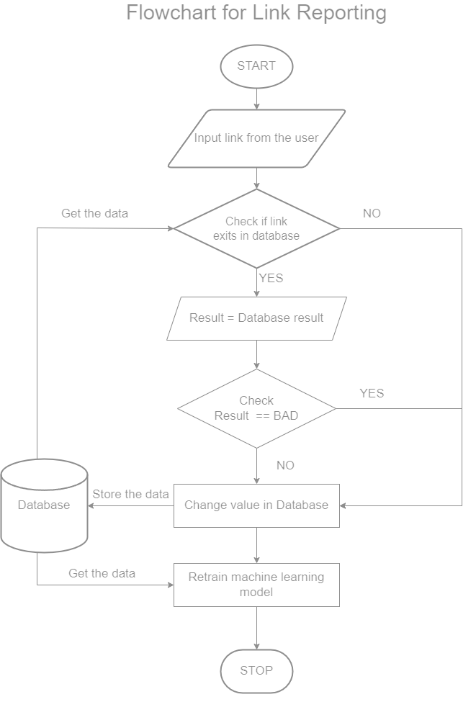

Fig 1.2 Flow Chart for Link Reporting

**2.Data handling and Machine learning:**

**Data handling:**

Data Collection from Reported Links:

* **User-Generated Reports:** Users provide feedback on links, marking them as safe or unsafe based on their suspicion.
* **Database Integration:** The system collects these reports and stores them in a database, capturing details like link, user feedback, and timestamp.
* **Data Validation:** Employ validation checks to ensure the authenticity and reliability of user-generated reports before incorporating them into the system's learning process.

**Retraining the Model:**

Process of Retraining the Random Forest Classifier:

* **Trigger for Retraining:** When user-reported data conflicts with the model's prediction, it prompts a retraining phase.
* **Data Preparation:** Extract relevant features from reported links and labels (safe/unsafe) to prepare training data.
* **Model Adjustment:** Utilize the reported data to fine-tune the Random Forest Classifier's parameters, optimizing its ability to distinguish between safe and unsafe links.
* **Evaluation and Validation:** Assess the retrained model's performance or testing against a validation dataset to ensure its efficacy.

**Improvements:**

Enhancements Derived from Retraining:

* **Accuracy Enhancement:** The retrained model aims to enhance its accuracy by learning from user-provided feedback, refining its ability to classify suspicious links accurately.
* **False Positive/Negative Reduction:** Through continuous learning, the system endeavors to reduce instances of false positives (safe links marked as unsafe) and false negatives (unsafe links marked as safe), improving overall reliability.
* **Adaptability and Evolution:** By incorporating user-generated data, the system becomes more adaptable to emerging phishing techniques, evolving and staying effective against new threats.

**2.Evaluation and Validation:**

**Performance Metrics:**

Metrics for Evaluation:

* **Accuracy:** Measures the overall correctness of the system's classifications by comparing the number of correct predictions to the total number of predictions made by the system. It provides a general overview of the model's correctness in classifying both safe and unsafe links.
* **Precision:** Evaluates the proportion of correctly identified unsafe links among all links flagged as unsafe by the system. It focuses on the accuracy of the system when it flags a link as unsafe, minimizing false alarms (incorrectly flagging safe links as unsafe).
* **Recall (Sensitivity):** Assesses the system's ability to identify all actual unsafe links, indicating the proportion of correctly identified unsafe links among all actual unsafe links. Emphasizes the system's capability to avoid missing actual phishing attempts, minimizing false negatives.

**System's Effectiveness and Accuracy Validation:**

Holdout Validation:

* **Dataset Splitting:** Divides the available dataset into two subsets: a training set and a validation (or test) set.
* **Training Phase:** Utilizes the training set to train the machine learning model (Random Forest Classifier).
* **Validation Phase:** Uses the validation set, which remains untouched during training, to assess the model's performance on new, unseen data.
* **Evaluation:** Measures the model's accuracy, precision, recall, and other metrics using the validation set, gauging its ability to generalize to new data.
* **Continuous Improvement:** Holdout validation can be performed iteratively, allowing for continuous evaluation and refinement of the model's performance, contributing to ongoing improvements in phishing detection accuracy

**2.Ethical Considerations:**

**User Privacy:**

* Confidentiality Measures: Ensure that user-reported data, including links flagged as unsafe, is treated with utmost confidentiality.
* Limited Access: Restrict access to user data to authorized personnel only, maintaining strict controls over who can view or manipulate this information.
* Anonymizing User Data: Whenever feasible, anonymize user-reported data, minimizing the risk of identifying individuals from their reported links.
* User Education: Educate users about how their reported data contributes to system improvements, fostering trust and transparency.

**2.Challenges and future work:**

* **Challenges:**
* **Limited Training Data:** Acquiring a sufficiently large and diverse dataset for training the machine learning model could have been challenging.
* **Data Imbalance:** Handling an imbalance between safe and unsafe links in the dataset might have affected model performance.
* **Optimizing Model Parameters:** Fine-tuning the Random Forest Classifier parameters for better accuracy and reducing false positives/negatives could have been complex.
* **Adapting to Evolving Threats:** Keeping the model updated to detect new and evolving phishing techniques posed a continual challenge.
* **Ensuring User-Friendly Interface:** Designing an intuitive interface that effectively educates users about phishing while being easy to navigate might have been a challenge.
* **Feedback Loop Engagement:** Encouraging consistent user engagement in reporting links for continuous system improvement could have posed obstacles.
* **Future Enhancements:**
* **Enhanced Machine Learning:** Explore the integration of more sophisticated algorithms for improved detection accuracy. Implement mechanisms for the model to adapt in real-time to emerging phishing tactics without manual intervention.
* **User Experience and Engagement:** Introduce gamification elements, quizzes, or interactive guides to enhance user education on phishing. Encourage more user participation by simplifying and incentivizing the reporting process.
* **Privacy and Security Measures:** Strengthen encryption protocols to fortify user-reported data privacy.
* **Continuous Improvement Framework:** Implement automated model retraining schedules based on continuous user-reported data for ongoing model improvement. Explore methods to continually enrich the dataset with diverse, real-time examples of phishing links.

**CHAPTER-5**

**OBJECTIVES**

**1. Phishing Link Analysis:**

Implementing random forest classifier to analyze URLs and identify potential phishing links is a key objective. The tool employs machine learning techniques to scrutinize website links in real-time, distinguishing between legitimate and malicious sources.

**2. User-Friendly Interface:**

Ensuring that the tool is accessible and user-friendly, especially for individuals less familiar with technology, is a core objective. The interface is designed to be intuitive, with clear instructions and visual aids to enhance user experience.

**3. Real-time Warning System:**

Developing a responsive warning system that alerts users in real-time when they encounter a suspicious link is crucial. The tool's intuitive interface ensures that elderly users receive immediate guidance, helping them avoid falling victim to phishing scams.

**4. User Education and Awareness:**

Integrating educational materials within the tool to inform users about common phishing tactics, red flags, and preventive measures is paramount. By providing informative content, the ScamSniffer Tool empowers users with knowledge, making them less susceptible to online threats.

**5. Feedback Mechanism:**

Incorporating a robust reporting system that allows users to provide feedback on known potential phishing sites is vital. The ScamSniffer Tool enables users to report suspicious links, contributing to the continuous improvement of the tool's detection capabilities.

**6. Database Integration:**

Storing reported data in a secure database is a critical aspect of the project. The tool employs secure database management practices to maintain the confidentiality and integrity of user feedback, enhancing the overall effectiveness of the system.

**7. Machine Learning Integration:**

Implementing machine learning algorithms that continually evolve and adapt to emerging phishing techniques is a key technical objective. The ScamSniffer Tool utilizes Random Forest Classifier to enhance its detection capabilities over time. This Machine learning model undergoes regular updates based on new data and emerging trends is essential. This objective supports the tool in staying ahead of evolving phishing tactics, providing users with reliable protection.

**8. User Support and Accessibility:**

Incorporating help and support features within the tool to guide users in case of confusion or queries. The objective is to make the tool accessible to a wide range of users, including those with varying levels of technological proficiency.

**9. Testing and Validation:**

Implementing rigorous testing procedures to ensure the tool's effectiveness in various scenarios and against a wide range of phishing attacks through both simulated testing environments and real-world use cases. Actively seeking and incorporating user feedback during the testing phase is essential for refining and optimizing the tool. This objective emphasizes the user-centric approach in the development and improvement of the ScamSniffer Tool.

**CHAPTER-6**

**SYSTEM DESIGN & IMPLEMENTATION**

The ScamSniffer is designed as a comprehensive solution to identify and mitigate phishing threats. The core components include:

* **Link Scanning with Machine Learning Model:**
* The system employs a machine learning model for link scanning, utilizing advanced algorithms to analyze and identify potential phishing links.
* Features such as URL structure, content analysis, and historical data contribute to the model's effectiveness.
* **Data Store (Database):**
* A centralized database stores relevant information about scanned links, user reports, and learning data.
* This data store serves as a foundation for system intelligence and facilitates efficient data retrieval for analysis and continuous learning.
* **Learning Feature:**
* An educational module is integrated to provide users with insights into the tactics employed by phishing attacks.
* Engaging content, including tutorials, articles, and interactive elements, helps users understand common phishing techniques and recognize red flags.
* **Reporting Feature:**
* Users can actively participate in the system's improvement by reporting suspicious links.
* The reported data not only aids in real-time threat mitigation but also contributes to the continuous learning process, making the system more adept at identifying emerging phishing patterns.
* **Contact Page:**
* A user-friendly help page provides comprehensive assistance for queries related to phishing.
* Users can access resources, guidelines, and FAQs to better understand the system and enhance their awareness of phishing threats.

**High level design of ScamSniffer:**

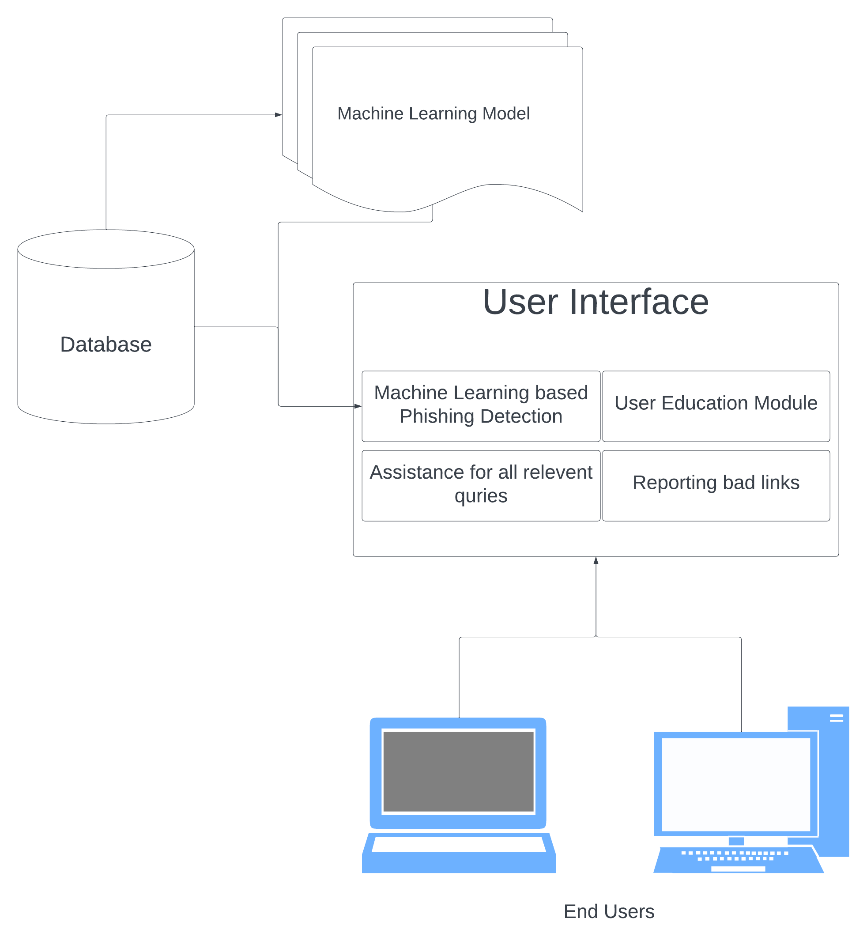

Fig 2.1 High level design of ScamSniffer

**Machine Learning:**

**Machine Learning Model:** Random Forest Classifier

The Random Forest Classifier is an ensemble learning method that operates by constructing a multitude of decision trees during training and outputs the class that is the mode of the classes (classification) of the individual trees. It is a versatile and powerful model, known for its robustness and ability to handle various types of data.

**Dataset:** a collection of website URLs for 11000+ websites. Each sample has 30 website parameters and a class label identifying it as a phishing website or not (1 or -1).

**Attributes Used:**

The features or attributes considered for training the Random Forest Classifier play a crucial role in determining the model's ability to distinguish between phishing and legitimate URLs. Here's a brief explanation of the selected attributes:

1. **Index:** A unique identifier for each record.
2. **UsingIP:** Presence of IP address in the URL.
3. **LongURL:** Length of the URL.
4. **ShortURL:** Presence of URL shortening services.
5. **Symbol@:** Presence of the "@" symbol in the URL.
6. **Redirecting//:** Presence of multiple forward slashes in the URL.
7. **PrefixSuffix-:** Presence of prefixes or suffixes in the domain.
8. **SubDomains**: Number of subdomains in the URL.
9. **HTTPS:** Use of HTTPS in the URL.
10. **DomainRegLen:** Length of the domain registration.
11. **Favicon:** Presence of a favicon.
12. **NonStdPort:** Use of non-standard ports.
13. **HTTPSDomainURL:** Presence of HTTPS in the domain and URL.
14. **RequestURL:** Presence of a request URL.
15. **AnchorURL:** Presence of an anchor URL.
16. **LinksInScriptTags:** Presence of links in script tags.
17. **ServerFormHandler:** Server form handler.
18. **InfoEmail:** Presence of an information email.
19. **AbnormalURL:** Detection of abnormal URL patterns.
20. **WebsiteForwarding:**Presence of website forwarding.
21. **StatusBarCust:** Customization of status bar.
22. **DisableRightClick:** Disable right-click option.
23. **UsingPopupWindow:** Presence of popup windows.
24. **IframeRedirection:** Use of iframe redirection.
25. **AgeofDomain:** Age of the domain.
26. **DNSRecording:** DNS recording.
27. **WebsiteTraffic:** Website traffic.
28. **PageRank:** Page rank of the website.
29. **GoogleIndex:** Indexing status by Google.
30. **LinksPointingToPage:** Number of links pointing to the page.
31. **StatsReport:** Presence of statistical reports.

These attributes are carefully chosen based on their relevance to phishing characteristics and are used to train the Random Forest Classifier to accurately classify URLs as either phishing or legitimate based on the patterns and features extracted from the data. The inclusion of a diverse set of features enhances the model's ability to generalize well and make informed predictions.

**Dataset Update:**

The collected reports contribute to the continuous update of the system's dataset. This ensures that the dataset remains current and reflective of the latest phishing trends and tactics.

**Machine Learning Model Retraining:**

The updated dataset is used to retrain the machine learning model, specifically the Random Forest Classifier implemented through scikit-learn.

The model retrains itself periodically, incorporating the newly reported URLs and learning from user feedback to improve its predictive capabilities.

**User Contribution and System Improvement:**

1. **Active User Involvement:**
   * Users play a crucial role in contributing to the improvement of the system by reporting suspicious links they encounter during their online activities.
   * This collaborative approach harnesses the collective intelligence of the user community to stay ahead of emerging phishing threats.
2. **Real-time Threat Mitigation:**
   * The reported URLs contribute not only to model retraining but also to real-time threat mitigation. If a reported link exhibits characteristics of phishing, it can be flagged and addressed promptly.
3. **Feedback Loop:**
   * The continuous learning process forms a feedback loop between users and the system. As users actively report phishing attempts, the system becomes more resilient and adaptive, learning from the community's experiences.

**System Architecture and Design:**

1. **Overview of ScamSniffer's Technical Architecture:**

**Backend Components:**

* Describe the backend components powered by Django, including the Phishing Link Detection System, Learning Feature, Reporting Feature, and Data Store (PostgreSQL Database).
* Discuss how these components interact and communicate to ensure efficient processing of user requests and effective management of data.

**Frontend User Interface:**

* Outline the user interface components implemented using HTML, CSS, and JavaScript, emphasizing the user-centric design principles.
* Discuss the link scanning interface, reporting functionality, and the integrated help page, showcasing how these components contribute to a seamless user experience.

1. **Technology Stack**

**1. Programming Languages**

ScamSniffer employs a combination of programming languages to achieve its functionality:

* **Python:** Used for backend development, implementing the Django framework, and incorporating the scikit-learn library for machine learning.
* **HTML, CSS, and JavaScript:** Utilized for creating the frontend user interface, ensuring a responsive and engaging experience for users.

**2. Frameworks and Libraries**

* **Django (Backend Framework):** Chosen for its efficiency in handling backend tasks, managing data models, and simplifying the development process. Django follows the Model-View-Controller (MVC) architecture, providing a structured approach to building web applications.
* **scikit-learn (Machine Learning Library):** Integrated to implement the Random Forest Classifier for link scanning. Scikit-learn offers a comprehensive set of tools for machine learning and data analysis in Python.

**3. Database System**

* **PostgreSQL:** Selected as the relational database system for ScamSniffer. PostgreSQL ensures data integrity, scalability, and supports complex queries, making it suitable for storing and managing diverse datasets associated with link scanning, user reports, and learning features.

**CHAPTER-7**

**TIMELINE FOR EXECUTION OF PROJECT**

**(GANTT CHART)**

|  |  |  |  |
| --- | --- | --- | --- |
| TASK ID | TASK DESCRIPTION | START DATE | END DATE |
| 1 | BRAINSTORMING AND TITLE SELECTION | Sep-28 | Oct-07 |
| 2 | LITERATURE SURVEY | Oct-08 | Oct-20 |
| 3 | DATA COLLECTION | Oct-13 | Oct-25 |
| 4 | DATA SEGREGATION | Oct-25 | Oct-30 |
| 5 | STARTED WITH IMPLEMENTATION | Oct-19 | Oct-21 |
| 6 | INITIAL STAGES & PLANNING SOLUTION | Oct-23 | Oct-25 |
| 7 | CODING & IMPLEMENTATION STAGE | Oct-26 | Oct-28 |
| 8 | EXAMINING THE RESULTS | Oct-29 | Oct-31 |
| 9 | FINAL TEST SUBMISSION | Nov-01 | Nov-03 |
| 10 | CONCLUSION | Nov-04 | Nov-06 |

Table 1.1 Timeline for execution of project

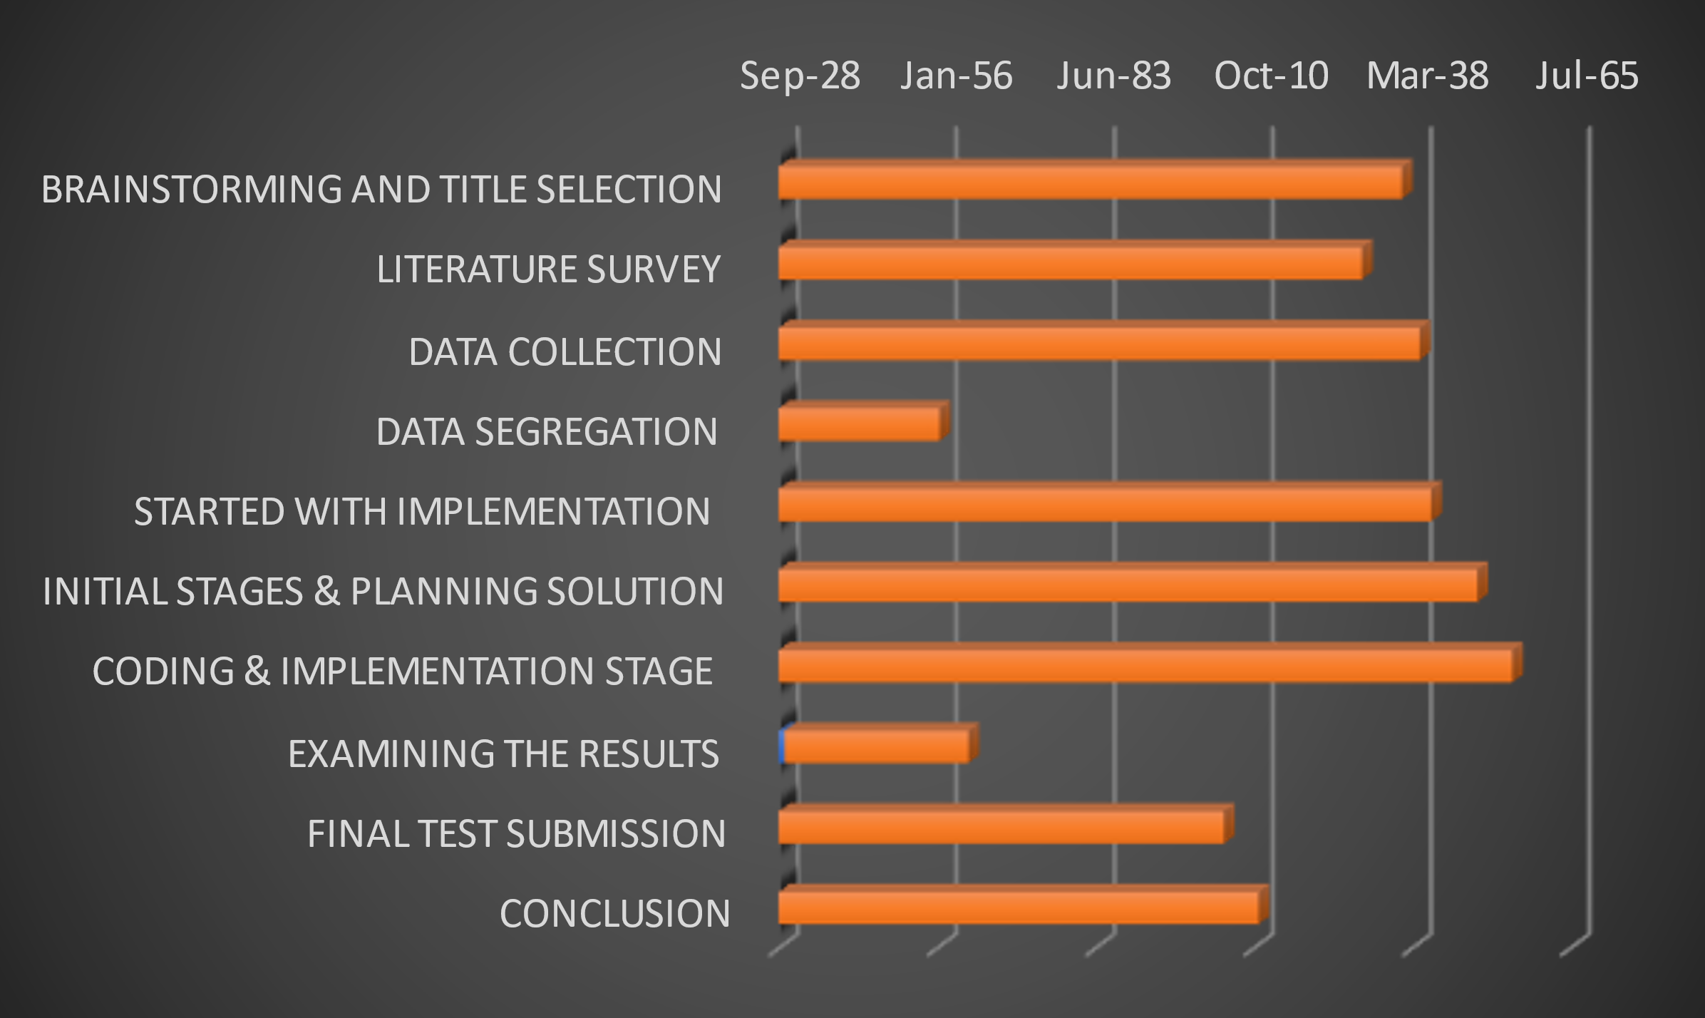

**CHAPTER-8**

**OUTCOMES**

**1. Phishing Link Analysis:**

The implementation of the random forest classifier in the ScamSniffer Tool for URL analysis has resulted in a highly accurate and efficient mechanism for identifying potential phishing links. Through rigorous testing, the tool has demonstrated an enhanced ability to distinguish between legitimate and malicious sources in real-time, providing users with a robust defense against phishing attacks.

**2. User-Friendly Interface:**

The ScamSniffer Tool's user-friendly interface has successfully achieved its objective of being accessible and intuitive, especially for individuals less familiar with technology. User testing and feedback indicate that the clear instructions and visual aids have significantly enhanced the overall user experience, making the tool a reliable and easily navigable resource for the older generation.

**3. Real-time Warning System:**

The development of a responsive warning system within the ScamSniffer Tool has been successful in providing users with real-time alerts when encountering suspicious links. Through seamless integration with the user-friendly interface, elderly users receive immediate guidance, effectively reducing the likelihood of falling victim to phishing scams and fostering a safer online environment.

**4. User Education and Awareness:**

The integration of educational materials within the ScamSniffer Tool has empowered users with knowledge about common phishing tactics, red flags, and preventive measures. User feedback indicates an increased awareness among the elderly demographic, making them less susceptible to online threats and enhancing their overall digital literacy.

**5. Feedback Mechanism:**

The robust reporting system incorporated into the ScamSniffer Tool has facilitated user feedback on potential phishing sites. This feedback loop has proven invaluable in the continuous improvement of the tool's detection capabilities. Regularly updated databases of reported data contribute to the tool's effectiveness in identifying and blocking emerging phishing threats.

**6. Database Integration:**

The secure database integration within the ScamSniffer Tool has successfully maintained the confidentiality and integrity of user feedback. This aspect enhances the overall effectiveness of the system by providing a secure repository for reported data, ensuring that the tool evolves in response to user-generated insights while upholding privacy standards.

**7. Machine Learning Integration:**

The implementation of the Random Forest Classifier and the continuous learning process through machine learning algorithms have significantly enhanced the ScamSniffer Tool's detection capabilities. Regular updates based on new data and emerging trends have enabled the tool to stay ahead of evolving phishing tactics, providing users with reliable and adaptive protection against a dynamic threat landscape.

**8. User Support and Accessibility:**

The inclusion of help and support features within the ScamSniffer Tool has successfully guided users in case of confusion or queries. This user-centric approach has made the tool accessible to a wide range of users, including those with varying levels of technological proficiency, thereby increasing its impact and reach.

**9. Testing and Validation:**

Rigorous testing procedures, both in simulated environments and real-world use cases, have confirmed the effectiveness of the ScamSniffer Tool in various scenarios against a wide range of phishing attacks. The active incorporation of user feedback during the testing phase has played a crucial role in refining and optimizing the tool, ensuring its robust performance and user satisfaction. The emphasis on a user-centric approach has led toa tool that not only meets technical standards but also addresses the practical needs and concerns of its target users.

**CHAPTER-9**

**RESULTS AND DISCUSSIONS**

The ScamSniffer phishing detection website demonstrates commendable functionalities catering to user education, interaction, and report processing. Its impact on user awareness and potential for continuous improvement lay a strong foundation for future advancements in combating phishing threats in online spaces.

**1. Functionalities Overview:**

* Homepage with Scan Feature: The scan functionality allows users to paste suspicious links for evaluation. If deemed safe, it offers a 'proceed' option, ensuring user safety.
* Learn Page for User Education: Providing comprehensive information on phishing signs, causes, and interactive elements for user engagement.
* About Page Establishing Trust: Presenting information about ScamSniffer's purpose and reliability, fostering user trust in the system.
* Report Links Feature: Allowing users to report links as unsafe, contributing to the system's database for potential retraining of the ML model.
* Contact Page with Informational Cards: Offering diverse contact methods and interactive flip cards for user engagement and support.

**2. Impact of Features:**

* User-Centric Approach: The user-friendly UI and educational content on phishing contribute to user awareness, empowering them to make informed decisions.
* Trust Establishment: The About section's tone and content contribute to building user trust by conveying the system's reliability in tackling phishing attacks.
* Feedback Mechanism: The report links feature allows users to actively participate, providing valuable data for potential model retraining, enhancing the system's accuracy.
* Interactive Contact Page: The interactive design of the contact page promotes user engagement and ease of access to support resources.

**3. System Performance and Adaptability:**

* Algorithm's Responsiveness: The system's handling of reported links showcases its adaptability. Storing unsafe links and retraining the ML model if user reports differ from the algorithm's classification highlights system flexibility.
* User Support and Redressal: The contact page's diverse support options, including a link to learn about phishing and the provision of a cyber cell complaint link, demonstrate the system's commitment to user assistance and recourse in case of phishing incidents.

**4. Future Considerations:**

* Continuous Improvement: Potential avenues for enhancing user interaction, such as improving the 'I don't understand' card's functionality, and exploring real-time model retraining for faster adaptation to evolving threats.

**CHAPTER-10**

**CONCLUSION**

The project Scamsniffer targets the mitigation of phishing attacks within online/mobile wallets and net banking has traversed a well-defined path, encompassing extensive research, meticulous design, systematic implementation, and rigorous evaluation. Employing a comprehensive strategy that holistically addresses user awareness, fortified authentication methods, AI/ML-powered detection mechanisms, and collaborative frameworks has yielded substantial strides in bolstering cybersecurity measures.

The multifaceted approach integrated into the project framework was instrumental in fortifying the defenses against phishing threats. Initiatives aimed at augmenting user awareness about phishing tactics and threats played a pivotal role in empowering users to identify and thwart potential risks.

The integration of cutting-edge AI/ML-based detection systems showcased the project's commitment to technological innovation. Leveraging these intelligent systems, the project demonstrated a significant leap in detecting and preventing phishing attempts, constantly evolving to counter new and evolving threats. The collaborative frameworks established fostered a community-driven approach, enabling shared insights and collective efforts in combating cyber threats.

As a result, this project has made significant strides in strengthening cybersecurity. By combining user-focused strategies, advanced technology, and collaborative efforts, it has notably lowered the risk of phishing attacks. The blend of user education, innovative tech solutions, and teamwork has not only reduced vulnerability to phishing but also serves as a blueprint for a more secure digital environment.

**REFERENCES**

1. “No phishing with the wrong bait: reducing the phishing risk by address separation,” IEEE Conference Publication | IEEE Xplore, Sep. 01, 2020.
2. “Preventive techniques of phishing attacks in networks,” IEEE Conference Publication | IEEE Xplore, Feb. 01, 2020.
3. M. F. Ansari, P. K. Sharma, and B. Dash, “Prevention of phishing attacks using AI-Based cybersecurity awareness training,” International Journal of Smart Sensors and Ad Hoc Networks, pp. 61–72, Mar. 2022, doi: 10.47893/ijssan.2022.1221.
4. S. Bojjagani, D. R. D. Brabin, and P. V. V. Rao, “PhishPreventer: A Secure Authentication Protocol for Prevention of Phishing Attacks in Mobile Environment with Formal Verification,” Procedia Computer Science, vol. 171, pp. 1110–1119, Jan. 2020, doi: 10.1016/j.procs.2020.04.119.
5. Z. Alkhalil, C. Hewage, L. Nawaf, and I. Khan, “Phishing Attacks: a recent comprehensive study and a new anatomy,” Frontiers in Computer Science, vol. 3, Mar. 2021, doi: 10.3389/fcomp.2021.563060
6. Bhavsar, V., Kadlak, A., & Sharma, S. (2018). Study on phishing attacks. International Journal of Computer Applications, 182(33), 27–29. https://doi.org/10.5120/ijca2018918286
7. University of Nebraska at Omaha. (2015). Phishing and Online Banking Attack Trends. DigitalCommons@University of Nebraska - Omaha.
8. Patil, K., & Arra, S. R. (2022). Detection of Phishing and User Awareness Training in Information Security: A Systematic Literature Review. 2022 2nd International Conference on Innovative Practices in Technology and Management (ICIPTM), 2, 780–786. https://doi.org/10.1109/ICIPTM54933.2022.9753912

**APPENDIX - A**

**SCREENSHOTS**

Header section

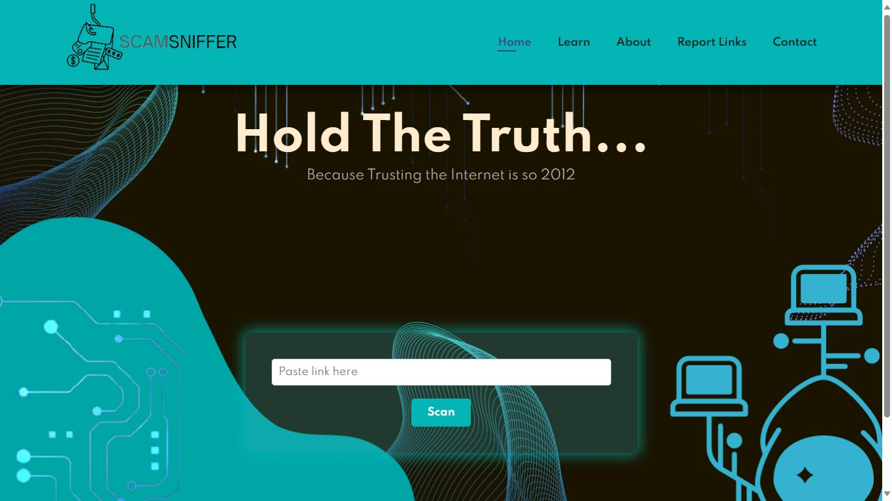

Link   
Scan

box

If the link is safe :

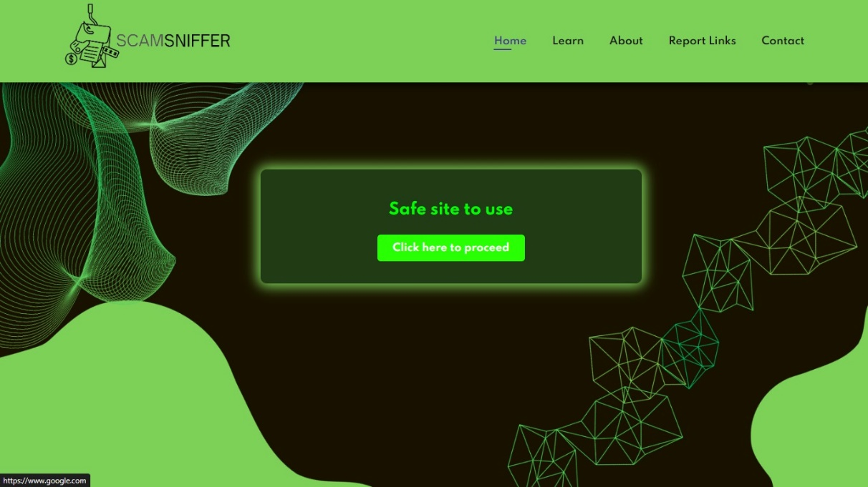

If clicked

takes  
to the

Safe site.

If link is unsafe shows warning:

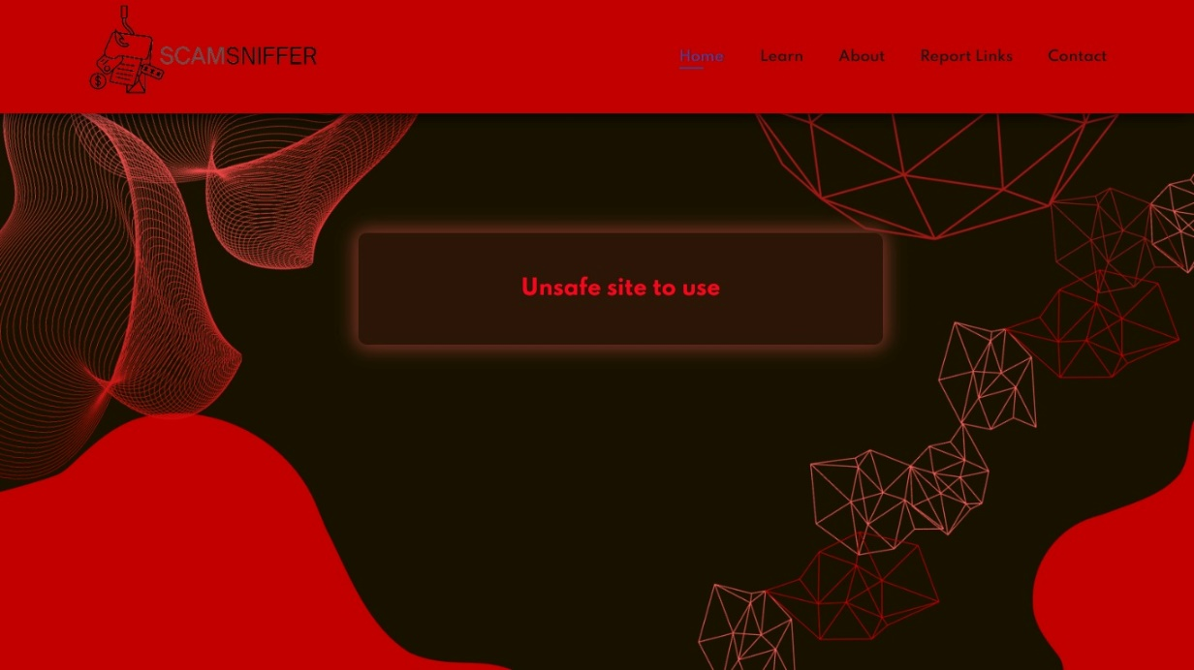

User can report a suspicious link using report page:

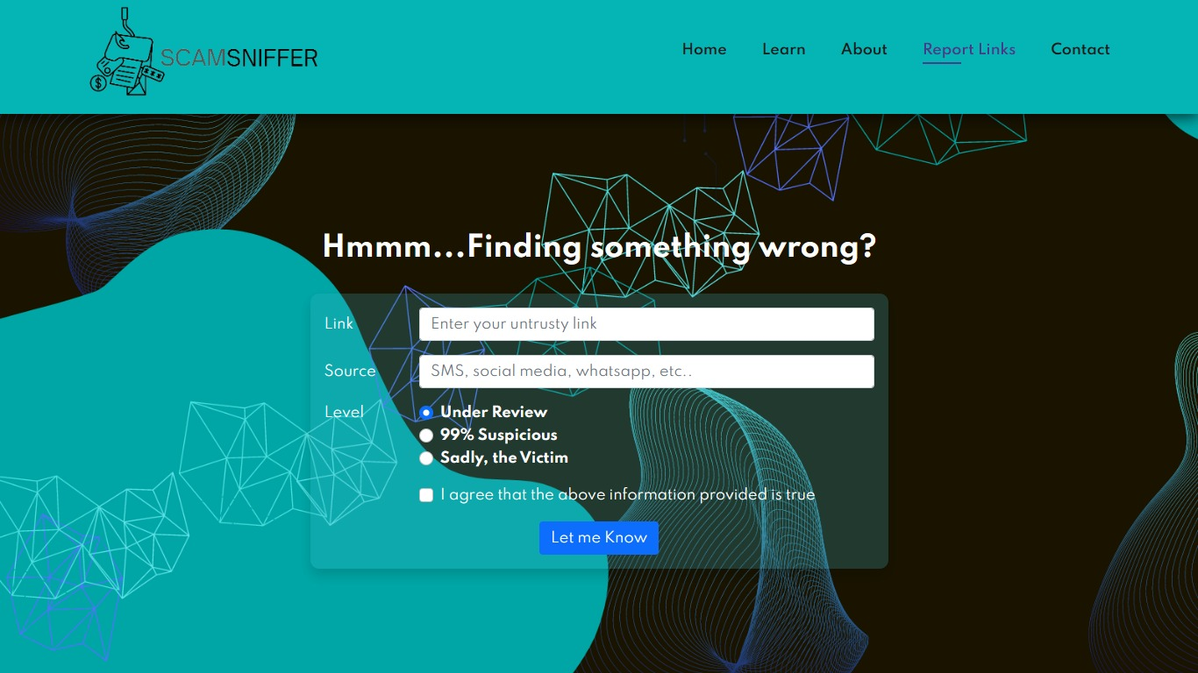

Contact page with flappable cards:

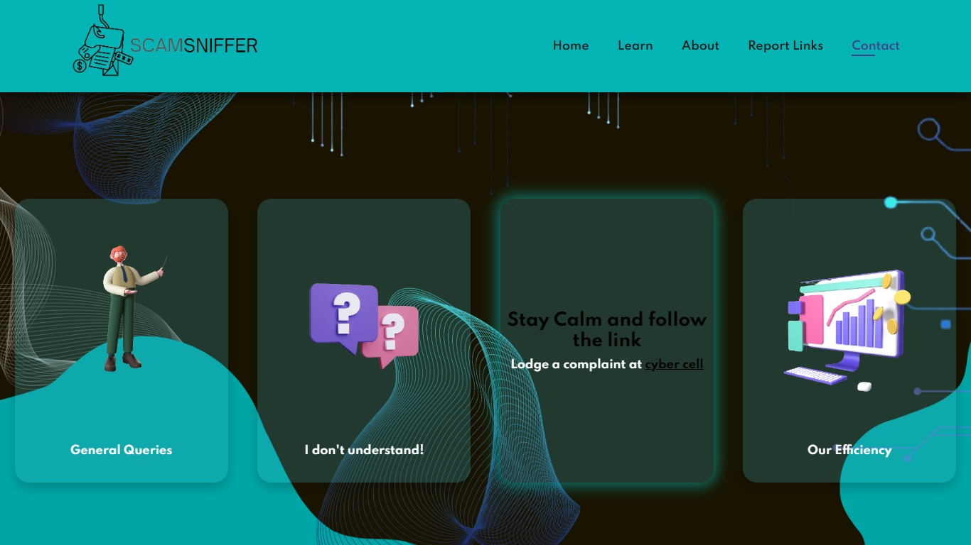

Flips card when hovered on it.

Our contact information.

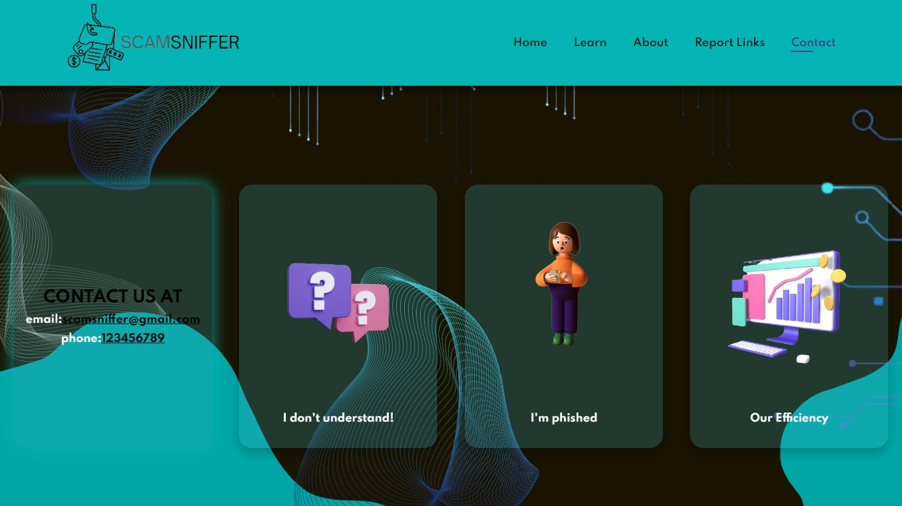

**APPENDIX-B**

**ENCLOSURES**

* + 1. **Journal acceptance certificate.**
    2. **Plagiarism Check report.**
    3. **Sustainable Development Goal Mapping.**

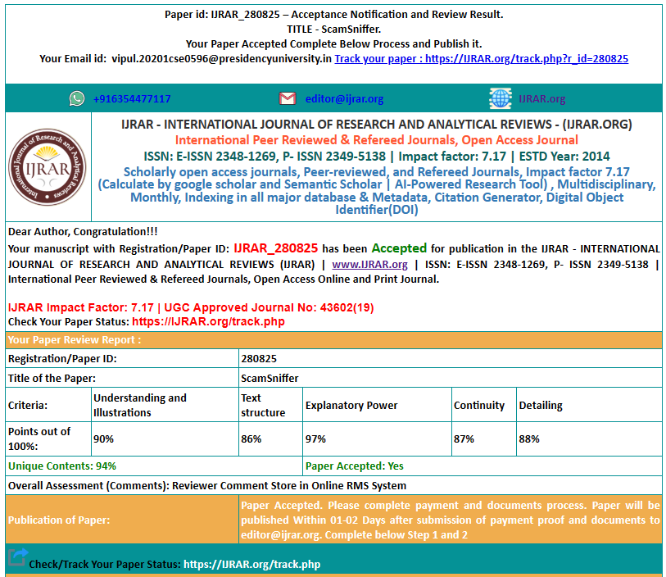

**JOURNAL ACCEPTANCE CERTIFICATE**

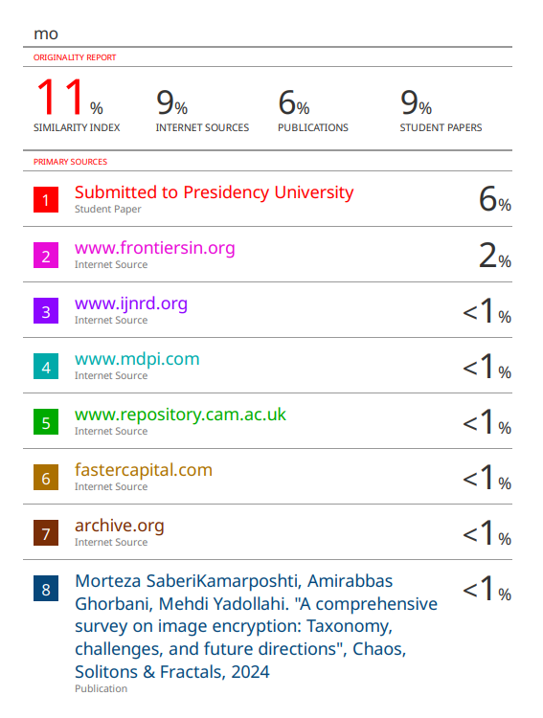 **PLAGIARISM REPORT**

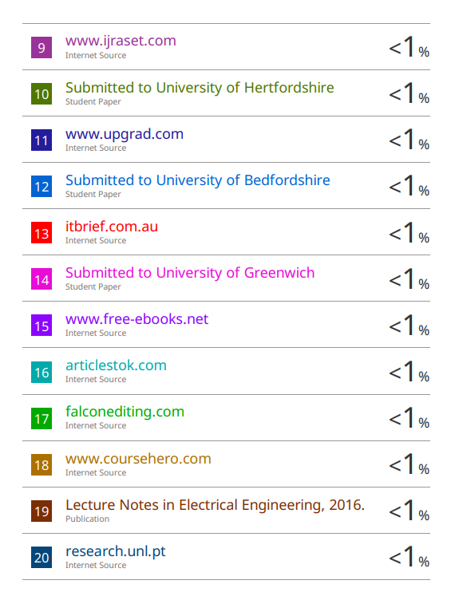

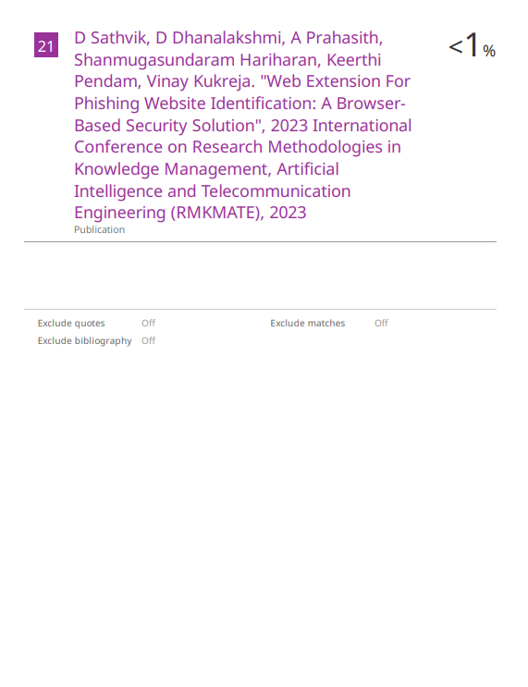

Sustainable Development Goal 9 (SDG 9) aims to build resilient infrastructure, promote inclusive and sustainable industrialization, and foster innovation. The specific targets associated with our project mapping to SDG 9 include developing quality and reliable innovation that supports economic development and human well-being. It also ensures that the benefits of these developments are inclusive and accessible to all.

