- Top 5 highest salary employees

SELECT Emp_id, emp_name, salary
FROM employee
ORDER BY salary DESC
LIMIT 5;

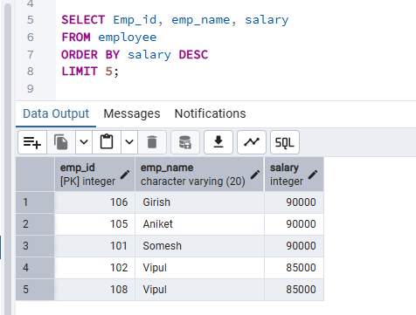

- Department wise employee count

SELECT d.dept_name,
COUNT(e.emp_id) AS EmployeeCount
FROM department d
JOIN employee e
ON d.dept_id = e.dept_id
GROUP BY d.dept_name;

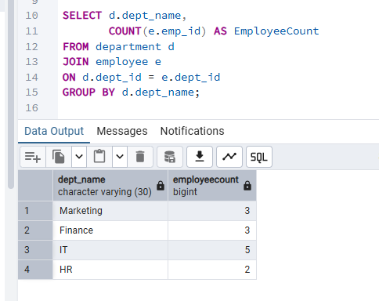

- Find Second highest salary

SELECT DISTINCT salary
FROM employee
ORDER BY salary DESC
OFFSET 1 LIMIT 1;

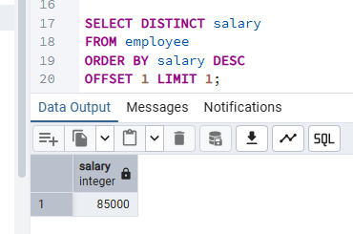

- Employees whose salary > department average salary

SELECT e.*
FROM employee e
WHERE e.salary >
(
SELECT AVG(e2.salary)
FROM employee e2
WHERE e2.dept_id = e.dept_id
);

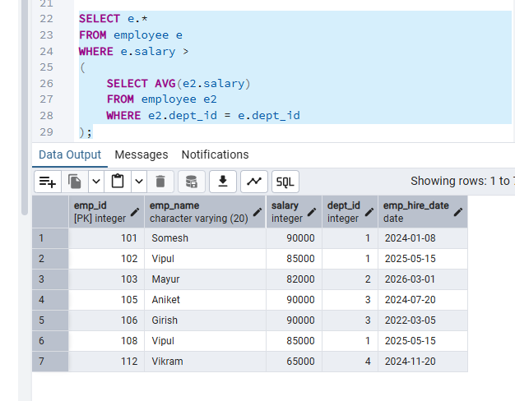

- Inner Join

SELECT e.empt_id, e.empt_name,d.dept_name
FROM employee e
INNER JOIN department d
ON e.dept_id = d.dept_id;

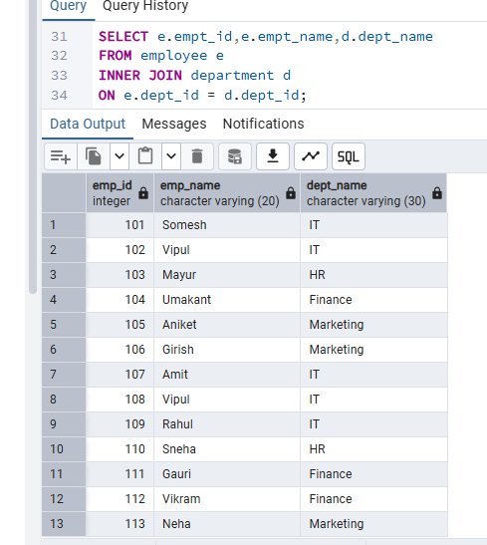

- Left Join
SELECT e.Emp_id, e.Emp_name, d.dept_name
FROM employee e
LEFT JOIN department d
ON e.dept_id = d.dept_id;

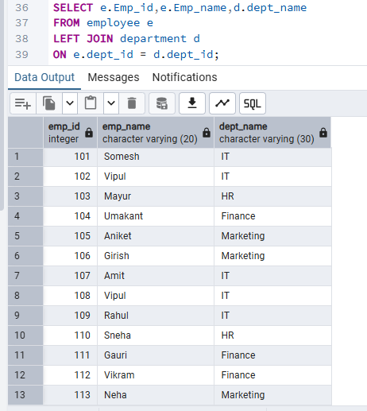

- Group By with Having

SELECT dept_id,
COUNT(*) AS employeeCount
FROM employee
GROUP BY dept_id
HAVING COUNT(*) > 1;

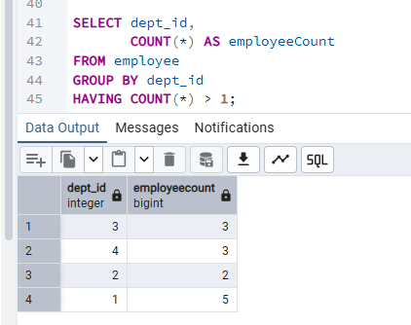

- Employees hired in last 6 months

SELECT * FROM employee
WHERE emp_hire_date >= CURRENT_DATE - INTERVAL '6 months';

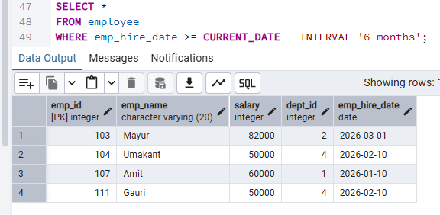

- Find the Duplicates records

SELECT emp_name, dept_id,
COUNT(*) FROM employee
GROUP BY emp_name, dept_id
HAVING COUNT(*) > 1;

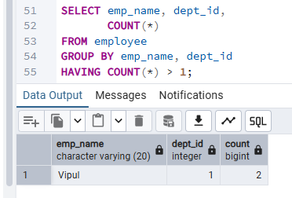

- How to remove the duplicates record
WITH duplicate_rows AS (
SELECT ctid,
ROW_NUMBER() OVER (
PARTITION BY emp_name, dept_id, salary
ORDER BY emp_id
) AS rn
FROM employee
)
DELETE FROM employee
WHERE ctid IN (
SELECT ctid
FROM duplicate_rows
WHERE rn > 1
);

- Submission: SQL file Output screenshots GitHub upload

