- Add some records in the existing table

INSERT INTO employee
(emp_id,emp_name,salary,dept_id,emp_hire_date)
VALUES
(114, 'Rahul', 50000, 1, '2026-01-10'),
(115, 'Priya', 45000, 2, '2026-02-15'),
(116, 'Ajit', 60000, 4, '2025-04-20'),
(117, 'Pallavi', 55000, 3, '2024-12-01'),
(118, 'Vikas', 70000, 1, '2025-05-12'),
(119, 'Atul', 55000, 3, '2024-10-11'),
(120, 'Vilas', 70000, 1, '2025-03-19');

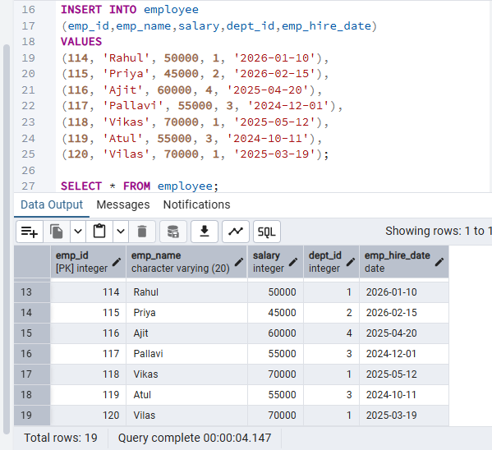

- Apply window function on the data

ROW_NUMBER()
Give to each employee unique rank.

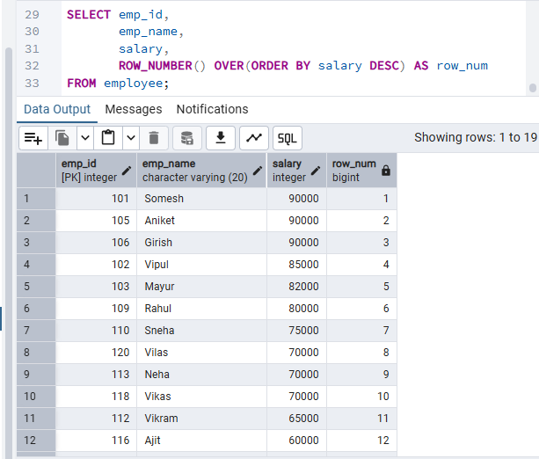

2. RANK()

Definition:
RANK() gives the same rank to duplicate values, but it skips the next rank.
Example:
SELECT emp_name, salary,
RANK() OVER(ORDER BY salary DESC) AS salary_rank
FROM employee;

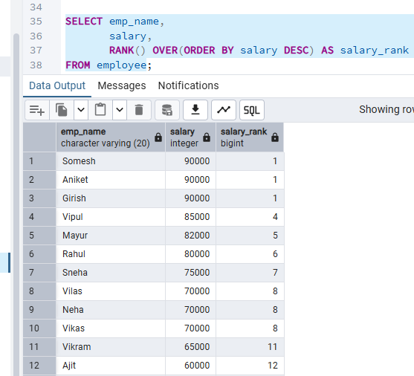

3. DENSE_RANK()

Definition:
DENSE_RANK() also gives the same rank for duplicate values, but it does not skip ranks.
Example:
SELECT emp_name, salary,
DENSE_RANK() OVER(ORDER BY salary DESC) AS dense_rank
FROM employee;

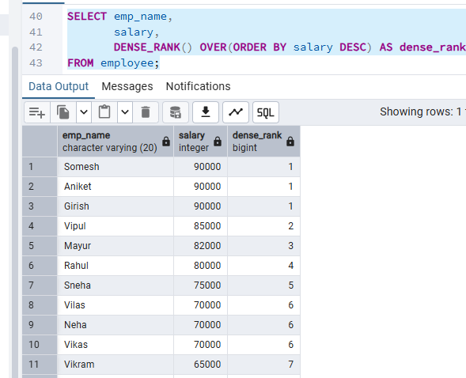

Function | Duplicate Salary | Skip Rank
ROW_NUMBER | Different rank | No
RANK | Same rank | Yes
DENSE_RANK | Same rank | No

3.LAG() :
SELECT emp_name, salary,
LAG(salary) OVER(ORDER BY salary DESC) AS previous_salary
FROM employee;

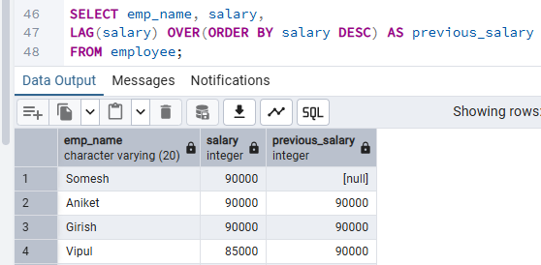

4. LEAD():

SELECT emp_name, salary,
LEAD(salary) OVER(ORDER BY salary DESC) AS next_salary
FROM employee;

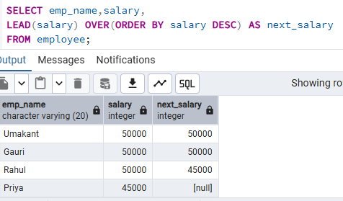

5. FIRST_VALUE() :
SELECT emp_name, salary,
FIRST_VALUE(salary)
OVER(ORDER BY salary ASC) AS lowest_salary
FROM employee;

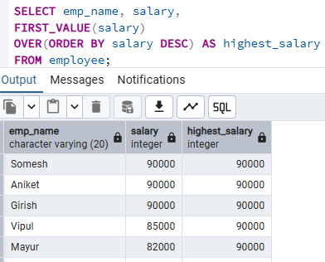

6. LAST VALUE ():

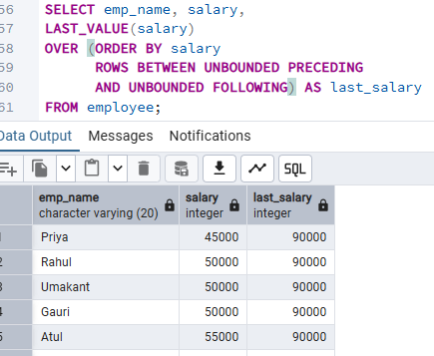
This means:
- UNBOUNDED PRECEDING → Start from the first row.
- UNBOUNDED FOLLOWING → End at the last row.

7. SUM() OVER() → Running Total
- It calculates cumulative sum without grouping rows.
SELECT emp_name, salary,
SUM(salary) OVER(ORDER BY salary) AS running_total
FROM employee;

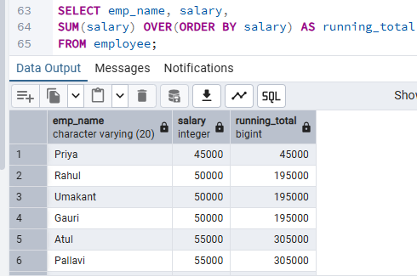

8. AVG() OVER() :-

- average of all previous + current rows

SELECT emp_name,salary,
AVG(salary) OVER(ORDER BY salary) AS running_avg
FROM employee;
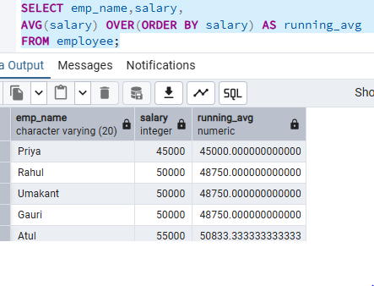

9. COUNT() OVER() :
- It returns total rows for every record.
SELECT emp_name,
COUNT(*) OVER() AS total_employees
FROM employee;

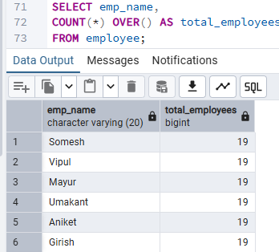

10. PARTITION BY
- It divides data into groups for window functions without collapsing rows.
- It splits data into groups (like GROUP BY)
BUT:
1.It does NOT merge rows
2.Each row is still visible

SELECT emp_name, dept_id, salary,
RANK() OVER(PARTITION BY dept_id ORDER BY salary DESC)
AS dept_rank
FROM employee;

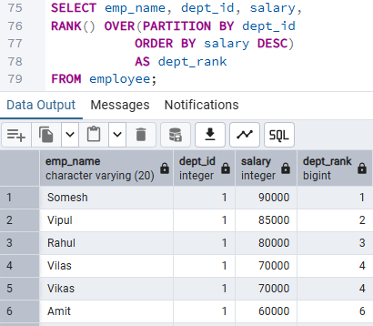

Apply View on the data

What is View?
A View is a virtual table created from a SQL query.
It helps:
- Hide sensitive data
- Reuse complex queries
- Improve security
CREATE VIEW high_salary_employee1 AS
SELECT emp_id, emp_name,salary
FROM employee
WHERE salary > 80000;

SELECT *
FROM high_salary_employee1

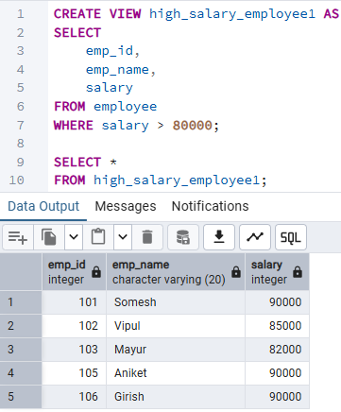

Create Department Salary View

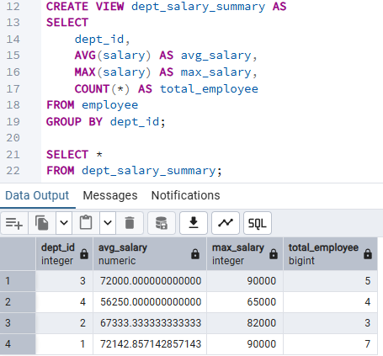
- Apply Triggers on the data

- A Trigger is a special SQL program that runs automatically when an event happens on a table.

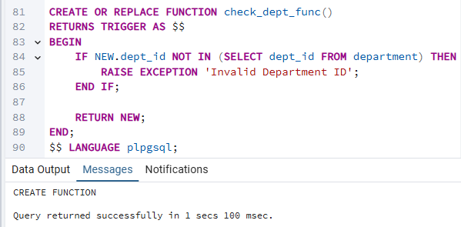

- Handle Case When in the data

SELECT emp_name, salary,
CASE
WHEN salary >= 80000 THEN 'High Salary'
WHEN salary >= 60000 THEN 'Medium Salary'
ELSE 'Low Salary'
END AS salary_category
FROM employee;

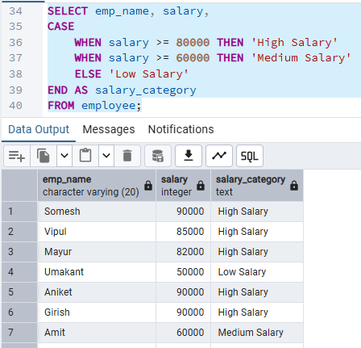

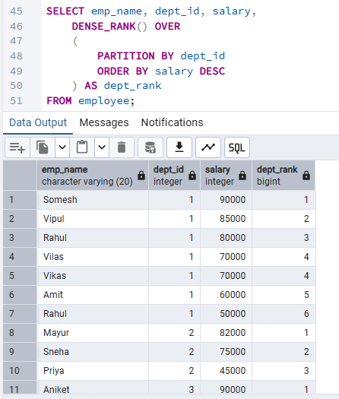
- Submission: SQL file Output screenshots GitHub upload

