**TIC TAC TOE GAME:**

1. **Task Description**

Design a fully functional Tic-Tac-Toe game where two players can alternately play using "X" and "O". The game should visually indicate the player's turn, declare a winner when any player completes a winning combination (row, column, or diagonal), and reset the game on demand. The game also uses responsive styles and animations for an engaging user experience.

1. **Task Output Screenshot**

**Initial screen with an empty board:**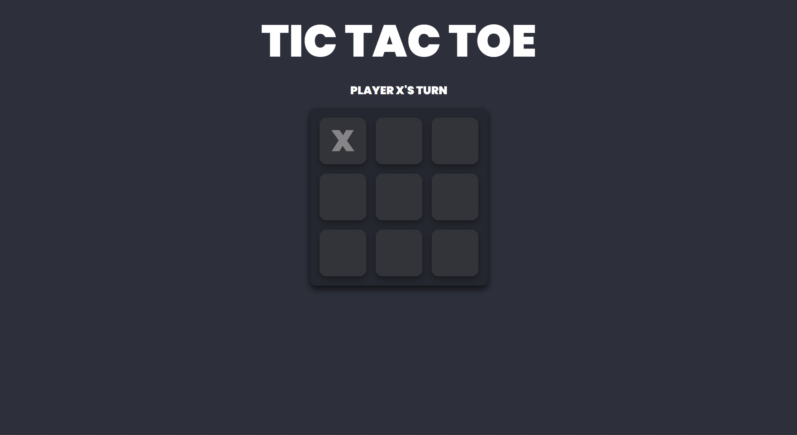

**Gameplay showing "Player Turn" text and moves being made:**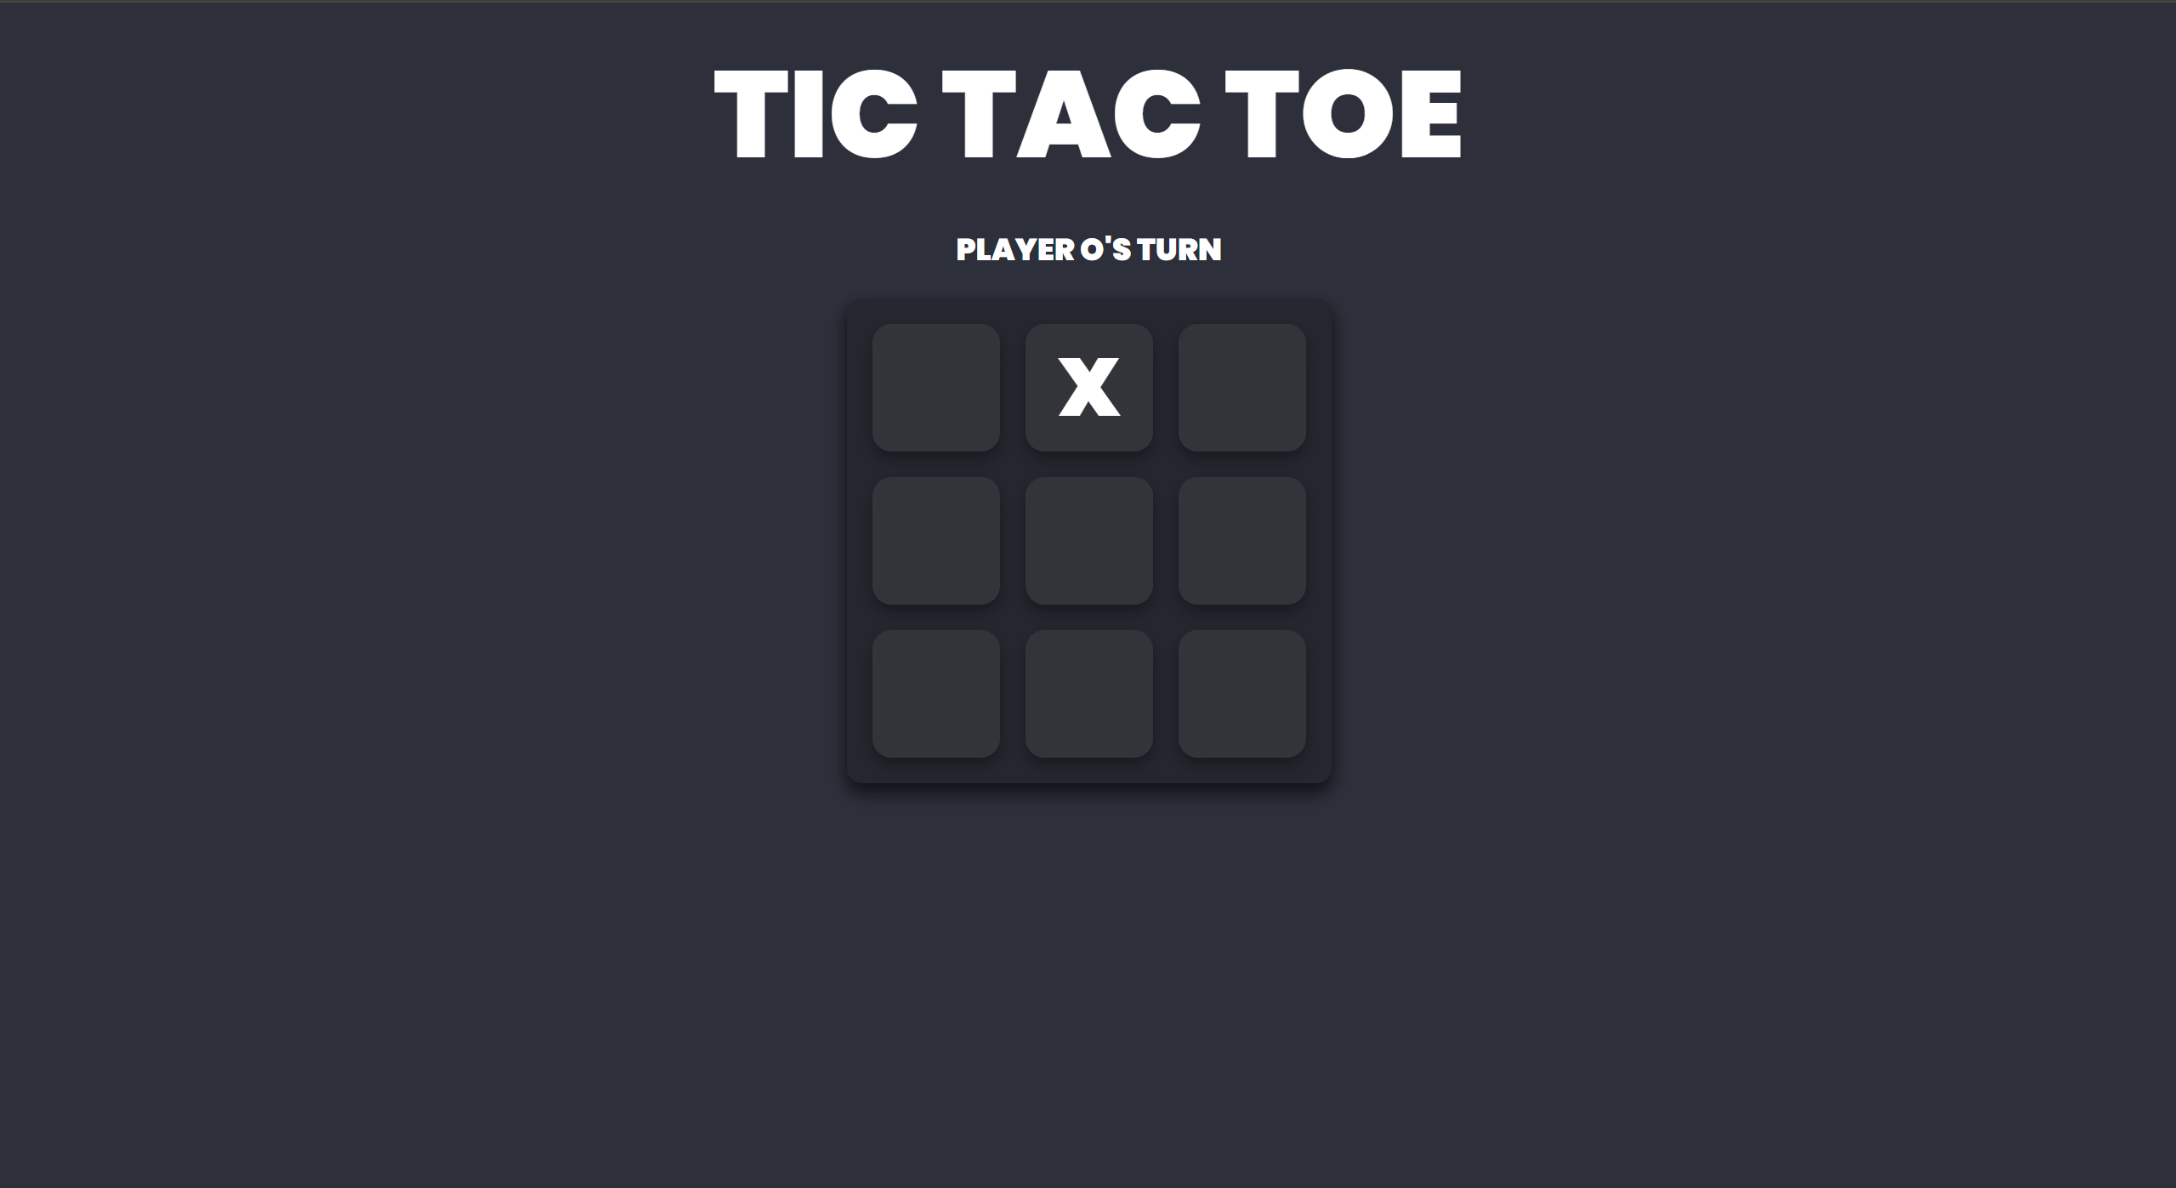

**Winning combination with the "Winner" text displayed.**

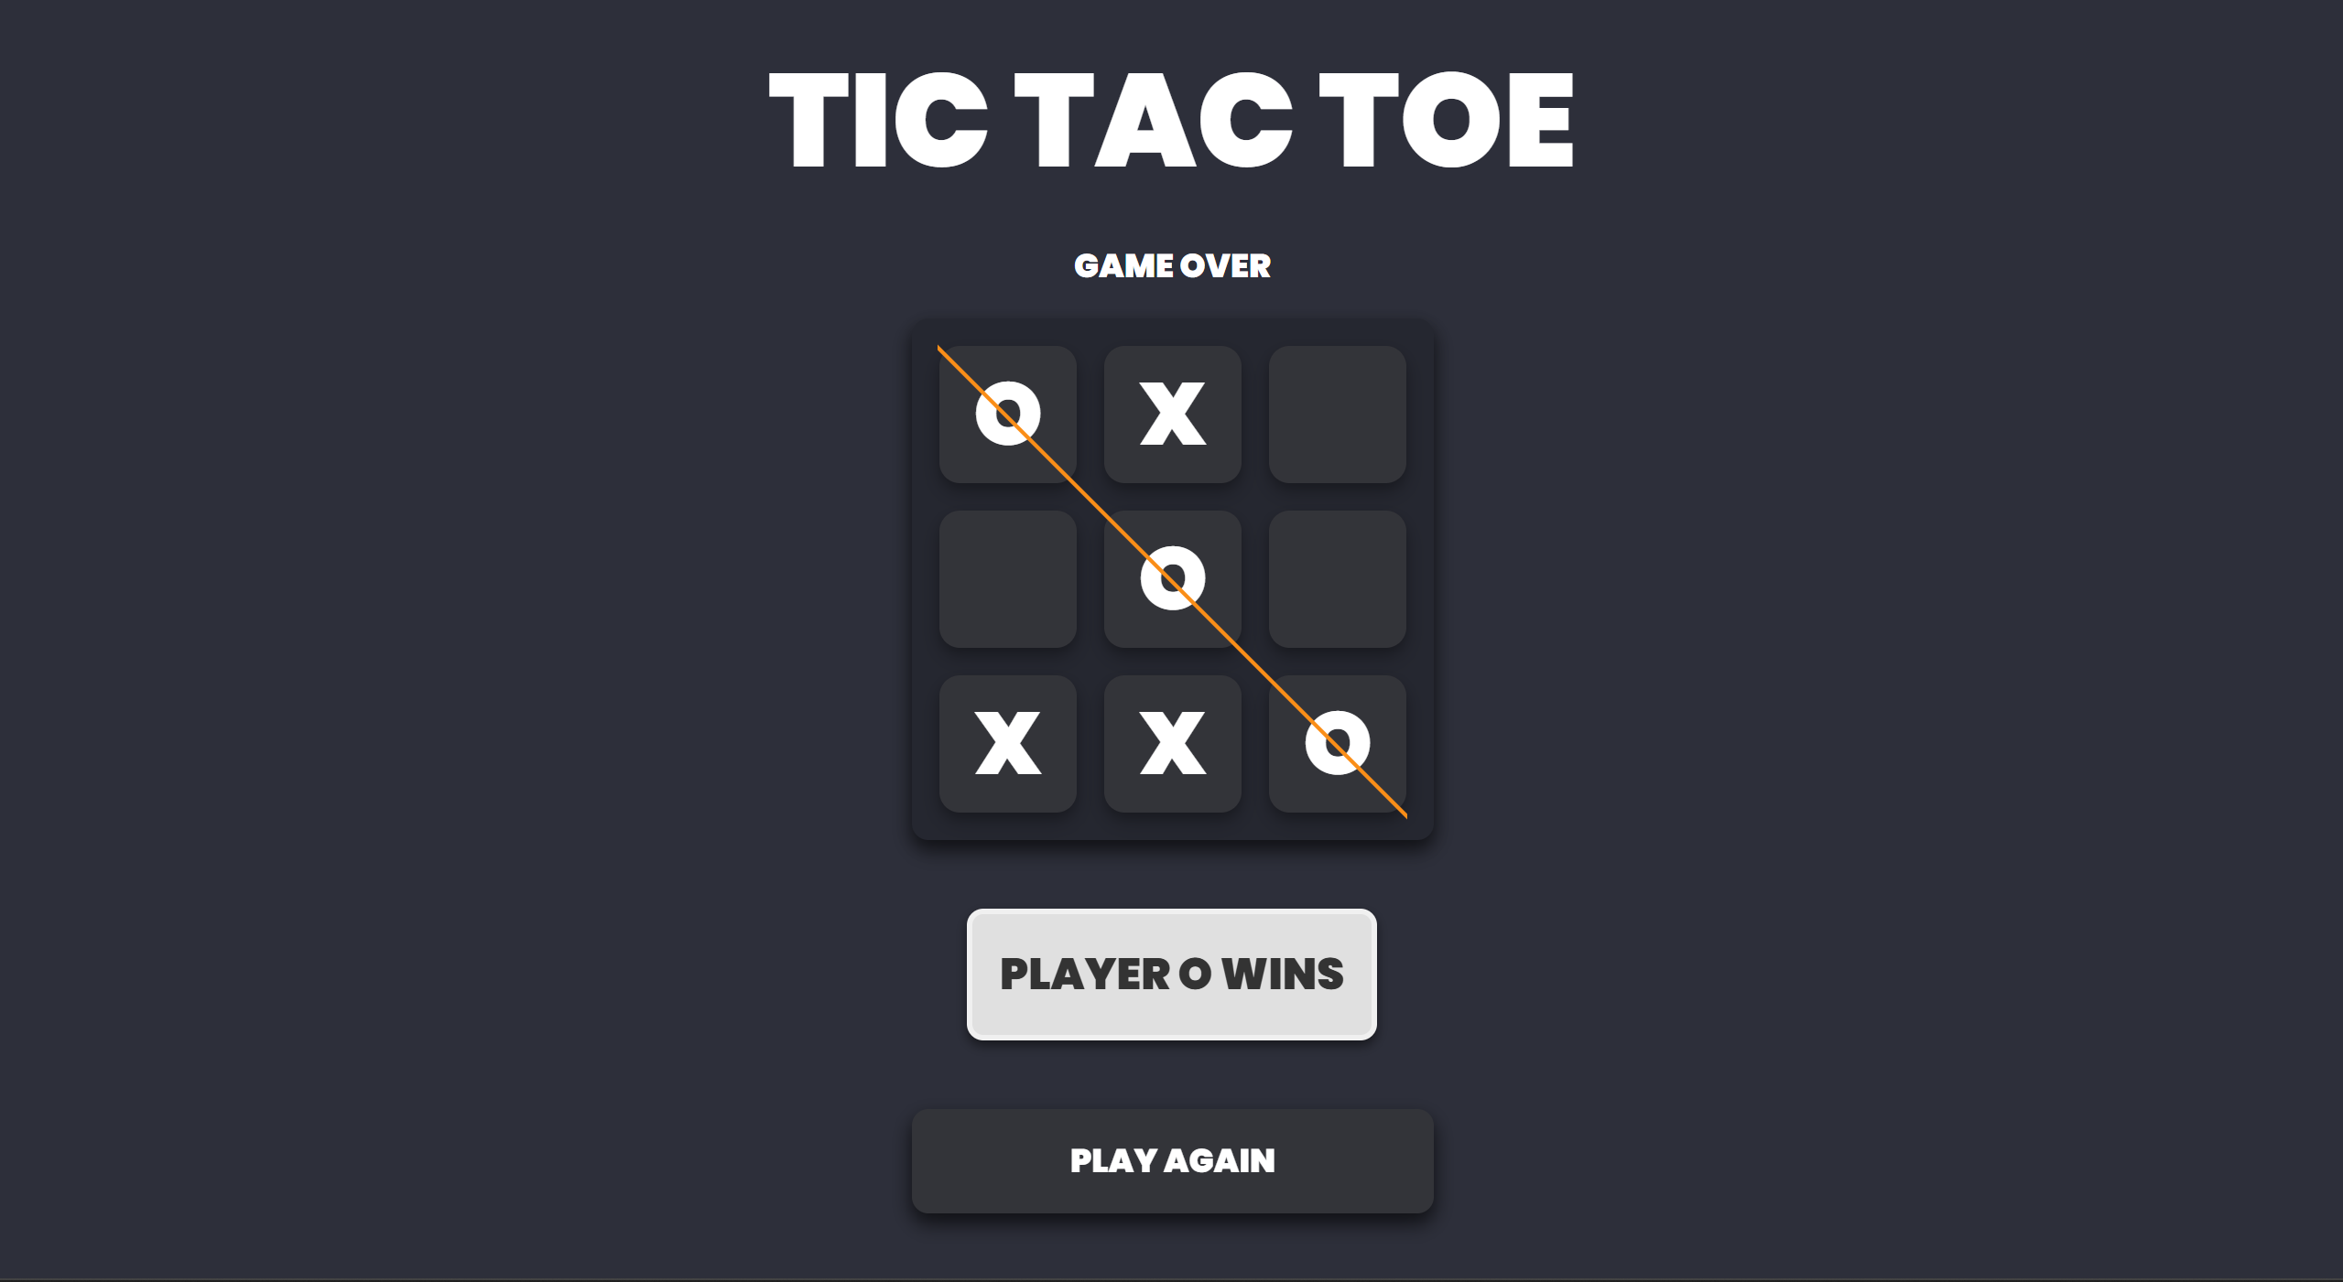

**Reset functionality returning to the empty board.**

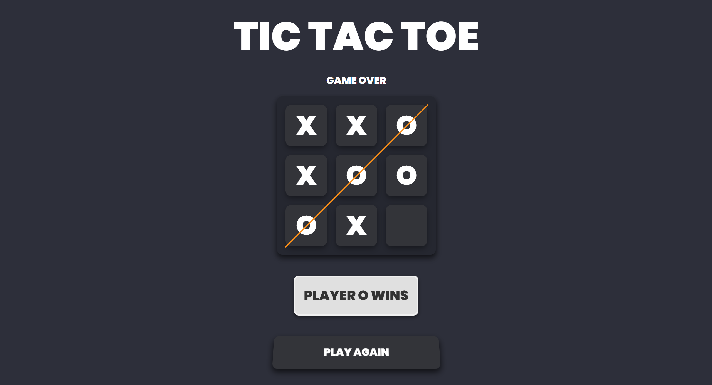



1. **Widget/Algorithm Used In Task**

**Widgets Used**

* **Button Widget: Used for the "Reset" button to replay the game.**
* **Text Display: Displays the player turn indicator and winner announcement dynamically.**
* **Grid Layout: Used to display the game board as a 3x3 grid with boxes for the players to make their moves.**
* **CSS Hover Effects: Added interactivity and improved UX through hover animations on tiles and buttons.**
* **Animations: Provided smooth transitions and tilt effects to enhance the visual appeal.**

**Algorithm**

* **Player Turn Logic:**
* **Maintains alternate turns between Player X and Player O.**
* **Tracks the current player's turn and updates the UI accordingly.**
* **Winning Combination Check:**
* **Utilized arrays to store and compare possible winning combinations (rows, columns, diagonals).**
* **Checks after every move if the current player satisfies any winning condition.**
* **Reset Functionality:**
* **Clears the board and resets all variables to the initial state.**
* **Responsive Design:**
* **Ensured adaptability for different screen sizes using media queries and dynamic scaling.**

1. **Vercel Link:**

**https://tic-tac-toe-theta-sable.vercel.app/**