**Social Media Dashboard:**

1. **Task Description**

Design a **Social Media Dashboard** to display analytics and statistics using various components in React. The dashboard includes sections for social media follower counts, daily visitor trends, device overview, Messages, audience location, and user profile information. Additionally, implement a **Dark Mode Toggle** to switch between light and dark themes.

1. **Task Output Screenshot**

**Dark Mode:**

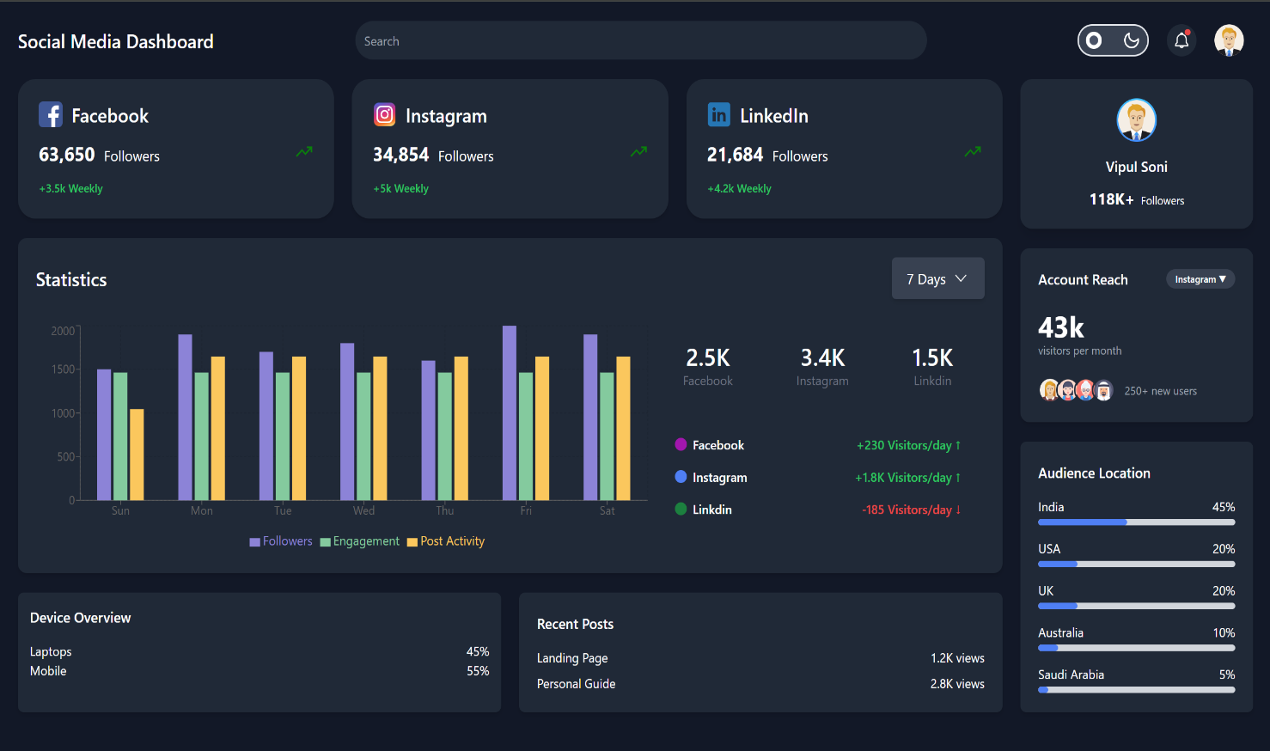

**Light Mode:**

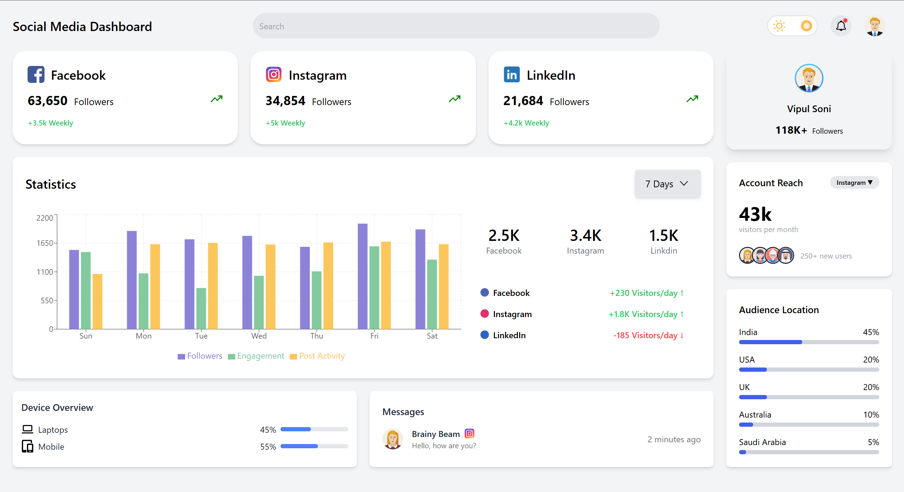

1. **Widget/Algorithm Used In Task**

* **Header Component**:  
  Displays the app's title, a search bar, and a toggle switch for Dark Mode.
* **Card Component**:  
  Used to represent individual social media platforms like Facebook, Instagram, and LinkedIn, showing follower counts and percentage growth.
* **GraphSection Component**:  
  Displays a bar chart for daily visitor trends using a charting library like **Chart.js** or **Recharts**.
* **DeviceOverview Component**:  
  Represents device statistics (e.g., mobile, desktop usage) with descriptive labels and icons.
* **Messages Component**:  
  Lists recent Messages of different platforms
* **ProfileCard Component**:  
  Displays user profile information, such as name, role, and follower count.
* **AccountReach Component**:  
  Shows the monthly visitor count and overall page reach in a compact card.
* **AudienceLocation Component**:  
  Uses a horizontal bar chart to display the geographic location of the audience, categorized by countries.
* **Dark Mode Implementation**:
* **State Management**: Utilized useState to toggle dark and light themes.
* **CSS Classes**: Conditional rendering of bg-gray-900 for dark mode and bg-gray-100 for light mode.

1. **Vercel Link:**

**https://social-analytics-dashboard.vercel.app/**