**DYNAMIC FORM:**

1. **Task Description**

Design a dynamic form that allows the user to add and remove input fields dynamically. The form should consist of two fields: First Name and Last Name. The user can add multiple sets of fields and remove them as needed. Each set of fields should include validation to ensure that both fields are filled before submission. Additionally, implement a **Clear** button to reset the form and a **Submit** button to log the input data.

1. **Task Output Screenshot**

**Initial State of the Form**

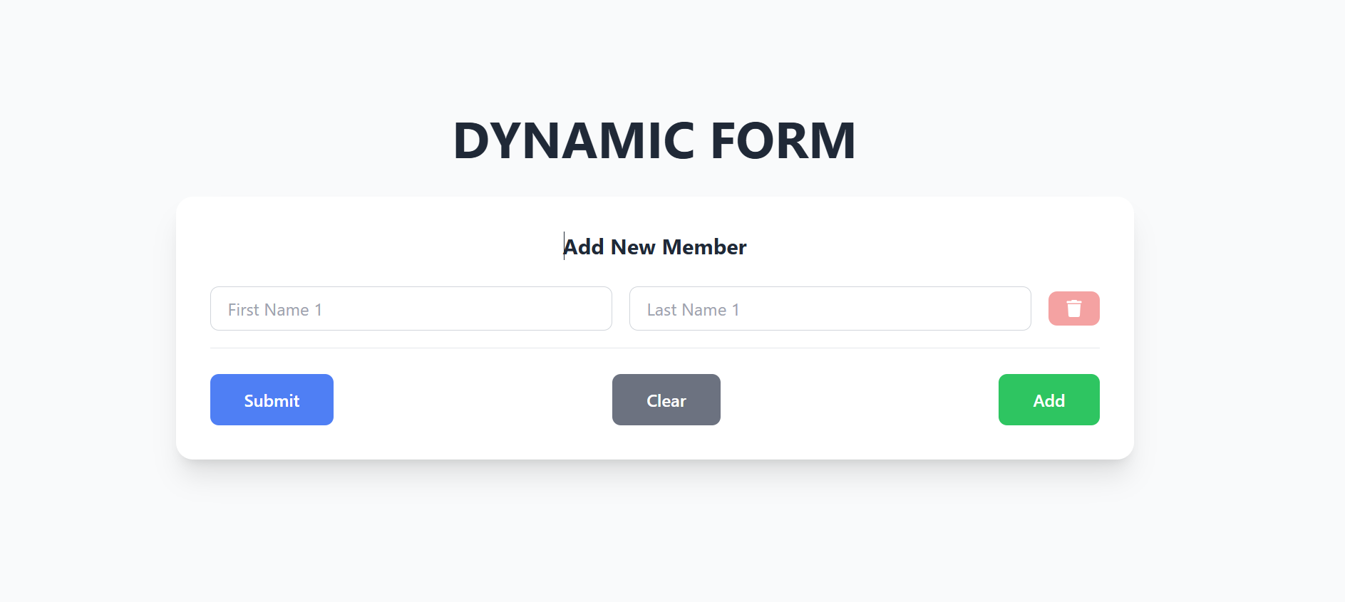

**Form with Multiple Input Fields Added**



**Form with Validation Alert (After Submit)**

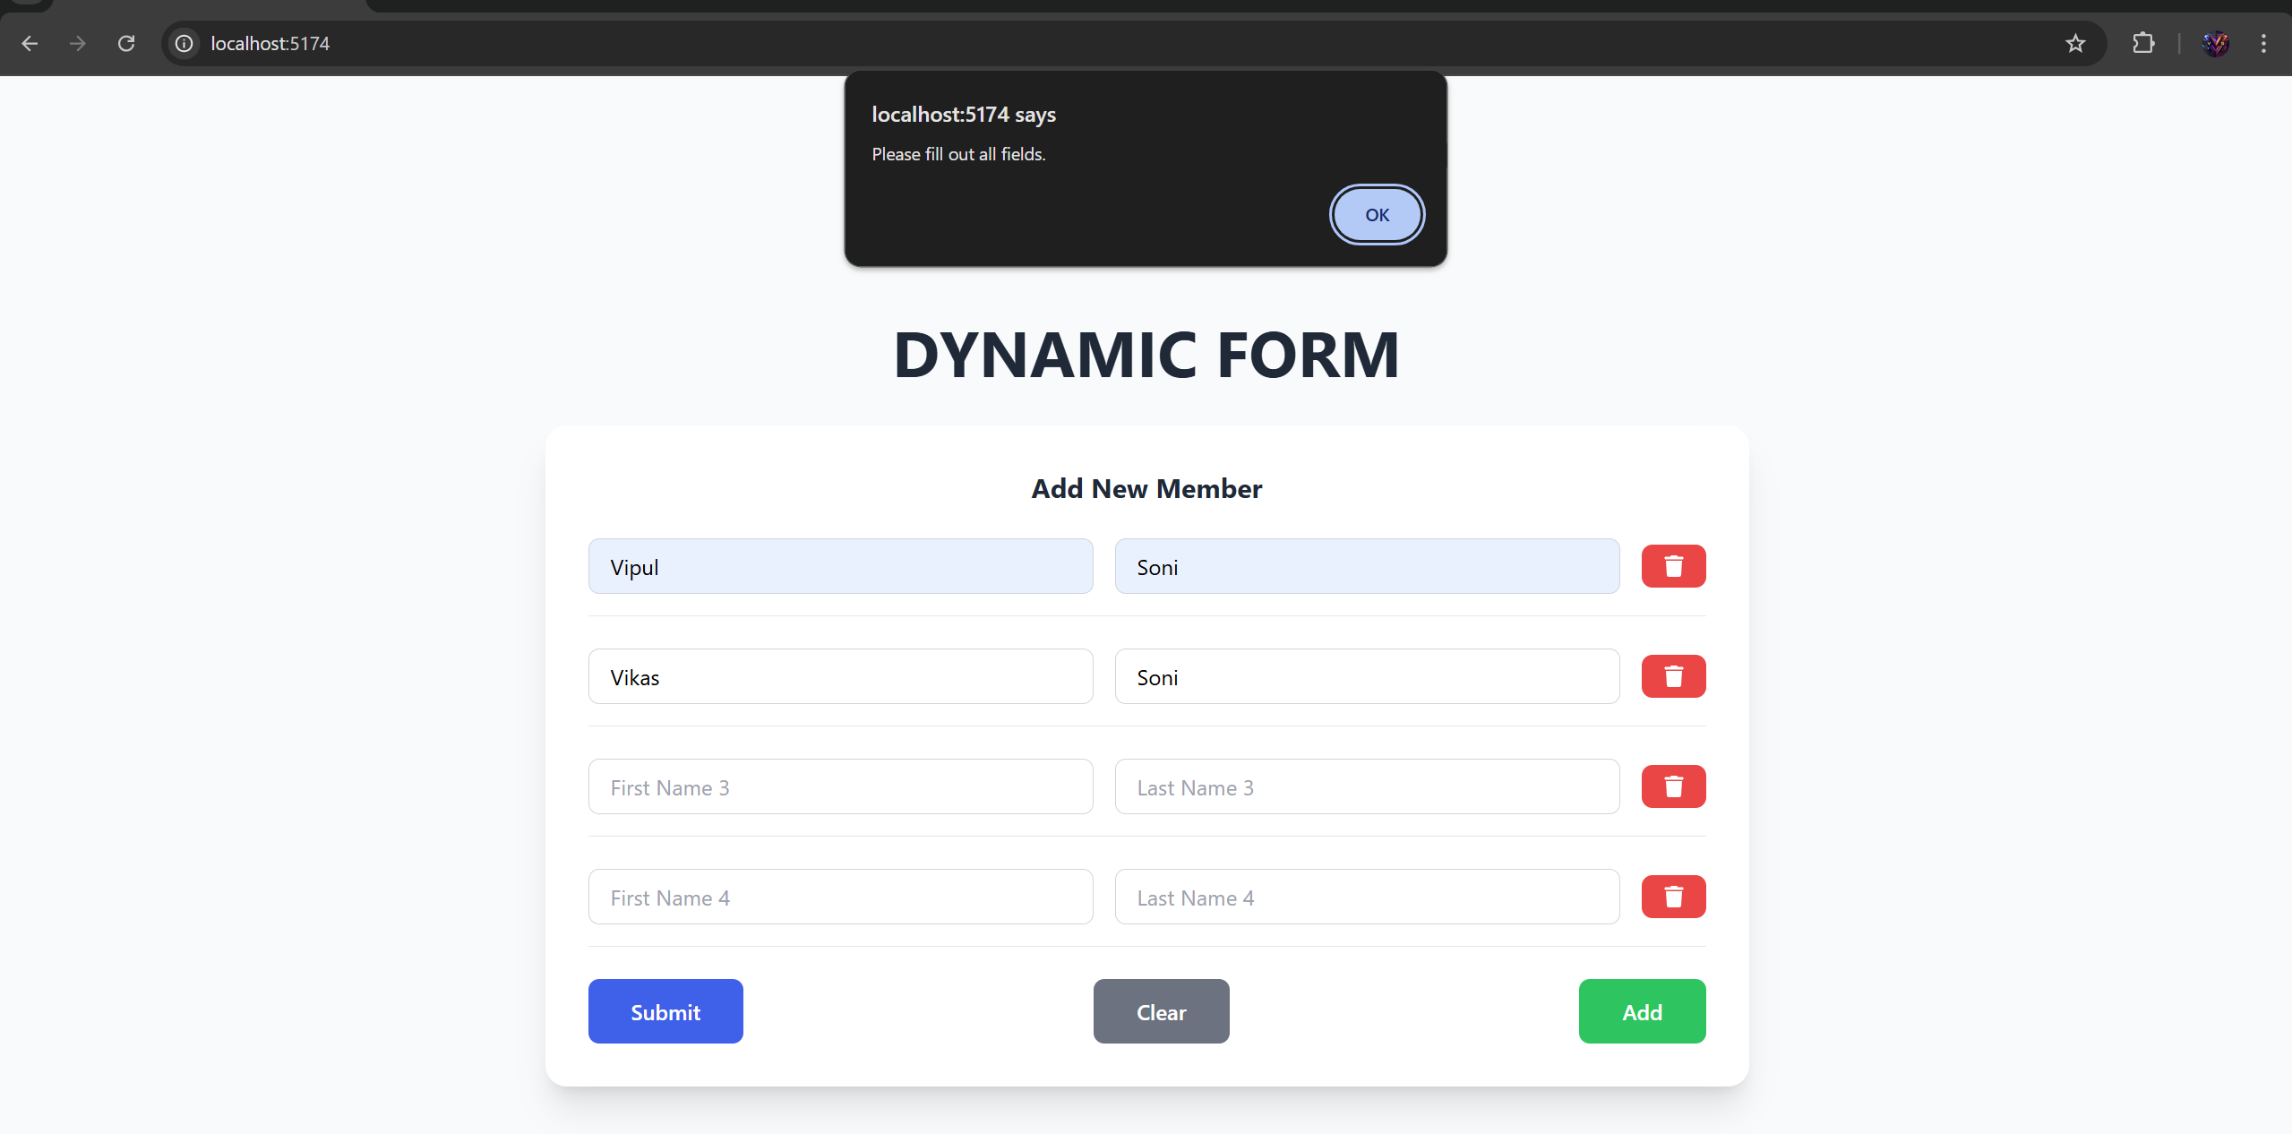

**Form After Data Submission**

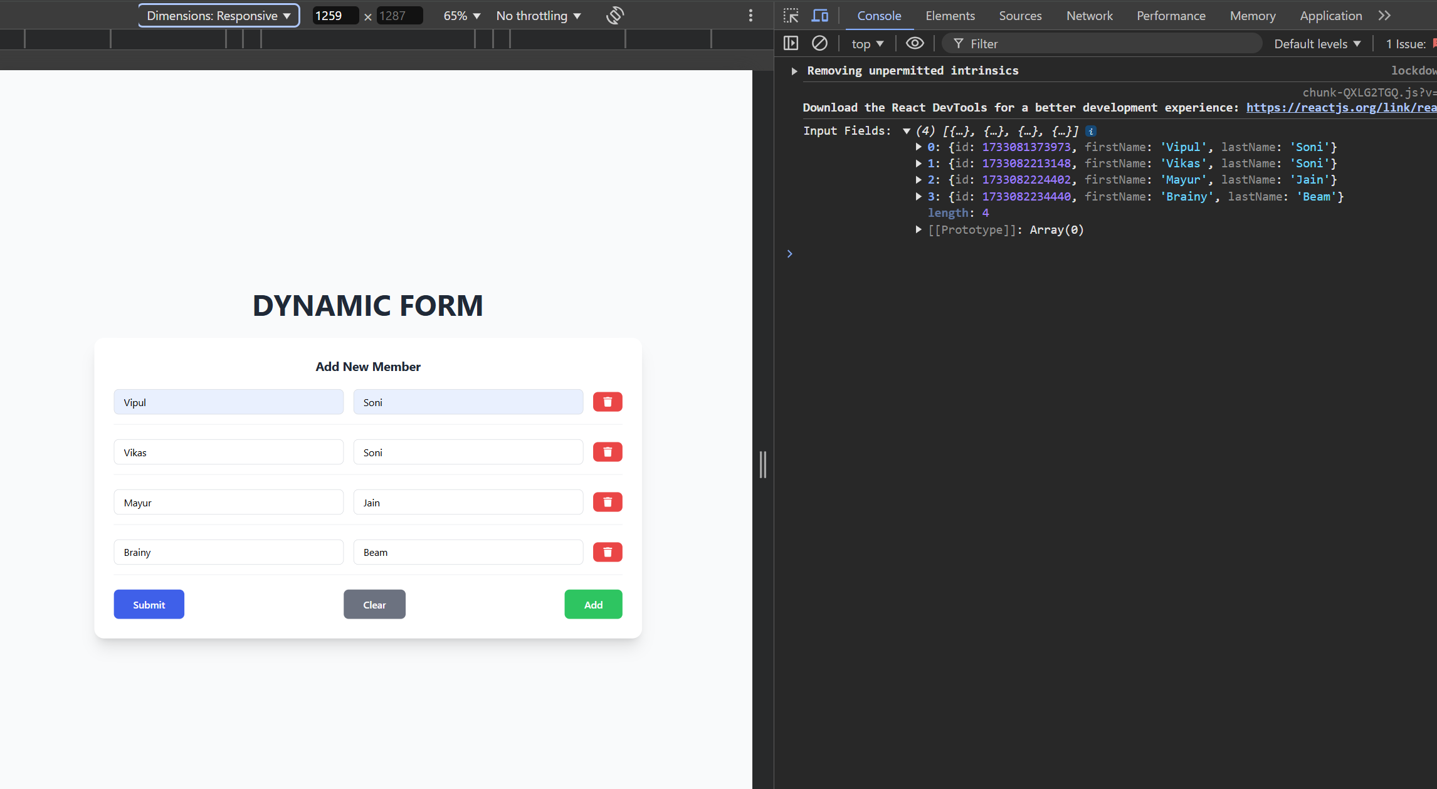

1. **Widget/Algorithm Used In Task**

**Input Fields (Text Inputs):**

* **Used the input tag with type "text" for accepting user input for First Name and Last Name.**
* **Dynamically created input fields using React state and mapped them to the form.**

**Button Widget:**

* **Submit Button: Used for form submission. It checks if the fields are filled and logs the data.**
* **Add Button: Allows adding new input fields dynamically.**
* **Remove Button: Deletes a set of input fields. The button's opacity decreases when only one input field remains, visually indicating it cannot be removed further.**
* **Clear Button: Resets all the input fields and starts the form with just one set of fields.**

**React State Management:**

* **Managed the dynamic addition and removal of input fields using React useState.**
* **Handled input field changes and submission logic through functions like handleAddFields, handleRemoveFields, handleChangeInput, and handleSubmit.**

**Validation Algorithm:**

* **Ensured that both First Name and Last Name fields are filled before submission. If any field is empty, an alert message is shown.**

1. **Vercel Link:**

**https://dynamic-form-five-henna.vercel.app/**