**DYNAMIC FORM:**

1. **Task Description**

Develop a **Currency Converter** application that allows users to convert between multiple currencies in real-time using live exchange rates. The application includes features like a dropdown to select currencies, a swap button to switch the "From" and "To" currencies, a field to input the amount, and a button to calculate the converted value. The app also allows users to mark favorite currencies for quicker selection.

1. **Task Output Screenshot**

**Dropdown menus for selecting currencies with flag icons.**

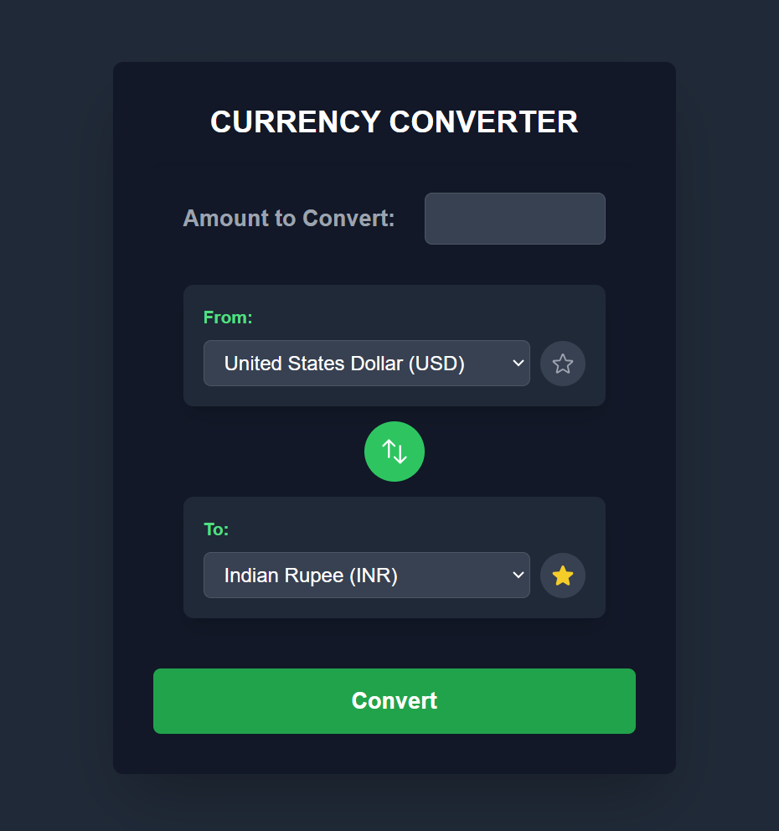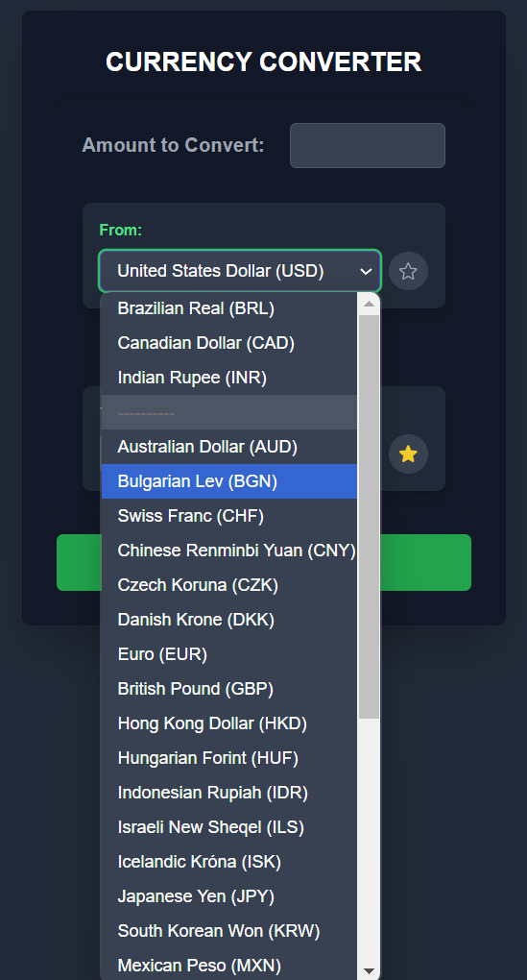

**Converted value displayed on the screen.**

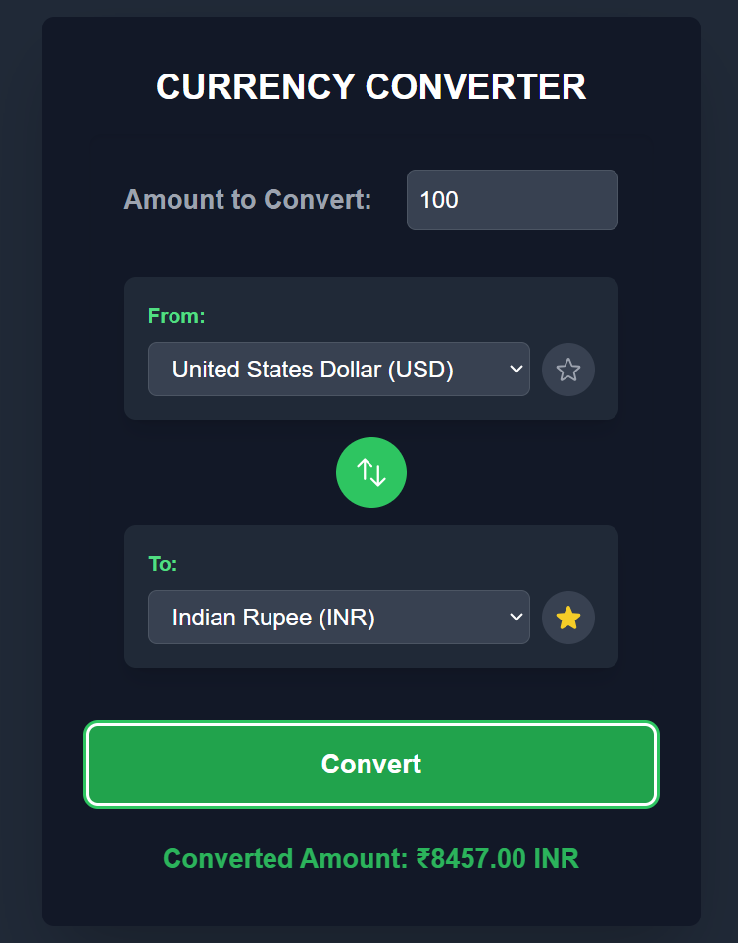

**Swap functionality button.**

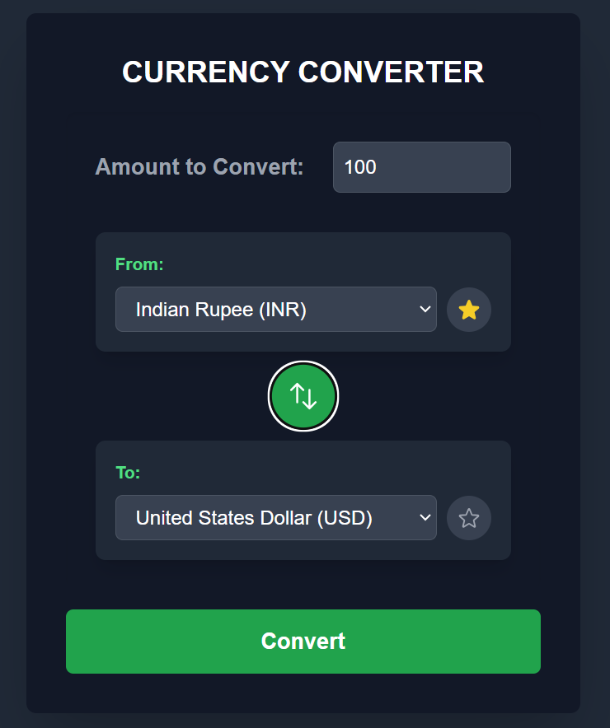

1. **Widget/Algorithm Used In Task**

**Dropdown Widget (Select Element):**

* **Used for displaying the list of currencies with flags and enabling the selection of "From" and "To" currencies.**

**Button Widget:**

* **Used for the "Convert" and "Swap" functionalities.**

**Text Input Widget:**

* **Used for inputting the amount to be converted.**

**Real-time API Integration:**

* **Implemented using a currency exchange API (e.g., https://api.frankfurter.app/latest API) to fetch live exchange rates dynamically.**

**Favorites Logic:**

* **Maintains a list of frequently used currencies for quick access.**

**Flag Icon Integration:**

* **Displays the country flags alongside the currency names in the dropdown for better user experience.**

1. **Vercel Link:**

**https://currency-converter-kappa-eight.vercel.app/**