**# CUSTOM KVM STORE SETUP:**

1. Download hybris **v6.3.0.0** and extract the SAP Hybris Commerce installation ZIP file to the newly-created installation folder, for example: **C:\hybris**.
2. Go to the installer directory, for example: **C:\hybris\installer**.

If you don't know the name of your installer recipe, you can verify it in the recipes directory, for example: C:\hybris\installer\recipes.

1. Install the SAP Hybris Commerce flavor using the required recipe by entering the following command:

To install SAP Hybris Commerce with B2C Accelerator, enter the following command:

**install.bat -r b2c_acc**

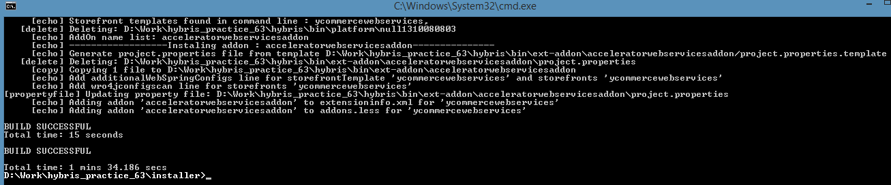

1. Configuring the modulegen tool

The modulegen tool is configured in two steps. The first step is to configure the **platform/extgen/project.properties** file, which contains the following properties:

|  |  |
| --- | --- |
| **Property** | **Descripton** |
| extgen.template.default | The default template extension used for extgen. This is not used for modulegen. |
| modulegen.module.default | The preselected module that will be chosen if you do not enter a value for the module. |
| **extgen.extension.path** | **The path where the new extension will be generated.** |
| extgen.extension.name | The default name of the new extension if no name is chosen. |
| extgen.extension.package | The default Java package for the new extension's classes. |

Add below key to **local.properties**

**extgen.extension.path=${HYBRIS_BIN_DIR}/ext-kvm**

1. Execute below ant command from **“../hybris/bin/platform”** directory to generate custom extensions

**ant modulegen -Dinput.module=accelerator -Dinput.name=kvm -Dinput.package=com.hybris.kvm -Dinput.template=develop**

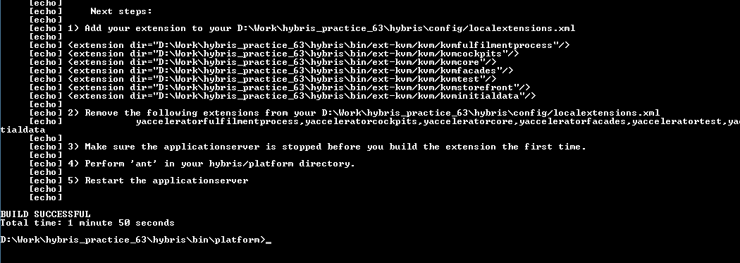

1. Comment out all **yaccelerator\*** extensions from **localextensions.xml** file and add ext-kvm extensions to autoload path

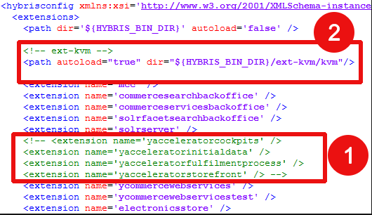

1. Initialize the system using below ant command from **“../hybris/bin/platform”**

**ant initialize**

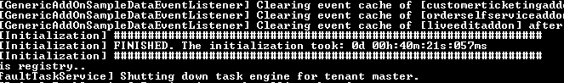

1. Start the server using **“hybrisserver.bat”** command.

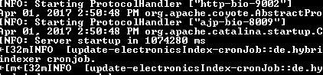

1. Add below entry in **hosts** file

**127.0.0.1 kvm.local**

you can then access the site using:  [https://kvm.local:9002/kvmstorefront/](http://kvm.local:9001/kvmstorefront%20)

1. Access the site using below URL

<https://kvm.local:9002/kvmstorefront/?site=electronics>

**OR**

<https://localhost:9002/kvmstorefront/?site=electronics>

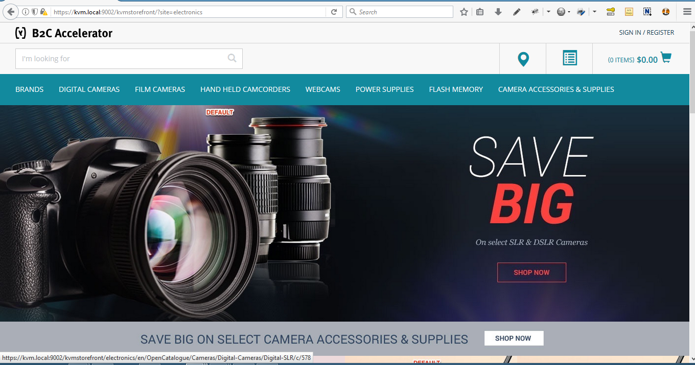

…... Keep Smiling 😊

# Getting below error while accessing the site.

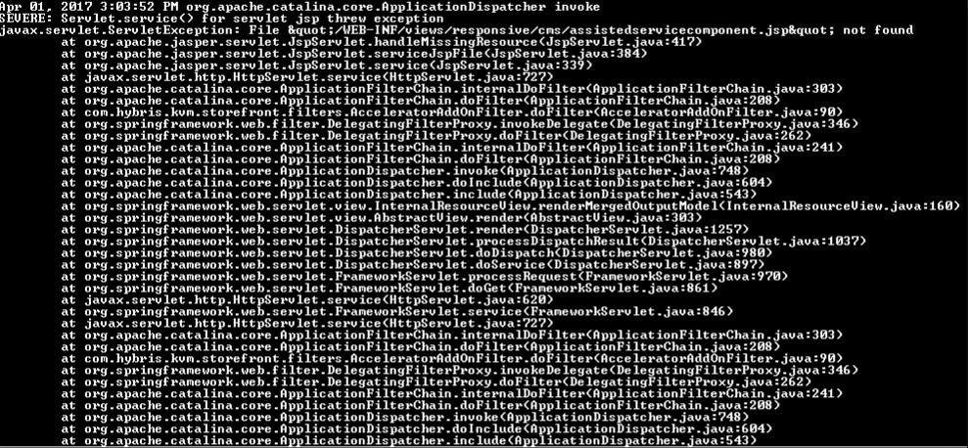

Select * from {AbstractCMSComponent} where {pk}='8796140373052' [Get the PK from the LOGS]

