City Operations Risk Monitor — Data Model
Star schema · 8 Indian cities · daily grain · 1 Oct 2024 – 30 Sep 2026 · Source: Open-Meteo (Historical Weather + Air Quality)
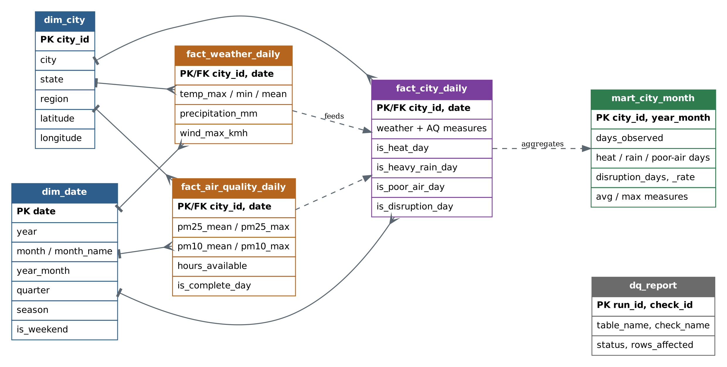
■ Dimensions ■ Source facts ■ Integrated fact ■ Aggregate mart ■ Data-quality log
Solid lines: one-to-many (dimension → fact). Dashed lines: data flow (source facts → integrated fact → monthly mart).

