Set 5
Q1. Generate Python code for the Fibonacci sequence with Cursor AI. Refine your prompts to handle only positive integers and record the changes and outcomes.
Prompt: # Generate python code for Fibonacci sequence Ensure that the Function only accepts the positive integers
Program :
def fibonacci(n: int) -> list[int]:
"""
Generate the Fibonacci sequence up to n terms.

Parameters:
n (int): Number of terms (must be positive).

Returns:
list[int]: Fibonacci sequence of length n.

Raises:
ValueError: If n is not a positive integer.
"""
if n <= 0:
raise ValueError("Number of terms must be a positive integer.")

sequence = [0, 1]
for i in range(2, n):
sequence.append(sequence[i-1] + sequence[i-2])
return sequence[:n]

# --- Interactive part ---
def main():
try:
user_input = int(input("Enter the number of terms for Fibonacci sequence: "))
result = fibonacci(user_input)
print(f"Fibonacci sequence with {user_input} terms: {result}")
except ValueError as ve:
print(f"Error: {ve}")
except TypeError as te:
print(f"Error: {te}")

if __name__ == "__main__":
main()
Output :
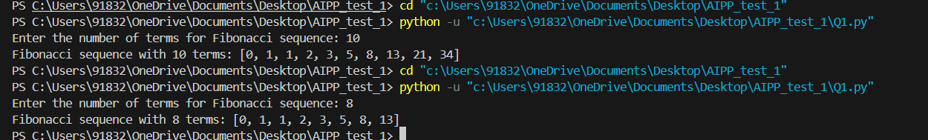

Q2. Write a Python queue class (`enqueue`, `dequeue`, `peek`). Use an AI assistant and test the class with multiple scenarios. Describe how AI-generated code manages edge cases and how you improved it.
Prompt : #Write a Python queue class with enqueue, dequeue, and peek methods.
Program :
class Queue:
def __init__(self):
self.items = []

def enqueue(self, item):
"""Add an item to the queue."""
self.items.append(item)

def dequeue(self):
"""Remove and return the front item. Return None if empty."""
if not self.items:
print("Queue is empty. Cannot dequeue.")
return None
return self.items.pop(0)

def peek(self):
"""Return the front item without removing it. Return None if empty."""
if not self.items:
print("Queue is empty. Nothing to peek.")
return None
return self.items[0]

def is_empty(self):
return len(self.items) == 0

def size(self):
return len(self.items)

# --- Interactive Menu ---
def main():
q = Queue()
while True:
print("\nQueue Menu:")
print("1. Enqueue")
print("2. Dequeue")
print("3. Peek")
print("4. Size")
print("5. Exit")

choice = input("Enter your choice (1-5): ")

if choice == "1":
value = input("Enter value to enqueue: ")
q.enqueue(value)
print(f"Enqueued {value}. Queue: {q.items}")

elif choice == "2":
result = q.dequeue()
if result is not None:
print(f"Dequeued: {result}. Queue: {q.items}")

elif choice == "3":
result = q.peek()
if result is not None:
print(f"Peek: {result}")

elif choice == "4":
print(f"Queue size: {q.size()}")

elif choice == "5":
print("Exiting program.")
break

else:
print("Invalid choice. Please enter 1-5.")

if __name__ == "__main__":
main()
Output:
