**IT32043 – Computer Animation**

**Assignment 02**

**Computer Game**

* I created a simple 3-level 2D game called HAPPY BLOCK using Unity.
* Its function is also simple you just need to press the Space bar to play.
* I used the simple 5 steps to create the game, you can see each step following.

**Step #1**

* 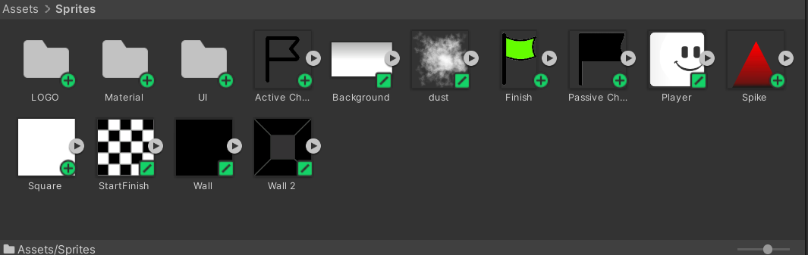First, I collect the images to create the 2D game and I move all of the images to a folder called sprites.

**Step #2**

* 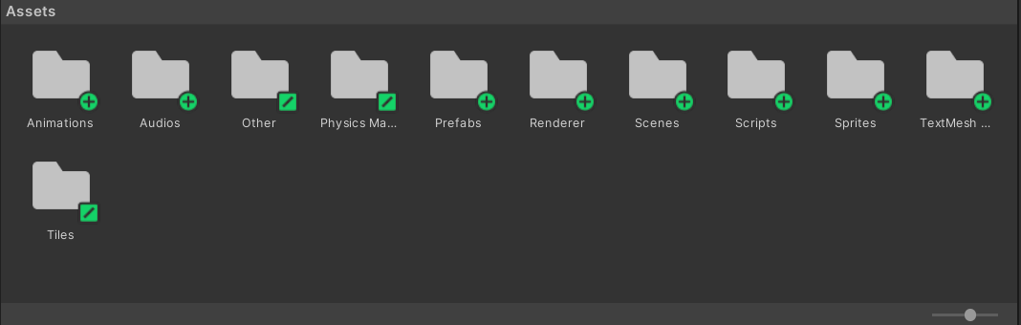Then, I created different folders for each asset.

**Step #3**

* After I started to create the main objects of the player, ground, area effecter, portal, moving platforms, moving squares, moving spikes, obstacles (spikes), checkpoint, and, finish point.
* Now let’s see how I created each part one by one.

***Ground:***

* 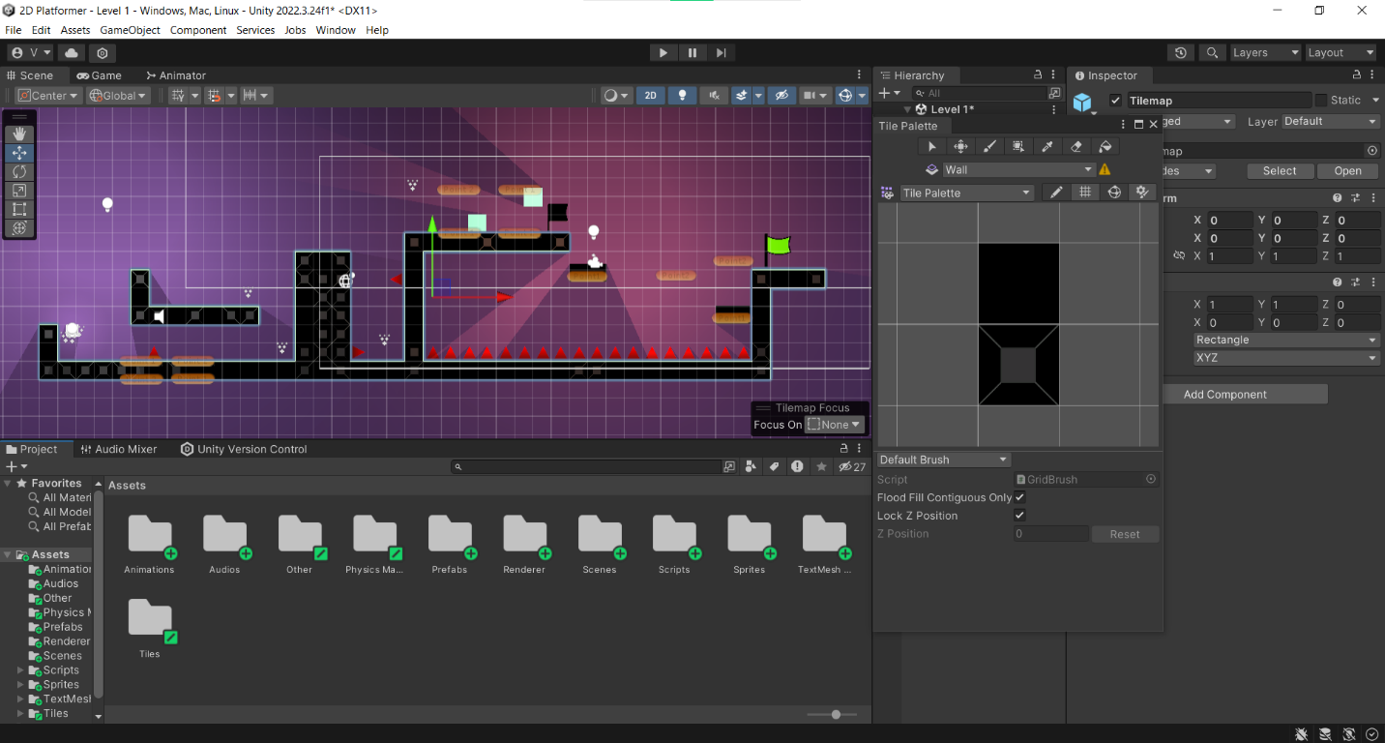I created the game ground using Tilemap, which helps to create the ground easily.

***Player:***

* 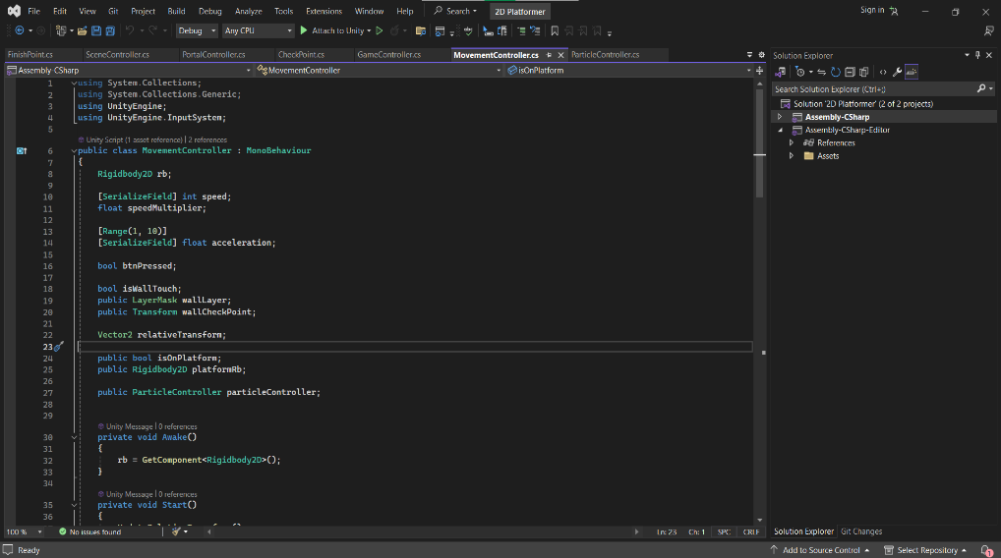I simply drag and drop the player image from the sprites folder to the scene and I create a script called MovementController.cs to move the object when press the Space bar.

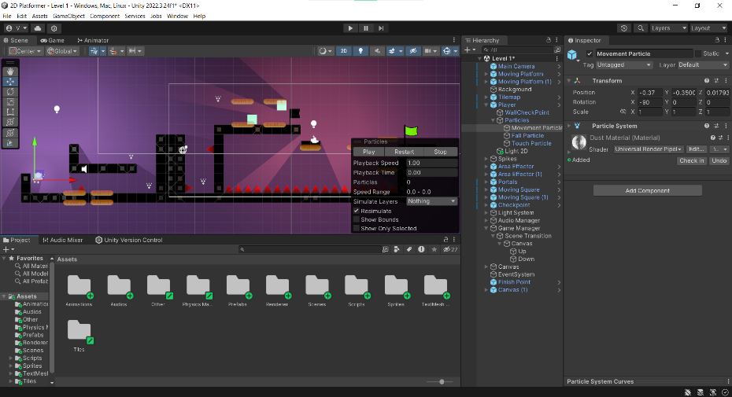

* If the player hits the ground the player turns to the other side (right to left and left to right).
* Also, I add some dust effects to the player when moving, falling, and hitting the ground.
* To that, I created a material called dust material and I moved it to the material folder in the sprites folder.
* After, I used the particle system to create the dust effecter and dragged and dropped the dust material into the particle system I created 3 different particles movement particle, fall particle, and touch particle.
* And, I created a script called ParticleController to function the above particles.

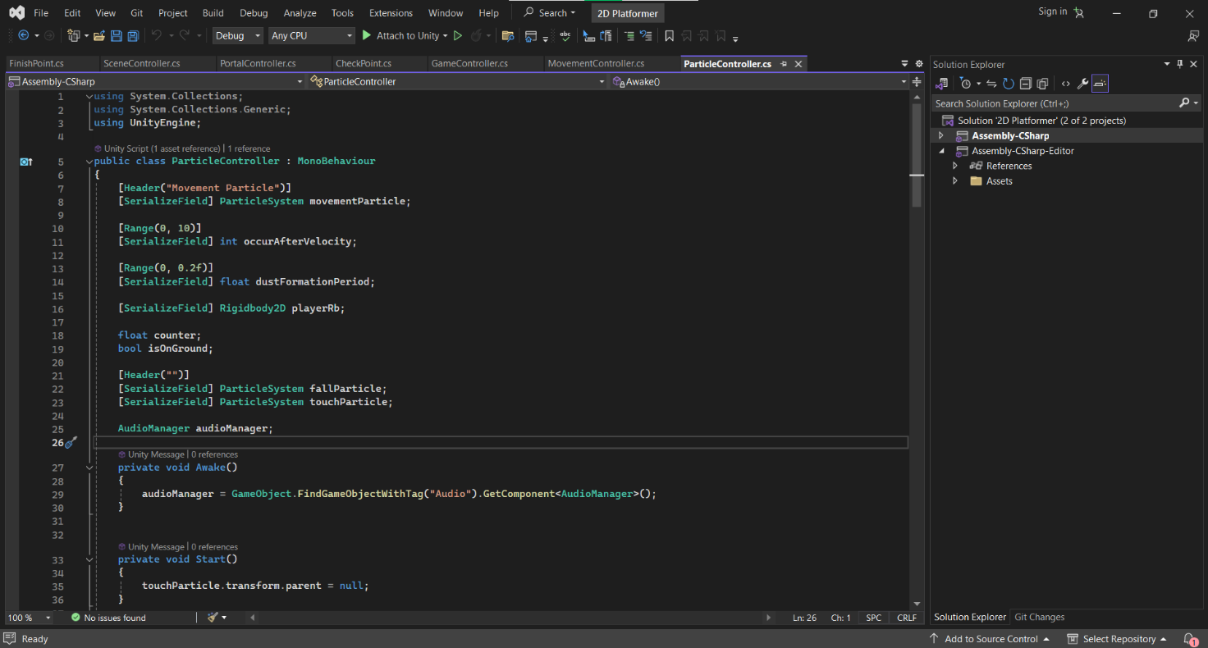

***Area Effector & Portals:***

* To the area effecter and portals also, I created using the particle systems by adding the dust material.

***Moving Squares, Moving Spikes & Moving Platforms:***

* To create the moving squares, moving spikes, and moving platforms I used the square and tile map, and I created two points to move between those two points.
* The moving square and moving spikes are kind of obstacles and the moving platform helps to player to reach one point to another point by protecting from the obstacles.
* 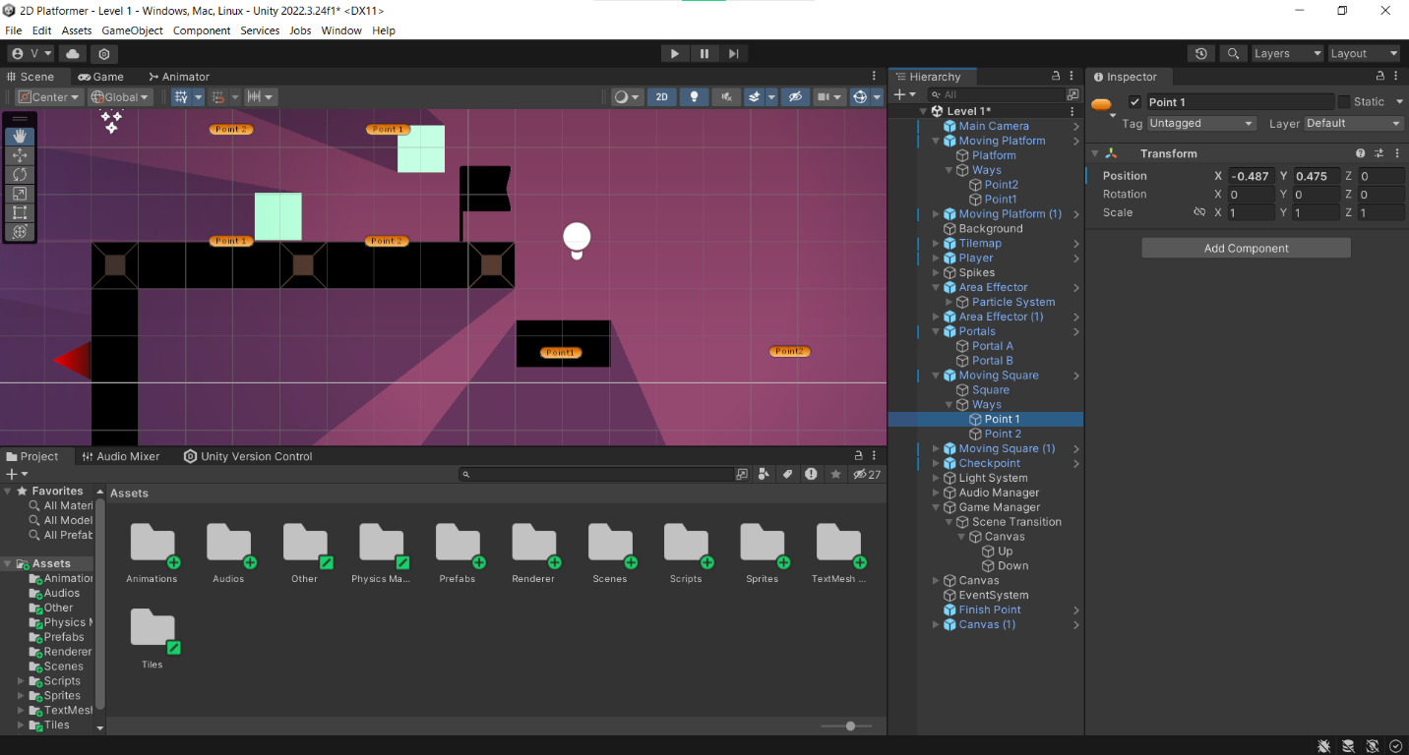The moving platform is similar to the portals.

***Spikes:***

* 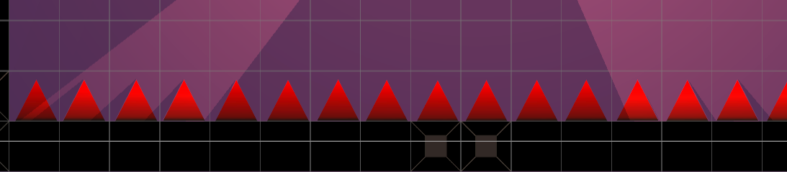It is a triangle-shaped obstacle when the player hits that the player will die.

***Checkpoint & Finish Point:***

* In checkpoint, when a player reaches one checkpoint and after the player dies, the player can play the game from that checkpoint without going to the start point.
* At the finish point, the player can move to the next level of the game.

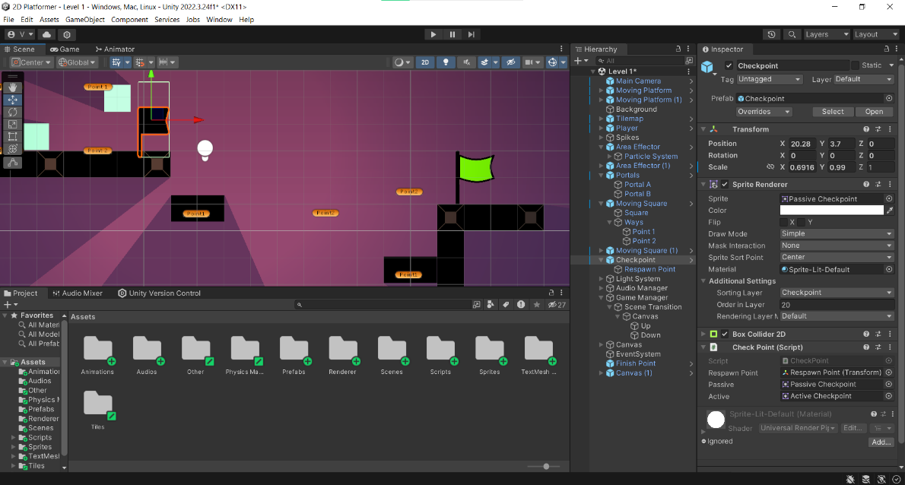

**Step #4**

* After that, I added the shadow caster 2D and created a script called Shadow Caster 2D Creator.
* After creating the all objects I moved them into the prefabs folder, which helps to use those objects easily without creating them again from the beginning.
* Then I created the 3 different levels (scenes) using those objects, and you can see each level one by one following.

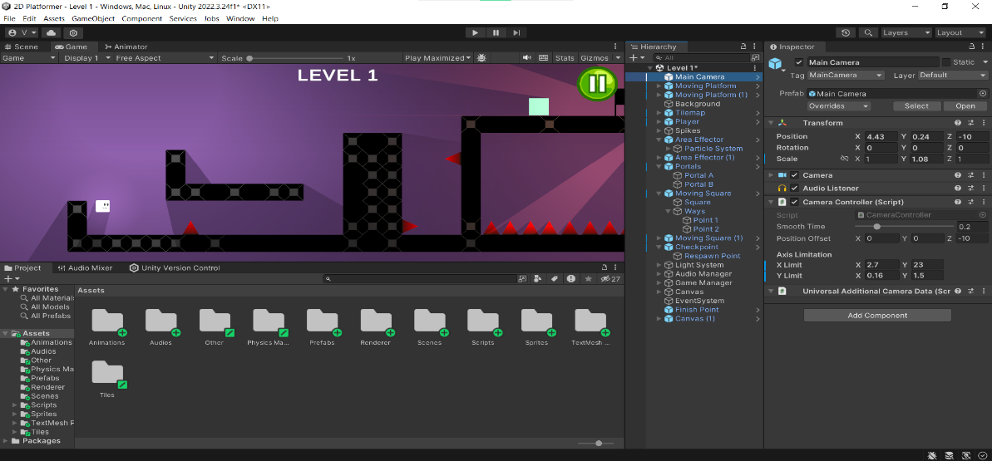

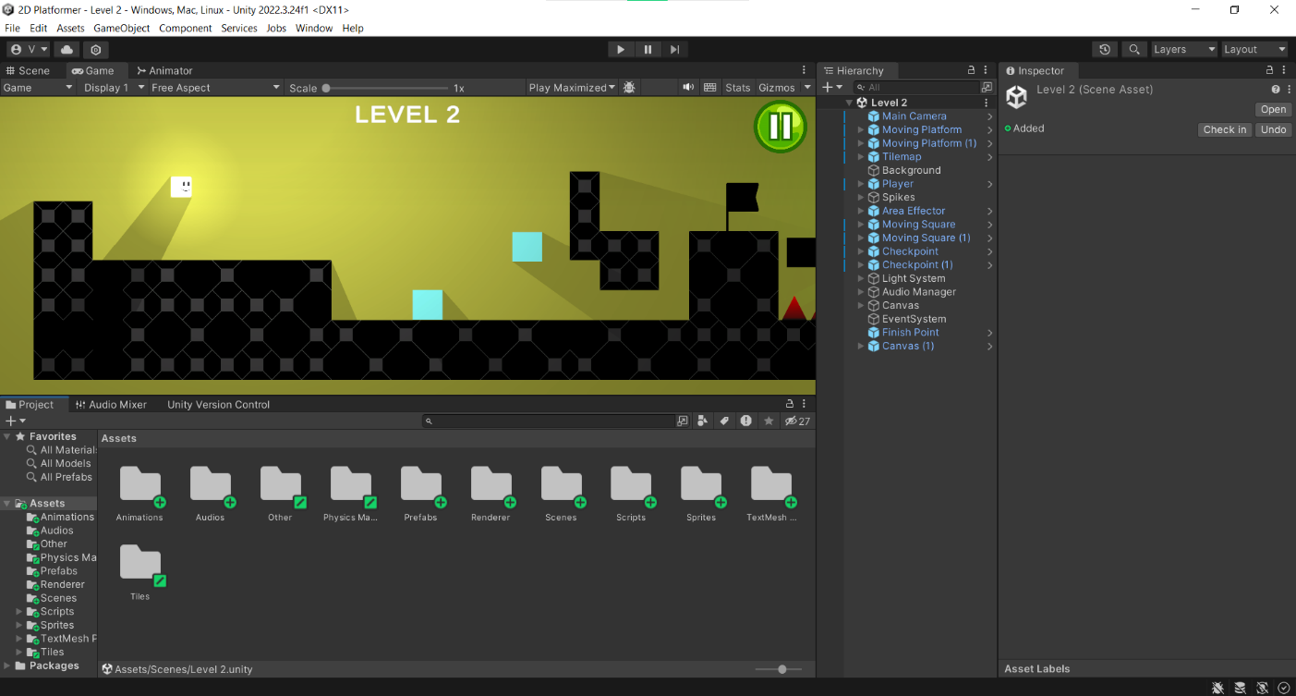

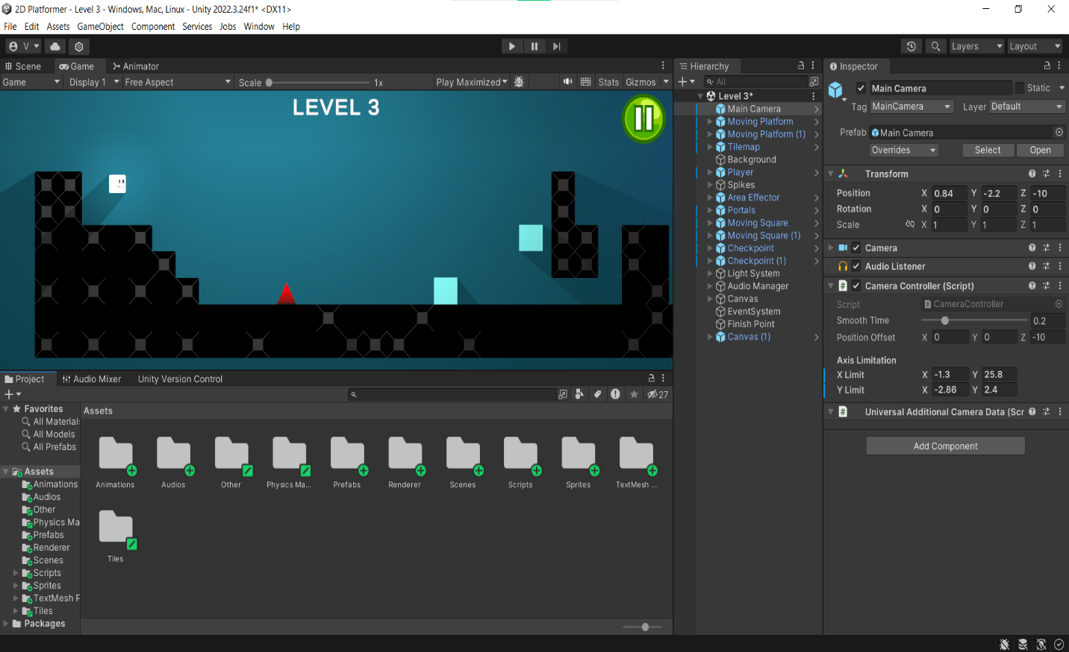

**Step #5**

* 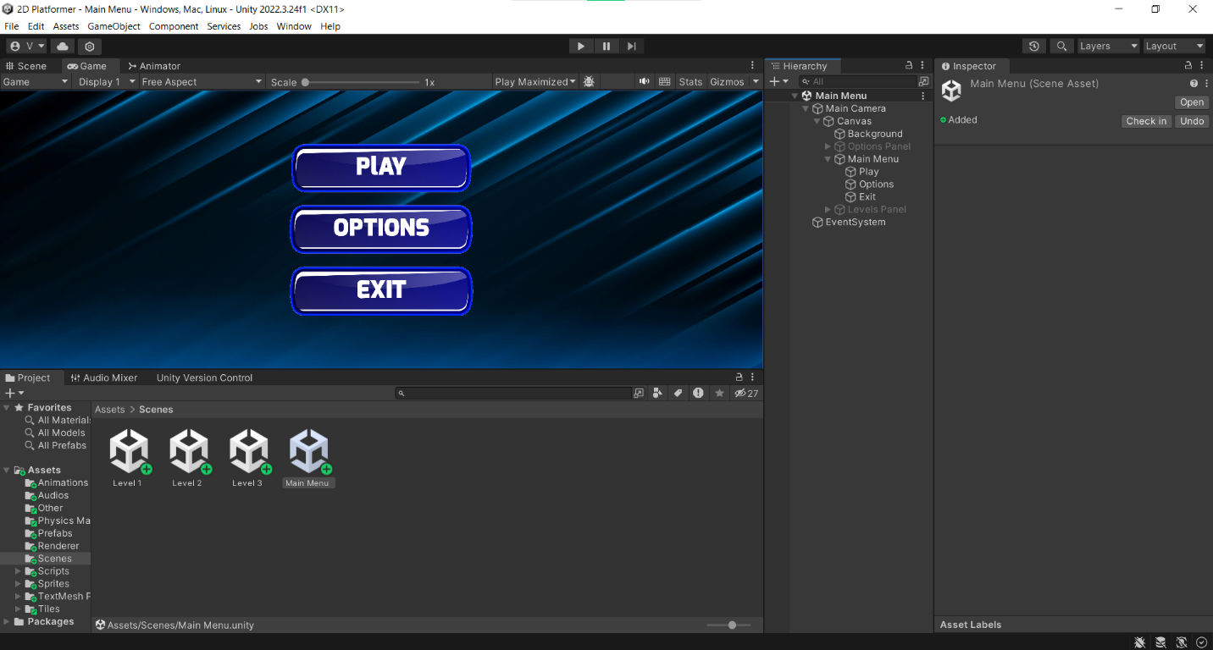I created a new scene called Main Menu, which can help to player select the levels, go to the options, and exit the game.
* 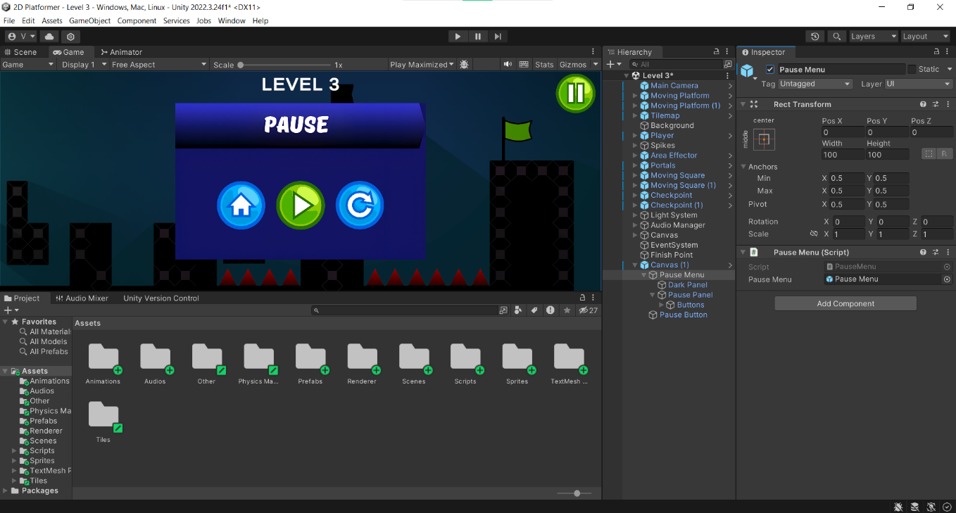Also, I added the pause button to each level, which helps to player pause and restart the game and, go to the home (Main menu).
* 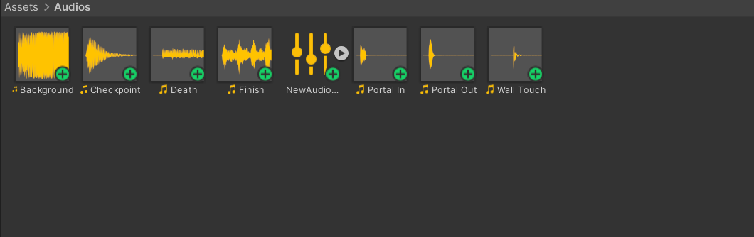I added the music and SFX to the portals, background, death, checkpoints, finish, and wall touch.
* 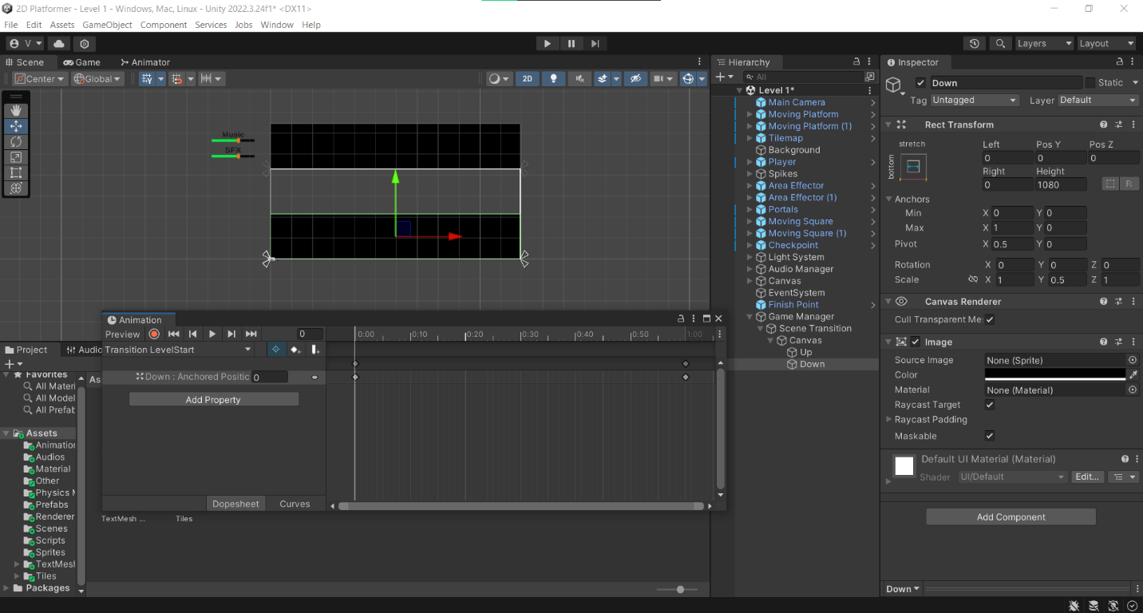Finally, I added a scene transition which gives a smooth transition when the player moves to the next level.
* OneDrive main folder link:[Intake 10 - Computer Animation Assignment - ITBIN-2110-0041](https://horizoncampus-my.sharepoint.com/:f:/g/personal/itbin-2110-0041_horizoncampus_edu_lk/EjQMh9wPxb1Buf4FUobba08B3uczrVvNMHdwI6W-EP5zxQ?e=OkmG61)