Game Design Document

Fill up the following document

1. Write the title of your project.

Tom and jerry infinite runner

1. What is the goal of the game?

Tom should catch the jerry

1. Write a brief story of your game.

In this game the tom wiil try to catch the jerry and tom need to over come the obstacles.

1. Which are the playing characters of this game?

* Playing characters are the ones who respond to the user based on the input from the user.
* Cars, monkeys, dinos, wizards, etc., are the playing characters in the game.

|  |  |  |
| --- | --- | --- |
| Number | Character Name | What can this character do? |
| 1 | Tom | Need to catch the jerry. Over come the obstacles. |
| 2 |  |  |
| 3 |  |  |
| 4 |  |  |
| 5 |  |  |
| 6 |  |  |
| 7 |  |  |
| 8 |  |  |

1. Which are the Non-Playing Characters of this game?

* Non-Playing characters are the ones that don't have an action or behavior when the user interacts with the game.
* Hurdles, stones, bananas, coins, etc., are non-playing characters in the game.

|  |  |  |
| --- | --- | --- |
| Number | Character Name | What can this character do? |
| 1 | Jerry | Jerry run before the tom and tries to save his life. |
| 2 | obstacles | Obstacles may stop the tom and make him fall. |
| 3 |  |  |
| 4 |  |  |
| 5 |  |  |
| 6 |  |  |
| 7 |  |  |
| 8 |  |  |

Draw your imagination of this game. What does this game look like?

* Draw the game either on your computer or on paper.
* Add images of the game scenes to show each of the playing and non-playing characters at least once.

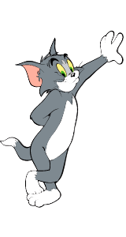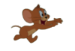

How do you plan to make your game engaging?

Player can restart the game and score will be displayed based on player performance