WEB DEVELOPMENT FRAMEWORKS (ITUE203)
ID: 25CE012
NAME: VIRAJ CHAKLASIYA
REPOSITORY: Source code and project files are included in the accompanying ZIP archive.
Practical 7
Aim: Process submitted registration/contact form data using PHP. Validate and
sanitize inputs on the server side and store records in CSV or JSON file
format. Display success/error messages.

Practical7.php

<?php
ob_start();
$csvFile = __DIR__ . '/practical7_data.csv';
$jsonFile = __DIR__ . '/practical7_data.json';
$errors = [];
$success = '';

if ($_SERVER['REQUEST_METHOD'] === 'POST') {

$fullname = isset($_POST['fullname']) ? trim($_POST['fullname']) : '';
$email = isset($_POST['email']) ? trim($_POST['email']) : '';
$phone = isset($_POST['phone']) ? trim($_POST['phone']) : '';
$course = isset($_POST['course']) ? trim($_POST['course']) : '';
$message = isset($_POST['message']) ? trim($_POST['message']) : '';

$fullname = htmlspecialchars($fullname, ENT_QUOTES, 'UTF-8');
$email = htmlspecialchars($email, ENT_QUOTES, 'UTF-8');
$phone = htmlspecialchars($phone, ENT_QUOTES, 'UTF-8');
$course = htmlspecialchars($course, ENT_QUOTES, 'UTF-8');
$message = htmlspecialchars($message, ENT_QUOTES, 'UTF-8');

if (empty($fullname)) {
$errors[] = 'Full Name is required.';
} elseif (!preg_match('/^[A-Za-z ]+$/', $fullname)) {
$errors[] = 'Full Name should contain only letters and spaces.';
}
if (empty($email)) {
$errors[] = 'Email is required.';
} elseif (!filter_var($email, FILTER_VALIDATE_EMAIL)) {
$errors[] = 'Please enter a valid email address.';
}
if (empty($phone)) {
$errors[] = 'Phone number is required.';
} elseif (!preg_match('/^[0-9]{10}$/', $phone)) {
$errors[] = 'Phone number must be exactly 10 digits.';
}
$validCourses = ['CE', 'IT', 'EC', 'ME'];
if (empty($course)) {
$errors[] = 'Please select a course.';
} elseif (!in_array($course, $validCourses)) {
$errors[] = 'Invalid course selected.';
}

if (empty($message)) {
$errors[] = 'Message is required.';
} elseif (strlen($message) < 10) {
$errors[] = 'Message must be at least 10 characters long.';
}
if (empty($errors)) {

$timestamp = date('Y-m-d H:i:s');
$csvHeader = !file_exists($csvFile);
$csvHandle = fopen($csvFile, 'a');

if ($csvHandle) {
if ($csvHeader) {
fputcsv($csvHandle, ['Full Name', 'Email', 'Phone', 'Course', 'Message', 'Timestamp']);
}
fputcsv($csvHandle, [$fullname, $email, $phone, $course, $message, $timestamp]);
fclose($csvHandle);
} else {
$errors[] = 'Error writing to CSV file.';
}

$jsonData = [];
if (file_exists($jsonFile)) {
$existingData = file_get_contents($jsonFile);
$jsonData = json_decode($existingData, true);
if (!is_array($jsonData)) {
$jsonData = [];
}
}

$newRecord = [
'fullname' => $fullname,
'email' => $email,
'phone' => $phone,
'course' => $course,
'message' => $message,
'timestamp' => $timestamp
];

$jsonData[] = $newRecord;

$jsonResult = file_put_contents($jsonFile, json_encode($jsonData, JSON_PRETTY_PRINT));

if ($jsonResult === false) {
$errors[] = 'Error writing to JSON file.';
}

if (empty($errors)) {
$success = 'Your form has been submitted successfully! Data saved to CSV and JSON files.';
}
}

} else {
header('Location: practical7_form.HTML');
exit;
}
?>
<!DOCTYPE html>
<html lang="en">
<head>
<meta charset="UTF-8">
<meta name="viewport" content="width=device-width, initial-scale=1.0">
<title>StudentHub - Form Submission Result</title>
<link rel="stylesheet" href="style.css">
<style>
.success-msg {
color: green;
font-weight: bold;
background-color: #d4edda;
border: 2px solid green;
padding: 12px;
border-radius: 8px;
margin: 10px auto;
max-width: 500px;
}
.error-msg {
color: red;
font-weight: bold;
background-color: #f8d7da;
border: 2px solid red;
padding: 12px;
border-radius: 8px;
margin: 10px auto;
max-width: 500px;
}
.error-msg ul {
text-align: left;
margin: 5px 0;
}
</style>
</head>
<body>

<div id="header">
<h1 align="center">STUDENTHUB</h1>
</div>

<br>

<div align="center">
<a href="home.HTML"><button type="button">Home</button></a>
<a href="practical7_form.HTML"><button type="button">Contact Form</button></a>
</div>

<br>
<hr>
<br>

<div align="center">

<h2><u>Form Submission Result</u></h2>

<br>

<?php if (!empty($success)): ?>
<div class="success-msg">
<p><?php echo $success; ?></p>
</div>
<?php endif; ?>

<?php if (!empty($errors)): ?>
<div class="error-msg">
<p>Please fix the following errors:</p>
<ul>
<?php foreach ($errors as $err): ?>
<li><?php echo $err; ?></li>
<?php endforeach; ?>
</ul>
</div>
<?php endif; ?>

<br>

<a href="practical7_form.HTML">
<button type="button">Go Back to Form</button>
</a>

<br><br>

<a href="practical7_records.php">
<button type="button">View Stored Records</button>
</a>

</div>

<br>
<hr>

<footer align="center">
<h4>@ 2026 Viraj Chaklasiya</h4>
</footer>

</body>
</html>
<?php ob_end_flush(); ?>

Practical 8
AIM: Design the database for StudentHub with students, events and registrations. Create PHP database connection using MYSQL statements.

<?php

require_once 'db.php';
?>
<!DOCTYPE html>
<html lang="en">
<head>
<meta charset="UTF-8">
<meta name="viewport" content="width=device-width, initial-scale=1.0">
<title>StudentHub - DB Connection Test</title>
<link rel="stylesheet" href="style.css">
<style>
.success-msg {
color: green;
font-weight: bold;
background-color: #d4edda;
border: 2px solid green;
padding: 12px;
border-radius: 8px;
margin: 10px auto;
max-width: 500px;
}
.info-table {
border-collapse: collapse;
margin: 10px auto;
}
.info-table th, .info-table td {
border: 2px solid rgb(17, 8, 8);
padding: 8px 15px;
text-align: left;
}
.info-table th {
background-color: rgb(144, 164, 165);
color: white;
}
.info-table tr:nth-child(even) {
background-color: #eaf4fc;
}
</style>
</head>
<body>

<div id="header">
<h1 align="center">STUDENTHUB</h1>
</div>

<br>

<div align="center">
<a href="home.HTML"><button type="button">Home</button></a>
</div>

<br>
<hr>
<br>

<div align="center">

<h2><u>Database Connection Test (Practical 8)</u></h2>

<br>

<div class="success-msg">
<p>✅ Database connection successful!</p>
</div>

<br>

<h3>Database Information</h3>

<table class="info-table">
<tr>
<th>Property</th>
<th>Value</th>
</tr>
<tr>
<td>Host</td>
<td><?php echo htmlspecialchars($conn->host_info); ?></td>
</tr>
<tr>
<td>Server Version</td>
<td><?php echo htmlspecialchars($conn->server_info); ?></td>
</tr>
<tr>
<td>Database</td>
<td>studenthub</td>
</tr>
<tr>
<td>Character Set</td>
<td><?php echo htmlspecialchars($conn->character_set_name()); ?></td>
</tr>
</table>

<br>

<h3>Tables in Database</h3>

<table class="info-table">
<tr>
<th>#</th>
<th>Table Name</th>
<th>Row Count</th>
</tr>
<?php
$tables = $conn->query("SHOW TABLES");
$count = 1;
while ($row = $tables->fetch_row()) {
$tableName = $row[0];
$countResult = $conn->query("SELECT COUNT(*) AS cnt FROM `$tableName`");
$rowCount = $countResult->fetch_assoc()['cnt'];
echo '<tr>';
echo '<td>' . $count . '</td>';
echo '<td>' . htmlspecialchars($tableName) . '</td>';
echo '<td>' . $rowCount . '</td>';
echo '</tr>';
$count++;
}
?>
</table>

<br><br>

<a href="home.HTML">
<button type="button">BACK</button>
</a>

</div>

<br>
<hr>

<footer align="center">
<h4>@ 2026 Viraj Chaklasiya</h4>
</footer>

</body>
</html>
<?php $conn->close(); ?>

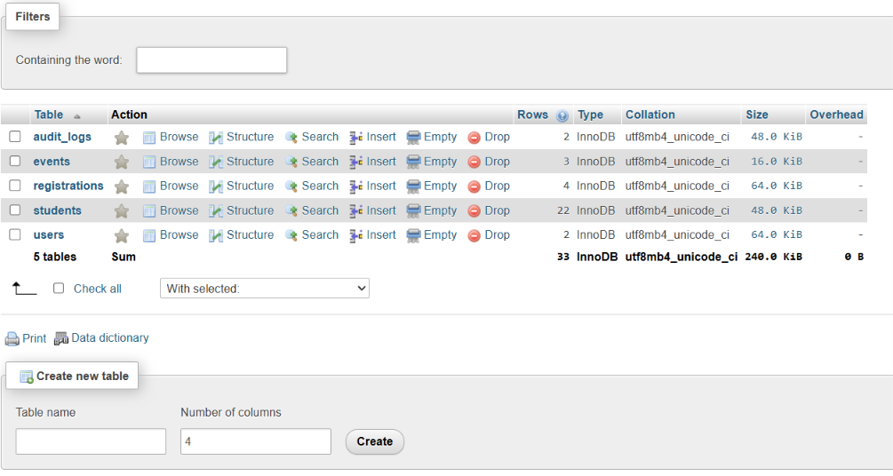

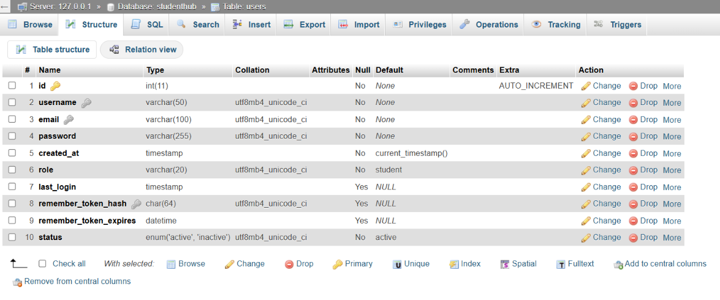

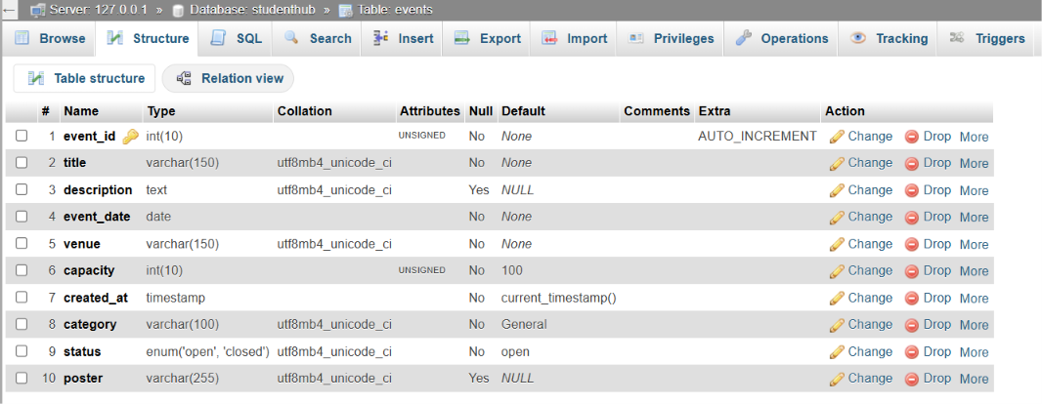

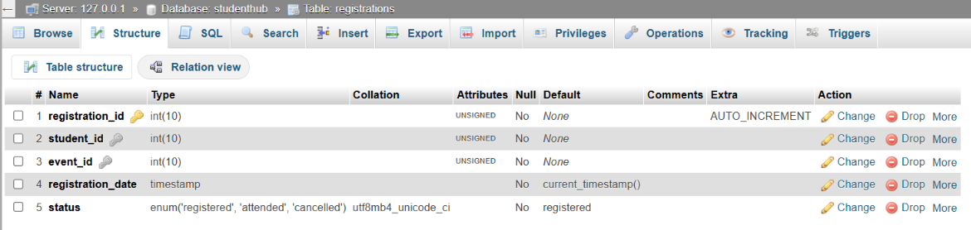

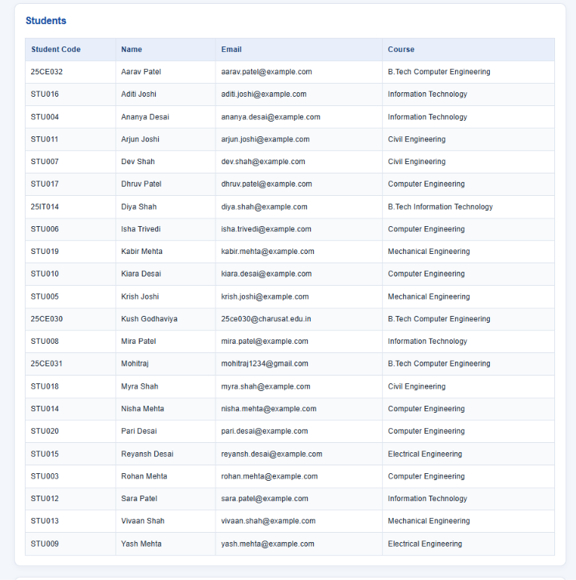

Practical 9
Aim: Implement secure user registration by inserting user details into MySQL using MySQLi. Validate inputs on both the frontend and backend, check for duplicate email addresses and usernames, hash passwords using password_hash(), and display appropriate success or error messages.

<?php
require_once 'db.php';

$errors = [];
$success = '';
$old = [
'username' => '',
'email' => ''
];

if ($_SERVER['REQUEST_METHOD'] === 'POST') {

$username = isset($_POST['username']) ? trim($_POST['username']) : '';
$email = isset($_POST['email']) ? trim($_POST['email']) : '';
$password = isset($_POST['password']) ? $_POST['password'] : '';
$confirm = isset($_POST['confirm_password']) ? $_POST['confirm_password'] : '';
$old['username'] = htmlspecialchars($username, ENT_QUOTES, 'UTF-8');
$old['email'] = htmlspecialchars($email, ENT_QUOTES, 'UTF-8');

if (empty($username)) {
$errors[] = 'Username is required.';
} elseif (!preg_match('/^[A-Za-z ]{3,100}$/', $username)) {
$errors[] = 'Username must contain only letters and spaces (3-100 characters).';
}
if (empty($email)) {
$errors[] = 'Email is required.';
} elseif (!filter_var($email, FILTER_VALIDATE_EMAIL)) {
$errors[] = 'Please enter a valid email address.';
}

if (empty($password)) {
$errors[] = 'Password is required.';
} elseif (strlen($password) < 8) {
$errors[] = 'Password must be at least 8 characters long.';
} elseif (!preg_match('/[A-Z]/', $password)) {
$errors[] = 'Password must contain at least one uppercase letter.';
} elseif (!preg_match('/[0-9]/', $password)) {
$errors[] = 'Password must contain at least one number.';
}
if ($password !== $confirm) {
$errors[] = 'Passwords do not match.';
}
if (empty($errors)) {
$stmt = $conn->prepare("SELECT id FROM users WHERE email = ?");
$stmt->bind_param("s", $email);
$stmt->execute();
$stmt->store_result();

if ($stmt->num_rows > 0) {
$errors[] = 'This email is already registered. Please use a different email.';
}
$stmt->close();
}
if (empty($errors)) {
$stmt = $conn->prepare("SELECT id FROM users WHERE username = ?");
$stmt->bind_param("s", $username);
$stmt->execute();
$stmt->store_result();

if ($stmt->num_rows > 0) {
$errors[] = 'This username is already taken. Please choose a different one.';
}
$stmt->close();
}
if (empty($errors)) {
$hashedPassword = password_hash($password, PASSWORD_DEFAULT);

$stmt = $conn->prepare("INSERT INTO users (username, email, password, role) VALUES (?, ?, ?, 'student')");
$stmt->bind_param("sss", $username, $email, $hashedPassword);

if ($stmt->execute()) {
$success = 'Registration successful! You can now login.';
$old = ['username' => '', 'email' => ''];

$userId = $stmt->insert_id;
$action = 'REGISTER';
$details = "New user registered: $username ($email)";
$ip = $_SERVER['REMOTE_ADDR'];
$logStmt = $conn->prepare("INSERT INTO audit_logs (user_id, action, details, ip_address) VALUES (?, ?, ?, ?)");
$logStmt->bind_param("isss", $userId, $action, $details, $ip);
$logStmt->execute();
$logStmt->close();
} else {
$errors[] = 'Registration failed. Please try again.';
}

$stmt->close();
}
}
?>
<!DOCTYPE html>
<html lang="en">
<head>
<meta charset="UTF-8">
<meta name="viewport" content="width=device-width, initial-scale=1.0">
<title>StudentHub - User Registration</title>
<link rel="stylesheet" href="style.css">
<style>
.success-msg {
color: green;
font-weight: bold;
background-color: #d4edda;
border: 2px solid green;
padding: 12px;
border-radius: 8px;
margin: 10px auto;
max-width: 500px;
}
.error-msg {
color: red;
font-weight: bold;
background-color: #f8d7da;
border: 2px solid red;
padding: 12px;
border-radius: 8px;
margin: 10px auto;
max-width: 500px;
}
.error-msg ul {
text-align: left;
margin: 5px 0;
}
small.field-error {
color: red;
display: block;
margin-top: 2px;
}
</style>
</head>
<body>

<div id="header">
<h1 align="center">STUDENTHUB</h1>
</div>

<br>

<div align="center">
<a href="home.HTML"><button type="button">Home</button></a>
<a href="practical10_login.php"><button type="button">Login</button></a>
</div>

<br>
<hr>
<br>

<div align="center">

<?php if (!empty($success)): ?>
<div class="success-msg">
<p><?php echo $success; ?></p>
</div>
<br>
<a href="practical10_login.php"><button type="button">Go to Login</button></a>
<br><br>
<?php endif; ?>

<?php if (!empty($errors)): ?>
<div class="error-msg">
<p>Please fix the following errors:</p>
<ul>
<?php foreach ($errors as $err): ?>
<li><?php echo htmlspecialchars($err); ?></li>
<?php endforeach; ?>
</ul>
</div>
<br>
<?php endif; ?>

<form action="practical9_register.php" method="POST" class="card" id="registerForm">

<h2 align="center"><u>User Registration (Practical 9)</u></h2>

<br>

<table class="form-table" align="center">

<tr>
<td><label for="username">Username :</label></td>
<td>
<input type="text" id="username" name="username"
placeholder="Enter your name"
value="<?php echo $old['username']; ?>"
>
<small id="usernameError" class="field-error"></small>
</td>
</tr>

<tr>
<td><label for="email">Email :</label></td>
<td>
<input type="email" id="email" name="email"
placeholder="abc@gmail.com"
value="<?php echo $old['email']; ?>"
>
<small id="emailError" class="field-error"></small>
</td>
</tr>

<tr>
<td><label for="password">Password :</label></td>
<td>
<input type="password" id="password" name="password"
placeholder="Min 8 chars, 1 uppercase, 1 number"
>
<small id="passwordError" class="field-error"></small>
</td>
</tr>

<tr>
<td><label for="confirm_password">Confirm Password :</label></td>
<td>
<input type="password" id="confirm_password" name="confirm_password"
placeholder="Re-enter password"
>
<small id="confirmError" class="field-error"></small>
</td>
</tr>

</table>

<br>

<div align="center">
<button type="submit">Register</button>
<button type="reset">Reset</button>
</div>

<br>

</form>

<br>

<p>Already have an account? <a href="practical10_login.php">Login here</a></p>

<br>

<a href="home.HTML">
<button type="button">BACK</button>
</a>

</div>

<br>
<hr>

<footer align="center">
<h4>@ 2026 Viraj Chaklasiya</h4>
</footer>

<script>
const registerForm = document.getElementById('registerForm');

registerForm.addEventListener('submit', function(event) {
let valid = true;

document.getElementById('usernameError').innerText = '';
document.getElementById('emailError').innerText = '';
document.getElementById('passwordError').innerText = '';
document.getElementById('confirmError').innerText = '';

const username = document.getElementById('username').value.trim();
const email = document.getElementById('email').value.trim();
const password = document.getElementById('password').value;
const confirm = document.getElementById('confirm_password').value;

const namePattern = /^[A-Za-z ]{3,100}$/;
const emailPattern = /^[^\s@]+@[^\s@]+\.[^\s@]+$/;

if (username === '') {
document.getElementById('usernameError').innerText = 'Username is required.';
valid = false;
} else if (!namePattern.test(username)) {
document.getElementById('usernameError').innerText = 'Only letters and spaces (3-100 chars).';
valid = false;
}

if (email === '') {
document.getElementById('emailError').innerText = 'Email is required.';
valid = false;
} else if (!emailPattern.test(email)) {
document.getElementById('emailError').innerText = 'Please enter a valid email.';
valid = false;
}

if (password === '') {
document.getElementById('passwordError').innerText = 'Password is required.';
valid = false;
} else if (password.length < 8) {
document.getElementById('passwordError').innerText = 'Min 8 characters required.';
valid = false;
} else if (!/[A-Z]/.test(password)) {
document.getElementById('passwordError').innerText = 'Must contain an uppercase letter.';
valid = false;
} else if (!/[0-9]/.test(password)) {
document.getElementById('passwordError').innerText = 'Must contain a number.';
valid = false;
}

if (password !== confirm) {
document.getElementById('confirmError').innerText = 'Passwords do not match.';
valid = false;
}

if (!valid) {
event.preventDefault();
}
});
</script>

</body>
</html>
<?php $conn->close(); ?>

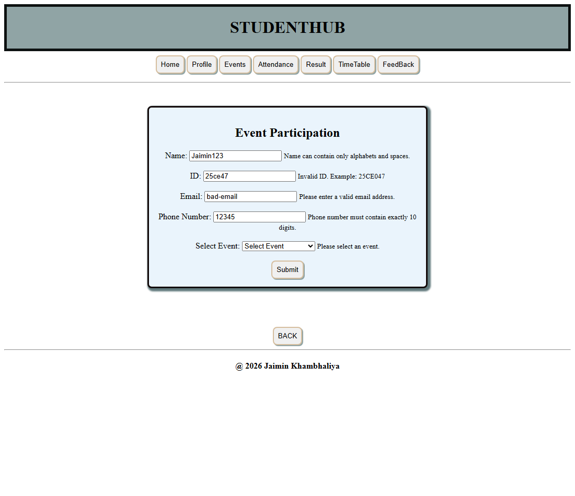

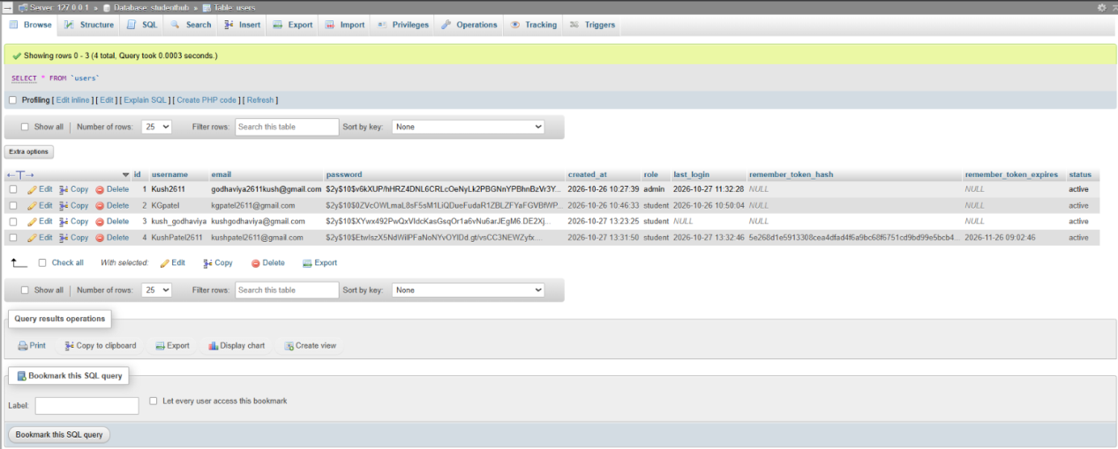

Practical 10
AIM: Develop secure login and logout functionality using PHP sessions. Verify
password using password_verify(), regenerate session ID after login,
restrict dashboard access, implement role-based redirection, session
timeout, and optional secure remember-me token.

<?php

session_start();
require_once 'db.php';
if (isset($_SESSION['user_id'])) {
if ($_SESSION['role'] === 'admin') {
header('Location: practical14_dashboard.php');
} else {
header('Location: practical10_student_dashboard.php');
}
exit;
}

$errors = [];
$old_email = '';

if ($_SERVER['REQUEST_METHOD'] === 'POST') {

$email = isset($_POST['email']) ? trim($_POST['email']) : '';
$password = isset($_POST['password']) ? $_POST['password'] : '';

$old_email = htmlspecialchars($email, ENT_QUOTES, 'UTF-8');

// Validation
if (empty($email)) {
$errors[] = 'Email is required.';
} elseif (!filter_var($email, FILTER_VALIDATE_EMAIL)) {
$errors[] = 'Please enter a valid email address.';
}

if (empty($password)) {
$errors[] = 'Password is required.';
}

if (empty($errors)) {
$stmt = $conn->prepare("SELECT id, username, email, password, role, status FROM users WHERE email = ?");
$stmt->bind_param("s", $email);
$stmt->execute();
$result = $stmt->get_result();

if ($result->num_rows === 1) {
$user = $result->fetch_assoc();

if ($user['status'] !== 'active') {
$errors[] = 'Your account is inactive. Please contact the administrator.';
}
elseif (password_verify($password, $user['password'])) {

session_regenerate_id(true);

$_SESSION['user_id'] = $user['id'];
$_SESSION['username'] = $user['username'];
$_SESSION['email'] = $user['email'];
$_SESSION['role'] = $user['role'];
$_SESSION['login_time'] = time();
$_SESSION['last_activity'] = time();
$updateStmt = $conn->prepare("UPDATE users SET last_login = NOW() WHERE id = ?");
$updateStmt->bind_param("i", $user['id']);
$updateStmt->execute();
$updateStmt->close();

$action = 'LOGIN';
$details = "User logged in: " . $user['username'] . " (" . $user['email'] . ")";
$ip = $_SERVER['REMOTE_ADDR'];
$logStmt = $conn->prepare("INSERT INTO audit_logs (user_id, action, details, ip_address) VALUES (?, ?, ?, ?)");
$logStmt->bind_param("isss", $user['id'], $action, $details, $ip);
$logStmt->execute();
$logStmt->close();
if ($user['role'] === 'admin') {
header('Location: practical14_dashboard.php');
} else {
header('Location: practical10_student_dashboard.php');
}
exit;

} else {
$errors[] = 'Invalid password. Please try again.';
}
} else {
$errors[] = 'No account found with this email.';
}

$stmt->close();
}
}

$conn->close();
?>
<!DOCTYPE html>
<html lang="en">
<head>
<meta charset="UTF-8">
<meta name="viewport" content="width=device-width, initial-scale=1.0">
<title>StudentHub - Login</title>
<link rel="stylesheet" href="style.css">
<style>
.error-msg {
color: red;
font-weight: bold;
background-color: #f8d7da;
border: 2px solid red;
padding: 12px;
border-radius: 8px;
margin: 10px auto;
max-width: 500px;
}
.error-msg ul { text-align: left; margin: 5px 0; }
.info-msg {
color: #0c5460;
background-color: #d1ecf1;
border: 2px solid #0c5460;
padding: 12px;
border-radius: 8px;
margin: 10px auto;
max-width: 500px;
font-weight: bold;
}
small.field-error {
color: red;
display: block;
margin-top: 2px;
}
</style>
</head>
<body>

<div id="header">
<h1 align="center">STUDENTHUB</h1>
</div>

<br><br>

<div align="center">

<?php if (isset($_GET['timeout'])): ?>
<div class="info-msg">
<p>Your session has expired due to inactivity. Please login again.</p>
</div>
<br>
<?php endif; ?>

<?php if (isset($_GET['logout'])): ?>
<div class="info-msg">
<p>You have been logged out successfully.</p>
</div>
<br>
<?php endif; ?>

<?php if (isset($_GET['unauthorized'])): ?>
<div class="error-msg">
<p>⚠️ Access denied. Please login to continue.</p>
</div>
<br>
<?php endif; ?>

<?php if (!empty($errors)): ?>
<div class="error-msg">
<p>Login Failed:</p>
<ul>
<?php foreach ($errors as $err): ?>
<li><?php echo htmlspecialchars($err); ?></li>
<?php endforeach; ?>
</ul>
</div>
<br>
<?php endif; ?>

<form action="practical10_login.php" method="POST" class="card" id="loginForm">

<br>

<u><h3>Secure Login (Practical 10)</h3></u>

<br>

<table class="form-table" align="center">

<tr>
<td><label for="email">Email :</label></td>
<td>
<input type="email" id="email" name="email"
placeholder="Enter your email"
value="<?php echo $old_email; ?>"
>
<small id="emailError" class="field-error"></small>
</td>
</tr>

<tr>
<td><label for="password">Password :</label></td>
<td>
<input type="password" id="password" name="password"
placeholder="Enter your password"
>
<small id="passwordError" class="field-error"></small>
</td>
</tr>

</table>

<br><br>

<input type="submit" value="Login" style="width: 250px;">

<br><br>

<a href="practical9_register.php">
<button type="button">Register</button>
</a>

</form>

<br>

<p>Don't have an account? <a href="practical9_register.php">Register here</a></p>

<br>

<div>
<p><strong>Test Credentials:</strong></p>
<p>Admin: admin@studenthub.com / password123</p>
<p>Student: jaimin@gmail.com / password123</p>
</div>

</div>

<br>
<hr>

<footer align="center">
<h4>@ 2026 Viraj Chaklasiya</h4>
</footer>

<script>
const loginForm = document.getElementById('loginForm');

loginForm.addEventListener('submit', function(event) {
let valid = true;

document.getElementById('emailError').innerText = '';
document.getElementById('passwordError').innerText = '';

const email = document.getElementById('email').value.trim();
const password = document.getElementById('password').value;
const emailPattern = /^[^\s@]+@[^\s@]+\.[^\s@]+$/;

if (email === '') {
document.getElementById('emailError').innerText = 'Please enter your email.';
valid = false;
} else if (!emailPattern.test(email)) {
document.getElementById('emailError').innerText = 'Please enter a valid email.';
valid = false;
}

if (password === '') {
document.getElementById('passwordError').innerText = 'Please enter your password.';
valid = false;
}

if (!valid) {
event.preventDefault();
}
});
</script>

</body>
</html>

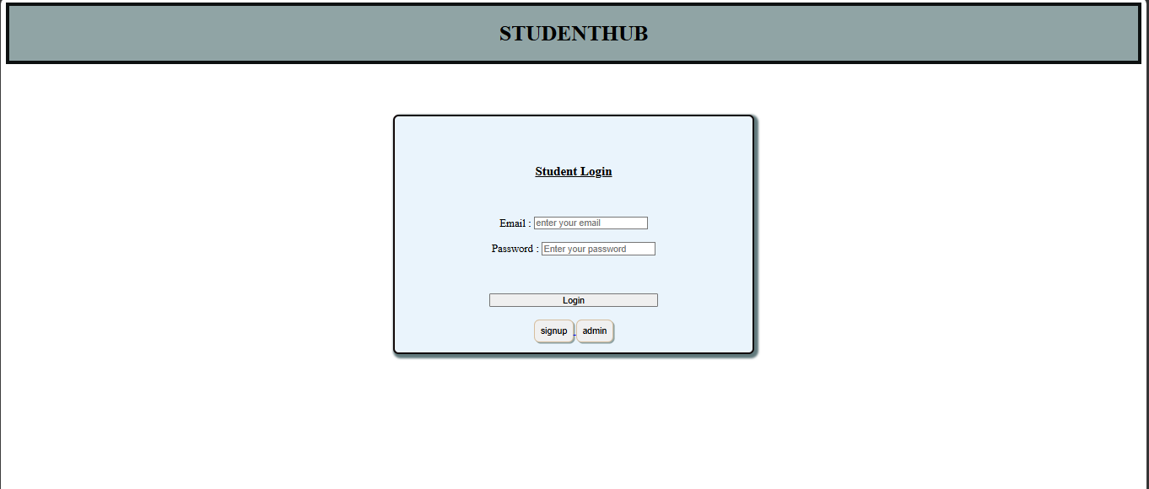
Practical 11
AIM: Create a student management module to add, view, edit, delete, search and
filter student records. All database operations must use MYSQLi
statements and clear success/failure messages.

<?php

require_once 'auth_check.php';
require_once 'db.php';

$message = '';
$messageType = '';

if (isset($_GET['delete']) && is_numeric($_GET['delete'])) {
$deleteId = (int)$_GET['delete'];

$stmt = $conn->prepare("UPDATE students SET status = 'deleted' WHERE id = ?");
$stmt->bind_param("i", $deleteId);

if ($stmt->execute() && $stmt->affected_rows > 0) {
$message = 'Student record deleted successfully.';
$messageType = 'success';

$action = 'DELETE_STUDENT';
$details = "Soft deleted student ID: $deleteId";
$ip = $_SERVER['REMOTE_ADDR'];
$logStmt = $conn->prepare("INSERT INTO audit_logs (user_id, action, details, ip_address) VALUES (?, ?, ?, ?)");
$logStmt->bind_param("isss", $_SESSION['user_id'], $action, $details, $ip);
$logStmt->execute();
$logStmt->close();
} else {
$message = 'Failed to delete student record.';
$messageType = 'error';
}
$stmt->close();
}
if ($_SERVER['REQUEST_METHOD'] === 'POST' && isset($_POST['action']) && $_POST['action'] === 'add') {
$fullname = trim($_POST['fullname']);
$email = trim($_POST['email']);
$phone = trim($_POST['phone']);
$course = trim($_POST['course']);
$year = (int)$_POST['year'];
$gender = trim($_POST['gender']);
$address = trim($_POST['address']);

$errors = [];

if (empty($fullname) || !preg_match('/^[A-Za-z ]+$/', $fullname)) $errors[] = 'Valid full name is required.';
if (empty($email) || !filter_var($email, FILTER_VALIDATE_EMAIL)) $errors[] = 'Valid email is required.';
if (empty($phone) || !preg_match('/^[0-9]{10}$/', $phone)) $errors[] = 'Valid 10-digit phone is required.';
if (empty($course)) $errors[] = 'Course is required.';
if ($year < 1 || $year > 4) $errors[] = 'Year must be between 1 and 4.';
if (!in_array($gender, ['Male', 'Female', 'Other'])) $errors[] = 'Valid gender is required.';

if (empty($errors)) {
$stmt = $conn->prepare("SELECT id FROM students WHERE email = ? AND status = 'active'");
$stmt->bind_param("s", $email);
$stmt->execute();
$stmt->store_result();
if ($stmt->num_rows > 0) {
$errors[] = 'A student with this email already exists.';
}
$stmt->close();
}

if (empty($errors)) {
$stmt = $conn->prepare("INSERT INTO students (fullname, email, phone, course, year, gender, address) VALUES (?, ?, ?, ?, ?, ?, ?)");
$stmt->bind_param("sssssss", $fullname, $email, $phone, $course, $year, $gender, $address);

if ($stmt->execute()) {
$message = 'Student added successfully!';
$messageType = 'success';

$action = 'ADD_STUDENT';
$details = "Added student: $fullname ($email)";
$ip = $_SERVER['REMOTE_ADDR'];
$logStmt = $conn->prepare("INSERT INTO audit_logs (user_id, action, details, ip_address) VALUES (?, ?, ?, ?)");
$logStmt->bind_param("isss", $_SESSION['user_id'], $action, $details, $ip);
$logStmt->execute();
$logStmt->close();
} else {
$message = 'Failed to add student.';
$messageType = 'error';
}
$stmt->close();
} else {
$message = implode(' ', $errors);
$messageType = 'error';
}
}

if ($_SERVER['REQUEST_METHOD'] === 'POST' && isset($_POST['action']) && $_POST['action'] === 'edit') {
$editId = (int)$_POST['edit_id'];
$fullname = trim($_POST['fullname']);
$email = trim($_POST['email']);
$phone = trim($_POST['phone']);
$course = trim($_POST['course']);
$year = (int)$_POST['year'];
$gender = trim($_POST['gender']);
$address = trim($_POST['address']);

$errors = [];

if (empty($fullname) || !preg_match('/^[A-Za-z ]+$/', $fullname)) $errors[] = 'Valid full name is required.';
if (empty($email) || !filter_var($email, FILTER_VALIDATE_EMAIL)) $errors[] = 'Valid email is required.';
if (empty($phone) || !preg_match('/^[0-9]{10}$/', $phone)) $errors[] = 'Valid 10-digit phone is required.';
if (empty($course)) $errors[] = 'Course is required.';
if ($year < 1 || $year > 4) $errors[] = 'Year must be between 1 and 4.';
if (!in_array($gender, ['Male', 'Female', 'Other'])) $errors[] = 'Valid gender is required.';

if (empty($errors)) {
$stmt = $conn->prepare("SELECT id FROM students WHERE email = ? AND id != ? AND status = 'active'");
$stmt->bind_param("si", $email, $editId);
$stmt->execute();
$stmt->store_result();
if ($stmt->num_rows > 0) {
$errors[] = 'Another student with this email already exists.';
}
$stmt->close();
}

if (empty($errors)) {
$stmt = $conn->prepare("UPDATE students SET fullname=?, email=?, phone=?, course=?, year=?, gender=?, address=? WHERE id=?");
$stmt->bind_param("sssssssi", $fullname, $email, $phone, $course, $year, $gender, $address, $editId);

if ($stmt->execute()) {
$message = 'Student updated successfully!';
$messageType = 'success';

$action = 'UPDATE_STUDENT';
$details = "Updated student ID $editId: $fullname ($email)";
$ip = $_SERVER['REMOTE_ADDR'];
$logStmt = $conn->prepare("INSERT INTO audit_logs (user_id, action, details, ip_address) VALUES (?, ?, ?, ?)");
$logStmt->bind_param("isss", $_SESSION['user_id'], $action, $details, $ip);
$logStmt->execute();
$logStmt->close();
} else {
$message = 'Failed to update student.';
$messageType = 'error';
}
$stmt->close();
} else {
$message = implode(' ', $errors);
$messageType = 'error';
}
}
if (isset($_GET['export']) && $_GET['export'] === 'csv') {
header('Content-Type: text/csv');
header('Content-Disposition: attachment; filename="students_export.csv"');

$output = fopen('php://output', 'w');
fputcsv($output, ['ID', 'Full Name', 'Email', 'Phone', 'Course', 'Year', 'Gender', 'Address', 'Created At']);

$result = $conn->query("SELECT id, fullname, email, phone, course, year, gender, address, created_at FROM students WHERE status = 'active' ORDER BY id");
while ($row = $result->fetch_assoc()) {
fputcsv($output, $row);
}

fclose($output);
$conn->close();
exit;
}

$search = isset($_GET['search']) ? trim($_GET['search']) : '';
$filterCourse = isset($_GET['course_filter']) ? trim($_GET['course_filter']) : '';

$sql = "SELECT * FROM students WHERE status = 'active'";
$params = [];
$types = '';

if (!empty($search)) {
$sql .= " AND (fullname LIKE ? OR email LIKE ? OR course LIKE ?)";
$searchParam = "%$search%";
$params[] = $searchParam;
$params[] = $searchParam;
$params[] = $searchParam;
$types .= 'sss';
}

if (!empty($filterCourse)) {
$sql .= " AND course = ?";
$params[] = $filterCourse;
$types .= 's';
}

$sql .= " ORDER BY id DESC";

$stmt = $conn->prepare($sql);

if (!empty($params)) {
$stmt->bind_param($types, ...$params);
}

$stmt->execute();
$result = $stmt->get_result();
$students = [];
while ($row = $result->fetch_assoc()) {
$students[] = $row;
}
$stmt->close();
$editStudent = null;
if (isset($_GET['edit']) && is_numeric($_GET['edit'])) {
$editId = (int)$_GET['edit'];
$stmt = $conn->prepare("SELECT * FROM students WHERE id = ? AND status = 'active'");
$stmt->bind_param("i", $editId);
$stmt->execute();
$editResult = $stmt->get_result();
if ($editResult->num_rows === 1) {
$editStudent = $editResult->fetch_assoc();
}
$stmt->close();
}
$coursesResult = $conn->query("SELECT DISTINCT course FROM students WHERE status = 'active' ORDER BY course");
$courses = [];
while ($row = $coursesResult->fetch_assoc()) {
$courses[] = $row['course'];
}
?>
<!DOCTYPE html>
<html lang="en">
<head>
<meta charset="UTF-8">
<meta name="viewport" content="width=device-width, initial-scale=1.0">
<title>StudentHub - Student Management</title>
<link rel="stylesheet" href="style.css">
<style>
.success-msg {
color: green; font-weight: bold; background-color: #d4edda;
border: 2px solid green; padding: 12px; border-radius: 8px;
margin: 10px auto; max-width: 700px;
}
.error-msg {
color: red; font-weight: bold; background-color: #f8d7da;
border: 2px solid red; padding: 12px; border-radius: 8px;
margin: 10px auto; max-width: 700px;
}
table.records {
border-collapse: collapse; margin: 10px auto; max-width: 95%;
}
table.records th, table.records td {
border: 2px solid rgb(17, 8, 8); padding: 6px 10px; text-align: left; font-size: 14px;
}
table.records th {
background-color: rgb(144, 164, 165); color: white;
}
table.records tr:nth-child(even) { background-color: #eaf4fc; }
.search-bar { margin: 10px auto; }
.search-bar input, .search-bar select { padding: 6px 8px; margin: 4px; }
.action-btn {
padding: 4px 10px; margin: 2px; border-radius: 4px; cursor: pointer; font-size: 13px;
}
.edit-btn { background-color: #ffc107; border: 1px solid #e0a800; }
.delete-btn { background-color: #dc3545; color: white; border: 1px solid #c82333; }
</style>
</head>
<body>

<div id="header">
<h1 align="center">STUDENTHUB</h1>
</div>

<br>

<div align="center">
<a href="home.HTML"><button type="button">Home</button></a>
<?php if ($_SESSION['role'] === 'admin'): ?>
<a href="practical14_dashboard.php"><button type="button">Admin Dashboard</button></a>
<?php else: ?>
<a href="practical10_student_dashboard.php"><button type="button">Dashboard</button></a>
<?php endif; ?>
<a href="practical10_logout.php"><button type="button">Logout</button></a>
</div>

<br>
<hr>
<br>

<div align="center">

<h2><u>Student Management (Practical 11)</u></h2>

<?php if (!empty($message)): ?>
<div class="<?php echo $messageType === 'success' ? 'success-msg' : 'error-msg'; ?>">
<p><?php echo htmlspecialchars($message); ?></p>
</div>
<?php endif; ?>

<br>

<form action="practical11_students.php" method="POST" class="card">

<h3><?php echo $editStudent ? 'Edit Student' : 'Add New Student'; ?></h3>

<?php if ($editStudent): ?>
<input type="hidden" name="action" value="edit">
<input type="hidden" name="edit_id" value="<?php echo $editStudent['id']; ?>">
<?php else: ?>
<input type="hidden" name="action" value="add">
<?php endif; ?>

<table class="form-table" align="center">
<tr>
<td><label>Full Name:</label></td>
<td><input type="text" name="fullname" placeholder="Enter name" value="<?php echo $editStudent ? htmlspecialchars($editStudent['fullname']) : ''; ?>" required></td>
</tr>
<tr>
<td><label>Email:</label></td>
<td><input type="email" name="email" placeholder="abc@gmail.com" value="<?php echo $editStudent ? htmlspecialchars($editStudent['email']) : ''; ?>" required></td>
</tr>
<tr>
<td><label>Phone:</label></td>
<td><input type="tel" name="phone" placeholder="10-digit number" value="<?php echo $editStudent ? htmlspecialchars($editStudent['phone']) : ''; ?>" required></td>
</tr>
<tr>
<td><label>Course:</label></td>
<td>
<select name="course" required>
<option value="">Select Course</option>
<?php
$courseOptions = ['CE', 'IT', 'EC', 'ME'];
foreach ($courseOptions as $c) {
$selected = ($editStudent && $editStudent['course'] === $c) ? 'selected' : '';
echo "<option value=\"$c\" $selected>$c</option>";
}
?>
</select>
</td>
</tr>
<tr>
<td><label>Year:</label></td>
<td>
<select name="year" required>
<option value="">Select Year</option>
<?php for ($y = 1; $y <= 4; $y++): ?>
<option value="<?php echo $y; ?>" <?php echo ($editStudent && $editStudent['year'] == $y) ? 'selected' : ''; ?>><?php echo $y; ?></option>
<?php endfor; ?>
</select>
</td>
</tr>
<tr>
<td><label>Gender:</label></td>
<td>
<select name="gender" required>
<option value="">Select Gender</option>
<?php
$genders = ['Male', 'Female', 'Other'];
foreach ($genders as $g) {
$selected = ($editStudent && $editStudent['gender'] === $g) ? 'selected' : '';
echo "<option value=\"$g\" $selected>$g</option>";
}
?>
</select>
</td>
</tr>
<tr>
<td><label>Address:</label></td>
<td><input type="text" name="address" placeholder="City, State" value="<?php echo $editStudent ? htmlspecialchars($editStudent['address']) : ''; ?>"></td>
</tr>
</table>

<br>
<button type="submit"><?php echo $editStudent ? 'Update Student' : 'Add Student'; ?></button>
<?php if ($editStudent): ?>
<a href="practical11_students.php"><button type="button">Cancel</button></a>
<?php endif; ?>
</form>

<br>

<div class="search-bar">
<form action="practical11_students.php" method="GET">
<input type="text" name="search" placeholder="Search name/email/course" value="<?php echo htmlspecialchars($search); ?>">
<select name="course_filter">
<option value="">All Courses</option>
<?php foreach ($courses as $c): ?>
<option value="<?php echo htmlspecialchars($c); ?>" <?php echo ($filterCourse === $c) ? 'selected' : ''; ?>><?php echo htmlspecialchars($c); ?></option>
<?php endforeach; ?>
</select>
<button type="submit">Search</button>
<a href="practical11_students.php"><button type="button">Clear</button></a>
<a href="practical11_students.php?export=csv"><button type="button">Export CSV</button></a>
</form>
</div>

<br>
<p><strong>Total Records: <?php echo count($students); ?></strong></p>

<?php if (count($students) > 0): ?>
<table class="records">
<tr>
<th>ID</th>
<th>Full Name</th>
<th>Email</th>
<th>Phone</th>
<th>Course</th>
<th>Year</th>
<th>Gender</th>
<th>Address</th>
<th>Actions</th>
</tr>
<?php foreach ($students as $s): ?>
<tr>
<td><?php echo $s['id']; ?></td>
<td><?php echo htmlspecialchars($s['fullname']); ?></td>
<td><?php echo htmlspecialchars($s['email']); ?></td>
<td><?php echo htmlspecialchars($s['phone']); ?></td>
<td><?php echo htmlspecialchars($s['course']); ?></td>
<td><?php echo $s['year']; ?></td>
<td><?php echo htmlspecialchars($s['gender']); ?></td>
<td><?php echo htmlspecialchars($s['address']); ?></td>
<td>
<a href="practical11_students.php?edit=<?php echo $s['id']; ?>"><button class="action-btn edit-btn">Edit</button></a>
<a href="practical11_students.php?delete=<?php echo $s['id']; ?>" onclick="return confirm('Are you sure you want to delete this student?');"><button class="action-btn delete-btn">Delete</button></a>
</td>
</tr>
<?php endforeach; ?>
</table>
<?php else: ?>
<p>No student records found.</p>
<?php endif; ?>

<br><br>

<a href="home.HTML">
<button type="button">BACK</button>
</a>

</div>

<br>
<hr>

<footer align="center">
<h4>@ 2026 Viraj Chaklasiya</h4>
</footer>

</body>
</html>
<?php $conn->close(); ?>

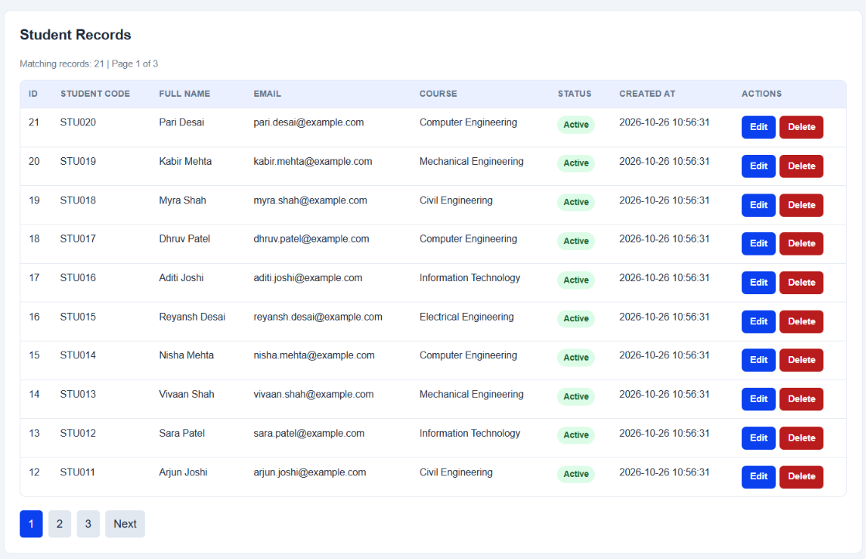

Practical 12
AIM: Develop event management functionality for admin users. Admin can add,
view, update, delete, and upload event posters with file type and file size
validation.

<?php

require_once 'auth_check.php';
require_once 'db.php';

if ($_SESSION['role'] !== 'admin') {
echo '<div style="text-align:center;padding:50px;"><h2>Access Denied</h2><p>Only admin users can manage events.</p><a href="practical10_login.php"><button>Go to Login</button></a></div>';
exit;
}
$uploadDir = __DIR__ . '/uploads/posters/';
if (!is_dir($uploadDir)) {
mkdir($uploadDir, 0755, true);
}

$message = '';
$messageType = '';
if (isset($_GET['delete']) && is_numeric($_GET['delete'])) {
$deleteId = (int)$_GET['delete'];

$stmt = $conn->prepare("SELECT poster FROM events WHERE id = ?");
$stmt->bind_param("i", $deleteId);
$stmt->execute();
$result = $stmt->get_result();
if ($result->num_rows > 0) {
$event = $result->fetch_assoc();
if (!empty($event['poster']) && file_exists($uploadDir . $event['poster'])) {
unlink($uploadDir . $event['poster']);
}
}
$stmt->close();

$stmt = $conn->prepare("DELETE FROM events WHERE id = ?");
$stmt->bind_param("i", $deleteId);

if ($stmt->execute() && $stmt->affected_rows > 0) {
$message = 'Event deleted successfully.';
$messageType = 'success';

$action = 'DELETE_EVENT';
$details = "Deleted event ID: $deleteId";
$ip = $_SERVER['REMOTE_ADDR'];
$logStmt = $conn->prepare("INSERT INTO audit_logs (user_id, action, details, ip_address) VALUES (?, ?, ?, ?)");
$logStmt->bind_param("isss", $_SESSION['user_id'], $action, $details, $ip);
$logStmt->execute();
$logStmt->close();
} else {
$message = 'Failed to delete event.';
$messageType = 'error';
}
$stmt->close();
}
function handlePosterUpload($uploadDir) {
$allowedTypes = ['image/jpeg', 'image/png', 'image/gif', 'image/webp'];
$maxSize = 2 * 1024 * 1024; // 2MB

if (!isset($_FILES['poster']) || $_FILES['poster']['error'] === UPLOAD_ERR_NO_FILE) {
return ['filename' => '', 'error' => ''];
}

$file = $_FILES['poster'];

if ($file['error'] !== UPLOAD_ERR_OK) {
return ['filename' => '', 'error' => 'File upload error.'];
}

$finfo = new finfo(FILEINFO_MIME_TYPE);
$mimeType = $finfo->file($file['tmp_name']);

if (!in_array($mimeType, $allowedTypes)) {
return ['filename' => '', 'error' => 'Invalid file type. Only JPEG, PNG, GIF, and WebP are allowed.'];
}
if ($file['size'] > $maxSize) {
return ['filename' => '', 'error' => 'File size exceeds 2MB limit.'];
}

$ext = pathinfo($file['name'], PATHINFO_EXTENSION);
$filename = 'poster_' . time() . '_' . mt_rand(1000, 9999) . '.' . $ext;

if (move_uploaded_file($file['tmp_name'], $uploadDir . $filename)) {
return ['filename' => $filename, 'error' => ''];
} else {
return ['filename' => '', 'error' => 'Failed to move uploaded file.'];
}
}

if ($_SERVER['REQUEST_METHOD'] === 'POST' && isset($_POST['action']) && $_POST['action'] === 'add') {
$title = trim($_POST['title']);
$description = trim($_POST['description']);
$event_date = trim($_POST['event_date']);
$location = trim($_POST['location']);
$category = trim($_POST['category']);
$event_status = trim($_POST['event_status']);

$errors = [];

if (empty($title)) $errors[] = 'Title is required.';
if (empty($event_date)) $errors[] = 'Event date is required.';
if (empty($location)) $errors[] = 'Location is required.';
if (empty($category)) $errors[] = 'Category is required.';
if (!in_array($event_status, ['open', 'closed'])) $errors[] = 'Valid status is required.';

$posterResult = handlePosterUpload($uploadDir);
if (!empty($posterResult['error'])) {
$errors[] = $posterResult['error'];
}

if (empty($errors)) {
$poster = $posterResult['filename'];
$createdBy = $_SESSION['user_id'];

$stmt = $conn->prepare("INSERT INTO events (title, description, event_date, location, category, poster, event_status, created_by) VALUES (?, ?, ?, ?, ?, ?, ?, ?)");
$stmt->bind_param("sssssssi", $title, $description, $event_date, $location, $category, $poster, $event_status, $createdBy);

if ($stmt->execute()) {
$message = 'Event added successfully!';
$messageType = 'success';

$action = 'CREATE_EVENT';
$details = "Created event: $title";
$ip = $_SERVER['REMOTE_ADDR'];
$logStmt = $conn->prepare("INSERT INTO audit_logs (user_id, action, details, ip_address) VALUES (?, ?, ?, ?)");
$logStmt->bind_param("isss", $_SESSION['user_id'], $action, $details, $ip);
$logStmt->execute();
$logStmt->close();
} else {
$message = 'Failed to add event.';
$messageType = 'error';
}
$stmt->close();
} else {
$message = implode(' ', $errors);
$messageType = 'error';
}
}
if ($_SERVER['REQUEST_METHOD'] === 'POST' && isset($_POST['action']) && $_POST['action'] === 'edit') {
$editId = (int)$_POST['edit_id'];
$title = trim($_POST['title']);
$description = trim($_POST['description']);
$event_date = trim($_POST['event_date']);
$location = trim($_POST['location']);
$category = trim($_POST['category']);
$event_status = trim($_POST['event_status']);

$errors = [];

if (empty($title)) $errors[] = 'Title is required.';
if (empty($event_date)) $errors[] = 'Event date is required.';
if (empty($location)) $errors[] = 'Location is required.';
if (empty($category)) $errors[] = 'Category is required.';
if (!in_array($event_status, ['open', 'closed'])) $errors[] = 'Valid status is required.';

$posterResult = handlePosterUpload($uploadDir);
if (!empty($posterResult['error'])) {
$errors[] = $posterResult['error'];
}

if (empty($errors)) {
if (!empty($posterResult['filename'])) {
$stmt = $conn->prepare("SELECT poster FROM events WHERE id = ?");
$stmt->bind_param("i", $editId);
$stmt->execute();
$oldResult = $stmt->get_result();
if ($oldResult->num_rows > 0) {
$oldEvent = $oldResult->fetch_assoc();
if (!empty($oldEvent['poster']) && file_exists($uploadDir . $oldEvent['poster'])) {
unlink($uploadDir . $oldEvent['poster']);
}
}
$stmt->close();

$poster = $posterResult['filename'];
$stmt = $conn->prepare("UPDATE events SET title=?, description=?, event_date=?, location=?, category=?, poster=?, event_status=? WHERE id=?");
$stmt->bind_param("sssssssi", $title, $description, $event_date, $location, $category, $poster, $event_status, $editId);
} else {
$stmt = $conn->prepare("UPDATE events SET title=?, description=?, event_date=?, location=?, category=?, event_status=? WHERE id=?");
$stmt->bind_param("ssssssi", $title, $description, $event_date, $location, $category, $event_status, $editId);
}

if ($stmt->execute()) {
$message = 'Event updated successfully!';
$messageType = 'success';

$action = 'UPDATE_EVENT';
$details = "Updated event ID $editId: $title";
$ip = $_SERVER['REMOTE_ADDR'];
$logStmt = $conn->prepare("INSERT INTO audit_logs (user_id, action, details, ip_address) VALUES (?, ?, ?, ?)");
$logStmt->bind_param("isss", $_SESSION['user_id'], $action, $details, $ip);
$logStmt->execute();
$logStmt->close();
} else {
$message = 'Failed to update event.';
$messageType = 'error';
}
$stmt->close();
} else {
$message = implode(' ', $errors);
$messageType = 'error';
}
}

$filterCategory = isset($_GET['category_filter']) ? trim($_GET['category_filter']) : '';
$filterStatus = isset($_GET['status_filter']) ? trim($_GET['status_filter']) : '';

$sql = "SELECT * FROM events WHERE 1=1";
$params = [];
$types = '';

if (!empty($filterCategory)) {
$sql .= " AND category = ?";
$params[] = $filterCategory;
$types .= 's';
}

if (!empty($filterStatus)) {
$sql .= " AND event_status = ?";
$params[] = $filterStatus;
$types .= 's';
}

$sql .= " ORDER BY event_date DESC";

$stmt = $conn->prepare($sql);
if (!empty($params)) {
$stmt->bind_param($types, ...$params);
}
$stmt->execute();
$result = $stmt->get_result();
$events = [];
while ($row = $result->fetch_assoc()) {
$events[] = $row;
}
$stmt->close();

$editEvent = null;
if (isset($_GET['edit']) && is_numeric($_GET['edit'])) {
$editId = (int)$_GET['edit'];
$stmt = $conn->prepare("SELECT * FROM events WHERE id = ?");
$stmt->bind_param("i", $editId);
$stmt->execute();
$editResult = $stmt->get_result();
if ($editResult->num_rows === 1) {
$editEvent = $editResult->fetch_assoc();
}
$stmt->close();
}
$catResult = $conn->query("SELECT DISTINCT category FROM events ORDER BY category");
$categories = [];
while ($row = $catResult->fetch_assoc()) {
$categories[] = $row['category'];
}
?>
<!DOCTYPE html>
<html lang="en">
<head>
<meta charset="UTF-8">
<meta name="viewport" content="width=device-width, initial-scale=1.0">
<title>StudentHub - Event Management</title>
<link rel="stylesheet" href="style.css">
<style>
.success-msg {
color: green; font-weight: bold; background-color: #d4edda;
border: 2px solid green; padding: 12px; border-radius: 8px;
margin: 10px auto; max-width: 700px;
}
.error-msg {
color: red; font-weight: bold; background-color: #f8d7da;
border: 2px solid red; padding: 12px; border-radius: 8px;
margin: 10px auto; max-width: 700px;
}
table.records {
border-collapse: collapse; margin: 10px auto; max-width: 95%;
}
table.records th, table.records td {
border: 2px solid rgb(17, 8, 8); padding: 6px 10px; text-align: left; font-size: 14px;
}
table.records th {
background-color: rgb(144, 164, 165); color: white;
}
table.records tr:nth-child(even) { background-color: #eaf4fc; }
.action-btn {
padding: 4px 10px; margin: 2px; border-radius: 4px; cursor: pointer; font-size: 13px;
}
.edit-btn { background-color: #ffc107; border: 1px solid #e0a800; }
.delete-btn { background-color: #dc3545; color: white; border: 1px solid #c82333; }
.poster-thumb { max-width: 80px; max-height: 60px; border-radius: 4px; }
.status-open { color: green; font-weight: bold; }
.status-closed { color: red; font-weight: bold; }
</style>
</head>
<body>

<div id="header">
<h1 align="center">STUDENTHUB</h1>
</div>

<br>

<div align="center">
<a href="home.HTML"><button type="button">Home</button></a>
<a href="practical14_dashboard.php"><button type="button">Admin Dashboard</button></a>
<a href="practical10_logout.php"><button type="button">Logout</button></a>
</div>

<br>
<hr>
<br>

<div align="center">

<h2><u>Event Management (Practical 12)</u></h2>

<?php if (!empty($message)): ?>
<div class="<?php echo $messageType === 'success' ? 'success-msg' : 'error-msg'; ?>">
<p><?php echo htmlspecialchars($message); ?></p>
</div>
<?php endif; ?>

<br>

<!-- Add / Edit Form -->
<form action="practical12_events.php" method="POST" enctype="multipart/form-data" class="card">

<h3><?php echo $editEvent ? 'Edit Event' : 'Add New Event'; ?></h3>

<?php if ($editEvent): ?>
<input type="hidden" name="action" value="edit">
<input type="hidden" name="edit_id" value="<?php echo $editEvent['id']; ?>">
<?php else: ?>
<input type="hidden" name="action" value="add">
<?php endif; ?>

<table class="form-table" align="center">
<tr>
<td><label>Title:</label></td>
<td><input type="text" name="title" placeholder="Event title" value="<?php echo $editEvent ? htmlspecialchars($editEvent['title']) : ''; ?>" required></td>
</tr>
<tr>
<td><label>Description:</label></td>
<td><textarea name="description" rows="3" cols="35" placeholder="Event description"><?php echo $editEvent ? htmlspecialchars($editEvent['description']) : ''; ?></textarea></td>
</tr>
<tr>
<td><label>Date:</label></td>
<td><input type="date" name="event_date" value="<?php echo $editEvent ? $editEvent['event_date'] : ''; ?>" required></td>
</tr>
<tr>
<td><label>Location:</label></td>
<td><input type="text" name="location" placeholder="Event venue" value="<?php echo $editEvent ? htmlspecialchars($editEvent['location']) : ''; ?>" required></td>
</tr>
<tr>
<td><label>Category:</label></td>
<td>
<select name="category" required>
<option value="">Select Category</option>
<?php
$catOptions = ['Technical', 'Sports', 'Cultural', 'Workshop', 'Academic', 'Career'];
foreach ($catOptions as $c) {
$selected = ($editEvent && $editEvent['category'] === $c) ? 'selected' : '';
echo "<option value=\"$c\" $selected>$c</option>";
}
?>
</select>
</td>
</tr>
<tr>
<td><label>Status:</label></td>
<td>
<select name="event_status" required>
<option value="open" <?php echo ($editEvent && $editEvent['event_status'] === 'open') ? 'selected' : ''; ?>>Open</option>
<option value="closed" <?php echo ($editEvent && $editEvent['event_status'] === 'closed') ? 'selected' : ''; ?>>Closed</option>
</select>
</td>
</tr>
<tr>
<td><label>Poster:</label></td>
<td>
<input type="file" name="poster" accept="image/jpeg,image/png,image/gif,image/webp">
<br><small>Max 2MB. JPEG, PNG, GIF, WebP only.</small>
<?php if ($editEvent && !empty($editEvent['poster'])): ?>
<br><small>Current: <?php echo htmlspecialchars($editEvent['poster']); ?></small>
<?php endif; ?>
</td>
</tr>
</table>

<br>
<button type="submit"><?php echo $editEvent ? 'Update Event' : 'Add Event'; ?></button>
<?php if ($editEvent): ?>
<a href="practical12_events.php"><button type="button">Cancel</button></a>
<?php endif; ?>
</form>

<br>

<form action="practical12_events.php" method="GET">
<select name="category_filter">
<option value="">All Categories</option>
<?php foreach ($categories as $c): ?>
<option value="<?php echo htmlspecialchars($c); ?>" <?php echo ($filterCategory === $c) ? 'selected' : ''; ?>><?php echo htmlspecialchars($c); ?></option>
<?php endforeach; ?>
</select>
<select name="status_filter">
<option value="">All Status</option>
<option value="open" <?php echo ($filterStatus === 'open') ? 'selected' : ''; ?>>Open</option>
<option value="closed" <?php echo ($filterStatus === 'closed') ? 'selected' : ''; ?>>Closed</option>
</select>
<button type="submit">Filter</button>
<a href="practical12_events.php"><button type="button">Clear</button></a>
</form>

<br>

<p><strong>Total Events: <?php echo count($events); ?></strong></p>

<?php if (count($events) > 0): ?>
<table class="records">
<tr>
<th>ID</th>
<th>Title</th>
<th>Date</th>
<th>Location</th>
<th>Category</th>
<th>Status</th>
<th>Poster</th>
<th>Actions</th>
</tr>
<?php foreach ($events as $e): ?>
<tr>
<td><?php echo $e['id']; ?></td>
<td><?php echo htmlspecialchars($e['title']); ?></td>
<td><?php echo $e['event_date']; ?></td>
<td><?php echo htmlspecialchars($e['location']); ?></td>
<td><?php echo htmlspecialchars($e['category']); ?></td>
<td class="<?php echo $e['event_status'] === 'open' ? 'status-open' : 'status-closed'; ?>">
<?php echo ucfirst($e['event_status']); ?>
</td>
<td>
<?php if (!empty($e['poster']) && file_exists($uploadDir . $e['poster'])): ?>
<img src="uploads/posters/<?php echo htmlspecialchars($e['poster']); ?>" class="poster-thumb" alt="Poster">
<?php else: ?>
No poster
<?php endif; ?>
</td>
<td>
<a href="practical12_events.php?edit=<?php echo $e['id']; ?>"><button class="action-btn edit-btn">Edit</button></a>
<a href="practical12_events.php?delete=<?php echo $e['id']; ?>" onclick="return confirm('Are you sure you want to delete this event?');"><button class="action-btn delete-btn">Delete</button></a>
</td>
</tr>
<?php endforeach; ?>
</table>
<?php else: ?>
<p>No events found.</p>
<?php endif; ?>

<br><br>

<a href="home.HTML">
<button type="button">BACK</button>
</a>

</div>

<br>
<hr>

<footer align="center">
<h4>@ 2026 Viraj Chaklasiya</h4>
</footer>

</body>
</html>
<?php $conn->close(); ?>

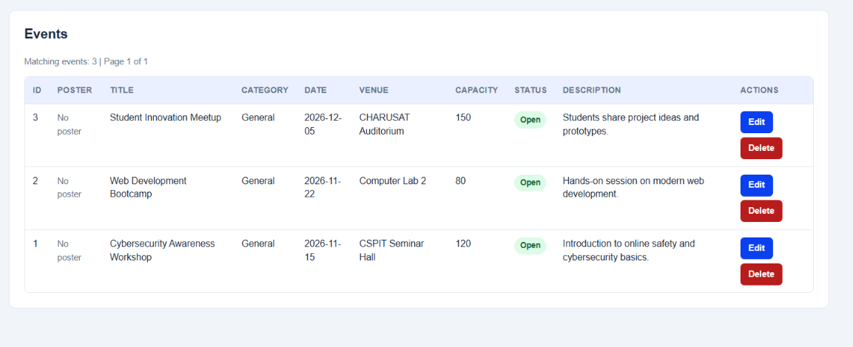

Practical 13
AIM: Create simple PHP JSON API endpoints for events or students and
consume them using Fetch API. Perform list, add, update, and delete
operations asynchronously without full page reload.

<?php

session_start();
$isLoggedIn = isset($_SESSION['user_id']);
$userRole = $_SESSION['role'] ?? 'guest';
$userName = $_SESSION['username'] ?? 'Guest User';
?>
<!DOCTYPE html>
<html lang="en">
<head>
<meta charset="UTF-8">
<meta name="viewport" content="width=device-width, initial-scale=1.0">
<title>StudentHub - Practical 13: AJAX/Fetch API CRUD</title>
<link rel="stylesheet" href="style.css">
<style>
:root {
--primary: #1f4e5b;
--primary-light: #eaf4fc;
--success: #28a745;
--danger: #dc3545;
--warning: #ffc107;
--info: #17a2b8;
--dark: #333333;
--border: #ccd6dd;
}

body {
font-family: Arial, sans-serif;
margin: 0;
padding: 10px;
background-color: #f7f9fa;
}

.container {
max-width: 1200px;
margin: 0 auto;
background: #ffffff;
border-radius: 8px;
box-shadow: 0 4px 15px rgba(0,0,0,0.08);
padding: 20px;
}

.page-badge {
display: inline-block;
background: #1f4e5b;
color: #ffffff;
padding: 4px 10px;
border-radius: 12px;
font-size: 12px;
font-weight: bold;
margin-bottom: 8px;
}
.toolbar {
display: flex;
flex-wrap: wrap;
gap: 12px;
justify-content: space-between;
align-items: center;
background: #eef3f7;
padding: 15px;
border-radius: 8px;
margin-bottom: 20px;
border: 1px solid #d9e2ec;
}

.search-group {
display: flex;
gap: 10px;
align-items: center;
flex-grow: 1;
max-width: 600px;
}

.search-input {
flex-grow: 1;
padding: 9px 12px;
border: 1px solid #bccad6;
border-radius: 6px;
font-size: 14px;
}

.select-filter {
padding: 9px 12px;
border: 1px solid #bccad6;
border-radius: 6px;
font-size: 14px;
background: white;
}

.btn {
padding: 9px 16px;
border-radius: 6px;
border: none;
cursor: pointer;
font-weight: bold;
font-size: 14px;
transition: all 0.2s;
display: inline-flex;
align-items: center;
gap: 6px;
}

.btn-primary {
background-color: #1f4e5b;
color: white;
box-shadow: 0 2px 4px rgba(31,78,91,0.25);
}
.btn-primary:hover { background-color: #15353e; }

.btn-success { background-color: #28a745; color: white; }
.btn-success:hover { background-color: #218838; }

.btn-danger { background-color: #dc3545; color: white; }
.btn-danger:hover { background-color: #c82333; }

.btn-secondary { background-color: #6c757d; color: white; }
.btn-secondary:hover { background-color: #5a6268; }

.btn-sm {
padding: 5px 10px;
font-size: 12px;
border-radius: 4px;
}

.stats-row {
display: flex;
gap: 15px;
margin-bottom: 20px;
flex-wrap: wrap;
}
.stat-card {
flex: 1;
min-width: 180px;
background: #ffffff;
border: 1px solid #e1e8ed;
border-left: 5px solid #1f4e5b;
padding: 12px 16px;
border-radius: 6px;
box-shadow: 0 2px 6px rgba(0,0,0,0.04);
}
.stat-number {
font-size: 22px;
font-weight: bold;
color: #1f4e5b;
}
.stat-label {
font-size: 13px;
color: #657786;
}

.table-responsive {
overflow-x: auto;
border: 1px solid #e1e8ed;
border-radius: 6px;
}

table.data-table {
width: 100%;
border-collapse: collapse;
font-size: 14px;
text-align: left;
}

table.data-table th {
background-color: #e9ecef;
color: #333333;
padding: 12px;
border-bottom: 2px solid #dee2e6;
font-weight: 600;
}

table.data-table td {
padding: 12px;
border-bottom: 1px solid #e9ecef;
vertical-align: middle;
}

table.data-table tr:hover {
background-color: #f8fafc;
}

.badge {
display: inline-block;
padding: 3px 8px;
border-radius: 12px;
font-size: 11px;
font-weight: bold;
}
.badge-ce { background: #d1ecf1; color: #0c5460; }
.badge-it { background: #d4edda; color: #155724; }
.badge-ec { background: #fff3cd; color: #856404; }
.badge-me { background: #f8d7da; color: #721c24; }
.badge-default { background: #e2e3e5; color: #383d41; }
#toastContainer {
position: fixed;
top: 20px;
right: 20px;
z-index: 9999;
display: flex;
flex-direction: column;
gap: 10px;
}

.toast {
min-width: 280px;
max-width: 380px;
padding: 12px 18px;
border-radius: 6px;
color: white;
font-size: 14px;
box-shadow: 0 4px 12px rgba(0,0,0,0.2);
animation: slideIn 0.3s ease-out;
display: flex;
justify-content: space-between;
align-items: center;
}
.toast-success { background: #28a745; }
.toast-error { background: #dc3545; }
.toast-info { background: #17a2b8; }

@keyframes slideIn {
from { transform: translateX(100%); opacity: 0; }
to { transform: translateX(0); opacity: 1; }
}

.modal-overlay {
display: none;
position: fixed;
top: 0; left: 0; right: 0; bottom: 0;
background: rgba(0, 0, 0, 0.55);
z-index: 1000;
justify-content: center;
align-items: center;
}
.modal-overlay.active {
display: flex;
}
.modal-box {
background: white;
border-radius: 8px;
width: 100%;
max-width: 550px;
max-height: 90vh;
overflow-y: auto;
box-shadow: 0 10px 30px rgba(0,0,0,0.25);
animation: popIn 0.25s ease-out;
}
@keyframes popIn {
from { transform: scale(0.9); opacity: 0; }
to { transform: scale(1); opacity: 1; }
}
.modal-header {
padding: 15px 20px;
background: #1f4e5b;
color: white;
display: flex;
justify-content: space-between;
align-items: center;
border-top-left-radius: 8px;
border-top-right-radius: 8px;
}
.modal-header h3 { margin: 0; font-size: 18px; }
.modal-close {
background: transparent;
border: none;
color: white;
font-size: 22px;
cursor: pointer;
box-shadow: none;
padding: 0;
}
.modal-body {
padding: 20px;
}
.modal-footer {
padding: 12px 20px;
background: #f1f3f5;
display: flex;
justify-content: flex-end;
gap: 10px;
border-bottom-left-radius: 8px;
border-bottom-right-radius: 8px;
}

.form-row {
margin-bottom: 12px;
}
.form-row label {
display: block;
font-size: 13px;
font-weight: 600;
margin-bottom: 4px;
color: #333;
}
.form-control {
width: 100%;
box-sizing: border-box;
padding: 8px 10px;
border: 1px solid #ced4da;
border-radius: 5px;
font-size: 14px;
}
.form-grid {
display: grid;
grid-template-columns: 1fr 1fr;
gap: 12px;
}
.api-monitor {
margin-top: 25px;
background: #1e1e1e;
color: #d4d4d4;
border-radius: 8px;
padding: 15px;
font-family: Consolas, monospace;
font-size: 13px;
}
.api-monitor-header {
display: flex;
justify-content: space-between;
color: #4ec9b0;
font-weight: bold;
margin-bottom: 10px;
padding-bottom: 6px;
border-bottom: 1px solid #333;
}
.log-line {
margin: 4px 0;
word-break: break-all;
}
.log-line .method { color: #569cd6; font-weight: bold; }
.log-line .url { color: #dcdcaa; }
.log-line .code-200, .log-line .code-201 { color: #4ec9b0; font-weight: bold; }
.log-line .code-400, .log-line .code-404, .log-line .code-409, .log-line .code-500 { color: #f44747; font-weight: bold; }

.spinner {
display: inline-block;
width: 16px;
height: 16px;
border: 2px solid rgba(255,255,255,0.3);
border-radius: 50%;
border-top-color: white;
animation: spin 0.8s ease-in-out infinite;
}
@keyframes spin {
to { transform: rotate(360deg); }
}
</style>
</head>
<body>

<div id="header">
<h1 align="center">STUDENTHUB</h1>
</div>

<br>

<div align="center">
<a href="home.HTML"><button type="button">Home</button></a>
<a href="events.HTML"><button type="button">Events</button></a>
<a href="practical11_students.php"><button type="button">Students (Standard CRUD)</button></a>
<a href="practical12_events.php"><button type="button">Event Management</button></a>
<a href="practical13_ajax.php"><button type="button" style="background:#1f4e5b;color:white;">AJAX CRUD (P13)</button></a>
<a href="practical14_dashboard.php"><button type="button">Admin Dashboard (P14)</button></a>
<?php if ($isLoggedIn): ?>
<a href="practical10_logout.php"><button type="button" style="color:red;">Logout (<?php echo htmlspecialchars($userName); ?>)</button></a>
<?php else: ?>
<a href="practical10_login.php"><button type="button">Login</button></a>
<?php endif; ?>
</div>

<br><hr><br>
<div id="toastContainer"></div>

<div class="container">
<span class="page-badge">PRACTICAL 13: ASYNC AJAX & FETCH API</span>
<h2>Student Management (Zero Page Reload CRUD)</h2>
<p style="color:#666; font-size:14px; margin-top:-5px;">
This page communicates with <code>practical13_api.php</code> asynchronously via JavaScript <strong>Fetch API</strong>.
All search, filter, insert, update, and delete actions occur live without refreshing the browser.
</p>
<div class="stats-row">
<div class="stat-card">
<div class="stat-number" id="statTotalStudents">--</div>
<div class="stat-label">Total Active Students</div>
</div>
<div class="stat-card" style="border-left-color: #28a745;">
<div class="stat-number" id="statCE">--</div>
<div class="stat-label">CE Department</div>
</div>
<div class="stat-card" style="border-left-color: #17a2b8;">
<div class="stat-number" id="statIT">--</div>
<div class="stat-label">IT Department</div>
</div>
<div class="stat-card" style="border-left-color: #ffc107;">
<div class="stat-number" id="statLastAction">Ready</div>
<div class="stat-label">Last AJAX Status</div>
</div>
</div>

<div class="toolbar">
<div class="search-group">
<input type="text" id="searchInput" class="search-input" placeholder="🔍 Search by name, email, or phone (Live Debounce)...">
<select id="courseFilter" class="select-filter">
<option value="">All Departments</option>
<option value="CE">Computer Eng (CE)</option>
<option value="IT">Information Tech (IT)</option>
<option value="EC">Electronics (EC)</option>
<option value="ME">Mechanical (ME)</option>
</select>
<button type="button" id="btnRefresh" class="btn btn-secondary btn-sm" title="Reload data via API">
↻ Refresh
</button>
</div>
<div>
<button type="button" id="btnOpenAddModal" class="btn btn-success">
+ Add New Student
</button>
</div>
</div>
<div class="table-responsive">
<table class="data-table" id="studentsTable">
<thead>
<tr>
<th width="60">ID</th>
<th>Student Name</th>
<th>Email</th>
<th>Phone</th>
<th>Course</th>
<th>Year</th>
<th>Gender</th>
<th>Address</th>
<th width="150" style="text-align:center;">Actions</th>
</tr>
</thead>
<tbody id="studentsTableBody">
<tr>
<td colspan="9" style="text-align:center; padding: 40px; color: #888;">
<div class="spinner" style="border-color:#1f4e5b; border-top-color:transparent; width:24px; height:24px;"></div>
<p style="margin-top:10px;">Loading student records from JSON API...</p>
</td>
</tr>
</tbody>
</table>
</div>

<div class="api-monitor">
<div class="api-monitor-header">
<span>📡 Live Fetch API Network Activity & Inspector</span>
<span id="networkPulse" style="color:#28a745;">● Live Connected</span>
</div>
<div id="apiLogOutput" style="max-height: 140px; overflow-y: auto;">
<div class="log-line" style="color:#888;">[Ready] Waiting for fetch requests to <code>practical13_api.php</code>...</div>
</div>
</div>

</div>
<div class="modal-overlay" id="studentModal">
<div class="modal-box">
<div class="modal-header">
<h3 id="modalTitle">Add New Student</h3>
<button type="button" class="modal-close" id="modalCloseBtn">&times;</button>
</div>
<form id="studentForm">
<div class="modal-body">
<input type="hidden" id="studentId" name="id" value="">
<input type="hidden" id="formAction" name="action" value="create">

<div class="form-row">
<label for="modalFullname">Full Name *</label>
<input type="text" id="modalFullname" name="fullname" class="form-control" required placeholder="e.g. John Doe">
</div>

<div class="form-grid">
<div class="form-row">
<label for="modalEmail">Email Address *</label>
<input type="email" id="modalEmail" name="email" class="form-control" required placeholder="john@example.com">
</div>
<div class="form-row">
<label for="modalPhone">Phone (10 digits) *</label>
<input type="text" id="modalPhone" name="phone" class="form-control" required pattern="[0-9]{10}" placeholder="9876543210">
</div>
</div>

<div class="form-grid">
<div class="form-row">
<label for="modalCourse">Course / Department *</label>
<select id="modalCourse" name="course" class="form-control" required>
<option value="">Select Course</option>
<option value="CE">CE - Computer Engineering</option>
<option value="IT">IT - Information Technology</option>
<option value="EC">EC - Electronics & Comm.</option>
<option value="ME">ME - Mechanical Engineering</option>
</select>
</div>
<div class="form-row">
<label for="modalYear">Year of Study *</label>
<select id="modalYear" name="year" class="form-control" required>
<option value="1">1st Year</option>
<option value="2">2nd Year</option>
<option value="3">3rd Year</option>
<option value="4">4th Year</option>
</select>
</div>
</div>

<div class="form-row">
<label>Gender *</label>
<div style="display:flex; gap: 20px; padding-top: 4px;">
<label><input type="radio" name="gender" value="Male" checked> Male</label>
<label><input type="radio" name="gender" value="Female"> Female</label>
<label><input type="radio" name="gender" value="Other"> Other</label>
</div>
</div>

<div class="form-row">
<label for="modalAddress">Address</label>
<textarea id="modalAddress" name="address" class="form-control" rows="2" placeholder="City, State"></textarea>
</div>

<div id="modalErrorMsg" style="display:none; color:#dc3545; background:#f8d7da; padding:8px 12px; border-radius:4px; font-size:13px; margin-top:10px;"></div>
</div>

<div class="modal-footer">
<button type="button" class="btn btn-secondary" id="modalCancelBtn">Cancel</button>
<button type="submit" class="btn btn-primary" id="modalSubmitBtn">
<span id="btnSubmitText">Save Student</span>
</button>
</div>
</form>
</div>
</div>
<div class="modal-overlay" id="deleteModal">
<div class="modal-box" style="max-width: 400px;">
<div class="modal-header" style="background:#dc3545;">
<h3>Confirm Deletion</h3>
<button type="button" class="modal-close" id="deleteModalCloseBtn">&times;</button>
</div>
<div class="modal-body">
<p>Are you sure you want to delete <strong id="deleteStudentName">this student</strong>?</p>
<p style="font-size:13px; color:#888;">This action will soft-delete the record from the database asynchronously.</p>
</div>
<div class="modal-footer">
<button type="button" class="btn btn-secondary" id="deleteCancelBtn">Cancel</button>
<button type="button" class="btn btn-danger" id="deleteConfirmBtn">Yes, Delete</button>
</div>
</div>
</div>

<br><br>
<footer align="center">
<h4>@ 2026 StudentHub - Practical 13 Asynchronous AJAX CRUD</h4>
</footer>

<script>
const API_URL = 'practical13_api.php';

const tableBody = document.getElementById('studentsTableBody');
const searchInput = document.getElementById('searchInput');
const courseFilter = document.getElementById('courseFilter');
const btnRefresh = document.getElementById('btnRefresh');
const studentModal = document.getElementById('studentModal');
const deleteModal = document.getElementById('deleteModal');
const studentForm = document.getElementById('studentForm');
const apiLogOutput = document.getElementById('apiLogOutput');
const modalErrorMsg = document.getElementById('modalErrorMsg');
const modalSubmitBtn = document.getElementById('modalSubmitBtn');
const btnSubmitText = document.getElementById('btnSubmitText');

let currentStudents = [];
let deleteTargetId = null;
let searchDebounceTimer = null;

function showToast(message, type = 'success') {
const container = document.getElementById('toastContainer');
const toast = document.createElement('div');
toast.className = `toast toast-${type}`;
toast.innerHTML = `
<span>${escapeHtml(message)}</span>
<span style="cursor:pointer; margin-left:10px; font-weight:bold;">&times;</span>
`;
toast.querySelector('span:last-child').onclick = () => toast.remove();
container.appendChild(toast);
setTimeout(() => {
toast.style.opacity = '0';
toast.style.transform = 'translateX(100%)';
toast.style.transition = 'all 0.3s ease-out';
setTimeout(() => toast.remove(), 300);
}, 3500);
}

function logNetwork(method, url, statusCode, message) {
const time = new Date().toLocaleTimeString();
const logItem = document.createElement('div');
logItem.className = 'log-line';
logItem.innerHTML = `
<span style="color:#6a9955;">[${time}]</span>
<span class="method">${method}</span>
<span class="url">${escapeHtml(url)}</span>
&rarr; <span class="code-${statusCode}">${statusCode}</span>
<span style="color:#d4d4d4;">(${escapeHtml(message)})</span>
`;
apiLogOutput.insertBefore(logItem, apiLogOutput.firstChild);
document.getElementById('statLastAction').textContent = `${statusCode} OK`;
}

function escapeHtml(str) {
if (!str) return '';
return String(str)
.replace(/&/g, '&amp;')
.replace(/</g, '&lt;')
.replace(/>/g, '&gt;')
.replace(/"/g, '&quot;')
.replace(/'/g, '&#039;');
}

function getBadgeClass(course) {
switch(course) {
case 'CE': return 'badge-ce';
case 'IT': return 'badge-it';
case 'EC': return 'badge-ec';
case 'ME': return 'badge-me';
default: return 'badge-default';
}
}

async function loadStudents() {
const searchVal = encodeURIComponent(searchInput.value.trim());
const courseVal = encodeURIComponent(courseFilter.value);
const queryUrl = `${API_URL}?action=list&search=${searchVal}&course=${courseVal}`;

tableBody.innerHTML = `
<tr>
<td colspan="9" style="text-align:center; padding: 30px; color:#666;">
<div class="spinner" style="border-color:#1f4e5b; border-top-color:transparent; width:20px; height:20px;"></div>
<span style="margin-left:10px;">Fetching records...</span>
</td>
</tr>
`;

try {
const response = await fetch(queryUrl);
const result = await response.json();

logNetwork('GET', queryUrl, response.status, result.message || 'OK');

if (response.ok && result.status === 'success') {
currentStudents = result.data.students || [];
renderTable(currentStudents);
updateStats();
} else {
tableBody.innerHTML = `<tr><td colspan="9" style="text-align:center; color:red; padding:20px;">Failed to load: ${escapeHtml(result.message)}</td></tr>`;
showToast(result.message, 'error');
}
} catch (error) {
tableBody.innerHTML = `<tr><td colspan="9" style="text-align:center; color:red; padding:20px;">Network Error: ${escapeHtml(error.message)}</td></tr>`;
logNetwork('GET', queryUrl, 500, error.message);
showToast('Network error while fetching students', 'error');
}
}

function renderTable(students) {
if (!students || students.length === 0) {
tableBody.innerHTML = `
<tr>
<td colspan="9" style="text-align:center; padding: 40px; color: #888;">
<strong>No student records found.</strong>
<p style="margin:5px 0 0; font-size:13px;">Try adjusting your search criteria or click '+ Add New Student'.</p>
</td>
</tr>
`;
return;
}

tableBody.innerHTML = students.map(s => `
<tr id="row-student-${s.id}">
<td><strong>#${s.id}</strong></td>
<td><strong>${escapeHtml(s.fullname)}</strong></td>
<td>${escapeHtml(s.email)}</td>
<td>${escapeHtml(s.phone)}</td>
<td><span class="badge ${getBadgeClass(s.course)}">${escapeHtml(s.course)}</span></td>
<td>Year ${escapeHtml(s.year)}</td>
<td>${escapeHtml(s.gender)}</td>
<td>${escapeHtml(s.address || '-')}</td>
<td style="text-align:center;">
<button type="button" class="btn btn-secondary btn-sm" onclick="openEditModal(${s.id})">Edit</button>
<button type="button" class="btn btn-danger btn-sm" onclick="openDeleteModal(${s.id}, '${escapeHtml(s.fullname)}')">Delete</button>
</td>
</tr>
`).join('');
}

async function updateStats() {
try {
const response = await fetch(`${API_URL}?action=stats`);
const res = await response.json();
if (response.ok && res.status === 'success') {
document.getElementById('statTotalStudents').textContent = res.data.total_students;
const courses = res.data.course_breakdown || [];
const ce = courses.find(c => c.course === 'CE')?.count || 0;
const it = courses.find(c => c.course === 'IT')?.count || 0;
document.getElementById('statCE').textContent = ce;
document.getElementById('statIT').textContent = it;
}
} catch (err) {
console.error('Stats error:', err);
}
}

searchInput.addEventListener('input', () => {
clearTimeout(searchDebounceTimer);
searchDebounceTimer = setTimeout(() => {
loadStudents();
}, 300); });

courseFilter.addEventListener('change', () => {
loadStudents();
});

btnRefresh.addEventListener('click', () => {
loadStudents();
showToast('Refreshed student records', 'info');
});

const btnOpenAddModal = document.getElementById('btnOpenAddModal');
const modalCloseBtn = document.getElementById('modalCloseBtn');
const modalCancelBtn = document.getElementById('modalCancelBtn');

btnOpenAddModal.addEventListener('click', () => {
studentForm.reset();
document.getElementById('studentId').value = '';
document.getElementById('formAction').value = 'create';
document.getElementById('modalTitle').textContent = 'Add New Student';
btnSubmitText.textContent = 'Save Student';
modalErrorMsg.style.display = 'none';
studentModal.classList.add('active');
});

function closeModal() {
studentModal.classList.remove('active');
}
modalCloseBtn.addEventListener('click', closeModal);
modalCancelBtn.addEventListener('click', closeModal);

window.openEditModal = async function(id) {
modalErrorMsg.style.display = 'none';
btnSubmitText.textContent = 'Updating...';

try {
const response = await fetch(`${API_URL}?action=get&id=${id}`);
const res = await response.json();
logNetwork('GET', `${API_URL}?action=get&id=${id}`, response.status, res.message);

if (response.ok && res.status === 'success') {
const s = res.data;
document.getElementById('studentId').value = s.id;
document.getElementById('formAction').value = 'update';
document.getElementById('modalTitle').textContent = `Edit Student #${s.id}`;
document.getElementById('modalFullname').value = s.fullname;
document.getElementById('modalEmail').value = s.email;
document.getElementById('modalPhone').value = s.phone;
document.getElementById('modalCourse').value = s.course;
document.getElementById('modalYear').value = s.year;
document.getElementById('modalAddress').value = s.address || '';

const radios = document.getElementsByName('gender');
for (const r of radios) {
r.checked = (r.value === s.gender);
}

btnSubmitText.textContent = 'Update Student';
studentModal.classList.add('active');
} else {
showToast(res.message, 'error');
}
} catch (err) {
showToast('Failed to load student details: ' + err.message, 'error');
}
};

studentForm.addEventListener('submit', async (e) => {
e.preventDefault();
modalErrorMsg.style.display = 'none';

const action = document.getElementById('formAction').value;
const payload = {
action: action,
id: document.getElementById('studentId').value,
fullname: document.getElementById('modalFullname').value.trim(),
email: document.getElementById('modalEmail').value.trim(),
phone: document.getElementById('modalPhone').value.trim(),
course: document.getElementById('modalCourse').value,
year: document.getElementById('modalYear').value,
gender: document.querySelector('input[name="gender"]:checked')?.value,
address: document.getElementById('modalAddress').value.trim()
};

if (!/^[0-9]{10}$/.test(payload.phone)) {
modalErrorMsg.textContent = 'Phone must be exactly 10 numeric digits.';
modalErrorMsg.style.display = 'block';
return;
}

modalSubmitBtn.disabled = true;
btnSubmitText.textContent = 'Saving...';

try {
const response = await fetch(API_URL, {
method: 'POST',
headers: { 'Content-Type': 'application/json' },
body: JSON.stringify(payload)
});
const res = await response.json();

logNetwork('POST', `${API_URL} (action: ${action})`, response.status, res.message);

if (response.ok && res.status === 'success') {
showToast(res.message, 'success');
closeModal();
loadStudents();
} else {
modalErrorMsg.textContent = res.message || 'Operation failed.';
modalErrorMsg.style.display = 'block';
showToast(res.message, 'error');
}
} catch (err) {
modalErrorMsg.textContent = 'Network error: ' + err.message;
modalErrorMsg.style.display = 'block';
logNetwork('POST', API_URL, 500, err.message);
showToast('Network error during save', 'error');
} finally {
modalSubmitBtn.disabled = false;
btnSubmitText.textContent = (action === 'create') ? 'Save Student' : 'Update Student';
}
});

document.getElementById('deleteModalCloseBtn');
const deleteCancelBtn = document.getElementById('deleteCancelBtn');
const deleteConfirmBtn = document.getElementById('deleteConfirmBtn');

window.openDeleteModal = function(id, name) {
deleteTargetId = id;
document.getElementById('deleteStudentName').textContent = name;
deleteModal.classList.add('active');
};

function closeDeleteModal() {
deleteModal.classList.remove('active');
deleteTargetId = null;
}

deleteCloseBtn.addEventListener('click', closeDeleteModal);
deleteCancelBtn.addEventListener('click', closeDeleteModal);

deleteConfirmBtn.addEventListener('click', async () => {
if (!deleteTargetId) return;

deleteConfirmBtn.disabled = true;
deleteConfirmBtn.textContent = 'Deleting...';

const url = `${API_URL}?action=delete&id=${deleteTargetId}`;

try {
const response = await fetch(url, { method: 'POST' });
const res = await response.json();

logNetwork('POST', url, response.status, res.message);

if (response.ok && res.status === 'success') {
showToast(res.message, 'success');

const row = document.getElementById(`row-student-${deleteTargetId}`);
if (row) {
row.style.transition = 'all 0.4s ease';
row.style.backgroundColor = '#f8d7da';
row.style.opacity = '0';
setTimeout(() => {
row.remove();
updateStats();
}, 400);
}
closeDeleteModal();
} else {
showToast(res.message, 'error');
}
} catch (err) {
showToast('Failed to delete student: ' + err.message, 'error');
logNetwork('POST', url, 500, err.message);
} finally {
deleteConfirmBtn.disabled = false;
deleteConfirmBtn.textContent = 'Yes, Delete';
}
});

document.addEventListener('DOMContentLoaded', () => {
loadStudents();
});
</script>
</body>
</html>

<?php
header('Content-Type: application/json; charset=utf-8');
header('X-Content-Type-Options: nosniff');

session_start();
}

require_once 'db.php';

function sendResponse($status, $statusCode, $message, $data = null) {
http_response_code($statusCode);
echo json_encode([
'status' => $status,
'code' => $statusCode,
'message' => $message,
'data' => $data,
'timestamp' => date('Y-m-d H:i:s')
], JSON_UNESCAPED_UNICODE | JSON_PRETTY_PRINT);
exit;
}
helper
function logAction($conn, $action, $details) {
$userId = isset($_SESSION['user_id']) ? (int)$_SESSION['user_id'] : null;
$ip = $_SERVER['REMOTE_ADDR'] ?? '127.0.0.1';
$stmt = $conn->prepare("INSERT INTO audit_logs (user_id, action, details, ip_address) VALUES (?, ?, ?, ?)");
if ($stmt) {
$stmt->bind_param("isss", $userId, $action, $details, $ip);
$stmt->execute();
$stmt->close();
}
}
$rawInput = file_get_contents('php://input');
$jsonInput = json_decode($rawInput, true);
$requestData = array_merge($_GET, $_POST, is_array($jsonInput) ? $jsonInput : []);
$action = isset($requestData['action']) ? trim($requestData['action']) : '';
$method = $_SERVER['REQUEST_METHOD'];
try {
switch ($action) {

case 'list':
$search = isset($requestData['search']) ? trim($requestData['search']) : '';
$course = isset($requestData['course']) ? trim($requestData['course']) : '';

$sql = "SELECT id, fullname, email, phone, course, year, gender, address, status, created_at
FROM students
WHERE status != 'deleted'";
$params = [];
$types = "";

if (!empty($search)) {
$sql .= " AND (fullname LIKE ? OR email LIKE ? OR phone LIKE ?)";
$searchWildcard = "%" . $search . "%";
$params[] = $searchWildcard;
$params[] = $searchWildcard;
$params[] = $searchWildcard;
$types .= "sss";
}

if (!empty($course) && $course !== 'all') {
$sql .= " AND course = ?";
$params[] = $course;
$types .= "s";
}

$sql .= " ORDER BY id DESC";

$stmt = $conn->prepare($sql);
if (!empty($params)) {
$stmt->bind_param($types, ...$params);
}
$stmt->execute();
$result = $stmt->get_result();

$students = [];
while ($row = $result->fetch_assoc()) {
$students[] = $row;
}
$stmt->close();

sendResponse('success', 200, 'Students retrieved successfully', [
'count' => count($students),
'students' => $students
]);
break;

case 'get':
$id = isset($requestData['id']) ? (int)$requestData['id'] : 0;
if ($id <= 0) {
sendResponse('error', 400, 'Valid Student ID is required');
}

$stmt = $conn->prepare("SELECT id, fullname, email, phone, course, year, gender, address, status, created_at FROM students WHERE id = ? AND status != 'deleted'");
$stmt->bind_param("i", $id);
$stmt->execute();
$result = $stmt->get_result();

if ($result->num_rows === 0) {
$stmt->close();
sendResponse('error', 404, 'Student not found');
}

$student = $result->fetch_assoc();
$stmt->close();

sendResponse('success', 200, 'Student details retrieved', $student);
break;

case 'create':
if ($method !== 'POST') {
sendResponse('error', 405, 'HTTP Method Not Allowed. Use POST.');
}

$fullname = trim($requestData['fullname'] ?? '');
$email = trim($requestData['email'] ?? '');
$phone = trim($requestData['phone'] ?? '');
$course = trim($requestData['course'] ?? '');
$year = isset($requestData['year']) ? (int)$requestData['year'] : 0;
$gender = trim($requestData['gender'] ?? '');
$address = trim($requestData['address'] ?? '');
$errors = [];
if (empty($fullname) || strlen($fullname) < 3) {
$errors[] = 'Full name is required (min 3 characters).';
}
if (empty($email) || !filter_var($email, FILTER_VALIDATE_EMAIL)) {
$errors[] = 'A valid email address is required.';
}
if (empty($phone) || !preg_match('/^[0-9]{10}$/', $phone)) {
$errors[] = 'Phone must be exactly 10 digits.';
}
if (empty($course)) {
$errors[] = 'Course selection is required.';
}
if ($year < 1 || $year > 4) {
$errors[] = 'Year must be between 1 and 4.';
}
if (!in_array($gender, ['Male', 'Female', 'Other'])) {
$errors[] = 'Please select a valid gender.';
}

if (!empty($errors)) {
sendResponse('error', 400, 'Validation failed: ' . implode(' ', $errors), ['errors' => $errors]);
}
$checkStmt = $conn->prepare("SELECT id FROM students WHERE email = ? AND status != 'deleted'");
$checkStmt->bind_param("s", $email);
$checkStmt->execute();
$checkStmt->store_result();
if ($checkStmt->num_rows > 0) {
$checkStmt->close();
sendResponse('error', 409, 'A student with this email address already exists.');
}
$checkStmt->close();

$insertStmt = $conn->prepare("INSERT INTO students (fullname, email, phone, course, year, gender, address) VALUES (?, ?, ?, ?, ?, ?, ?)");
$insertStmt->bind_param("ssssiss", $fullname, $email, $phone, $course, $year, $gender, $address);

if ($insertStmt->execute()) {
$newId = $conn->insert_id;
$insertStmt->close();

logAction($conn, 'AJAX_CREATE_STUDENT', "Created student: $fullname ($email), ID: $newId");

sendResponse('success', 201, 'Student created successfully', [
'id' => $newId,
'fullname' => $fullname,
'email' => $email,
'phone' => $phone,
'course' => $course,
'year' => $year,
'gender' => $gender
]);
} else {
$insertStmt->close();
sendResponse('error', 500, 'Database error: unable to create student');
}
break;

case 'update':
if ($method !== 'POST' && $method !== 'PUT') {
sendResponse('error', 405, 'HTTP Method Not Allowed. Use POST.');
}

$id = isset($requestData['id']) ? (int)$requestData['id'] : 0;
$fullname = trim($requestData['fullname'] ?? '');
$email = trim($requestData['email'] ?? '');
$phone = trim($requestData['phone'] ?? '');
$course = trim($requestData['course'] ?? '');
$year = isset($requestData['year']) ? (int)$requestData['year'] : 0;
$gender = trim($requestData['gender'] ?? '');
$address = trim($requestData['address'] ?? '');

if ($id <= 0) {
sendResponse('error', 400, 'Valid Student ID is required.');
}

$errors = [];
if (empty($fullname) || strlen($fullname) < 3) {
$errors[] = 'Full name is required (min 3 characters).';
}
if (empty($email) || !filter_var($email, FILTER_VALIDATE_EMAIL)) {
$errors[] = 'A valid email address is required.';
}
if (empty($phone) || !preg_match('/^[0-9]{10}$/', $phone)) {
$errors[] = 'Phone must be exactly 10 digits.';
}
if (empty($course)) {
$errors[] = 'Course selection is required.';
}
if ($year < 1 || $year > 4) {
$errors[] = 'Year must be between 1 and 4.';
}
if (!in_array($gender, ['Male', 'Female', 'Other'])) {
$errors[] = 'Please select a valid gender.';
}

if (!empty($errors)) {
sendResponse('error', 400, 'Validation failed: ' . implode(' ', $errors), ['errors' => $errors]);
}
$checkExist = $conn->prepare("SELECT id FROM students WHERE id = ? AND status != 'deleted'");
$checkExist->bind_param("i", $id);
$checkExist->execute();
if ($checkExist->get_result()->num_rows === 0) {
$checkExist->close();
sendResponse('error', 404, 'Student not found.');
}
$checkExist->close();

$checkEmail = $conn->prepare("SELECT id FROM students WHERE email = ? AND id != ? AND status != 'deleted'");
$checkEmail->bind_param("si", $email, $id);
$checkEmail->execute();
if ($checkEmail->get_result()->num_rows > 0) {
$checkEmail->close();
sendResponse('error', 409, 'Another student is already registered with this email.');
}
$checkEmail->close();

$updateStmt = $conn->prepare("UPDATE students SET fullname = ?, email = ?, phone = ?, course = ?, year = ?, gender = ?, address = ? WHERE id = ?");
$updateStmt->bind_param("ssssissi", $fullname, $email, $phone, $course, $year, $gender, $address, $id);

if ($updateStmt->execute()) {
$updateStmt->close();
logAction($conn, 'AJAX_UPDATE_STUDENT', "Updated student ID: $id ($fullname)");
sendResponse('success', 200, 'Student updated successfully', [
'id' => $id,
'fullname' => $fullname,
'email' => $email,
'phone' => $phone,
'course' => $course,
'year' => $year,
'gender' => $gender
]);
} else {
$updateStmt->close();
sendResponse('error', 500, 'Database error: unable to update student');
}
break;

case 'delete':
$id = isset($requestData['id']) ? (int)$requestData['id'] : 0;
if ($id <= 0) {
sendResponse('error', 400, 'Valid Student ID is required.');
}

$stmt = $conn->prepare("UPDATE students SET status = 'deleted' WHERE id = ? AND status != 'deleted'");
$stmt->bind_param("i", $id);
$stmt->execute();

if ($stmt->affected_rows > 0) {
$stmt->close();
logAction($conn, 'AJAX_DELETE_STUDENT', "Deleted student ID: $id");
sendResponse('success', 200, "Student with ID $id deleted successfully.");
} else {
$stmt->close();
sendResponse('error', 404, "Student with ID $id not found or already deleted.");
}
break;

case 'stats':
$totalResult = $conn->query("SELECT COUNT(*) AS total FROM students WHERE status != 'deleted'");
$total = $totalResult->fetch_assoc()['total'];

$courseResult = $conn->query("SELECT course, COUNT(*) AS count FROM students WHERE status != 'deleted' GROUP BY course");
$courses = [];
while ($cRow = $courseResult->fetch_assoc()) {
$courses[] = $cRow;
}

sendResponse('success', 200, 'Stats retrieved', [
'total_students' => (int)$total,
'course_breakdown' => $courses
]);
break;

default:
sendResponse('error', 400, "Invalid or missing 'action' parameter. Supported: list, get, create, update, delete, stats.");
break;
}
} catch (Exception $e) {
sendResponse('error', 500, 'Server Exception: ' . $e->getMessage());
}

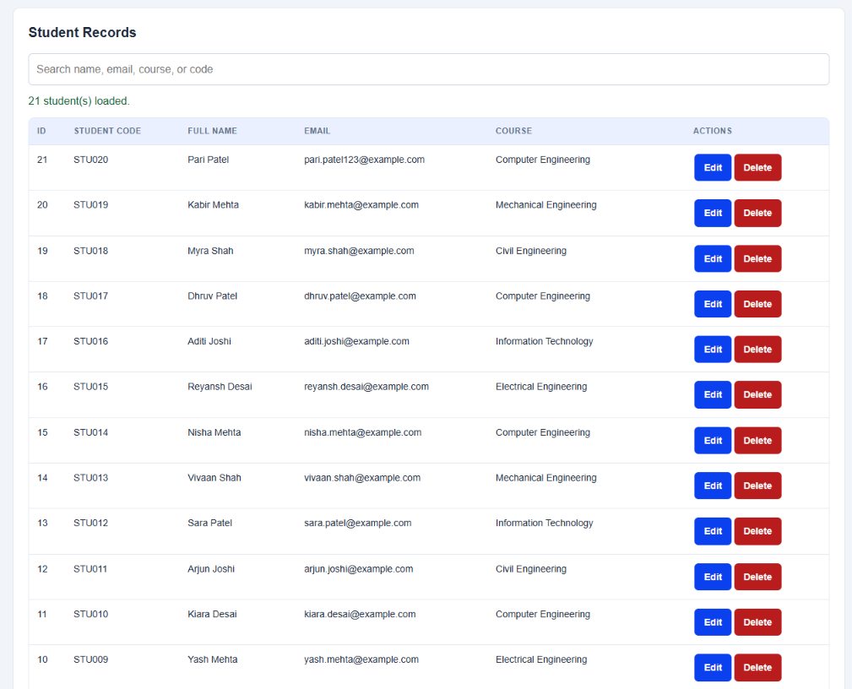
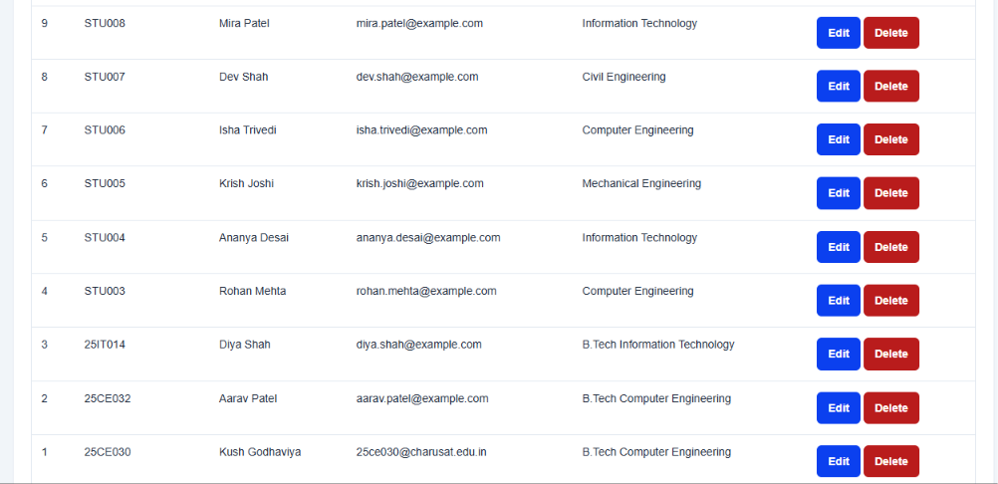

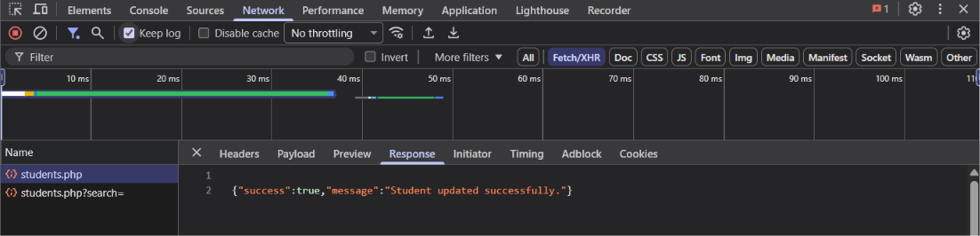
Practical 14
AIM: Develop an admin dashboard that displays user statistics, student count,
event count and latest registrations. Restrict access to admin users only
and show dynamic menu options based on role.

<?php

require_once 'auth_check.php';
require_once 'db.php';

if (!isset($_SESSION['role']) || $_SESSION['role'] !== 'admin') {
http_response_code(403);
echo '<!DOCTYPE html>
<html lang="en">
<head>
<meta charset="UTF-8">
<title>Access Denied - Admin Only</title>
<link rel="stylesheet" href="style.css">
</head>
<body style="font-family:Arial, sans-serif; text-align:center; padding:60px 20px; background:#f7f9fa;">
<div style="max-width:500px; margin:0 auto; background:white; padding:30px; border-radius:8px; border:2px solid #dc3545; box-shadow:0 4px 12px rgba(0,0,0,0.1);">
<h2 style="color:#dc3545; margin-top:0;">⛔ Access Denied</h2>
<p>You do not have administrative privileges to view this page.</p>
<p style="color:#666; font-size:14px;">Logged in as: <strong>' . htmlspecialchars($_SESSION['username'] ?? 'User') . '</strong> (Role: ' . htmlspecialchars($_SESSION['role'] ?? 'None') . ')</p>
<br>
<a href="practical10_student_dashboard.php"><button type="button">Go to Student Dashboard</button></a>
<a href="practical10_logout.php"><button type="button" style="color:red;">Logout</button></a>
</div>
</body>
</html>';
exit;
}

$message = '';
$messageType = '';
if ($_SERVER['REQUEST_METHOD'] === 'POST' && isset($_POST['action']) && $_POST['action'] === 'toggle_user_status') {
$targetUserId = (int)($_POST['user_id'] ?? 0);

if ($targetUserId === (int)$_SESSION['user_id']) {
$message = 'You cannot change your own account status.';
$messageType = 'error';
} elseif ($targetUserId > 0) {
$statusStmt = $conn->prepare("SELECT username, email, status FROM users WHERE id = ?");
$statusStmt->bind_param("i", $targetUserId);
$statusStmt->execute();
$userRes = $statusStmt->get_result();

if ($userRes->num_rows === 1) {
$uData = $userRes->fetch_assoc();
$newStatus = ($uData['status'] === 'active') ? 'inactive' : 'active';
$statusStmt->close();

$updateStmt = $conn->prepare("UPDATE users SET status = ? WHERE id = ?");
$updateStmt->bind_param("si", $newStatus, $targetUserId);
if ($updateStmt->execute()) {
$message = "User '{$uData['username']}' status changed to " . strtoupper($newStatus) . ".";
$messageType = 'success';

$action = 'TOGGLE_USER_STATUS';
$details = "Admin changed status of {$uData['username']} (ID: $targetUserId) to $newStatus";
$ip = $_SERVER['REMOTE_ADDR'] ?? '127.0.0.1';
$logStmt = $conn->prepare("INSERT INTO audit_logs (user_id, action, details, ip_address) VALUES (?, ?, ?, ?)");
$logStmt->bind_param("isss", $_SESSION['user_id'], $action, $details, $ip);
$logStmt->execute();
$logStmt->close();
} else {
$message = 'Failed to update user status.';
$messageType = 'error';
}
$updateStmt->close();
} else {
$statusStmt->close();
$message = 'User not found.';
$messageType = 'error';
}
}
}

$userCountRes = $conn->query("SELECT COUNT(*) AS total,
SUM(CASE WHEN role = 'admin' THEN 1 ELSE 0 END) AS admin_count,
SUM(CASE WHEN role = 'student' THEN 1 ELSE 0 END) AS student_user_count,
SUM(CASE WHEN status = 'active' THEN 1 ELSE 0 END) AS active_count
FROM users");
$userData = $userCountRes->fetch_assoc();

$studentCountRes = $conn->query("SELECT COUNT(*) AS total FROM students WHERE status != 'deleted'");
$totalStudents = (int)$studentCountRes->fetch_assoc()['total'];
$eventCountRes = $conn->query("SELECT COUNT(*) AS total,
SUM(CASE WHEN event_status = 'open' THEN 1 ELSE 0 END) AS open_count
FROM events");
$eventData = $eventCountRes->fetch_assoc();
$regCountRes = $conn->query("SELECT COUNT(*) AS total FROM registrations");
$totalRegistrations = (int)$regCountRes->fetch_assoc()['total'];
$latestRegQuery = "SELECT r.id, r.registered_at,
s.fullname AS student_name, s.email AS student_email, s.course,
e.title AS event_title, e.event_date, e.category
FROM registrations r
JOIN students s ON r.student_id = s.id
JOIN events e ON r.event_id = e.id
ORDER BY r.id DESC LIMIT 8";
$latestRegs = $conn->query($latestRegQuery);

$usersQuery = "SELECT id, username, email, role, status, last_login, created_at
FROM users
ORDER BY id DESC LIMIT 10";
$recentUsers = $conn->query($usersQuery);
$auditQuery = "SELECT a.id, a.action, a.details, a.ip_address, a.created_at, u.username
FROM audit_logs a
LEFT JOIN users u ON a.user_id = u.id
ORDER BY a.id DESC LIMIT 10";
$auditLogs = $conn->query($auditQuery);

$chartQuery = "SELECT e.title, COUNT(r.id) AS reg_count
FROM events e
LEFT JOIN registrations r ON e.id = r.event_id
GROUP BY e.id, e.title
ORDER BY reg_count DESC LIMIT 6";
$chartData = $conn->query($chartQuery);
$chartLabels = [];
$chartValues = [];
while ($row = $chartData->fetch_assoc()) {
$chartLabels[] = $row['title'];
$chartValues[] = (int)$row['reg_count'];
}
?>
<!DOCTYPE html>
<html lang="en">
<head>
<meta charset="UTF-8">
<meta name="viewport" content="width=device-width, initial-scale=1.0">
<title>StudentHub - Admin Dashboard (Practical 14)</title>
<link rel="stylesheet" href="style.css">
<style>
:root {
--primary: #1f4e5b;
--primary-dark: #14353e;
--accent: #e76f51;
--success: #2a9d8f;
--warning: #e9c46a;
--danger: #e63946;
--bg-light: #f4f6f9;
}

body {
font-family: Arial, sans-serif;
background-color: var(--bg-light);
margin: 0;
padding: 10px;
}

.dashboard-container {
max-width: 1250px;
margin: 0 auto;
}

.dynamic-navbar {
background: #1f4e5b;
padding: 10px 20px;
border-radius: 8px;
display: flex;
justify-content: space-between;
align-items: center;
flex-wrap: wrap;
gap: 10px;
margin-bottom: 20px;
box-shadow: 0 4px 10px rgba(0,0,0,0.12);
}

.nav-role-badge {
background: #e76f51;
color: white;
padding: 4px 10px;
border-radius: 12px;
font-size: 12px;
font-weight: bold;
text-transform: uppercase;
letter-spacing: 0.5px;
}

.nav-links {
display: flex;
gap: 8px;
flex-wrap: wrap;
}

.nav-links a button {
background: white;
color: #1f4e5b;
border: 1px solid #1f4e5b;
font-weight: bold;
padding: 7px 12px;
border-radius: 6px;
cursor: pointer;
box-shadow: none;
transition: all 0.2s;
}

.nav-links a button:hover {
background: #eaf4fc;
}

.nav-links a.active button {
background: #e9c46a;
color: #333;
border-color: #d4a737;
}

.metrics-grid {
display: grid;
grid-template-columns: repeat(auto-fit, minmax(240px, 1fr));
gap: 16px;
margin-bottom: 25px;
}

.metric-card {
background: white;
border-radius: 8px;
padding: 20px;
box-shadow: 0 2px 8px rgba(0,0,0,0.06);
border-top: 4px solid var(--primary);
position: relative;
overflow: hidden;
}
.metric-card.users { border-top-color: #3a86ff; }
.metric-card.students { border-top-color: #2a9d8f; }
.metric-card.events { border-top-color: #e76f51; }
.metric-card.regs { border-top-color: #f4a261; }

.metric-number {
font-size: 32px;
font-weight: bold;
color: #222;
margin: 5px 0;
}

.metric-label {
font-size: 13px;
color: #666;
text-transform: uppercase;
letter-spacing: 0.5px;
font-weight: 600;
}

.metric-sub {
font-size: 12px;
color: #888;
margin-top: 6px;
}

.panels-grid {
display: grid;
grid-template-columns: 2fr 1fr;
gap: 20px;
margin-bottom: 25px;
}

@media (max-width: 900px) {
.panels-grid { grid-template-columns: 1fr; }
}

.panel {
background: white;
border-radius: 8px;
padding: 20px;
box-shadow: 0 2px 8px rgba(0,0,0,0.06);
margin-bottom: 20px;
}

.panel-title {
margin-top: 0;
margin-bottom: 15px;
font-size: 18px;
color: #1f4e5b;
border-bottom: 2px solid #eef2f5;
padding-bottom: 10px;
display: flex;
justify-content: space-between;
align-items: center;
}

.dash-table {
width: 100%;
border-collapse: collapse;
font-size: 13px;
}

.dash-table th {
background-color: #f1f5f8;
color: #333;
text-align: left;
padding: 10px;
border-bottom: 2px solid #dee2e6;
}

.dash-table td {
padding: 10px;
border-bottom: 1px solid #edf2f7;
vertical-align: middle;
}

.dash-table tr:hover {
background-color: #f8fafc;
}

.tag {
padding: 3px 8px;
border-radius: 10px;
font-size: 11px;
font-weight: bold;
display: inline-block;
}
.tag-active { background: #d4edda; color: #155724; }
.tag-inactive { background: #f8d7da; color: #721c24; }
.tag-admin { background: #cce5ff; color: #004085; }
.tag-student { background: #e2e3e5; color: #383d41; }
.tag-tech { background: #d1ecf1; color: #0c5460; }
.tag-cult { background: #fce8e6; color: #c5221f; }
.tag-sports { background: #e6f4ea; color: #137333; }

.btn-toggle {
padding: 4px 8px;
font-size: 11px;
border: 1px solid #ccc;
border-radius: 4px;
cursor: pointer;
background: white;
font-weight: bold;
}
.btn-toggle:hover {
background: #eee;
}
.chart-box {
display: flex;
flex-direction: column;
gap: 12px;
padding-top: 10px;
}
.chart-row {
display: flex;
flex-direction: column;
gap: 4px;
}
.chart-row-header {
display: flex;
justify-content: space-between;
font-size: 12px;
font-weight: bold;
color: #444;
}
.chart-bar-bg {
background: #e9ecef;
border-radius: 6px;
height: 18px;
overflow: hidden;
}
.chart-bar-fill {
background: linear-gradient(90deg, #1f4e5b, #2a9d8f);
height: 100%;
border-radius: 6px;
transition: width 0.6s ease;
}

.alert {
padding: 12px 18px;
border-radius: 6px;
margin-bottom: 18px;
font-size: 14px;
font-weight: 500;
}
.alert-success { background: #d4edda; color: #155724; border: 1px solid #c3e6cb; }
.alert-error { background: #f8d7da; color: #721c24; border: 1px solid #f5c6cb; }
</style>
</head>
<body>

<div id="header">
<h1 align="center">STUDENTHUB</h1>
</div>

<br>

<div class="dashboard-container">

<div class="dynamic-navbar">
<div style="display:flex; align-items:center; gap:12px;">
<span style="color:white; font-size:16px; font-weight:bold;">StudentHub Portal</span>
<span class="nav-role-badge">Role: <?php echo htmlspecialchars($_SESSION['role']); ?></span>
</div>

<div class="nav-links">
<a href="home.HTML"><button type="button">Home</button></a>
<a href="practical14_dashboard.php" class="active"><button type="button">Dashboard (P14)</button></a>
<a href="practical11_students.php"><button type="button">Students (P11)</button></a>
<a href="practical12_events.php"><button type="button">Events (P12)</button></a>
<a href="practical13_ajax.php"><button type="button">AJAX API (P13)</button></a>
<a href="practical10_logout.php"><button type="button" style="color:red; background:#ffebeb; border-color:#f5c2c7;">Logout (<?php echo htmlspecialchars($_SESSION['username']); ?>)</button></a>
</div>
</div>

<?php if (!empty($message)): ?>
<div class="alert alert-<?php echo $messageType; ?>">
<?php echo htmlspecialchars($message); ?>
</div>
<?php endif; ?>

<div style="background:white; padding:16px 20px; border-radius:8px; margin-bottom:20px; box-shadow:0 2px 8px rgba(0,0,0,0.05); display:flex; justify-content:space-between; align-items:center; flex-wrap:wrap; gap:10px;">
<div>
<h2 style="margin:0; color:#1f4e5b;">Welcome to the Administrative Control Center</h2>
<p style="margin:5px 0 0; color:#666; font-size:14px;">
Signed in as <strong><?php echo htmlspecialchars($_SESSION['username']); ?></strong> (<?php echo htmlspecialchars($_SESSION['email']); ?>)
</p>
</div>
<div>
<span style="background:#eaf4fc; color:#1f4e5b; border:1px solid #b8daff; padding:6px 12px; border-radius:6px; font-size:13px; font-weight:bold;">
Server Time: <?php echo date('d M Y, h:i A'); ?>
</span>
</div>
</div>
<div class="metrics-grid">
<div class="metric-card users">
<div class="metric-label">Total Users</div>
<div class="metric-number"><?php echo (int)($userData['total'] ?? 0); ?></div>
<div class="metric-sub">
<strong><?php echo (int)($userData['active_count'] ?? 0); ?></strong> Active &bull;
<strong><?php echo (int)($userData['admin_count'] ?? 0); ?></strong> Admins
</div>
</div>

<div class="metric-card students">
<div class="metric-label">Enrolled Students</div>
<div class="metric-number"><?php echo $totalStudents; ?></div>
<div class="metric-sub">
In database across CE, IT, EC, ME
</div>
</div>

<div class="metric-card events">
<div class="metric-label">Total Events</div>
<div class="metric-number"><?php echo (int)($eventData['total'] ?? 0); ?></div>
<div class="metric-sub">
<strong><?php echo (int)($eventData['open_count'] ?? 0); ?></strong> Currently Open
</div>
</div>

<div class="metric-card regs">
<div class="metric-label">Event Registrations</div>
<div class="metric-number"><?php echo $totalRegistrations; ?></div>
<div class="metric-sub">
Participating student signups
</div>
</div>
</div>
<div class="panels-grid">
<div class="panel">
<div class="panel-title">
<span>📋 Latest Event Registrations</span>
<span style="font-size:12px; font-weight:normal; color:#888;">Real-time database join</span>
</div>
<div style="overflow-x:auto;">
<table class="dash-table">
<thead>
<tr>
<th>Student</th>
<th>Department</th>
<th>Event Title</th>
<th>Category</th>
<th>Registration Date</th>
</tr>
</thead>
<tbody>
<?php if ($latestRegs && $latestRegs->num_rows > 0): ?>
<?php while ($reg = $latestRegs->fetch_assoc()): ?>
<tr>
<td>
<strong><?php echo htmlspecialchars($reg['student_name']); ?></strong><br>
<span style="font-size:11px; color:#777;"><?php echo htmlspecialchars($reg['student_email']); ?></span>
</td>
<td><span class="tag tag-student"><?php echo htmlspecialchars($reg['course']); ?></span></td>
<td><strong><?php echo htmlspecialchars($reg['event_title']); ?></strong></td>
<td>
<?php
$cat = strtolower($reg['category']);
$catTag = ($cat === 'technical') ? 'tag-tech' : (($cat === 'sports') ? 'tag-sports' : 'tag-cult');
?>
<span class="tag <?php echo $catTag; ?>"><?php echo htmlspecialchars($reg['category']); ?></span>
</td>
<td style="font-size:12px; color:#555;">
<?php echo date('d M Y, h:i A', strtotime($reg['registered_at'])); ?>
</td>
</tr>
<?php endwhile; ?>
<?php else: ?>
<tr>
<td colspan="5" style="text-align:center; padding:20px; color:#888;">No event registrations found.</td>
</tr>
<?php endif; ?>
</tbody>
</table>
</div>
</div>

<div class="panel">
<div class="panel-title">
<span>📊 Registrations by Event</span>
<span class="tag tag-tech" style="font-size:10px;">Analytics</span>
</div>
<p style="font-size:12px; color:#666; margin-top:-5px;">Top events by student participation:</p>
<div class="chart-box">
<?php
$maxVal = max(array_merge([1], $chartValues));
for ($i = 0; $i < count($chartLabels); $i++):
$pct = round(($chartValues[$i] / $maxVal) * 100);
?>
<div class="chart-row">
<div class="chart-row-header">
<span title="<?php echo htmlspecialchars($chartLabels[$i]); ?>">
<?php echo htmlspecialchars(mb_strimwidth($chartLabels[$i], 0, 22, '...')); ?>
</span>
<span><?php echo $chartValues[$i]; ?> regs</span>
</div>
<div class="chart-bar-bg">
<div class="chart-bar-fill" style="width: <?php echo max(5, $pct); ?>%;"></div>
</div>
</div>
<?php endfor; ?>
</div>

<hr style="margin:20px 0; border:0; border-top:1px solid #eee;">

<h4 style="margin:0 0 10px; font-size:14px; color:#1f4e5b;">Quick Admin Actions</h4>
<div style="display:flex; flex-direction:column; gap:8px;">
<a href="practical11_students.php?export=csv"><button type="button" style="width:100%; text-align:left; background:#eaf4fc;">📥 Export Students to CSV</button></a>
<a href="practical12_events.php"><button type="button" style="width:100%; text-align:left; background:#eaf4fc;">➕ Create New Event</button></a>
<a href="practical13_ajax.php"><button type="button" style="width:100%; text-align:left; background:#eaf4fc;">⚡ Launch AJAX Fetch CRUD</button></a>
</div>
</div>

</div>

<div class="panel">
<div class="panel-title">
<span>👥 User Management & Status Toggle (Intermediate Extension)</span>
<span style="font-size:12px; font-weight:normal; color:#888;">Toggle Active / Inactive status instantly</span>
</div>
<div style="overflow-x:auto;">
<table class="dash-table">
<thead>
<tr>
<th>ID</th>
<th>Username</th>
<th>Email</th>
<th>Role</th>
<th>Account Status</th>
<th>Last Login</th>
<th>Created On</th>
<th style="text-align:center;">Action</th>
</tr>
</thead>
<tbody>
<?php if ($recentUsers && $recentUsers->num_rows > 0): ?>
<?php while ($u = $recentUsers->fetch_assoc()): ?>
<tr>
<td>#<?php echo $u['id']; ?></td>
<td><strong><?php echo htmlspecialchars($u['username']); ?></strong></td>
<td><?php echo htmlspecialchars($u['email']); ?></td>
<td>
<span class="tag <?php echo ($u['role'] === 'admin') ? 'tag-admin' : 'tag-student'; ?>">
<?php echo ucfirst(htmlspecialchars($u['role'])); ?>
</span>
</td>
<td>
<span class="tag <?php echo ($u['status'] === 'active') ? 'tag-active' : 'tag-inactive'; ?>">
<?php echo ucfirst(htmlspecialchars($u['status'])); ?>
</span>
</td>
<td style="font-size:12px; color:#666;">
<?php echo $u['last_login'] ? date('d M Y, h:i A', strtotime($u['last_login'])) : 'Never'; ?>
</td>
<td style="font-size:12px; color:#666;">
<?php echo date('d M Y', strtotime($u['created_at'])); ?>
</td>
<td style="text-align:center;">
<?php if ($u['id'] == $_SESSION['user_id']): ?>
<span style="font-size:11px; color:#999; font-style:italic;">Current User</span>
<?php else: ?>
<form method="POST" style="display:inline;" onsubmit="return confirm('Change status for <?php echo addslashes(htmlspecialchars($u['username'])); ?>?');">
<input type="hidden" name="action" value="toggle_user_status">
<input type="hidden" name="user_id" value="<?php echo $u['id']; ?>">
<button type="submit" class="btn-toggle">
<?php echo ($u['status'] === 'active') ? 'Deactivate' : 'Activate'; ?>
</button>
</form>
<?php endif; ?>
</td>
</tr>
<?php endwhile; ?>
<?php endif; ?>
</tbody>
</table>
</div>
</div>

<div class="panel">
<div class="panel-title">
<span>🛡️ Security & Activity Audit Log</span>
<span style="font-size:12px; font-weight:normal; color:#888;">Logged actions from <code>audit_logs</code> table</span>
</div>
<div style="overflow-x:auto;">
<table class="dash-table">
<thead>
<tr>
<th width="70">Log ID</th>
<th>User</th>
<th>Action Type</th>
<th>Details</th>
<th>IP Address</th>
<th width="180">Timestamp</th>
</tr>
</thead>
<tbody>
<?php if ($auditLogs && $auditLogs->num_rows > 0): ?>
<?php while ($log = $auditLogs->fetch_assoc()): ?>
<tr>
<td>#<?php echo $log['id']; ?></td>
<td><strong><?php echo htmlspecialchars($log['username'] ?? 'System/Guest'); ?></strong></td>
<td>
<span class="tag tag-admin" style="font-family:monospace;">
<?php echo htmlspecialchars($log['action']); ?>
</span>
</td>
<td style="font-size:12px; color:#444;">
<?php echo htmlspecialchars($log['details']); ?>
</td>
<td style="font-size:12px; font-family:monospace; color:#666;">
<?php echo htmlspecialchars($log['ip_address']); ?>
</td>
<td style="font-size:12px; color:#777;">
<?php echo date('d M Y, h:i:s A', strtotime($log['created_at'])); ?>
</td>
</tr>
<?php endwhile; ?>
<?php else: ?>
<tr>
<td colspan="6" style="text-align:center; padding:20px; color:#888;">No audit logs recorded yet.</td>
</tr>
<?php endif; ?>
</tbody>
</table>
</div>
</div>

</div>

<footer align="center" style="margin-top:30px;">
<h4>@ 2026 StudentHub - Practical 14 Role-Based Admin Dashboard</h4>
</footer>

</body>
</html>

