Ubuntu user: viraj/281105

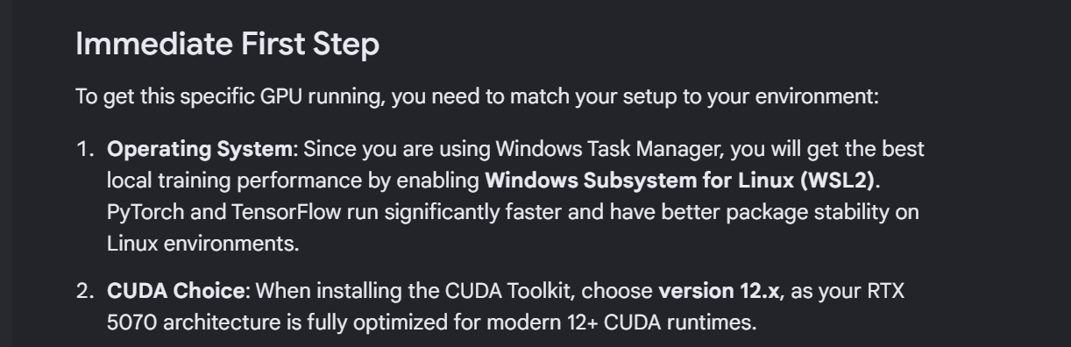
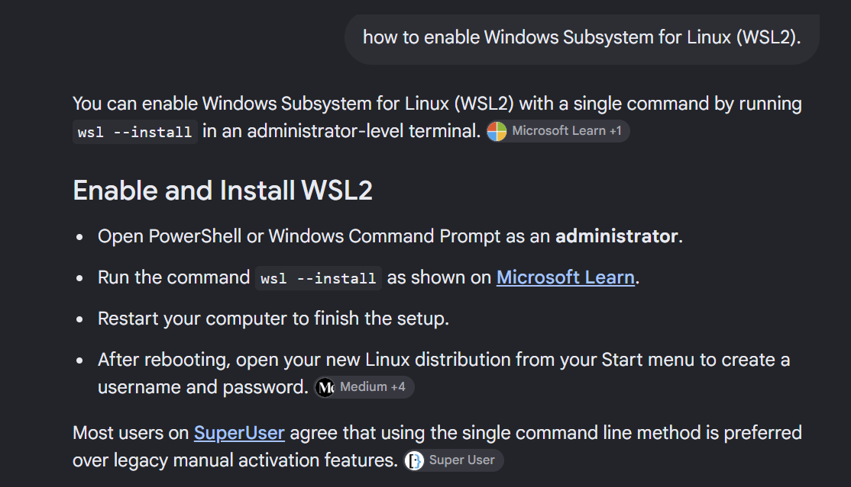
SO INSTALLED WSL using command >wsl –install
It installed
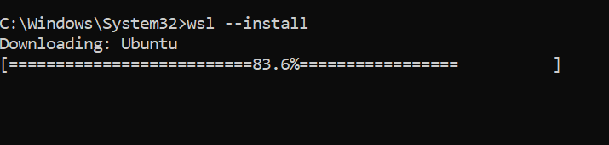
Installed latest Nvidia graphics driver for windows.
Next check if GPU is accessible from the Ubuntu linux using command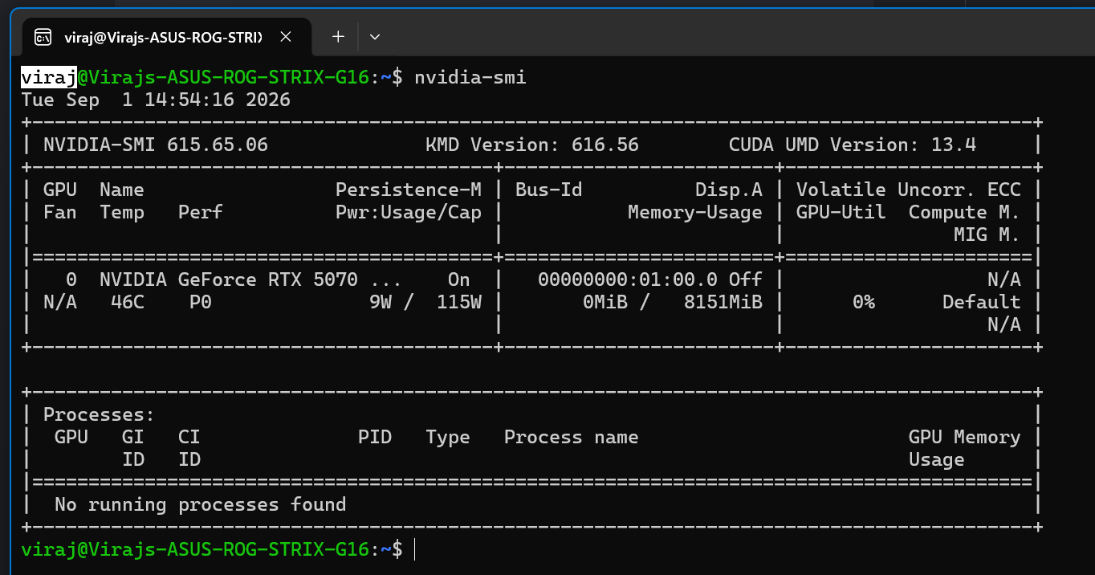
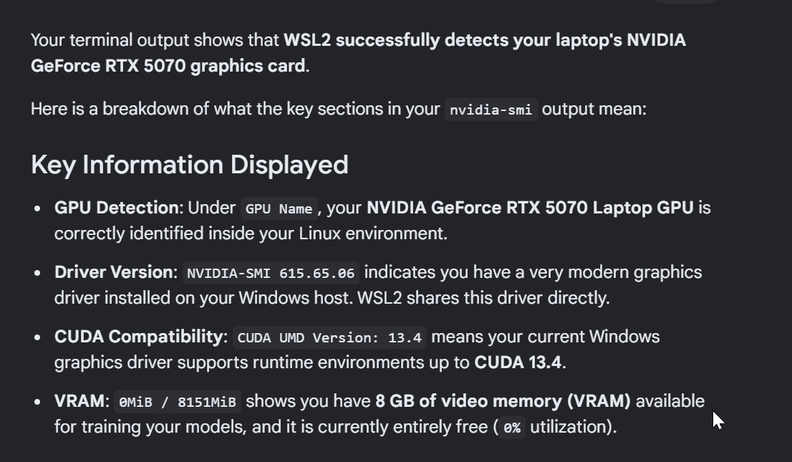
All good till now.
Ran same command on windows and output is
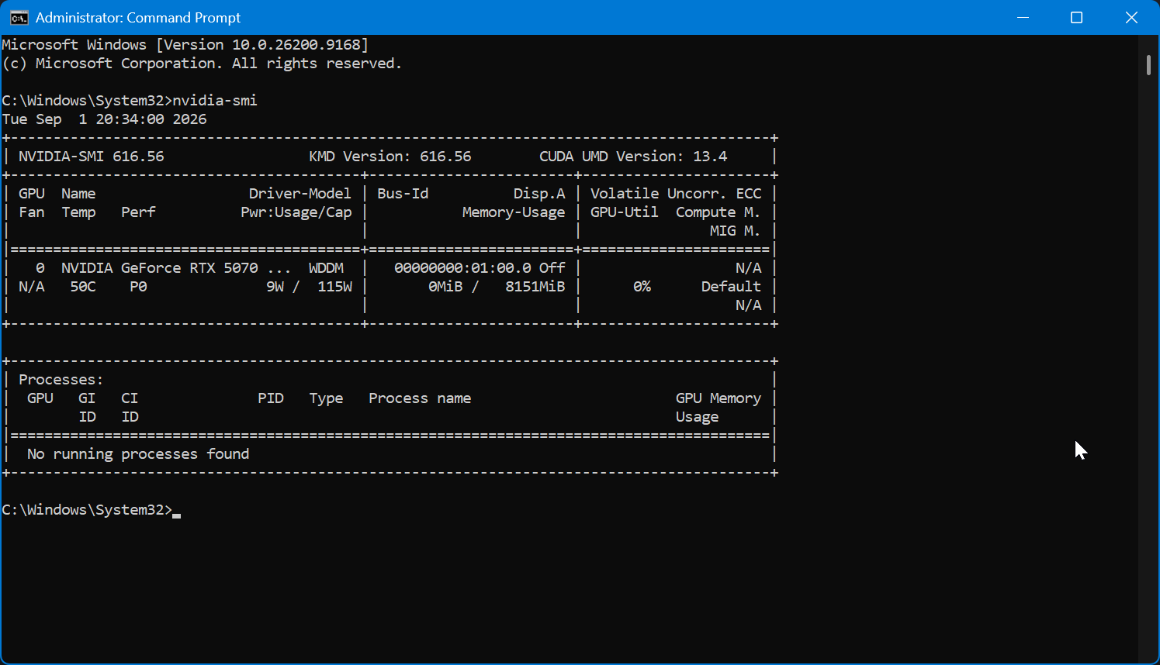

Open command prompt in admin mode
Upgrade pip
>python.exe -m pip install --upgrade pip

Please make sure you are running the following command

pip install torch torchvision --index-url https://download.pytorch.org/whl/cu132

this will install NVIDIA GPU (With CUDA Support) If you have an NVIDIA graphics card and want GPU acceleration, you must target the correct CUDA version. Here it is 13.2

