C13) Design and develop Apartment Rental Application using Sales-force Cloud. (Authentication, Listing of Sale / Rent Property: Property Type: 1/2/3 BHK, Cost/Rent, Area).4

--🡪>>

Authentication: You might want to use a Text field to store authentication details, unless it's more complex and requires encryption, in which case you might use a Encrypted Text field.

Listing of Sale / Rent Property: This could be represented by a Picklist field with options for Sale or Rent.

Property Type: You could use a Picklist field with options for 1 BHK, 2 BHK, and 3 BHK.

Cost/Rent: For a monetary value like cost or rent, you would typically use a Currency field.

Area: Area could be represented by a Number field, possibly with decimal places, depending on the precision you need. Alternatively, if you need to specify a unit of measurement (like square feet or square meters), you might use a Text field.

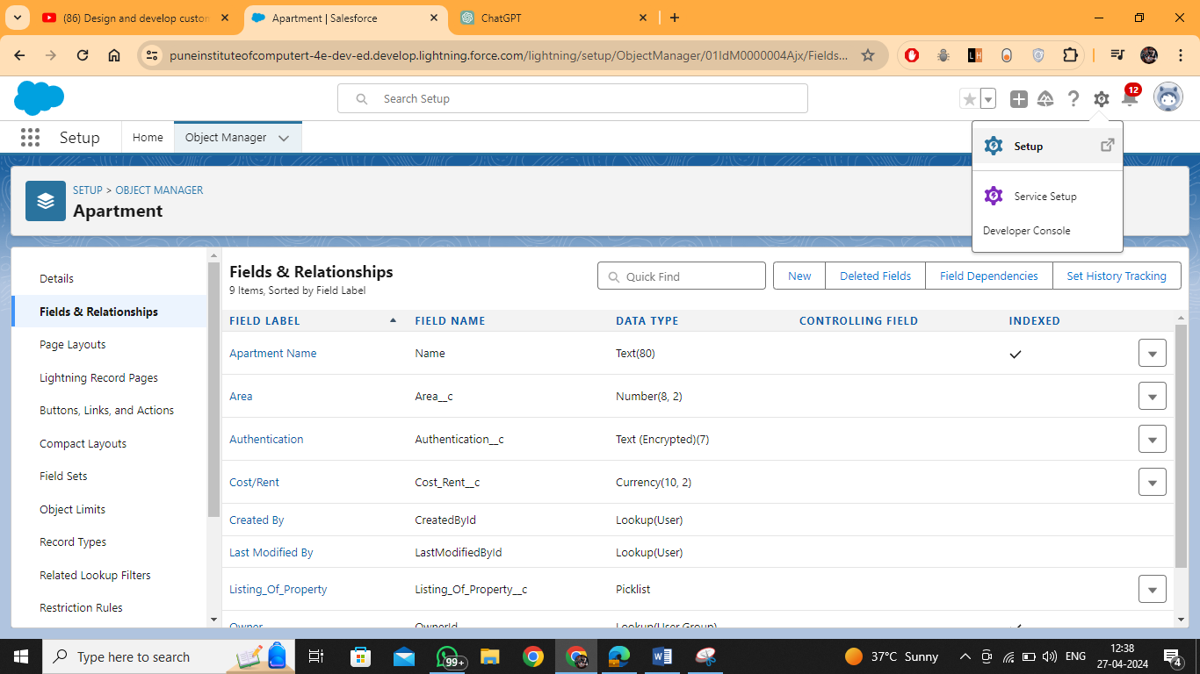

Click on setup

Then in search box select tabs  
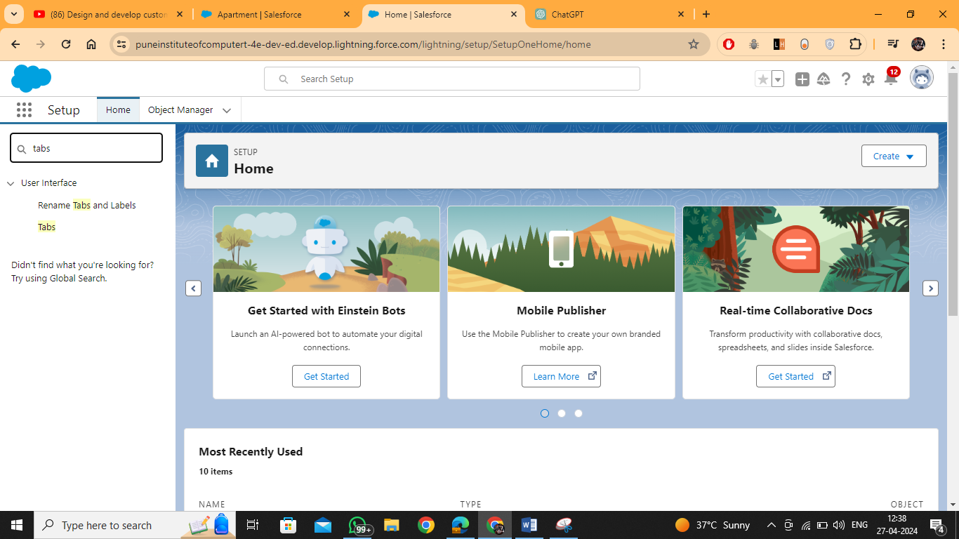  
  
Then click on new in Custom Object Tabs   
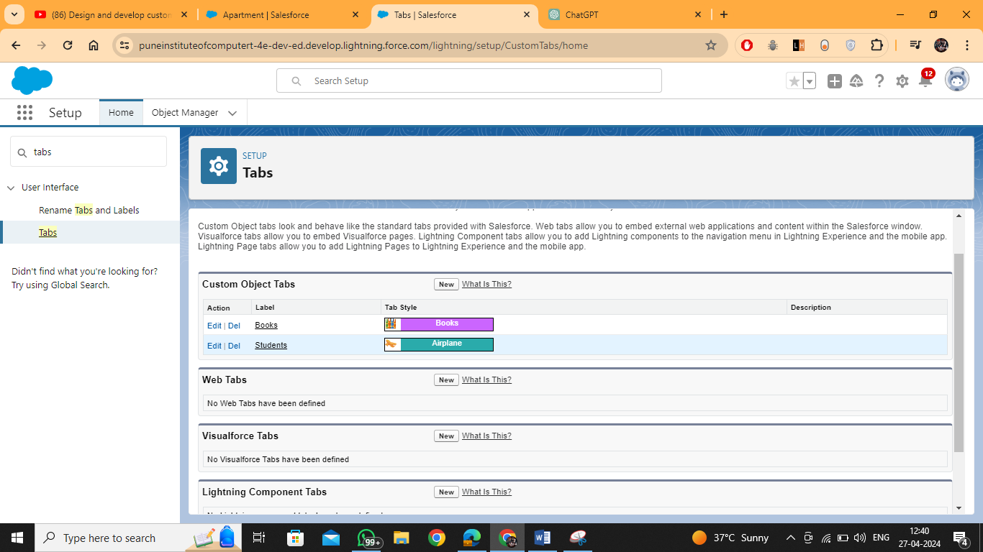

Select the type of Object and also tab style   
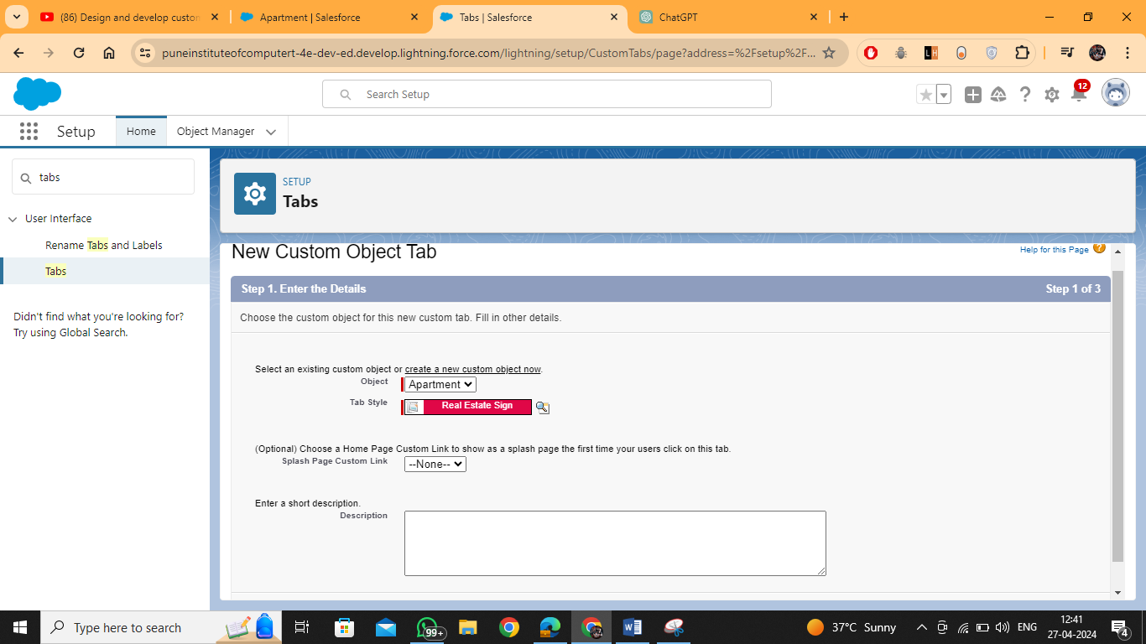  
  
Next -- > Next  
  
  
  
  
  
  
Now Repeat this same step of   
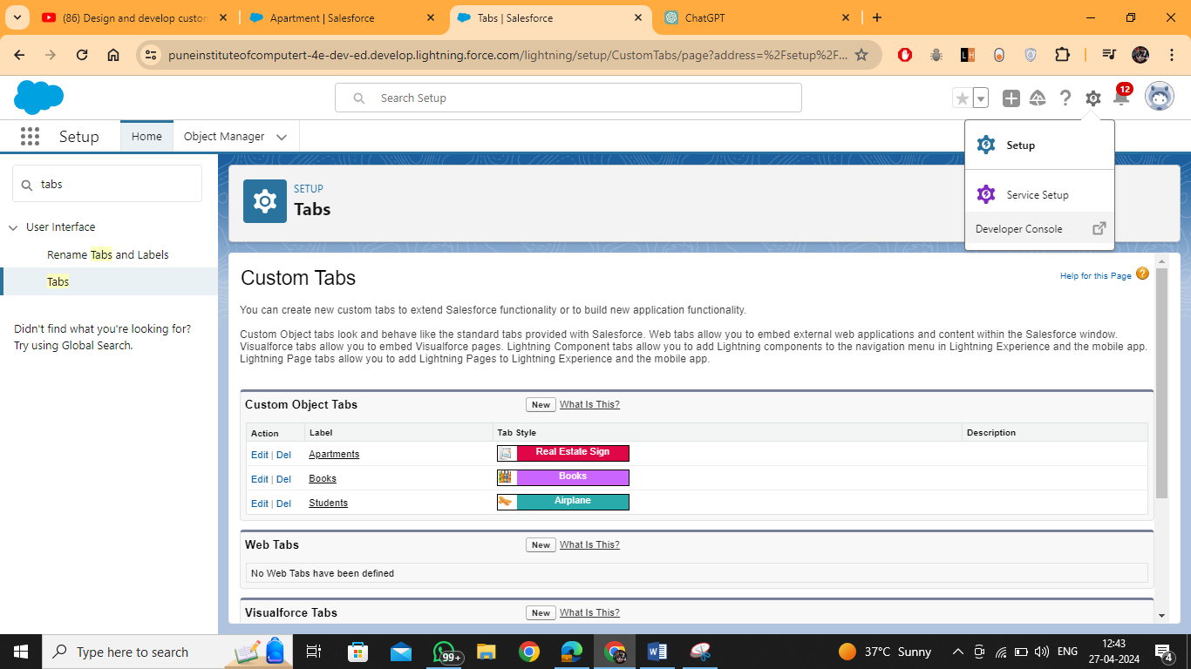  
  
Then search for app  
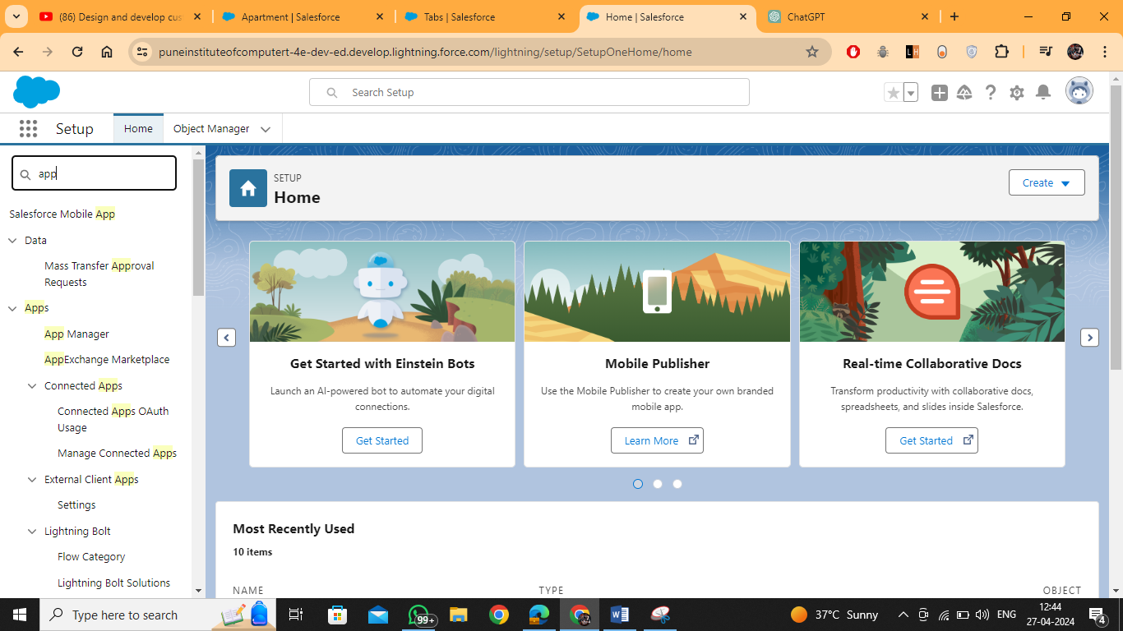

Then Select the app manager   
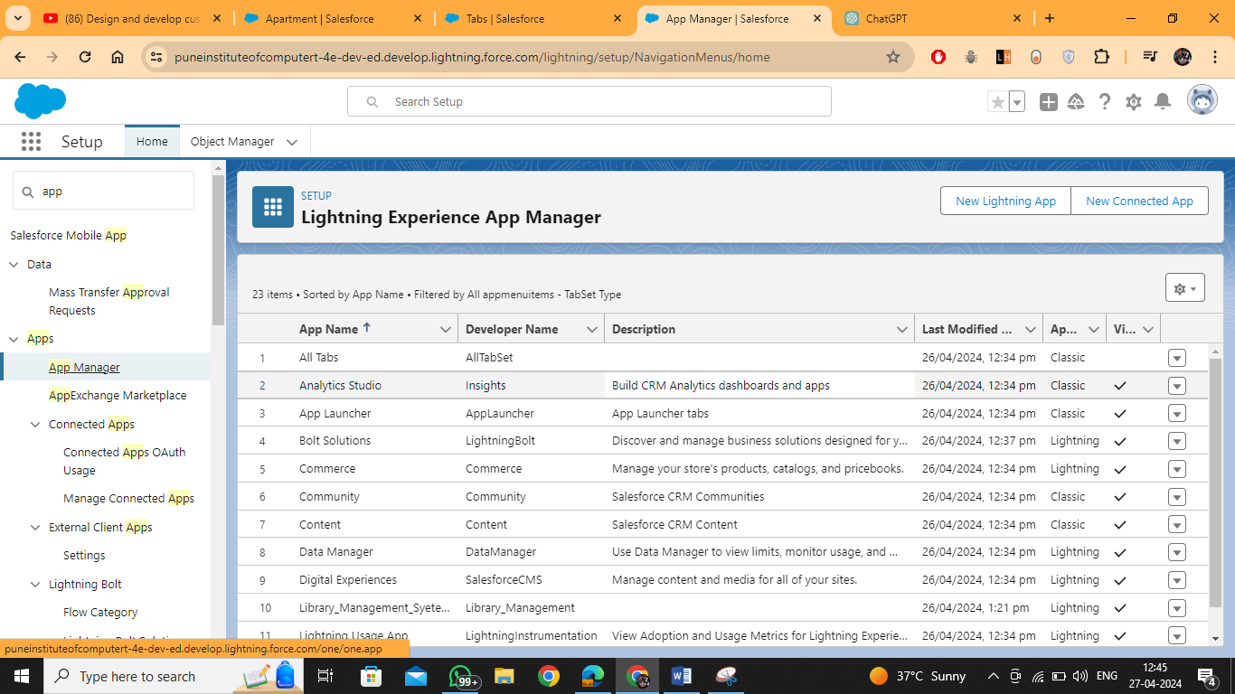

Select the new lighting app

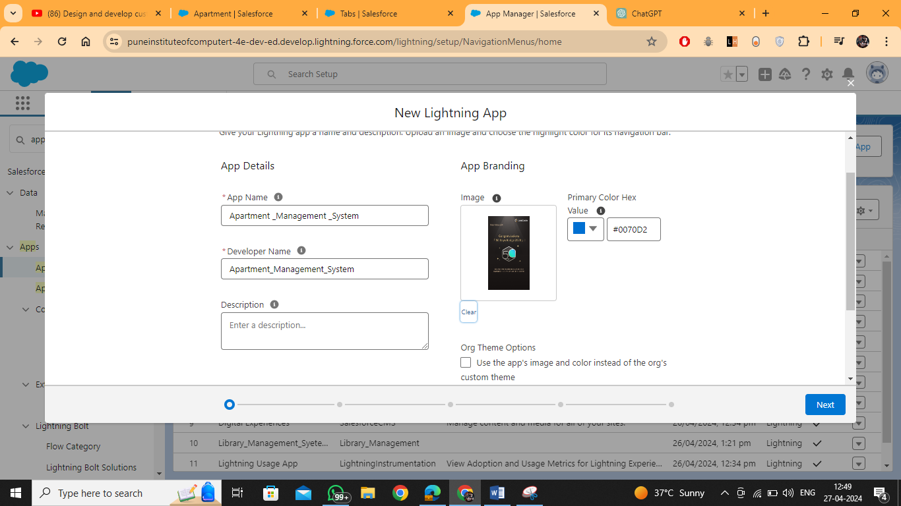

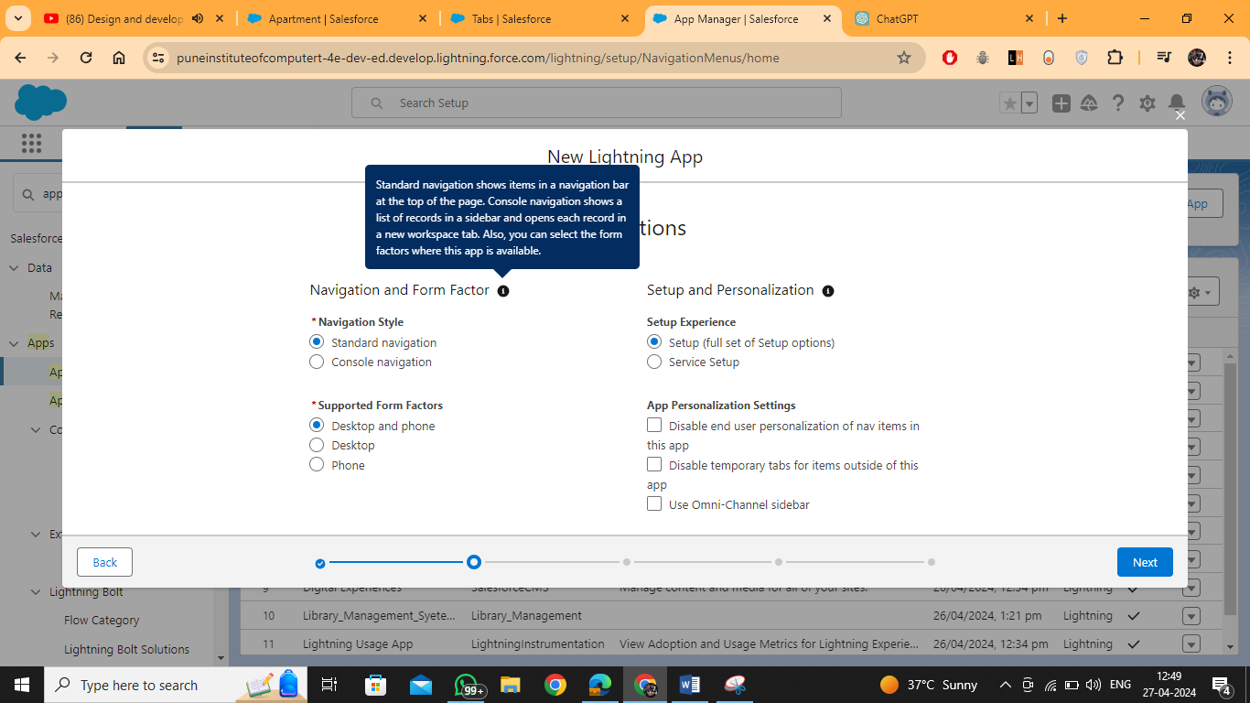  
  
  
Then click on next -🡪 next -- >   
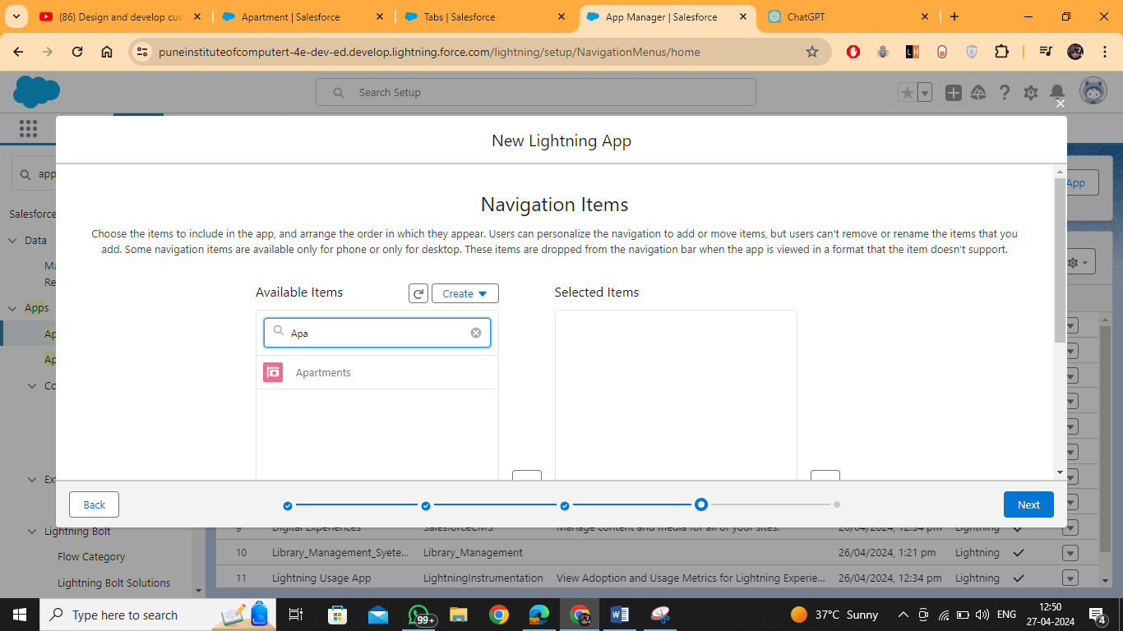

User Profile (Select System Administrator)  
then to find ur newly created Application  
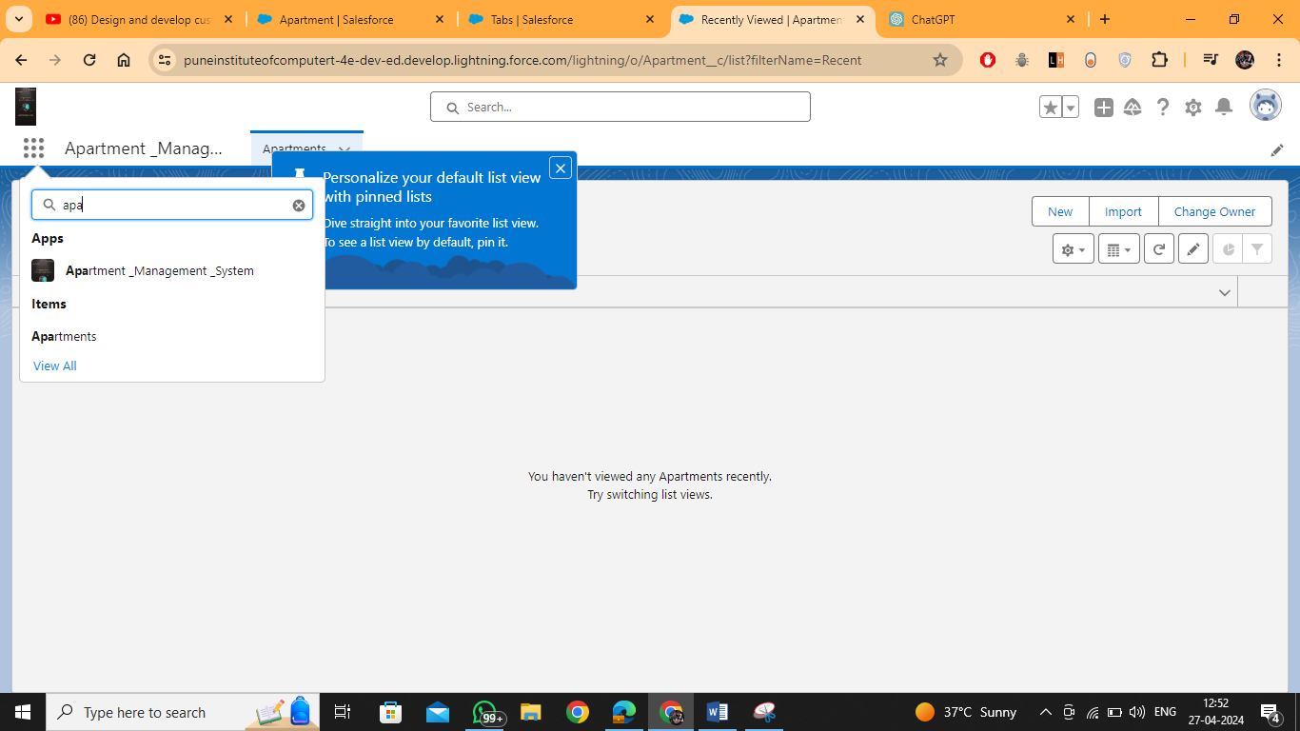

And then add new Record  
