Problem Statement 7) Design and develop Student Management System using Salesforce Cloud.  
🡪  
Student Name: Text field.

Student ID: Auto-number field (to ensure uniqueness).

Date of Birth: Date field.

Gender: Picklist field with options for Male, Female, Other.

Address: Text area field.

Email: Email field.

Phone Number: Phone field.

Guardian Name: Text field.

Guardian Email: Email field.

Guardian Phone Number: Phone field.

Enrollment Date: Date field.

Course Enrolled: Lookup field to a Course object.

Attendance: Checkbox field (or a Number field to track attendance percentage).

Grades: Text area field.

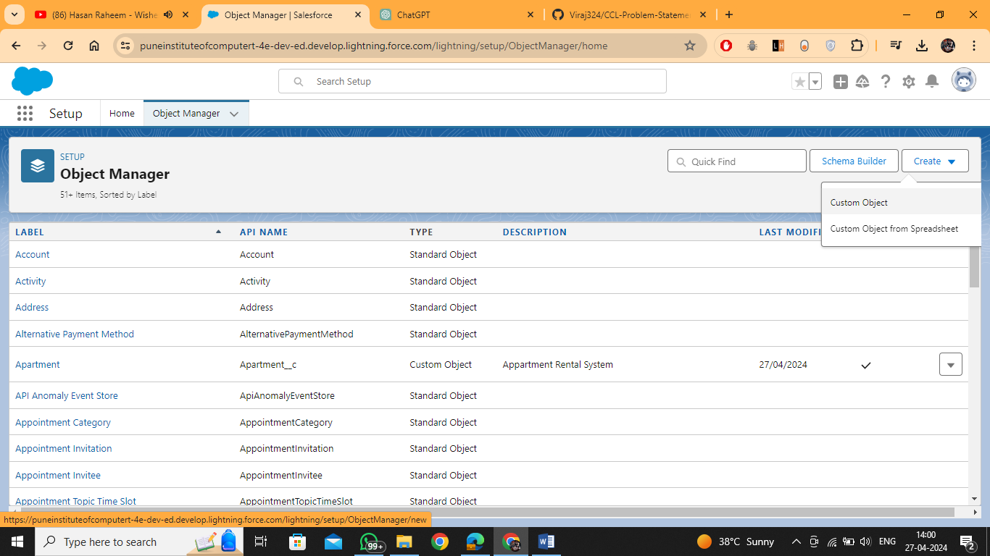

Create a Custom Object  
  
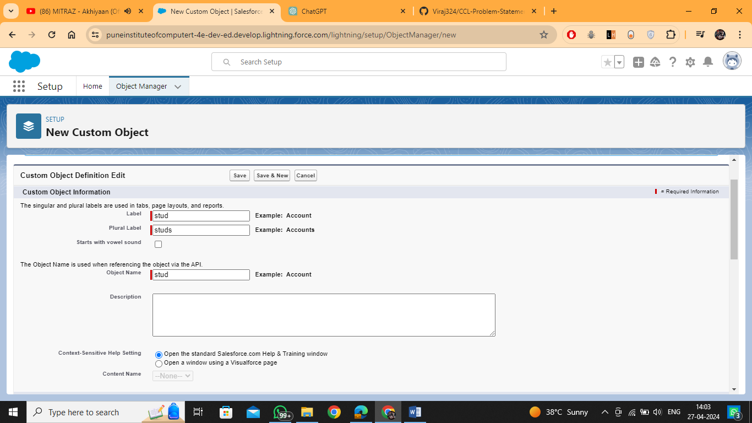

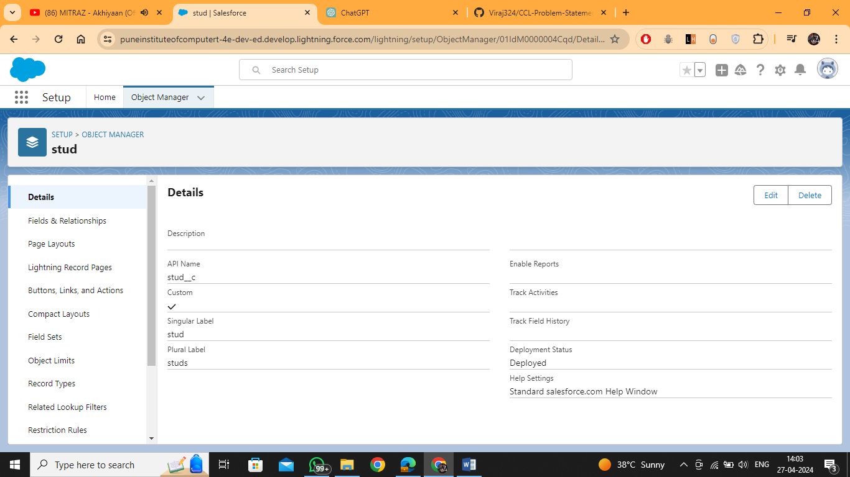

Click on Fields and Relationship for adding the attributes  
Then click on new to add the attributes  
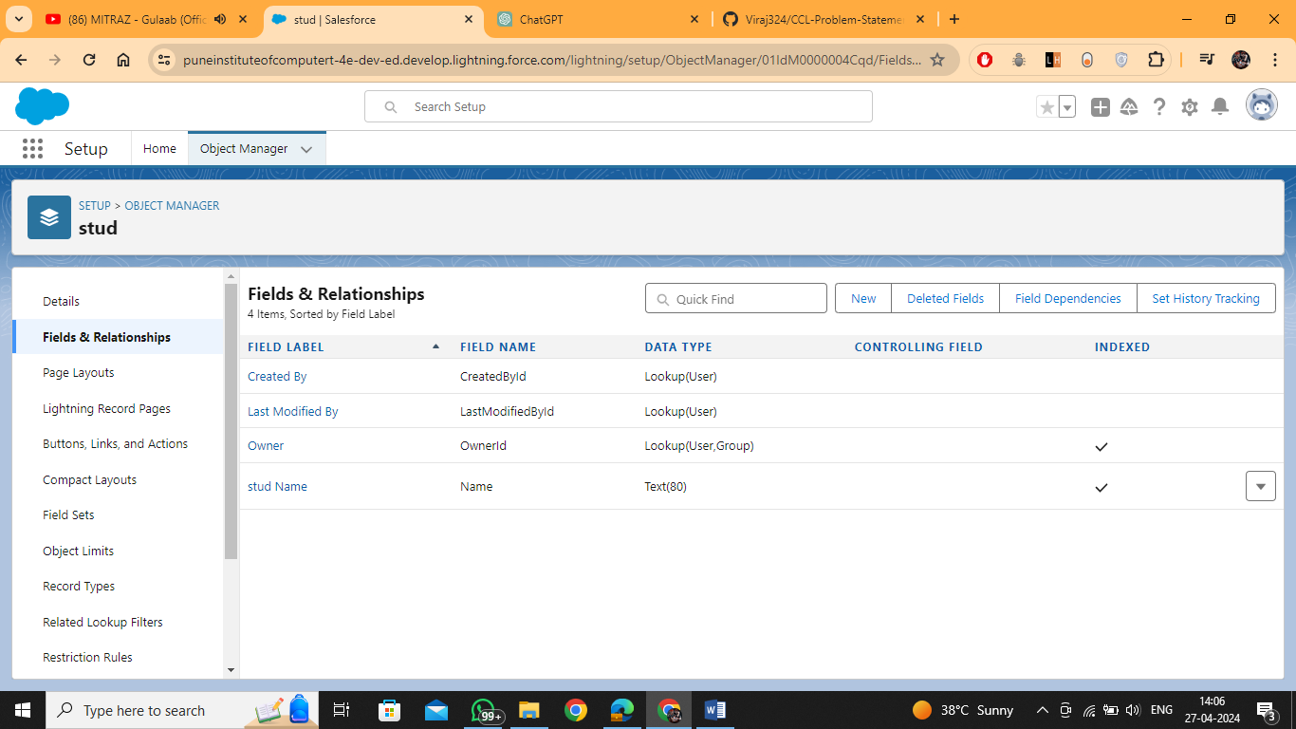

Select the type of attribute  
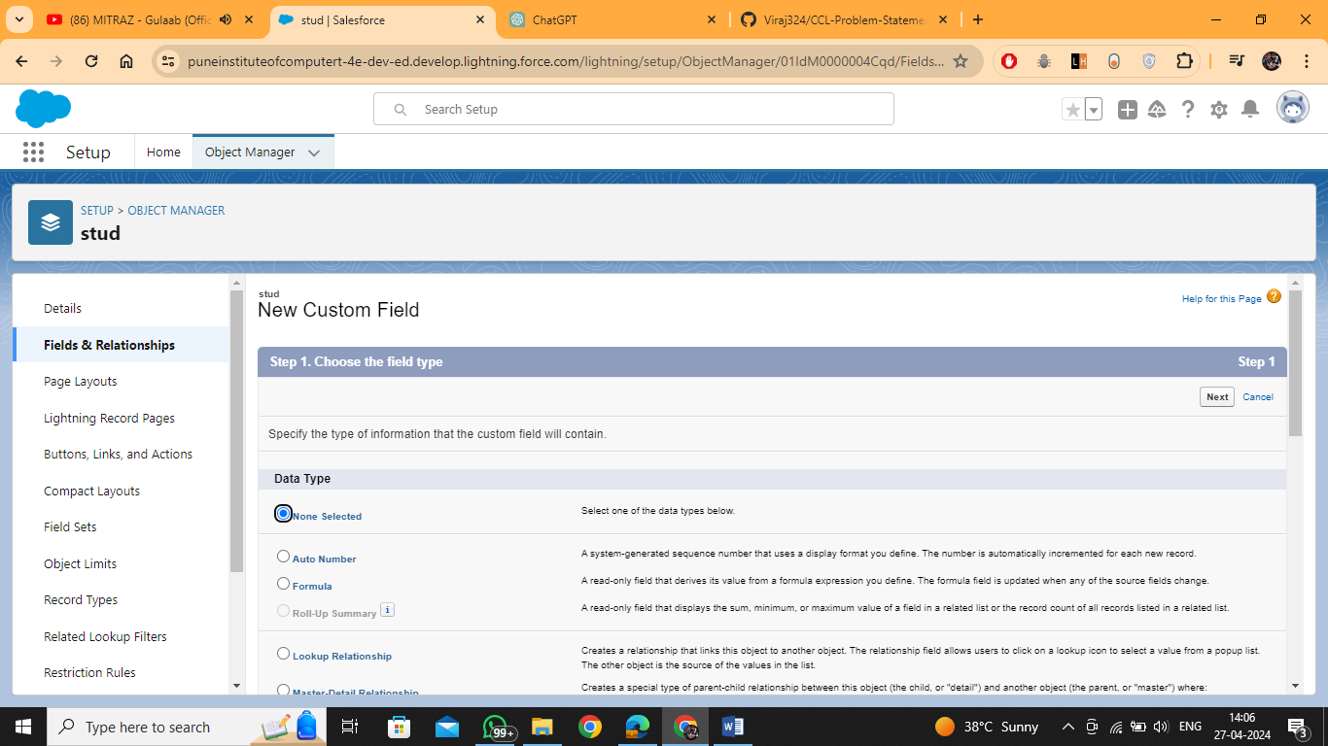

Here Student_id  
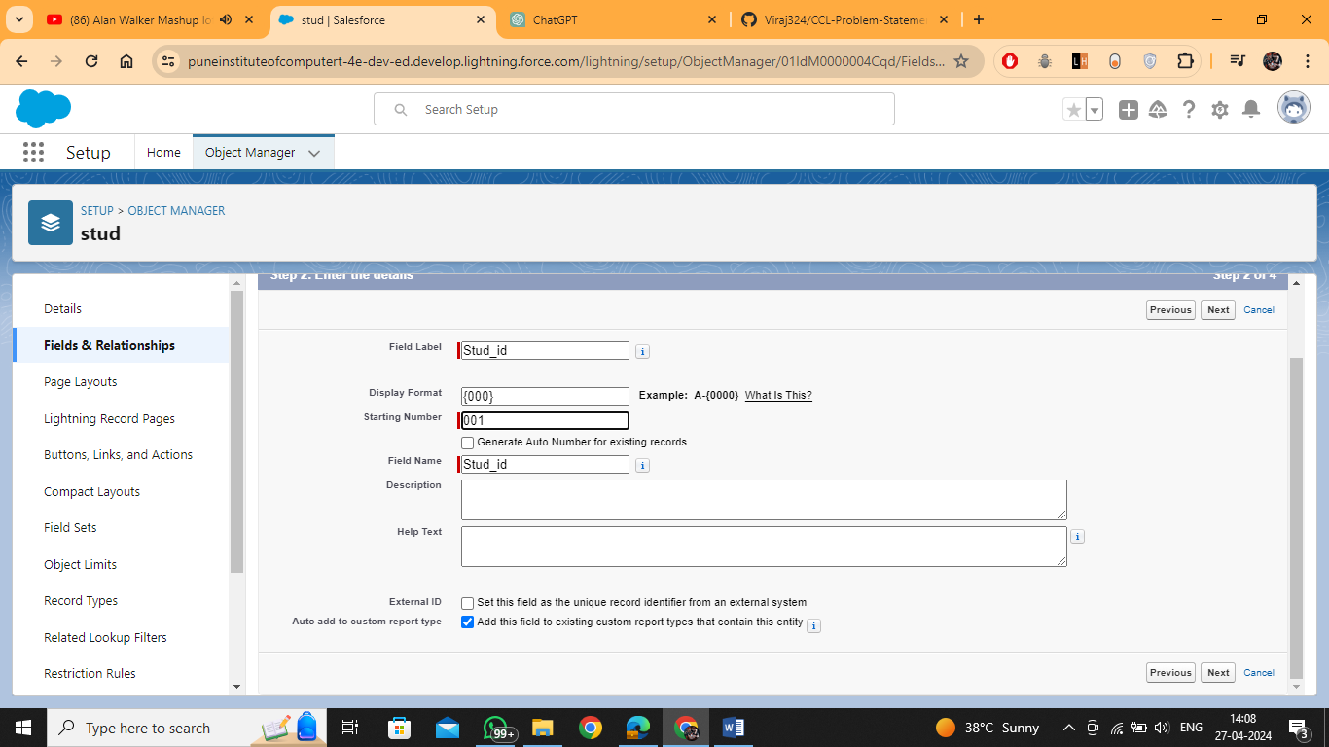  
  
Click on next 🡪 next 🡪 Save and new  
Add all fields  
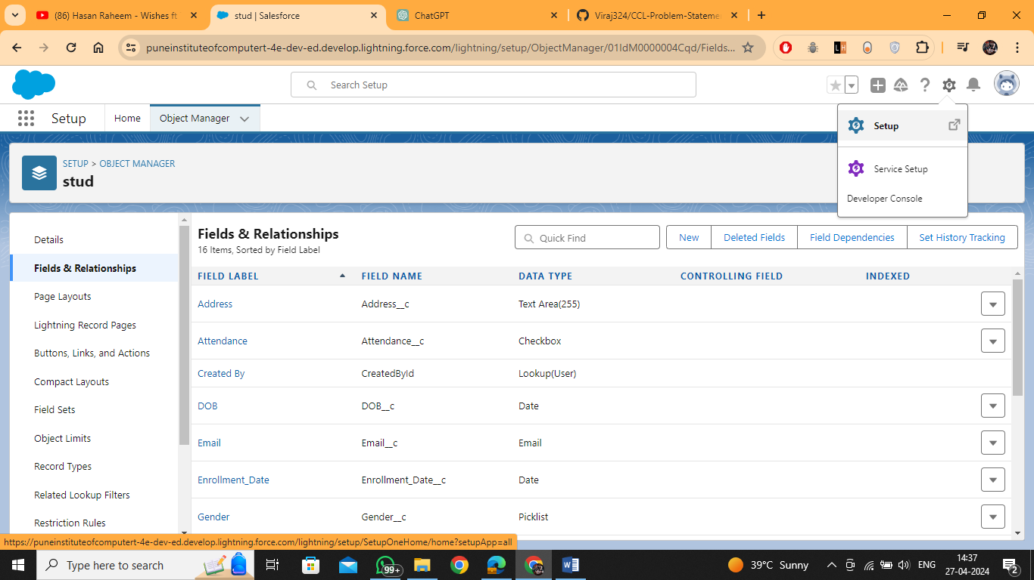

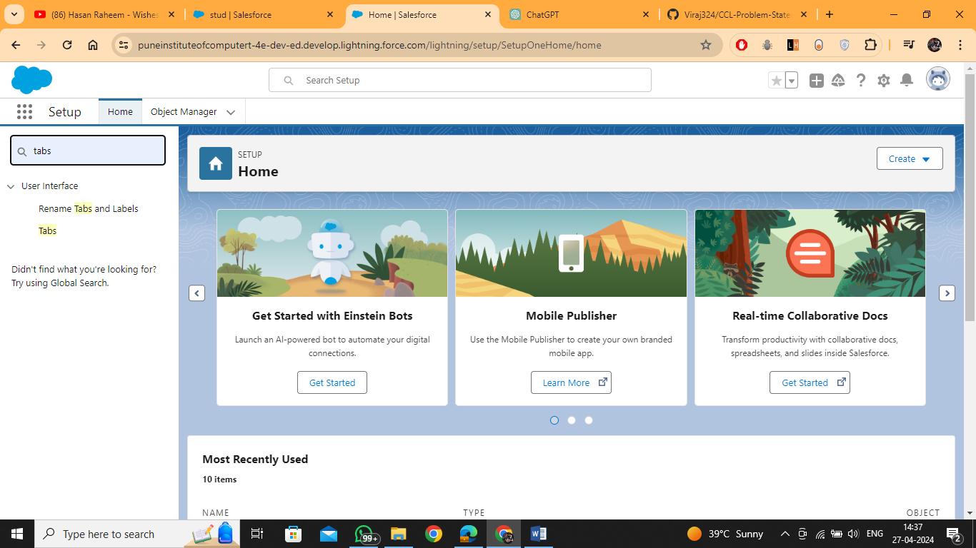

Create new Custom Object

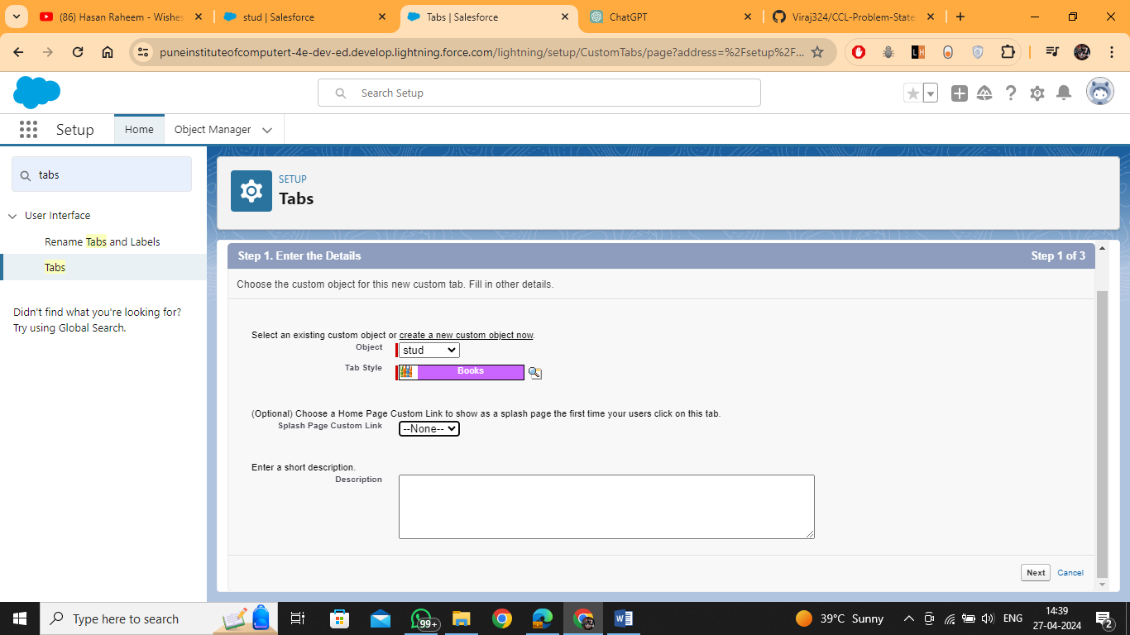

Next 🡪 next 🡪 Save

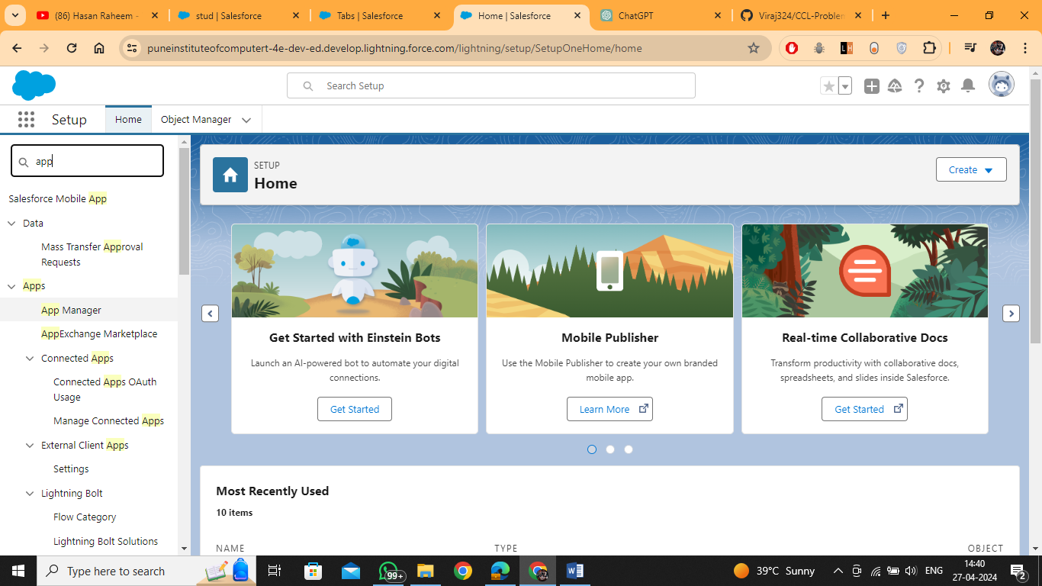

Select app manager

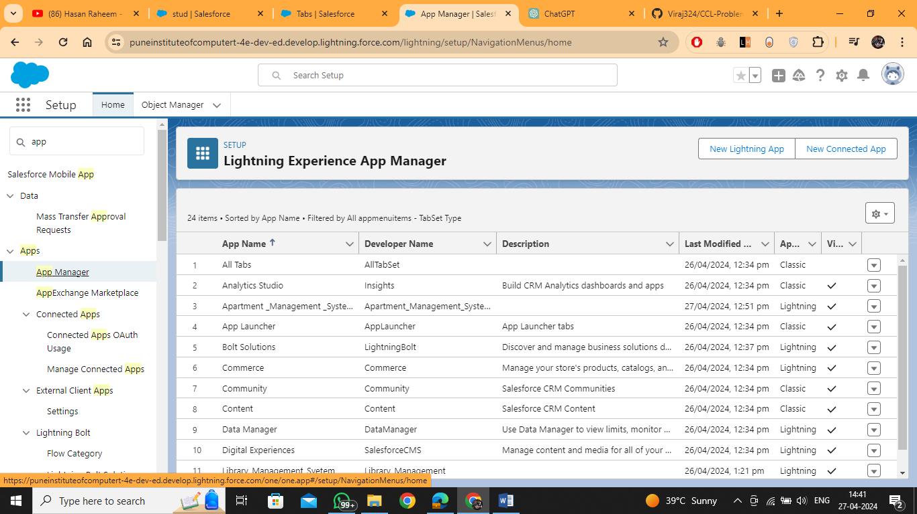

New Lighting app

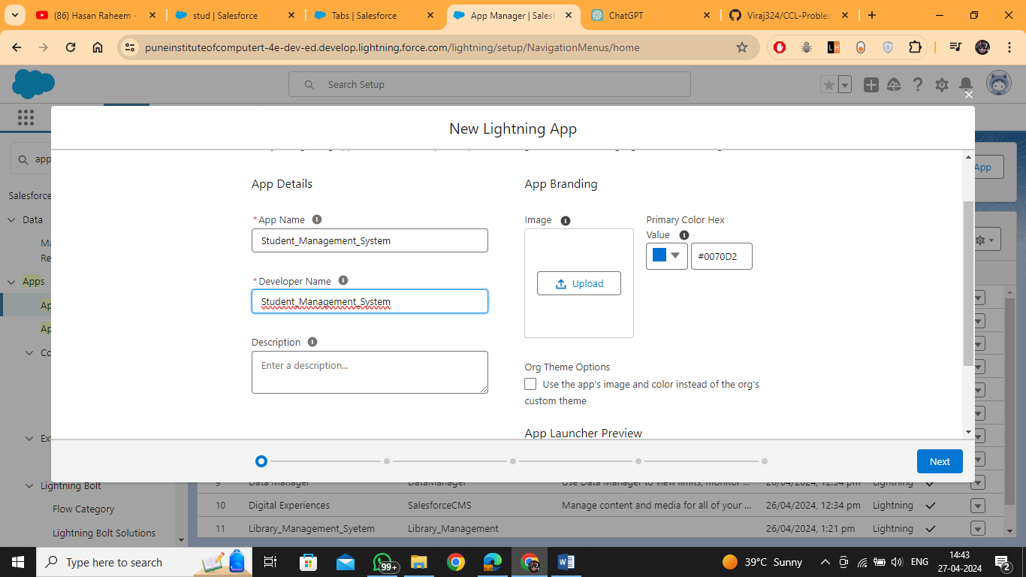

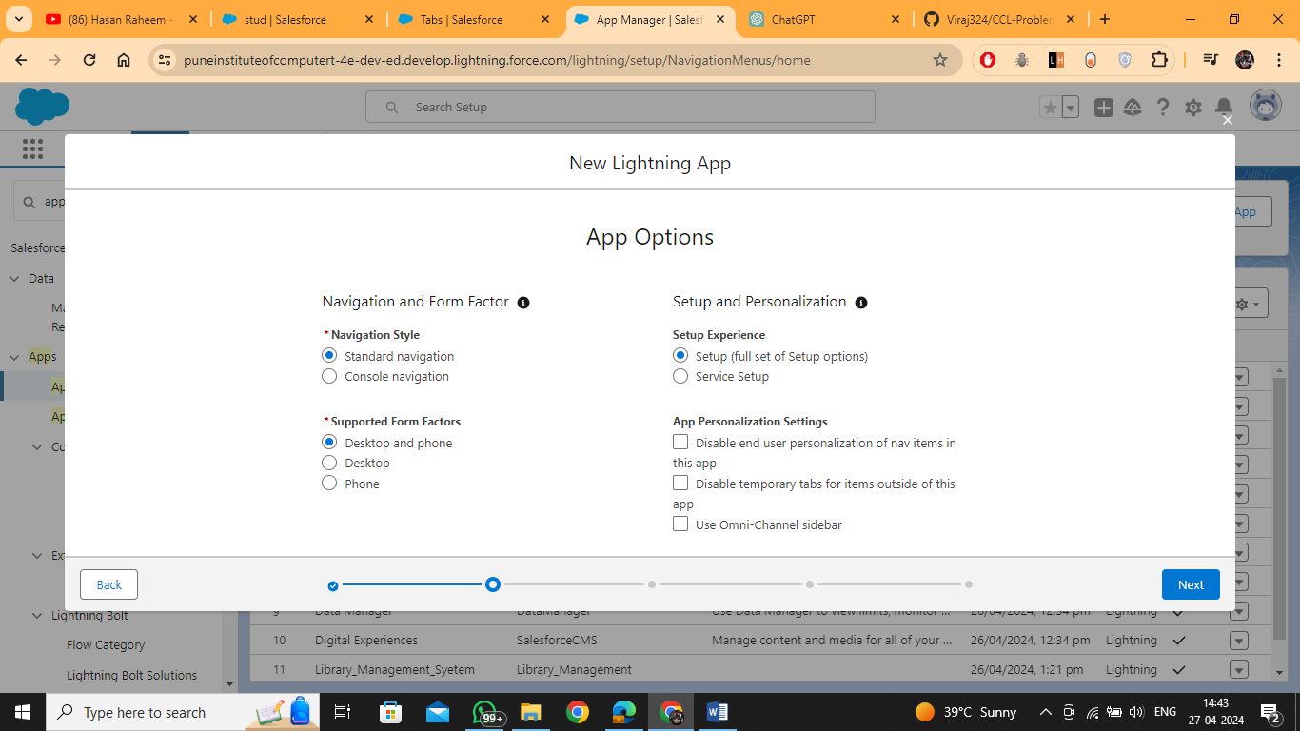

Next -> next ->   
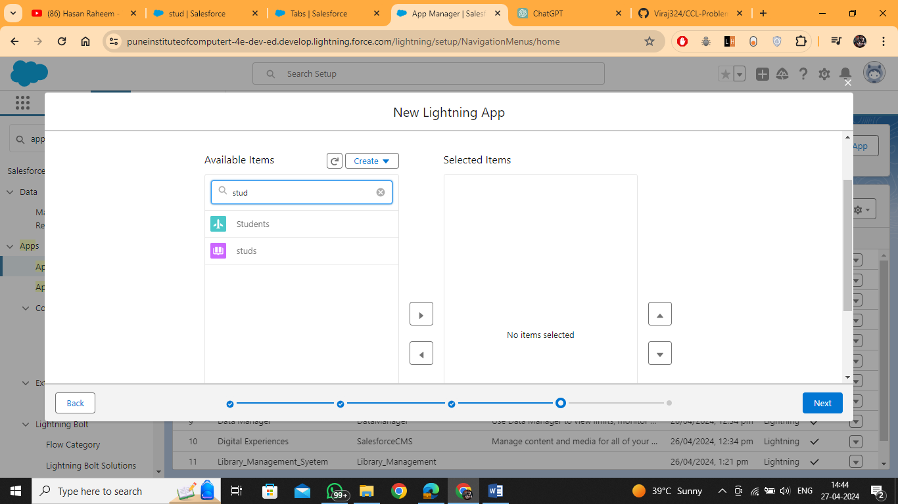

Next 🡪 Then selected system Administrator

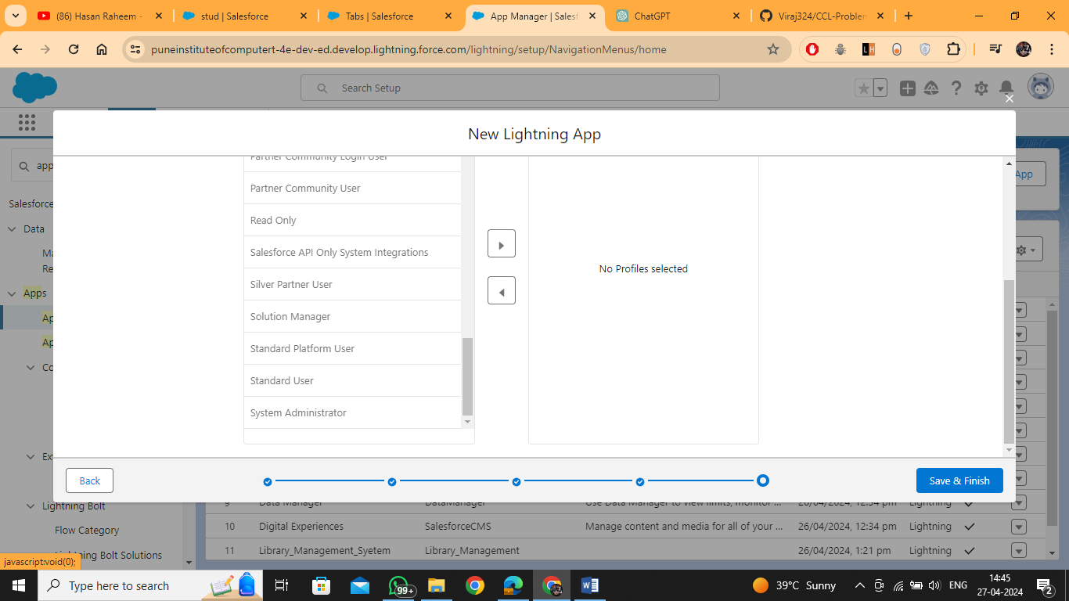

Then save

