Viraj Chetan Desai – 210905019
1)Configure two VMs that will be used to test connectivity from end to end and R1 will
serve as a DHCP server to distribute IP addresses. The diagram below details the
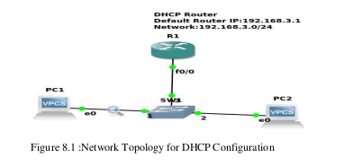
current setup:

1. In order to configure our router as a DHCP server the following commands were used.
R1(config)#IP dhcp pool NAME
R1(dhcp-config)#Network 192.168.3.0 255.255.255.0
R1(dhcp-config)#Default-router 192.168.3.1
The commands above create a DHCP pool, adds the network that we want to assign IP addresses
from, and specifies the default gateway for this subnet.
Note: There are many other parameters that go into configuring a DHCP server but this will
suffice for our test environment.
That should be it for the DHCP configuration.
2.The next thing that you want to do is configure the fastethernet 0/0 interface which will
connect to our switch.
R1(config)#Interface fastEthernet 0/0
R1(config-if)#No shutdown
R1(config-if)#ip address 192.168.3.1 255.255.255.0
The commands above will turn the interface on and assign an IP address.
3. Turn on the VPCS. In PC1 and PC2 type dhcp
PC1>dhcp
PC2>dhcp
4. Let’s analyze some of the traffic patterns using Wireshark.
In Wireshark we see the following information with regards to DHCP:
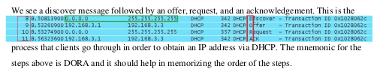

ANS: NOTE: use “ip exclude address ...” to not assign certain addresses in dhcp

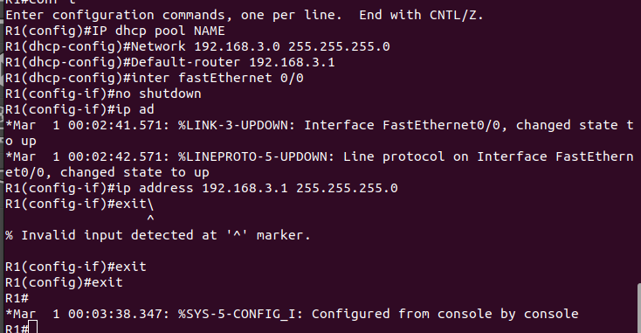
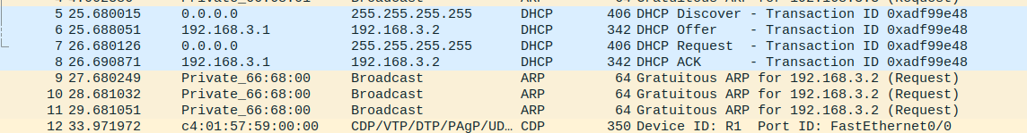
Output after executing dhcp on PC1 and PC2

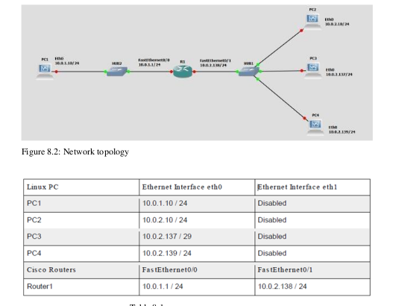
2.Network Prefixes and Routing
In this exercise, you study how the network prefixes (netmasks) play a role when hosts determineif a datagram can be
directly delivered or if it must be sent to a router.
This part uses the network setup shown in Figure 8.2. The network includes one router, four
hosts and two hubs. The IP addresses of all devices are given in Table 8.1. Here, each host hasonly a
default route. In other words, the routing table at a host only knows about the directly connected
networks and the default gateway.

Exploring the role of prefixes at hosts
In this exercise, you explore how hosts that are connected to the same local area network, but
that have different netmasks, communicate, or fail to communicate.
a. Configure the hosts and the router to conform to the topology shown in Figure 8.2, using the
IP addresses as given in Table 9.1. Note that PC2, PC3, and PC4 have different netmasks.
b. Add Router1 as default gateway on all hosts. (PC1, PC2, PC3, and PC4).
c. Issue ping commands from PC1
ai) Clear the ARP table on all PCs.
aii) Start Wireshark on PC1 and on PC3, and set the capture filter to capture ICMP and
ARP packets only.
aiii) Issue a ping command from PC1 to PC3 for at least two sends (-c 2).
aiv) Save the output of the ping command at PC1 and the output of Wireshark on PC1
and PC3.
v) Save the ARP tables, routing tables, and routing caches of each host. Please note that
these are the tables entries from Step 3 after the ping commands are issued.
d. Issue ping commands from PC3 to PC4
ai) Clear the ARP table on all PCs.
aii) Start Wireshark on PC3, and set the capture filter to capture ICMP and ARP packets
only.
iii) Check the ARP table, routing table, and routing cache of each host. Save the
output.
iv) Issue a ping command from PC3 to PC4 for at least three sends (-c 3) .
Please note that these are the table entries from Step 4 before the ping is issued.
v) Save the output of the ping command and the output of Wireshark on PC3.
vi) Save the ARP table, routing table, and routing cache of PC3. Please note that these are
the table entries from Step 4 after the ping commands are issued.
5. Repeat Step 4, but this time issues a ping from PC3 to PC2. Note that once an entry is made in
the routing cache, you cannot repeat the previous experiment to obtain the same results. You
have to wait until the routing cache is reset or you can delete all the routing caches on all
devices.

ANS:

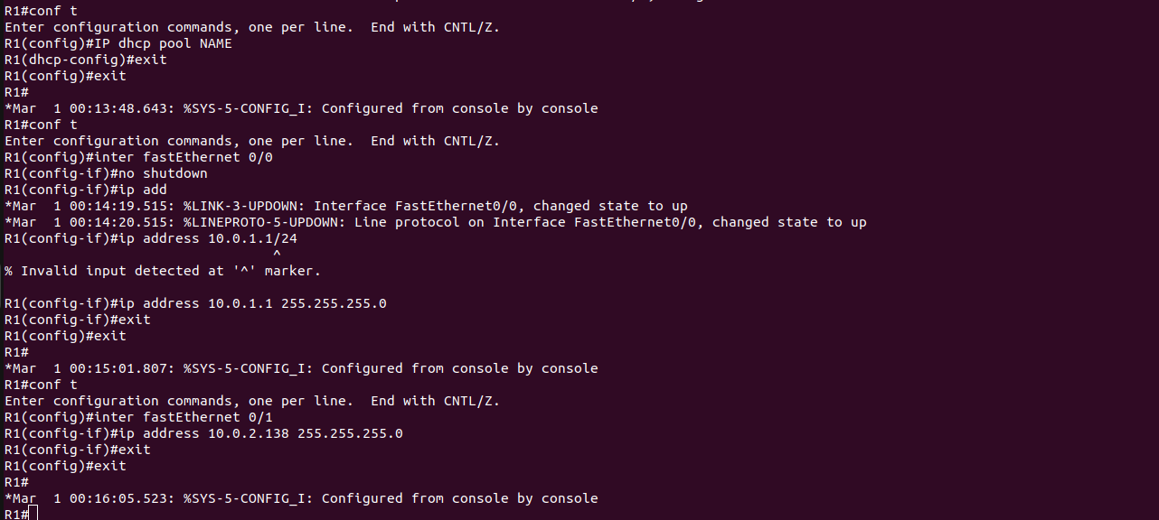
PC1> ip 10.0.1.10/24 10.0.1.1
Checking for duplicate address...
PC1 : 10.0.1.10 255.255.255.0 gateway 10.0.1.1

PC2> ip 10.0.2.10/24 10.0.2.138
Checking for duplicate address...
PC2 : 10.0.2.10 255.255.255.0 gateway 10.0.2.138

PC3> ip 10.0.2.137/29 10.0.2.138
Checking for duplicate address...
PC3 : 10.0.2.137 255.255.255.248 gateway 10.0.2.138

PC4> ip 10.0.2.139/24 10.0.2.138
Checking for duplicate address...
PC4 : 10.0.2.139 255.255.255.0 gateway 10.0.2.138

PC1 to PC3
PC1>ping 10.0.2.137

10.0.2.137 icmp_seq=1 timeout
84 bytes from 10.0.2.137 icmp_seq=2 ttl=63 time=10.973 ms
84 bytes from 10.0.2.137 icmp_seq=3 ttl=63 time=18.202 ms
84 bytes from 10.0.2.137 icmp_seq=4 ttl=63 time=19.238 ms
84 bytes from 10.0.2.137 icmp_seq=5 ttl=63 time=19.137 ms
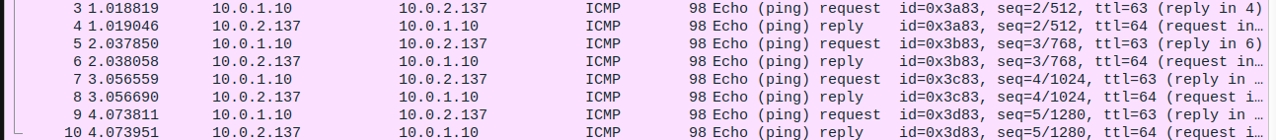

PC1> show arp

c4:01:59:d6:00:00 10.0.1.1 expires in 113 seconds

PC3 TO PC4
PC3> ping 10.0.2.139

84 bytes from 10.0.2.139 icmp_seq=1 ttl=64 time=0.683 ms
84 bytes from 10.0.2.139 icmp_seq=2 ttl=64 time=0.923 ms
84 bytes from 10.0.2.139 icmp_seq=3 ttl=64 time=0.417 ms
84 bytes from 10.0.2.139 icmp_seq=4 ttl=64 time=0.865 ms
84 bytes from 10.0.2.139 icmp_seq=5 ttl=64 time=0.875 ms

PC3> show arp

00:50:79:66:68:03 10.0.2.139 expires in 5 seconds

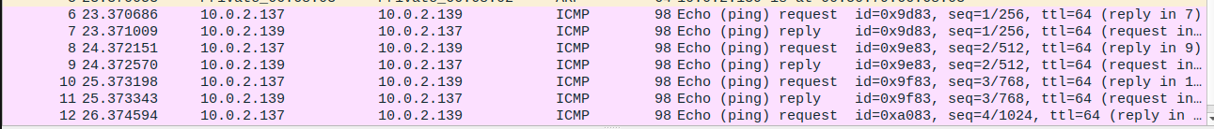
II. In an institute, there is one DHCP server and two departments that want IP addresses for the end users. A
DHCP client could request an IP address and DHCP server must respond to client requests as the server is
always active. So, configure DHCP for the below configuration. Also, show the configuration if connecting
one more DHCP server with the current DHCP server.

