**Sentiment analysis using pre-trained deep learning models**

**1. Model:** Distilbert-base-uncased-finetuned-sst-2-english

**Sample data:**

1. The_Apollo_11_Conspiracy.docx (Size 14.5kb)
2. James_Webb_Space_Telescope.html (100 kb/ 9200 words approx.)

**Execution time:**

Sentiment analysis for The_Apollo_11_Conspiracy.docx completed in 3.33 seconds for James_Webb_Space_Telescope.html completed in 6.92 seconds

**Plots:**

**1)**

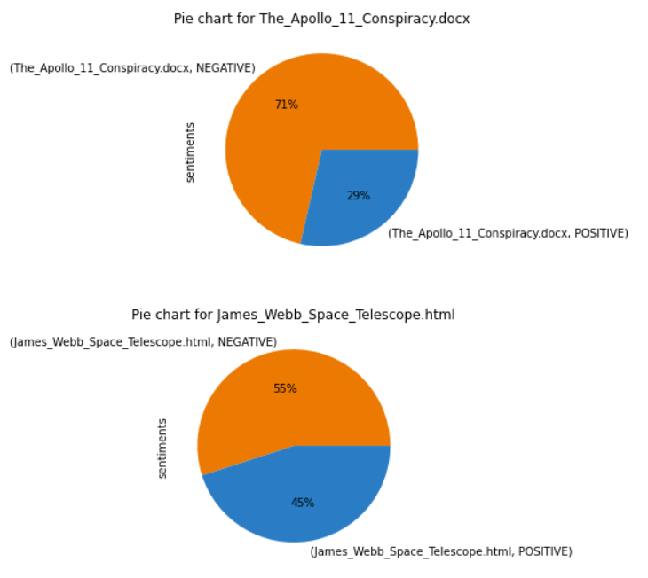

**2)**

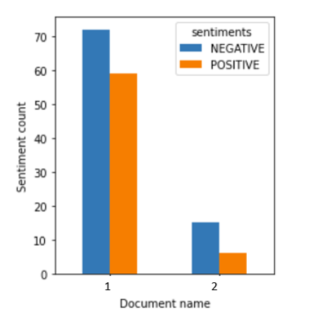

**Sentiment DataFrame:**

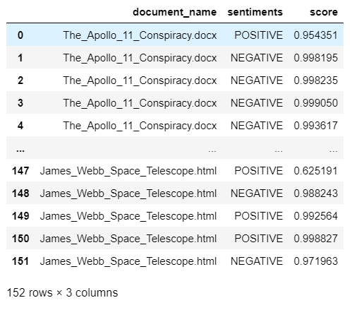

**2. Model:** Distilbert-base-uncased-finetuned-sst-2-english

**Sample data:**

1. The_Apollo_11_Conspiracy.docx (Size 14.5kb)
2. James_Webb_Space_Telescope.html (100 kb/ 9200 words approx.)

**Execution time:**

Sentiment analysis for The_Apollo_11_Conspiracy.docx completed in 4.31 seconds for James_Webb_Space_Telescope.html completed in 10.88 seconds

**Plots:**

**1)**

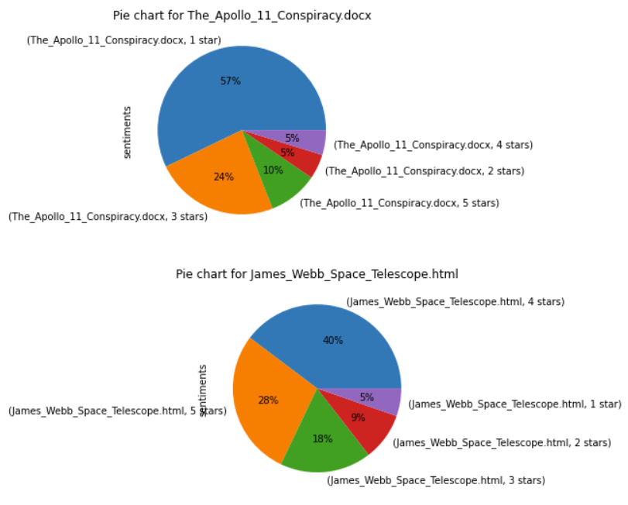

**2)**

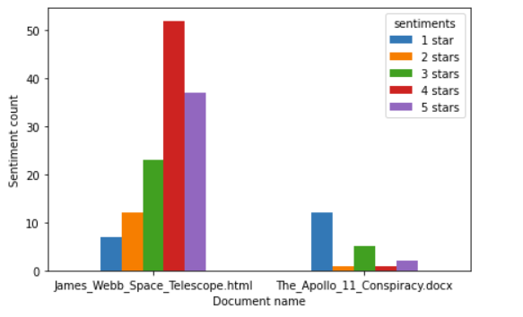

**Sentiment DataFrame:**

